|  |  |
| --- | --- |
| cetlogo ***CHEMICAL ENGINEERING TRANSACTIONS***  ***VOL. 76, 2019*** | A publication of  aidiclogo_grande |
| The Italian Association  of Chemical Engineering  Online at www.cetjournal.it |
| Guest Editors: Sauro Pierucci, Jiří Jaromír Klemeš, Laura Piazza  Copyright © 2019, AIDIC Servizi S.r.l. **ISBN** 978-88-95608-73-0; **ISSN** 2283-9216 | |

Study of Liquefied Natural Gas production Cycles for Novel Low-Temperature Natural Gas Purification Processes

Giorgia De Guido\*, Laura Annamaria Pellegrini

Dipartimento di Chimica, Materiali e Ingegneria Chimica “G. Natta”, Politecnico di Milano, Piazza Leonardo da Vinci 32, I-20133 Milano, Italy

giorgia.deguido@polimi.it

The primary energy mix forecasted for the future shows that growth rates will be the highest for renewable energy sources but, in absolute terms, fossil fuels will remain dominant. Among them, natural gas is the most attractive due to the advantages it offers in terms of environmental impact. This has recently contributed to the increased demand for natural gas and to the interest in developing those reserves that were left undeveloped in the past because of their high acid gas (particularly CO2) content. This has driven the recent research towards novel technologies that are suitable for the production of these gas fields. These novel technologies are based on low-temperature/cryogenic separation methods, which produce a purified natural gas stream at a temperature much lower than that reached when conventional technologies are used for acid gas removal.

In addition to the key role played by natural gas, it is important to also take into account the one played by liquefied natural gas, which represents a valuable alternative to the common method for natural gas transportation via pipelines to reach the utilization zones. Currently, all the natural gas liquefaction technologies are developed for a natural gas stream coming from a conventional purification process that produces a purified stream at about ambient temperature. Considering the recent development of low-temperature/cryogenic natural gas purification technologies, it is important to study liquefaction cycles so that they can be applied to a purified natural gas stream at low/cryogenic temperatures.

This work deals with this study and aims at adapting the Single Mixed Refrigerant (SMR) liquefaction process currently used to liquefy a natural gas stream at ambient temperature, so that it can be applied to a purified natural gas stream at low/cryogenic temperatures. Simulations have been carried out in Aspen Hysys® V9.0 in order to adjust the composition and flowrate of the mixed refrigerant depending on the conditions of the purified natural gas stream that undergoes the liquefaction process.

* 1. Introduction

The rising concern about climate has contributed to the change the world of energy is experiencing today. A key player in this transition towards lower carbon sources is natural gas (NG), which is the most attractive among fossil fuels due to the advantages it offers in terms of environmental impact. The composition of NG can vary widely, depending on the extraction site. Among the other characteristics that define its quality, the content of acid gases (mainly CO2 and H2S) is a key one, since it affects the choice of the acid gas removal (AGR) process. Indeed, several technologies are currently available for NG purification (De Guido et al., 2017) and each of them has advantages and disadvantages. In particular, considering the most widespread technology (i.e., chemical absorption by amines solutions), the main drawback is related to the need for solvent regeneration that becomes very expensive if the content of the acid gas in the raw NG stream is high (above about 10-15 mol%).

Since the increased demand for natural gas has led to the interest in developing those natural gas reserves that were left undeveloped in the past because of their high acid gas (particularly CO2) content, this has driven the recent research towards novel technologies that are suitable for their production. These novel technologies are based on low-temperature/cryogenic separation methods, which are also of interest for upgrading biogas to biomethane (Pellegrini et al., 2018). Three of them, which are based on distillation, are reported in Table 1: the Ryan-Holmes process (Holmes and Ryan, 1982), the DCCDTM process (Pellegrini et al., 2016), and the CFZTM process (Valencia et al., 2014). As shown in Table 1, the main difference between a conventional amine absorption technology and a low-temperature one lies in the temperature of the purified gas stream that is, then, sent to the liquefaction unit in case of LNG production. Such a temperature is close to the ambient one in the conventional case, and it is of about -90 °C in the case of low-temperature AGR technologies. The synergy between a low-temperature AGR technology and the downstream liquefaction process (Pellegrini et al., 2019) increases the interest in these novel technologies.

Table 1: Temperature and pressure of the NG stream purified by means of different AGR technologies

|  |  |  |  |
| --- | --- | --- | --- |
| Technology | T, °C | P, bar | Literature source |
| Amine absorption | 32 | 50 | Kohl and Nielsen (1997) |
| Ryan-Holmes | -86 | 41 | Holmes and Ryan (1982) |
| DCCDTM | -87 | 40 | Pellegrini (2014) |
| CFZTM (pipeline-quality) | -89/-86 | 39/42 | Valencia et al. (2014) |
| CFZTM (LNG-quality) | -90 | 37 | Valencia et al. (2014) |

In the case of LNG production, the CO2 content must be reduced to 50 ppm (Berstad et al., 2012) and the purified NG stream must be sent to the liquefaction unit. All the liquefaction technologies currently available have been designed to liquefy a NG stream coming from a conventional AGR process and, thus, at a temperature close to the ambient one. The current interest in low-temperature AGR technologies requires to rationalize the liquefaction process in order to make it suitable to treat a NG feed stream at low temperature. To the authors’ knowledge, this issue has not been addressed in the literature yet. Therefore, this work presents a preliminary analysis dealing with the study of the liquefaction process by means of the Single Mixed Refrigerant (SMR) technology applied to a purified NG stream obtained from both a conventional AGR process and from a novel one based on low-temperature distillation. The two case studies will be denoted in the following by “conventional” and “low-temperature”, respectively. Simulations have been carried out in Aspen Hysys® V9.0 (AspenTech, 2016) to adjust the composition and the flowrate of the mixed refrigerant (MR), depending on the conditions of the purified NG stream that undergoes the liquefaction process.

* 1. Methods
     1. Simulations

For the low-temperature case study, a methane gas mixture containing 50 ppm CO2 has been considered. A binary mixture of the two components has been taken into account considering that, if hydrocarbons heavier than methane are present in the raw NG feed stream, they are recovered at the bottom of the distillation tower, together with CO2. For comparison purposes, the same binary mixture has been also considered in the conventional case study. The two streams differ for the temperature set equal to 32 °C and -87 °C, respectively, in the conventional and low-temperature case study (Table 2). Moreover, a pressure of 50 bar and 40 bar has been considered in each case (Table 2), taking into account the typical operating conditions of the upstream AGR unit. A mass flowrate of 1 kg/h has been considered for the NG stream entering the liquefaction unit so that the resulting compression power for unit flowrate corresponds to the specific power required for NG liquefaction. The optimization effort in this study regards the SMR liquefaction technology: it has been selected since it is the simplest one and was believed to be suitable for beginning the analysis that represents the scope of this work. The scheme is illustrated in Figure 1.

The SMR liquefaction process employs a single cycle with a mixture of N2 and hydrocarbons (typically, methane, ethane and propane) as refrigerant. Like all systems that use a mixture of refrigerant components and, thus, can be tailored to the specific application, it is considered as the most flexible of all the liquefaction systems. Indeed, the refrigerant can easily be adjusted for changes in feed conditions while the plant is in operation, contrarily to other liquefaction processes that make use of pure refrigerants and can only alter its flowrate. Moreover, the use of a mixture of refrigerant components allows obtaining a better match between the warming and cooling curves, increasing the cycle efficiency. The SMR process involves a reverse Rankine cycle, in which the refrigerant passes through some basic steps. As shown in Figure 1, the MR undergoes an inter-refrigerated compression train (4 stages) used to rise its pressure from 1.3 bar to the maximum pressure reached in the process. Then, it is partially condensed, prior to entering the main cryogenic heat exchanger (MCHE). The MCHE represents the heart of the process and it is where refrigeration and liquefaction of NG take place. In it, the MR is totally condensed before being flashed across an expansion valve, which causes a further drop in its temperature. Refrigeration for condensing and sub-cooling the NG feed is provided by the vaporizing MR (cold fluid), which is recovered to be compressed again (the stream “Out of MR from HE” has the same characteristics of the stream “In of MR Comp” entering the first compressor “MR Comp 1” in Figure 1, to close the MR cycle). Thus, the MCHE is a multi-stream heat exchanger, with two hot streams (the warm MR and NG) and one cold stream (the cold MR).

Table 2: Composition and conditions of the NG stream entering the liquefaction unit for the two case studies

|  |  |  |
| --- | --- | --- |
|  | Conventional | Low-temperature |
| Temperature, °C | 32 | -87 |
| Pressure, bar | 50 | 40 |
| Mass flowrate, kg/h | 1 | 1 |
| Composition, mol/mol |  |  |
| Methane | 0.99995 | 0.99995 |
| CO2 | 0.00005 | 0.00005 |

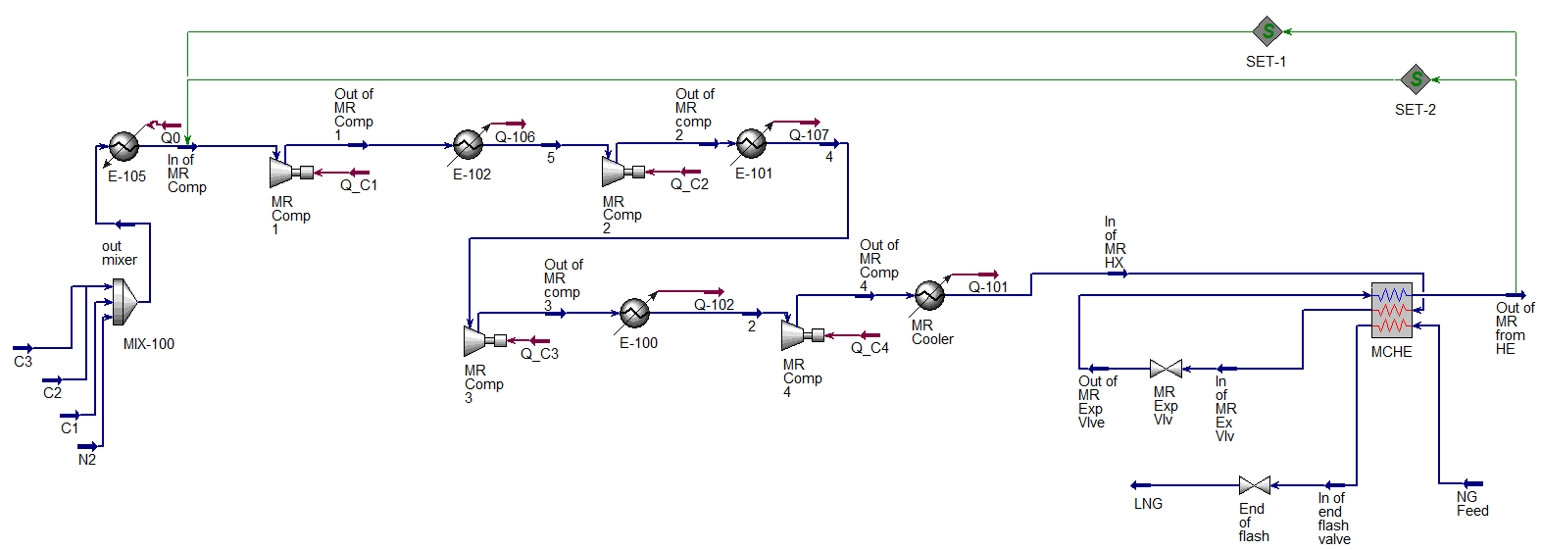

Figure 1: Scheme of the SMR liquefaction process

Considering the two case studies investigated in this work, the composition and the flowrate of the MR have been optimized in order to minimize the power required for compression, while guaranteeing there is no temperature cross in the MCHE. To avoid that, the minimum approach temperature (MAT) has been considered to be the design constraint for the process and set at 3°C, as recommended in the literature (Khan et al., 2013) for low-temperature/cryogenic applications. To set-up the simulation, the pressure at the outlet of each compressor has been specified at (Khan et al., 2015): 3.205, 7.899, 19.47, and 48 bar. The temperature at the outlet of each inter-cooler has been fixed at 40 °C. Based on some information available in the literature, the temperature and pressure of the MR stream exiting the valve (“MR Exp Vlv”) have been specified, respectively, at -155 °C and 2.3 bar (the temperature difference the MR as hot fluid experiences in the MCHE is of about 190 °C in both cases). On the NG side, the inlet stream is completely specified (according to the information reported in Table 2). Moreover, the temperature at which it is cooled down has been fixed at -149.5 °C and, then, it is depressurized to 1.21 bar (Khan et al., 2015). Pressure drops have been neglected in the inter-coolers, whereas they have been assumed to be equal to 1 bar at each side of the MCHE.

* + 1. Procedure

The analysis has been carried out by simulating the process schemes in Aspen Hysys® V9.0 (AspenTech, 2016), using the Peng-Robinson thermodynamic package. The optimization has been managed through MATLAB® (MathWorks Inc., 2018), connecting the two tools using the ActiveXserver functionality. The following constrained minimization problem has been solved:

|  |  |
| --- | --- |
|  | (1) |

to minimize the total compression power required for the MR, subject to the constraint that the MAT is ≥ 3 °C, by optimizing the MR composition and flowrate. In the simulations of the liquefaction process, different streams for each pure component in the MR (i.e., propane, ethane, methane and nitrogen) have been defined (Figure 1) and, then, sent to a mixer (MIX-100) in order to create the refrigerant mixture while changing its composition directly from MATLAB®. To find the optimal composition and flowrate of the MR, the grid-search method (Sepiacci et al., 2017) has been adopted and implemented in MATLAB®. It consists of four steps. In the first one, the mole fractions of each component in the MR are varied between 0 and 1 (with a step of 0.1) and all the non-feasible combinations (i.e., those that don’t add up to unity) are discarded. Assuming a first guess value for the total molar flowrate of the MR, the simulation is carried out for all the other feasible combinations, thus determining the total compression power and MAT for each of them. In the second step, all the combinations that lead to a MAT ≥ 3°C are selected and, for each of them, the total molar flowrate of the MR is reduced (with a step size of 0.0001 kmol/h) until the MAT approaches the target value: this ensures the total compression power to decrease as well. If no feasible combination is found, then the procedure is repeated starting from a higher MR total flowrate. Otherwise, the combination with the minimum compression power is chosen. The third and fourth steps are similar to the first and second ones, but allow a further refinement of the composition and flowrate of the MR.

* 1. Results and discussion

Table 3 summarizes the best results obtained for the two case studies investigated in this work. Figure 2 illustrates the hot and cold composite curves (including the two individual warming curves for the sake of clarity) for the MCHE in these two cases.

Table 3: Results of optimization with the grid-search method for the two case studies

|  |  |  |
| --- | --- | --- |
|  | Conventional | Low-temperature |
| MR molar flowrate, kmol/h | 0.1645 | 0.1510 |
| MR composition, mol/mol |  |  |
| Propane | 0.4700 | 0.3761 |
| Ethane | 0.2097 | 0.2060 |
| Methane | 0.2401 | 0.3424 |
| Nitrogen | 0.0802 | 0.0755 |
| MAT, °C | 3.017 | 2.998 |
| Total compression power, kW | 0.5556 | 0.5271 |

The shape of the cold composite curve is due to the fact that in the low-temperature region, the evaporation of the MR occurs, while at higher temperatures the vapour is superheated. Note that the hot composite curve in Figure 2 is made of warm refrigerant (dotted red line) and natural gas (dashed red line), and it varies with both the MR composition and the NG inlet conditions. The discontinuity that can be observed in the hot composite curve occurs in the region of the MCHE where the natural gas stream is liquefied (around -83 °C and -87.6 °C, respectively, in the conventional and in the low-temperature case study). The heat to be removed in the low-temperature case study is certainly lower than the one in the conventional case, requiring a lower amount of refrigerant to be used (Table 3) and, thus, resulting in a lower total compression power. The little difference is due to the fact that the optimization focused on the MR composition and flow rate without taking into account other variables, which might lead to larger differences between the power consumptions of the two case studies.

a) b)

Figure 2: Hot and cold composite curves for the MCHE in the: a) conventional case study; b) low-temperature case study

It is important to point out that, if the same MR that resulted the best one for the conventional case study were used in the low-temperature one, a temperature cross in the MCHE would have occurred. Assuming the same composition has to be used while changing the inlet conditions (namely, decreasing the inlet temperature) of the NG stream, the liquefaction could be performed by increasing the MR flowrate and, therefore, at a higher compression power. As far as the composition is considered, in order to better understand how it affects the problem under investigation, Figure 3 and Figure 4 illustrate the power and the MAT in the MCHE, given by the colourful scale on the right side of each figure, for different sets of mole fractions of propane (C3), ethane (C2) and methane (C1) for the low-temperature case study (the mole fraction of nitrogen in the MR can be inferred by subtracting the sum of the other three mole fractions from unity). The molar flowrate of the MR has been set equal to the value reported in Table 3 for the low-temperature case study.

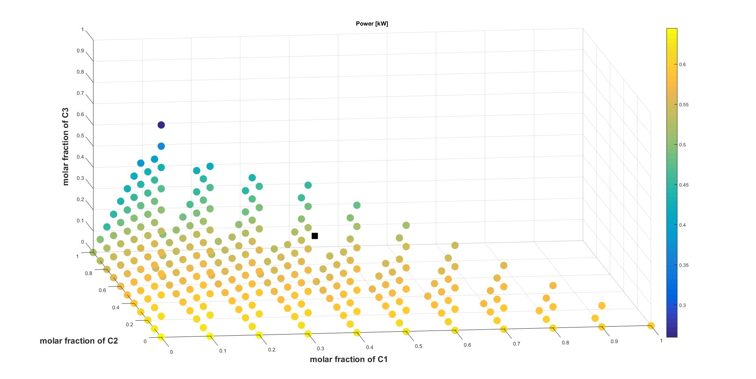

Figure 3: Effect of the composition of the MR on the total compression power at fixed molar flowrate, as reported in Table 3 for the low-temperature case study (the black filled square corresponds to the optimum in Table 3)

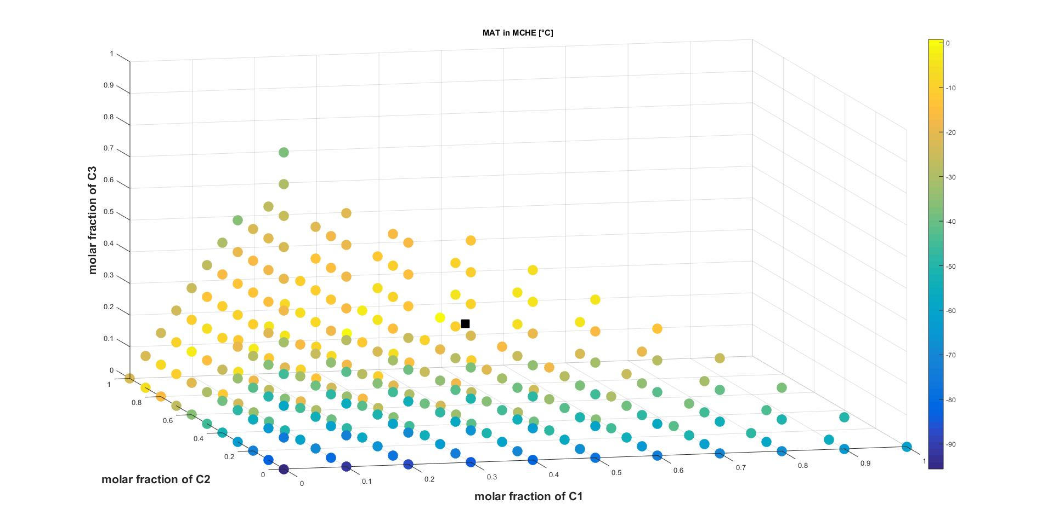

Figure 4: Effect of the composition of the MR on the MAT in the MCHE at fixed molar flowrate, as reported in Table 3 for the low-temperature case study (the black filled square corresponds to the optimum in Table 3)

The pyramidal shape of the two plots is due to the fact that only the feasible mole fractions combinations are illustrated. Figure 3 shows that, if the mixed refrigerant is composed of propane only, the total power required for compression is minimum (blue circle in Figure 3), which, however, leads to an unfeasible condition due to a negative MAT, as shown in Figure 4. On the contrary, if it is composed of N2 only (which also leads to an unfeasible condition due to a negative MAT, as shown in Figure 4), it requires the highest compression power (bright yellow circle in Figure 3). This can be explained considering that a mixture mainly consisting of N2 and methane is able to exchange less latent heat (due to a lower heat of vaporization) and, when it exchanges sensible heat, it tends to increment its temperature more than a mixture mainly consisting of propane and ethane (due to a lower specific heat). This leads, in turn, to a higher temperature at the outlet of the MCHE and, thus, at the inlet of the compression train, resulting in a higher compression power required, which is proportional to the temperature at the inlet of the compression train. Of course, these observations regarding the power requirement must be coupled with those concerning the feasibility of the heat exchange process itself and, therefore, with the analysis of the MAT in the MCHE. As shown in Figure 4, if the MR is composed of a pure component the refrigeration process is not feasible because of a temperature cross within the MCHE, with the worst case corresponding to the one involving pure N2 as cooling medium.

* 1. Conclusions

Considering the recent interest in novel low-temperature acid gas removal technologies for the purification of natural gas and the increasing importance gained by LNG, this work points out the need for adapting the liquefaction process so that it is able to treat a NG stream that is at a temperature lower than the typical ones. Thus, taking the SMR liquefaction process into account, simulations have been performed in Aspen Hysys® and the optimization has been managed through MATLAB® on the basis of the grid-search method. The results confirm that, even with a relatively simple liquefaction process, it is not possible to use the same mixed refrigerant in a convenient way for liquefaction of a natural gas mixture obtained from different acid gas removal units. On the contrary, its composition and flowrate must be adjusted for each case, which results in a lower consumption for a natural gas stream that is already available at low-temperature. The problem addressed in this work certainly requires further investigation in order to find a method for an overall optimization of the liquefaction process and/or to design one more suitable to liquefy a natural gas that has undergone a low-temperature acid gas removal process upstream.

References

AspenTech, 2016, Aspen Hysys®, Burlington, MA, United States.

Berstad D., Nekså P., Anantharaman R., 2012, Low-temperature CO2 removal from natural gas, Energy Procedia, 26, 41-48.

De Guido G., Pellegrini L.A., Besagni G., Inzoli F., 2017, Acid gas removal from natural gas by water washing, Chemical Engineering Transactions, 57, 1129-1134.

Holmes A.S., Ryan J.M., 1982, Cryogenic Distillative Separation of Acid Gas from Methane, US Patent 4,318,723.

Khan M.S., Lee S., Rangaiah G.P., Lee M., 2013, Knowledge based decision making method for the selection of mixed refrigerant systems for energy efficient LNG processes, Applied Energy, 111, 1018-1031.

Khan M.S., Karimi I.A., Bahadori A., Lee M., 2015, Sequential coordinate random search for optimal operation of LNG (liquefied natural gas) plant, Energy, 89, 757-767.

Kohl A.L., Nielsen R., 1997, Gas Purification, 5th ed, Texas: Gulf Publishing Company, Book Division.

MathWorks, Inc., MATLAB®, 2018.

Pellegrini L.A., 2014, Process for the removal of CO2 from Acid Gas, WO Patent 2014/054945A2.

Pellegrini L.A., De Guido G., Langè S., Moioli S., Picutti B., Vergani P., Franzoni G., Brignoli F., 2016, The Potential of a New Distillation Process for the Upgrading of Acid Gas, in: Abu Dhabi International Petroleum Exhibition & Conference, Society of Petroleum Engineers.

Pellegrini L.A., De Guido G., Langé S., 2018, Biogas to liquefied biomethane via cryogenic upgrading technologies, Renewable Energy, 124, 75-83.

Pellegrini L.A., De Guido G., Valentina V., 2019, Energy and exergy analysis of acid gas removal processes in the LNG production chain, Journal of Natural Gas Science and Engineering, 61, 303-319.

Sepiacci P., Depetri V., Manca D., 2017, A systematic approach to the optimal design of chemical plants with waste reduction and market uncertainty, Computers & Chemical Engineering, 102, 96-109.

Valencia J.A., Kelman S.D., Nagavarapu A.K., Maher D.W., 2014, The controlled freeze zone technology for the commercialization of sour gas resources, in: International Petroleum Technology Conference (IPTC 2014).