 CHEMICAL ENGINEERING TRANSACTIONS  VOL. | A publication of  
The Italian Association
of Chemical Engineering
Online at www.aidic.it/cet
Guest Editors:
Copyright © AIDIC Servizi S.r.l.
ISSN 2283-9216

Methane/Hydrogen blends in Controlled Auto Ignition Engines with EGR: Evaluation of NOx Emissions
Antonio Mariani, Andrea Unich, Mario Minale
Università della Campania “Luigi Vanvitelli”, Via Roma 29, 81031 Aversa (Caserta), Italy.
mario.minale@unicampania.it
Gaseous fuel utilisation reduces pollutant emissions and makes energy systems less dependent from oil. Their carbon content is low, which means a reduction in CO₂ emissions per unit of energy in comparison with liquid fossil fuels. The use of biogases (BG) and/or natural gas (NG) in internal combustion engines (ICE) is very attractive. To increase the efficiency of NG engines hydrogen can be added to natural gas, and innovative BG containing hydrogen can be conveniently used. Hydrogen has a high combustion speed, providing a reduction of the combustion duration when mixed with methane. Consequently higher temperatures are attained in the combustion chamber and thus engines fuelled with NG/H₂ blends increase the NOx emissions. NG and BG are generally adopted as fuel in positive ignition ICEs; however they are also suitable for fuelling Controlled Auto Ignition (CAI) engines.
The authors investigated combustion in CAI ICE by means of numerical simulations. Starting with pure CH₄, the fuel was subsequently enriched with H₂, comparing engine performance and exhaust emissions.
CAI systems are indirectly controlled with varying air-fuel ratio, boost pressure and charge temperature. Charge temperature depends on the residual gas content, which has an impact on the combustion process as the burning mixture composition consequently changes. The authors investigated the effect of exhaust gas recirculation on the in-cylinder gas temperature and reaction mechanism, with main focus on NOx emissions. Hydrogen addition reduces the intake temperature requirement for the autoignition, which means less EGR. Hydrogen enriched fuels also require lower boost pressure than CH₄ to deliver the reference imep while engine efficiency does not change significantly between tested fuels. Hydrogen also helps in reducing NOx emissions due to lower boost pressure and EGR rates.
  - Introduction
The depletion of energy sources and the environmental effects of fossil fuels use in energy conversion systems are important challenges for today's society. Costs related to fossil fuel are also a big concern not only for the economic aspect but also for social repercussions.
Unconventional oils (Merola et al., 2016) represent the vast majority of the world oil reserves but their exploitation is technically difficult and expensive (Minale et al., 2018). The reduction of CO₂ emissions, pollutant emissions and the diffusion of renewable energies are not anymore options but a necessity also in view of the global energy demand intensification. In this scenario the use of biogases (BG) and natural gas (NG) is of big interest: BG is typically produced from the anaerobic digestion of organic materials (Carotenuto et al., 2016a). Biogas is typically composed by 55-70% of CH₄, 30-45% CO₂ (Carotenuto et al., 2016b), though innovative digestion processes (Guarino et al., 2014) may lead to the production of BG made of CH₄, CO₂ and H₂ since, e.g., animal manure naturally contains hydrogen-producing bacteria, as eubacteria, (Carillo et al., 2012). The addition of hydrogen to NG can lead to an engine efficiency increase (Ma et al., 2008) that, together with the low exhaust emissions (Ristovski et al., 2000; Prati et al., 2011), suggests that fuelling engines with innovative biogases may be very promising.
Hydrogen has a laminar combustion speed about eight times greater than methane, providing a reduction of the combustion duration when mixed with natural gas in small concentrations (Ilbas et al., 2006). By the way, as a consequence of a faster combustion, higher temperatures are attained in the combustion chamber. NOx emissions consequently increase in engines fuelled with NG/H₂ blends, compared to NG, for a given equivalence ratio. NOx can be kept low and engine efficiency further improved if the engine is run with lean mixtures (e.g., Hoekstra et al., 1995) or adopting EGR at stoichiometric air-fuel ratio (Mariani et al., 2012). NG/H₂ blends have been mainly considered as a fuel in positive ignition ICEs. However their use is also suitable in Controlled Auto Ignition (CAI) engines. The combustion process in CAI engines is characterized by the absence of a flame front propagation and by an extremely rapid evolution. This allows an efficiency improvement, limited however by the constraint that cylinder pressure rise rate cannot exceed certain values (Cho et al., 2010). Jamsaran et al. (2016) investigated the auto-ignition reactivity of natural gas in CAI engines with regard to the effects of intake air temperature and equivalence ratio. Nishi et al. (2016) studied the effects of EGR ratio and engine speed on CAI combustion; Mohamed Ibrahim and Ramesh (2014) improved the performance and extended the load range of a hydrogen fuelled CAI engine through charge temperature regulation and of carbon dioxide addition.
Main focus of this paper is the investigation of NOx emissions reduction in a CAI engine fuelled with innovative BG. While in a previous paper the authors controlled the combustion phasing of a CAI engine by changing the charge temperature (Mariani et al, 2018), here the effect of exhaust gas recirculation (EGR) is considered. Since the reduction of NOx emissions was also achieved when the CAI engine was fuelled with mixtures of CH₄ and H₂, in this work the authors considered CH₄/H₂ blends. CAI combustion is investigated by means of numerical simulations focusing on the hydrogen potential in improving the combustion behaviour and investigating the effect of EGR on the in-cylinder gas temperature, reaction mechanism and NOx emissions.
  - Methods
Controlled Auto-Ignition combustion has the potential of combining together the advantages of spark ignition and compression ignition engines. The combustion is characterized by an extremely rapid evolution with high thermal efficiency; however cylinder pressure rise rate cannot exceed certain limits to prevent unacceptable mechanical and thermal loads and noise. With the absence of flame front propagation, CAI combustion is dominated by chemical kinetics. Implementation of a detailed reaction mechanism is therefore necessary for CAI combustion analysis. The complex gas-phase chemical kinetics is here modelled with the detailed radical chain reactions mechanism GRI-Mech 3.0, designed for methane. The mechanism has 325 elementary chemical reactions and 53 species, including those to predict NOx formation; all kinetic constants are provided. GRI-Mech 3.0 mechanism includes all the reactions required to accurately describe hydrogen combustion and it is thus appropriate to study the combustion of mixtures of methane and hydrogen, as those investigated in this paper.
The combustion process of a CAI engine is studied using the Package HCCI of Chemkin 17.0 that allows simulating the engine cycle, except the gas exchange process. The CAI model simulates the combustion in an internal combustion engine under auto-ignition conditions. The implemented single-zone CAI combustion model permits detailed description of the chemical kinetics by assuming homogeneous gas properties in the combustion chamber. The single-zone model can adequately predict ignition. However, because it does not account for low-temperature regions within the thermal boundary layers and crevices, the model underestimates carbon monoxide and unburned hydrocarbon emissions. For this reason NOx emissions only are here considered. The main characteristics of the engine selected for the simulations are reported in Table 1. The CAI engine was fuelled with CH₄ and two CH₄/H₂ blends whose compositions, in agreement with those of innovative biogases (di Cristofaro et al., 2014), are summarized in Table 2.
Table 1: Engine parameters and operating conditions
Engine type | 4-stroke
Compression ratio | 16.7:1
Bore x Stroke [mm] | 135 x 170
Engine speed [rpm] | 1500
Table 2 Fuels composition
Fuel | CH₄ molar fraction | H₂ molar fraction
CH4 | 1 | 0
CH4H2_1 | 0.9 | 0.1
CH4H2_2 | 0.8 | 0.2

The equivalence ratio (ER) is defined as the ratio between the actual ${\left(\frac{m_{f}}{m_{a}}\right)}_{actual}$and the stoichiometric ${\left(\frac{m_{f}}{m_{a}}\right)}_{stoic.}$fuel-to-air mass ratio, Eq(1):
$ER={{\left(\frac{m_{f}}{m_{a}}\right)}_{actual}}/{{\left(\frac{m_{f}}{m_{a}}\right)}_{stoic.}}$ (1)
CAI engines operate with lean air-fuel mixtures (ER<1) so to have a better control of pressure gradient in the cylinder. For this reason the analysis is carried out considering ER = 0.4 as a reference value for methane (Kozarac et al., 2014). Indicated Mean Effective Pressure (imep) is an engine performance index independent from engine size, obtained dividing the indicated work per cycle by the displacement, V_{d}, Eq(2). The indicated work per cycle $\oint{pdV}$ is the integral of the cylinder pressure p, being dV the cylinder volume variation.
$imep={\oint{pdV}}/{V_{d}}$ (2)
Engine indicated efficiency is defined as:
$η_{i}={P_{i}}/{\left({\overset{˙}{m}}_{f} LHV\right)}$ (3)
where P_{i} is the indicated power, ${\overset{˙}{m}}_{f}$ is the fuel mass flow rate, LHV the fuel lower heating value.
  - Results and discussion
    - Effect of EGR and boosting pressure on engine performance and emissions
The intake temperature is an important control parameter for the combustion in CAI engines. The combustion takes place only if the in-cylinder gases reach the conditions for auto-ignition. Engine performance strongly depends on the initial gas temperature as it directly affects the combustion phasing. In CAI engines the temperature can be controlled varying the EGR rate. Hot exhaust gases are recirculated and mixed with the fresh charge, an air-fuel mixture whose composition is defined by the equivalence ratio. Normally, in supercharged ICEs the air is cooled down before entering the cylinders to improve volumetric efficiency and reduce knock tendency. In this analysis the air cooler was not considered because the air temperature increase due to the compression is beneficial for auto ignition. Intake temperature consequently depends on the compressor pressure ratio and EGR rate.
Figure 2 shows the effect of EGR on the CH₄ combustion process for 223 kPa intake pressure and 10% EGR, with temperature (a) and pressure (b) traces versus crank angle. Without EGR there is no combustion, while increasing the EGR rate the combustion start angle moves towards top dead center because in-cylinder gases reach the thermodynamic conditions for auto-ignition earlier. Engine indicated efficiency is consequently affected. If auto-ignition occurs too late, peak cylinder pressure is positioned later in the expansion stroke and is reduced in magnitude with negative effects on imep; if it is too advanced, peak cylinder pressure occurs too early so increasing the compression work (Heywood, 1988). The solid line (10% EGR) corresponds to the optimal operating conditions, where the target imep is attained with the best efficiency. It is also the lowest EGR rate which guarantees auto-ignition.

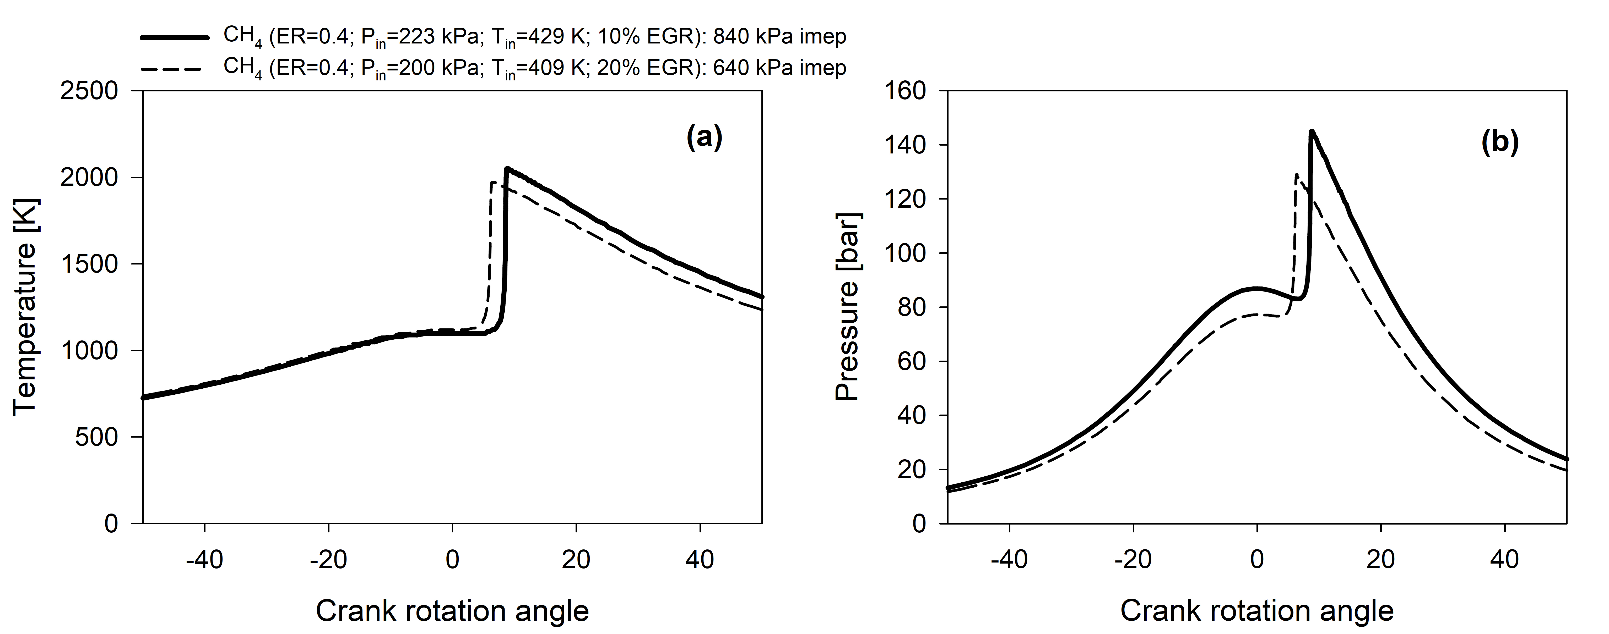
Figure 1: Temperature (a) and Pressure (b) traces versus crank angle at different boost pressures and EGR rates (CH₄). Solid line shows the operative conditions delivering the target imep of 840 kPa.
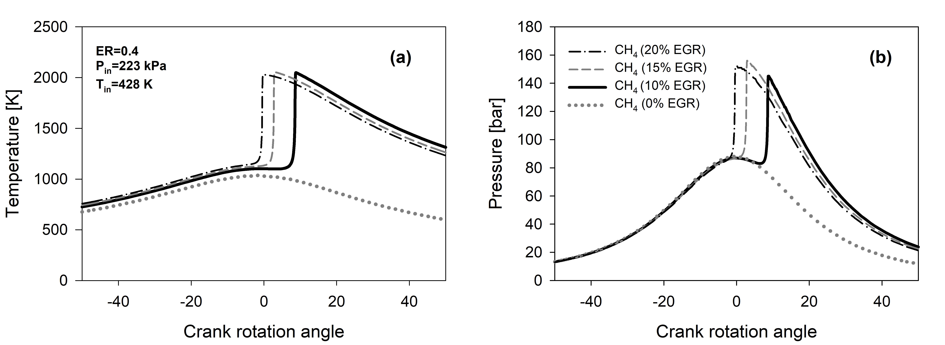
Figure 2: Temperature (a) and Pressure (b) traces vs. crank angle at different EGR rates (CH₄). Solid line shows the best operative conditions.
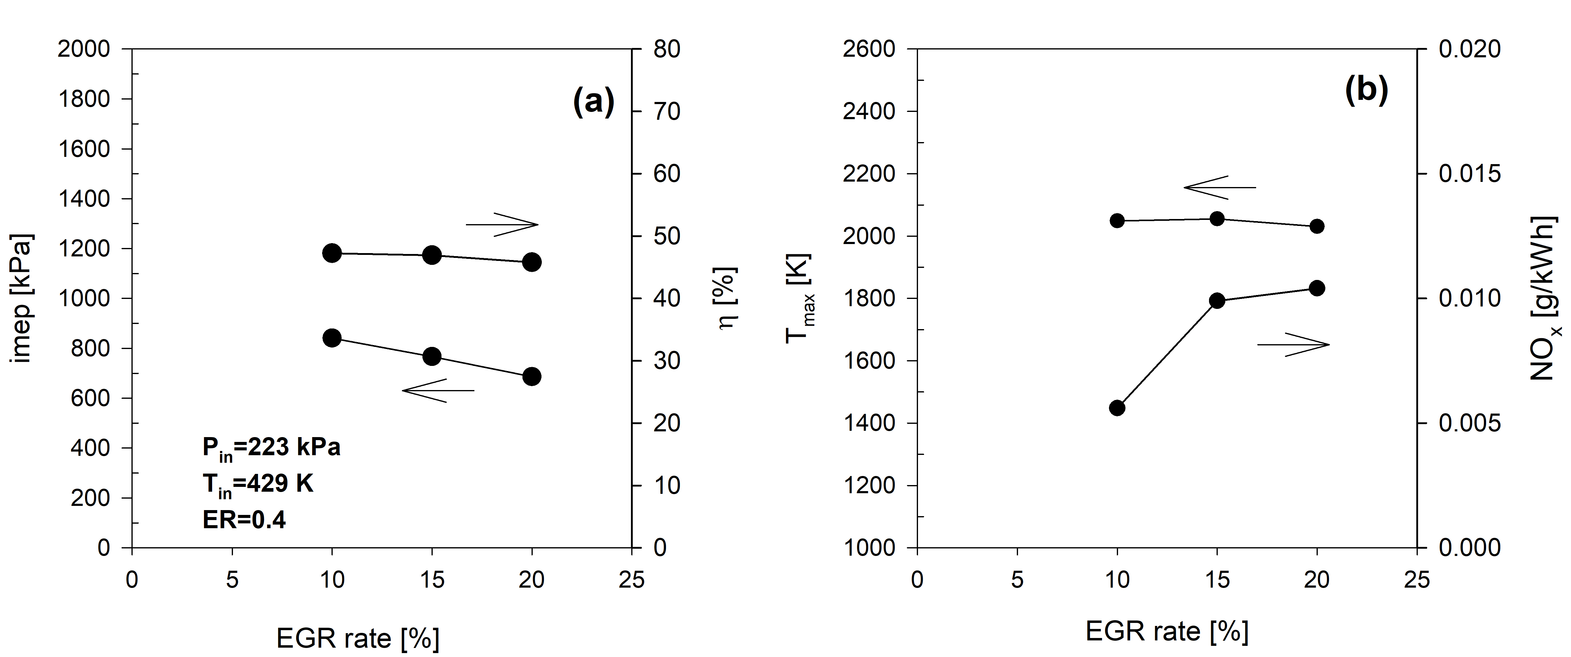
Figure 3: Effect of EGR rate on imep and efficiency (a), on maximum temperature and NOx emissions (b).
Figure 3 shows the effect of EGR on engine performance and NOx emissions. Imep and indicated efficiency (a) are higher with 10% EGR because the combustion phasing is optimal. An EGR rate higher than 10% reduces engine power output and causes higher NOx emissions (b) due to a higher peak cylinder temperature (15% EGR) and to a longer exposition of the combustion products to high in-cylinder temperature (20% EGR).
    - Effect of hydrogen on engine performance and emissions
To reduce the auto-ignition temperature methane can be mixed with hydrogen; as a consequence less EGR is required. Boost pressure should be consequently adjusted. Figure 4 shows how boost pressure and EGR were adjusted depending on the hydrogen content in order to get 840 kPa imep, with an optimal combustion phasing, keeping an equivalence ratio of 0.4. The results obtained fueling the engine with CH₄/H₂ blends are compared with the optimal operating condition for pure CH₄ previously identified (10% EGR).
The 90% CH₄/10% H₂ mixture requires 8% EGR for the auto-ignition and a boost pressure of 205.5 kPa, which gives an intake air temperature of 414K. Increasing the hydrogen content up to 20%, the required EGR rate is further reduced to 7% and the boost pressure to 204.2 kPa. In this case the intake air temperature is 413K.
When hydrogen is added, the engine delivers the target imep (Figure 5a) with a lower peak pressure; peak temperature reduction is less evident (c). Engine efficiency does not change significantly, Figure 5b, while NOx emissions are drastically reduced, from 5.6 mg/kWh with CH₄ to 2.9 mg/kWh for both CH4H2_1 and CH4H2_2, Figure 5 (d).
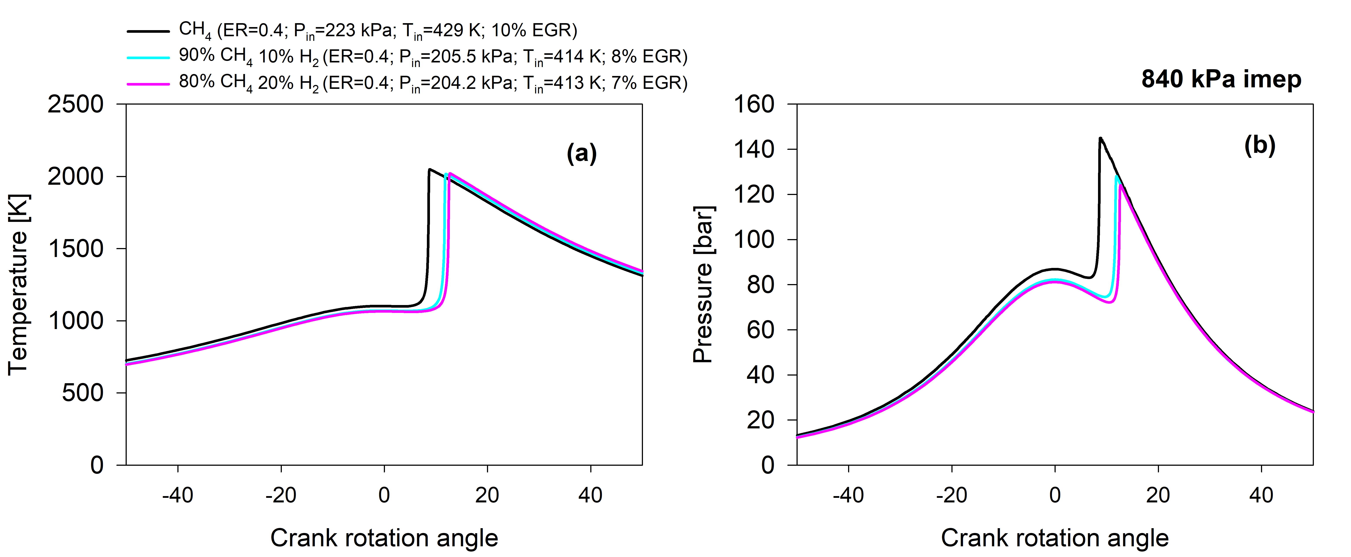
Figure 4: Temperature (a) and Pressure (b) traces versus crank angle for CH₄ and CH₄/H₂ blends with 10% and 20% hydrogen. Boost pressure and EGR rate optimised for each fuel in order to obtain 840 kPa imep.
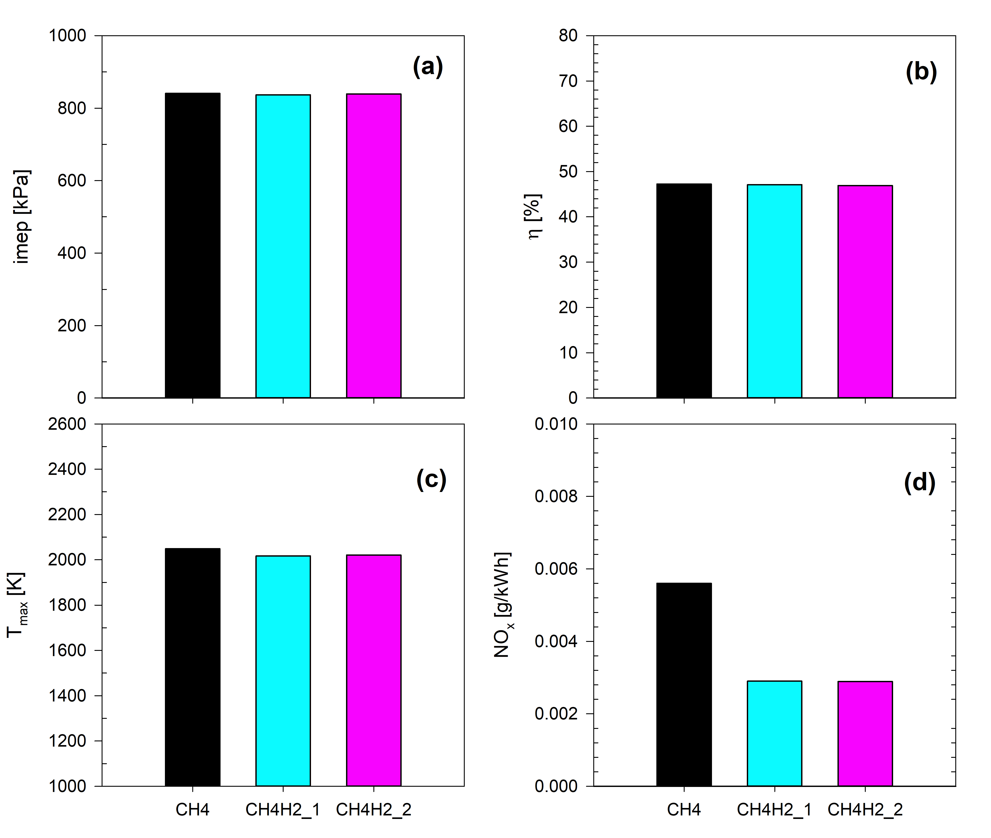
Figure 5: Effect of hydrogen on imep (a), efficiency (b), maximum temperature (c) and NOx emissions (d).
  - Conclusions
The paper describes a numerical study on a Controlled Auto Ignition engine fed by pure methane and methane enriched with 10% and 20% hydrogen by volume. The model predicts indicated mean effective pressure, indicated efficiency and NOx emissions. The comparison among the different fuels is performed by adjusting the CAI engine to obtain a constant imep, being boost pressure and EGR rate the parameters. The equivalence ratio was kept constant at 0.4. The results can be summarized as follow: Hydrogen addition reduces the intake temperature requirement for the autoignition: with methane the required EGR rate is 10%, which drops to 8% with the addition of 10% hydrogen and to 7% with the addition of 20% hydrogen; hydrogen enriched fuels require lower boost pressure than CH₄ to deliver the reference imep: 223KPa for CH₄, 205.5kPa for CH4H2_1 and 204.2 for CH4H2_2; engine efficiency does not change significantly between tested fuels for the operating conditions considered. Hydrogen enrichment of methane significantly reduces NOx emissions due to lower boost pressure and EGR rates. NOx emissions are 5.6 mg/kWh with CH₄ and 2.9 mg/kWh for both CH4H2_1 and CH4H2_2, showing that the effect of hydrogen addition reduces. The results allow concluding that the use of innovative biogases, made of methane, hydrogen and carbon dioxide, in CAI engine is very promising with respect to NOx emissions reduction when EGR is used for combustion control.
References
Ansys, Chemkin - Reaction Design.
Carillo P., Carotenuto C., di Cristofaro F., Kafantaris I., Lubritto C., Minale M., Morrone B., Papa S., Woodrow P., 2012, DGGE analysis of buffalo manure eubacteria for hydrogen production: effect of pH, temperature and pretreatments, Mol Biol Rep, 39, 10193-10200.
Carotenuto C., Guarino G., Minale M., Morrone B., 2016a, Biogas production from anaerobic digestion of manure at different operative conditions, International Journal of Heat and Technology, 34, 623-629.
Carotenuto C., Guarino G., Morrone B., Minale M., 2016b, Temperature and ph effect on methane production from buffalo manure anaerobic digestion, International Journal of Heat and Technology, 34, S425-S429.
Cho G., Jeong D., Moon G., Bae C., 2010, Controlled auto-ignition characteristics of methane–air mixture in a rapid intake compression and expansion machine, Energy, 35, 4184-4191.
di Cristofaro F., Carotenuto C., Carillo P., Woodrow P., Morrone B., Minale M., 2014, Evaluation of CH4 and H2 yield with different mixtures of digested and fresh buffalo manure, Chemical Engineering Transactions, 37, 283-288.
Gas Research Institute, GRI-MECH 3.0, www.me.berkeley.edu/gri_mech/
Guarino G., di Cristofaro F., Carotenuto C., Morrone B., Minale M., 2014, Effect of thermal and mechanical pre-treatments on the CH4-H2 production from water buffalo manure in different process conditions, Chemical Engineering Transactions, 38, 205-210.
Heywood J.B., 1988, Internal Combustion Engine Fundamentals, McGraw-Hill, New York, NY, USA.
Hoekstra R.L., Collier K., Mulligan N., Chew L., 1995, Experimental study of a clean burning vehicle fuel, International Journal of Hydrogen Energy, 20, 737-745.
Ilbas M., Crayford A.P., Yılmaz İ., Bowen P.J., Syred N., 2006, Laminar-burning velocities of hydrogen–air and hydrogen–methane–air mixtures: An experimental study, International Journal of Hydrogen Energy, 31, 1768-1779.
Jamsran N., Putrasari Y., Lim O., 2016, A computational study on the autoignition characteristics of an HCCI engine fueled with natural gas, Journal of Natural Gas Science and Engineering, 29, 469-478.
Kozarac D., Vuilleumier D., Saxena S., Dibble R.W., 2014, Analysis of benefits of using internal exhaust gas recirculation in biogas-fueled HCCI engines, Energy Conversion and Management, 87, 1186-1194.
Ma F., Wang Y., Liu H., Li Y., Wang J., Ding S., 2008, Effects of hydrogen addition on cycle-by-cycle variations in a lean burn natural gas spark-ignition engine, International Journal of Hydrogen Energy, 33, 823-831.
Mariani A., Morrone B., Unich A., 2012, Numerical evaluation of internal combustion spark ignition engines performance fuelled with hydrogen – Natural gas blends, International Journal of Hydrogen Energy, 37, 2644-2654.
Mariani A., Unich A., Minale M., 2018, Combustion of Hydrogen Enriched Methane and Biogases Containing Hydrogen in a Controlled Auto-Ignition Engine, Applied Sciences, 8.
Merola M.C., Carotenuto C., Gargiulo V., Stanzione F., Ciajolo A., Minale M., 2016, Chemical–physical analysis of rheologically different samples of a heavy crude oil, Fuel Processing Technology, 148, 236-247.
Minale M., Merola M.C., Carotenuto C., 2018, Effect of solvents on the microstructure aggregation of a heavy crude oil, Fuel Processing Technology, 177, 299-308.
Mohamed Ibrahim M., Ramesh A., 2014, Investigations on the effects of intake temperature and charge dilution in a hydrogen fueled HCCI engine, International Journal of Hydrogen Energy, 39, 14097-14108.
Nishi M., Kanehara M., Iida N., 2016, Assessment for innovative combustion on HCCI engine by controlling EGR ratio and engine speed, Applied Thermal Engineering, 99, 42-60.
Prati M.V., Mariani A., Torbati R., Unich A., Costagliola M.A., Morrone B., 2011, Emissions and Combustion Behavior of a Bi-Fuel Gasoline and Natural Gas Spark Ignition Engine, SAE Int. J. Fuels Lubr., 4, 328-338.
Ristovski Z.D., Morawska L., Hitchins J., Thomas S., Greenaway C., Gilbert D., 2000, Particle Emissions From Compressed Natural Gas Engines, Journal of Aerosol Science, 31, 403-413.

