|  |  |
| --- | --- |
| cetlogo***CHEMICAL ENGINEERINGTRANSACTIONS***  ***VOL. 76, 2019*** | A publication of  aidiclogo_grande |
| The Italian Association  of Chemical Engineering  Online at www.cetjournal.it |
| Guest Editors:Sauro Pierucci,Jiří Jaromír Klemeš, Laura Piazza  Copyright © 2019, AIDIC Servizi S.r.l. **ISBN**978-88-95608-73-0;**ISSN** 2283-9216 | |

Scenedesmus almeriensis solutions dewatering by using PVDF membrane

Tiziana Marinoa,b, Alberto Figolia, Elena Chianesec, Juri Rimaurod, Sanjeet Mehariyab,d, Dino Musmarrab, Antonio Molino(d,\*)

*aInstitute on Membrane Technology, National Research Council (ITM-CNR) Via Pietro Bucci, Cubo 17C, 87036 Rende (CS), Italy*

bDepartment of Engineering, University of Campania “Luigi Vanvitelli”, Via Roma, 29 - 81031 Aversa, Italy

c*Department of Science and Technology, Parthenope University of Naples, Centro Direzionale Isola C4, 80143, Naples, Italy*

dItalian National Agency for New Technologies, Energy and Sustainable Economic Development (ENEA), Territorial and Production System Sustainability Department, CR Portici Piazzale Enrico Fermi, 1 - 80055, Portici, Italy

*\* Corresponding author name: PhD Antonio Molino - ENEA, Italian National Agency for New Technologies, Energy and sustainable economic Development. Department of Sustainability - Biotechnologies and Agroindustry Division. CR Portici. P. Enrico Fermi, 1, 80055 Portici (NA), Italy. Tel.: +39 081/7723276 E-mail address: antonio.molino@enea.it*

In this work, a membrane-based separation was investigate for Scenedesmus almeriensis solutions dewatering. A commercial polyvinylidene fluoride (PVDF) membrane, having a pore size of 3 m was used in order to allow the water passage through it (permeate), retaining, at the same time, algae biomass (retentate). The possibility to reuse the permeate for a second Scenedesmus almeriensis growth step, was also studied. The registered data evidenced the feasibility of the membrane-based dewatering as an alternative competitive technology, even though the recovery of water should need further investigations to be optimized.

* 1. Introduction

Microalgae represent a large group of aquatic organisms that have garnered remarkable interest since their manifest attracting physical-chemical properties (Molino et al. 2018a). The majority of microalgae species are able to convert solar into chemical energy by means photosynthesis (Pierobon et al. 2018). Microalgae are considered as valuable feedstock for biofuel generation, due to their high sugars and fats content, but also for animal feed, since they produce proteins (Pierobon et al. 2018, Molino et al. 2018b). Moreover, microalgae are able to synthesize bioactive molecules such as pigments that reveal health properties (Di Sanzo et al. 2018, Molino et al. 2018b, Molino et al. 2019a, Molino et al. 2019b). In particular, Scenedesmus almeriensis is characterized by a high content of lutein, which is a xantophile used as food additive and suggested for retinal degeneration, cancer prevention and cardiovascular diseases (Sánchez et al. 2008).

Basically, the microalgae production involves three steps, i.e. microalgae cultivation, dewatering and/or harvesting and extraction of added-value compounds. After the microalgae cultivation, the dewatering operation consents to separate and concentrate the biomass from the algae culture. Commonly used separation technologies, mainly sedimentation, centrifugation, dissolved air and/or froth flotation, filter press and rotary vacuum filter, do not assure high efficiency, entail operating high costs costs and require chemicals addition (Coons et al. 2014). Additionally, they are difficult to scale-up and in some cases the achieved filtrate is unsuitable for recycle to microalgae cultivation. On the contrary, membrane-based filtration as emerging technology (Marino et al. 2017, Marino et al. 2019) should represent a cost-effective dewatering solution, due to the potential benefits in terms of process intensification performance. For microalgae dewatering step, a selected membrane allows water to pass across it matrix (permeate), hindering, at the same time, microalgae passage (retentate).

In this work, a preliminary membrane-based separation was carried out with the aim to recover water and to reuse it for a subsequent Scenedesmus almeriensis microalagae growth. A commercial PVDF membrane, having a pore size in the microfiltration range, was used for the filtration tests and morphologically characterized before and after filtration tests.

* 1. Materials and methods

2.1 Experimental design

The chemical installation consisted of a tubular photobioreactors with volume-surface ratio of about 56.5 L/m2 equipped with control and monitoring systems of the microalgal biomass growth. Temperature and pH were monitored in real time by SCADA (Supervisory Control And Data Acquisition) with alarms. Photobioreactors were equipped with a feeding system (sparger) of gaseous mixtures, consisting of Nitrogen, Oxygen and Carbon Dioxide. Light was provided by LED (white, blue and red light) of three different wavelengths but in this experimental test only white light was used. Luminous flux, which was perpendicular to photobioreactor surface, varied in the range 500 – 4,000 lux on the surface. It was possible to regulate the optimal algal growth temperature through a single tube exchanger positioned inside the photobioreactor and connected to a cooling chiller for the dissipation of the excess heat supplied by the led. The operating temperature range was between 15 and 35 °C. For the growth of Scenedesmus Almeriensis in the photobioreactor, a luminous flux of 4,000 lux and a gas flow rate of 300 mL/min were used. The whole experimental apparatus was installed on an aluminum structure with the following dimensions: 2,500 mm x 1,000 mm x 500 mm and the cylindrical PBR with effective volume of 28.8 L was made in Plexiglas having dimensions height = 680 mm, external diameter = 250 mm and thickness = 10 mm. The bottom of the PBR is equipped with 6 filleted holes (1/2”), in which 6 sintered steel spargers of gaseous mixture were installed, and with 3 holes for temperature/pH sensor insertion. Temperature control systems consisted in an AISI 316L coaxial pipe (Diameter = 60.3 mm - Thickness = 1 mm) in which the cooling water flows and its temperature were regulated by special chillers. Experimental tests were performed at 28 °C.

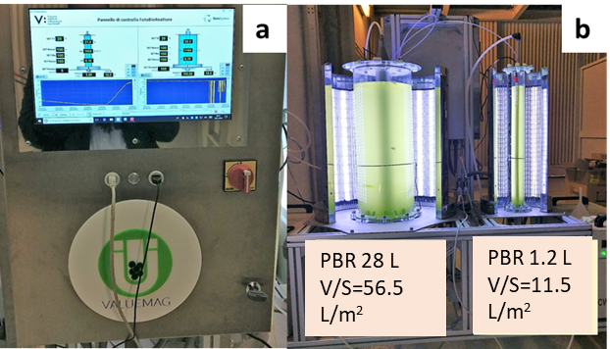

*Figure 1: Picture of the photobioreactor used for microalgal growth*

Scenedesmus Almeriensis inoculum was bought by Algares Srl (Rome, Italy). The culture medium used for the growth of the microalga Scenedesmus Almeriensis in the photobioreactor was the Mann and Myers’s, while the inoculum starter used for experimental tests and deriving from Algares is reported in the table 1.

*Table 1: Cations and Anions specie contained into the Inoculum starter bought from Algares*

|  |  |  |  |  |
| --- | --- | --- | --- | --- |
| **Cations/Anions** | **Concentration**  **(mg/l)** |  | **MICRONUTRIENTS** | **Concentration**  **(mg/l)** |
| Mg2+ | *28.69* |  | Fe2+ | 0.25 |
| SO42- | *310.25* |  | Mn2+ | 0.21 |
| Na+ | *234.75* |  |  |  |
| NO3- | *70.91* |  |  |  |
| NO2- | *5.66* |  |  |  |
| Ca2+ | *49.95* |  |  |  |
| Cl- | *82.94* |  |  |  |
| K+ | *15.24* |  |  |  |
| PO43- | *00.00* |  |  |  |

Monitoring of microalgal biomass growth was performed using a spectrophotometer. The used spectrophotometer was the Thermo Fisher Scientific Multiskan®, while analysis on the liquid phase was carried out by using Thermo Scientific Dionex™ ICS-1100 Ion Chromatography System (Dionex ICS-1100) that performed ion analyses using suppressed or non-suppressed conductivity detection.

After the growth step in the photobioreactor, the microalgal biomass was separated from the liquid medium by means of a commercial PVDF membrane with a pore size of 3 μm. The microalgal suspension passed through the membrane with the aid of a pump. The particles with a diameter bigger than 3 μm were retained by the membrane (the retentate, i.e. the microalgal biomass), while those with a diameter smaller than 3 μm passed through the membrane (the permeate, i.e. the liquid medium). The powder of the microalga Scenedesmus Almeriensis, after the growth and the harvesting phase, were frozen and then lyophilized for 24 hours with the aim of producing biomass with a first level of pretreatment and a very low degree of humidity, ready for the following phases of mechanical pretreatment and extraction.

2.2 Experimental setup

This sub-section describes the methodological approach used for the complete characterization of Scenedesmus Almeriensis. In table 2 the operative conditions adopted for the microalgae growth, are listed.

*Table 2: Operative conditions adopted for microalgal growth. White light; Q=300l/min; Irradiance at the wall=4000lux*

|  |  |  |  |  |
| --- | --- | --- | --- | --- |
| **Test number** | **Growth phase** | **Nitrogen composition**  **vol %** | **Oxigen composition**  **vol %** | **Carbon dioxide composition**  **vol %** |
| 1 | 1ST | 79.0 | 21 | 0.0 |
| 2 | 1ST | 78.5 | 21 | 0.5 |
| 3 | 2ND | 78.5 | 21 | 0.5 |

Test N°1 was chosen to have a baseline without using carbon source. In fact, only technical air was used for this test, while tests N°2 and N°3 were performed with 0.5 vol.% of CO2 and fixing oxygen composition at 21vol.%. The inoculum used for the first test (N°1) had a composition reported in table 1.

In order to obtain a volume of about 28 L for starting the growth phase, it was added the culture medium in the quantity as reported in the table 3.

Table 3: Volumes starter used for each experimental tests

|  |  |  |  |  |
| --- | --- | --- | --- | --- |
| **Test number** | **Inoculum (L)** | **Culture medium (L)** | **Permeate (L)** | **Total volume(L)** |
| 1 | 3 | 25 | - | 28 |
| 2 | 28 | - | - | 28 |
| 3 | 2 | 17 | 9 | 28 |

As illustrated in table 3, in the first test only inoculum and culture medium were used and after 11 days, the microalgae growth arrived at the maximum optical density. Therefore, the same inoculum with 28 L was fed with 0.5 CO2 for the test N°2. Test N°3 was carried out by using the permeate deriving from membrane separation and by adding 17 L of culture medium and 2 L of inoculum from test N°2. For the dewatering tests, a laboratory cross-flow cell (Delta E S.r.l., Italy) provided of a gear pump (Tuthill Pump Co., California) was used. Microalgae aqueous solution was forced to pass through the membrane (area of 8 cm2) and the permeate was collected. Tests were performed starting with a pressure of 1-1.2 bar and corresponding to a feed flow rate 0.5 L/h, till to achieve the pressure of 5 bar (0.1 L/h) after 36 hours filtration. The lowering in the feed flow rate was attributed to the fouling phenomenon, in turn caused by the deposition of biomass on the membrane surface during time. Membrane morphology was observed by Zeiss-EVO MA10 scanning electron microscope (SEM) before and after its use. In order to improve image resolution preventing electrical charging, a conductive gold layer was deposited (Quorum Q150 RS) on the PVDF membrane before SEM analysis.

3. Results and discussion

In Figure 2 the net biomass production and the time of growth are reported. For the test N°1, in absence of CO2, only 3.94 mg/L\*d was observed after 11 days growth, which increased, reaching the highest registered value, for test N°2 (38.87 mg/L\*d after 18 days), conducted in presence of 0.5% vol. CO2. The second growth (test N°3, 0.5% vol. CO2) led to a biomass production of 23.41 mg/L\*d after 14 days.

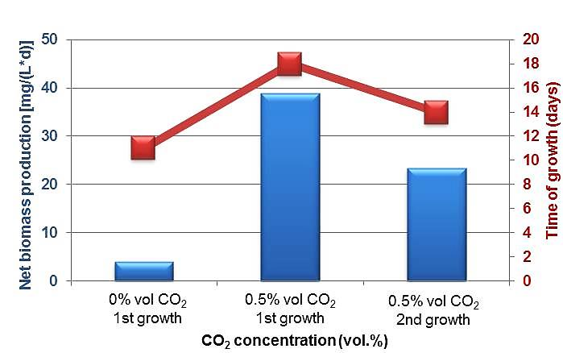

*Figure 2: Net biomass production (blue) and time of growth (red) observed for Scenedesmus Almeriensis*

Scenedesmus Almeriensis growth was related to the consumption of cations and anions, as shown in Table 4. During test N°1, in which no CO2 was supplied, the variation of ions was nearly negligible. This highlighted the importance of CO2 as essential growth factor for microalgae. During tests N°2 and N°3, the presence of CO2 guaranteed the microalgae growth, which was demonstrated by monitoring the variation of ions (Table 4). In particular, nitrates and phosphates were essential nutrients, as evidenced by their concentration reduction detected after 18 days (test N°2) and 14 days (test N°3). Nitrates consumption reached the highest values during test N° 2, ending at ~90% and ~100%, respectively. Phosphates were also completely consumed in test N°2 as well as in test N°3. The obtained results were in accordance with literature data (Fried et al. 2003, Kwon et al. 2013) which evidenced as microalgae growth was strongly affected by the initial nitrate and phosphate content.

*Table 4: Initial and final ions concentration detected by tests N° 1, 2 and 3*

|  |  |  |  |  |  |  |  |  |  |  |
| --- | --- | --- | --- | --- | --- | --- | --- | --- | --- | --- |
| **Test**  **N°** | **Time**  **days** | **Mg(2+)**  **mg/L** | **SO4(2-)**  **mg/L** | **Na(+)**  **mg/L** | **NO3(-)**  **mg/L** | **NO2(-)**  **mg/L** | **Ca(2+)**  **mg/L** | **Cl(-)**  **mg/L** | **K(+)**  **mg/L** | **PO4(3-)**  **mg/L** |
| 1 | 0 | 100.44 | 451.28 | 259.45 | 620.58 | 0.66 | 99.35 | 165.78 | 38.80 | 47.58 |
| 11 | 100.25 | 432.27 | 235.82 | 589.12 | 0.52 | 95.32 | 161.87 | 37.98 | 25.68 |
| 2 | 0 | 100.25 | 432.27 | 235.82 | 589.12 | 0.52 | 95.32 | 161.87 | 37.98 | 25.68 |
| 18 | 75.63 | 363.09 | 219.20 | 236.37 | 0.48 | 71.63 | 125.21 | 32.05 | 0.00 |
| 3 | 0 | 96.09 | 381.97 | 268.43 | 555.74 | 1.90 | 89.16 | 181.03 | 38.65 | 30.14 |
| 14 | 89.00 | 316.72 | 218.14 | 59.83 | 0.00 | 72.30 | 141.13 | 31.82 | 0.00 |

Figure 4, which shows the SEM pictures of the PVDF membrane before and after the filtration tests, evidences as the membrane structure remained almost unchanged after its use. Accordingly, the same membrane may be potentially used for consecutive separation tests.

*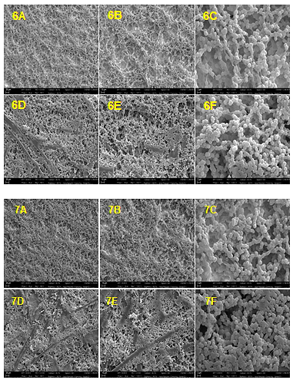*

*Figure 4: SEM images of the PVDF membrane: 6A,6B,6C top and 6D, 6E, 6F bottom surface before the filtration tests; 7A, 7B, 7C top and 7D, 7E, 7F bottom surface after the filtration tests. Magnification: A) 500x, B)1000x, C)5000x*

* 1. Conclusions

In this work the most relevant parameters affecting Scenedesmus Almeriensis growth were investigated. After the growth step, the possibility to recover water from the aqueous biomass solution, was preliminarily studied by means a PVDF membrane separation. The presence of CO2 was a dominant condition in order to observe microalgae growth. In fact, in absence of this gaseous nutrient, Scenedesmus Almeriensis production assumed the lowest obtained value (3.94 mg/L\*d after 11 days). On the contrary, a noticeable growth was obtained by providing 0.5% vol. CO2. More precisely, a first growth in which was supplied fresh water led to a biomass content of 38.87 mg/L\*d after 18 days, which reduced to 23.41 mg/L\*d after 14 days when the membrane-recovered water was added to the growth medium. Nitrate and phosphate seemed to be crucial factor for the biomass production, as demonstrated by monitoring their depletion during growth tests. Dewatering step, carried out by using a commercial PVDF membrane with 0.3 m pore size, allowed to retain biomass on the feed-side and to collect water on the permeate-side. However, the process needs to be optimized, since the membrane flux was negatively influenced by cake formation on the membrane surface. Nevertheless, SEM analysis showed that the membrane structure did not change significantly after 36 hours filtration, evidencing the possibility to reuse the same membrane for consecutive separations.

Acknowledgments

This paper has received funding from the Bio Based Industries Joint Undertaking under the European

Union’s Horizon 2020 research and innovation program under grant agreement No. 745695 (VALUEMAG).

References

Coons J.E., D.M. Kalb, T. Dale, B.L. Marrone, 2014, Getting to low-cost algal biofuels: A monograph on conventional andcutting-edge harvesting and extraction technologies, *Algal Research*, 6, 250.

Di Sanzo G., Mehariya S., Martino M., Larocca V., Casella P., Chianese S., Musmarra D., Balducchi R., Molino A., 2018, Supercritical carbon dioxide extraction of astaxanthin, lutein, and fatty acids from Haematococcus pluvialis microalgae, *Marine drugs*, *16*(9), 334.

Fried S., Mackie B., Nothwehr E., 2003, Nitrate and phosphate levels positively affect the growth of algae species found in Perry Pond, *Tillers*, 4, 21.

Kwon H. K., Oh S. J., Yang H. S., 2013, Growth and uptake kinetics of nitrate and phosphate by benthic microalgae for phytoremediation of eutrophic coastal sediments, *Bioresource Technology*, 129, 387.

MarinoT., Galiano F., Molino A., Figoli A., New frontiers in sustainable membrane preparation: Cyrene™ as green bioderived solvent, 2019, Journal of membrane Science, 580, 224.

Marino T., Russo F., Criscuoli A., Figoli A.,TamiSolve® NxG as novel solvent for polymeric membrane preparation, 2017, Journal of Membrane Science, 542, 418.

Molino A., Iovine A., Casella P., Mehariya S., Chianese S., Cerbone A., Rimauro J., Musmarra D., 2018a, Microalgae characterization for consolidated and new application in human food, animal feed and nutraceuticals, International Journal of Environmental Research and Public Health, 15(11), 2436.

Molino A., Larocca V., Di Sanzo G., Martino M., Casella P., Marino T., Karatza D., Musmarra, D., 2019a, Extraction of bioactive compounds using supercritical carbon dioxide, Molecules, 24(4), Article number 782.

Molino A., Martino M., Larocca V., Di Sanzo G., Spagnoletta A., Marino T., Karatza D., Iovine A., Mehariya S., Musmarra

D., 2019b, Eicosapentaenoic acid extraction from Nannochloropsis gaditana using carbon dioxide at supercritical

conditions, Marine Drugs, 17(2), 132.Molino A., Mehariya S., Iovine A., Larocca V., Di Sanzo G., Martino M., Mehariya S., Ferraro A., Musmarra D., 2018b,Extraction of astaxanthin and lutein from microalga Haematococcus pluvialis in the red phase using CO2 supercritical fluid extraction technology with ethanol as co-solvent, *Marine drugs*, *16*(11), 432.

[Pierobon](https://pubs.rsc.org/en/results?searchtext=Author%3AS.%20C.%20Pierobon) S. C., Cheng X., [Graham](https://pubs.rsc.org/en/results?searchtext=Author%3AP.%20J.%20Graham) P. J., [Nguyen](https://pubs.rsc.org/en/results?searchtext=Author%3AB.%20Nguyen) B., [Karakolis](https://pubs.rsc.org/en/results?searchtext=Author%3AE.%20G.%20Karakolis)E., Sinton D., 2018, Emerging microalgae technology: a review, ***Sustainable Energy Fuels***, **2**, 13.

[Sánchez J.F](https://www.ncbi.nlm.nih.gov/pubmed/?term=S%C3%A1nchez%20JF%5BAuthor%5D&cauthor=true&cauthor_uid=18491039)., [Fernández-Sevilla J.M](https://www.ncbi.nlm.nih.gov/pubmed/?term=Fern%C3%A1ndez-Sevilla%20JM%5BAuthor%5D&cauthor=true&cauthor_uid=18491039)., [Acién F.G](https://www.ncbi.nlm.nih.gov/pubmed/?term=Aci%C3%A9n%20FG%5BAuthor%5D&cauthor=true&cauthor_uid=18491039)., [Cerón M.C](https://www.ncbi.nlm.nih.gov/pubmed/?term=Cer%C3%B3n%20MC%5BAuthor%5D&cauthor=true&cauthor_uid=18491039)., [Pérez-Parra J](https://www.ncbi.nlm.nih.gov/pubmed/?term=P%C3%A9rez-Parra%20J%5BAuthor%5D&cauthor=true&cauthor_uid=18491039)., [Molina-Grima E](https://www.ncbi.nlm.nih.gov/pubmed/?term=Molina-Grima%20E%5BAuthor%5D&cauthor=true&cauthor_uid=18491039)., 2008, Biomass and lutein productivity of Scenedesmus almeriensis: influence of irradiance, dilution rate and temperature**,** *Applied Microbiology and Biotechnology***,** 79(5)**,** 719**.**