CHEMICAL ENGINEERING TRANSACTIONS  VOL. 76, 2019 | A publication of
The Italian Association
of Chemical Engineering
Online at www.cetjournal.it
Guest Editors: Sauro Pierucci, Jiří Jaromír Klemeš, Laura Piazza
Copyright © 2019, AIDIC Servizi S.r.l.
ISBN 978-88-95608-73-0; ISSN 2283-9216

A Resilient Approach to the Safety Management of Ageing and Obsolescence in Oil and Chemical Industries
Paolo Bragatto^{a,}*, Maria Francesca Milazzo^{b}
ªDipartimento Innovazioni Tecnologiche, INAIL, 00078 Monteporzio Catone, Roma (Italy)
^{b}Dipartimento di Ingegneria, Università di Messina, Contrada di Dio, 98166 Messina (Italy)
*p.bragatto@inail.it
Oil and chemical industries are subject to very strict legislations throughout Europe, in particular about the control of major accident hazards (Seveso Directive) and the integrated prevention and reduction of pollution (IPPC Directive). Further restrictions come from the legislation about the safety of chemicals as well as from that concerning occupational safety and health. Ageing of plants and equipment, due to corrosion and other phenomena, is currently a problem recognised by the Seveso Competent Authorities, as well Natural Technological (NaTech) risk and cybersecurity. This paper focuses on further critical issues emerging in Seveso industries. Equipment ageing produces also long-term environmental effects, which should concern also IPPC regulations. Another problem is obsolescence. The regulatory framework that guides chemical and oil industries is becoming tighter, hence establishments that are still in good condition could become unusable because the operator did not make in advance adequate changes to face the new context. Ageing of staff and organization is a further emerging issue. Market is becoming more and more competitive and financial context in many industries is becoming difficult. This paper outlines a few practical solutions, to face adequately these emerging critical issues by using a dynamic model for risk management. A case-study, which is a chemical coastal depot, is presented to understand the effects of new threats on safety in a very specific sector. The benefits of a dynamic risk assessment and management are discussed in the detail.
  - Introduction
Industrial establishments are complex systems, as they are characterised by a combination of different technical and social subsystems that interact each other according to specific and, usually, non-linear schemes. Complexity makes safety management dependent on the control of different factors, therefore, in order to achieve an as effectively as possible management, a holistic approach is needed (Madni and Jackson, 2009). The main problem associated with complex systems is that their management is more articulated than the management of the sum of its parts; in such a context, incidents are originated due to lack of understanding of the complex interactions or to the inability to deal with them (Jian et al., 2018).
Today, an approach to the study of safety, based on resilience engineering, is increasingly spreading; it analyses events taking into account the system’s complexity and considering them as an emerging outcome of the interaction among a large number of factors. This approach shifts the general focus of safety studies from the analysis of failures to the investigation of elements able to guarantee reliability, flexibility and, at the same time, stability of the system. Attention moves from the mere analysis of past events, such as the calculation of the number of accidents or the probabilities, to the prevention of critical events in a proactive way, or trying to anticipate their occurrence. Accidents are not considered as collapsing or malfunctioning of a system, but as changes in performance, which must be analysed in a dynamic way (Paltrinieri & Reniers, 2017). With respect to these considerations, chemical and oil industry deserves special attention as, if on the one hand, it is an indispensable part of modern society, given that it provides essential products to the market, on the other hand, it can cause serious damage to people and the environment. The management of the safety becomes an important challenge to which social factors, technical factors, human and organisational factors, external factors will contribute.
Across Europe, chemical and oil industry is subject to very stringent legislation, in particular those controlling major-accident hazards (Seveso Directive) and preventing and reducing pollution (IPPC); further restrictions come from the legislation about safety of chemicals and occupational safety. Ageing of structures and equipment, due to corrosion and other deterioration phenomena, is currently a problem recognised by the competent authorities, which in recent years made a relevant effort in order to improve controls under the Seveso legislation (Milazzo & Bragatto, 2019). However, other aspects are emerging, first of all ageing also produces long-term environmental effects concerning IPPC regulations. Another important issue is the obsolescence that is due to regulatory constraints becoming increasingly tight; this causes that even a small change has the power to make systems obsolete and, therefore, unusable even if equipment is still in good condition (Gyenes and Wood, 2016). Technological innovation offers incredible advantages, in particular to prevent uncontrolled releases, by monitoring deterioration phenomena, detecting dangerous situations; but are susceptible to cyber-attacks. Current management systems are designed to address one problem at a time and fail in responding all together. As a matter of fact, some recent incidents are due to this failure. Therefore, there is a need to develop integrated systems that allow resisting to different threats.
This present paper outlines the treats that, over the time, can undermine the safety of chemical or oil establishments. The goal is to understand quickly the changes and to develop dynamic models in order to face these threats, prevent accidents and also transform the treats in opportunities. Each establishment types, obviously, is stressed by different dynamic factors, thus different models have to be developed. The novelty of the proposed approach is the use of the system dynamic concept to improve risk management in chemical/oil establishments. This article discusses in the detail the case of coastal depots, which are representative cases of quick changes that are currently affecting chemical industry. The methodology is presented in section 2; section 3 describes the case-study and the dynamic model; results and conclusions are respectively given in section 4 and 5.
  - Methodology
The proposed methodology aims answering a few basic questions: What are major threats? How may operators successfully identify, assess and analyse them? What countermeasures may operators adopt to face the threats? How may the control bodies verify the adequateness of adopted countermeasures? Cyber-attacks and NaTech (Natural Technological) events, even though relevant for the matter of this paper, have not been included in the discussion, as there are already many consolidated results, adopted in common practice.
    - Major threats and effects’ assessment
Two pillars of the Seveso Directive are the Risk Analysis (RA), contained in the Safety Report of the establishment, and the Safety Management System (SMS), including procedures for the prevention of accidents. Risk analysis is usually based on HazOp combined with FTA and/or ETA and is updated every five years; procedures are instead reviewed every two years, based on accidents, near misses and non-conformities detected during audits and inspections by authorities. Several external factors (threats) can undermine these two pillars over the time. The model allows timely assessing risks deriving from these factors. Based on these evaluations, specific procedures will be developed aiming at the adaptation of the system to different contexts. Destabilising factors are listed below with their effects on risk analysis and safety management system:
- Ageing: Deterioration of equipment and structures is due to physical and chemical mechanisms (in some case also biological). It gradually increases failure probabilities. A method verifying the adequacy of ageing management plans at Seveso establishments has been developed (Bragatto et al., 2018). RA should be updated because non-credible events could become credible in less than five years. Increases of risk are not compensated and inspections need to be improved.
- Technical obsolescence: Systems becomes unusable at a given time and must be adjusted or replaced. Obsolescence impact on the risk level, in case of failures of safety critical systems; thus, risk must be recalculated for points with foreseeable criticalities. Procedures could not be compliant with emerging technical standards.
- Regulatory Changes: A certain material/activity/product is excluded from a local/regional/national/ community regulation, typically due to environmental issues. These regulatory changes induce rapid changes in processes and in procedures. They are aimed at the compliance, but could induce new risks.
- Ageing of organisation: Experience is a valuable resource and must be kept and managed in the natural personal turnover. Cut of personnel, retirement and outsourcing of important activities impoverish the internal knowledge and jeopardize safety.
- Market: Market changes impose rapid adjustments of the production, even faster than technical and legislative changes. Changes that are relevant to safety must be analysed to predict economic fluctuations and update risk analysis and procedures, with respect to points of foreseeable consequences.
- Community: The consequences of external releases of hazardous materials are related to the external context. There are regulations about land-use around establishments, but anyway the external context changes very quickly. If it is not monitored, the emergency preparedness could become inadequate and the risk for the society could increase, even if industrial activities are always the same.
- Environment: It refers to variations in the environmental context, i.e. microclimate, RA and emergency plans has to be updated with respect to the points of foreseeable consequences.
- Finance: To better respond to changes in the economic-financial context, companies operate different financial actions, including the entire sales or of some divisions, mergers, etc. These affect the organisation of resources and policies, therefore, procedures accompanying the transition phase are needed.
    - Evaluation criteria
To understand the importance of the different threats, immediate and delayed effects must be discussed. Three qualitative prioritization criteria, freely derived on Yodo & al. (2016), have been used. The vulnerability of the system to the threats is the first criterion to estimate them. The predictability of threats has also to be considered because, if the operators have the capability of foresight them, they may also in some way control these. The third criterion is the recoverability, which relates to countermeasures to reduce the effects and to recover the system from damage at an early stage. Each threat is evaluated by means of a score with three digits ranging from A to D, with A as the worst case and D as the best one.
    - Management of major threats
For each threat, the operators can improve risk analysis and safety management; even control bodies and authorities could improve their methods for the verification and check in order to increase the awareness towards the threats. Table 1 lists potential improvements in current practices.
Table 1. Improvements to face major threats in Seveso Industries.
Threat | Improvements by Plant Operators | Improvement by Control Bodies
1-Ageing | Fault Tree Analysis: Dynamic update of failure rates based on real data and human error. RBI analysis: Recalculation of the failure probability with corrective factors. | Index Methods for quick assessment (e.g. Fishbone Method)
2-Technical Obsolescence | HAZID: Identification of dependencies of failure probability on programmable instrumentation interfaced with other systems. | Instruments Verifications
3-Regulatory Changes | HAZID: Identification of technical systems subject to regulations that may change over the time | Regulatory Checks
4-Ageing of organisation | Fault Tree Analysis: Dynamic update human error. Consequence Analysis: Dynamic update of response times based on actions contrasting ageing and results of tests. | Workers’ Interviews. Emergency exercise
5-Market | HAZID: Identification of hazards for each new product or material due to market changes. Resilience assessment: Use of advanced methods (e.g. system dynamic simulations) | Stress Simulation
6-Community | Consequence analysis: Dynamic update of scenarios. Update of external emergency planning and territorial plans. | External Emergency exercise
7-Environment | Consequence analysis: Analysis of long-term environmental effects of small releases of hazardous substances, even if without immediate consequences. | Shared inspections Environment & Safety Authorities
8-Finance | RA: Use of available resources, analysis of effects (minimum and maximum) of the decrease in resources. Resilience assessment: Use of advanced methods (e.g. system dynamic simulations) | Stress Simulations

    - System Dynamic
To understand potential impacts (both direct and indirect) of the threats and, then, to analyse the system behaviour, a causal loop can be drawn. A causal loop is a sequence of events (actions, information, objects, people), in which an event is the causes of another event, which in turn is the cause of the first-mentioned event. This representation technique (well known in economics) may be valuable to understand emerging and increasing risks and to find the leverages to control them and prevent accidents. It may give dynamism to the conventional risk assessment techniques, as discussed by Vallerotonda et al. (2018).
  - Coastal Depots: a case-study
The transport and storage of chemicals is essential for both chemical industries and others. Major chemicals’ producers supply a large number of end-users mainly by ship. At major ports, there are depots featuring liquid storage tanks of different size and type. In Italy, there are about twenty depots of this type, with an overall capacity of 4 10⁵ cubic meters; not included petrol depots and depots connected to industrial plants (Assocostieri, 2014). Tanks typically are vertical above ground vessel at atmospheric pressure, these may have fixed or floating roof. Tanker ships unload materials, which can be hazardous or not. The final user is the owner of the unloaded material; whereas the depot operator, on behalf of the final user, is in charge to keep safely the tank and, when required, to deliver the contents by tanker truck or tanker ferry. Contaminations and losses are in charge of the depot operator. Exchanges between plant operator (end-user) and depot operator are ruled by a framework agreement, which lasts for a number of years. The depot operator shall use different tanks for different materials. The use of a tank may be changed, provided emptying and remediation, to avoid any undesired contaminations. Empty tanks shall be kept blanketed with nitrogen and can be used to unload ships or displace materials from other filled tanks, in the event of maintenance or emergency operations. This establishment is quite simple, as the main activity is to keep safe a number of chemicals. Losses due to the sudden rupture of containment systems (tanks and pipes) are considered unlike, because of the quality of steel used according construction codes. Losses due to overfilling are controlled by means of level gauges, connected to blocking systems. Hazardous activities are ship unloading, material displacement and truck loading (these are mentioned in order of increasing hazardousness). The most hazardous operation is the decontamination of tanks, as in most case a manual intervention may be required. During manual operations, in the case of flammable materials, having low vapour pressure, there is the hazard of formation of an explosive mixture in air, and consequently an explosion could occur and, in case of toxic materials, a toxic exposure for workers could be expected. Until few years ago, the profit of these activities provided adequate resources to control risk, unfortunately, in recent years many facts are weakening this sector.
Threats are listed in Table 2. Their combination is the root cause of a major accident happened in 2018 at an Italian chemical depot. During the decontamination of a tank, two contractors used a portable hose to suck residual products from the concavities of the bottom, as the automatic emptying system was not efficient because of the bottom deformation. As described, changes in market increased the number of hazardous operations; equipment ageing caused deformations and, consequently, the need of interventions of the operators. Personnel reduction forced to outsource operations. No consequences were recorded outside of the establishment, but in other sites the distance from crowded roads is short that external effects are highly probable. For a better understanding of the impact (both direct and indirect) of the threats, a causal loop has been outlined (see Figure 1).
Table 2. Threats and effects at depots of hazardous liquid.
Threats | Effects
1- Ageing | The sequence of emptying/filling operations stresses the tank. In particular, tank bottom is placed over a gravel layer, which modifies its shape due to adaptations, this compromises its symmetry and regularity. The service time of most tanks does not exceed the expected lifetime and leakage with consequent contamination are still unusual, even though possible. Deterioration mechanisms for tanks include atmospheric and soil corrosion, which at the end may cause passing cracks in the bottom, with consequent minor leakages.
2-Technical Obsolescence | Technologies, implemented in sensors and communication systems, dramatically increased in the last years. These include level gauges to prevent overfilling and gas detector to control vapour leakages. Minor incidents due obsolete or inadequate level gauges are discussed by Ansaldi et al. (2016). Costs to definitely overcome the technological gap is currently not affordable, posing additional risks.
3-Regulatory Changes | Quality standards are becoming higher, driven by very strict regulations. As an example, identical substances, having different origin, cannot be mixed. Even the test protocols after any remediation are demanding additional requirements.
4-Ageing organisation | The reduced profit hinders the personnel turnover; thus, the average age is increasing. To reduce costs, maintenance activities are outsourced as well as decontamination of tanks and other activities.
5-Market | Market is becoming more aggressive and end-users do not sign long term framework agreement and are ready to change logistic partner even for a very little difference in fees.
6-Community | Depots are always constrained between the harbour and the city. Urban intensification is a policy, aimed at better exploiting all areas inside the city, instead of expanding indefinitely its boundaries. This implies more people in the potential damage areas.
7-Environment | Soil pollution may be caused by minor leakages from the bottom, due to equipment ageing, and by occasional losses in loading operation. This is an emerging issue, for both the increasing attention of authorities on soil pollution and the equipment ageing, as discussed in point 1 of this table.
8-Finance | Chemical logistic is still a niche market and the interest of big financial group is low. Financial weakness, anyway, implies reduced resources and poor investments.

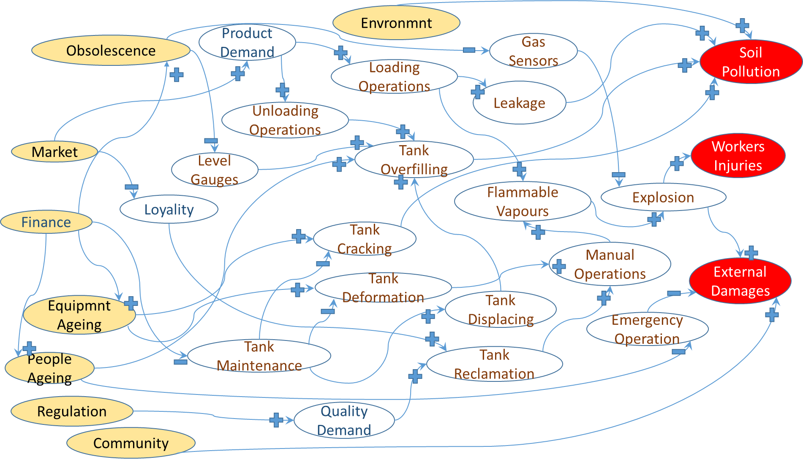
Figure 1. Causal Loop. Threats are filled in yellow. Undesired consequences are in red.
  - Results
Firstly, threats have been classified according to the criteria proposed in Section 2.2 and by using expert judgments. Results are shown in Table 3. The first digit represents the severity of consequences, the second one the uncertainties in foresight and the third one the difficulties to mitigate risks. In general, in depots of hazardous liquids, destabilisation come from the aggressive market, the demanding regulation and the financial weakness. Financial weakness stresses the effect of ageing and obsolescence
Table 3 Score for the threats associated to the case-study.
Threat | Score | Threat | Score | Threat | Score
1-Ageing | ABC | 4-Ageing Organisation | ACC | 7-Environment | CCC
2-Technical Obsolescence | ACC | 5-Market | AAB | 8-Finance | ABC
3-Regulatory | BBB | 6-Community | CCC

The operator cannot fight against the threat derived from finance changes, but they have the capability to control equipment ageing, instrument obsolescence and personnel ageing, which are related to major driving forces. To face these phenomena, as well other changes, it is essential to have a dynamic management of risk. It includes the adoption of tools for the dynamic risk assessment (e.g. system dynamics) as well as dynamic procedure as discussed in section 2. Figure 2 shows that this “dynamic risk management” could benefit this sector, by counteracting emerging threats.

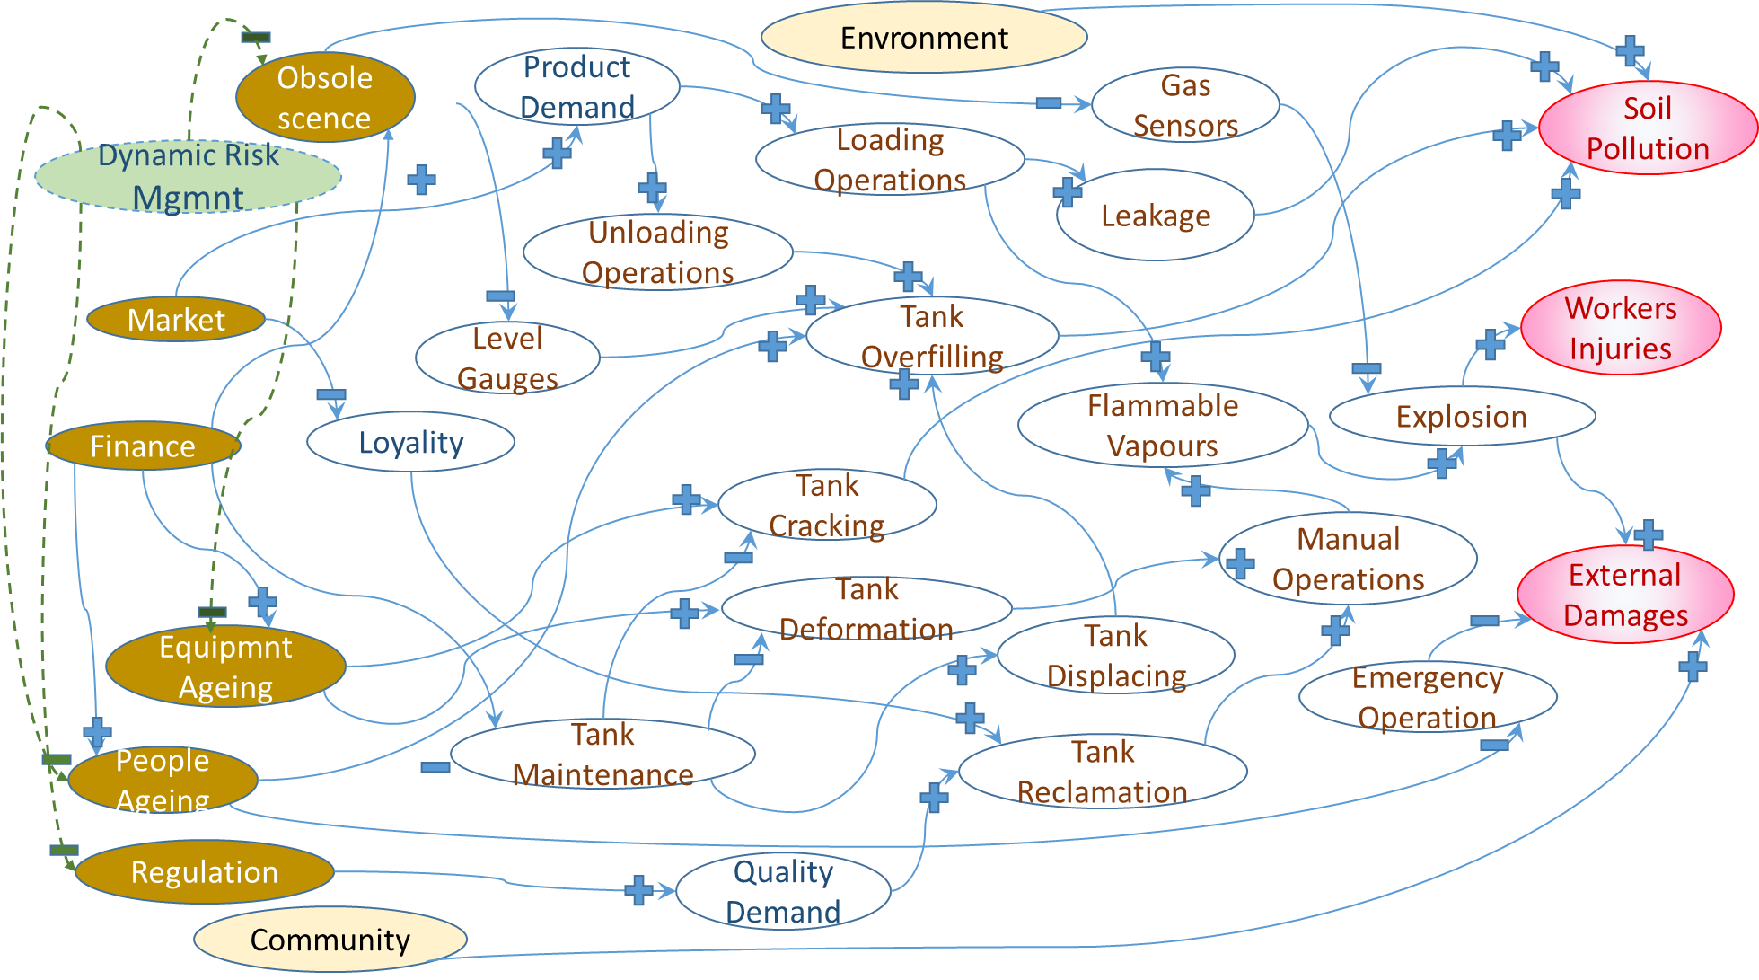
Figure 2. Dynamic safety management system. Higher priority threats darkened.
  - Conclusions
The model allows integrating various management systems, with respect to various types of threats, and thus creating a holistic vision and approach to safety management. However, research needs further developments, which emerged from the application to the case study. First of all, the model would acquire added value from the combination of the analysis with dynamic simulations of the various phenomena; further enhancement would result from the extension of the field of application of the method, which is currently limited to the analysis of ageing and obsolescence of primary containment equipment and associated piping. The application to more complex case-studies will certainly provide other elements to improve the model.
References
Ansaldi S., Agnello P., Bragatto P., 2016, Incidents triggered by failures of level sensors, Chemical Engineering Transactions, 53, 223-228.
Assocostieri, Impianti e Depositi Chimici 2014 http://censimento.assocostieri.it/censimento2014/chimici.aspx
Bragatto P., Delle Site C., Milazzo M.F., 2018, Audit of ageing management in plants at major accident hazard, 2017 2nd International Conference on System Reliability and Safety, ICSRS 2017, 2018-January, 400-404.
Gyenes Z., Wood M.H., 2016, Lessons Learned from Major Accidents Relating to Ageing of Chemical Plants, Chemical Engineering Transactions, 48, 733–738.
Jain P., Pasman H.J., Waldram S., Pistikopoulos E.N., Mannan M.S., 2018, Process Resilience Analysis Framework (PRAF): A systems approach for improved risk and safety management, J. of Loss Prevention, 53, 61–73.
Madni A.M., Jackson S., 2009, Towards a Conceptual Framework for Resilience Engineering, IEEE Systems Journal, 3(2), 181–191.
Milazzo M.F., Bragatto P., 2019, A framework addressing a safe ageing management in complex industrial sites: The Italian experience in «Seveso» establishments, Journal of Loss Prevention, 58, 70-81.
Paltrinieri N., Reniers G., 2017, Dynamic risk analysis for Seveso sites, J. of Loss Prevention, 49, 111–119.
Vallerotonda, R., Leva, A., Ansaldi, S.M., 2018, Modeling and training: How system dynamics is usable in OSH and MAH frameworks, Chemical Engineering Transactions, 67, 325-330.
Yodo, N., Wang, P., 2016, Engineering resilience quantification and system design implications: A literature survey, Journal of Mechanical Design, Transactions of the ASME, 138(11).

