CHEMICAL ENGINEERING TRANSACTIONS  VOL. | A publication of
The Italian Association
of Chemical Engineering
Online at www.aidic.it/cet
Guest Editors:
Copyright © AIDIC Servizi S.r.l.
ISSN 2283-9216

Detoxification of Olive Mill Wastewaters by liquid-liquid extraction with Natural Deep Eutectic Solvents
Martina Buldoª , Agnese Cicci^{b} , Giorgia Sedª, Vittoria Saponeª, Marco Braviª
ªDipartimento di Ingegneria Chimica, Materiali e Ambiente, via Eudossiana, 00184, Roma
^{b}Bio-P s.r.l., via di Vannina, 88, 00156, Roma
marco.bravi@uniroma1.it
Olive oil mill wastewaters (OOMWs) are the main waste stream of olive processing into olive oil and, although the polyphenolic fraction contained therein can find numerous uses as a nutraceutical and cosmeceutical ingredient, they still have a very hard time to be considered a byproduct rather than a waste. The deployment of this large volume resources has, so far, been hindered by the fact that the polyphenolic mixture that can be extracted from it also contained phenol, which is highly toxic for humans, thus requiring a purification step which adds up to the complexity and cost of the separation. A method capable of separating the toxic compound directly from the liquid stream would therefore be highly desirable.
In this work the hydrophobic character of three hydrophobic natural deep eutectic solvents (NaDES) recently developed by Florindo et al. (2017 and 2018), which are composed by pairs of substances among C₈ and C₁₂ fatty acids and menthol, has been used to investigate Liquid-Liquid Extraction for detoxifying olive mill wastewaters (OMW) from endogenous phenol. Explorative experiments were carried out on a synthetic mixture containing water, tyrosol (representing desired polyphenols) and phenol, representing a model OMW, at different pH of the treated mixture.
Experimental results show that the C₈:C₁₂ NaDES exhibits the most favourable extraction features among the three solvents and that neutral pH yields an optimal selectivity.
  - Introduction
Olive oil production is one of the biggest Mediterranean agro-industrial activities, giving rise to huge amounts of wastewater. The three phases extraction system, mostly used in Italy and Greece, produces about 12 x 10⁶ m³ yearly, called olive mill wastewater (OMW) (Cicci et al. 2013). OMW is characterized by a high concentration of organic compounds (40-220 g/l), which inhibit the natural degradation of wastewater (Yangui et al. 2017) . At present, the waste from the olive oil sector represents an economic and environmental problem, being partly destined for fertigation and the remaining for disposal. Nonetheless, high concentration of phenolic compounds may not only inhibit the germination of plant seeds, but infiltrate through soil layers and contaminate the ground water. While on the one hand the polyphenols contained in OMW are environmentally (phytotoxic) and technologically (inhibitory in anaerobic digestion) obnoxious, on the other, they are a potentially valuable source of molecules with demonstrated biological activities. Innumerable studies on the health properties of polyphenolic compounds and minor polar compounds and its correlation with the lower incidence of cardiovascular and oncological risk have stimulated the interest of researchers in the concentration of these substances in waste products such as pruning leaves, olive oil mill wastewaters (OOMWW) and pomace. EFSA (EFSA, 2011) has accepted 5 health claims concerning protection of LDL particles from oxidative damage by polyphenols contained in olive wastewaters (and other fruit constituents and process streams), thus paving the way to widespread deployment of this resource. The expanding nutraceutical market has pushed the pharmaceutical, nutrition and cosmetics sectors to focus on natural matrices rich in active ingredients, especially those of a polyphenolic nature. Polyphenols are a group of molecules widely diffused in the plant kingdom and have long been object of interest for scientific and clinical studies. According to recent works, we can say that the main polyphenolic compounds present in OMW are hydroxytyrosol, 3,4-dihydroxybenzoic acid, tyrosol, caffeic acid, vanillic acid, catechin, syringic acid and p-coumaric acid. Among the mentioned phenolic compounds, hydroxytyrosol is the most representative active compound and exhibits relevant properties such as strong antioxidant, anti-inflammatory, antiatherogenic and antiplatelet, antiproliferative and anti-cancer activities (Yangui et al. 2017). Consequently, an OMW treatment with the removal of toxic phenol and the recovery of valuable hydroxytyrosol are of great interest, both economically and environmentally. One of the most used process to recover phenolic compounds is the membrane system which, through different phases characterized by membranes with decreasing pores size promotes the production of polyphenol concentrated aqueous solutions which can subsequently be treated in adsorption columns. Adsorption is an effective technique which requires relatively low economic investment, quit energy saving and high efficiency in removal, recovery and selective separation of some compounds. In the recent years several polymeric resins have attracted increasing attention due to their high adsorption capacities towards phenolic compounds from OMWW (Yangui et al, 2017). Liquid-liquid extraction is a promising method in extraction phenols because this type of extraction exhibits large capacity and easy accessibility. however, the selectivity and recyclability of extraction agents limit the application of this method, and the exploration of new extraction agent becomes extremely essential (Tiantian et al. 2015). Over the past decade, some green solvents have emerged as harmless solvents, namely supercritical fluids, biobased solvents, ionic liquids (ILs), and more recently deep eutectic solvents (Florindo et al. 2017-2018). One of the main advantages of DESs is their very simple synthetic process, which consists on mixing different proportions of two or more components, until a liquid with a melting point lower than the starting materials is obtained. They are a mixture of hydrogen bond acceptors (HBA) such as quaternary ammonium salts combined with a hydrogen bond donor (HBD) such as amino acid, sugar, alcohol or carboxylic acid. Very recently, some researchers, such as Florindo, have focused the development of DESs behavior so that they can be used in extraction of micropollutants from an aqueous solutions of pesticides in water previously prepared. Hydrophobic NaDESs are a brand new natural DES (NaDES) domain that open new frontiers to liquid-liquid extraction of hydrophobic compounds from aqueous matrices and to biorefining altogether, as Di Paola et al. (2015) anticipated and Sed et al. (2018) recently demonstrated. In this work, three hydrophobic natural deep eutectic solvents (NaDES) developed by Florindo et al. (2017 and 2018) have been used to investigate Liquid-Liquid Extraction for detoxifying OMW from phenol.
  - Materials and Methods
    - NaDES formulation
The C₈:C₁₂ NaDES is a hydrophobic solvent that forms two distinct phases when placed in contact with water. It is an eutectic mixture based on two ingredients: octanoic and dodecanoic acid mixed in the molar ratio 3:1. Octanoic acid acts as HBD, dodecanoic acts as HBA. The C₈:C₁₂ NaDES has been demonstrated to be hydrophilicity-switchable (Sed et al., 2018), although this feature has not been deployed in the present work.
Two DL-Menthol-based NaDESs were prepared by adding two different hydrogen bond donors to DL-Menthol acting as the HBA. The C₈:Menthol NaDES is a mixture of caprylic acid and DL-Menthol in the ratio 1:1. C₁₂:Menthol NaDES is prepared mixing lauric acid and DL-Menthol in the ratio 1:2.
All NaDESs were prepared using a heating-based method: the two-component mixture was placed in a capped bottle with a stirring bar and heated in a water bath below 50°C with agitation till a clear liquid was formed (~20 min).
    - Experimental Set-up and Design
In this work the parameter that was selected to investigate the use of the NaDESs for polyphenols purification was pH. The volumetric ratio between the aqueous and the NaDES phase (3:1) and the contact time (24 h) were assigned after a few preliminary exploratory runs. Thirty experimental runs were carried out, ensuring two replicae for each experimental point.
An aqueous synthetic matrix was prepared with a starting concentration of 1200 mg/L of tyrosol and 3696 mg/L of phenol, reflecting the typical composition measured by us in during years of sampling of OMW having undergone a few weeks of storage in open vessels, as a consequence of the reducing environment that develops after oxygen depletion by contaminating microorganisms. The pH of the aqueous synthetic matrix was adjusted to the assigned value by means of a potassium bitartrate buffer (pH = 3.5), a citrate-phosphate buffer (pH = 6 or 7), a sodium bicarbonate buffer (pH = 8.2), or TRIS (pH = 9.5).
Each experimental condition was trialled by mixing the appropriate amounts of a pH-conditioned synthetic water-based matrix and of the adopted NaDES, putting them in a cylindric vial with triple volume, and agitating the sample holders in an orbital shaker with an orientation ensuring thorough mixing. All the experiments were carried out at room temperature, which was found to be 25 °C.
After equilibration, the water phase was sampled and analysed by HPLC.
    - Analysis by High Performance Liquid Chromatography
The analyses were performed on an Agilent Technologies 1200 HPLC system fitted with a SUPELCOSIL LC-18 column (length 250 mm, diameter 4.6 mm, packaging size 5 mm). The column temperature was set equal to 20 °C. The mobile phase consisted of an aqueous solution of 1% (v/v) acetic acid (“A”) and acetonitrile (“B”). Elution was performed by following this protocol: at start and lasting for the first 2 min of the run, 100% of A. from 2 min to 60 min after run start a linear ramp was used, targeting 40% of A and 60% of B. The flow rate was set equal to 1 mL/min. Polyphenols were detected by a UV detector (280 nm). Beforehand, the retention times of the polyphenolic compounds of interest were measured by using of single polyphenol standard solutions at a concentration of 100 mg/L.
  - Results and Discussion
The tendency of the compounds that need to be separated and concentrated in a pair of immiscible liquids (here, the water-based feed and the NaDES extractant) is expressed by selectivity. Selectivity S_{ij} is calculated as the ratio of partition coefficients K_{i} and K_{j}

S_{ij} = K_{i} / K_{j} (1)

which are calculated from the concentrations of the extracted substances at equilibrium, x_{i1} and x_{i2}, in each of the two immiscible phases:

K_{i} = x_{i1} /x_{i2} (2)

subscripts i and j referring to the substances, subscripts 1 and 2 denoting the two immiscible phases, x indicating concentration and K indicating the partition coefficient. Being a ratio, selectivity is hardly normally distributed. Therefore, the inter-percentile range was used in place of standard error. The interpercentile range was calculated based on 68% likelyness, which is equivalent to the customary ±1 standard deviations bracket of normally distributed quantities.
The experimental results, summarised in the figure below, show selectivity in extracting phenol rather than tyrosol from the water phase containing both, for the three NaDESs as a function of the pH.
From the analysis of the data displayed in Figure 1, it can be seen that the three NaDES display a preference for the extraction of phenol rather than tyrosol from the aqueous phase, with selectivity ranging from ~5 to ~30. More specifically, the three NaDES show two common traits (pH-dependent selectivity, and maximum selectivity toward extracting phenol rather than tyrosol exhibited at the neutral pH) and two distinctive features (range of variation of selectivity over the tested pH range, and average value of selectivity over the tested pH range) which are worth commenting individually with the aid of known properties of the involved compounds, such as their pK_{a}s.
It is well known that the state of dissociation of a chemical compound capable of giving off hydrogen ions in aqueous solution is given by the Henderson–Hasselbalch equation:

pH = pK_{a} + log([A⁻]/[HA]) (3)

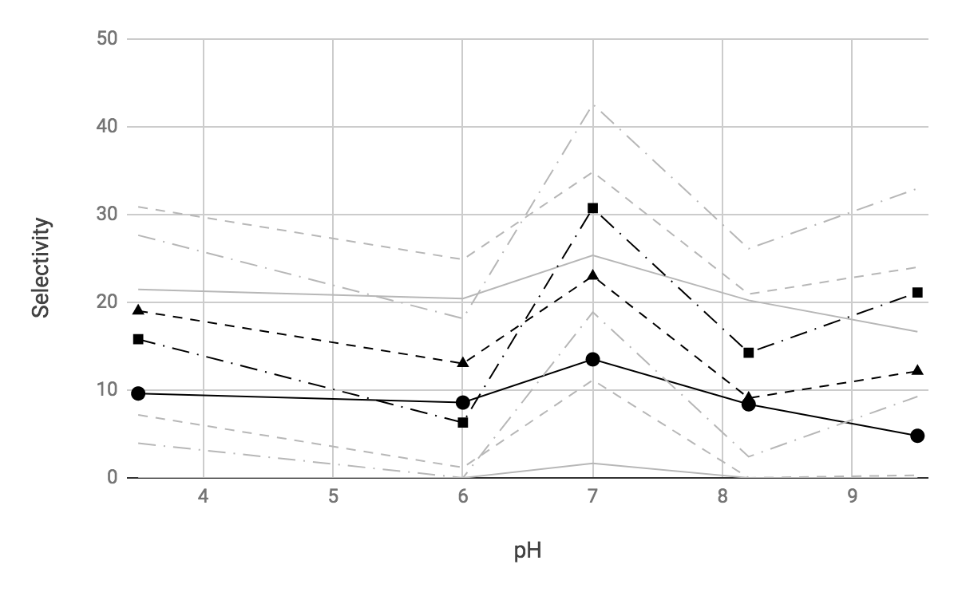
Figure 1: Selectivity in liquid-liquid partitioning of tyrosol and phenol between an aqueous solution and a NaDES extracting solvent. (⚫): C8:M NaDES, (▲): C12:M NaDES, (◾): C8:C12 NaDES. Black lines refer to the observed trend of selectivity, while each of the grey line pairs refer to the upper and lower limits calculated by adding and subtracting half of the interpercentile range to the relevant black line.

Eq. (3) states that pH - pK_{a} provides the orders of magnitude the dissociated fraction of a chemical species exceeds the undissociated fraction or, when the difference is a negative number, the orders of magnitude the undissociated fraction of a chemical species exceeds the dissociated fraction. At pH equalling pK_{a}, the dissociated and undissociated fraction are equally concentrated.
By considering Eq. (3), and the literature values of the pK_{a}s of the involved species (Table 1) the state of dissociation of tyrosol and phenol can be estimated both in the synthetic OMW and in each hydrophobic NaDES phases. Some of the species utilised in the presented experimental work, however, feature two possible ionisation states related to two hydrogen atoms that can be lost, and correspondingly feature two pK_{a}'s, which complicate the matter if the matter should be dealt with rigorously, especially if each of the two phases involved in the liquid-liquid extraction features one. For the time being, the average value between the two tabulated pK_{a}s was adopted as an indicative value for species exhibiting more than one ionisation state.
While this state is pH-dependent in the synthetic OMW because pH is adjusted following the experimental design, based on the literature pK_{a}s the three NaDESs feature one well-defined ratio of the dissociated to the undissociated form (Table 2).
Table 1: pK_{a}s of the involved species. Tyr: tyrosol, Ph: phenol, M: DL-menthol, C8: octanoic acid, C12: dodecanoic acid.
pK_{a} | Tyr | Ph | M | C₈ | C₁₂
First ionisation | 10.2 | 9.98 | 19.55 | 4.89 | 5.30
Second ionisation | -2.4 | − | −0.81 | − | −

Table 2. Decimal logarithm of the ratio of the concentrations of the dissociated to the undissociated form in the synthetic OMW and in the NaDES phase. Tyr: tyrosol, Ph: phenol, M: DL-menthol, C8: octanoic acid, C12: dodecanoic acid.
pH | Synthetic solution |  | C8:M |  | C12:M |  | C8:C12
 | Tyr | Ph | Tyr | Ph | Tyr | Ph | Tyr | Ph
3.5 | -0.4 | -16.7 | 5.5 | 2.2 | 5.5 | 2.4 | 1.2 | -4.9
6 | 2.1 | -14.2
7 | 3.1 | -13.2
8.2 | 4.3 | -12.0
9.5 | 5.6 | -10.7
 | Half dissociated (low pH) to dissociated (high pH) | Undiss-  ociated | Dissoci-  ated | Dissoci-  ated | Dissoci-  ated | Dissoci-  ated | Moder-  ately Dissoci-  ated | Undiss-  ociated

For molecules whose structure is dominated by the essentially hydrophobic aromatic ring, the dissociated or undissociated state can be expected to determine the increase of affinity toward the hydrophilic and hydrophobic phase, respectively. Therefore, a reduced dissociation can be expected to reduce solubility in water and increase solubility in organic solvents and hydrophobic substances alike, such as the NaDESs used here.
It can be seen that phenol is expected to be essentially in undissociated state in all the buffers, while tyrosol dissociation is expected to be markedly lower at all pHs, and notably half dissociated at the lowest pH and well dissociated at the highest pH, with a progressive increase of its dissociation degree with the buffer pH increase.
Both tyrosol and phenol are expected to be in dissociated state in menthol-containing NaDESs. The menthol-devoid NaDES, only featuring fatty acids, instead, can be predicted to solubilise tyrosol in moderately dissociated state and phenol in undissociated state. Therefore, this latter NaDES can be expected to be a more favourable solvent for accomodating phenol, which is poorly solubilised by OMW at all pH values.
However this observation alone only explains the better performance of C8:C12 compared to C8:M and C12:M, not the optimality of the neutral pH for the selection of phenol in the liquid-liquid extraction which all solvents exhibit, albet to a different degree. Indeed, Table 2 suggests that a continuous decrease of selectivity should be expected when pH is increased from the minimum to the maximum adopted values. A second phenomenon with an opposite pH dependence should be playing a role here, possibly involving a role of hydrogen bond donation at the interface between otherwise immiscible phases, that needs further in-depth investigation.
  - Conclusions
Three representatives of the novel class of hydrophobic natural deep eutectic solvents based on fatty acids and menthol have been tested in the extraction of phenol, a toxic endogenous contaminant of olive wastewaters which taints a potentially valuable source of valuable and healthy polyphenols. Liquid-liquid extraction of a simple synthetic OMW containing tyrosol and phenol has shown that the octanoic acid:dodecanoic acid NaDES exhibits the most favourable extraction features among the test set and that it is capable of separating unwanted phenol from the water phase and that all the tested extractants are most very efficient at neutral pH. The reported results show that NaDES solvents are promising food-safe solvents to improve existing processes for the separation of the healthy fraction of polyphenols from OOMWs.
Reference

EFSA, EFSA Panel on Dietetic Products, Nutrition and Allergies (NDA). (2011). Scientific Opinion on the substantiation of health claims related to polyphenols in olive and protection of LDL particles from oxidative damage (ID 1333, 1638, 1639, 1696, 2865), maintenance of normal blood HDL cholesterol concentrations (ID 1639), maintenance of normal blood pressure (ID 3781),“anti‐inflammatory properties”(ID 1882),“contributes to the upper respiratory tract health”(ID 3468),“can help to maintain a normal function of gastrointestinal tract”(3779), and “contributes to body defences .... EFSA Journal, 9(4), 2033.
Florindo C., Branco L. C., Marrucho, I. (2017). Development of hydrophobic deep eutectic solvents for extraction of pesticides from aqueous environments. Fluid Phase Equilibria, 448, 135-142.
Florindo C., Romero L., Rintoul I., Branco L. C., Marrucho I. (2018). From phase change materials to green solventes: hydrophobic low viscous fatty acid-based deep eutectic solvents. ACS Sustainable Chemistry & Engineering, 6.3, 3888-3895.
Cicci A., Stoller M., Bravi M. (2013). Microalgal biomass production by using ultra- and nanofiltration membrane fractions of olive mill wastewater. Water Research, 47, 4710-4718.
Yangui A., Njimou J. R., Cicci A., Bravi M., Abderrabba M., Chianese A. (2017). Competitive adsorption selectivity and separation of valuable hydroxytyrosol and toxic phenol from olive oil mill wastewater. Journal of Environmental Chemical Engineering, 5, 3581-3589.
Tiantian J., Xulei Z., Hongyan H., Chunshan L., Hongnan C., Suojiang Z. (2015). Separation of phenolic compounds from coal tar via liquid-liquid extraction using amide compounds. Industrial & Engineering Chemistry Research 54 (9), 2573-2579.
Sed G., Cicci A., Jessop P.G., and Bravi M. (2018). A novel switchable- hydrophilicity, natural deep eutectic solvent (NaDES)-based system for bio-safe biorefinery. RSC Adv., 2018, 8, 37092

