CHEMICAL ENGINEERING TRANSACTIONS  VOL. 76, 2019 | A publication of
The Italian Association
of Chemical Engineering
Online at www.cetjournal.it
Guest Editors: Sauro Pierucci, Jiří Jaromír Klemeš, Laura Piazza
Copyright © 2019, AIDIC Servizi S.r.l.
ISBN 978-88-95608-73-0; ISSN 2283-9216

Fuel Spill after Ship Collision: Accident Scenario Modelling for Emergency Response
Stefania Magri’ª*, Mauro Quagliatiª, Patrizia De Gaetanoª, Tomaso Vairo^{ab}, Bruno Fabiano^{b}
ªARPAL – UTCR, via Bombrini 8 – 16149 Genoa, Italy
^{b}DICCA Civil, Chemical and Environmental Eng. Dept. – University of Genoa, via Opera Pia 15 – 16145 Genoa, Italy
* stefania.magri@arpal.gov.it

Mitigation associated with oil spill events in sea environment depends largely on the design and implementation of adequate contingency plans, which should incorporate the simulation of the spill dispersion patterns and the characterization of marine and coastal areas that could be affected. This paper is focused on the development of an actual emergency response plan following a major sea accident verified in the Liguria Sea and causing a fuel spill of about 600 m³. The theoretical approach relies on a model developed on a Lagrangian scheme, running decoupled from hydrodynamics, for predicting fate of hydrocarbons and covering both the transport and the weathering. Simulations were performed on the basis of daily updated meteo-hydrodynamics forecast by the operational circulation model of the Liguria Sea (MIKE 3 HD), reports of sightings of material from the Coast Guard and images of the spill captured by Copernicus Sentinel-1 satellites. The reliability of the modelling was assessed via analysis based on actual oil trajectories. A remarkable agreement was verified between calculated oil forecast, satellite images and actual empirical sightings of material, confirming the effectiveness of the combined modelling approach in oil spill risk assessment and in setting-up emergency planning.
  - Introduction
A number of international regulations, safety and design standards were developed over the years to prevent groundings, collisions and steering or propulsion failures, with the focus of mitigating accidental spills over the sea. In this regard, the last goal-based standards amendments of the Regulation II-1/3-10 International Convention for the Safety of Life at Sea (SOLAS) entered into force in 2012, with a date of 1st July 2016 set for application to new oil tankers and bulk carriers. The reader is addressed to ongoing trends in the field critically discussed by Papanikolaou (2016). Should an accident occur, planning of spill response measures and their effectiveness are strictly dependent on the oil spill trajectory and fate prediction and still represent an up-to-date research area. In fact, likewise in the process sector, the uncertain and unpredictable behaviour of accidents and their consequence in the last decades highlighted the importance of reliable risk management (Fabiano, 2017). A preferable way to deal with hazardous spill risks is through prevention, which can be mainly based on technical requirements, operational measures for tankers and personnel requirements. Mitigation for the given context is tackled by preparedness to respond and comprehensively including safety operations, identification of site-specific hazards, evaluation of protection needs and available resources. In the aftermath of severe accidents, Regulatory Bodies, research companies, healthy organizations and more generally society are forced to re-examine the way things were done, determine immediate and root causes and make appropriate changes, possibly applying novel methodologies and solutions. An effective contingency plan to mitigate spill risk should incorporate the source term identification, the modelling of the dispersion patterns and the characterization of sensitive areas potentially affected by the spill (Vairo et al., 2017). In case of possible risks of tankers spilling their cargo when entering harbors, the consequences can derive also from the development of flammable and/or toxic clouds due to hydrocarbons (HC) vaporization. The specific safety measures must be adopted starting from the knowledge of the time-dependent concentration of HC vapours in the cloud along with the three spatial coordinates, (Palazzi et al., 2004). Reliable numerical modelling can provide important information to predict and evaluate the hazardous distance and the reaction time scale identifying hazardous areas where ignition can give rise to different scenario evolutions (Pesce et al., 2012). According to this scenario, the decision of evacuating people potentially exposed to HC vapours from the spill can be based, with enough reliability, on simple integral modelling such as ALOHA (US-EPA), provided that the validation is limited to the near-field (Vairo et al., 2014). Numerical model simulating the transport and weathering of an oil spill occurred in a coastal area, coupled with a 3D hydrodynamic model, was recently applied to a limited semi-confined water body (Zafirakpu et al., 2015). The fate and behaviour of oil spill in open sea is governed by a series of physical and chemical processes, e.g. spreading, evaporation, emulsification, dissolution, biodegradation, current transport and sedimentation, highly depending on the properties of the spill, hydrodynamic and environmental conditions. The reader is addressed to the comprehensive reviews on spill modelling approaches provided by ASCE (1996) and Foreman et al. (2005). Spoulding (2017) provided a recent perspective on the development and application of oil spill models for emergency response, impact assessment and lessons in spill models design. The remainder of this paper is as follows: section 2 outlines the system modelling strategy based on a thorough hydrodynamic simulation by a Lagrangian particle approach, section 3 and 4 illustrate the capability of the proposed approach applied to an actual sea accident, comparing results from numerical simulations with experimental evidences covering a wide Mediterranean Sea area. At last, conclusions and research perspectives are drawn in section 5.
  - Methodology and modelling
The proposed modelling approach is based on the application of an oil spill module decoupled from the hydrodynamics provided by the forecast operational model at Liguria Sea scale, operating at ARPAL. The three-dimensional hydrodynamic circulation model is achieved utilizing MIKE 3 HD approach (Hørsholm, Denmark), which simulates level and stream variations as a function of all the relevant phenomena affecting coastal hydrodynamics and ocean environments: density gradients (temperature/ salinity), effect of the tides, wind effect, heat exchange with the atmosphere and the Coriolis force. The modelling system is based on the numerical solution of the 2/3-dimensional incompressible Reynolds averaged Navier-Stokes equations, subject to the assumptions of Bousinnesq and of hydrostatic pressure. Thus, the model consists of continuity, momentum, temperature, salinity, and density equations, and is closed by a turbulent closure scheme. The hydrodynamic circulation model relies on data from the Mediterranean-scale circulation (Model MFS Copernicus), combined with weather data from the meteorological model MOLOCH developed at the Meteo Hydrological Functional Centre for Civil Protection (CFMI-PC) in ARPAL. Resolution is based on a numerical finite volume discretization method, on the flow and transport equations in the horizontal dimension, with a non-structured triangular mesh having a variable resolution from offshore and towards the coast, as detailed and preliminarily validated by Vairo et al. (2018). The operational chain runs on a daily basis, and provides a 48 h prediction of circulation, sea level, salinity and temperature. The hydrodynamic stream fields provide the basis for the calculation of hydrocarbons transport. A Lagrangian modelling approach (MIKE Oil Spill –DHI) is used, allowing to simulate the trajectories of dragged and dispersed particles under the combined action of current and wind. Particles are transported according to a drift regime (deterministic component) and adding dispersion by introducing a “random walk term” (stochastic component). The Lagrangian dispersion model describes the oil by two fractions: a light volatile and a heavy non-volatile one, while the chemical transformation of the spilled organic product is considered as a function of the state variables, as results of physical and biological processes. The model describes the total amount of spilled oil as an assemblage of smaller oil amounts represented by individual oil particles that are subject to weathering and drift process working solely on the represented oil. Each particle is linked to state variables describing the changing of the associated oil fractions and other information. The oil spill model divides oil into three main fractions; a volatile fraction, a semi-volatile fraction and a heavy fraction that undergo detailed weathering and two fractions, i.e. wax and asphaltenes. Water content, represented surface area and the (average) depth are relevant characteristics of the spilled oil. Wax and asphaltenes components are considered as special fractions of the oil and according to a conservative approach, they are assumed neither to degrade, evaporate, nor dissolve in the water. The wax and asphaltene overall content is considered highly relevant for the formation and stability of water-in-oil emulsions
  - Sea spill scenario
On October 7th, 2018 under calm weather and sea conditions (10 m wind speed < 2m/s), at 7.00 a.m. ca. two ships collided about 30 km North of Cap Corse and Capraia island, in French waters. There were no casualties, but the collision caused a fuel leak – which has resulted in an oil slick with a major extension of nearly 20 km. The impact region (shown in Fig. 1) is characterized by a high environmental value being localized within the international Pelagos Sanctuary for Mediterranean marine mammals, which covers an extension of 87,500 km² of the NW Mediterranean Sea and 2,022 km of coast, extending in the area between southeastern France, northwestern Italy, northern Sardinia and surrounding Corsica and the Tuscan Archipelago. The RAMOGEPOL Agreement relating to marine pollution between France, Monaco and Italy was activated by the French Prefect for the Mediterranean, and ARPAL was involved to provide support to Liguria Coast Guard. The ship collision caused a loss of containment with a breach several metres long in the tanks of the container ship and immediately a continuous discharge flow.

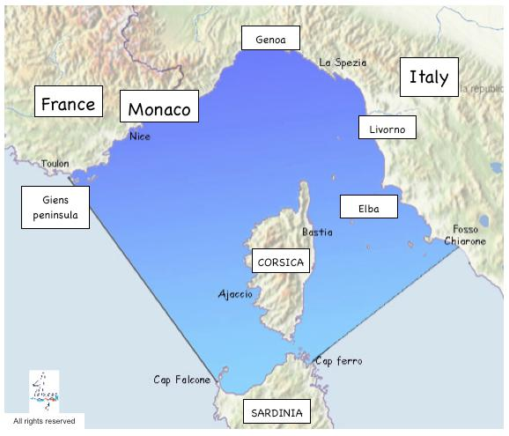

Figure 1: Map of the Pelagos Sea Cetacean Sanctuary (Pelagos, 2018).

Figure 2: Oil spill spread captured by Sentinel-1 satellites on 8th October 2018 at 07:28 CEST (05:28 UTC).

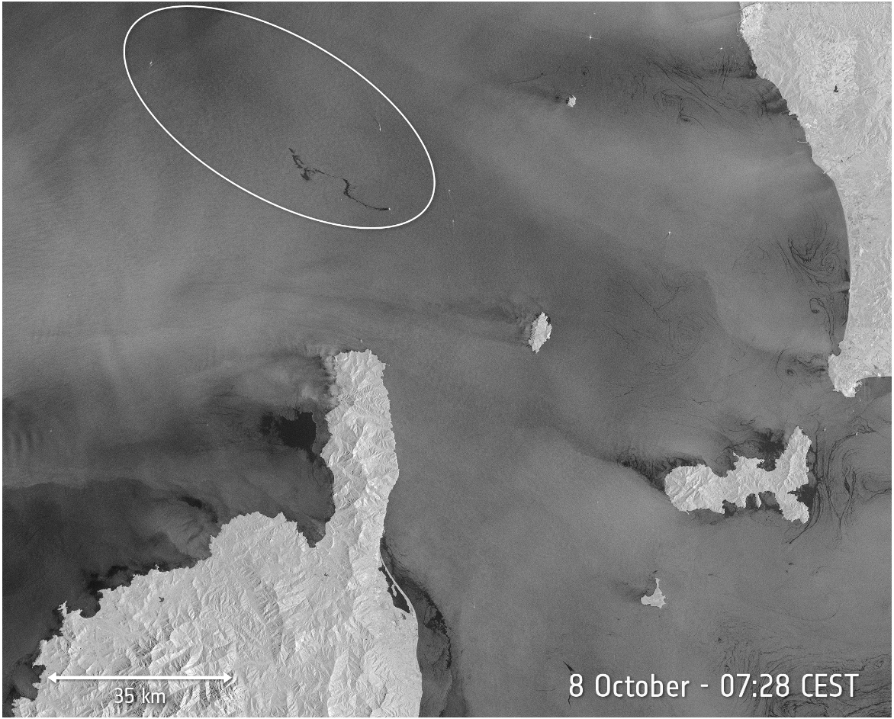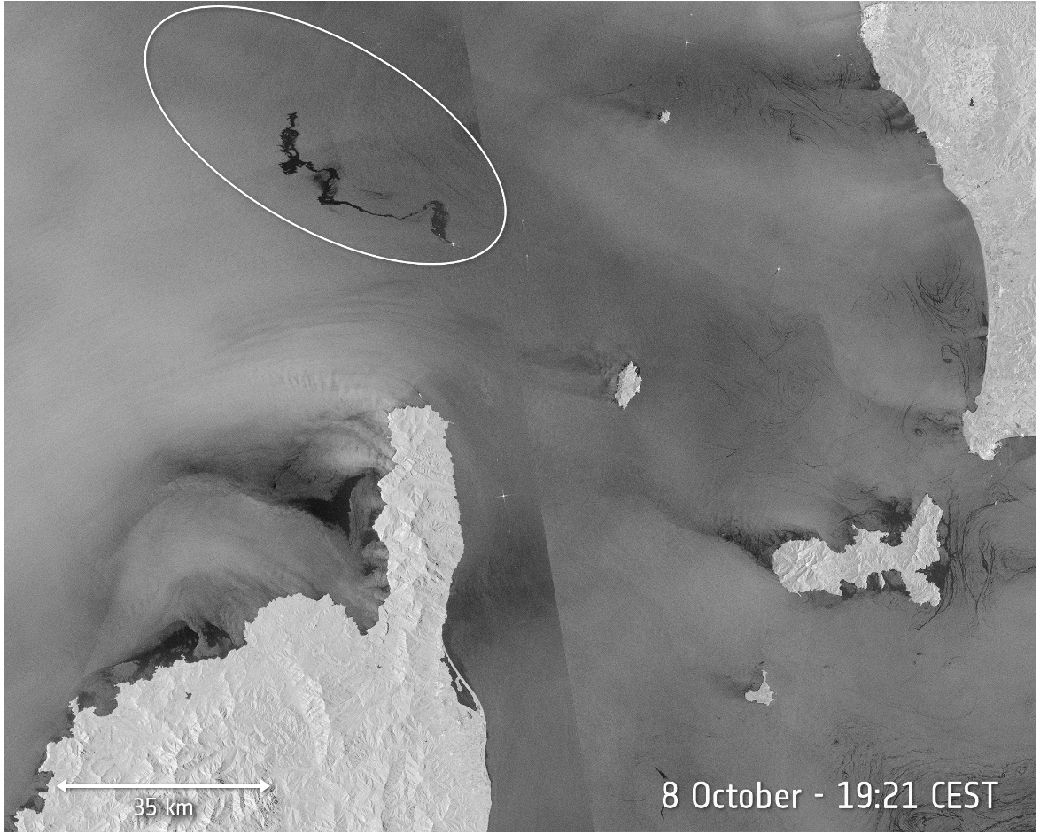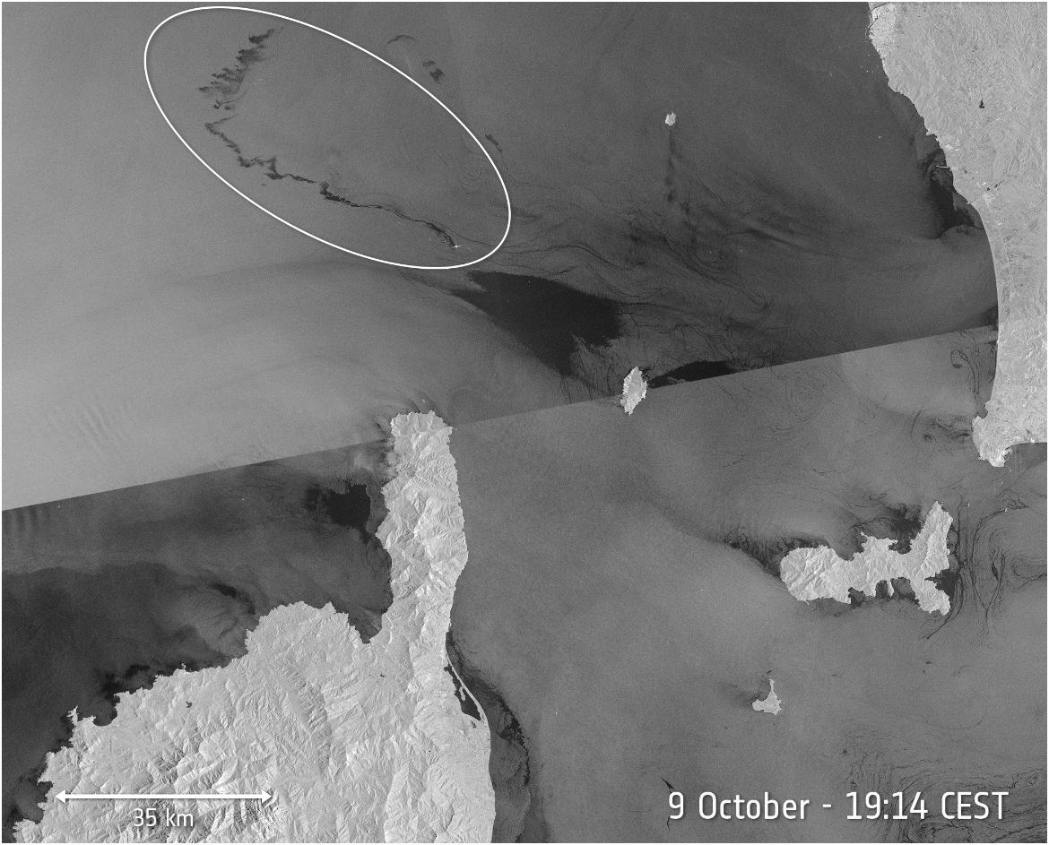
a
b
c

Figure 3 (a,b,c): Oil slick evolution captured by Sentinel-1 satellites, on 8th October 2018 at 07:28 CEST (a), 8th October 2018 at 19:21 CEST (b), 9th October 2018 at 19:14 CEST(c).
Sentinel-1 is a constellation of two polar-orbiting satellites, under the EC “Copernicus” environmental monitoring program, operating day and night performing C-band synthetic aperture radar imaging, enabling them to acquire imagery regardless of the weather. Since radar measures surface texture, in the images the oil slicks show up well – as black smears on a grey background, while other dark areas show patterns featuring low reflectivity of the radar signal, for instance very calm waters. Sentinel-1 images are used by the European Maritime Safety Agency as part of CleanSeaNet, the European satellite-based oil spill and vessel detection service. On 8th October 2018 at 07:28 CEST (05:28 UTC), the Copernicus Sentinel-1A satellite captured its first images of the oil spill from the collision between the two ships on Sunday 7th October 2018, which can be seen as a dark patch North of the tip of Corsica. Fig. 2 visualizes the pollution extension just after the collision time, covering nearly 20 km. Fig. 3 a,b,c shows the evolution of the oil slick in the subsequent days: by the evening at 19:21 CEST, the slick had lengthened to about 35 km while 24 hours later, on 9th October at 19:14 CEST, the extension reached nearly a length of 60 km. It should be noted that similar studies presented in the past usually are forced with climatological data and/or model data to study events but without following a systematic modelling approach enabling the development of a rapid and effective response plan.
  - Results and discussion
Numerical simulations started on 7th October, assuming, as worst-case scenario, the hypothesis a continuous fuel release following ship collision. The availability of satellite data allowed validating the models of spill evolution, to map the area affected by the pollution used for re-initialization of the slick position for the updated forecast. According to the currents regime simulated by the hydrodynamic model (as described above) and the wind drift resulting from the meteorological model. Fig. 4 evidences the particles trajectory towards NW after 24 h. Comparison between the slick forecasted position and Sentinel-1A satellite image in Fig. 4 shows a fairly good agreement, with a prevailing direction of the oil slick again towards NW. Satellite data were used for the model re-initialization of the slick position for the following simulation, based on the meteo-oceanographic forecast produced on October 8th 12:00. Results are depicted in Fig. 5, again with a good accordance between the slick forecasted position and Sentinel-1A satellite image. For the following days, only visual observations by aircraft were available and were used to follow the evolution of the hydrocarbon trails (Fig. 6). Until the two ships were separated on 11th October evening, simulations were carried out, still considering a continuous spill from the ship tank. The dispersed oil slicks remaining after recovery operations headed toward western Liguria at a distance of about 12 miles from the coast and eventually reached the French coastline. (see Fig. 7). In general, the simulated results show that the model is capable of predicting the oil spill behaviour in sea environment. Spill model predictions showed considerable sensitivity to predicted surface currents and to wind
as evidenced by tests performed using the varying meteorological and Mediterranean circulation predictions as input. This study confirms the determining role of the accuracy of atmospheric forcing and sea current forecasting to achieve reliable pollution trajectories and dispersion patterns, thus confirming the results obtained by Broström et al. (2011) in ocean environment.

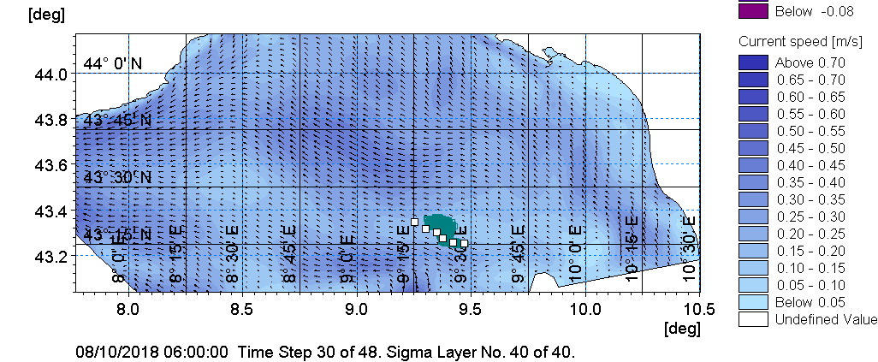

Figure 4: Slick position on 8th October 2018 at 09:00 UTC: comparison between simulated (dark) and experimental data by Sentinel-1 satellites (white dots).

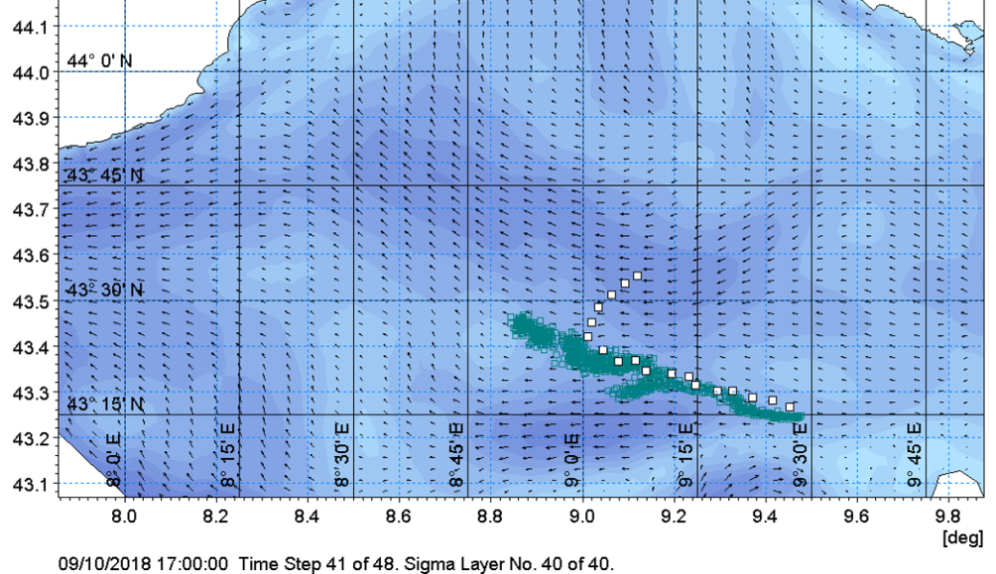
Figure 5: Slick position on 9th October 2018 at 17:00 UTC: comparison between simulated (dark) and experimental data by Sentinel-1 satellites (white dots).

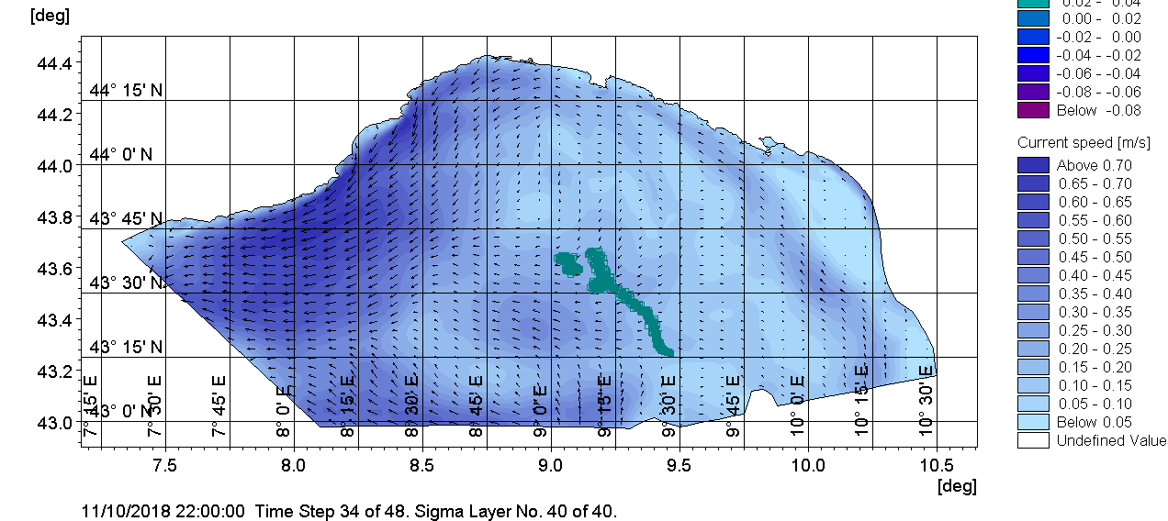
Figure 6. Forecast of the oil slick on 11th October 2018 at 22:00 UTC obtained with initial source position by aircraft observations and a continuous spill scenario from the ship tank.

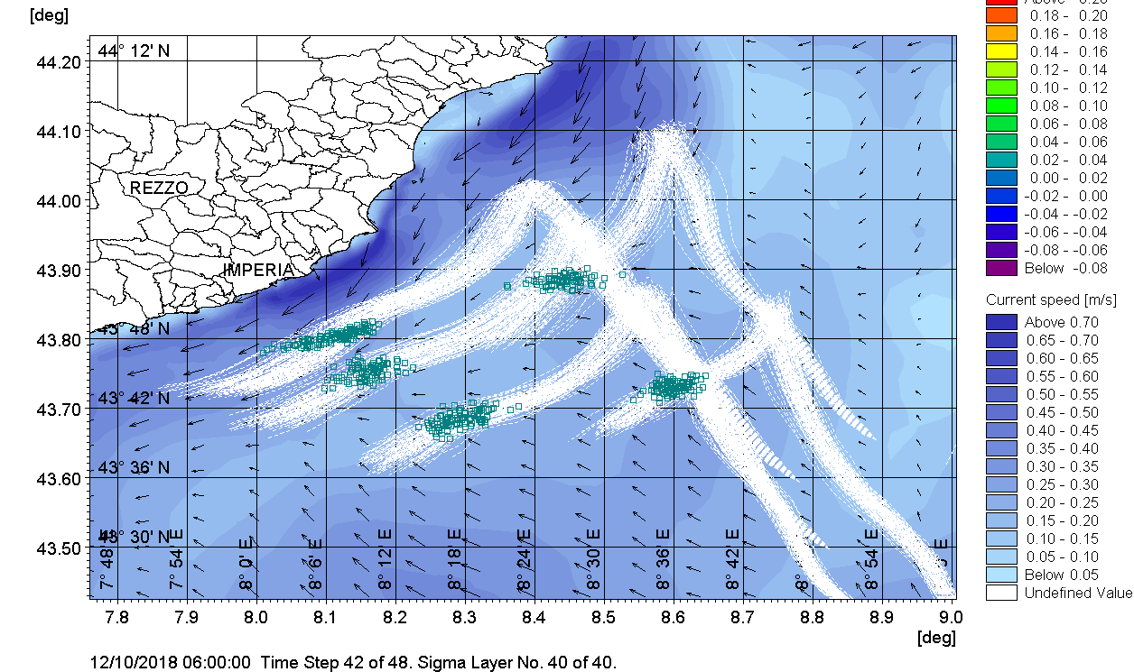
Figure 7: Forecast of the oil slick fate on 12t^{h} October 2018 at 22:00 UTC, obtained with initial source position provided by aircraft visual observations.
As a main drawback of the approach, it should be noted that the simulation was unable to catch the final eastward change in the slick direction, highlighting the need of actual observations to assess the forecasts reliability and operate re-initialization for long range planning. It follows that the spill prediction capability can be sharply increased by enhancing the accuracy of the hydrodynamic circulation model, by tuning parametrization with systematic observations and by developing accurate data assimilation procedures.
  - Conclusions
This paper shows the benefits of integrating Satellite Informations in environmental models for local applications and underlines the need for a closer collaboration among environmental model developers and satellite - remote sensing scientists. With more upcoming satellite missions, especially the Sentinel platforms, concerted efforts to further integrate Satellite Remote Sensing into modelling are in great demand and these types of applications are well worth of further studies and field validation. Owing to the large area potentially affected by spill evolution, environmental remediation efforts can be geographically widespread, time consuming and extremely expensive. The use of modelling to predict oil slick trajectory and fate in sea environment and thus identify the areas at sea and shore potentially affected by the spill can represent an important tool to support the emergency response. This paper outlined spill modelling framework to support the Coast Guard in delimiting the marine areas affected by this oil spill and evaluating possible impact on the coast. The success of this approach can be found in its efficacy in detecting the directions along which oil transport is likely to develop. Lessons learned include the importance of availability of observation data, useful during the emergency phases to assess the forecast reliability and improve the long-range predictions. The availability of empirical data is essential to improve the performance of the computational model in terms of resolution, meteorological forcing and parameterization of the physical processes. The described framework can provide a technical basis for setting-up emergency planning, with appropriate response equipment and thus minimizing coastal impact from a spill.
References
ASCE, 1996 State-of-the-art review of modeling transport and fate of oil spills. Task Committee on Modeling of Oil Spills of the Water Resources Engineering Division. J. Hydraul. Eng., 122(11), 594-609.
Broström G., Carrasco A., Hole L.R., Dick S., Janssen F., Mattsson J., Berger S., 2011, Usefulness of high resolution coastal models for operational oil spill forecast: the ‘‘Full City’’ accident, Ocean Sci. 7, 805–820.
ESA (European Space Agency), 2018, Copernicus: Sentinel-1 < https://earth.esa.int/web/eoportal/satellite-missions/c-missions/copernicus-sentinel-1> accessed 10.10.2018.
Fabiano B., 2017, Loss prevention and safety promotion in the process industries: issues and challenges, Process Safety and Environmental Protection 110, 1-4.
Foreman M.G.G., Beauchemin L., Cherniawsky J.Y., Peña M.A., Cummins P.F., Sutherland G., 2005. A review of models in support of oil and gas exploration off the north coast of British Columbia. Can. Tech. Rep. Fish. Aquat. Sci., 2612: v + 58p.
George, P., Skjong, R., Vanem, E., 2011. Risk acceptance criterion for tanker oil spill risk reduction measures, Marine Pollution Bulletin 62, 116–127.
Palazzi E., Currò F., Fabiano B., 2004, Simplified modelling for risk assessment of hydrocarbon spills in port area, Process Safety and Environmental Protection 82, 412-420.
Papanikolaou A., 2016, Tanker design and safety: historical developments and future trends. Chapter in: S. Orszulik (ed.), Environmental Technology in the Oil Industry, Springer Int. Publishing, Switzerland, 285-320.
Pelagos, 2018, Pelagos Sanctuary <sanctuaire-pelagos.org> accessed 10.01.2019
Pesce M., Paci P., Garrone S., Pastorino R., Fabiano B., 2012, Modelling ignition probabilities within the framework of quantitative risk assessments, Chemical Engineering Transactions 26, 141-146.
Spaulding M.L., 2017, State of the art review and future directions in oil spill modeling, Marine Pollution Bulletin 115, 7-19.
Vairo T., Curro' F., Scarselli S., Fabiano B., 2014, Atmospheric emissions from a fossil fuel power station: dispersion modelling and experimental comparison, Chemical Engineering Transactions 36, 295-300.
Vairo T., Del Giudice T., Quagliati M., Barbucci A., Fabiano B., 2017, From land- to water-use-planning: A consequence based case-study related to cruise ship risk, Safety Science 97, 120-133.
Vairo T., Magri S., De Gaetano P., Quagliati M., Fabiano B., 2018, Multicomponent dispersion of hydrocarbons at sea: source term evaluation and hydrodynamic simulation of the spill, Chemical Engineering Transactions 67, 61-66.
WHO, 2007, WHO six-year strategy for the health sector and community capacity development, <who.int/hac/techguidance/preparedness/emergency_preparedness_eng.pdf> accessed 10.01.2019.
Zafirakou A., Palantzas G., Samaras A., Koutitas C., 2015, Oil spill modelling aiming at the protection of ports and coastal areas, Environmental Processes 2, S41-S53.

