CHEMICAL ENGINEERING TRANSACTIONS  VOL. 76, 2019 | A publication of
The Italian Association
of Chemical Engineering
Online at www.aidic.it/cet
Guest Editors: Sauro Pierucci, Jiří Jaromír Klemeš, Laura Piazza
Copyright © 2019, AIDIC Servizi S.r.l.
ISBN 978-88-95608-73-0; ISSN 2283-9216

Major Accident Prevention: a Construction Site Approach for Pro-active Management of Unsafe Conditions
Daniele Cermelli*, Margherita Pettinato, Fabio Currò, Bruno Fabiano
DICCA Department of Civil, Chemical and Environmental Engineering, Polytechnic School of Genoa University, via Opera Pia 15,16145 Genoa, Italy
daniele.cermelli@gmail.com

In large-scale construction projects, site situation and surrounding environment can change daily. This is due to multiple factors acting as “incident catalysts”, like less, or un-skilled workers, outsourcing, more complex construction phases (heights or confined spaces), under pressure working conditions, as well as changes in environmental conditions (e.g. wind, temperature, etc.). It is essential to acquire a statistical significant reference concerning the unsafe acts and risky behaviour to implement proactive measures preventing occurrences of major incidents. In this paper, the construction phase in the Middle East of one of the world’s largest oil and petrochemical integrated complex was considered. Starting from the accident/incident pyramid approach, management, direct field supervisors, as well as subcontractors were involved in the development and upgrading of a Multilayer Reporting System, covering any risk behaviours, unsafe situation, violations or acts, safety or environmental issues, near misses as well as minor, or major accidents. The modular approach provided a comprehensive overview of the core human and technical issues in the construction and testing of the process plant, suggesting how to implement technical and managerial solutions to handle them effectively, reduce the likelihood of errors, violations and avoid damages to the facilities, environment and humans.
  - Introduction
Construction sites are becoming everyday more and more challenging due to the todays more than ever dynamics of projects, their schedules, owner’s requirements and the increased employment of low skilled workforces. The International Labour Organization (ILO) estimated that the construction sector accounts for one in every six fatal accidents recorded at work annually with at least 60,000 fatal accidents occurring each year on construction sites around the world, averaging one fatality every 10 min (Lingard, 2013). EU statistics evidenced that construction environment is still one of the most hazardous with more than 1,000 fatalities and over 800,000 workers suffering injuries on a year basis (EU-OSHA, 2017). Similar statistical trends were recorded in U.S.A. (Bureau of Labor Statistics, 2016) and in Great Britain (HSE, 2016). Major accidents in today’s industry are not occurring with any sign of them: actually, many signs are present in the working site, such as from workers’ risk behaviours, violations or unsafe acts, to unsafe situations or environment, near misses and minor accidents. All of these mentioned conditions are clear pre-alerts or predecessors, which are pointing out at a possible major accident occurrence in the future. Incidents result as consequence of human, organizational, mechanical, and operational failures, with physiological differences between major accidents and minor incidents related to the actual activities involved, the amount of energy released, the characteristics and number of safety barriers or protection layers that were in place, or could have been relevant to the final incident. But major accidents in industrial settings are only the tip of the incident/accident pyramid, firstly illustrated in 1931 by Heinrich in his old fashioned work (Heinrich, 1931), showing that in some way there is a factual foundation of major accidents. Different accident ratios were developed from the original one by Heinrich 1:29:300, respectively referred to major injury (OSHA recordable case), first aid case and no injury accident. For example, HSE report (1997) mentions the ratio 1:7:189 based on more recent accident statistics and evidencing that not all near misses involve hazards that may cause fatal or major accidents. In expanding the top section of Heinrich triangle, starting from 17 years of real data observations by the US Bureau of Labor Statistics, over the time span 1992-2008, Collins (2011) proposed an updated occupational accident ratio in the form 1:500:1000:43,500:450,000, respectively referred to fatality, lost workday case, OSHA recordable case, first aid-case and no injury (near-miss). It must be remarked that major (process) accidents and occupational accidents basically are characterised by separate triangles, even though in some cases a possible escalation may arise or an overlapping of personal and process impact may exist. Thus, in order to improve safety management and enhance safety culture, data about near misses should be taken into consideration as useful tool. Indeed, these events are much more frequent than accidents and can be used, in a proactive way, as indicators of critical areas (Cambraia et al., 2010). Particularly, the use of near miss analysis in construction was recently employed by Raviv et al. (2017), who demonstrated that the approach in which all incident types are investigated, including high-frequency very low-severity incidents, is able to provide noteworthy incident records that could be used as raw data for quantitative analyses. Conversely, several examples are reported in literature concerning the disastrous consequences due to the lack of management of observed near misses (Phimister et al, 2003). As reported by Jones et al. (1999), near miss can be seen as a hazardous situation or unsafe act, where the chain of events could have brought about an accident if it had not been interrupted. Since the statistics on accidents are often too few in number to help in some decision making about safety improvements, the analysis of near misses, under the common cause hypothesis, could provide a significant increase in the number of data (Wright and van der Schaaf, 2004). According to a detailed near-miss reporting system and the development of a step-by step analysis it is possible evidencing how immediate causes of a near-miss could be linked in some kind of causal chain to underlying causes, that should be controlled by middle or higher management, or are parts of the corporate safety culture (Fabiano et al, 2012). If on the one hand, incidents and accidents are generally accurately reported, because of the high severity of the outcome, on the other hand the numbers related to the statistics of near misses have low accuracy. Indeed, these reports are often omitted, since they do not produce a result different from a success (Smith et al., 2017). Additionally, Gnoni and Saleh (2017) discussed another crucial issue regarding the employee’s confusion regarding what is reportable as near miss, since it was not often perceived as an existing adverse condition but as an event-based concept. However, it would be of a great help to record as many of these pre-alerts as possible in a systematic and organised way, which would help to predict possible major accidents and prevent them with specific preventive measures and campaigns. Indeed, different modelling were studied to mitigate the risk, such as the systematic model to reinforce and accentuate the real-time tracking of precursors and immediate factors on construction sites (Wu et al., 2010), or empirical method via complex network theory for the modelling of near miss accidents in metro construction (Zhou et al., 2017), and evidence-based risk modelling for maritime risk analysis (Mazaheri et al., 2015). In all of them, the importance of the analysis of precursors and near misses were emphasised, since near miss reports could provide a substantial contribution in understanding and controlling accidents and incidents. On these bases, a supporting tool, enabling to perform on-site hazard assessment in a detailed manner and coupling information concerning the potential prevention technical and management measures based on performed working activities, is advisable. This paper firstly outlines the occupational accident trends recorded over the long period in a mature industrial Country, referring to the industrial sectors mainly involved in the construction of a new integrated downstream oil processing plant. Subsequently, preliminary results from the development of a procedure for the hazard analysis and prioritization of the interventions related to hazardous working activities in the given context are shown, evidencing the main findings during the first construction phase. The indicators on the basis of these hazardous events can be considered as leading to less severity events, or near misses.
  - Occupational risk assessment
Traditionally, the construction safety relies on strategies based on safety standards and regulation, human error and behavioural controls, mainly by training, performance monitoring and development of a combined health and safety management system. Looking at the Italian perspective over the long period (Figure 1), it can be observed that the trend of Frequency Index (FI) in construction sector (occupational accident per 10⁶ worked hours) is constantly over the average trend for all industrial sectors, with a marked evidence of a cyclic evolution connected to the economic cycle. As term of comparison of overall activities involved in the construction of a new refinery, the metallurgical group was added, which in Italy shows high frequency indices and the chemical one which for many years (1951-1963) was characterised by a low frequency of injuries and then is more or less at the average value (all industries). According to most recent INAIL (Istituto Nazionale Assicurazione Infortuni sul Lavoro) raw data (INAIL, 2017), mainly as a consequence of the economic contingency and drop of worked hours in the construction sector, in the year 2017 in Italy, construction recorded FI = 14 and FAFR = 11 (Fatal Accident Frequency Rate) expressed as fatal accidents per 10⁸ worked hours). These figures should be compared with the average values for all Italian industrial sectors, respectively corresponding to FI = 7 and FAFR = 3, evidencing the inherent hazardous character of the sector.
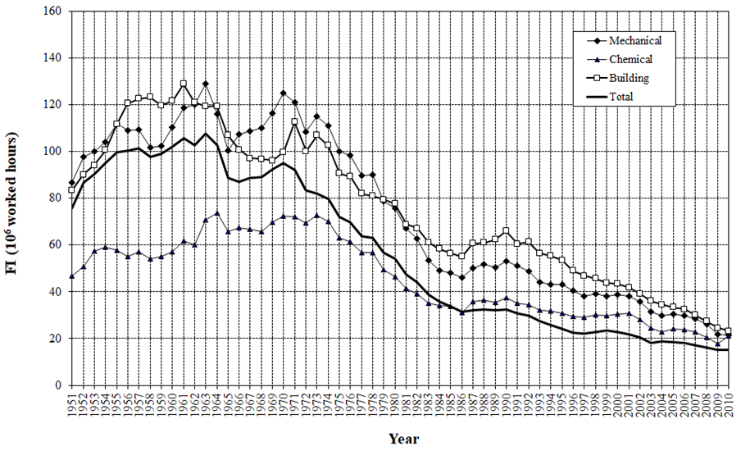
Figure 1: Frequency Index (FI) in the building, mechanical and chemical sectors in Italy over the long trend.

    - Reference context
The basis of this research was the findings from the construction phase of a large petrochemical complex in the Middle East. The oil and petrochemical integrated complex is composed of a traditional refinery complex (crude distillation, atmospheric residue desulphurization, diesel hydrotreating, naphtha hydrotreating, kerosene hydrotreating, hydrogen production and compression, strippers, amine regeneration, tank farm and administration area) which will produce high value fuel oil and feedstock to the petrochemical facility dedicated to the production of polypropylene, p-xylene, gasoline and other fuels. The oil complex includes utility production (steam, air, water, and cooling towers) and Waste Water Treatment, Hydrogen Production and Compression well as recovery units and flare systems. The plant is currently at the end of its first year of construction on a land of approximately 1 square kilometer and the construction is forecasted to last 36-40 months in total. The building site underground facilities and building complex are currently at the final stage and are accounted for in this study, while the electrical and structural, mechanical and piping activities are forecasted to ramp up in the following 3-4 months.
    - Workforce sample
The workforce varies from the carpenters and helpers utilized in the civil and concrete structures to prepare formworks’ to the Concrete Pipe installation crews and the more trained and qualified fiberglass pipe lamination teams. These labor crews are supervised by construction foremen and directed by site engineers and construction managers. Current workforce consists of 5,000 workers and it is expected to peak at 15,000 within a year time. The human sample comprehended from workforce to engineers and managers, since all the involved people were supposed to report unsafe conditions, unsafe acts or near misses.
    - Reference definitions
In the following, we provide a short description of the basic terminology adopted for on-site recording, for both accidents and hazardous events without consequences. Work related unwanted events could include dangerous situations; near misses; first aid; medical treatment; restricted duty injury; lost time injury; fatality.
Clearly, every hazardous event is required to be thoroughly investigated, to ensure that a reoccurrence is prevented, starting from factual collection, event course, immediate and root cause identification, and setting up of the corrective actions/preventive measures including accountability for their implementation.
In expanding the lower part of the pyramid, following reference terms were adopted:
Unsafe Act – The performance of a task or an activity performed in a manner that may threaten the health and/or safety of workers (e.g. lack of Personal Protective Equipment (PPEs), which represent the ultimate layer of protection against accident).
Unsafe Condition – A condition that is likely to cause injury (e.g. use of a defective tool; improper use of PPE, improper design of PPE).
Near Miss – An unplanned event that has the potential to cause, but does not have actually resulted in a human injury, environmental or equipment damage, or an interruption to normal operation (e.g. lack of routine inspection/maintenance; lack of visual inspection, or clearing people from working areas prior to operations).
Accident – An unfortunate and unplanned incident that happens unexpectedly and unintentionally, typically resulting in damage or injury.
    - Research framework
Starting from Heinrich’s concept that major incidents are just the tip of the pyramid (Heinrich, 1931) and subsequent improvements, the essential purpose for this research was the generation of the wide pyramid base. By identifying and categorizing causal factors of unwanted events, a number of candidate management elements for occupational safety were identified. For this step every personnel on the job site was stimulated to generate any type of findings with brief description and possible measure to resolve the matter. In order to facilitate the categorizing process, personnel were requested to select one of the multiple-choice options for hazard identification and a slightly more detailed hazard classification. This organizational process contributed tremendously to nailing few main categories down and therefore largely supported the mitigation strategy identification and implementation allowing concentrating main effort into the most reported hazards. Report forms were prepared with two reporting sections. The first category of hazard identification proposed for personnel selection (single selection allowed) was on the classification of the hazard itself among the following options: “unsafe conditions”, “unsafe acts”, “near misses” and “positive findings”. While near misses and positive findings are self-explanatory, the option of unsafe condition is meant for those findings that are part of the environment or workplace and unsafe act part of people’s actions or workforce’s culture. The secondary and more detailed classification of the identified hazards, allowed focusing on the ultimate issue related with the findings and therefore the hazard itself. For this section, a multiple choice was allowed, with proposed options as follows: Personal Protective Equipment (PPE), excavations/holes/barricades, rigging, motorised equipment, confined space work, energy related hazards, housekeeping, material and tools handling and fires. Subsequently, reported hazards were registered and deeply analysed and their immediate/perceived causes were grouped in order to actively and effectively implement safety/prevention plans for the specific hazard. Most reported hazards were also tackled in monthly awareness campaigns stimulating people to develop implementations and corrective actions, as well as practical solutions to occupational safety issues.
  - Results and discussion
Based on the first 6 months of the project from ground breaking to initial UG works, civil foundations and preliminary building construction activities, the below information were raised by personnel. As reported elsewhere (Fabiano et al., 1995), four main factors can be sorted as affecting productivity and occupational accidents, namely economic factors, typical technologies used, environmental conditions and work organization, typology of the labour force. The last item is related to labour turnover, with marked in- and out- flows that negatively affect the professional experience, as demonstrated in different industrial sectors (e.g. Pastorino et al., 2014). It should be evidenced that in the peculiar examined context, environmental conditions may pose additional hazardous conditions: in the first part of the project was executed during the Middle East autumn/winter seasons when temperatures are mild to warm and not too hot. The second step of the building project is planned in the centre of the Arabic peninsula’s Spring/Summer, when temperature will raise substantially and day work will be substituted only by night work. As summarised in Figure 2, from more than 5,800 reported instances, 930 were positive comments related to personnel following procedures, while 1,687 unsafe acts and 2,951 unsafe conditions were raised. Reported Near Misses were only 22. However, due to the nature and low-skill of workforce, it was believed that only 10-20 % of the total actual near-misses was self-reported, evidencing also for this item the phenomenon of under-reporting. This was justified by the weekly safety inspections and their findings, which were surfacing by far more near misses per week. There is room for continuous improvement in near miss recording by front-end workers, so that investigations on this item can represent a powerful tool for occupational safety in a construction setting. It is noteworthy noting that the relative increase in reporting by the safety inspections, adopting the framework should not be viewed as a decline in operating safety standards, but as a development of a corporate safety culture acknowledging that submission of information about the smallest deviations (i.e. unsafe conditions/unsafe acts) can help in identifying practical actions to prevent major events.
Additionally, the detailed study of the secondary classification can help to understand the exact cause of the issues reported and possibly set-up additional layer of protections by proper refinement of workplace, process and construction steps and relevant technical/management issues (Fabiano et al., 2019).

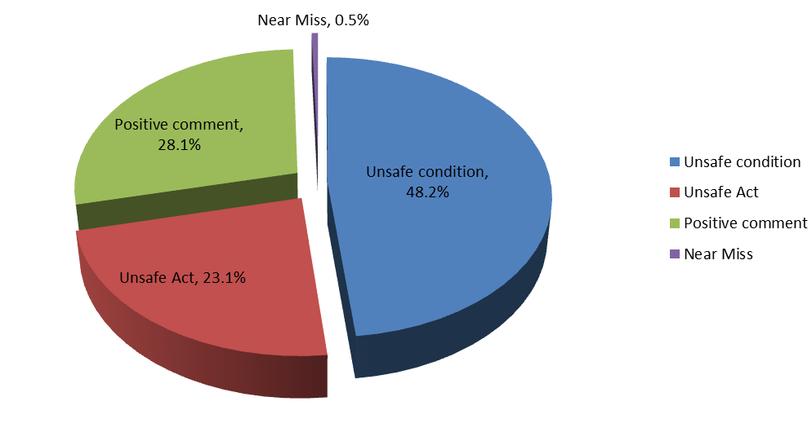
Figure 2: Classification of information collected form raw data examination and statistical elaboration.
The most recorded causes, highlighted by personnel from the secondary and detailed-out classification in this initial phase of the project, were by far PPE, housekeeping and procedure compliance; followed by excavation/ barricades and slip/ tripping/falls, as summarised in Table 1. During the “safety on-site walk”, in filling the reporting form, the person was also requested, based on their experience to suggest the possible final consequences of the unsafe act/ condition that would have occurred if the accident had materialised.
Table 1: Detailed analysis of secondary classification
Secondary and detailed-out classification of causes | %
PPE | 17
Housekeeping | 15
Procedure Compliance | 14
Others | 13
Slip/Trip/Fall | 7
Excavation/ Barricade/ Hole cover | 7
Ladder/ Work Platform/ Scaffold | 5
Tools/ Equipment | 5
Fire | 4
Motorised Equipment / Vehicle | 4
Human and Machine Interface | 3
Material Handling | 2
Crane/Rigging | 2

The consequence categories and resulting statistics are summarised in Table 2. Obtained figures from the first stage of this study may help the organization to develop a better strategy to improve occupational safety practices and performances in construction settings, improving as well the efficacy of safety training sessions aimed at providing practical experience on the job.
Table 2: Proposed categories of the possible ultimate consequences
Reported possible ultimate consequences | %
Injury or illness | 57
None | 19
Environmental Damage/Spill | 6
Equipment /Property Damage or Loss | 6
Motor Vehicle Accident | 6
Fire | 4
Blank | 3
  - Conclusions
For a sustainable improvement in preventing reoccurrence of occupational accidents, it is important that the corrective actions are fully and systematically deduced, starting from the analysis of the root causes, so that the derived comprehensive actions can be learnt effectively by the organization. The first phase of this study, concerned mainly civil construction dominated activities of the refinery complex, contributed to find out which were the causes of the findings, helping to focus on the ones which were reported most frequently (PPE selection and use (17%), housekeeping (15%) and procedure non-compliance (14%), excavation/ barricades (7%) and slip/tripping/falls (7%)). Specific monthly awareness campaigns were initiated to inform personnel with the objectives of eliminate, reduce hazards and limit their consequences if any would occur, mainly on the perceived most relevant items. Furthermore, during awareness campaigns also contractors can be stimulated to come up with implementations plans, as well as practical solutions to the issues. According to a new vision, the lower part of the accident pyramid, expanded taking into account three ranking acts (unsafe condition; unsafe act; near miss) may be considered to some extent leading. Upon further statistical refinement and on-site validation accounting for next steps of the refinery complex development and start-up, the approach is argued to provide predictive qualitative correlation with the low probability events, i.e. major injury/fatality.
References
INAIL, 2017, Banca dati statistica INAIL- Istituto nazionale Assicurazione Infortuni sul Lavoro, Italy,<https://bancadaticsa.inail.it> accessed 02.03.2019.
Bureau of Labor Statistics, 2016, National census of fatal occupational injuries in 2015, Bureau of Labor Statistics: Washington, DC.
Cambraia F.B., Saurin T.A., Formoso C.T., 2010, Identification, analysis and dissemination of information on near misses: A case study in the construction industry, Safety Science, 48, 91–99.
Collins R.L., 2011, Heinrich and beyond, Process Safety Progress, 30, 2-5.
EU-OSHA, 2017, European Agency for Safety and Health at Work, Estimating the cost of work related accidents and ill-health: an analysis of European data sources, Publications Office of the European Union, Luxembourg.
Fabiano B., Parentini I., Ferraiolo A., Pastorino R., 1995, A century of accidents in the Italian industry - Relationship with the production cycle, Safety Science, 21, 65-74.
Fabiano B., Currò F., 2012, From a survey on accidents in the downstream oil industry to the development of a detailed near-miss reporting system, Process Safety and Environmental Protection, 90, 357-367.
Fabiano B., Reverberi, A.P., Varbanov, P.S., 2019, Safety opportunities for the synthesis of metal nanoparticles and short-cut approach to workplace risk evaluation, J. of Cleaner Production 209, 297-308.
Gnoni M.G., Saleh J.H., 2017, Near-miss management systems and observability-in-depth: Handling safety incidents and accident precursors in light of safety principles, Safety Science, 91, 154–167.
HSE- Health Safety and Executive, 1997, Successful health and safety management, HSG65, Sudbury, UK.
HSE- Health Safety and Executive, 2016, Health and safety in construction sector in G.B:, 2014/2015, UK.
Heinrich H.W., 1931, Industrial accident prevention- a scientific approach, McGraw-Hill, New York, US.
Jones S., Kirchsteiger C., Bjerke W., 1999, The importance of near miss reporting to further improve safety performance, Journal of Loss Prevention in the Process Industries, 12, 59–67.
Lingard H., 2013, Occupational health and safety in the construction industry, Construction Management and
Economics 31, 505–514.
Mazaheri A., Montewka J., Nisula J., Kujala, P., 2015, Usability of accident and incident reports for evidence-based risk modeling – A case study on ship grounding reports, Safety Science, 76, 202–214.
Pastorino R., Vairo T., Benvenuto A., Fabiano B., 2014, Area risk analysis in an urban port: personnel and major accident risk issues, Chemical Engineering Transactions, 36, 343-348.
Phimister J.R., Oktem U., Kleindorfer P.R., Kunreuther H., 2003, Near-Miss Incident Management in the Chemical Process Industry, Risk Analysis, 23, 3, 445–459.
Raviv G., Fishbain B., Shapira A., 2017, Analyzing risk factors in crane-related near-miss and accident reports, Safety Science, 91, 192–205.
Smith D., Veitch B., Khan F., Taylor R., 2017, Understanding industrial safety: Comparing Fault tree, Bayesian network and FRAM approaches, Journal of Loss Prevention in the Process Industries, 45, 88–101.
Wright L., van der Schaaf T., 2004, Accident versus near miss causation: a critical review of the literature an empirical test in the UK railway domain and their implications for other sectors, J Haz Mat, 111, 105–110.
Wu W., Gibb A.G.F., Li Q., 2010, Accident precursors and near misses on construction sites: An investigative tool to derive information from accident databases, Safety Science, 48, 845–858.
Zhou C., Ding L., Skibniewski M.J., Luo H., Jiang S., 2017, Characterizing time series of near-miss accidents in metro construction via complex network theory, Safety Science, 98, 145–158.

