CHEMICAL ENGINEERING TRANSACTIONS  VOL. 76, 2019 | A publication of
The Italian Association
of Chemical Engineering
Online at www.cetjournal.it
Guest Editors: Sauro Pierucci, Jiří Jaromír Klemeš, Laura Piazza
Copyright © 2019, AIDIC Servizi S.r.l.
ISBN 978-88-95608-73-0; ISSN 2283-9216

Preliminary investigation on regeneration of simulated radionuclide-contaminated activated carbons by microwave irradiation
Erica Gaglianoª, Pietro P. Falciglia^{a,b}*, Vincenza Brancato^{c}, Guglielmo Finocchiaro^{d}, Alfio Catalfo^{d}, Guido De Guidi^{d,e}, Stefano Romano^{b,f}, Paolo Roccaroª, Federico G.A. Vagliasindiª
ªDipartimento di Ingegneria Civile e Architettura, Università di Catania, Viale A. Doria 6, 95125, Catania, Italia
^{b}Laboratori Nazionali del Sud – Istituto Nazionale di Fisica Nucleare, Via S. Sofia, 62, 95125, Catania, Italia
^{c}CNR-ITAE – Istituto di Tecnologie Avanzate per l’Energia “Nicola Giordano”, Salita S. Lucia sopra Contesse, 5, 98126, Messina, Italia
^{d}Dipartimento di Scienze Chimiche, Università di Catania, Viale A. Doria, 6, 95125, Catania, Italia
^{e}Centro di ricerca per l’analisi, il monitoraggio e le metodologie di minimizzazione del rischio ambientale (CRAM3RA), Università di Catania, Italia
^{f}Dipartimento di Fisica e Astronomia, Università di Catania, Viale A. Doria, 6, 95125, Catania, Italia
ppfalci@dica.unict.it
This work investigates the feasibility of microwave (MW) irradiation for the regeneration of activated carbon (AC) spent with cesium. Adsorption batch experiments were carried out using commercially available granular activated carbon (Norit GAC 830). The Cs-saturated AC was treated using a controllable bench-scale 2.45-GHz MW oven at the power of 440 W for 3 min. The adsorption-regeneration cycle was repeated three times. The potentiality of the MW regeneration was assessed as regeneration efficiency (RE) and weight loss percentage of the AC samples during the adsorption/regeneration cycles. Textural properties of saturated and regenerated ACs were also evaluated by nitrogen adsorption isotherms at 77 K. Overall, results demonstrated a relatively low adsorption capacity for cesium, although the dielectric nature of the GAC allowed a rapid and effective regeneration process. Specifically, the weight loss percentage was found less than 2% jointly with an important increase in RE after 3 regeneration cycles. A preservation of the pore structure of regenerated ACs during MW regeneration was also observed.

  - Introduction
Contamination caused by γ-particle emitter radionuclides is a very serious problem worldwide (Falciglia et al., 2013). Over the past years, many anthropogenic activities have generated alarming levels of radionuclide (Falciglia et al., 2015). Due to their high potential toxicity, they caused severe environmental and health problems (Munthali et al., 2015). Cesium-137 (¹³⁷Cs) is a major radionuclide in spent nuclear fuel processing and represents the most important risk driver after nuclear accident (Li et al., 2014). Contamination by ¹³⁷Cs has impacted large areas worldwide and through fall-out processes caused high soil and groundwater impacts. Cesium-137 is a beta (β) and gamma (γ)-emitter radionuclide with long-term radiological effects (extended half-life of 30.4 years) being a potential cause of thyroid cancer through irradiating in living tissues (Khandaker et al., 2017). Consequently, the need for radio-cesium (r-Cs) removal led to new methods being proposed to accelerate the process of environment decontamination (Zhang et al., 2019). Several physico-chemical methods have been studied for decontaminating r-Cs-impacted water including solvent extraction, ion-exchange, adsorption, chemical precipitation, membrane process, coagulation and electrochemical. The first three methods are the most widely used based on ionic selectivity and efficiency (Liu et al., 2014). Solvent extraction using macrocyclic ligand (crown ethers, calix-crowns, chlorinated cobalt dicarbollide) has been shown effective, however its full-scale application is very restricted due to equipment and chemical high costs. On the other hand, adsorption is considered a more cost-effective solution (Awual et al., 2014). Several clay minerals (i.e.: montmorillonite, zeolite, bentonite, vermiculite) or Prussian blue supported materials have also been employed for Cs-removal from groundwater and wastewater. However, high concentrations of Na and K ions make the former less effective adsorbents, while the latter produces huge waste because their non-reusable character (Awual et al., 2014). Activated carbon (AC) has high surface area and developed porosity and is recognized as a low-cost and effective adsorbent for a wide range of pollutants among which radionuclides (Tan and Hameed, 2017). Adsorption of Cs onto ACs has been investigated in very few and not exhaustive studies (Caccin et al., 2013; Li et al., 2014; Liu et al., 2014; Vanderheyden et al., 2016). Exhausted activated carbons are always incinerated or discarded in landfill. However, this is an uneconomic solution and it can result in a secondary dangerous pollution. Moreover, the regeneration of ¹³⁷Cs-exhausted carbons also allows the recovering of the radionuclide that is recognized as an excellent source for gamma irradiators (Awual et al., 2014). Therefore, the regeneration of the exhausted activated carbons is considered a preferable choice for their reuse and in order to minimize costs and environmental impacts (Foo and Hameed, 2012). Several alternatives, including conventional thermal-, solvent-, biological- and electrochemical-regeneration, are available (Yuen and Hameed, 2009). The previous mentioned techniques have several drawbacks, for instance solvent-regeneration involves the transfer of adsorbate to another phase, whereas biological regeneration is very slow and it relates only to biodegradables (Zanella et al., 2014).
Microwave (MW) irradiation has been widely used in industrial and environmental applications and it has attracted many attentions on regenerating activated carbons (Yang et al., 2017). After being initially applied for communication purposes, for several decades MW irradiation has been adopted as a cost-effective alternative to current heating technologies for many other applications, namely mineral processing and extractive metallurgy, drying processing, cement and concrete processing, food industry and oil processing (Falciglia et al., 2018b). In recent years, MW technology has been exploited as a powerful tool in several energy and environmental applications (Falciglia et al., 2017a). The growing interest in MW technique is also based on the passive ability of the irradiated matrices to convert a low power irradiation energy into a rapid and large temperature increase. This depends on the dielectric features of the media, which undoubtedly represent a major driving force. Their increase results in a decreases in the energy requirements, making MW regeneration a very cost-effective and sustainable alternative (De Guidi et al., 2017). Other great advantages are the higher ability of MW over conventional thermal remediation to heat the irradiated materials homogenously and rapidly (Falciglia et al., 2017b). Activated carbons are in fact excellent MW-absorbers, due to the interactions of the delocalized π-electrons with the MWs, and they have multiple surface functionalities, a high mechanical strength and a good resistance towards chemicals, heat and radiation (Zanella et al., 2014).
The main objective of this study was to investigate the effect of MW regeneration of Cs-saturated activated carbons, in terms of conservation of the regenerated materials physical properties and contaminant adsorption performance. Textural characterization of activated carbon samples before and after MW regeneration was performed by analyzing the nitrogen adsorption isotherm at 77 K. Preliminary results obtained classify MW irradiation as a potential suitable and cost-effective alternative for the regeneration of Cs-loaded activated carbons.
  - Materials and methods
    - Batch adsorption experiments
For batch adsorption studies, water contamination was simulated using ¹³³Cs as soluble salt. Contaminated water samples were prepared by dissolving cesium chloride (CsCl, Sigma-Aldrich) (De Haro-Del Rio et al., 2015) in deionized water at different concentrations. Commercially available Cabot Norit granular activated carbons (GAC 830) were selected as adsorbent material. Norit GAC 830 is produced by steam activation of select grades of coal and its superior hardness makes its particularly suited for thermal reactivation. The chemico-physical properties of GAC 830 are summarized in Table 1.
The ACs were washed with deionized water, sieved at 2.0 mm, then oven-dried at 100 °C. Experiments were carried out in a series of 50 mL-flasks containing the adsorbent (GAC 830) and the Cs-water solution at varying concentrations up to 250 mg L⁻¹ (Solid to Water ratio of 1:10). The flasks were agitated for 24 h in a shaker at a speed of 180 rpm (20 °C), finally all water samples were filtered prior analysis. Initial (C_{0,} mg L⁻¹) and equilibrium concentration (C_{e,} mg L⁻¹) were obtained by ICP-MS, and Cs-uptake at equilibrium q_{e} (mg g⁻¹) was calculated as follow:
$${\text{q}}_{\text{e}}\text{=}\frac{\left({\text{C}}_{\text{0}}\text{-}{\text{C}}_{\text{e}}\right)\text{V}}{\text{W}}$$ | (1)
where V (L) and W (g) are the volume of the solution and the mass of the adsorbent, respectively.
Table 1: Chemico-physical properties of GAC 830.
Parameter | U.M. | Value
Surface area (B.E.T.) | m² g⁻¹ | 872.09
Pore volume (T-plot method) | cm³ g⁻¹ | 0.43
Median pore width | nm | 0.71
Apparent density | kg m⁻³ | 500
Particle size > 8 mesh | mass-% | max. 8
Particle size < 30 mesh | mass-% | max.4

    - Isotherm modelling
Adsorption isotherms are valuable tools to describe the adsorption equilibrium and give information on the adsorbent/adsorbate reciprocity. Over the years, different equilibrium isotherm models have been proposed (Zhang et al, 2017). In this study, obtained data were fitted using the Langmuir (1916) (Eq. 2) and Freundlich (1906) (Eq. 3) isotherm models. The former derived from the assumption that the adsorption occurs onto a surface with a finite number of identical sites, while the latter occurs on heterogeneous surfaces:
$${\text{q}}_{\text{e}}\text{=}\frac{{\text{Q}}_{\text{0}}{\text{k}}_{\text{L}}{\text{C}}_{\text{e}}}{\text{1+}{\text{k}}_{\text{L}}{\text{C}}_{\text{e}}}$$ | (2)
$${\text{q}}_{\text{e}}\text{= }{{\text{C}}_{\text{e}}}^{\frac{\text{1}}{\text{n}}}{\text{k}}_{\text{F}}$$ | (3)
where Q₀ (mg g⁻¹) and k_{L} (L mg⁻¹) are Langmuir constants related to the adsorption capacity and energy. k_{F} (mg g⁻¹(L mg⁻¹)^{1/n}) and 1/n are the Freundlich adsorption constant and adsorption intensity, respectively.
    - Regeneration of Cs-exhaust activated carbons
For the regeneration tests, Cs-exhausted AC samples were prepared following the same procedure described above for the adsorption phase. In this case, C₀ was 250 mg L⁻¹. The regeneration procedure was performed using a controllable 2.45-GHz MW bench-scale oven (maximum power of 1 kW). Its MW-cavity was hydraulically connected with an exhaust vapour capture line (cold traps, AC filter and electric vacuum pump). In a typical regeneration-step, 15 g of AC sample were irradiated at 440 W for 3 min. A 1.5 mm type-k thermocouple system was used for AC temperature recording. After the irradiation, ACs were analysed for residual Cs-concentration. The adsorption-regeneration process was repeated 3 times.
In order to assess the yield of the whole regeneration treatment, the regeneration efficiency (RE) (Ania et al., 2007) and the weight loss percentage (η) (Sun et al., 2017) were calculated using Eqs. (4) and (5), respectively:
$$\text{RE=}\frac{{\text{q}}_{\text{i}}}{{\text{q}}_{\text{0}}}\text{∙100}$$ | (4)
$$\text{η= }\frac{{\text{W}}_{\text{t}}}{{\text{W}}_{\text{0}}}\text{∙100}$$ | (5)
where q_{i} is the adsorption capacity (mg g⁻¹) of the regenerated AC, q₀ is the adsorption capacity (mg g⁻¹) of the fresh AC, W_{t} is the weight (g) of the AC after the regeneration and W₀ is the weight (g) of the fresh AC.
Textural characterization of GAC 830 was carried out by measuring the nitrogen adsorption isotherms at 77 K using an automatic volumetric adsorption analyser (Micromeritics ASAP 2020). Prior to gas adsorption measurements, samples were degassed for 3 h under vacuum at 433.15 K in order to remove GAC impurities.
  - Results and discussion
    - Batch adsorption experiments
Experimental data from batch adsorption studies were fitted with both Langmuir and Freundlich models (Table 2). The high values of regression coefficients (R² > 0.97) demonstrated that both models can feasible describe Cs uptake onto activated carbon and Langmuir model resulted more appropriate than Freundlich one (Table 2). This evidence suggests that Cs uptake on GAC 830 is monolayer and all active sites can be considered identical and independent from adsorbate quantity (Tran et al., 2017). The maximum adsorption capacity (q₀) obtained by Langmuir model is equal to 2.91 mg g⁻¹. GAC 830 exhibits higher adsorption capacity than that obtained in a previous experimental study (< 1 mg g⁻¹) (Caccin et al., 2013) where the Cs initial concentration varied from 10 to 30 mg L⁻¹, while the dose of AC (coconut shell) ranged from 0.6 to 3.3 g L⁻¹.
Table 2: Isotherm parameters for the adsorption of Cs onto GAC 830.
 | Value
Langmuir
Q₀ (mg g⁻¹) | 2.916
k_{L} (L mg⁻¹) | 0.005
R² (-) | 0.992
Freundlich
k_{F} (mg g⁻¹ L^{1/n} mg^{-1/n}) | 0.041
n (-) | 1.495
R² (-) | 0.979
    - Regeneration efficiency and weight loss percentage of GAC 830
Temperature monitoring gives insights about Cs desorption mechanism during MW irradiation. The overall heating rate (equal to 168 °C min⁻¹) causes the rapid evaporation of water and the successive stripping of Cs sorbed onto GAC 830. In addition, the temperature reached by GAC 830 samples was among equal to boiling temperature of Cs (equal to 685 °C) (Hazardous Substances Data Bank, HSDB) and probably allowed the partial fusion/sublimation of the adsorbate (Honda et al., 2017). It has been demonstrated that stripping mechanism is another important contaminant removal mechanism during MW heating (Falciglia et al., 2018a). Figure 1a shows the regeneration efficiency of the activated carbon calculated for the 1st and 3rd cycle. The RE increased after the 3rd cycle thanks to MW irradiation which allowed the modification of microporous structure and surface functional group of the activated carbon (Sun et al., 2017). Therefore, an increase of regeneration efficiency was not ascribable to the complete desorption of the adsorbate but it could be linked with AC porous structure modification (Ania et al., 2007). RE percentages obtained in the present study is similar to that obtained in previous researches regarding the regeneration of exhausted ACs by MW irradiation (Ania et al., 2007; Quan et al., 2004; Sun et al., 2017).
The weight loss percentage of GAC 830 in three adsorption-regeneration cycles is shown in Figure 1b. GAC 830 lost only 1.1% of its weight at the first regeneration cycle and the weight loss percentage was almost constant among the second and third adsorption-regeneration cycles (1.8 and 1.9%, respectively). The overall weight loss percentage was less than 2% and it does not represent a limitation of the technical feasibility of MW regeneration. The weight loss percentage observed was lower than that obtained during conventional heat treatment (5 – 15% for each regeneration cycle (Zanella et al., 2014)). In addition, the percentage of AC weight loss depends on the temperature reached during MW irradiation and on type of activated carbon and adsorbate (Ania et al., 2004).

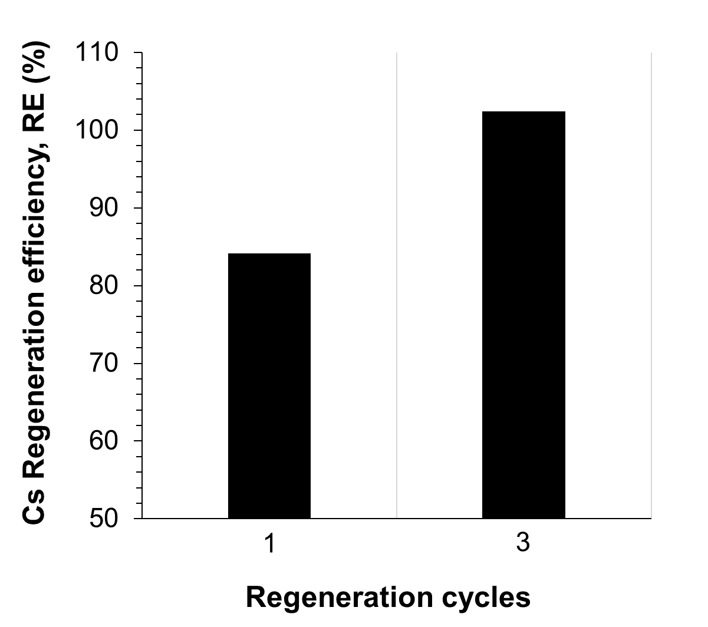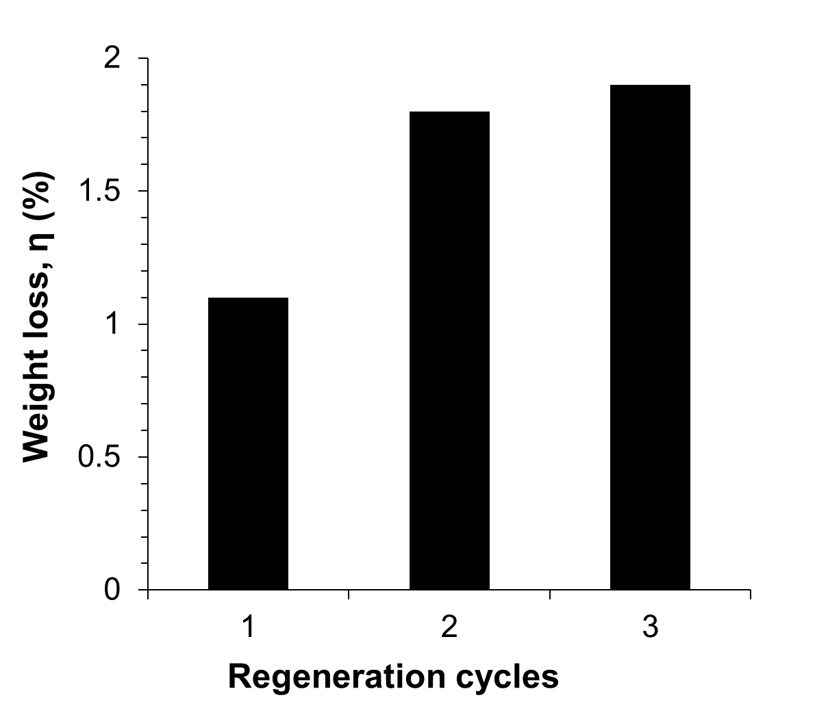
(a) | (b)
Figure 1: Regeneration efficiency (RE) after the first and the third cycles (a). Weight loss percentage (η) in three regeneration cycles (b).
    - Textural change of GAC 830
The nitrogen adsorption isotherms of GAC 830 before and after MW regeneration are reported in Figure 2a. The isotherms show a type I of International Union of Pure and Applied Chemistry (IUPAC) classification, suggesting that structure of GAC 830 is manly microporous. Looking on Figure 2a, the shape of nitrogen isotherm is almost preserved after MW irradiation at 440 W for 3 min. The BET area and Langmuir area of GAC 830 samples before and after MW regeneration are reported in Figure 2b. GAC 830 surface area increased after the third regeneration cycle and it was higher than that before regeneration. As demonstrated by Quan et al. (2004), the increase in specific surface area after several regeneration cycles depends on the AC type and on the chemical characteristics of the adsorbate.
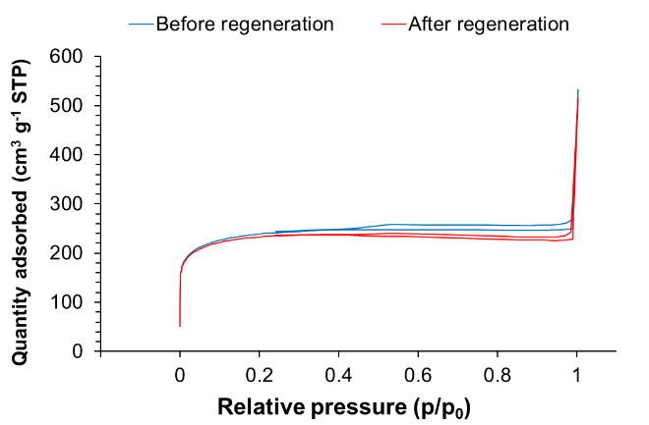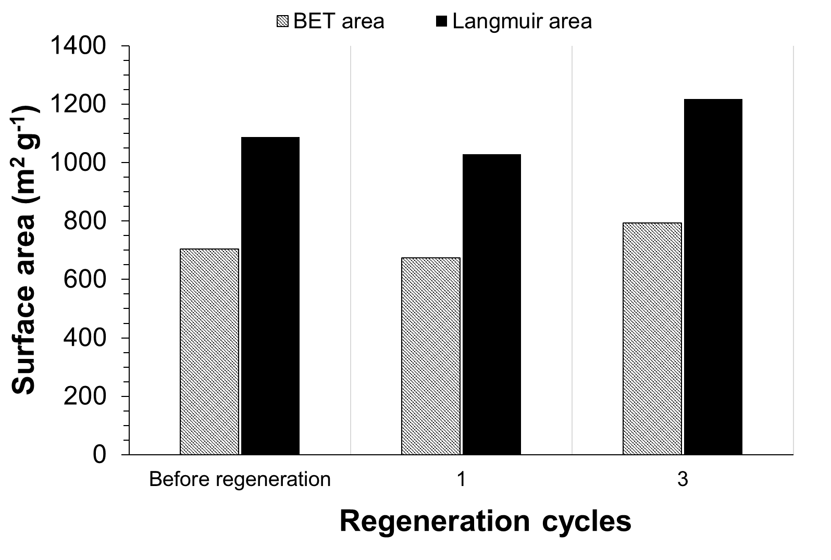
(a) | (b)
Figure 2: Nitrogen adsorption isotherm of GAC 830 samples before and after MW irradiation at 440 W for 3 min (a). Specific surface area (BET area and Langmuir area) of GAC 830 samples before and after MW regeneration (b).
The effect of MW irradiation on pore volume and median pore width of GAC samples was also investigated. Preliminary results show that the median pore width was equal to 0.67 nm and it remains almost constant during regeneration cycles. This proves that the porous structure of AC samples is not modified by MW irradiation. On the other hand, the increasing of pore volume after the 3rd cycle is consistent with the increase of specific surface area.
  - Conclusions
This preliminary study has demonstrated the feasibility of MW irradiation for Cs-saturated activated carbons. MW irradiation effectively restores the adsorption capacity of activated carbon as demonstrated by the increasing of regeneration efficiency after the 3rd cycle. The increasing in BET area and the reasonable weight loss percentage (less than 2%) demonstrate that MW irradiation is an alternative regeneration technique. Moreover, MW regeneration preserves the porous structure of activated carbon as demonstrated by comparing the textural properties of AC samples before and after regeneration cycles. Despite a low adsorption capacity obtained in the present study, the feasibility of activated carbon is strictly linked to its dielectric nature which allows a very efficient thermal regeneration by microwave. Moreover, adsorption capacity of GAC 830 could be increased by means of chemical synthesis and by mixing with other materials (i.e. chabazite). Overall, further investigations on more adsorption-regeneration cycles or using fixed-bed columns are required in order to better explore the applicability of MW regeneration also at a larger scale.
References
Ania, C.O., Menéndez, J.A., Parra, J.B., Pis, J.J., 2004, Microwave-induced regeneration of activated carbons polluted with phenol. A comparison with conventional thermal regeneration, Carbon, 42, 1377–1381.
Ania, C.O., Parra, J.B., Menéndez, J.A., Pis, J.J., 2007, Microwave-assisted regeneration of activated carbons loaded with pharmaceuticals, Water Research, 41, 3299–3306.
Awual, M.R., Suzuki, S., Taguchi, T., Shiwaku, H., Okamoto, Y., Yaita, T., 2014, Radioactive cesium removal from nuclear wastewater by novel inorganic and conjugate adsorbents, Chemical Engineering Journal, 242, 127–135.
Caccin, M., Giacobbo, F., Da Ros, M., Besozzi, L., Mariani, M., 2013, Adsorption of uranium, cesium and strontium onto coconut shell activated carbon, Journal of Radioanalytical and Nuclear Chemistry, 297, 9–18.
De Guidi, G., Falciglia, P.P., Catalfo, A., De Guidi, G., Fagone, S., Vagliasindi, F.G.A., 2017, Soil contaminated with PAHs and nitro-PAHs: contamination levels in an urban area of Catania (Sicily, southern Italy) and experimental results from simulated decontamination treatment, Clean Technologies and Environmental Policy, 19, 1121–1132.
De Haro-Del Rio, D.A., Al-Joubori, S., Kontogiannis, O., Papadatos-Gigantes, D., Ajayi, O., Li, C., Holmes, S.M., 2015, The removal of caesium ions using supported clinoptilolite, Journal of Hazardous Materials, 289, 1–8.
Falciglia, P.P., Cannata, S., Pace, F., Vagliasindi, F.G.A., 2013, Stabilisation / solidification of Radionuclides Polluted Soils : a Novel Analytical Approach for the Assessment of the γ - radiation Shielding Capacity, Chemical Engineering Transactions, 32, 223–228.
Falciglia, P.P., Catalfo, A., Finocchiaro, G., Vagliasindi, F.G.A., Romano, S., De Guidi, G., 2018a, Microwave heating coupled with UV-A irradiation for PAH removal from highly contaminated marine sediments and subsequent photo-degradation of the generated vaporized organic compounds, Chemical Engineering Journal, 334, 172–183.
Falciglia, P.P., Puccio, V., Romano, S., Vagliasindi, F.G.A., 2015, Performance study and influence of radiation emission energy and soil contamination level on γ-radiation shielding of stabilised/solidified radionuclide-polluted soils, Journal of Environmental Radioacticity, 143, 20–28.
Falciglia, P.P., Roccaro, P., Bonanno, L., De Guidi, G., Vagliasindi, F.G.A., Romano, S., 2018b, A review on the microwave heating as a sustainable technique for environmental remediation/detoxification applications, Renewable and Sustainable Energy Reviews, 95, 147–170.
Foo, K.Y., Hameed, B.H., 2012, A cost effective method for regeneration of durian shell and jackfruit peel activated carbons by microwave irradiation, Chemical Engineering Journal, 193–194, 404–409.
Honda, M., Okamoto, Y., Shimoyama, I., Shiwaku, H., Suzuki, S., Yaita, T., 2017, Mechanism of Cs Removal from Fukushima Weathered Biotite by Heat Treatment with a NaCl-CaCl2 Mixed Salt, ACS Omega, 2, 721–727.
Khandaker, S., Kuba, T., Kamida, S., Uchikawa, Y., 2017, Adsorption of cesium from aqueous solution by raw and concentrated nitric acid-modified bamboo charcoal, Journal of Environmental Chemical Engineering, 5, 1456-1464.
Li, W., Wang, X., Peng, J., 2014, Effects of microwave heating on porous structure of regenerated powdered activated carbon used in xylose, Environmental Technology, 35, 532–540.
Liu, X., Chen, G.R., Lee, D.J., Kawamoto, T., Tanaka, H., Chen, M.L., Luo, Y.K., 2014, Adsorption removal of cesium from drinking waters: A mini review on use of biosorbents and other adsorbents, Bioresource Technology, 160, 142–149.
Munthali, M.W., Johan, E., Aono, H., Matsue, N., 2015, Cs+ and Sr2+ adsorption selectivity of zeolites in relation to radioactive decontamination, Journal of Asian Ceramic Societies, 3, 245–250.
Quan, X., Liu, X., Bo, L., Chen, S., Zhao, Y., Cui, X., 2004, Regeneration of acid orange 7-exhausted granular activated carbons with microwave irradiation, Water Research, 38, 4484–4490.
Sun, Y., Zhang, B., Zheng, T., Wang, P., 2017, Regeneration of activated carbon saturated with chloramphenicol by microwave and ultraviolet irradiation, Chemical Engineering Journal, 320, 264–270.
Tan, K.L., Hameed, B.H., 2017, Insight into the adsorption kinetics models for the removal of contaminants from aqueous solutions, Journal of the Taiwan Institute of Chemical Engineers, 74, 25–48.
Tran, H.N., You, S.J., Hosseini-Bandegharaei, A., Chao, H.P., 2017, Mistakes and inconsistencies regarding adsorption of contaminants from aqueous solutions: A critical review, Water Research, 120, 88–116.
Vanderheyden, S.R.H., Van Ammel, R., Sobiech-Matura, K., Vanreppelen, K., Schreurs, S., Schroeyers, W., Yperman, J., Carleer, R., 2016, Adsorption of cesium on different types of activated carbon, Journal of Radioanalytical and Nuclear Chemistry, 310, 301–310.
Yang, Z., Yi, H., Tang, X., Zhao, S., Yu, Q., Gao, F., Zhou, Y., Wang, J., Huang, Y., Yang, K., Shi, Y., 2017, Potential demonstrations of “hot spots” presence by adsorption-desorption of toluene vapor onto granular activated carbon under microwave radiation, Chemical Engineering Journal, 319, 191–199.
Yuen, F.K., Hameed, B.H., 2009, Recent developments in the preparation and regeneration of activated carbons by microwaves, Advances in Colloid and Interface Science, 149, 19–27.
Zanella, O., Tessaro, I.C., Féris, L.A., 2014, Desorption- and decomposition-based techniques for the regeneration of activated carbon, Chemical Engineering Technology, 37, 1447–1459.
Zhang, H., Tangparitkul, S., Hendry, B., Harper, J., Kim, Y.K., Hunter, T.N., Lee, J.W., Harbottle, D., 2019, Selective separation of cesium contaminated clays from pristine clays by flotation, Chemical Engineering Journal, 355, 797–804.

