 CHEMICAL ENGINEERING TRANSACTIONS  VOL. | A publication of  
The Italian Association
of Chemical Engineering
Online at www.aidic.it/cet
Guest Editors:
Copyright © AIDIC Servizi S.r.l.
ISSN 2283-9216

Influence of polymer electrospun nanofibers on thermal properties of epoxy resins
Sabina Alessi*, Maria Di Filippo, Clelia Dispenza
Università degli Studi di Palermo, Dipartimento di Ingegneria (DIING)
Viale delle Scienze 90128, Palermo, Italy sabina.alessi@unipa.it

Electrospinning of polymers has gained surging interest in the last decades due to its wide range of applications in different fields, such as sensors, electronic devices, separation systems, biomedical materials. Still there are only few reports on the use of these nanofibers as reinforcement in polymer composites. In this paper, solution electrospinning was employed to produce nanofibrous mats impregnating two epoxy resins to form “monolayer“ systems, with the aim to study the influence of the nanofibers on both the curing behaviour and the morphology of the resin systems. Three polymers were chosen for producing electrospun mats, a polysulfone (PSF), a polyamide Nylon 6,6 (Ny66) and a polyacrilonitrile (PAN). The nanofibrous mats were employed to produce mat/epoxy monolayers by soaking the mat in two different epoxy resin systems, one in lab-synthesized-high performance, and the other commercial-low performance.
The results show a different extent of swelling of the electronspun mats, as derived by morphological analysis. The observation of the fractured surfaces also indicates the formation of several fracture planes or phase separation phenomena, suggesting the possibility of dissipation of fracture energy by the epoxy/mat nanocomposites. Additionally, for all resin/mat arrangements, thermal analysis indicates no significant interference of the mat with the cure reactions of the resins and only slight changes of the glass transition temperatures.
  - Introduction
The use of electrospinning process for the production of polymeric nanofibers has gained raising attention in the last decades due to their very high surface area to volume ratio, which gives them unique properties in several applications, such as filtration (Gopal at al., 2006), tissue engineering (Peng et al. 2016, Lee et al., 2018), electronic devices and nanocomposite materials (Liu et al., 2005; Wang et al. 2017, Cai et al., 2019). Dzenis (2008) firstly reported the use of nanofibres to reinforce carbon fibre composite laminate and together with Reneker (Dzenis and Reneker, 2001) presented a patent for the production of polymeric nanofibers by electrospinning. Since then, many papers were published on the use of electrospun nanofibers in polymeric systems, but the research papers on their application as reinforcement in polymer composite laminates are still limited. It is well known that delamination (interlaminar cracking) in a laminate composite component is one of most dangerous failure modes (Drzal and Madhukar, 1993). Delamination takes place when a crack develops and propagates between two consecutive plies (the interlaminar region) usually filled with a thermosetting resin that is a brittle material, which, once cracked, allow the delamination to propagate rapidly. In order to reduce delamination of composite laminates several strategies are pursued, consisting in the use of additional reinforcing agents, such as through-thickness reinforcement (stitching or z-pin) (Dransfield, 1994; Mouritz, 2007), nanotubes (Zhu et al, 2007; White and Sue, 2012) or polycarbonate films (Qian et al, 2018). Improvement of damage resistance with electrospun nano-interlayers can be a very promising and cost-effective approach. Different polymers have been used to produce such nano-interlayers. Li et al. (2008) compared the toughening effect of polysulfone (PSU) electrospun nanofibers with that of PSU films in carbon-fiber-reinforced laminates, while Magniez et al (2010) used electrospun poly(vinylidene fluoride) (PVDF) nanofibres to toughen an epoxy matrix composite. Cicala et al. (2018) used electrospun soluble veils from blends of polyethersulfones (PES) with different molecular mass for toughening carbon ﬁber/epoxy prepreg composites and studied the effect of the molecular mass on both the morphology and thermo-mechanical properties of the composites. They compared two kinds of laminates, one with PES powder pre-dissolution in the resin and the other with PES veils placed within the pre-preg laminate. Evidence of dissolution and phase-separation phenomena of the nanofibrous veils were reported for low molecular mass of thermoplastic and traces of undissolved fibers at high molecular mass were detected. Also the glass transition temperatures resulted differently affected by both the two arrangements and molar masses used. Improvements of both fracture toughness and interlaminar shear strength were observed with electrospun Nylon 66 nanofiber mats placed in the mid-plane of carbon fiber/epoxy composite laminates (Alessi et al, 2015 a) together with a decrease of water uptake when samples were immersed in water at 90°C (Di Filippo et al., 2016). As well described in the review of Palazzetti and Zucchelli (2017), although a large number of papers published on the use of electrospun nanofibers for reinforcing purposes, the toughening mechanism of the polymer matrix exerted by the electrospun nanofibers is not yet fully clarified due to the large number of variables that has to be taken into account (electrospun process parameters, compatibility resin/nanofibers, ambient conditions, etc.) which makes also difficult the repeatability of the manufacturing of the interleaved composites.
In this work a preliminary investigation on the role played by different electrospun mats on both the curing behaviour and the morphology of epoxy resin systems was performed, in order to get more information on the possibility to use them as means to increase the thermo-mechanical performance of carbon fiber/epoxy composite laminates. To this purpose, two model epoxy resin systems were selected, one synthesized-high performance, having high Young’s modulus and glass transition temperature, and the other commercial-low performance. Three different nanofiber mats were produced by electrospinning of the solutions of three polymers: Nylon 6,6 (Ny66), polyacrilonitrile (PAN), polysulfone (PSU). They were impregnated by the two epoxy resin systems and cured with a suitable curing cycle, under pressure, for producing different epoxy/electrospun nanofibers monolayers. The influence of the nanofibrous mats on both the thermal and morphological characteristics of the different epoxy/mat arrangements was investigated by Differential Scanning Calorimetry (DSC) and by Scanning Electron Microscopy (SEM), respectively. The synthesized resin chosen in the present study was the same used as matrix of carbon fiber reinforced laminates, in the before mentioned work (Alessi et al, 2015 a), by some of the authors. In this last work Nylon 6,6 electronspun nanofibers were already employed as interleaved membranes in carbon fiber/epoxy laminates and the results were very promising for the improvement of the delamination fracture toughness of carbon fiber laminates, since an increase of G_{IC initial} of 23% (Mode I crack opening on DCB samples) was obtained.

2. Experimental
2.1 Resin systems
A commercial epoxy resin SX10 EVO and type M (medium) amine hardener, having low transition temperature (hereafter named LPE, low performance epoxy resin), were purchased by Mates Italiana s.r.l. The synthesized epoxy resin (HPE, high performance epoxy resin), at high glass transition temperature, consisted of a blend of a tetrafunctional monomer, Tetraglycidylether of 4,4’diaminodiphenyl methane (TGDDM), a bifunctional monomer, bisphenol A diglycidyl ether (DGEBA), and an amine curing agent, 4,4’ diaminodiphenyl sulfone (DDS). All the components of the HPE system were supplied by Sigma Aldrich (Italy).
LPE resin, prepared at a 100:26 monomer to hardener weight ratio, was cured at room temperature for 8 hr, followed by a post-cure at 60 °C for 24 h, as recommended by the supplier (Alessi et al. 2015 b). HPE resin blend was prepared and cured at high temperature, as already described in (Alessi et al. 2015 a).
Three point bending test (EN ISO 178-2003 standard), Dynamic Mechanical Thermal Analysis (DMTA) and fracture toughness tests (ASTM D5045-96 standard) were performed on the two neat resin panels. The glass transition temperature derived by the temperature correspondent to the peak of the loss factor of DMTA analysis, the flexural modulus E_{f} and the fracture toughness (in terms of critical stress intensity factor K_{IC}) derived by the above mentioned mechanical tests, were determined and their values are reported in Table 1.

Table 1: Properties of the neat resin panels
System | T_{g}  (°C) | E_{f}  (GPa) | K_{IC}  (MPa*m^{0.5})
LPE | 90 | 2.9±0.12 | 0.68±0.04
HPE | 215 | 3.7±0.13 | 0.56±0.06

2.2 Electrospun nanofiber mats
Three different polymers were used for the production of electrospun polymer mats: Nylon 6,6 (ZytelVR E53 NC010) supplied by DuPont , Polyacrilonitrile (PAN), supplied by Scientific Polymer Product Inc., Polysulfone (PSU, Mn=22000), supplied by Sigma Aldrich. Formic acid (FAc), chloroform (CLF) Dimethylformamide (DMF), N,N-dimethylacetamide (DMAc) , acetone (Ac), by Sigma Aldrich, were used as solvents for the electrospinning process.Nanofibrous mats were produced by using an electrospinning apparatus, composed of a high voltage power supply, a syringe pump and a 10 ml disposable syringe. As collector aluminum foils were used.

Table 2 : Electrospinning parameters. C: concentration solution;
V: electric voltage; Q: flow rate; TCD: spinneret tip-collector distance
Polymer | Solvent | C [%w/v] | V [KV] | Q [mL/h] | TCD [cm]
Ny66 | FAc/CLF (50/50%v/v) | 14 | 22 | 0.3 | 10
PAN | DMF | 8 | 19 | 0.9 | 20
PSU | DMAc/Ac (90:10 v/v) | 26 | 17 | 1.5 | 17

The polymeric solution was prepared stirring at room temperature, until complete dissolution of the polymer in the corresponding solvent. In Table 2 the electrospun process parameters are reported for each polymer solution. The thickness of mats, averaged on ten measurements, was taken by a micrometer.

2.3 Epoxy resin/electrospun nanofiber mat monolayer
The monolayers were produced by manual impregnation of the mat with the resin, removing the excess of resin by rolling the monolayer between two release films and applying the thermal cure cycle of the corresponding neat epoxy resin. The curing process was performed in autoclave, at a pressure of 2.5 atm. As a result of the manual impregnation and curing of the monolayer, the mat showed different swelling degrees and, hence, different thicknesses of the resin/mat region, that was evaluated by means of SEM images analysis (see Figure1). The reported data are the average of three independent measurements.

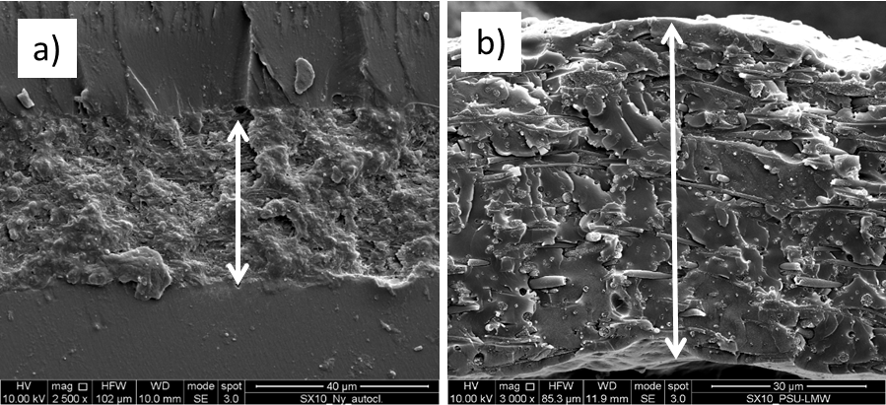
Figure 1: examples of SEM micrographs of fractured monolayers for the determination of the thickness of the mat/resin region. a) LPE/ Ny66 monolayer; b) LPE/PSU monolayer
2.4 Characterizations
Differential Scanning Calorimetry (DSC) analysis was performed on uncured resin, electrospun mats and uncured resin/mat samples, by a Perkin Elmer Precisely Jade calorimeter. The tests were carried out at a heating ramp of 10°C/min from room temperature to about 350°C, under nitrogen flow. Heat flow, normalized to sample weight, against temperature was recorded. For monolayer samples, the curing reaction heat was calculated taking into account the weight fraction of resin in the specimen.
Fractured surface morphology was observed by means of a Philips 505 Quanta 200 field-emission. The samples were mounted on SEM aluminium stubs by means of graphite adhesive or silver glue. Before testing, all the analysed surfaces were gold sputtered, in order to make them conductive.
3. Results and Discussion
SEM observation of the fractured transversal surfaces of the monolayers is very important for evaluating the mat swelling due to nanofibers dissociation for the prevalence of polymer-resin interactions over polymer-polymer interactions, as well as for observing the occurrence of indented surfaces, suggesting eventual toughening mechanism through energy dissipation phenomena.
For both LPE and HPE resins, SEM morphologies of the fractured monolayers produced with the three different mats are shown in Figure 2, together with the micrographs of the corresponding electrospun mats. For LPE resin, in all systems the nanofibers are clearly visible but the fracture surfaces show quite different morphologies. In fact, while in LPE/Ny66 monolayer the nanofibers are tightly interconnected to the resin with a marked corrugated surface, for both PAN and PSU the nanofibers seem to be more diluted in the matrix, giving rise to smoother surfaces, indication of a more brittle nature of the monolayers.
In Table 3 the characteristics of the LPE monolayers are reported in terms of nature of components and weight percent of mat; the relative thickness of the mats, resin/mat regions and monolayers are also indicated. The data point out that in the case of Ny66 the mat almost maintains its original thickness and is confined within two resin layers, sandwiched between two resin layers, as also Figure 1a shows. The low degree of mat swelling points to a situation where the resin is not significantly retained by the mat upon cure and diffuses out the mat; for PAN a partial swelling is observable and for PSU the swelling is complete (see also Figure 1b). Then in these last two cases, the nanofibrous mats result more dilute in the epoxy matrix and this could be the reason why the surfaces do not show traces of marked corrugation reasonably referable to the occurring of toughening mechanisms. For HPE resin with all the three mats, we observe the presence of the mat throughout the thickness of the monolayer (Table 3 and Figure 2c” for PSU). The SEM micrographs for HPE monolayers show in the case of both Ny66 and PAN that the nanofibres survive to the curing process and appear randomly distributed and strongly bound to the matrix (Figure 2 a”,b”). For both systems different fracture planes are noted, indicating that probably toughening effects were developed. A different behaviour can be observed for the PSU mat (Figure 2 c”) which gives rise to the formation of micro-particles, due to the occurrence of phase separation phenomena during the curing process of the resin upon high temperature. In the case of LPE resin the presence of PSU mat didn’t show a similar feature, since the cure temperature of the resin is lower than the activation temperature of separation phase phenomena. The thermograms of DSC analysis are reported in Figure 3a-b for all the investigated systems.

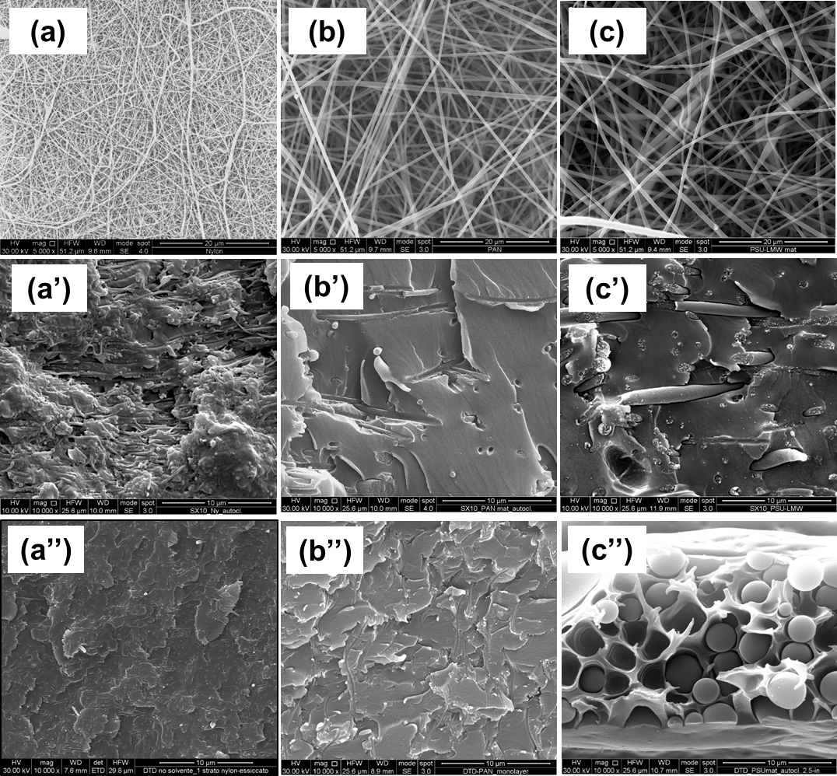
Figure 2: SEM morphologies: a) Ny66 electrospun mat; b) PAN electrospun mat; c) PSU electrospun mat; a’) LPE/Ny66 monolayer; b’) LPE/PAN monolayer; c’) LPE/PSU monolayer; a’’) HPE/Ny66 monolayer; b’’) HPE/PAN monolayer; c’’) HPE/PSU monolayer

In particular Figure 3a shows the calorimetric behaviour of the three mats, as obtained from electrospinning. It is well distinguishable the exothermic reaction peak of PAN at about 300°C due to the rapid free radical ring-closing of adjacent nitriles along the polymer chains to form conjugated carbon-nitrogen sequences. Ny66 mat shows the endothermic peak of fusion of the polymer (263°C), while no significant thermal events are detectable for PSU mat. In the same Figure 3a the thermograms of both HPE resin and its corresponding monolayers are shown, while Table 4 reports both the onset and the peak temperatures as well as the enthalpy of cure reactions for the same systems. With respect to the uncured HPE, the cured resin shows a small residual reaction heat (130 with respect to 664 J/g) which is still observable in all its monolayers, with slight differences. The presence of the mat in the cases of either Ny66 or PSU seems to not significantly affect the kinetics of the resin. Conversely, it is noteworthy the behaviour of HPE/PAN monolayer presenting two exothermic peaks. They can be related to the very different peak temperatures of its components (epoxy and PAN) which can give rise to different calorimetric events. The thermograms of the LPE based systems are reported in Figure 3b. Compared to the uncured resin, the cured neat LPE and its relative monolayers evidence no residual reaction heats. These results suggest a complete curing of the resin with almost no interference with the cure reactions by any of the mats. Only slight differences can be observed in the temperature value corresponding to the glass transition, derived from the DSC curves inflection, which is 75°C for the neat LPE resin and about 80°C for the all the monolayers. For LPE/Ny66 the endothermic peak of the Ny66 is detected at 260°C, barely distinguishable at this scale, indication of the presence of a distinguished phase in the monolayer.

Monolayer | W_{mat} % | Thickness mat  [μm] | Thickness mat/resin  [µm] | Thickness monolayer  [µm]
LPE/Ny66 | 2.3 | 36 | 36 | 105
LPE/PAN | 2.0 | 38 | 70 | 177
LPE/PSU | 7.7 | 44 | 65 | 65
HPE/Ny66 | 9.0 | 80 | 140 | 140
HPE/PAN | 8.5 | 38 | 125 | 125
HPE/PSU | 20 | 42 | 16 | 16
System | T_{onset}  [°C] | T_{peak} [°C] | ΔH  [J/g]
HPE uncured | 130 | 273 | 664
HPE cured | 195 | 272 | 130
HPE/Ny66 | 165 | 270 | 126
HPE/PAN | 200 | 264-330 | 111
HPE/PSU | 180 | 274 | 220
Table3 : Characteristics of the produced monolayers. vvbvvbvbTable4 : DSC analysis data.

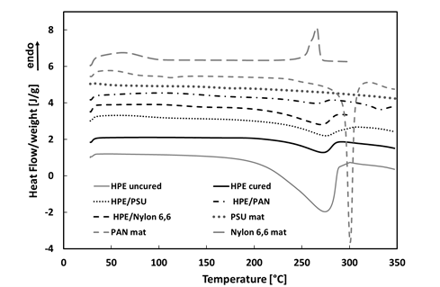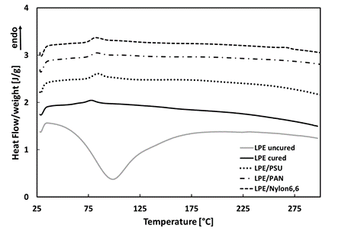
a) b)
Figure 3: DSC analysis. a) electrospun mats, neat HPE and HPE/mats monolayers; b) neat LPE and LPE/mats monolayers.

4. Conclusions
Electrospun Ny66, PAN and PSU nanofiber mats were produced by electrospinning of suitable solutions and then composed in the form of monolayers with two different epoxy resin systems, one commercial-low performance epoxy resin (LPE) and the other synthesized-high performance epoxy resin (HPE). The two lots of monolayers were cured following the curing cycle of the corresponding resin. The aim was to simulate the epoxy/mat layer within a carbon fiber/epoxy laminate modified by electrospun mats as interleaves, for the enhancement of its delamination resistance. For both LPE and HPE resins, SEM morphologies of the fractured monolayers, produced with the three different mats, were investigated and discussed on the basis of the level of mat swelling phenomena, related to nano-fibers/resin interactions. The results indicate for the commercial resin LPE a confinement of the mat between two layers of resin in the case of both PAN and Ny66, while the PSU mat gives rise to a more homogeneous monolayer. In all cases different fracture planes are noted in the resin/mat regions, marker for LPE/Ny66 monolayer. This evidence, although qualitative, suggests the possibility of dissipation of fracture energy by the epoxy/mat nanocomposites, that could result in an increase of the delamination reisistance of the correspondent carbon fiber laminates.For the synthesized HPE resin the mat always increases its thickness up to that of the whole monolayer, indicating a complete swelling of its nanofibrous network. For these systems two typologies of fractured surfaces are observed, one showing indented planes for Ny66 and PAN nanofibers and the the other presenting phase separation phenomena for PSU. The calorimetric analysis indicate a not significant influence of the mats in the residual exothermic heats of the HPE resin and a slight influence on the curing kinetics. For LPE/mat systems only slight difference in the transition can be observed with respect to the neat resin.

References
Alessi S., Di Filippo M., Dispenza C., Focarete M. L., Gualandi C., 2015a, Effects of Nylon 6,6 Nanofibrous Mats on Thermal Properties and Delamination Behavior of High Performance CFRP Laminates, Polymer Composites, 36(7), 1303-1313.
Alessi S., Di Filippo M., Pitarresi G., Scafidi M., Toscano A., 2015b, Fracture Toughness of Hydrothermally Aged Epoxy Systems with Different Crosslink Density, Procedia Engineering, 109, 507-516.
Cai T., Huang M., Huang Y., Zheng W., 2019, Enhanced performance of microbial fuel cells by electrospinning carbon nanofibers hybrid carbon nanotubes composite anode, International Journal of Hydrogen Energy, 44, 3088-3098.
Cicala G., Latteri A., Mannino S:, Ognibene G., Blanco I., Influence of Soluble Electrospun Co-Polyethersulfone Veils on Dynamic Mechanical and Morphological Properties of Epoxy Composites: Effect of Polymer Molar Mass, 2018, Advances in Polymer Technology, 37, 789-809.
Di Filippo M., Alessi S., Pitarresi G., Sabatino M. A., Zucchelli A., Dispenza C., 2016, Hydrothermal aging of carbon reinforced epoxy laminates with nanofibrous mats as toughening interlayers, Polymer Degradation and Stability, 126, 188-195.
Dransfield K., Baillie C., Mai Y.W., 1994, Improving the delamination resistance of CFRP by stitching-a review, Composites Science and Technology, 50 (3), 305-317.
Drzal L.T. and Madhukar M., 1993, Fibre-Matrix Adhesion and its Relationship to Composite Mechanical Properties, Journal of Material Science, 28, 569-610.
Dzenis Y., 2008, Structural nanocomposites. Science 319,419–420.
Dzenis ., Reneker DH., 2001, US patent 6265333.
Gopal R., Kaur S., Ma Z, Chan C., Ramakrishna S., Matsuura T., 2006, Electrospun nanofibrous filtration membrane. Journal of Membrane Science, 281(1-2), 581–586.
Lee J.K.Y., Chena N., Peng S., Li L., Tian L., Thakor N., Ramakrishna S.,2018, Polymer-based composites by electrospinning: Preparation &functionalization with nanocarbons. Progress in Polymer Science 86, 40-84.
Li G., Li P., Zhang C, Yu Y., Liu H., Zhang S., Jia X., Yang X., Xue Z., Ryu S., 2008, Inhomogeneous toughening of carbon fiber/epoxy composite using electrospun polysulfone nanofibrous membrances by in situ phase separation. Composite Science Technology,68, 987–994.
Liu H., Reccius C.H., Craighead H.G., 2005, Single electrospun regioregular poly(3- hexylthiophene) nanofiber field-effect transistor. Applied Physics Letters, 87, 253106.
Magniez K., De Lavigne C., Fox B.L., 2010, The effects of molecular weight and polymorphism on the fracture and thermo-mechanical properties of a carbonfibre composite modified by electrospun poly(vinylidene fluoride) membranes. Polymer, 51(12), 2585-2596.
Mouritz A., 2007, Review of Z-pinned composite laminates, Composites Part A: Applied Science and Manufacturing,38 (12), 2383-97.
Peng S., Jin G., Li L., Li K., Srinivasan M., S.Ramakrishna , Chen J., 2016, Multi-functional electrospun nanofibre fibers for advances in tissue regeneration, energy conversion & storage, and water treatment. Chemical Society Reviews 45(5), 1225-1241.
Qian X., Kravchenko O.G., Pedrazzoli D., Ica Manas-Zloczower., 2018, Effect of polycarbonate film surface morphology and oxygen plasma treatment on mode I and II fracture toughness of interleaved composite
Laminates, Composites: Part A, 105, 138–149.
Wang G., Yu D., Kelkar A. D., Zhang L., 2017, Electrospun nanofiber: Emerging reinforcing filler in polymer matrix composite materials. Progress in Polymer Science, 75, 73-107.
White K. L., Hung-Jue Sue., 2012, Delamination toughness of fiber-reinforced composites containing a carbon
nanotube/polyamide-12 epoxy thin film interlayer. Polymer, 53, 37-42.
Zhu J., Crane R., Imam A., Lozano K., 2007, Processing a glass fiber reinforced vinyl ester composite with nanotube enhancement of interlaminar shear strength. Composites Science and Technology, 67 (7-8), 1509-1517.
Zucchelli A., Palazzetti R., 2017, Electrospun nanofibers as reinforcement for composite laminates materials –
A review, Composite Structures 182, 711–727.

