CHEMICAL ENGINEERING TRANSACTIONS  VOL. 76, 2019 | A publication of
The Italian Association
of Chemical Engineering
Online at www.cetjournal.it
Guest Editors: Sauro Pierucci, Jiří Jaromír Klemeš, Laura Piazza
Copyright © 2019, AIDIC Servizi S.r.l.
ISBN 978-88-95608-73-0; ISSN 2283-9216

Application of Ultrasonic Intensification Technology in Chemical Processes in China
XU Wenlin, DING Yuanqiong, SHAO Qing, WANG Yaqiong
College of Chemistry & Chemical Engineering, Yangzhou University, Yangzhou 225002, China
corresponding. wlxu@yzu.edu.cn
  - Introduction
1.1 The importance of process intensification technologies in chemical processes
Process engineering is the study of the chemical, physical and biological transformation process in physical movement, transfer and reaction and their relations of an engineering science, provide a basis of process industry for social development, including energy, resources, environment, material, pharmaceutical, oil, chemical industry, metallurgy and other pillar industries, and related to emerging areas such as biotechnology, nanotechnology. The task is to create an efficient and clean material conversion process, process/equipment and system to solve key scientific and technological problems in the industrialization process of laboratory achievements.
Typical process in process engineering is chemical process. Chemical industry is the pillar industry of China's national economy, providing important raw materials, materials and products for China's social and economic development. But at the same time, chemical industry is also one of the major sources of industrial pollution and major energy consumption in China. Compared with developed countries, China's chemical industry has practical problems of "high material consumption, high energy consumption and high pollution", which seriously restricts the sustainable development of China's chemical industry.
In order to realize sustainable development, structural adjustment and industrial upgrading and transformation, we must carry out work from the aspects of policy, technology and management in view of the existing problems in chemical industry.
In the mid-1990s, chemical process intensification technologies with the goal of "energy saving, consumption reduction, environmental protection and intensification" appeared internationally, which was listed as one of the three priority areas for the development of chemical engineering in developed countries such as Europe and America ^{[1,2]}.
Chemical process intensification technologies refers to the new technology that significantly increases the mixing, transfer or reaction process rate in the bottleneck process and coordinates with the system, greatly reduces the equipment size of the chemical process, simplifies the process flow, reduces the number of devices, and significantly reduces the unit energy consumption, waste and by-products.
Process intensification is intended for practicing researchers in industry and academia, working in the field of Chemical processes and related to the subject of Process. Intensification technique demonstrate how novel discoveries, developments and theories in the field of Chemical processes and in particular Process.
Intensification may be used for analysis and design of innovative equipment and processing methods with substantially improved sustainability, efficiency and environmental performance. As equipment and plant miniaturization, alternative energy conversion and transport mechanisms, intensified hydrodynamics, structured environments, multi-functionality and intensified plant operation.
1.2 The application of intensification technologies in chemical processes in China
Chemical process intensification technology is regarded as an effective means to address the problems of “high consumption of energy, high pollution and high consumption of raw materials” in chemical industry and is expected to bring significant innovations to the chemical industry. China has shown unique characteristics and advantages in chemical process intensification technology thanks to the fundamental research and technology development in this field for many years. After years of basic research and technological development.
In recent years, the application of new technology in the field of process intensification of research have made progress, especially some of process intensification technology independent research and development in our country after original innovation, theory construction, such as the accumulation of basic research for a long time, then through technology improvement, until finally realize industrial application, in order to promote the development and progress of chemical industry ^{[1-8]}.
Literature [1] summarized the progress of China's typical chemical process enhancement technologies, such as supergravity technology, membrane process coupling technology, micro-chemical technology, magnetic stable bed technology, plasma technology, ionic liquid technology, supercritical fluid technology and microwave radiation technology. Although China's chemical process intensification technologies has made great progress in recent years, there are still some problems that need to be paid attention to that the intrinsic laws of complex systems need to be further understood. There is no perfect theoretical system to guide the development of chemical process intensification technologies. The lack of integration with chemistry, materials, machinery and information also restricts the development of chemical process intensification technologies.
1.3 The application of ultrasonic intensification in Chemical processes in China
Although Literature[1] has reviewed advances in some typical chemical process intensification technologies in China. However, there is not a review about the principle and application of ultrasonic intensification in chemical engineering in China. The progress and industrization of ultrasonic intensification in chemical processes in our country are reviewed to provide a theoretical basis and technical parameters for the application of the technology in chemical processes for the sustainable development of Chinese chemical industry.
2. Principle of application of ultrasonic in chemical processes
Two major principles are used in sono-chemistry or sono-processing used as ultrasonic intensification:
(1) Mechanical effects for mixing and disintegration.
(2) High energy processes for radical reactions.
2.1 Frequency and application of sound waves
Sound waves are mechanical vibrations that must travel through the medium. The application of sound waves for frequency is shown in Fig. 1.
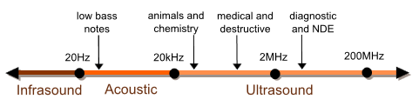
(a) Infrasound, audible sound and ultrasound
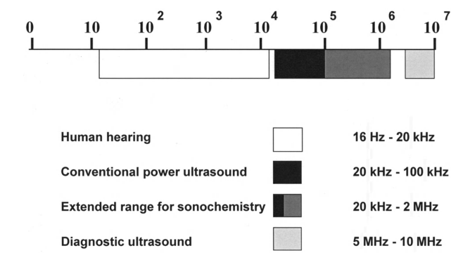
(b) Ultrasound and main application fields
Figure 1 Acoustic frequency domain and application
Ultrasonic wave refers to the sound wave whose frequency is higher than 20 kHz, which is higher than human being can hear. The ultrasonic wave applied in the process intensification refers to the sound wave whose frequency is 20 kHz-100 kHz and has sufficient energy intensity ^{[3-7]}.
Due to the high frequencies, the dynamics of oscillating bubbles create drastic conditions. Temperatures of several thousand Kelvin, extreme heating or cooling rates of 10⁵ K/s, and pressures of up to several hundred mega pascal are observed in a transient cavities while the bulk conditions in the liquid remain at ambient temperature and pressure.
Radiation forces create intense micro and macromixing with high shear forces, which are used in emulsification, homogenization, and fragmentation processes. Asymmetrical bubble oscillations in the vicinity of solid particles lead to liquid micro jets and shock waves, which are used in cleaning, dispersion, activation, and fragmentation of solid materials. Besides the main industrial applications in cleaning, emulsification, and welding, other uses of ultrasound, such as solids processing, crystallization, environmental protection and separation are emerging.
2.2 Effect of ultrasound on microbubbles in liquid phase media
The effect of ultrasound on microbubbles when propagating in liquid phase media is shown in Fig. 2. In the liquid, especially the liquid/solid interface, there are some small bubbles. When the ultrasonic wave of a certain frequency is propagated through the liquid, the small bubbles with appropriate size can generate resonance phenomenon. Bubbles that are larger than the resonant size are driven out of the liquid by ultrasound. Small bubbles, which are smaller than the resonance size, grow gradually under the action of sound waves. When the bubble grows to nearly resonant size, the sparse segment of sound wave causes the bubble to expand rapidly, and then the bubble is suddenly compressed until it is broken^{[2,7]}.
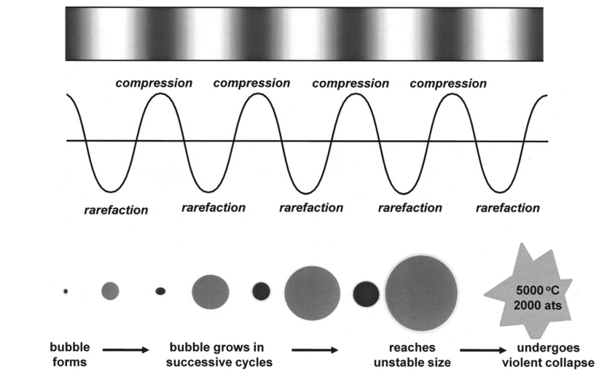
(a) The corresponding relation between the microbubble and the ultrasonic acting

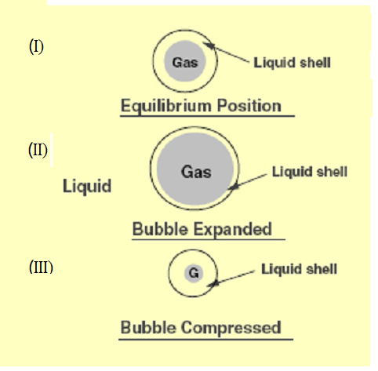
(b) Microbubbles are in three states: equilibrium (I), expansion (II) and compression (III)
Fig. 2 The effect of microbubbles and ultrasonic waves in the liquid phase
When ultrasonic wave propagates in liquid phase, microbubbles in liquid phase vibrate, grow, shrink and even collapse under the action of sound field stretching and compression, as well as the physical and chemical changes caused thereby.
2.3 Effect of microbubble collapse
The effect of microbubble collapse when ultrasound propagates in liquid phase media is shown in Fig.3.When the cavitation bubble collapses, in the very small space around the cavitation bubble, the extremely short time can produce high temperature and high pressure, accompanied by the strong shock wave and/or high-speed jet. These effects, such as high temperature, high pressure, high gradient flow and discharge luminescence, lead to chemical reactions that are difficult to be carried out under normal temperature and pressure, which can occur in local areas and make hard materials crush. Therefore, chemical unit operation can be improved and chemical reaction process can be strengthened. Therefore, it can be seen that ultrasound, like light, electricity and heat, can provide a new and special physical environment for the process to be carried out, thus making the chemical reaction process difficult or impossible in general conditions to be carried out. The frequency and intensity of ultrasonic wave, the characteristics of wave transmission source, the static pressure of the system and the type and content of gas in liquid will affect the cavitation effect of ultrasonic wave.
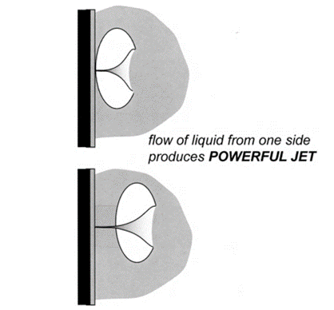
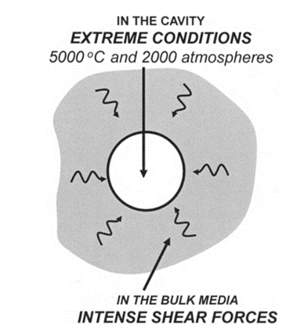
The chemical and physical effects of the microbubble collapse when the ultrasound propagates in the liquid phase medium are shown in Fig. 4. In liquid phase propagation, microbubbles in liquid phase and applied ultrasonic effects.
(a) The effect of microbubble explosion in homogeneous media
(b) The effect of microbubble explosion on the solid/liquid interface
Fig. 3 The effect of microbubble collapse

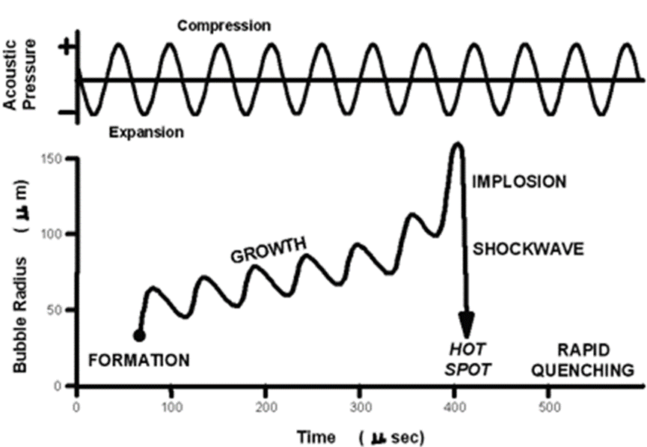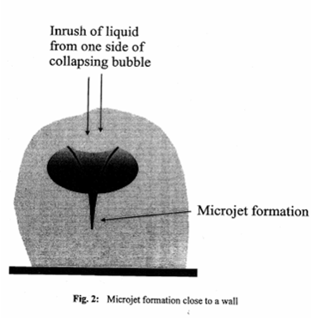
(a) Chemical action of ultrasound (b) Physical effects of ultrasound
Fig.4 Physical and chemical effects of microbubble collapse
(1) Surface renewal: update the solid/liquid interface and the surface to improve the reactivity and the intrinsic kinetic speed.
(2) Increase specific surface area: realize multiphase dispersion, increase the solid/liquid interface, improve the actual area of reaction and transfer, and significantly increase the macro speed of reaction and transfer.
(3) Micro-jet: improve the transfer speed and reduce the thickness of the transfer boundary.
2.4 Affecting parameters in sonochemical applications
Affecting parameters in sonochemical applications are as following^{[2]}.
(1) Vapor Pressure: The vapor pressure of liquids can cushion the bubble collapse like a high gas content. Vapor in a transient bubble can be condensed in the compression cycle and lead to higher cavitation intensities than gas filled bubbles.
(2) Viscosity: High viscosity of a sonicated liquid increases the cavitation threshold markedly. Viscous liquids generate bubbles only at high sound pressures. Bubble motion is damped by the dissipative effect of the viscosity and the smaller maximum bubble radii, and the lower inward wall velocities terminate most sonochemical effects.
(3) Static Pressure: The static pressure in a sound field alters the thresholds for rectified diffusion, transient bubbles and other characteristics.
A high static pressure can prevent the generation of bubbles by ultrasound or create a different size distribution. For a given amount of energy, smaller bubbles with a higher energy content are created, which show very strong erosion activities in heterogeneous systems.
(4) Ultrasonic frequency: The effect of frequency on sonochemical reactions is still an active field of research. Some measurements indicate that different frequency ranges are needed for special reaction types. Low frequencies in the range from 20 to 100 kHz, known as power ultrasound, are mainly active in heterogeneous systems with micro mixing, cleaning, mechanical action on suspended solids and intense bubble motion.
(5) Ultrasonic intensity: The effect of intensity or power input to the ultrasonic device is complicated. Higher intensities provoke a larger amplitude at the vibrating surface in contact with the liquid. At low intensities, a linear dependency between generated sound pressure and amplitude is observed. Raising this intensity above the cavitation threshold of the liquid causes oscillating bubbles, and under certain circumstances the contact between radiating surface and liquid is lost. The motion of the transducer and the liquid are out of phase, an effect known as decoupling. A second reason for the nonlinear relationship between intensity and sonochemical effects is the creation of cavitation zones. Higher intensities create more and larger bubbles, which may coalesce and lead to less transient events.
(6) Temperature: The effect of temperature on sonochemical processes is explained by its influence on viscosity, gas solubility, vapour pressure and surface tension. Any chemical reaction will be influenced by the temperature-dependent reaction rate coefficient. In most cases, cavitation is more pronounced at lower temperatures due to the lower vapour pressure of the liquid. This lowers the total gas content of the collapsing bubbles and causes higher cavitation intensities. This paradoxical temperature dependence is highly pronounced for sonochemical reactions involving radical generation in transient bubbles. Lesser effects are generally observed in heterogeneous systems, where intense micro mixing by oscillating bubbles favours mass and heat transfer.
3. Application of ultrasonic intensification technology in chemical processes
Applications of ultrasound in processing and synthesis are widespread and offer unusual beneficial operating conditions in China. Most sonochemical effects are secondary effects generated by oscillating bubbles. The effects of ultrasound on chemical processes are in most cases secondary effects caused by cavitation and can be divided as following:
Transport phenomena can be intensified by application of unconventional driving forces, such as centrifugal forces, electrical forces, or magnetic forces, as well as by smart combinations of different forces. Reactions and mass transport processes that run under diffusion limitation in liquid phases can be accelerated by application of ultrasound. Enhanced mass and heat transfer by macro and micro mixing. Radiation forces create intense micro and macro mixing with high shear forces, which are used in emulsification, homogenization, and fragmentation processes.
Asymmetrical bubble oscillations in the vicinity of solid particles lead to liquid micro jets and shock waves, which are used in cleaning, dispersion, activation, and fragmentation of solid materials. Besides the main industrial applications in cleaning, emulsification, and welding, other uses of ultrasound, such as solids processing, atomization, crystallization, environmental protection and separation are undisturbed bubbles in liquids show spherical Asymmetric bubble wall motion leads to the formation of an involution, which is directed towards the disturbance. In the late stages of the collapse of a transient bubble, a liquid micro jet breaks through the remote bubble wall and impinges on the boundary.
Nonlinear Effects (bubble collapse near boundaries): Effects caused by nonlinear bubble collapse near boundaries. Undisturbed bubbles in liquids show spherical oscillations in a sound field. Any extended disturbances such as boundaries, suspended solids, or reactor walls in the vicinity of the transient bubble prevent spherical collapse. Typical applications of ultrasound in chemical processes at large scale use in china are as following.
3.1 Mixing of liquid-liquid and dispersion of solids in liquid phases
Typical applications, such as mixing of immiscible liquids, dispersion of solids, particle agglomerates, and pigments, are the homogenization of water-oil mixtures.
Affecting factors were studied in our laboratory supported by supported by the National Natural Science Foundation of China (21076173, 20476087, 20576111 and 20876130) . The liquid-liquid dispersion system is a kind of dispersive system composed of two kinds of non-dissolving liquids. One of the phases consists of a droplet (dispersed phase) and the other is a disperse medium (continuous phase).The most common liquid-liquid dispersion systems are those in which oil is dispersed in water (W/O type) and water is dispersed in oil (O/W type).The liquid-liquid dispersion system is widely used in the fields of chemical industry, energy, food and cosmetics.
In chemical industry, the liquid-liquid dispersion system has been applied in the fuel oil and heating oil are used in oil burners and internal combustion engines. In terms of energy, fuel oil and heating oil are used in oil burners and internal combustion engines. Adding a small amount of water into a liquid-liquid dispersion system can reduce the combustion temperature of oil, which correspondingly reduces the deposition of carbon and ash on the heating surface.
3.2 Emulsification
Nonreactive mixtures of liquids can be mixed by ultrasound. High shear velocities and oscillating and transient bubbles create very intense local conditions, which are employed for homogenization or emulsification. Many industrial processes in the food and drug industries use a probe-type ultrasonic emulsifier.
Droplets formed from the collapse of waves have a diameter about the same size as the wavelength itself. Typical process parameters in emulsification lead to about 2-50 micron of droplets.
In cosmetics, the application of the liquid-liquid dispersion system makes the active ingredients in cosmetics easier to penetrate into the skin, economical and easy to use in China.
3.3 Extraction of solid-liquid (Leaching) and Extraction of liquid-liquid
Ultrasonic extraction processes from plants are used in research as well as on an industrial scale. The ultrasonic extraction equipment are mainly manufactured in Jingning, Shandong Province. The Ultrasonic Extraction Plants (Leaching) are mainly in Sichun, ChongQing, and Yuannan, etc. Application of ultrasonic extraction for Chinese herbal medicine preparation are operated on an industrial scale. The normally lower temperatures allow very mild processing with high yields.
Ultrasound—assisted Extraction (MAE) of Effective Compounds from Traditional Chinese Herbal Medicine. Comparing MAE with conventional methods, the former can save the extracting time and increase the content of the active ingredients in product. Optimized by uniform designate was proved to be an effective and novel process for extracting active ingredients in natural products.
Extraction of liquid-liquid separation of rare earth processes enhanced by ultrasound is also a successful example conducted in Changzhou.
3.4 Crystallization
The application of ultrasound influences the nucleation, agglomeration, and growth of particles within the liquid phase. The main aim of the application of ultrasound in crystallization is the formation of a narrow particle size distribution the sonication induces the homogenous nucleation in the sonicated volume. The nuclei are supposed to be of the same size, which is an advantage to the conventional seeded crystallization, which uses a seed suspension.
Power ultrasound promotes and improves nucleation and growth of crystals by cavitation bubbles, the disruption of seeds, and the breakage of larger crystals. There is some evidence that the sonication of supersaturated solutions leads to creation of highly uniform nucleation sites by disturbing the metastable equilibrium. The enhanced micro mixing avoids non-uniform concentration gradients in the solution. Further on, sonocrystallization is applied to control the shape and structure. This plays an important role in the field.
3.5 Heterogeneous reactions
Ultrasound waves can be applied to activate chemical reactions in liquid-phase systems. The mechanism is mainly based on the phenomenon that the exposure of a liquid to ultrasound results in the formation, growth, and subsequent collapse of microbubbles in a very short period of time, typically several hundred microseconds.
Mass transport and heat transport processes can be also intensified by ultrasound. For complex reactions, the main reaction rate can be selectively accelerated, the side reaction can be suppressed and the yield of the target product can be increased.
In heterogeneous solid-fluid reactions, asymmetrical bubble collapse creates shock waves and liquid micro jets. These are responsible for particle fragmentation, pitting, and cleaning of the solid. Microstreaming, shock waves, and liquid micro jets in the vicinity of solid surfaces lead to very efficient cleaning and surface renew. This effect has been used in industry for more than forty years. Insoluble layers of inorganic salts, polymers, or liquids can be removed by ultrasonic cleaning effect. In heterogeneous systems such a clean reactive surface leads to improved dissolution rates of metals in acids and enhanced reaction rates. The Grignard reactions, have found industrial utilization in China.
3.6 Application of ultrasonic strengthening technology in the electrochemical process
Ultrasound can not only be applied for the improvement of chemical reaction rates, but also for intensification of mass transfer in multiphase systems. The most important affecting factors for mass transfer enhancement were found to be the chemical composition of the liquid phase, the volumetric energy dissipation rate, and the distance between the ultrasonic source, i.e. the transducer and the gas sparger of the reactor. Similarly, liquid–solid mass transfer rates were increased by assistance of high frequency ultrasound. The postulated mechanisms of ultrasound enhancement are the reduction of the boundary layer thickness due to the micro-scale turbulence and the reduction of the viscosity in the boundary layer.
The electrochemical reaction process is a typical solid/liquid catalytic reaction process. The process of electrochemical reaction is shown in Fig. 5. The charge transfer is realized by the reactant reaction on the electrode surface, and the product of charge transfer is transferred from the electrode surface to the liquid phase body, or is precipitated in the electrode deposition.
The main mechanism of ultrasonic intensification is electrolytic surface renewal, enhancement of mass transfer and regulation of product deposition and crystallization.
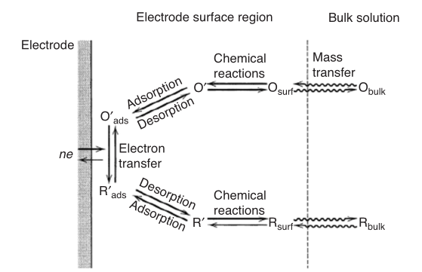
Fig. 5 Application of ultrasound enhancement technology in electrochemical reactions

Avoidance of mass transport limitations, electrode fouling, change in reaction pathways, cleaning and activating of electrode surface in aqueous and nona-queous media.
Deposition of Metals. Acoustic microstreaming and transient events can aid the deposition of metals in electroplating processes ^{[8]}. The very high mixing efficiency in cavitating sound fields is used to destroy the polarization barrier surrounding the electrode. Constant mechanical treatment by transient bubbles leads to surface hardening, less porosity, better brightness and to very good adhesive deposits for a variety of metals, including copper and gold.
Fig. 6 shows the effect of ultrasound on the structure of electrochemical deposition products of copper. Particle Disruption. Brittle solids can be cleaved by transient cavities. Like in milling operations, this leads to higher specific surfaces, high energy content at the disrupted site, and reactive fresh surfaces. Because of the tiny bubble size, very small particles in the micrometer range can be produced ^{[9]}.
A fine zinc powder (10kg/h Zn) workshop by cathodic deposition intensified by ultrasound was set up in Yangzhou, Jingsu Province. The production of powder is an effective way to develop the zinc source and to increase the added value of zinc.
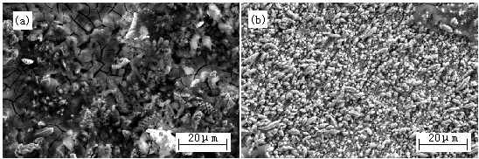
Fig. 6 Application of ultrasonic intensification technology in electrochemical reaction process
The main effects of ultrasonic in electrochemical deposition include electrode surface renewal, enhancement of mass transfer and control of metal crystal growth. The shock wave produced by the "mini bomb" produced by ultrasonic cavitation can penetrate into the surface and interstices of different electrode medium, so that the electrode surface can be thoroughly cleaned and updated. In electrochemical deposition, hydrogen is often accompanied by the generation of hydrogen, which can easily cause speckle and fringe. However, the ultrasonic cavitation allows hydrogen to enter the cavitation bubble or as the cavitation core, which accelerates the precipitation of hydrogen. The high-speed micro-jet produced by ultrasonic cavitation strengthens the stirring of the solution, strengthens the mass transfer capacity of the ions, reduces the thickness of the dispersion layer and concentration gradient, reduces the polarization of the solution, speeds up the electrode process, and optimizes the electrochemical deposition conditions. In addition, in the process of co-deposition of metal ions in the cathode, ultrasonic wave can break agglomerate granules, and promote the uniform distribution of granules in the sediment layer. Based on the above effect of ultrasonic wave, the grains of the sedimentary layer prepared by the method of ultrasonic electrochemical deposition were refined, and various properties were enhanced. Therefore, the introduction of ultrasonic wave in the electrochemical co-deposition process can effectively increase the nucleation rate of electrocrystallization, reduce the growth rate of grains and refine the grain structure.
4. Future development activities in ultrasonic intensification in chemical processes
Despite very valuable scientific works on sonochemical reactor scale-up, design, and operation have been carried, large-scale industrial process applications are rare. Although the ultrasonic intensification has been applied in the process of processes, such as oil-water mixing, oil-water mixing separation, leaching, crystallization and cleaning, future research and development activities in ultrasonic intensification in chemical processes in China are as follows:
4.1 The basic application principle and mechanism of ultrasonic intensification
The basic application principle and mechanism of ultrasonic intensification in chemical processes need to be further studied, and the affecting factors and laws to improve the enhancement efficiency need to be further systematically studied.
Application principle and mechanism of the chemical processes of ultrasonic intensification: carry out systematic research to further understand the principle and mechanism of the chemical processes of ultrasonic intensification, and influence sensitive parameters of the process. Affecting laws of the chemical processes of ultrasonic intensification: affecting factors and rules of the chemical processes of ultrasonic intensification. In particular, the quantitative data affecting the process and the quantitative rules are obtained.
4.2 Investigation of reliable measurement method of ultrasonic intensity and assessment sonic effects
Despite obvious process intensification effects caused by acoustic cavitation, the proposed technical solutions are either not reliable enough or not economically feasible to apply them on the large-scale. Readily available laboratory equipment such as ultrasonic baths, high-intensity disintegrator horns, and cup horn reactors are used to measure sonochemical effects.
The mapping of sononochemical reactors shows the intensity distribution of the pressure field within the reactor volume. This knowledge is essential, because most sonochemical effects need a minimum intensity of the ultrasound field. In the remaining reactor volume, where the sound intensity is too low, undesired side reactions can occur, decreasing the product quality, have to address specific design problems of sono-chemical apparatuses, namely the adjustment of geometries to the penetration depth of the applied acoustic waves, and the control of equipment erosion due to micro-bubble cavitation.
The electric-acoustic conversion efficiency and operational stability of ultrasonic transducer need to be further improved, in particular, a new material with both ultrasonic and corrosion resistance should be developed.
4.3 Research new material for ultrasonic emitters to the customers’ special application requirements
A transducer is a device that converts electrical energy to mechanical energy, in the form of sound. The main components are the active element, backing, and wear plate.
The active element, which is piezo or ferroelectric material, converts electrical energy such as an excitation pulse from a flaw detector into ultrasonic energy. The most commonly used materials are polarized ceramics which can be cut in a variety of manners to produce different wave modes. New materials such as piezo polymers and composites are also being employed for applications where they provide benefit to transducer and system performance.
The backing is usually a highly extenuative, high density material that is used to control the vibration of the transducer by absorbing the energy radiating from the back face of the active element. When the acoustic impedance of the backing matches the acoustic impedance of the active element, the result will be a heavily damped transducer that displays good range resolution but may be lower in signal amplitude. If there is a mismatch in acoustic impedance between the element and the backing, more sound energy will be reflected forward into the test material. The end result is a transducer that is lower in resolution due to a longer waveform duration, but may be higher in signal amplitude or greater in sensitivity.
The basic purpose of the transducer wear plate is to protect the transducer element from the testing environment. In the case of contact transducers, the wear plate must be a durable and corrosion resistant material in order to withstand the wear caused by use on materials such as steel or titanium. For immersion, angle beam, and delay line transducers the wear plate has the additional purpose of serving as an acoustic transformer between the high acoustic impedance of the active element and the liquid, the wedge or the delay line all of which are of lower acoustic impedance.
Thus research new material for ultrasonic transducers that must be designed as a durable and corrosion resistant material of long life and optimum operating performance. Ultrasonic emitters can be carried out by the use of a probe-type ultrasonic homogenizer or an ultrasonic bath or an Immersed transmitters. The experimental results show that probe-type ultrasonic devices have a high localized intensity compared to tank-type and hence, greater localized effect. This means a higher intensity and efficiency of the sonication process. However, high-power ultrasonic emitters are used in commercially available ultrasonic devices, the corrosion is serious.
4.4 Transducer Technology for Large-Scale ultrasonic Equipment
Ultrasound transducers create the high frequency vibrations which are submitted into the liquid. Two major types of transducers are used for liquids: liquid-driven and electromechanical. Electromechanical transducers are the most used and based on piezoelectric or magnetostrictive principles.
Both transducers need a high frequency generator for electrical supply. Magnetostrictive transducers are made of ferromagnetic material which alters its geometrical dimensions in an applied magnetic field. Bars or rods made of ferrite ceramics achieve high driving forces below 100 kHz. The major drawback of magnetostrictive transducers are their poor efficiency and rather broad frequency behaviour.
These transducers have a natural resonance frequency at which the driving current produces the highest efficiency. Piezoelectric transducers are often made of barium titanate, lead metaniobate, and lead zirconate titanate ceramics and are supplied in most laboratory and industrial equipment. Operation at highest efficiency is responsible for the fixed frequency of common ultrasonic systems and the reason for the difficulty in examining the influence of frequency on sonochemical effects. Modern piezoelectric transducers have a sandwich structure with two electrically opposed piezo ceramics between two metal blocks. The sandwich is clamped together to prevent mechanical damage due to stress in the ceramic.
4.5 Development of large-scale ultrasonic equipment used in chemical processes
Although there are three kinds of ultrasonic generators on the market at present, which meet the requirements of general users, there is a lack of specific ultrasound equipment for the particularity of chemical processes.
Development of large-scale ultrasonic equipment for unit operations, such as t in crystallization, leaching, liquid-liquid mixing and solid-solution separation. In view of the particularity of the unit operation process, the equipment with matching frequency and power are developed to improve the process rate, efficiency and energy utilization.
Development of large-scale ultrasonic reactors meeting the particularity of the reaction, such as electrochemical deposition of ultra-fine metal materials, hydrothermal synthesis of functional materials, and ultra-fine catalyst reaction.
Development of large-scale ultrasonic equipment used in non-water systems. At present, the ultrasonic equipment on the market is mainly for the water-liquid-phase system, lacking in the research and development of the ultrasonic equipment for organic system. Therefore, it is necessary to develop ultrasonic equipment for non-water system.
4.6 Scale-up, design and optimizing operation for sonochemical reactors
One of the major drawbacks in industrial applications of ultrasound is the complex scale-up procedure. Lack of systematic theory and parameters for design, development, and operation optimization of the chemical processes of ultrasonic intensification.
All affecting parameters such as intensity, frequency, temperature, and vessel geometry must be the same for reproducible results. Critical ultrasonic parameters include the amplitude of the transducer, the ultrasonic intensity, the total power input, the specific power input per volume, the gas content, the local sound-energy distribution, and, in the case of heterogeneous reactions, the distribution of reactants. A successful scale-up must take these various factors into account.
There are still some problems in the application of ultrasound in chemical processes However, with the cooperation and joint efforts of "production, study and research", basic research and applied research will inevitably make Chinese ultrasonic intensification will have be a broad application prospect.
Acknowledgments
The project was supported by NSFC(National Natural Science Foundation of China) (21076173, 20476087, 20576111, 20876130), The Natural Science and High-Tech Foundation of Jiangsu Province. (BE2008100, 2013063-05, 2015061-14) and The Innovation program by Yangzhou City-Yangzhou University(YZ2017293).
References
[1] Sun H. W., Chen J. F., 2011, Advances in fundamental study and application of chemical process intensification technology in China, Chemical Industry and Engineering Progress, 30, 1-14.
[2] Trainham J. A.(Chairperson) , 2006, Sustainability In The Chemical Industry, Grand Challenges and Research Needs, The National Academies Press, Washington, D.C.
[3] Ashokkumar M., Grieser F., 1999, Ultrasound assisted Chemical Processes, Review in Chemical Engineering, 15, 41-83.
[4] Xu W. L., Carry out interdisciplinary research, develop and apply optical, electrical and acoustic technologies to achieve cleaner chemical production process, China chemical industry news, Jun 24, 2002.
[5] Luo Ming Ronnier (Ed), 2016, Handbook of Ultrasonics and Sonochemistry, Springer Science Business Media Singapore.
[6] Mason T. J. , Lorimer J. P., 2002, Applied Sonochemistry, second edition, Wiley-VCH Verlag MmbH &Co. KGaA.
[7] Chen D., Sanjay K. S., Ackmez M. (Ed), 2012, Handbook on Applications of Ultrasound, Sonochemistry for Sustainability, CRC Press, Boca Raton London New York.
[8] Xu W. L., Wang Y. Q., Sun Y. P., 1995, The Application of Ultrasonic Technique in The Electrochemical Engineering, (4), 6-8.
[9] Wang Y. Q., Fu X. L., Xu W. L., Li M., Zhang X. X., 2004, Influence of ultrasound on electrochemical deposition rate and structure of deposition products of copper, The Chinese Journal of Process Engineering, 4 (4), 35-39.

