|  |  |
| --- | --- |
| cetlogo ***CHEMICAL ENGINEERING TRANSACTIONS***  ***VOL. 76, 2019*** | A publication of  aidiclogo_grande |
| The Italian Association  of Chemical Engineering  Online at www.aidic.it/cet |
| Guest Editors: Sauro Pierucci, Jiří Jaromír Klemeš, Laura Piazza  Copyright © 2019, AIDIC Servizi S.r.l. **ISBN** 978-88-95608-73-0; **ISSN** 2283-9216 | |

Analysis of multistage membrane and distillation hybrid processes for propylene/propane separation

Jaedeuk Parka,b, Kiwoong Kimb, Jae-Wook Shinb, Yong-Ki Parkb,\*

aChemical Safety Research Center, Korea Research Institute of Chemical Technology (KRICT) 141 Gajeongro, Yuseong, Daejeon, 34114, South Korea

bCenter for Convergent Chemical Process, Korea Research Institute of Chemical Technology (KRICT) 141 Gajeongro, Yuseong, Daejeon, 34114, South Korea

ykpark@krict.re.kr

The membrane based processes have been considered as a new and alternative processes for mixture separation offering lower energy requirements. It has advantageous features like low energy, modular design, easy operation, and low maintenance for a wide variety of commercial and industrial gas separation applications. In this study, membrane/distillation hybrid processes with heat pump integration for propylene/propane separation were investigated to reduce the energy and cost. The effects of the membrane on the system were confirmed by modifying different variables. The four schemes have been proposed by combining membrane and distillation with recompression heat pump satisfying the separation target of 99.6 wt% C3H6 purity and 99 % C3H6 separation recovery ratio. We compared the economic efficiency of the systems versus a conventional distillation process using various technical and economic indicators based on the membrane performance such as selectivity, permeability, stage-cut and pressure ratio. The results showed that the hybrid system yielded considerable energy and cost savings. Furthermore, it indicates that the percentage of cost savings depends on the permeability and selectivity of the membrane.

* 1. Introduction

The ethylene and propylene are the main petrochemical raw materials used in many chemical industries (Calamur et al., 2006). Propylene is produced by propane dehydrogenation, yielding a mixture of propane and propylene with by-product hydrogen (Mcketta et al., 1982). Currently, the separation of the mixture is mainly carried out by fractional distillation at cryogenic temperature with high capital investment and energy consumption due to the low relative volatility of the mixture (Baker et al., 2002). To find a more cost-effective separation process, a new alternative process for the separation requiring lower energy costs have been considered, such as membrane-based processes.

Membrane technologies are becoming increasingly important in the petrochemical industry as an alternative to traditional energy-intensive gas separation processes such as distillation. The advantageous process features, such as simplicity, low energy cost, modular design, easy operation, and low maintenance, allow membrane technology to be considered in a variety of commercial and industrial gas separation applications. In order to increase membrane separation factors for maximizing product recovery and purity, a multistage membrane process is commonly used in recycle configurations due to the limitation of single-stage membrane separation in obtaining high permeate or residue.

The separation of propane/propylene mixture is capital and energy intensive due to similar volatility and boiling point. To overcome these separation disadvantages by minimizing the energy consumption and maximizing product recovery, the integration and combination of membrane-based gas separation with conventional distillation have been widely discussed in the literature. A formal mathematical methodology for a superstructure proposed by Viswanathan and Grossmann (1993) and parametric optimization of membrane/distillation hybrid systems as a technological method to improve the performance of hydrocarbon separation and purification was investigated (Kookos et al., 2003). A number of commercial adsorbents have been reported to separate paraffins and olefins using commercial zeolites and carbon molecular sieves (CMS), and none can do so without problems such as durability and longevity (Burns and Koros, 2003, Pan et al., 2012). The ZIF-8 polycrystalline membranes produced in various types of porous support have been reported (Liu et al., 2014, Kwon et al., 2013). Kanezashi et al. reported a silica hybrid membrane using bis(triethoxysilyl) methane.

The CMS hollow fiber membranes have been shown to perform stably under high pressure gas feeds and can avoid plasticization commonly encountered in polymeric membranes caused by high pressure feed gases. (Das and Koros, 2010). 13X and 4A zeolites were widely studied and have been proven to be effective adsorbents for kinetic separation adsorbent, CMS 4A (Grande et al., 2005). The polyetherimide carbon membrane can be used economically showed similar performance with the carbon molecular sieve membranes (Hayashi et al., 1996).

In this study, the membrane separation of propane/propylene mixtures was modelled mathematically for a CMS hollow fibre module. The conventional distillation process for propane/propylene separation was compared with multistage membrane and hybrid systems, which combine membrane separation and distillation, in terms of separation performance and energy efficiency.

* 1. Mathematical model

The basic concept of membrane separation is governed by the pressure driving force and the permeability phenomenon of the flux according to Fick’s law as follows.

|  |  |
| --- | --- |
|  | (1) |

Here *NA* is the mass transfer flux of A, *DAB* is the diffusivity, *c* is the concentration of A and *z* is the length.

In this study, a single hollow fiber was considered and it is assumed that the separation for each hollow fiber is the same. Moreover, the pressure on the feed side of the membrane was assumed to be uniform. In membrane processes, the solute molecules in the high concentration side diffuse through the membrane to the low concentration side according to Henry’s law. The flux NA through the membrane given by Eq. 2 becomes

|  |  |
| --- | --- |
|  | (2) |

where, *t* is thickness and *p* is partial pressure.

The following assumptions are employed in the modelling:

(1) The pressure drop on the feed side is negligible.

(2) The permeate pressure drop can be explained by the Hagen–Poiseuille equation (Geankoplis et al., 2003).

(3) The process is isothermal and in a steady-state condition.

(4) The viscosities of the gases are independent of pressure.

(5) The deformation of the hollow fiber under pressure is negligible.

(6) The permeabilities of the gas components are assumed to be constant at a given temperature.

The flow diagram for counter-current flow model is given in Figure 1, where both streams are in plug flow. The detailed equations were reported by Kundu et al., 2012.

E:\01. 한국화학연구원\01. 프로젝트\01. CCP융합연구단\03. Membrane modeling(190110)v1\1단계\01. 논문작성\01. 분리막 에너지\03. I&ECR 1st\08. 그림작업\01. 제출자료\Fig. 2.tif

*Figure 1: Flow diagram for counter-current flow model.*

* 1. Description of the simulation method

The counter-current flow model equation of the membrane process was numerically calculated using the FORTRAN code associated with the process simulator (Aspen Plus). The membrane model using FORTRAN code have been developed in accordance with the requirement of the subroutine in the Aspen Plus user’s guide. The single stage membrane shown in Figure 2 represents a configuration without internal circulation of the outlet streams. Based on the membrane simulation platform, the definitions of several parameters are introduced in order to understand the C3H6/C3H8 membrane gas separation process for our case. The feed compositions used are 91.58 mol% C3H6 and 8.42 mol% C3H8. The flow rate of feed flue gas is 2,764 kmol/h at a temperature of 71.3 °C and a pressure of 31.74 kg/m2.

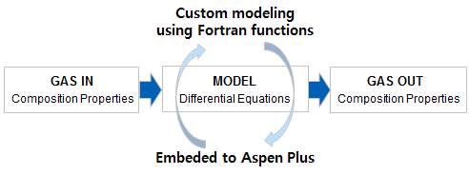

*Figure 2: Schematic illustration of a membrane process.*

The three-stage membrane configuration demonstrated in this study has two internal recycle streams with compression of the recycled permeates. The system recirculates the retentate of the 2nd/3rd membranes back to the feed side of the 1st/2nd membranes, respectively, based on the simulation results of the single-stage membrane system. The feed compositions and operating conditions were the same as used for the single-stage membrane. The stage cut is defined as the ratio of permeate to feed stream through the membrane.

|  |  |
| --- | --- |
|  | (3) |

The membrane unit can be configured with the distillation unit in three ways, as shown in Figure 3. The conventional distillation process (base case) with 200 stages for propane/propylene separation was compared with a multistage membrane and hybrid system, which is the combination of a membrane and distillation in terms of energy efficiency.

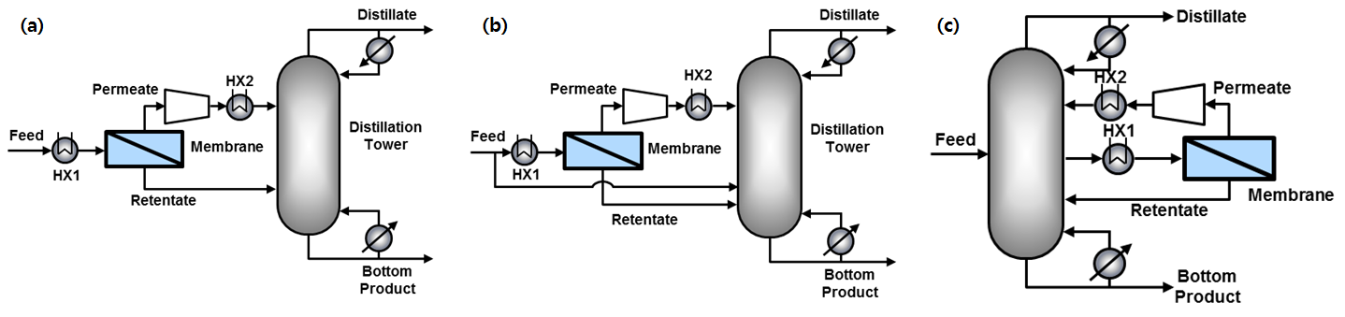

*Figure 3: Membrane/distillation hybrid processes.*

* 1. Results and discussion
     1. Validation of simulation results

The model validation of simulation results with experimental data was carried as a first step before proceeding with the detailed analysis of the membrane performance over various parameters. For validation of the mathematical model, the model estimations have been applied to be compared with experimental data for air separation published data as shown in Figure 4 (Feng et al., 1999). The membrane material is cellulose acetate with permeance values of 9.19 GPU for O2 and an O2/N2 selectivity of 5.4 according to the published data14. The feed pressure value is 790.8 kPa, and the pressure ratio of O2/N2 is 7.8. The feed compositions used are 20.5% O2 and 79.5% N2. The fibers have an outer diameter of 160 μm and an inner diameter of 80 μm.

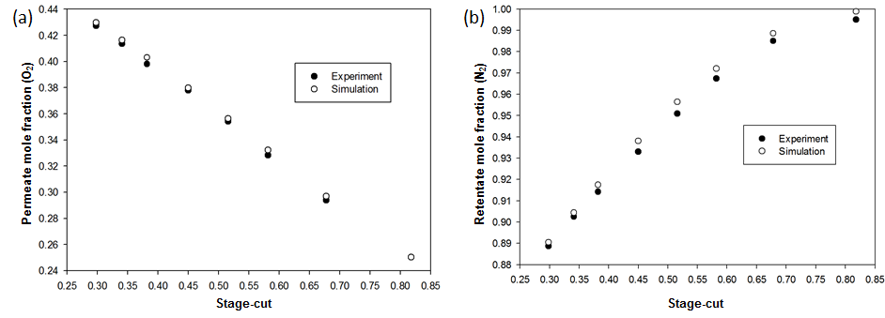

*Figure 4: Validation of the simulation results with experimental data (Feng et al. 1999).*

* + 1. Membrane system

The membrane process is characterized by the selectivity and pressure ratio of membrane process to reach the separation target of 99.6 mol% C3H6 purity. The single-stage membrane was conducted in Aspen Plus on the basis of operating conditions of C3H6 permeability of 38.83 GPU, C3H6/C3H8 selectivity of 16.15, and pressure ratio of 3. The variation of permeate mole fraction and recovery ratio of C3H6 in the three-stage membrane vs. stage cut is shown in Figure 5. While the permeate C3H6 mole fraction is slowly reduced with an increase in stage cut from 0.1 to 0.8, it sharply decreases above a stage cut of 0.8. These results appeared similar for both the selectivity and pressure ratio variation. The permeate C3H6 mole fraction increased with the increase in the selectivity and pressure ratio, while the growth rate decreased.

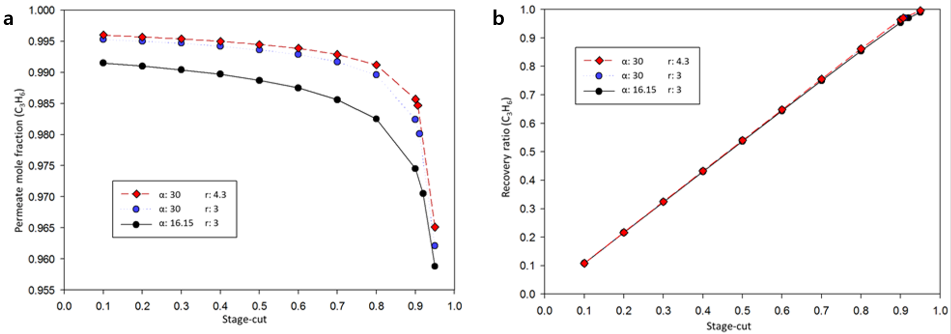

*Figure 5: The permeate C3H6 mole fraction in a single-stage membrane vs. stage cut over several; a: permeate mole fraction (C3H6), b: recovery ratio (C3H6).*

In multistage membranes, the model equations were calculated separately in each stage. Furthermore, the operating parameters can be individually changed for each step. The selectivity and pressure ratio of the membrane process were set to be equal at each stage. The performance of the multistage membrane model was adjusted by the stage cut for the entire flow rather than for the flow at each step due to the circulation of the retentate stream.

C:\Users\PJD\Desktop\Fig. 7.tif

*Figure 6: C3H6 permeate mole fraction and recovery ratio in three-stage membrane by stage cut.*

The membrane/distillation hybrid system is simulated in Aspen Plus with Fortran code using the Radfrac model and the Soave–Redlich–Kwong state equation. Minimizing the energy consumption by optimizing the feed tray locations for each feed composition can be fairly important (Luyben et al., 1975). The reboiler thermal efficiency of the distillation column was solved by changing the feed tray location as shown in Figure 7. For a given 200 stage distillation tower, the total energy consumption of case (a) reduced by 23% from 76.76 MW to 59.16 MW.

E:\01. 한국화학연구원\01. 프로젝트\01. CCP융합단 시뮬레이션\03. Membrane modeling\01. 논문작성\Membrane model\08. 그림작업\01. 제출자료\Fig. 8.tif

*Figure 7: Effect of the feed stages on the reboiler heat.*

The variations of reboiler heat in the distillation column and hybrid configurations are shown in Figure 8. The minimum energy consumption of the membrane/distillation hybrid process was calculated by adjusting the feed tray locations. The reboiler heat was reduced nonlinearly with increasing number of stages for all configurations.

The total energy consumption for each case decreased by 59.16 MW, 72.52 MW, and 74.87 MW, respectively comparing with conventional distillation. Applying hybrid processes reduce the number of stages required to meet specifications with the same energy consumption. The reboiler heat decreases nonlinearly as the number of stages increases for all configurations. In a given distillation column of 200 stages, the reboiler heat of pre-distillation was reduced by about 25% from 76.76 MW to 57.61 MW. For membrane/distillation hybrid processes, case (a) has the greatest advantage over other hybrid configurations.

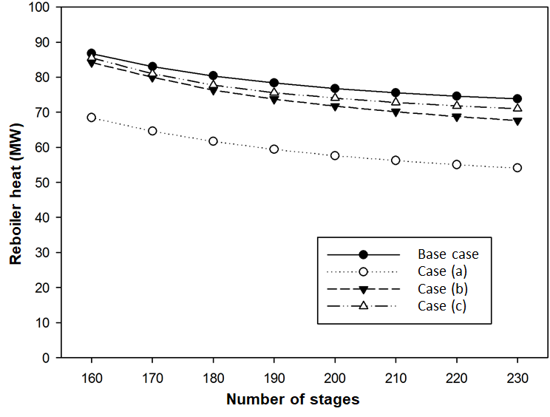

*Figure 8: Reboiler heat by the number of stages in hybrid processes.*

* 1. Conclusions

This study analysed the conventional distillation process for propane/propylene separation with multistage membrane and hybrid systems, which combine membrane separation and distillation. A counter-current flow model was applied to investigate the membrane system for propylene/propane separation under various operating conditions applying customized subroutines. The calculated results of the membrane model were confirmed by published experimental data for the membrane system and showed good agreement with the published results.

The membrane/distillation hybrid processes were proposed as an alternative process for propane/propylene separation. As a result, it is obvious that case (a) has significant advantage in terms of energy savings to meet the separation target. In addition, the investment cost for propane/propylene separation has reduced by reducing the number of stages in the distillation column.

Acknowledgments

This work was supported by the Ministry of Science & ICT and the National Research Council of Science & Technology (NST) grant by the Korea government (MSIP) (No. CRC-14-1-KRICT).

References

Baker, R.W., 2002, Future Directions of Membrane Gas Separation Technology. Industrial & Engineering Chemistry Research, 41, 1393-1411.

Burns, R.L., Koros, W.J., 2003, Defining the challenges for C3H6/C3H8 separation using polymeric membranes. Journal of Membrane Science, 211, 299-309.

Calamur, N., Carrera, M., 2006, Kirk-Othmer Encyclopedia of Chemical Technology (5th ed.), vol. 20. Wiley, New York.

Das, M., Koros, W.J., 2010, Performance of 6FDA-6FpDA polyimide for propylene/propane separations. Journal of Membrane Science, 365, 399-408.

Feng, X., Ivory, J., Rajan, V.S.V., 1999, Air Separation by Integrally Asymmetric Hollow-Fiber Membranes. AIChE Journal, 45, 2142-2152.

Geankoplis, C.J., 2003, Transport Processes and Separation Process Principles 4th edition. Prentice Hall, New Jersey, USA.

Grande, C.A., Cavenati, S., Da Silva, F.A., Rodrigues, A.E., 2005, Carbon molecular sieves for hydrocarbon separations by adsorption. Industrial & Engineering Chemistry Research, 44, 7218-7227.

Hayashi, J., Mizuta, H., Yamamoto, M., Kusakabe, K., Morooka, S., Suh, SH., 1996, Separation of ethane/ethylene and propane/propylene systems with a carbonized BPDA-pp'ODA polyimide membrane. Industrial & Engineering Chemistry Research, 35, 4176-4181.

Kanezashi, M., Shazwani, W.N., Yoshioka, T., Tsuru, T., 2012, Separation of propylene/propane binary mixtures by bis (triethoxysilyl) methane (BTESM)-derived silica membranes fabricated at different calcination temperatures. Journal of Membrane Science, 415-416, 478-785.

Kookos, I.K., 2003, Optimal Design of Membrane/Distillation Column Hybrid Processes. Industrial & Engineering Chemistry Research, 42, 1731-1738.

Kundu, P.K., Chakma, A., Feng, X., 2012, Simulation of binary gas separation with asymmetric hollow fibre membranes and case studies of air separation. The Canadian Journal of Chemical Engineering, 90, 1253-1268.

Kwon, H.T., Jeong, H.K., 2013, In situ synthesis of thin zeolitic-imidazolate framework ZIF-8 membranes exhibiting exceptionally high propylene/propane separation. Journal of the American Chemical Society, 135, 10763-10768.

Liu, D.F., Ma, X.L., Xi, H.X., Lin, Y.S. 2014, Gas transport properties and propylene/propane separation characteristics of ZIF-8 membranes. Journal of Membrane Science, 451, 85-93.

Luyben, W.L., 1975, Steady-State Energy Conservation Aspects of Distillation Column Control System Design. Industrial & Engineering Chemistry Fundamentals, 14, 321-325.

Mcketta, J.J., 1982, Encyclopedia of Chemical Processing and Design, vol. 14. Marcel Dekker, Inc., New York.

Pan, Y.C., Li, T., Lestari, G., Lai, Z.P., 2012, Effective separation of propylene/propane binary mixtures by ZIF-8 membranes. Journal of Membrane Science, 390-391, 93-98.

Viswanathan, J., Grossmann, I.E., 1993, An alternate MINLP model for finding the number of trays required for a specified separation objective. Computers & Chemical Engineering, 17, 949-955.