|  |  |
| --- | --- |
| cetlogo ***CHEMICAL ENGINEERING TRANSACTIONS***  ***VOL. 76, 2019*** | A publication of  aidiclogo_grande |
| The Italian Association  of Chemical Engineering  Online at www.cetjournal.it |
| Guest Editors: Sauro Pierucci, Jiří Jaromír Klemeš, Laura Piazza  Copyright © 2019, AIDIC Servizi S.r.l. **ISBN** 978-88-95608-73-0; **ISSN** 2283-9216 | |

Self-assembling Nanotechnology for Cancer Personalized Medicine

Domenico Marson\*, Erik Laurini, Suzana Aulic, Maurizio Fermeglia, Sabrina Pricl

Molecular Biology and Nanotechnology Laboratory (MolBNL@UniTS), Department of Engineering and Architecture, University of Trieste, Piazzale Europa 1, 34127 Trieste, Italy

domenico.marson@dia.units.it

Theranostics is a new field of medicine, which combines specific targeted therapies and diagnostic tests. With a key focus on patient centered care, theranostics provides a transition from conventional medicine to a contemporary personalized and precision medicine approach. The theranostic paradigm in cancer involves nanoscience to unite diagnostic and therapeutic applications to form nanosized agents for diagnosis, drug/gene delivery and treatment response monitoring. These nanocarriers can indeed be engineered to precisely control drug/gene/sensor-release rate and/or target specific organs/tissues within the body with a specific amount of therapeutic/diagnostic agent. In order to fulfill these expectations, any nanovector system must be designed to transport the optimum amount of therapeutic/diagnostic cargo to the desired target site where the active principle is to be released at an optimal rate during a specific time window.

Keeping the promises of theranostics is a current formidable challenge in (bio)nanotechnology, and major efforts are devoted to the design of integrated multifunctional and multivalent nanovectors able to provide selective recognition combined with sustained release and/or diagnostic reporting. In this contribution, the pathway leading to two types of nanosystems obtained by exploiting the quintessence of nanotechnology, i.e., the self-assembling process of small, amphiphilic molecules, is reported. Depending on the specific chemistry adopted, these nanomicelles are able to perform specific and effective gene silencing via targeted small interfering RNA (siRNA) delivery, and provide PET images with significantly superior imaging quality relating to sensitivity, specificity and accuracy when compared to the clinical standard [18F]FDG.

* 1. Introduction

Nanostructured and nanosized materials present several features in the field of theranostics, i.e., the relatively new branch of medicine which combines specific targeted therapies and diagnostic tests, particularly in oncology. First, they can selectively accumulate in tumor tissues by virtue of their enhanced permeation and retention (EPR) effect. Also, their increased surface area or specific size-linked effects may reflect into a variety of pharmacokinetics, pharmacodynamics and bio-distribution properties. Self-assembled nanovectors are nanomaterials whose design is often inspired by nature, as many biological systems originate from self-assembling mechanisms. In order to serve the goals of drug/gene delivery and sensor-reporting diagnostics, different components must be assembled to yield multivalent and multifunctional nanocarriers. To be effective in theranostics applications, these nanoparticles must present high drug/gene/sensor uptake, specific organ/tissue distribution, and optimal pharmacological properties to maximize efficacy while reducing side effects. Two main principles underlay the design and production of self-assembled nanovectors (SANVs): passive targeting strategies (exploiting the EPR effect) and active targeting strategies, according to which drug/gene delivery selectivity is enhanced by exploiting specific biological properties such as, e.g., receptor/ligand interactions.

Self-assembly is a prototypical nanotechnology method according to which atoms or, more often, molecules spontaneously arrange themselves into specific patterns via secondary forces, such as hydrogen bonding, electrostatics, van der Waals interactions and hydrophobic effects. A key feature of self-assembly is the multivalent, cooperative and synergistic nature of the intermolecular interactions leading to the organization of individual molecular entities into well-defined nanosized structures. This approach present at least two major conceptual advantages. The first relies on the evidence that the driving forces governing self-assembly lead to the formation of the nano-objects virtually with no flaws, as interactions between the nanomicelle building blocks are mediated by specific molecular recognition ultimately resulting in complex and ordered nanoscale structures. The second, by no means less important benefit of self-assembly is that very small amounts of material is required to accomplish the process.

In this area, as a part of a pan-European task force effort in the field a series of innovative theranostic systems as excellent agents for *in vivo* cancer imaging and therapeutics was developed (Dagrada et al. 2018; Dong et al., 2018; Garrigue et al., 2018; Wei et al., 2015). Specifically, a series of non-toxic nanosized micelles were designed, synthesized and tested for *in vitro* and *in vivo* performance. Depending on the specific chemistry, these nano-objects were able to induce specific and effective gene silencing via targeted small interfering RNA (siRNA) delivery and to provide positron emission tomography (PET) images with significantly superior imaging quality relating to sensitivity, specificity and accuracy when compared to the clinical standard [18F]FDG.

* 1. AD: the first adaptive multivalent self-assembling (MUSe) nanomicelles (NMs) for siRNA delivery

Ten years of computer-assisted nanovector (NV) design led to the discovery of **AD** (Figure 1A), an amphiphilic dendrimer able to self-assemble into adaptive supramolecular assemblies upon interaction with small interfering RNA (siRNA) duplexes (Figure 1B and C), and effectively deliver siRNAs to various cell lines, including human primary and stem cells (Liu et al., 2014).

A 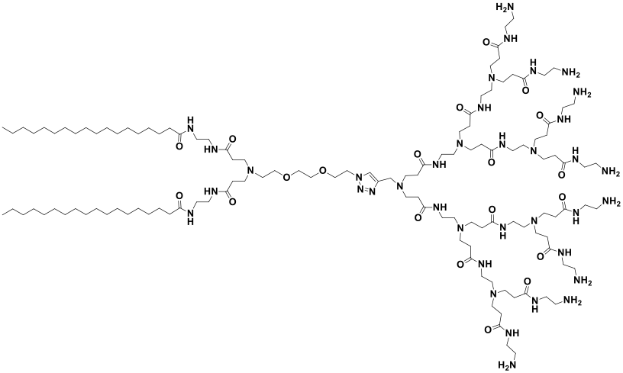 B 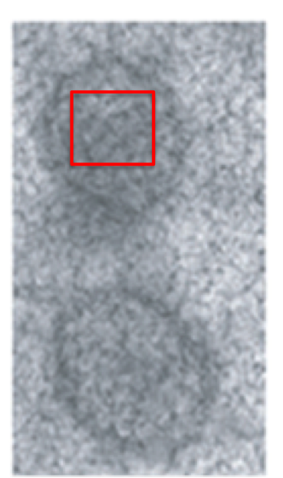 C 

Figure 1. (A) Molecular structure of the amphiphilic dendrimer **AD**. (B) TEM imaging of siRNA/**AD** complexes. (C) Computer simulations showing the nanostructures formed by **AD** in the presence of siRNA molecules. Panel C is a computer-generated, zoomed view of the TEM image area enclosed in the red square shown in panel B. Adapted from (Liu et al., 2014), with permission of Wiley-VCH.

The cellular uptake mechanism of **AD** occurs via macropinocytosis, since 1) only cytochalasin D (an inhibitor of the macropinocytosis process) exerts an negative influence on **AD**/siRNA complexes cell internalization (Figure 2A) and 2) actin depolymerization, the hallmark of macropinocytosis, is contextually observed (Figure 2B).

A 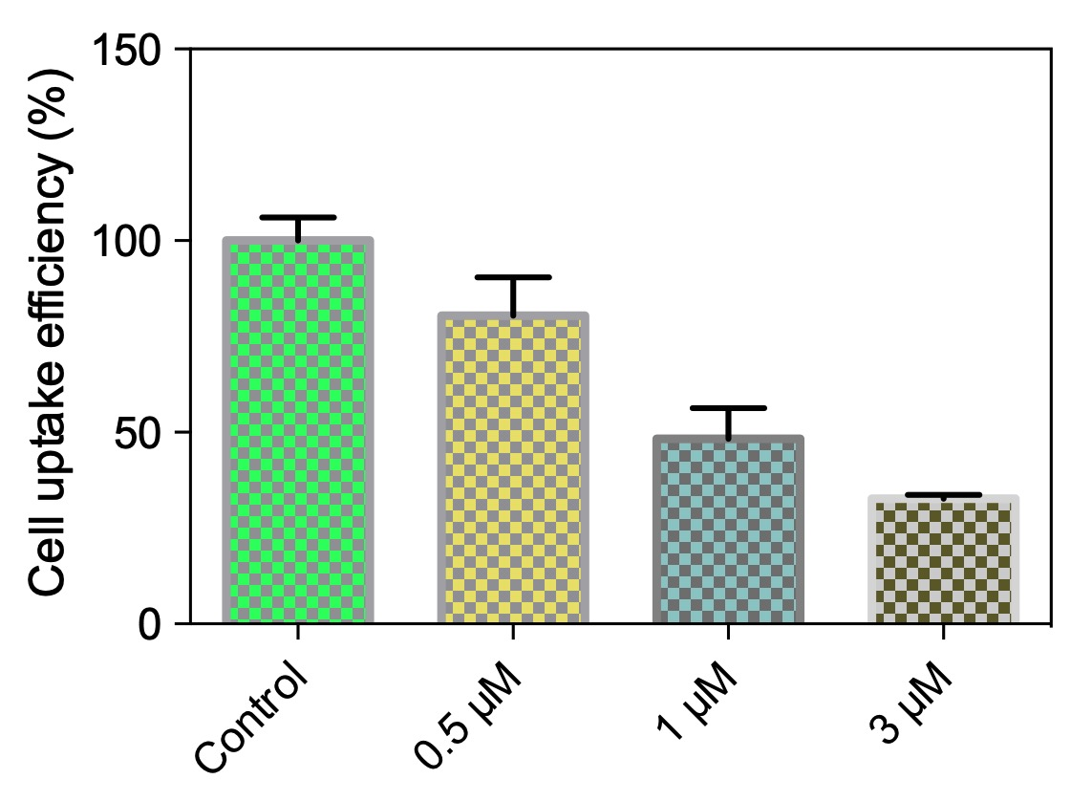 B  C 

Figure 2. (A) Inhibition of cellular uptake of **AD**/siRNA complexes by cytochalasin D and (b) actin depolymerization induced by **AD**/siRNA uptake supporting macropinicytosis as the underlying mechanism of AD/siRNA cellular uptake.

The **AD**-mediated siRNA delivery was next assessed in several, different human cancer cells, taking the delivery of Hsp27 (heat shock protein 27) siRNA as an example. A remarkable attenuation of Hsp27 expression (both at mRNA and protein levels) and related anticancer activity were achieved. Such RNAi efficacy was comparable to (or even better than) that obtained with the standard reference oligofectamine, and could be maintained over 1 week, even in serum-containing medium. As the final, decisive step to assess the effective therapeutic potential of **AD** in siRNA delivery, *in vivo* delivery studies A using a prostate cancer PC-3 xenograft mouse model were performed. As presented in Figure 3 (A), substantial down-regulation of Hsp27 was again achieved, ultimately leading to an effective inhibition of tumor growth (Figure 3B). Importantly, no discernible toxicity was observed, as no weight alteration, organ injury during treatment, or major histopathological changes were noted in the treated mice.

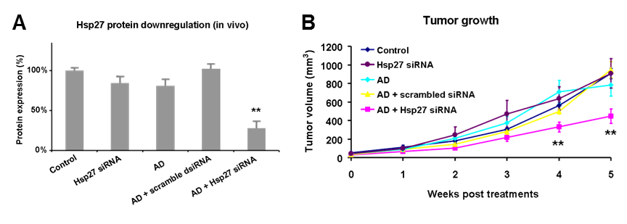

Figure 3. (A) Effective gene silencing of Hsp27 at protein levels, as measured using western blot, and (B) Inhibition on tumor growth assessed by measuring tumor size. Adapted from (Liu et al., 2014), with permission of Wiley-VCH.

* 1. AD functionalization for targeted siRNA delivery

Further improvement of **AD**-mediated siRNA delivery were next conducted with the purpose of endowing this self-assembled NV with active targeting ability for specific cancer cell delivery. To the scope, computer-assisted optimization studies led to the design of a dual targeting warhead RGDK peptide (Figure 4A) which, by virtue of electrostatic adsorption of its negative tail composed by 16 glutamic acid residues onto the nanocarrier surface (Figure 4B), was able to target the tumor endothelium by binding both to ανβ3 integrin (localization) and to the neuropilin-1 (Nrp-1) receptor, thereby promoting cancer cell penetration and uptake (Dong et al., 2018).

A 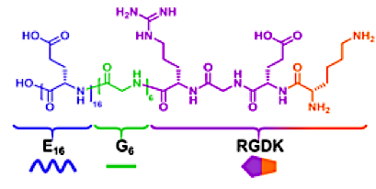 B 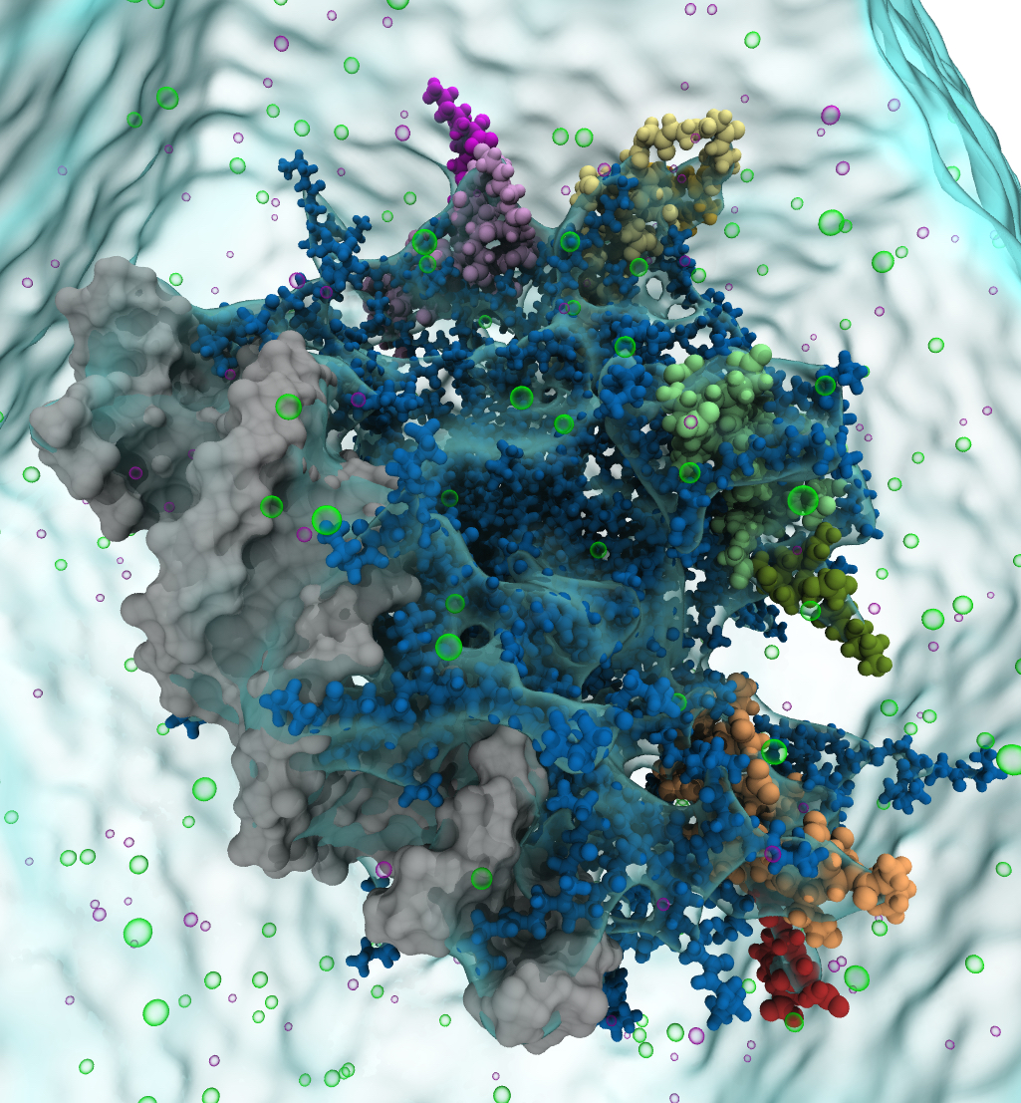 C 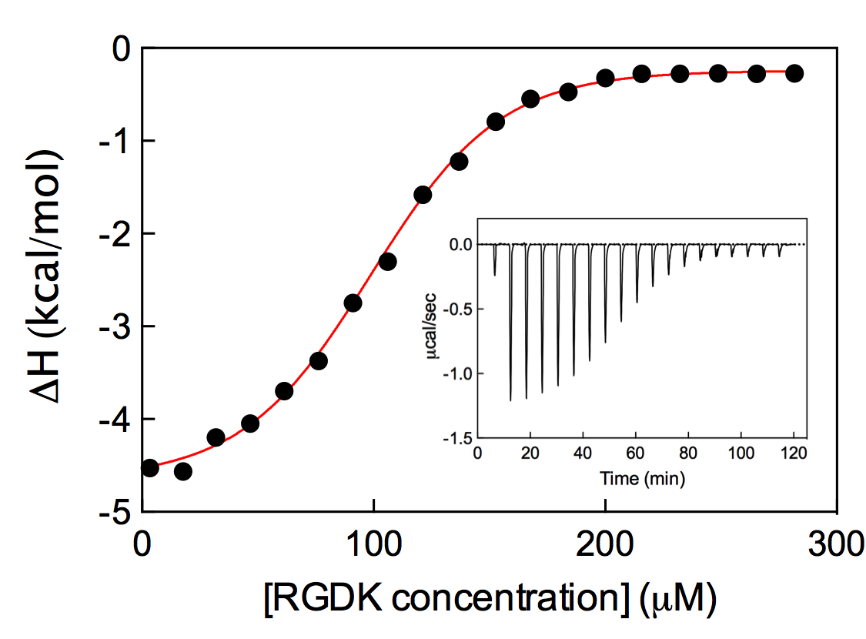

Figure 4. (A) Chemical structure of the designed targeting peptide. (B) Equilibrated molecular dynamics (MD) snapshot of a siRNA/**AD** micelle in complex with four E16G6RGDK peptides. The siRNA molecule is portrayed with its van der Waals surface in grey. The **AD** micelle is shown in dark slate blue sticks and balls, while the four peptides are depicted as colored spheres (pink, yellow, green and orange). Ions and counterions are shown as green and purple hollow spheres; water is shown as a light cyan surface. (C) Representative integrated ITC profiles for titration of the siRNA/**AD** complexes with the E16G6RGDK peptide (T = 25 °C). The solid red lines are data fitted with a sigmoidal function. The inset shows the corresponding ITC raw data. Adapted from (Dong et al., 2018), with the permission of the American Chemical Society.

Isothermal titration calorimetry (ITC) measurements were conducted to experimentally assess the efficacy of the interaction between the optimized RGDK warhead peptide and the **AD**/siRNA complexes (Figure 4C). The binding process was found to be mainly characterized by a favorable enthalpic contribution (ΔΗ = −5.0 ± 0.2 kcal/mol), as testified by the exothermic peaks of the corresponding thermogram (Figure 4C). A small favorable entropy change was also estimated (−TΔS = −1.9 kcal/mol); accordingly, the overall complex formation was thermodynamically favored, with a free energy of binding (ΔG) value of −6.8 kcal/mol.

After extensive characterization of the *in vitro* behavior of the new **AD**/RGDK nanocarrier, further experiments were performed to finally determine the performance of the targeting system for siRNA delivery *in vivo* (Figure 5).

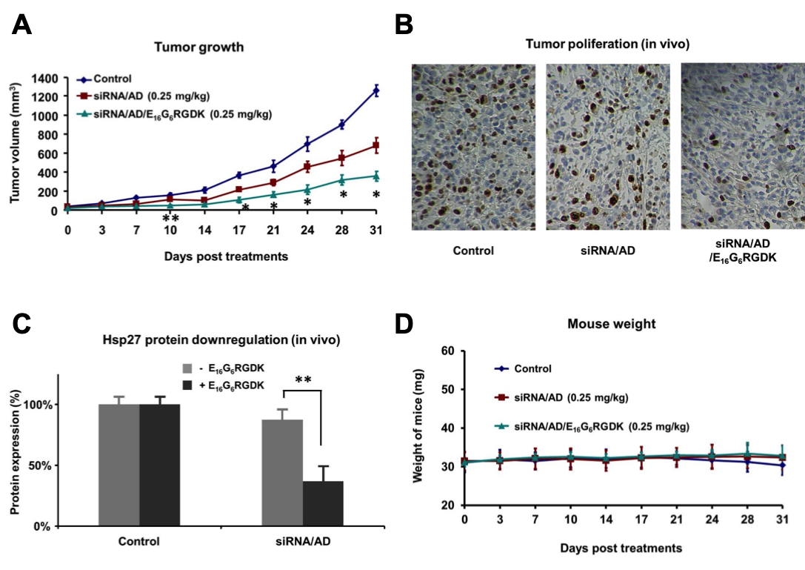

Figure 5. (A) Tumor growth assessed by measuring tumor size, (B) cancer cell proliferation in tumor tissue revealed by immunohistochemistry, (C) expression of Hsp27 protein in tumors quantified using Western blotting and (D) mice body weight monitoring during the treatment with the **AD**/RGK/siRNA nanosystem. Adapted from (Dong et al., 2018), with permission of the American Chemical Society.

With respect to the original self-assembled **AD** system, the new NV equipped with the dual targeting peptide was able to specifically target cancer cells for improved gene silencing; as such, it resulted to be endowed with much more potent anticancer activity at a significantly lower dosage of siRNA with respect to **AD** alone. In essence, this was the first report to explore a targeting strategy for self-assembling dendrimer-mediated siRNA delivery. Most importantly, compared with the original **AD** nanovector, this amphiphilic dendrimer system had similar siRNA loading capacity but more than 10-fold greater potency for *in vivo* siRNA delivery and consequent antitumor activity.

* 1. A single-tail AD derivative as potent cancer imaging system: [69Ga]Ga-1 micelles

Nanotechnology-based imaging in cancer diagnosis plays a prominent role in both improving imaging sensitivity and specificity, and reducing contrast agent toxicity. Quite recently, based on the previous experience with **AD** and further studies on **AD** modifications (Chen et al., 2016), an innovative nanosystem for positron emission tomography (PET) imaging was developed again exploiting amphiphilic dendrimer-based self-assembly (Figure 6A). To the purpose, the surface of the amphiphile was decorated with 1,4,7-triazacyclononane-1,4,7-triacetic acid (NOTA)-Gadolinium PET reporting units (Figure 6B) (Garrigue et al., 2018). The key findings of these efforts can be summarized as follows: the NV based on [69Ga]Ga-**1** was characterized by effective accumulation in tumors, excellent sensitivity and specific imaging of various tumors, and, most importantly, was especially efficacious for tumors otherwise undetectable using the clinical gold reference 2-fluorodeoxyglucose ([18F]FDG) (Figure 7).

In addition, this nanovector was endowed with an excellent safety profile and favorable pharmacokinetics for PET imaging, making it an effective and promising approach for cancer imaging. This study also demonstrated that nanotechnology based on self-assembling dendrimers can offer a fresh perspective for biomedical imaging and cancer diagnosis, i.e., cancer theranostics.

A  **B** 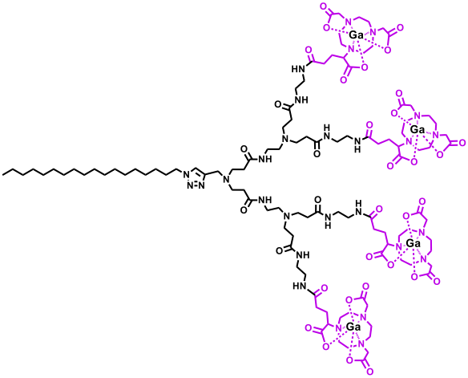

Figure 6. (A) Molecular model of the nanosystems for PET imaging based on the self-assembling molecule [69Ga]Ga-**1**, decorated with the 1,4,7-triazacyclononane-1,4,7-triacetic acid (NOTA)-Gadolinium PET reporting units (B).

B 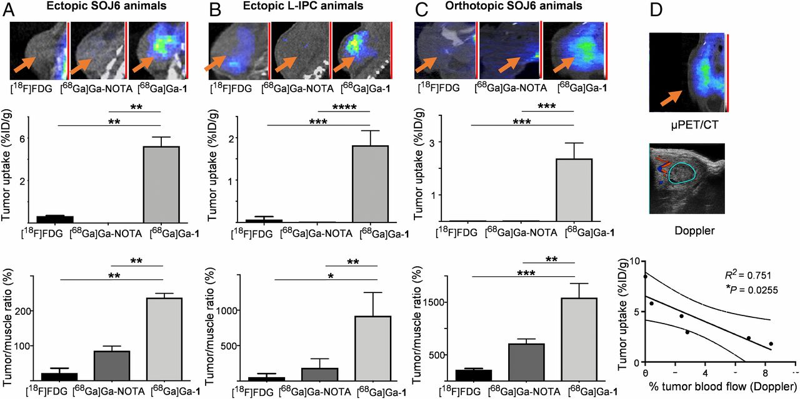

Figure 7. Comparison of the tumor accumulation of the dendrimer-based NV [68Ga]Ga-**1**, the small molecular complex [68Ga]Ga-NOTA, and the clinical reference [18F]FDG in ectopic (A) SOJ6- and (B) LIPC-xenografted mice as well as in (C) orthotopic SOJ6-xenograft mice. (Top panel) Representative examples of [18F]FDG (left), [68Ga]Ga-NOTA (middle), and [68Ga]Ga-**1** (right) PET images. The orange arrows indicate tumor positions. (Middle panel) Quantifications from PET images of tumor uptake. (Bottom panel) Quantifications from PET images of tumor-to-background ratios (right forelimb biceps muscle taken as background reference). (D) Correlation between [68Ga]Ga-**1** PET signal in tumors and tumor blood flow assessed by 3D-Doppler (percentage) in orthotopic SOJ6-xenografted mice. Adapted from (Garrigue et al., 2018), with permission of the National Academy of Science of the USA.

* 1. Conclusions

The main reason for the tremendous excitement of theranostics is its revolutionary approach that promises improved therapy selection on the basis of specific molecular features of disease, greater predictive power for adverse effects, and new ways to objectively monitor therapy response. These properties constitute the cornerstones of personalized medicine.

Nanovectors obtained exploiting self-assembling technologies have already revealed improved drug/gene delivery and diagnostic capability performance, coupled with reduced side effects (Bhuiyan et al., 2018). However, efforts focused on the conception, synthesis, and *in vitro*/*in vivo* testing of different, more effective and efficient self-assembled nanovectors for cancer theranostics have dramatically increased in recent years.

Under this perspective, this work initially describes an amphiphilic dendrimer able to self-assemble into nanosized micelles for effective and safe delivery of small interfering RNAs (siRNAs) both *in vitro* and *in vivo*. As a result of computer-assisted molecular design and optimization, the same amphiphilic dendrimer was next equipped with a dual targeting peptide bearing an RGDK warhead aimed at increasing tumor localization and cellular uptake via its interaction with specific cellular receptors (i.e., integrin and neuropilin-1) and, hence, gene silencing via RNAi. Indeed, when compared with other non-targeted or covalent dendrimer-based systems, the targeted NV exhibits enhanced siRNA delivery, stronger gene silencing, and more potent anticancer activity, coupled with no induced acute toxicity or induced inflammation.

Molecular theranostics represents a powerful emerging platform that intimately couples targeted therapeutic entities with noninvasive imaging that yields information on the presence of defined molecular targets before, during, and after cognate therapy. Therefore, hopes are high regarding potential major breakthroughs which nanotechnology-based imaging can bring in cancer diagnosis by improving imaging sensitivity and specificity while reducing toxicity. Thus, the final part of this work presents an innovative nanosystem for positron emission tomography (PET) imaging. Further optimization studies of the original self-assembling entity let to the design and synthesis of another amphiphilic dendrimer decorated with 1,4,7-triazacyclononane-1,4,7-triacetic acid (NOTA)-Gadolinium PET reporting units. The resulting nanosystems nanosystem effectively accumulates in tumors, leading to exceptionally sensitive and specific imaging of different cancer lesions, notably including those that otherwise undetectable using the clinical gold reference 2-fluorodeoxyglucose ([18F]FDG).

Acknowledgments

This project has received funding from the Italian Association for Cancer Research (AIRC, grant IG 2015 Id.17413 to SP).

References

Bhuiyan Z.H., Anderson C.F., Cui H., 2018, Self-assembling biomaterials for theranostic applications, In: Self-assembling Biomaterials: Molecular Design, Characterization and Application in Biology and Medicine, Ed Azevedo H.S., da Silva R.M.P, Woodhead Publishing, Sawston, Cambridge, U.K.

Chen C., Posocco P., Liu X., Cheng Q., Laurini E., Zhou J., Liu C., Wang Y., Tang J., Dal Col V., Yu T., Giorgio S., Fermeglia M., Qu F., Liang Z., Rossi J.J., Liu M., Rocchi P., Pricl S., Peng L, 2016, Mastering dendrimer self-assembly for efficient siRNA delivery: from conceptual design to *in vivo* efficient gene silencing, Small, 12, 3667-3676.

Dagrada G., Rupel K., Zacchigna S., Tamborini E., Pilotti S., Cavalleri A., Fechner L.E., Laurini E., Smith D.K., Brich S., Pricl S., 2018, Self-assembled nanomicelles as curcumin drug delivery vehicles: impact on solitary fibrous tumor cell protein expression and viability, Molecular Pharmaceutics, 15, 4689-4701.

Dong Y., Yu T., Ding L., Laurini E., Huang Y., Zhang M., Weng Y., Lin S., Chen P., Marson D., Jiang Y., Giorgio S., Pricl S., Liu X., Rocchi P., Peng L., 2018, A dual targeting dendrimer-mediated siRNA delivery system for effective gene silencing in cancer therapy, Journal of the American Chemical Society, 140, 16264-16274.

Garrigue P., Tang J., Ding L., Bouhlel A., Tintaru A., Laurini E., Huang Y., Lyu Z., Zhang M., Fernandez S., Balasse L., Lan W., Mas E., Marson D., Weng Y., Liu X., Giorgio S., Iovanna J., Pricl S., Guillet B., Peng L., 2018, Self-assembling supramolecular dendrimer nanosystem for PET imaging of tumors, Proceedings of the National Academy of Science USA, 115, 11454-11459.

Liu X., Zhou J., Yu T., Chen C., Cheng Q., Sengupta K., Huang Y., Li H., Liu C., Wang Y., Posocco P., Wang M., Cui Q., Giorgio S., Fermeglia M., Qu F., Pricl S., Shi Y., Liang Z., Rocchi P., Rossi J.J., Peng L., 2014, Adaptive amphiphilic dendrimer-based nanoassemblies as robust and versatile siRNA delivery systems, Angewandte Chemie International Edition, 53, 11882-11887.

Wei T., Chen C., Liu J., Liu C., Posocco P., Liu X., Cheng Q., Huo S., Liang Z., Fermeglia M., Pricl S., Liang X.J., Rocchi P., Peng L., 2015, Anticancer drug nanomicelles formed by self-assembling amphiphilic dendrimer to combat cancer drug resistance, Proceedings of the National Academy of Science USA, 112, 2978-2983.