CHEMICAL ENGINEERING TRANSACTIONS  VOL. 76, 2019 | A publication of
The Italian Association
of Chemical Engineering
Online at www.cetjournal.it
Guest Editors: Sauro Pierucci, Jiří Jaromír Klemeš, Laura Piazza
Copyright © 2019, AIDIC Servizi S.r.l.
ISBN 978-88-95608-73-0; ISSN 2283-9216

Integrating Multiscale Simulations for Composite Materials with Industrial Business Decision: the Eu H2020 COMPOSELECTOR Project Experience
Erik Laurini*, Domenico Marson, Suzana Aulic, Andrea Mio, Maurizio Fermeglia, Sabrina Pricl
Molecular Biology and Nanotechnology Laboratory (MolBNL@UniTS), Department of Engineering and Architecture, University of Trieste, Piazzale Europa 1, 34127 Trieste, Italy
erik.laurini@dia.units.it
The integration of modelling and simulation techniques to support material selection processes (MSPs) is one of the most compelling needs in advancing material industry and manufactory, due to the necessity of effective/efficient design and production of sophisticated materials, components and systems with advanced/extreme performance on a competitive time scale. In this arena, and specifically for complex structural materials such as polymer-based nanocomposites (PNCs) there is a strong industrial demand for chemistry/physics-based models and modelling workflows able to predict relevant materials properties (aka Key Performance Indicators or KPIs) in an accurate and reliable way and prior to any experimental set-up. With the aim of filling the gap between business processes and materials science/engineering workflows, this work reports the application – within the framework of the EU H2020 project COMPOSELECTOR – of a multi-disciplinary, multi-model approach for the accurate, reliable, efficient and cost-effective industry-driven KPIs determination for PNC materials. Specifically, three examples of questions and answers pertaining to aerospace and automotive applications are presented and discussed.
  - Introduction
The plethora of currently available composite materials and related production processes is steadily growing in number and type. Thus, for PNC designers and manufacturers the understanding and possibly evaluating different materials and processing conditions in the early stages – if not ahead – of product design is no longer an option. The wealth of information acquired during the product conceptual stage generates a product knowledge foundation for improved decision-making, thereby augmenting the innovation potential within new material and structure concepts. In this arena, the European Commission is devoting major economical efforts to support the integration of molecular simulation techniques in industrial business decision processes. According to this vision, during the delicate phase of material selection processes molecular simulations should be performed in two modes: the discovery mode, in which new material properties and phenomena not yet observed experimentally are predicted or explanations for un-understood observed behaviours are sought, and the data mode, basically consisting in the reliable prediction of material properties without resorting to any experimental activity.
Material selection is the result of the best match between material properties/performance, design/process optimization, cost analysis, life cycle engineering, societal requirements and regulations. Traditionally, material selection has been performed based on property cross-plots, i.e., a graphical representation of material-property-performance relationships (Ashby and Johnson, 2014). These methods rely on a combination of material databases and efficient search algorithms for properties that best satisfy a set of specified performance indices using pattern recognition, combinatorial search methodologies, etc. However, most of these tools are not well-suited for identifying/selecting the optimal material that is theoretically predicted to meet or exceed a set of designer-specified macroscale properties or performance criteria. Therefore, the major aim of the European Project COMPOSELECTOR, supported by the European Commission in the H2020 Research and Innovation Programme, is to contribute to a ground-breaking vision consisting in the integration of material modelling and simulation techniques into industrial manufacturing processes of materials characterized by increasing complexity such as PNCs, with specific regard to three industrial user cases, i.e., high performance PNCs for aeronautical (AIRBUS Industries) and automotive applications (DOW Corporation and Goodyear Tire and Rubber Company).
  - The AIRBUS case study
While the use of reinforced plastics (RPs) has become a mainstay in aircraft production, the choice of a suitable polymeric matrix and, particularly, the reinforcing filler/fibres remains a largely unexplored scenario. In the quest of new RPs for airplane specific applications, the AIRBUS Industries within the COMPOSELECTOR project posed the first challenge in material selection by rising the following issue: what is the behaviour of the glass transition temperature (T_{g}) and of the Young modulus (E) of a PNC based on carbon nanofibers (CFs) dispersed within a polyether ether ketone (PEEK) matrix, up to a CFs content of 15% wt/wt? To answer the question, specific computational procedures based on atomistic molecular dynamics (MD) simulations were developed and applied, starting from well-validated methodologies established for other thermoplastic-based PNCs (Laurini et al. 2018; Laurini et al., 2016;). MD simulations are computational techniques ideal to investigate phenomena that take place in length and time scale up to ≈ 10⁻⁹ m and 10⁻⁹-10⁻⁶ s, respectively. According to MD, all atoms are explicitly represented or, less frequently, small groups of atoms are treated by single sites (referred to as pseudo atoms). The potential energy in the system is estimated using a number of different classes of interactions, typically: a) bonded interactions, including bond-length (stretch) potentials, bond-angle (bend) potentials, torsion (twist) potentials, and cross-terms, and b) non-bonded interactions, which in general consist in Coulomb interactions and dispersion forces. The different combination of some/all of these terms in a single potential energy equation is generally defined as a force field. The results obtained are shown in Figure 1. According to the computer prediction, the Young modulus of the PNC moderately increases with increasing the CF loading (Figure 1A), as a result of the synergy of load transfer from the matrix to the reinforcement nanofibers. This reflects into an enhancement factor for the Young modulus of the PNCs with respect to the pure PEEK matrix (E_{f} = E_{PNC}/E_{matrix}) of 1.2, 1.4, and 1.5 at 5%, 10% and 15% wt/wt CF loading, respectively. On the other hand, the glass transition temperature T_{g} of PEEK - the fundamental KPI strictly connected with process and manufacturing parameters – is practically unaffected by the addition of the three different CF amounts, as shown in Figure 1B. This evidence indicates that the carbon fibres can be interspersed within the polymeric matrix without inducing significant perturbations in its molecular structure up to the desired maximum amount of 15% wt/wt.

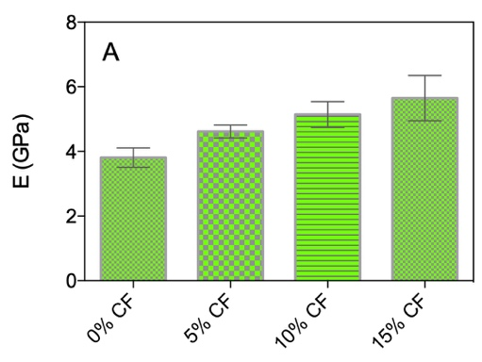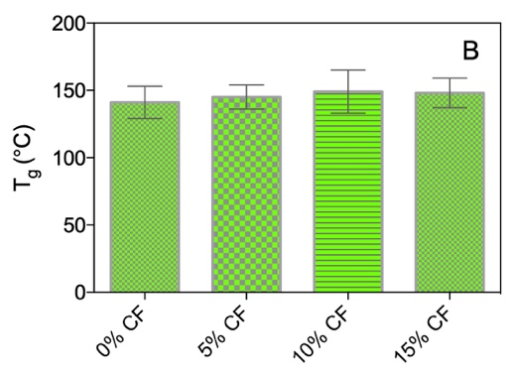

Figure 1. Values of the Young modulus E (A) and of the glass transition temperature T_{g} (B) for polymer-based nanocomposite systems based on a PEEK matrix and different amounts (% wt/wt) of carbon fibres (CFs) as obtained from atomistic molecular dynamics simulations.
  - The DOW case study
Leaf-spring design for the automotive industry is a particularly active field of research having material selection as one of the main goals. In fact, the possibility of replacing steel with, e.g., PNCs might ultimately result in a substantial weight (up to 50%) and cost reduction (approximately 5 Euro/kg). At DOW Corporation, currently part of the leaf-spring is composed by a thermoset polymer, with diglycidyl ether of bisphenol A (DGEBA) as the resin and triethylenetriamine (TETA) as hardener. The challenge posed to COMPOSELECTOR by DOW was then the following: can computer simulation select the best among 5 different suggested hardeners (i.e., ethylenediamine (ETA), diethyelentriamine (DETA), tetraethylenepentamine (TEPA), 1-(2-aminoethyl)piperazine (AEP), and isophorone diamine (IPD)) as a replacement to TETA? To answer the industrial question, again MD simulations based on the adaptation of computational recipes developed for similar systems were performed (Karimi et al., 2018; Laurini et al., 2016; Piscitelli et al., 2015; Maly et al., 2008a) to evaluate the following properties of the corresponding fully cured (85%) resins: density at room temperature, T_{g}, Young modulus E, stress and strain at break. All results are shown in Figure 2.

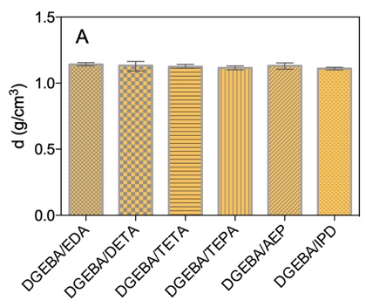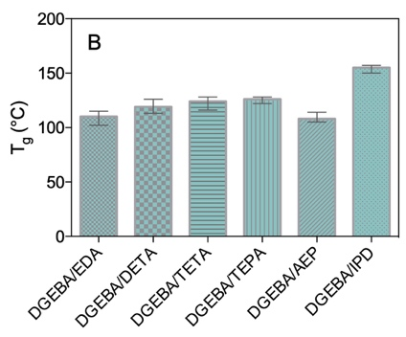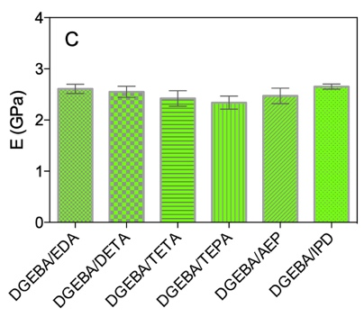
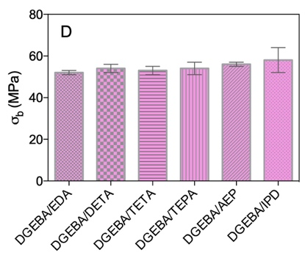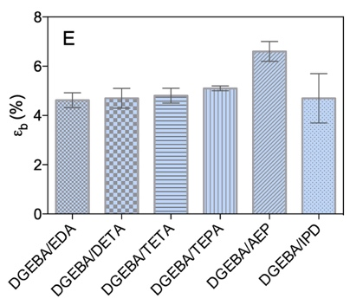

Figure 2. Values of the density d at 25ºC (A), glass transition temperature T_{g} (B), Young modulus E (C), stress at break σ_{b} (D) and strain at break ε_{b} (E) for a fully cured (85%) DGEBA resin as a function of different curing agents as obtained from atomistic molecular dynamics simulations.

As seen in Figure 2A, the chemical nature of the different hardeners does not affect the density value of the relevant cured systems. On the other hand, for the series EDA-DETA-TETA-TEPA the glass transition temperature slightly increases with increasing amine linear chain and functionality, while for the last two, cyclic amines (AEP and IPD), a more prominent effect of the resulting network packing density, related to initial functionality, seems to rule the network stiffness and, hence, its T_{g} value (Figure 2B). Form Figure 2C it can be observed that, for the networks based on the series of ethyleneamines, EDA shows the highest value of E, while the lowest modulus is observed for the network based on TEPA. These results agree with the fact that an increase of functionality induces an increase in crosslinking density and therefore the modulus decreases. For the cyclic series (AEP and IPD) an opposite trend is observed as IPD, characterized by a higher functionality with respect to AEP, exhibits a higher value of the Young modulus at room temperature, likely by virtue of the higher T_{g} value and the higher molecular rigidity of the isophorone ring. Interestingly, the values of all predicted Young’s moduli are in the range experimentally found for epoxy/amine networks (Won et al., 1990; Urbaczewski‐Espuche et al., 1991; Crawford and Lesser, 1999; Franco et al., 1999; Pascault et al., 2002). Finally, as concerns the values of the stress and strain at break, little effect of the hardener type is observed on both σ_{b} and ε_{b} (Figure 2D and 2E), the resin cured with ASP exhibiting a slightly higher strain at break value (6.8%).
In terms of material selection, these results suggest that, among all hardeners proposed by DOW corporation as an alternative to standard TETA, DGEBA-AEP networks present the best choice for all practical mechanical purposes.
  - The Goodyear case study
Natural rubber is characterized by weak mechanical performance; accordingly, rubber reinforcement with different fillers is an essential prerequisite for most of its practical applications. In particular, car tires must withstand the absorbed impact during operation and maintain traction under both dry or wet conditions. Current environmental concerns of CO₂ and other pollutant emissions are exerting a strong pressure on the automotive sector for improving fuel efficiency of tires. Accordingly, the majority of the so-called industrialized countries have already introduced regulations for the improvement of tire wet traction and the reduction of their rolling resistance, with the ultimate goal of accelerating the development of high-performance tires. Historically, carbon black has been used as a reinforcing filler by virtue of its high tensile and abrasion properties. Yet, its poor performance in the concomitant improvement of rolling resistance and wet traction led to the quest of alternative fillers for the tire rubber. Silica nanoparticles (SiNPs) have revealed better properties in this respect, ultimately leading to the replacement of large fractions of carbon black in tire formulations. The use of SiNPs, however, is not devoid of disadvantages such as surface polarity, which renders the SiNPs poorly dispersible within the apolar styrene-butadiene rubber (SBR) matrix. A variety of methods have been devised to improve the dispersion state and the interfacial interaction of silica nanoparticles with the rubber polymer, the addition of silane compatibilizers on the NP surface being one of the most industrially favoured. However, tailoring the chemistry and the degree of grafting of silane molecules onto the SiNPs is a daunting task, which involves notable economical and time efforts. In COMPOSELECTOR, the Goodyear industry has therefore proposed the following challenge: is it possible to predict the dispersion state and the viscoelastic properties of SiO₂ nanoparticles modified with OCTEO (trimethoxy(octyl)silane, degree of grafting = 1 chain/nm²) in a SRB model rubber at two different, industrially relevant NP concentrations, namely 8% and 20% wt/wt? To find a computational answer these questions, a combination of mesoscopic and MD simulation techniques has been adopted and adapted from our previous work in the field (Laurini et al., 2018; Posocco et al., 2016; Fermeglia and Pricl, 2009; Maly et al., 2008b;). In mesoscopic simulations, a molecule is usually treated with a field description or, most commonly, is represented by microscopic particles that incorporate molecular details implicitly. Therefore, mesoscopic simulations are able to treat phenomena on length and time scales currently inaccessible by classical atomistic approaches (≈ 10⁻⁶ m and 10⁻⁶-10⁻³ s, respectively). An example of the results obtained, two morphologies of OCTEO-modified SiNPs (Figure 3) dispersed within a model SBR rubber matrix at the two requested concentrations (8% and 20%, respectively) are shown in Figure 2B and C, together with the corresponding transmission electron microscopy (TEM) imaging validation.

A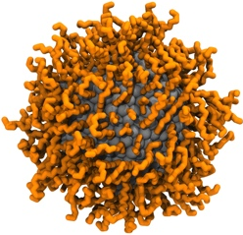 B 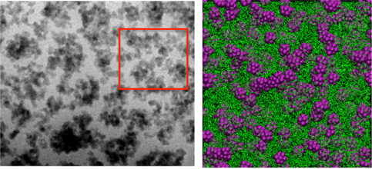 C 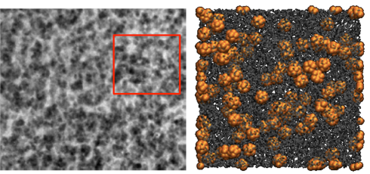

Figure 3. Atomistic representation of a 10 nm SiNP (gray) modified with OCTEO molecules (orange) with grafting density of 1 chain/nm² (A). Morphologies of OCTEO-modified SiNPs dispersed in a model SBR matrix at two different concentrations; 8% wt/wt (B) and 20% wt/wt (C) as predicted by mesoscopic simulations (right panels) and verified by TEM imaging (left panels). In the mesoscopic simulation panels, the modified SiNPs are portrayed as purple (B) and orange spheres (C), respectively, while the SBR polymer is shown as green and grey sticks, respectively. The red squares on the TEM images represent the area corresponding to the mesoscopic simulation boxes (200 nm length).

As can be appreciated from both experimental and simulated images in Figure 3B, for the more diluted system (8% wt/wt of modified SiNPs) finite size aggregates of primary particles forming branched structure can be seen, with a considerable amount of empty space between the branches filled up by pure polymer chains. By increasing SiNP concentration (20% wt/wt), the number of primary aggregates increases, and the formation of a primary connected network is detected (Figure 3C).
The two distinct morphologies of the SiNP-loaded SBR matrices should reflect into an evolution of the corresponding rheological (i.e., viscoelastic) properties. Figure 4 presents the variation of the elastic (G’) and loss moduli (G”) as a function of the applied oscillation frequency (ω) as predicted from the simulations for the pristine SBR matrix and the two SiNP-loaded systems.

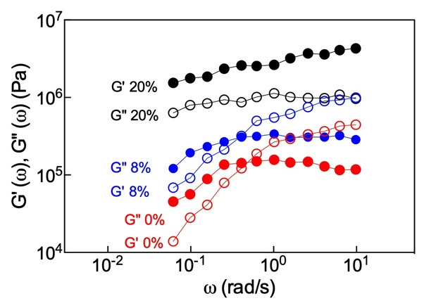

Figure 4. Mechanical spectra of pure and SiNP-loaded systems. Open symbols, G’. Filled symbols, G”.

For pure SBR, the curve has the usual shape characterizing polymer systems in a log-log representation, with the characteristic decrease of G’(ω) ~ ω² in the low ω region attributable to the liquid state of the polymer. On the other hand, the mechanical spectra of the SiNP-filled SBR systems reveals two distinct behaviours: while the viscoelastic properties of the system at 8% wt/wt loading still resemble those of the pure matrix but with a shifting of the G”/G’ crossover to lower frequencies, as expected, those of the system at higher NP loading already present the characteristic of a gel-like material, with the elastic component always higher than the viscous one and both moduli only slightly dependent on the applied pulsation, confirming the formation of a SiNP branched network pervading the entire system (Lapasin and Pricl, 1995).
  - Conclusions
In this work, within the framework of the H2020 European Project COMPOSELECTOR, we tackled three different challenges in material selections posed by three major industrial actors in the fields of aerospace and automotive production. In the former case study, proposed by the Airbus Industries, atomistic molecular simulations were applied to predict the effect of the addition - up to a given amount (15% wt/wt) - of carbon fibres to a thermoplastic polymer matrix (PEEK) on a fundamental process parameter, i.e., the glass transition temperature, and on the Young modulus. The results of the simulations revealed that, while the mechanical performance of the relevant PNCs increases with increasing CFs concentration, the corresponding value of the T_{g} remains practically unaffected, ultimately leading to the most concentrated PNC as the system of choice for a specific AIRBUS application. The second user case, posed by the DOW Corporation, was an exquisitely material selection problem, based on the substitution of the most popular hardener for DGEBA-based epoxy resin, TETA, with other amine-based molecules. All simulations techniques applied revealed that, among all hardener considered, the 1-(2-aminoethyl)piperazine (AEP) present the best compromise of properties as a TETA replacer. Finally, the Goodyear case study allowed to exploit multiscale (i.e., atomistic and mesoscopic) simulations to study the effect of the addition of different amounts of OCTEO-functionalized silica nanoparticles to an SBR matrix. The results clearly demonstrated that the two NP-loaded systems behave very differently, the most concentrated one (20% wt/wt) already being characterized by the presence of a three-dimensional NP network and a viscoelastic behaviour typical of a gel-like material.
Acknowledgments
This project has received funding from the European Union’s Horizon 2020 research and innovation programme under the Grant Agreement No.721105 (Project acronym: COMPOSELECTOR; project identifier: NMBP-23-2016 Advancing the integration of Materials Modelling in Business Processes to enhance effective industrial decision making and increase competitiveness).
References
Ashby M., Johnson K., 2014, Materials and Design: The Art and Science of Material Selection in Product Design, 3rd Edition, Butterworth-Heinemann, Oxford, UK.
Crawford E.D., Lesser A.J., 1999, Brittle to Ductile: Fracture Toughness Mapping on Controlled Epoxy Networks, Polymer Engineering and Science, 39, 385-392.
Fermeglia M., Pricl S., 2009, Multiscale Molecular Modeling in Nanostructured Material Design and Process System Engineering, Computers and Chemical Engineering, 33, 1701-1710,
Franco M. Mondragon I., Bucknall C.B., 1999, Blends of Epoxy Resin with Amine‐Terminated Polyoxypropylene Elastomer: Morphology and Properties, Journal of Applied Polymer Science, 72, 427-434.
Karimi M., Marchisio D., Laurini E., Fermeglia M., Pricl S., 2018; Bridging the Gap Across Scales: Coupling CFD and MD/GCMC in Polyurethane Foam Simulation, Chemical Engineering Science, 178, 39-47.
Lapasin R., Pricl S., 1995, Rheology of Industrial Polysaccharides: Theory and Applications, Chapman & Hall, Glasgow, UK.
Laurini E., Marson D., Fermeglia M., Pricl S., 2018, Multimodel Approach for Accurate Determination of Industry-Driven Properties for Polymer Nanocomposite Materials, Journal of Computational Science, 26, 28-38.
Laurini E., Posocco P., Fermeglia M., Pricl, S., 2016, MoDeNa Nanotools: An Integrated Multiscale Simulation Workflow to Predict Thermophysical Properties of Thermoplastic Polyurethanes, Journal of Computational Science, 15, 24-33.
Maly M., Posocco P., Fermeglia M., Pricl S., 2008a, Scripting Approach in Hybrid Organic–Inorganic Condensation Simulation: the GPTMS Proof-of-Concept, Molecular Simulation, 34, 10-15.
Maly M., Posocco P., Pricl S., Fermeglia M., 2008b, Self-Assembly of Nanoparticle Mixtures in Diblock Copolymers: Multiscale Molecular Modeling, Industrial and Engineering Chemistry Research 47, 5023-5038.
Pascault J.P., Sautereau H., Verdu J., Williams R.J.J., 2002, Thermosetting Polymers, Marcel Dekker, New York, USA.
Piscitelli F., Buonocore G.G., Lavorgna M., Verdolotti L., Pricl S., Gentile G., Mascia L., 2015, Peculiarities in the Structure – Properties Relationship of Epoxy-Silica Hybrids with Highly Organic Siloxane Domains, Polymer, 63, 222-229.
Posocco P., Hassan Y.M., Barandiaran I., Kortaberria G, Pricl S., Fermeglia, M., 2016, Combined Mesoscale/Experimental Study of Selective Placement of Magnetic Nanoparticles in Diblock Copolymer Films via Solvent Vapor Annealing, Journal of Physical Chemistry C, 120, 7403-7411.
Urbaczewski‐Espuche E., Galy J., Gerard J.-F., Pascault J.-P., Sautereau H., 1991, Influence of chain flexibility and crosslink density on mechanical properties of epoxy/amine networks, Polymer Engineering and Science, 31, 1572-1580.
Won Y.-G., Galy J., Gérard J.-F., Pascault J.-P., Bellenger V., Verdu J., 1990, Internal Antiplasticization in Copolymer and Terpolymer Networks Based on Diepoxides, Diamines and Monoamines, Polymer 31, 1787-1792.

