CHEMICAL ENGINEERING TRANSACTIONS  VOL. 76, 2019 | A publication of
The Italian Association
of Chemical Engineering
Online at www.cetjournal.it
Guest Editors: Sauro Pierucci, Jiří Jaromír Klemeš, Laura Piazza
Copyright © 2019, AIDIC Servizi S.r.l.
ISBN 978-88-95608-73-0; ISSN 2283-9216

Present and Future of Model Uncertainty Quantification in Process Systems Engineering
Francesco Rossi^{a,}*, Linas Mockusª, Flavio Manenti^{b}, Gintaras Reklaitisª
ªPurdue University, Forney Hall of Chemical Engineering, 480 Stadium Mall Drive, West Lafayette, IN 47907, United States
^{b}Politecnico di Milano, Dipartimento CMIC, Piazza Leonardo da Vinci 32, Milano 20123, Italy
frossi@purdue.edu
This contribution investigates the impact of model uncertainty quantification techniques in different areas of process systems engineering (PSE), namely dynamic optimization, predictive maintenance, soft-sensor systems and risk assessment, using three case studies inspired by typical chemical and pharmaceutical engineering problems. Our analyses confirm that the systematic use of model uncertainty quantification in the solution of PSE problems may often increase the effectiveness of models and extend their application domain. Therefore, model uncertainty quantification is expected to become one of the backbones of process systems engineering in the near future.
  - Introduction
The analysis and quantification of model uncertainty is a new paradigm, which has recently emerged due to two major aspects: (I) the growing interest of industry and of the PSE community in robust process monitoring, robust/stochastic optimization, robust process/product design and quantitative risk assessment; and (II) the rapid increase in the availability of accessible experimental/process data. As evidence for these two trends, we can mention the frameworks for individualized drug delivery, product quality risk quantification, stochastic dynamic optimization and robust model predictive control, proposed by Abbiati et al. (2015), Mockus et al. (2011), Rossi et al. (2016) and Oravec et al. (2018), respectively.
In most chemical engineering problems, model uncertainty quantification boils down to two principal tasks: (I) the estimation of the joint probability distribution (PDF) of the uncertain parameters of the model of the process of interest; and (II) the estimation of the joint PDF of the state variables of the model. These two probability distributions, along with the model equations, can then be used to solve any problem which falls in the four general categories, previously mentioned.
This contribution analyses the impact of model uncertainty quantification in four principal areas of process systems engineering, specifically dynamic optimization, predictive maintenance, soft-sensor systems and risk assessment. To this end, after a brief description of conventional and novel approaches for estimation of probability distributions, we offer three illustrative case studies. The first case study examines the benefits provided by stochastic dynamic optimization over conventional dynamic optimization, in terms of both performance and robustness (recall that stochastic optimization heavily relies on uncertainty quantification techniques). The reference system, used in these studies, is a fed-batch adaptation of the Williams and Otto chemical process (Chakraborti et al., 2006). The second case study shows that uncertainty quantification methods allow estimation of the joint PDF of unmeasurable model parameters (fouling factors, rate constants of catalyst deactivation models, etc.), and describes ways of using this information for predictive maintenance purposes. The reference process, utilized in these analyses, is a batch adaptation of the Tennessee Eastman Challenge problem (Downs and Vogel, 1993). Finally, the third case study deals with robust soft-sensors, i.e. advanced algorithms designed to estimate the joint PDF and confidence regions of measured and unmeasured process states. More specifically, it describes the innovative rationale of this type of sensors, which rely on uncertainty quantification techniques, and shows their usefulness for real-time risk assessment purposes. The reference system, utilized in these studies, is a pilot-scale drug product manufacturing plant.
The results of the three case studies, analysed in this paper, confirm that the systematic use of model uncertainty quantification within computational frameworks for solving chemical and pharmaceutical engineering problems may often increase the effectiveness of models and extend their application domain. Therefore, model uncertainty quantification is expected to become one of the backbones of PSE in the near future.
  - Conventional approaches and new approximate strategies for PDF estimation
Bayesian inference is the conventional approach used to estimate the probability distribution of the uncertain parameters of linear and nonlinear models, the so-called “posterior” PDF, from experimental data. This technique, which relies on Bayes theorem, computes the posterior distribution as a product of three distinct quantities: (I) the “prior”, defined as the latest known PDF of the model parameters; (II) the “likelihood”, which is a statistical measure of compliance of the model predictions with the available experimental data as a function of the model parameters; and (III) a nondimensionalization term, which insures the posterior is normalized.
There exist several implementations of the concept of Bayesian inference, the most popular of which are Bayesian Markov-Chain Monte Carlo (BMCMC) and Variational Inference (VI). BMCMC exploits sophisticated random sampling techniques to compute a discrete approximation of the high-probability regions of the posterior distribution (Green and Worden, 2015), while VI utilizes optimization strategies to fit a parametric family of kernel functions to the posterior distribution, using appropriate statistical distance measures as objective function (Beal, 2003). BMCMC, VI and other conventional frameworks for Bayesian inference are well-established, reliable and accurate, but their application domain is restricted to PDF estimation problems with small-scale algebraic models. This is because their computational cost becomes considerable (often unaffordable) when medium-/large-scale and/or differential-algebraic models must be dealt with. Therefore, conventional Bayesian inference strategies are often unsuitable for solving model uncertainty quantification problems in process systems engineering applications, in which most of the PDF estimation tasks must be completed within minutes/hours.
In view of these considerations, we have recently developed two new approximate Bayesian inference and alike strategies, called PDFE&U and ODMCMC, which offer a good trade-off between accuracy and computational efficiency. These methods have made it possible to build the three case studies, reported in section 3. Due to space limitations, we can only discuss the rationale of ODMCMC, but the reader can find additional information on PDFE&U in Rossi et al. (2018).
ODMCMC is a novel type of Markov-chain Monte Carlo algorithm, in which sampling is performed by optimization. Specifically, this method does not make use of conventional random strategies to sample the posterior PDF (e.g. Metropolis-Hastings, Gibbs and No-U-Turn samplers), which only accept about 30 % of all the samples analysed. Rather, it selects optimal posterior samples by iterative solution of small-scale, multi-objective optimization problems, which measure the degree of optimality of every single sample based on two indices, namely, its linear and angular distances from all the other samples and its posterior probability density. This innovative sampling approach can efficiently identify samples, which uniformly span only those regions of the uncertainty space that are associated with high values of posterior probability density. Therefore, it allows us to approximate the posterior PDF with fewer samples and, consequently, to save computational resources. In addition, unlike conventional random samplers, it allows reliable and efficient approximation of complex, multi-modal posterior PDFs.
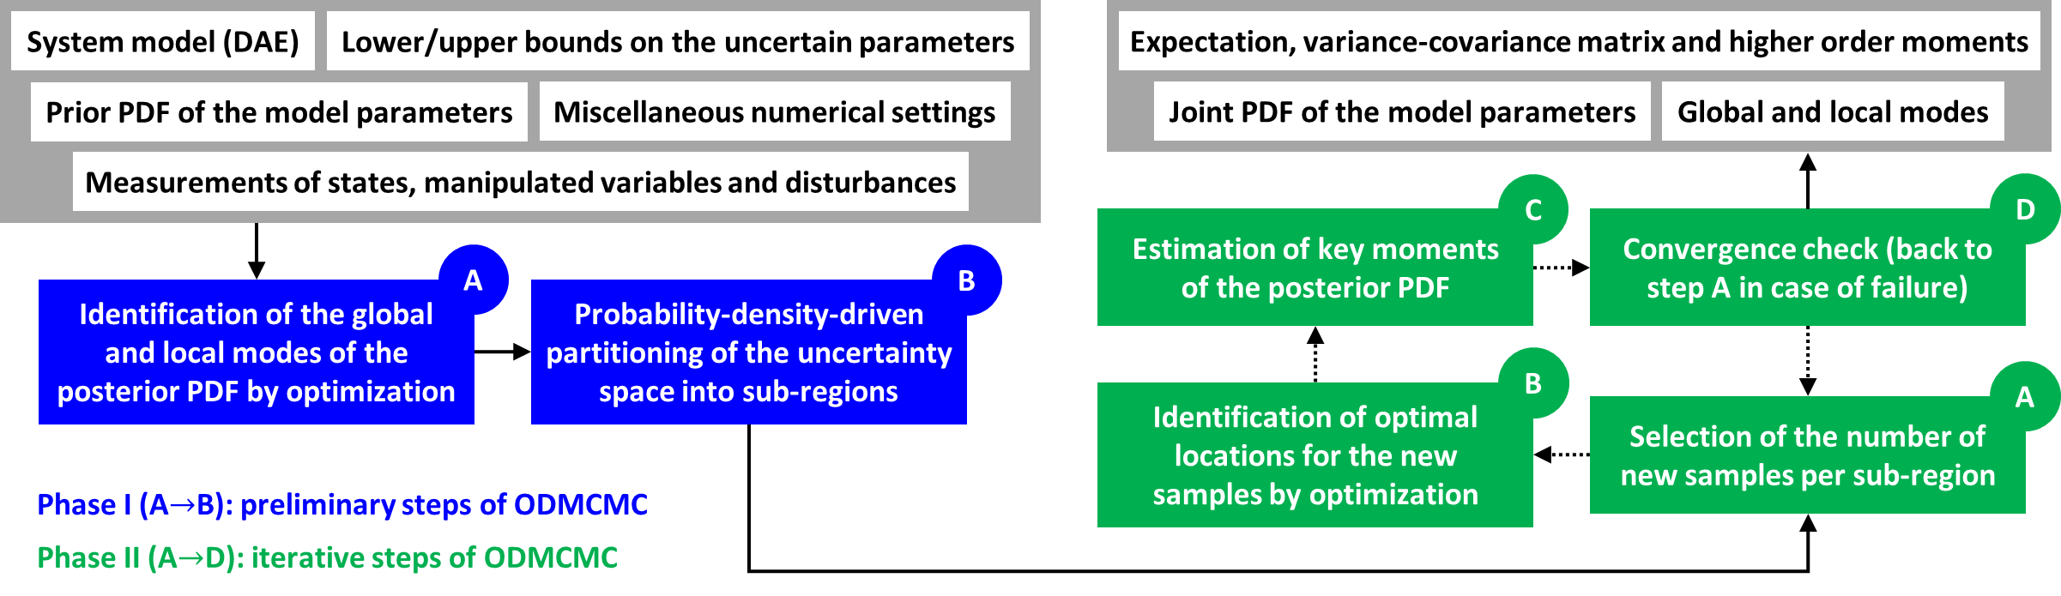
Figure 1: Architecture of the ODMCMC algorithm
The rationale of ODMCMC is summarized in Figure 1. The algorithm is comprised of two phases, called Phase I and Phase II, of which the second is executed in an iterative fashion until convergence is reached.
Phase I involves first computation of all the modes of the posterior PDF via multi-start optimization methods (step A), and then division of the uncertainty space into a user-supplied number of regions (step B), selected such that every one of them encompasses an appropriate interval of values of posterior probability density.
Phase II involves iterative execution of steps A, B and C in series, until the variation in the first, second and third order moments of the posterior PDF over two consecutive iterations is smaller than some predefined error tolerance (step D). In step A, we compute the number of samples that must be added to every region of the uncertainty space in the current iteration, using an estimate of the algorithm convergence rate calculated by error extrapolation. Step B involves solution of several multi-objective optimization problems (one problem per region) via goal programming, which allow identification of the optimal locations of the new samples. All of these optimization problems are independent of each other, thus can be solved in parallel to improve the overall computational efficiency of the algorithm. Finally, in step C, we estimate the first, second and third order moments of the posterior PDF, using the samples selected up to the current iteration. These calculations rely on simple formulas, derived by discretization of well-known integral expressions, utilized to compute the moments of continuous probability distributions.
This brief description of the rationale of this new algorithm must be complemented with two final remarks. First, note that ODMCMC technically requires identification of all the modes of the posterior PDF (Phase I – step A) via multi-start optimization. However, this requirement can be relaxed without affecting the accuracy of the algorithm, but at the cost of longer computation time. Second, note that the bottleneck for computational efficiency in ODMCMC is represented by step A of Phase I and step B of Phase II, which are both parallelizable. Therefore, ODMCMC exhibits very good scalability features, unlike conventional Bayesian inference strategies.
  - Impact of uncertainty quantification in chemical engineering
After introducing the concept of computationally efficient strategies for PDF estimation, we can now investigate the impact of model uncertainty quantification in four relevant research fields of PSE, namely dynamic optimization, predictive maintenance, soft-sensor systems and risk assessment.
    - Stochastic dynamic optimization
Deterministic dynamic optimization (DRTO) is a well-known model-based strategy for computing the optimal operating conditions of any target process in real time, based on case-specific performance functions. Although powerful, it suffers from a major drawback, namely, the need for accurate process models, which limits its application domain to a handful of processes. This important downside of DRTO is overcome by stochastic dynamic optimization (SDRTO), which explicitly considers the presence of uncertainty in the model predictions through the probability distribution of the uncertain model parameters. However, this algorithmic improvement requires efficient strategies for model uncertainty quantification, based on PDFE&U, which can estimate/re-estimate the PDF of the model parameters on a time scale of a few minutes. The reader can thus appreciate the importance of model uncertainty quantification in the field of dynamic process optimization.
Extensive analysis on the different robustness and performance characteristics, offered by deterministic and stochastic dynamic optimization, is reported in Rossi et al. (2016). However, Figure 2 already allows the reader to appreciate the different robustness levels, guaranteed by these two optimization techniques. Indeed, the constraint violations, triggered by DRTO, are much more severe than those triggered by SDRTO (this is especially true for the stochastic dynamic optimization method “std”, which is one of the best in the field).
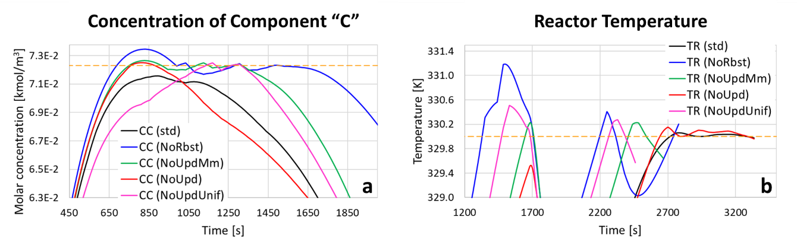
Figure 2: Optimal operating conditions of the Williams-Otto fed batch reactor computed by different SDRTO strategies (std, NoUpd, NoUpdMm, NoUpdUnif) and by DRTO (NoRbst)
    - Robust predictive maintenance
Predictive maintenance is an old concept, introduced for the first time by the Royal Air Force during World War II. It involves use of mathematical models for predicting when process equipment is expected to fail, foul and/or experience severe performance loss. This information is then utilized to optimize the maintenance schedules of key process units, thus reducing overall maintenance costs. This model-based maintenance approach could significantly improve the economics of chemical and pharmaceutical processes, by mitigating the undesirable effects of common problems such as equipment fouling and catalyst deactivation, which can lead to unplanned process shutdowns. However, it has never been systematically applied to chemical and pharmaceutical plants because the predictions of fouling and catalyst deactivation models are often too unreliable to provide useful information.
Robust predictive maintenance can mitigate this problem by computing the worst-case predictions of the aforementioned models in a statistical sense, which may be useful to build conservative, yet optimized, maintenance schedules. However, this new approach to maintenance must make use of computationally efficient uncertainty quantification techniques to estimate the PDF of the uncertain parameters of fouling and catalyst deactivation models. Therefore, model uncertainty quantification proves to be essential also to all those frameworks, which rely on this new concept of maintenance.
The benefits offered by robust predictive maintenance can be inferred from Figure 3, which shows two important items of information: (I) the batch-to-batch variations in some of the features of the process analysed due to fouling, specifically global heat transfer coefficient and activation energy of one of the main reactions; and (II) the lower/upper bounds on these quantities, computed using the PDF of the uncertain parameters of the process model (this parameter distribution is re-estimated at the end of every batch cycle). It is evident that extrapolation of the lower bound on the global heat transfer coefficient provides a robust estimate of when to schedule the next cleaning cycle. This can be considered a very simple example of robust predictive maintenance, which also highlights its potential benefits to chemical and pharmaceutical processes.
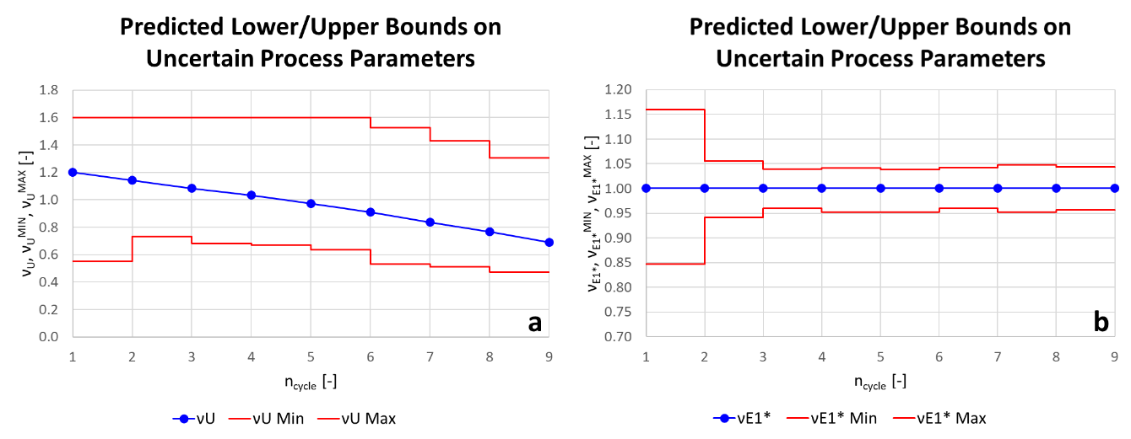
Figure 3: Batch-to-batch variations in the features of the Tennessee Eastman fed-batch reactor due to fouling ($ν_{U}$ – nondimensionalized global heat transfer coefficient; $v_{E_{1}^{*}}$ – nondimensionalized activation energy of one of the main reactions; blue lines – true values of $ν_{U}$ and $v_{E_{1}^{*}}$; red lines – confidence regions on $ν_{U}$ and $v_{E_{1}^{*}}$ at confidence level ≥ 99 %)
    - Robust soft-sensors and real-time risk assessment
Soft sensors are algorithms that provide estimates of the measurable/unmeasurable state variables of a process of interest, based on mechanistic/empirical process models and on experimental measurements of measurable state variables, manipulated variables and disturbances. They find application in many industrial sectors including the chemical and pharmaceutical industry, in which they are often responsible for inferential composition measurements (e.g. top/bottom tray composition in distillation columns and dosage API loading) and are used for estimation of key process indicators (KPIs) and product quality indicators (e.g. API temperature in freeze-drying processes and tablet tensile strength). However, conventional virtual sensors only provide point estimates of process state variables, complemented with very limited and inaccurate statistical information. Therefore, they may not be suitable for quantitative process monitoring and closed-loop control in regulated industries and in all those industrial processes, which manufacture high value-added goods (e.g. specialty chemicals).
Robust soft-sensors are novel types of virtual sensors that allow estimation of the joint PDF of measurable and unmeasurable process states along with their credible regions, at a reasonable computational cost. These new state observers rely on efficient model uncertainty quantification techniques, based on ODMCMC, and exploit the full-fledged nonlinear model of the process, thus can provide extensive and reliable statistical information on the estimates of the process states, which makes them suitable for any industrial application including real-time risk assessment and online quality control.
The architecture of a typical robust soft-sensor, configured for risk assessment, is shown in Figure 4. The sensor algorithm is comprised of an online phase and of an offline iterative phase, of which the first is carried out on the same time scale as model predictive control (MPC) strategies while the second is performed iteratively on a much longer time scale, proportional to a few times the characteristic transient time of the process.
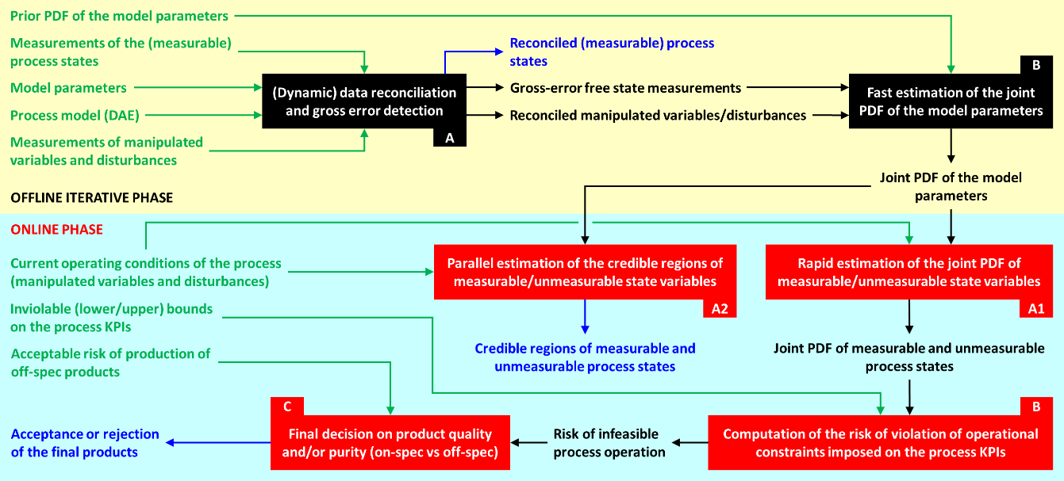
Figure 4: Typical architecture of a robust soft-sensor configured for risk assessment
The offline iterative phase serves to estimate/re-estimate the probability distribution of the uncertain parameters of the process model, based on process data collected since the previous PDF estimation (historical data replace process data the very first time we perform this operation). It is composed of two steps, executed in series. Specifically, we first solve a conventional (dynamic) data reconciliation problem with gross error detection, which allows identification and removal of potential gross errors from the process data set (Step A). Then, we approximate the PDF of the model parameters via fast PDF estimation techniques, specifically ODMCMC (Step B). This parameter distribution is then sent to the next phase of the algorithm.
The online phase is performed in a receding horizon fashion, similarly to MPC. It involves four steps, executed partially in parallel and partially in series. In steps A1 and A2, we make use of efficient methods for uncertainty propagation to predict the temporal trajectories of the joint PDF and of the credible regions of the process states over the next risk assessment interval (a risk assessment interval is equivalent to a control interval in MPC). Then, we utilize user-supplied lower/upper bounds on the process KPIs to estimate the risk of infeasible process operation within the next risk assessment interval (Step B). Finally, we compare this value of risk with a user-defined threshold and decide whether it is safe to assume that the products, produced over the next risk assessment interval, are on-spec, i.e. within specifications (Step C). The specific uses of this information and of the credible regions of the measurable and unmeasurable process states will depend on the type of process unit, equipped with the robust soft-sensor, and on the type of plant this process unit belongs to.
The effectiveness of this new robust virtual sensor system has been demonstrated on a pilot-scale drug product manufacturing process, which includes two feeders (one for the API and another one for the excipient), two blenders, a roller compactor and a tablet press. More specifically, the new sensor has been utilized to automatically identify and separate off-spec tablets from on-spec tablets, in real time, in the presence of three typical disruptive events: (I) a feeder recharge (this operation is common to most continuous pharmaceutical plants); and (II) two step changes in the excipient and API feed flows, due to as many variations in the desired API loading in the final product. The only process KPI, considered in this analysis, is the API loading in the final oral doses. The results, shown in Figure 5, confirm that the proposed robust virtual sensor can successfully identify off-spec tablets and suggest separating them from the on-spec product. Indeed, the temporal trajectory of the cumulative volume of on-spec product displays two flat regions (chart b), which clearly correspond to off-spec tablets, based on the 99 % credible region of the process KPI (chart a).
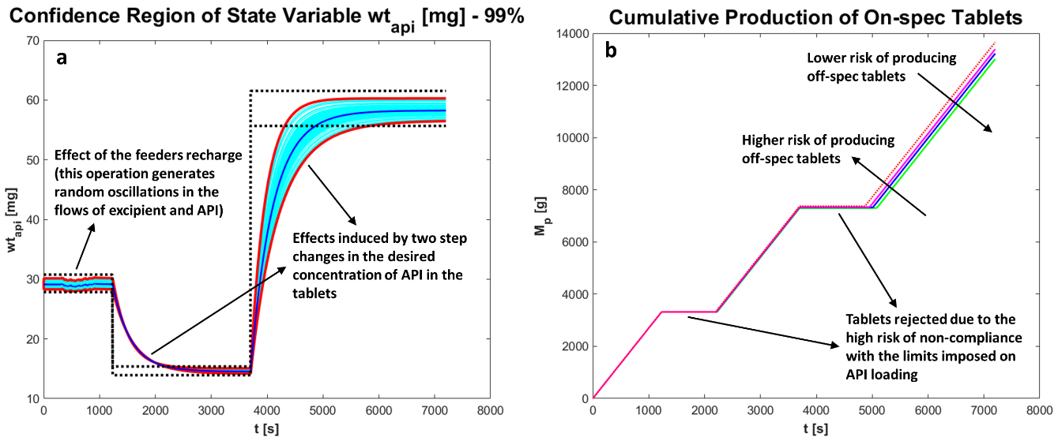
Figure 5: Outputs generated by the new robust soft-sensor algorithm applied to a pilot-scale drug product manufacturing plant (chart a: blue line – true value of the dosage API loading; red lines – 99 % confidence region on the dosage API loading; dotted black lines – lower/upper bounds on the KPI “dosage API loading”; chart b: dashed red line – maximum achievable production volume of on-spec tablets; solid green, blue and fuchsia lines – volume of on-spec tablets produced for increasing values of the acceptable risk of off-spec production)
  - Conclusions
The results of the case studies, reported herein, confirm that model uncertainty quantification techniques can significantly benefit dynamic optimization approaches, predictive maintenance frameworks, soft-sensor systems and risk assessment strategies both by mitigating some of their most significant limitations due to the inevitable presence of uncertainty in any model predictions, and by extending their application domain. Given the growing interest of the PSE and industrial communities in all of the aforementioned areas, we can expect uncertainty quantification to become one of the backbones of process systems engineering in the near future.
References
Abbiati R.A., Cavallaro G., Craparo E.F., Manca D., 2015, Sorafenib in mice – a pharmacokinetic study, Chemical Engineering Transactions, 43, 283–288.
Beal M.J., 2003, Variational algorithms for approximate Bayesian inference, PhD Thesis, University College London: The Gatsby Computational Neuroscience Unit, London, UK.
Chakraborti N., Mishra P., Aggarwal A., Banerjee A., Mukherjee S.S., 2006, The Williams and Otto chemical plant re-evaluated using a Pareto-optimal formulation aided by genetic algorithms, Applied Soft Computing, 6, 189–197.
Downs J.J., Vogel E.F., 1993, A plant-wide industrial process control problem, Computers & Chemical Engineering, 17, 245–255.
Green P.L., Worden K., 2015, Bayesian and Markov chain Monte Carlo methods for identifying nonlinear systems in the presence of uncertainty, Philosophical Transactions A, 373, 20140405.
Mockus L., Laínez J.M., Reklaitis G., Kirsch L., 2011, A Bayesian approach to pharmaceutical product quality risk quantification, Informatica, 22, 537–558.
Oravec J., Bakosova M., Vasickaninova A., Meszaros A., 2018, Robust model predictive control of a plate heat exchanger, Chemical Engineering Transactions, 70, 25–30.
Rossi F., Mockus L., Manenti F., Reklaitis G., 2018, Assessment of accuracy and computational efficiency of different strategies for estimation of probability distributions applied to ODE/DAE systems, Computer Aided Chemical Engineering, 44, 1543–1548.
Rossi F., Reklaitis G., Manenti F., Buzzi-Ferraris G., 2016, Multi-scenario robust online optimization and control of fed-batch systems via dynamic model-based scenario selection, AIChE Journal, 62, 3264–3284.

