|  |  |
| --- | --- |
| cetlogo ***CHEMICAL ENGINEERING TRANSACTIONS***  ***VOL. 76, 2019*** | A publication of  aidiclogo_grande |
| The Italian Association  of Chemical Engineering  Online at www.cetjournal.it |
| Guest Editors: Sauro Pierucci, Jiří Jaromír Klemeš, Laura Piazza  Copyright © 2019, AIDIC Servizi S.r.l. **ISBN** 978-88-95608-73-0; **ISSN** 2283-9216 | |

A Kinetic Biphasic Approach to Biodiesel Process Intensification

Elio Santacesariaa,\*, Vincenzo Russob, Riccardo Tesserb, Martino Di Seriob

aEurochem Engineering srl, Via Codogno 5 Milano (Italy);

b University of Naples Federico II, Chemical Sciences Department, Compl. Univ. M.S. Angelo, Via Cintia 4, I-80126 Naples

Corresponding author E.mail: info@eurochemengineering.com

Transesterification of vegetable oil with methanol, promoted by alkaline catalysts, has been tested in many different reactors and the reaction time to obtain a complete conversion, in some of these reactors, resulted in the range of few seconds. By using static mixers, micro-reactors, oscillatory-flow reactors, cavitation-inducing reactors, microwave reactors or centrifugal contactors, it is possible to obtain high biodiesel yields in a much shorter time than in stirred tank reactors. As these reactors are characterized by a very high liquid-liquid interface we can conclude that higher is the interface area shorter is the reaction time. This behavior cannot be described with the monophasic kinetic model reported in the literature. Therefore, we have developed a biphasic kinetic model that is able to describe any type of reactor such as: more or less stirred batch reactors, more or less efficient continuous structured reactors, micro-reactors etc. We have also experimentally observed that it is possible to obtain a complete conversion in less than 10 seconds by using a very efficient micro-mixer followed by a void settling tube of an opportune volume size. This reactor has been simulated also with the mentioned liquid-liquid biphasic model. This model is based on a reliable transesterification mechanism and takes into account both the intrinsic kinetic laws, mass transfer and reactants and products two phases partition. Some of the unexplained kinetic aspects, observed in batch runs, like the difference in the final conversions for different catalyst concentrations have been clarified with the biphasic model. This final conversion is due to catalyst deactivation and not to chemical equilibrium as suggested in the monophasic kinetic models normally employed in the literature. In this work, the developed biphasic approach will be applied on different kinds of laboratory reactors characterized by a different micromixing efficiency. The kinetic parameters for the intrinsic occurring reactions will be given and discussed. Moreover, the role of the mass transfer effect will be considered and the consequence of the methanol and glycerol partition on the conversion and yield will be described. By concluding, the possibility to produce biodiesel in a micro-device with residence times of few seconds will be experimentally shown and theoretically interpreted.

1. Introduction

The kinetics of transesterification reaction for producing biodiesel has been studied by many authors by introducing the oversimplification of assuming the existence of a unique homogeneous liquid phase. This approach, as before mentioned, has some drawbacks that are: (i) runs performed at the same temperature, with different amounts of catalysts, giving different final yields cannot be correctly interpreted; (ii) runs performed in continuous reactors characterized by very high local turbulence and giving place to very high yields in a very short time of few seconds cannot be interpreted; (iii) it is reasonable to think that the kinetics of transesterification is roughly the same independently of the oil employed as raw material but with the pseudo-monophasic kinetic model different kinetic parameters must be used for each oil considered. In the present paper a biphasic kinetic model, based on a reliable reaction mechanism, is proposed. As it will be seen, the drawbacks of the pseudo-monophasic model are all removed. The main novelty of the paper is that experiments conducted at different agitation speed were correctly simulated with a unique set of kinetic parameters independently on the vegetable oil. The concept is to fit only the parameters related to the liquid-liquid mass transfer depending on: flow-rate for the continuous device, stirring rate for the batch system.

1. The transesterification reaction mechanism

Two different mechanisms have been proposed in the literature for the transesterification of triglycerides promoted by KOH or NaOH alkaline catalysts. First of all, KOH and NaOH dissolve in methanol giving place to the equilibrium reaction:

K+ OH- + CH3OH K+ CH3O- + H2O (1)

Then, in both the mechanism the first step is a nucleophilic attack of the alkoxide anion to a carbonylic group of a triglyceride molecule with the formation of a tetrahedral intermediate anionic specie:

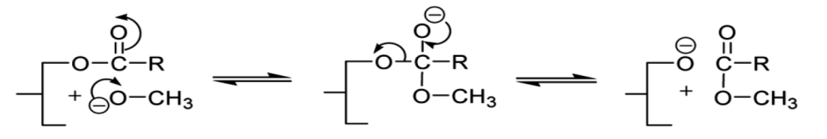 (2)

According to Dijkstra et al. (2005) the diacylglyceroxide anions D- reacts successively with a triglyceride molecule T, inside the oil phase, to give an intermediate enolate anion and the diacylglycerolate molecule D through the following reaction:

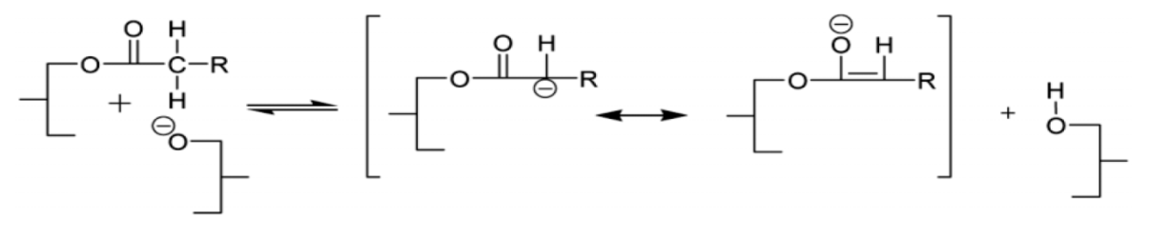 (3)

Then, the enolate anion further reacts with methanol dissolved in the oil phase to give the first molecule of the desired product (biodiesel) E and another molecule of diacylglycerolate anion:

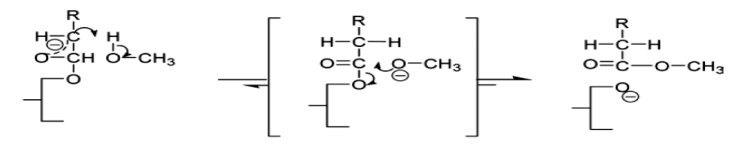 (4)

The methoxide and diacylglycerolate anions can also react with diacylglycerolate D, with a similar mechanism, giving place to a monoglycerolate anion M- and trough the corresponding enolates to the monoacylglycerolate M and a second molecule of ester E. In a similar way, CH3O-, D- and M- finally can both react with monoglycerolate M to give the glycerol anion G- and via enolate to glycerol and product E. Glycerol G and glycerolate anion G- migrate into the polar phase and G- is involved in the following exchange equilibrium:

CH3OH + G-  CH3O- + G

G- is much less active than CH3O- in promoting the transesterification reaction and its presence gives place to an inhibitory effect on the reaction rate. In conclusion, methoxide anions more or less quickly disappear by reacting at the external surface of the oil drops giving place to a family of anions D-, M- that are the true catalytic species formed in situ. In particular, D- and M- being completely dissolved in the oil phase promptly react as previously described. On the contrary when glycerol anion G- and glycerol are formed both migrate toward the polar phase of methanol subtracting catalyst to the system and slowing down the reaction. On the basis of this mechanism, it is reasonable to assume that the reaction rate is strongly affected by the interface area where the methoxide anions react with the triglyceride molecules to form the true reaction catalysts M-, D- and G-. As we have seen, the product formation E (biodiesel) occurs as a consequence of ionic reactions that are normally very fast. D and M are tenside molecules, in particular D- and M- are more powerful as surfactant. This tenside effect favor the drops breakage of the dispersed polar phase so increasing the interface area and increasing consequently the reaction rate.

The second mechanism proposed by different authors (see: Ma et al. (1999), Komers et al. (2002), Tapanes et al. (2008), Samios et al. (2009)) is characterized by two or more steps but the most important difference with respect to the mechanism suggested by Dijkstra et al. (2005) is that methoxide anion is restored after each catalytic step, as for example in the following simplified mechanism:

(5)

Accepting this mechanism methoxide anion, dissolved in the dispersed polar phase, reacts at the liquid-liquid interface and the mass transfer of this specie at the boundary layer affect the overall reaction rate.

As in both the mechanisms the interface area is a crucial parameter it is difficult to ascertain what is the most reliable mechanism and an accurate comparison would be necessary. In the present work, we based the kinetic study just on a simplified version of the Dijkstra et al. (2005) mechanism, while, in a future work the second mechanism will be considered.

1. The kinetic model based on a simplified Dijkstra et al. (2005) mechanism

By neglecting the enolate intermediates it is possible to write:

1. Reactions occurring at the liquid-liquid interface and related kinetic equations:
2. T + CH3O- D- + E (6)
3. D + CH3O- M- + E (7)
4. M + CH3O- G- + E (8)

p and a mean respectively polar and apolar phase. The kinetic constants for the three reactions occurring at the interface have been reasonably considered equals.

1. Reactions occurring in apolar phase
2. D- + CH3OH M- + E (9)
3. M- + CH3OH G- + E (10)
4. T + CH3OH D + E (Catalyst (D-+M-)) (11)
5. D + CH3OH M + E (Catalyst (D-+M-)) (12)
6. M + CH3OH G + E (Catalyst (D-+M-)) (13)

The reactions 6, 7 and 8 have been written neglecting the intermediate formation of the enolates species by supposing that their concentrations are low as their disappearing reaction is very fast.

1. Reaction occurring in polar phase
2. CH3OH + G- CH3O- + G (14)

The dependence of the kinetic constants on the temperature can be expressed in all cases by the relationship:

$k_{i}=k_{i}^{ref}exp\left[\frac{E_{a_{i}}}{R}\left(\frac{1}{T^{ref}}-\frac{1}{T}\right)\right]$ (15)

Reaction (9) could be considered near to the equilibrium. Methanol and glycerol are more intensively transferred between the two phases with respect to the other compounds and the equations describing their mass transfer rates are respectively:

*Polar phase:*

$J_{CH_{3}OH}^{p} ={ k}_{l,CH_{3}OH}∙a∙\left({\left[CH_{3}OH\right]}^{p}-H_{CH_{3}OH}∙{\left[CH_{3}OH\right]}^{a,*}\right)$ (16)

$J_{G}^{p} ={- k}_{l,G}∙a∙\left({\left[G\right]}^{p}-H_{G}∙{\left[G\right]}^{a,*}\right)$ (17)

$J_{G^{-}}^{p} ={- k}_{l,G^{-}}∙a∙\left({\left[G^{-}\right]}^{p}-H_{G}∙{\left[G^{-}\right]}^{a,*}\right)$ (18)

*Apolar phase*

$J_{CH_{3}OH}^{a} ={ k}_{l,CH_{3}OH}∙a∙\left({\left[CH_{3}OH\right]}^{a,*}-{\left[CH_{3}OH\right]}^{a}\right)$ (19)

$J_{G}^{a} ={- k}_{l,G}∙a∙\left({\left[G\right]}^{a,*}-{\left[G\right]}^{a}\right)$ (20)

$J_{G^{-}}^{a} ={- k}_{l,G^{-}}∙a∙\left({\left[G^{-}\right]}^{a,*}-{\left[G^{-}\right]}^{a}\right)$ (21)

The interfacial concentration (denoted by suffix \*) can be calculated solving the following balance that, considering a steady-state condition, is always valid for the J component.

$J_{J}^{p}∙V^{p} =J_{J}^{a}∙V^{a}$ (22)

It is It is then possible to write:

${\left[J\right]}^{a,*} =\frac{V^{p}∙β_{j}∙{[J]}^{p}+β_{j} ∙V^{a}∙{[J]}^{a}}{β_{j} ∙V^{a}+V^{p}∙β_{j}∙H_{A}}$ (23)

${\left[J\right]}^{p,*} =H_{J}∙{\left[J\right]}^{a,*}$ (24)

With βj = kl,j a.

To solve the mass transfer equations it is necessary to define the partition parameters: Hj = [J]a / [J]p for both methanol and glycerol. The solubility parameters have been estimated by using ChemCAD V. 6.3 and UNIFAC LLE model and the evolution of these parameters with the triglycerides conversion (x) has been estimated and expressed with the two following polynomial equations:

$\frac{1}{H_{CH_{3}OH}}=25.85-23x-11.21x^{2}+ 36.41x^{3}$ (25)

$\frac{1}{H_{G}}=6304.75-15430.10x-1643.71x^{2}+64912.73x^{3}-92127.03x^{4}+43103.45x^{5}$ (26)

1. Mass balance for both polar and apolar phase

Apolar phase

$\frac{d{[T]}^{a}}{dτ}=-r_{1}-r_{4}$

$\frac{d{[D]}^{a}}{dτ}=+r_{4}-r_{5}-r_{1'}$

$\frac{d{[M]}^{a}}{dτ}=+r_{5}-r_{6}-r_{1''}$

$\frac{d{[G]}^{a}}{dτ}=+r_{6}-J_{G}^{a}$

$\frac{d{[E]}^{a}}{dτ}=+r_{1}+r_{1'}+r_{1''}+r_{2}+r_{3}+r_{4}+r_{5}+r_{6}$

$\frac{d{[CH_{3}OH]}^{a}}{dτ}=-r_{2}-r_{3}-r_{4}-r_{5}-r_{6}+-J_{CH_{3}OH}^{a}$

$\frac{d{[D^{-}]}^{a}}{dτ}=+r_{1}-r_{2}$

$\frac{d{[M^{-}]}^{a}}{dτ}=+r_{2}-r_{3}+r_{1'}$

$\frac{d{[G^{-}]}^{a}}{dτ}=+r_{3}-J_{G^{-}}^{a}+r_{1''}$

Polar phase

$\frac{d{[CH_{3}OH]}^{p}}{dτ}=-J_{CH_{3}OH}^{p}-r_{7}$

$\frac{d{[G]}^{p}}{dτ}=+J_{G}^{p}+r_{7}$

$$\frac{d{[{CH_{3}O}^{-}]}^{p}}{dτ}=-(r_{1}+r_{1'}+r_{1''})∙\frac{V_{a}}{V_{p}}+r_{7}$$

$\frac{d{[G^{-}]}^{p}}{dt}=+J_{G^{-}}^{p}-r_{7}$

$${\left[{CH_{3}O}^{-}\right]}^{p,0}={[KOH]}^{p}$$

The symbol $τ$ corresponds to the time for runs performed in batch reactors, while, is the residence time for reactions performed in continuous tubular reactors. This model has been succesfully employed until now for interpreting all the batch runs performed respectively by Vicente et al. (2005 and 2006) using sunflower and brassica oil, and by Nourredini et al.(1997), using soybean oil, reproducing also the sigmoid shapes of conversion curves obtained at low stirring rates and the different yields obtained at a given temperature for different catalyst loaded amounts. The kinetic parameters obtained by mathematical regression analysis were the same for interpreting all the mentioned runs with the exclusion of the interface area and the mass transfer parameters that are obviously dependent on both the type of employed device and the operating fluid dynamic conditions. Finally, the same model with the same parameters has been used for interpreting also the runs performed by Berchmans et al. (2013) by using Jathropa Curcas oil. The interpreted runs have been made at different stirring rates from 400 to 1200 rpm and at different temperatures keeping constant the stirring rate at 900 rpm. The obtained agreements can be appreciated in Figures 1 and 2, while, the adjustable parameters kL and aL, obtained by parameter estimation analysis on the available experimental data, are reported in the legend of Figure 1 as empirical correlations characteristic of the employed device.



*Figure 1 – Oil conversions for different stirring rates. Runs performed by Berchmans et al. (2013) at 50°C using Jathropa Curcas oil with a methanol:oil molar ratio = 6. Catalyst KOH 1%.*





The same kinetic parameters have also been employed for describing 36 continuous runs performed in tubular reactors containing materials of different size and shape acting as static mixers, as described in the works published by Santacesaria et al. (2012 a,b,c). Finally, the same model with the same parameters has been used for describing 16 continuous runs performed by using a very efficient Micro Mixer (SIMM-V2 of IMM) followed a void cylindrical tube (see Santacesaria et al., 2012 a, b, c) in a device arranged as in Figure 3. Also in this case, liquid-liquid mass transfer parameters were fitted on the available experimental data.

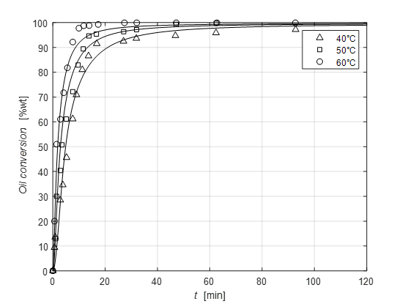

*Figure 2 – Oil conversion for different temperatures. Runs performed by Berchmans et al. (2013) at 900 rpm using Jathropa Curcas oil with a methanol:oil molar ratio = 6. Catalyst KOH 1%.*

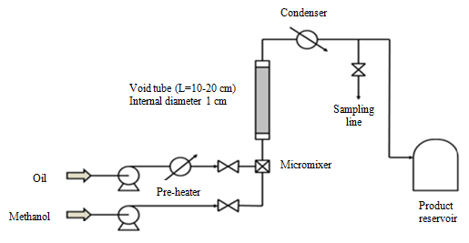

*Figure 3 - Scheme of the plant employed for the continuous runs with Slit Interdigital Micromixer of IMM*

The kinetic parameters obtained by interpreting all the mentioned kinetic runs are reported in Table 1.

The adjustable parameters for interpreting all the mentioned batch and continuous kinetic runs are only two and both depend on the specific interface area, that is: *γ1*=*k1*∙*aL* and *βC*=*kL*∙*aL*. Therefore, a refinement of the kinetic model would be to find a reliable correlation of the specific interface area with the fluid dynamic conditions and the tenside properties of the liquid-liquid mixture.

An example of the obtained agreements in the interpretation of both batch and continuous runs can be appreciated from the parity plot of Figure 4.

*Table 1 – Kinetic parameters determined by mathematical regression analysis from batch runs respectively performed by Vicente et al. (2005) and (2006) and Nourredini et al. (1997) and successfully employed for simulating continuous runs performed in tubular reactors filled with static mixers.*

|  |  |  |
| --- | --- | --- |
| Parameters | Values | Units |
| k2 | 0.225 | La/(mol∙min) |
| k3 | 0.225 | La/(mol∙min) |
| k4 | 18.16 | L2,a/(mol2∙min) |
| k5 | 4.61 | L2,a/(mol2∙min) |
| k6 | 1.92 | L2,a/(mol2∙min) |
| Keq,7 | 1.69·10-3 | - |
| Ea1 | ≈ 0 | kcal/mol |
| Ea2 | 17.61 | kcal/mol |
| Ea3 | 26.62 | kcal/mol |



*Figure 4 – Parity plot in which all the results of the simulation made by using different types of reactors are compared with the experimental results. Well stirred batch reactor* (⯈)*,continuous reactor filled with respectively:* (◼) *stainless steel spheres of 2.5 mm diameter,* (△) *double distribution of stainless steel spheres of 2.5/1mm diameter,* (⯅) *double distribution of stainless steel spheres of 2.5/0.39mm diameter,* (🞎) *stainless steel wool,* (▽) *threaded roads,* (◁) *micro-mixer in series with a void tube of 1/2” external diameter and 10 or 20 cm length,* (⯆) *micro-mixer in series with a Teflon capillary tube of 1/16” external diameter and 10 cm length. (see Santacesaria et al. 2012 b,c)*

1. Conclusions

A biphasic kinetic model able to describe the synthesis of biodiesel in any kind of reactor (batch, continuous, microreactor) has been developed. The kinetic parameters obtained by mathematical regression analysis extended to all the experimental runs considered are the same for different oils considered such as: Sunflower oil, Brassica Carinata oil, Soybean oil and Jathropa Curcas oil.

References

Berchmans H. J., Morishita K., Takarada T., 2013, Kinetic study of hydroxide-catalyzed methanolysis of

Jatropha curcas–waste food oil mixture for biodiesel production, Fuel 104, 46–52.

Dijkstra A.J., Toke E. R., Kolonits P., Recseg K., Kovári K, Poppe L., 2005, The base-catalyzed, low-

temperature interesterification mechanism revisited, Eur. J. Lipid Sci. Technol. 107, 912–921.

Komers K., Skopal F. Stloukal R., Machek J, *2002,* Kinetics and mechanism of the KOH – catalyzed

methanolysis of rapeseed oil for biodiesel production, Eur. J. Lipid Sci. Technol. 104,728–737.

Ma F., Hanna M.A., 1999, Biodiesel production: a review, Bioresource Technology 70,1-15.

Noureddini H., Zhu D., 1997, Kinetics of Transesterification of Soybean Oil, *JAOCS 74*, 1457–1463.

Samios D., Pedrotti F., Nicolau A., Reiznautt Q.B., Martini D.D., Dalcin F.M., 2009, A Transesterification

Double Step Process — TDSP for biodiesel preparation from fatty acids triglycerides, Fuel Processing

Technology 90 599–605.

Santacesaria E., Vicente G. Martinez, Di Serio M., Tesser R.; 2012a, Main Technologies in biodiesel

production: State of the art and future challenges; Catalysis Today, 195(1), 2-13.

Santacesaria E., Turco R., Tortorelli M., Russo V., Di Serio M., Tesser R.**;** 2012b,Biodiesel process

intensification: the role of the liquid-liquid interface area in the achievement of a complete conversion in

few seconds; Green Process Synth. 1,181-189.

# Santacesaria E., M. Di Serio, R. Tesser, R. Turco, M. Tortorelli, V. Russo; 2012c, Biodiesel Process

# Intensification in a very simple microchannel device; Chemical Engineering and Processing: Process

# Intensification 52,47-54.

# Tapanes N.C. Om, Aranda D. A. Gomes, Carneiro J.W. de Mesquita, Antunes O. A. Ceva, 2008,

Transesterification of Jatropha curcas oil glycerides: Theoretical and experimental studies of biodiesel

reaction, Fuel 87, 2286–2295.

Vicente G., Aracil J., Martınez M., Esteban A., 2005, Kinetics of Sunflower Oil Methanolysis, Ind. Eng. Chem.

Res. 44, 5447-5454.

Vicente G., Martinez M., Aracil J., 2006, Kinetics of Brassica carinata Oil Methanolysis, Energy & Fuels**,** 20,

1722-1726