CHEMICAL ENGINEERING TRANSACTIONS  VOL. 76, 2019 | A publication of
The Italian Association
of Chemical Engineering
Online at www.cetjournal.it
Guest Editors: Sauro Pierucci, Jiří Jaromír Klemeš, Laura Piazza
Copyright © 2019, AIDIC Servizi S.r.l.
ISBN 978-88-95608-73-0; ISSN 2283-9216

Practical Controllability and Systematic Tuning in a Control System of Bioethanol Purification
Jesús M. Zamudio-Lara, Oscar D. Lara-Montaño, Héctor Hernández-Escoto*, Salvador Hernández-Castro, Fernando López-Caamal
Departamento de Ingeniería Química, Universidad de Guanajuato, Noria Alta s/n, 36050, Guanajuato, Gto., México.
hhee@ugto.mx

For a system of bioethanol purification based on extractive distillation, this work addresses the problem of determining the better control configuration and the systematic tuning of the PI controllers in a framework of physical insight. The purification system is a distillation column train consisting of a preconcentration column, a dehydration column and a entrainer recovery column. To establish the control loops, a parameter called Operability Index (OI) was proposed and applied. All possible control loops were evaluated, and unlike typical works, also impurities in the product streams were considered as control outputs. The outcomes suggested that less control effort is achieved by controlling impurities than controlling purities; this means, the OI for impurities were lower than the ones for purities, and the control configuration was easily established by choosing loops of small OI. In the next step of tuning the linear PI controller for each loop, an approach of stable pole assignment was followed. Through this technique, all controllers were tuned simultaneously, and the values of the controller gains were calculated directly from the static gains and a pseudo time constant identified for every loop; this pseudo time constant corresponds to the best first order dynamics matched to the dynamics of the control output with respect to unit change of the control input. Through simulations in Aspen Plus Dynamics®, the performance of controlling impurities was illustrated and compared with the one of controlling purities, and the simultaneous tuning of controllers was demonstrated.
  - Introduction
Since the petroleum crisis in the 1970s, renewable energy sources have been sought that are environmentally friendly due to the high emission of gases caused using fossil fuels (Meirelles et al., 1992). In this scheme, biofuels have been widely accepted, and particularly bioethanol has become the most popular because it could substitute gasoline. It is obtained by fermentation of sugar coming from different raw materials such as sugar cane, corn, sorghum, etc.; however, one production disadvantage is that ethanol concentration in the fermentation broth is very low (5-12 %wt), and the component with the highest concentration is water. In order to be used as a fuel, bioethanol must have an ethanol concentration of 99.5 %wt to not generate two phases when mixed with gasoline (Ramos et al., 2013).
To achieve the desired bioethanol composition, several purification alternatives have been proposed based on pervaporation, adsorption, distillation with pressure change, extractive distillation, etc. (Folkrova & Raeva, 2010; Kiss et al.,2014). Among these alternatives, distillation-based alternatives have been the most widely used, and mainly extractive distillation due to the azeotropic nature of the ethanol-water mixture, which requires a third compound known as entrainer to interact with the ethanol-water mixture and dehydrate the bioethanol. Due to the low concentration of bioethanol that is obtained in fermentation, it must be processed through a preconcentration process, then pass to a dehydration stage where pure ethanol is obtained, and finally the entrainer-water is taken to a third separation process where the entrainer is recovered and recirculated to the second stage (Kiss & Ignat, 2012).
The design of this kind of processes has been widely addressed; however, the issue on control is scarce. In the open literature just a few works are found (Gil et al., 2012), showing the feasibility of controlling this kind of purification systems with conventional PI controllers. They have established the control configuration under an RGA approach and tuning the controllers with Ziegler-Nichols and Tyreus-Luyben type techniques. These works enclose a high component of trial-and-error activity to achieve the goals. It is worth to highlight that the complex nature of ethanol-water mixture makes corresponding distillation columns to have a sensitive behaviour, and characteristics a little away from systems considered as ideals, so other control configurations with respect to conventional are worth to be considered. Even more, since ethanol composition in fermentation broths is variable, the purification system must be robust, and systematic schemes of tuning are convenient for likely future changes in established process systems.
Since the above mentioned, aimed to make robust the performance of a control system, in this work the consideration of controlling impurities is explored, following a Luyben’s proposal (Luyben, 1992). In this way, in order to establish in an easy way an effective control configuration, also it is explored the physical insight outcomes of a known parameter that in this work is called Operability Index. In the construction of the control system, conventional PI controllers are considered, and a technique proposed by Zavala-Guzman et al. (2012) is applied to tune the controllers in a systematic way.

2. Bioethanol purification process

Due to the low concentration of ethanol produced in fermentation (5-12 %wt), it is necessary to carry out its purification in order to achieve fuel grade bioethanol (99.5 %wt) (Kiss & Ignat, 2012). To do this, first fermentation broth is taken through a preconcentrating column where the water is removed to leave the remaining mixture with an ethanol concentration (e.g., 91 %wt) near the azeotropic point (95.6 %wt). This preconcentrated bioethanol is run out by the dome and driven to the dehydration column. This is an extractive distillation column where a third compound known as entrainer is added, which modifies the properties of the azeotropic mixture causing that water is taken along with the extractant by the bottom, and allowing the bioethanol goes through the dome with a 99.5 %wt of purity; this dehydrated bioethanol can be used in blends with the gasoline. On the other hand, the bottom stream, in which the water is mixed with the entrainer, is driven to the recovery column where the entrainer is recovered and recirculated to the dehydrating column. Figure 1 shows the scheme of the bioethanol purification process.
It was considered a feed stream to the preconcentration column of 507.08 kmol/hr with a composition of 10 %wt of ethanol and 90 %wt of water. The ethanol composition in the preconcentration column’s dome must be 91 %wt, and in the bottom the water composition is 99 %wt. In the dehydration column, the ethanol composition in the dome is 99.5 %wt, while in the bottoms it should not exceed 0.1 %wt and finally in the recovery column, glycerol composition should not exceed 99.9 %wt in the bottom stream and in the dome should be less than 0.1 %wt.
The design of this process was carried out in the commercial simulator Aspen Plus®, and subsequently exported to Aspen Dynamics® for the study of process dynamics and performance of the control system.

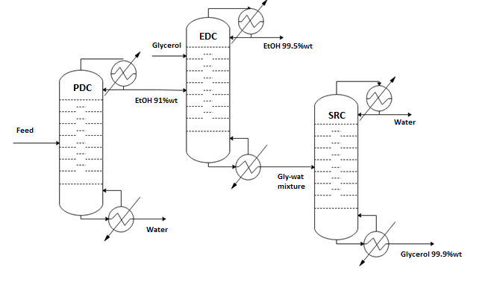
Figure 1: Flowsheet of bioethanol purification process

3. The Control System Configuration and the Operability Index

In a first step of setting up an effective configuration for the control system of the purification process (Figure 1), as control outputs, two sets can be considered: (i) purity of ethanol in the dome streams (x_{DEtOH}) of preconcentration column and dehydration column, purity of water in the bottom streams (x_{Bwater}) of these columns, and purity of water (x_{Dwater}) in the dome stream of recovery column and purity of entrainer in the bottom stream (x_{Bglycerol}) of this column; and (ii) impurity given by water in the dome stream (x_{Dwater}) of preconcentration column and by entrainer (x_{Dglycerol}) in the dome stream of the dehydration column, impurity given by ethanol in the bottom streams (x_{BEtOH}) of preconcentration column and dehydration column, impurity given by entrainer in the dome (x_{Dglycerol}) of recovery column, and water in the bottom (x_{Bwater}) of this column. As control inputs, reflux ratio (RR) and reboiler duty (Q_{R}) are considered for every column, and entrainer input flow is additionally considered for the dehydration column.
The feasibility of certain control input to move certain control output can firstly be visualized through the corresponding static gain; however, this information is not sufficient to determine if the control output can effectively take the control output to a desired point. In other words, although the control input can drive the control output, by taking into account the control input span provided by process constraints, the necessary values in the control input might be unfeasible. In addition, if there is more than one choice of control input, and more than one control output, the matter turns into which control input would make the lesser effort to drive any control output, and the control input-control output pairing becomes in a combinatorial problem.
An estimation, in terms of percentage with respect to the nominal value, of the change that must be made in certain control input (u_{i}) to drive a unit change in certain control output (y_{i}), in percentage in relation to its nominal value as well, is given by the following parameter, which in this work is proposed to call as Operability Index (OI):

$${OI}_{ij}=\frac{\overline{y_{j}}}{\overline{u_{i}}} .\frac{1}{K_{ij}}$$ | (1)

where $\overline{u_{i}}$ is the nominal value of u_{i} and $\overline{y_{j}}$, the one of y_{j}; K_{ij} is the static gain of the control input-control output pair (u_{i}, y_{j}). Although K_{ij} can be accurately calculated through a linearization of the process model and application of Laplace transform to obtain the transfer function of the pair (u_{i}, y_{j}), in the cases of this work, which are systems of high-dimension and nonlinear models, K_{ij} can be easily calculated through the reaction curve method (Romagnoli & Palazoglu, 2012).
Since K_{ij} does not enclose the effect of other inputs on y_{j}, but only u_{i}, so OI_{ij} likewise; so, if there were other acting inputs with a kind of adverse effect, the OI value can be seen as the lowest change of u_{i} that brings about the unit change of y_{j}. Therefore, if the OI for different control input-control output pairs are compared each other, the better pair at least must have the lower OI.

4. PI Controller and Tuning

The aim of the control system is to maintain the ethanol composition above its nominal value in the dome of the preconcentration column and in the dehydration column´s dome, and the glycerol composition above its nominal value at the bottom of the recovery column.
Once the control configuration has been set, on the tuning of linear PI controllers for each control input-control output pair (u_{i}, y_{j}),
$$u_{i}\left(t\right)= {\overline{u}}_{i}+k_{C}^{ij}∙\left(y_{j}\left(t\right)-{\overset{̿}{y}}_{j}\right)+\frac{k_{C}^{ij}}{τ_{I}^{ij}} ∙ \int_{0}^{t}{\left(y_{j}\left(θ\right)-{\overset{̿}{y}}_{j}\right)∙dθ}$$ | (2)
where $u_{i}$ = reflux or reboiler duty and $y_{j}$ = ethanol, or glycerol, or water. $u_{i}$ is any of the control inputs, and $y_{j}$ is any of the control outputs
The tuning relationships used are from Zavala-Guzmán et al. (2012), which were applied straightforwardly,
$$k_{C}^{ij}=\frac{2n-1}{K_{ij}}$$ | (3)
$$τ_{I}^{ij}=τ_{p}^{ij}∙{\left(ξ_{ij}\right)}^{2}∙\left(\frac{2n-1}{n^{2}}\right)$$ | (4)

where the proportional gain ($k_{C}^{ij}$) and the integral time ($τ_{I}^{ij}$) of the controller are calculated through three parameters: (i) a kind of time constant ($τ_{p}^{ij}$), (ii) a kind of damping factor ($ξ_{ij}$), and (iii) a kind of final-adjustment button (n). The time constant refers to the one of the better first order model that describes the open-loop behavior of the pair (u_{i}, y_{j}). The damping factor refers to the one of a second order model pretended to be followed by the closed-loop behavior of the pair (u_{i}, y_{j}). The parameter n refers to the times the closed-loop behavior is desired faster than the open-loop behavior.

6. Results
The Operability Index (OI) was obtained for each column to find the best input-output control pair and simultaneously an RGA was done with the aim of comparing the performance of the control loops found by OI and RGA. In order to find the OI, the static gain of the process is needed. To determine it, a change of ±1 % was applied to the input variables of each column and the output trajectories were recorded until there was no significant change, the final value was taken and divided between the nominal value of the output variable, thus obtaining the static gain for each column. Subsequently, the equation (1) was applied to obtain the OI for each column and the control loops with the closest value to zero are chosen. Table 1 shows the result of the OI for the preconcentrator column (PDC), in the same way it was found for the other columns, respectively, being those that are in bold the control loops that require less effort in the input variables. Table 2 shows RGA for PDC, it can be noted that control loops are different that the ones obtained by OI; the RGA analysis says that pairs with a negative value must be avoided and that´s why the control pairs shown in the Table 2 are selected. But the OI analysis says that the pairs that RGA does not take in account are the ones that require a minor effort in the control inputs. In the case of the purities the OI and RGA shows the same control pairs and they are the same as the heuristic approach dictates. The OI values are higher which means a larger effort is required by the control input.
Table 1: Operability index for PDC
Control input | $$x_{DEtOH}$$ | $$x_{Bwater}$$ | $$x_{Dwater}$$ | $$x_{BEtOH}$$
 | Purity |  | Impurity
RR | 11.81 | -13.47 | -1.16 | 0.13
Q_{R} | -5.60 | 3.01 | 0.55 | -0.03
Table 2: RGA for PDC
Control input | $$x_{DEtOH}$$ |  | $$x_{Bwater}$$ | $$x_{Dwater}$$ | $$x_{BEtOH}$$
 | Purity |  |  | Impurity
RR | 1.8845 |  | -0.8845 | -0.8871 | 1.8871
Q_{R} | -0.8845 |  | 1.8845 | 1.8871 | -0.8871

These results indicate that if impurities were controlled, the control loops for the preconcentration column are (RR, x_{Dwater}) and (Q_{R}, x_{BEtOH}), for the dehydration column are (RR, x_{Dwater}) and (Q_{R}, x_{BEtOH}), and for the solvent recovery column are (RR, x_{Dglycerol}) and (Q_{R}, x_{Bwater}). If purity were controlled, the control loops are as follows: for the preconcentrator are (RR, x_{DEtOH}) and (Q_{R}, x_{Bwater}), for the extractive column are (RR, x_{DEtOH}) and (Q_{R}, x_{Bwater}), and finally for the solvent recovery column are (RR, x_{Dwater}) and (Q_{R}, x_{Bglycerol}). Figure 2 shows the control loops implemented in the process. Once the control loops were obtained, the controllers for each distillation column were implemented and tuned using stable pole assignment technique. A damping factor of 0.8412 was used for all cases and n varied for each controller.

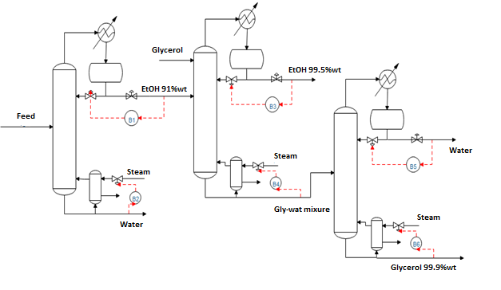
Figure 2: Control Loops for each column.

To determine the performance of the controllers, a disturbance of +5 % was applied in the ethanol composition of the feed stream to the preconcentration column. In Figures 3-8, it can be observed that the performance of the controller is better when controlling the impurity since the time in which the nominal value is reached is smaller than when controlling the purity. In the case of the preconcentration column, it can be observed that the control inputs do not change radically when implementing one controller or another. In the case of the extractive column, by not being able to control with the purities, it is concluded that the best option is to control impurities, and this has also meaning in the input variables that it would require a lot of effort to control purity, this could also be observed with the OI.
Something to keep in mind was that for the case of controlling the purities in the extractive column was not achieved to reach the nominal value; even that this was tried for several values of n, resulting easier to control impurities in the distillation process.
In the recovery column, the reboiler duty is slightly higher when the impurity is controlled for impurity. Also, for the RGA, the performance can´t be determined because the column could not be controlled for both the control purities and impurities although the value of n varied.
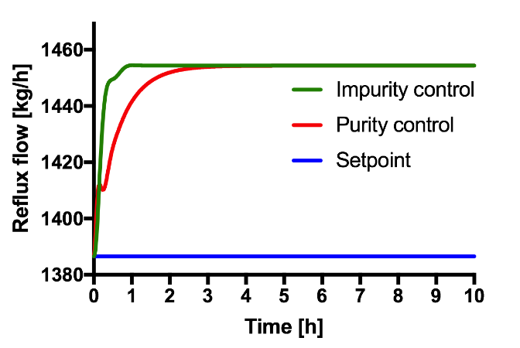
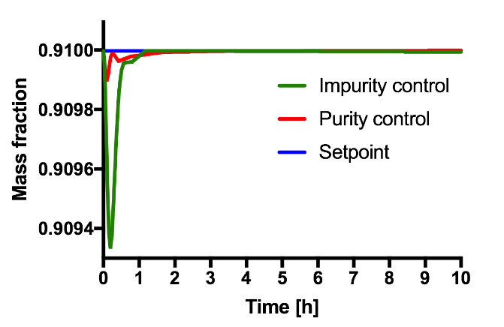
Figure 3: Performance of the controller for the PDC Figure 4: Change in the control input for the PDC
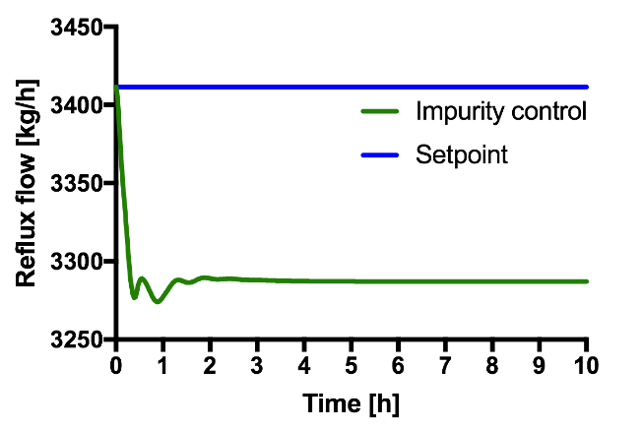
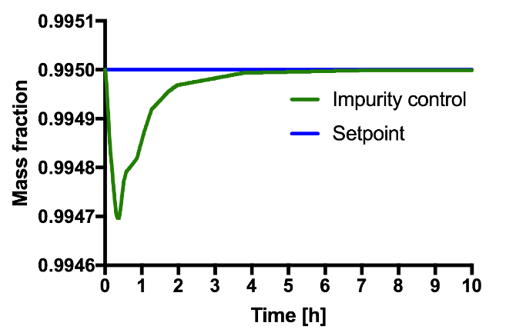
Figure 5: Performance of the controller for the EDC Figure 6: Change in the control input for the EDC
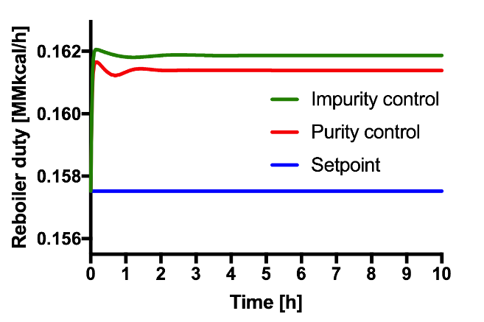
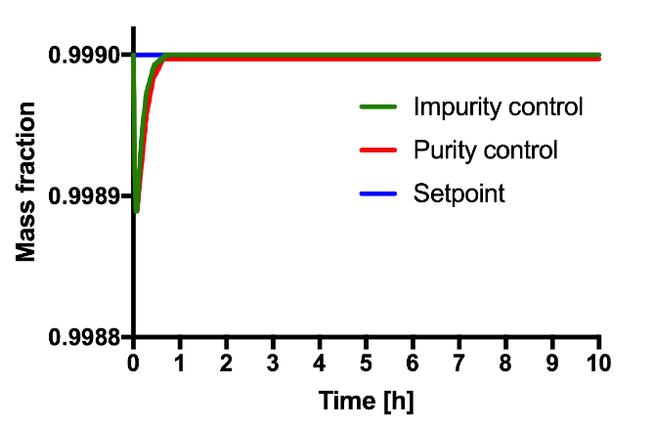
Figure 7: Performance of the controller for the SRC Figure 8: Change in the control input of the SRC
  - Conclusions
By using the Operability Index, the best control loops were obtained for each column of the bioethanol purification process, the control loops that showed the operability indices closest to zero were chosen, and these were the ones belonging to the respective impurities for each output stream; this means that controlling impurities in each stream give rise to less control effort in the control inputs. Once these results were obtained, the controllers for the study case of impurities and purities were implemented and tuned using a stable pole assignment approach choosing the best n value where the trajectories did not present too many oscillations. Finally, Luyben's advice could be corroborated, which indicates that it is easier to control the impurities of the process, this can be seen by the faster response of the controller and therefore arrives earlier to the setpoint, not so when controlling the purity that takes longer to reach the nominal value or simply does not reach the setpoint. It was also shown that for the extractive column, it was not possible to control by using purities what Luyben once again states.

References
Frolkova A. K., Raeva, V. M., 2010, Bioethanol dehydration: State of art. Theoretical Foundations of Chemical Engineering, 44(4), 545-556.
Gil I. D., Gómez J. M., Rodríguez G., 2012, Control of an extractive distillation process to dehydrate ethanol using glycerol as entrainer. Computers and Chemical Engineering, 39, 129-142.
Kiss A. A., Ignat R. M., 2012, Innovative single step bioethanol dehydration in an extractive dividing-wall column, Separation and Purification Technology, 98, 290-297.
Kiss A. A., Ignat R. M., Bildea C. S., 2014, Optimal Extractive Distillation Process for Bioethanol Dehydration, Computer Aided Chemical Engineering, 33, 1333-1338.
Luyben W. (Ed), 1992, Practical Distillation Control, Van Nostrand Reinhold, New York, the United States of America.
Meirelles A., Weiss S., Herfurth H., 1992, Ethanol Dehydration by Extractive Distillation, J. Chem. Tech. Biotechnol, 53, 181-188.
Ramos M. A., García-Herreos P., Gómez J. M., 2013, Optimal Control of the Extractive Distillation for the Production of Fuel-Grade Ethanol. Industrial & Engineering Chemistry research, 52, 8471-8487.
Romagnoli J.A., Palazoglu A., 2012. Introduction to Process Control. 2nd Ed., CRC Press.
Zavala-Guzmán A. M., Hernández-Escoto H., Hernández S., Segovia-Hernández J. G., 2012, Conventional Proportional-Integral (PI) Control of Dividing Wall Distillation Columns: Systematic Tuning, 51, 10869-10880.

