CHEMICAL ENGINEERING TRANSACTIONS  VOL. 76, 2019 | A publication of
The Italian Association
of Chemical Engineering
Online at www.cetjournal.it
Guest Editors: Sauro Pierucci, Jiří Jaromír Klemeš, Laura Piazza
Copyright © 2019, AIDIC Servizi S.r.l.
ISBN 978-88-95608-73-0; ISSN 2283-9216

In Vitro Degradation of Gelatin/Carboxymethylcellulose Scaffolds for Skin Tissue Regeneration
Fasai Wiwatwongwana*, Prayoon Surin
Department of Advanced Manufacturing Technology, Faculty of Engineering, Pathumwan Institute of Technology, 833 Rama 1 Road, Wangmai, Pathumwan, Bangkok 10330, Thailand
*corresponding author: fasaiw227@gmail.com
Abstract. The field of tissue engineering has grown in response to many medical needs for tissue replacement. For the skin replacement, there have to develop the different types of tissue engineered skin substitutes. The artificial scaffold have to be a biodegradable material with appropriate degradation rate for skin regeneration. In this study, gelatin blended with carboxymethylcellulose (CMC) scaffold was fabricated via freeze drying method. The various gelatin and CMC ratios were 100/0, 90/10, 80/20, 70/30 and 60/40, respectively. In vitro degradation of the scaffold was done by degradation in lysozyme in PBS buffer within desired time. The swelling ratio of the scaffolds was done by immersing in PBS buffer for 2 h at 37ºC. The results revealed that the gelatin/CMC (80:20) scaffold showed the highest value of swelling ratio and have an appropriate degradation rate with completely degraded after 36 h. Moreover, the gelatin/CMC (90:10) also showed good degradation rate and high value of swelling ratio. However, the gelatin/CMC (60:40) scaffold occurred fast degradation rate with the lowest value of swelling ratio. The in vitro degradation result was consistency with the result of swelling ratio. This could imply the best condition for scaffold fabrication from biological and physical analysis which might suitable for skin tissue engineering applications.

  - Introduction
Tissue engineering is an interdisciplinary field which can be referred to biomaterials development that combining scaffold, cells and biologically active molecules into functional tissues. For example porous scaffold for improving, maintaining and restoring the function of skin tissues and organs. Skin loss of patient can cause from different ways such as accidents, burns, ulcers and diseases. The scaffold, skin replacement, has been widely used and recently available. It have to be biocompatible and biodegradable material with non-toxicity. The scaffold functions have to prevent infection, accelerate the wound healing and generate the skin tissues (Ma 2004 and Ma & Elisseeff 2006). Moreover, it can be allowed skin around the wound to reproduce a new regeneration of skin tissues in a suitable conditions. However, the presently available scaffolds are expensive due to its components. Therefore, the cheaper scaffold which has the same functions is the propose of this research. The scaffold fabrication have to be designed for supporting the recovery mechanism of skin functions. The applications of tissue engineering is the main propose of the scaffold design. Its components can be used from the naturally derived or chemically synthesized in the compositions (Hollinger 2012).
The important functions of the scaffold are the appropriate degradation properties and suitable physical properties which have to be perfectly fit the rate of skin tissue regeneration that would need around 2 weeks to be completed. Moreover, their mechanical properties, ease of processing and biochemical activity are prominent in the design of tissue engineering materials that elicit a specific and desired biological response (Fisher et al. 2007).
Nanofibrous structure such as aerogel-based scaffolds can be used in tissue engineering applications. There have a study of bi-component natural aerogels Alginate-Gelatin (AG) and Chitosan-Gelatin (CS/G) produced by Supercritical gel drying. The results revealed that both A/G and CS/G mixtures formed uniform gels and Supercritical gel drying provided nanostructured morphology. The porosity values higher that 80% of all the aerogels. CS/G aerogels crosslinked with Glutaraldehyde (GTA) showed improved in thermal behavior (Baldino et al. 2015). Other scaffolds such as small diameter vascular grafts can be used to treat peripheral vascular pathologies and ischemic heart diseases. The small grafts made of poly (ε-caprolactone) (PCL) and poly (glycerol sebacat) (PGS) by electrospinning technique. Their surface was modified by dynamic coating of gelatin at 37 ºC for 1 h followed by UV-irradiation to reduce water permeability.The results showed that gelatin could improve the properties of PCL:PGS electrospun grafts by decreasing in the water permeability and did not affect the 3D structure and pore interconnectivity of the scaffolds (Ferrari et al. 2017).
There have been studied in vitro degradation of polycaprolactone and polycaprolactone/gelatin nanofibrous scaffold. The polycaprolactone (PCL) and polycaprolactone/gelatin (PCL/Ge) 70:30 nanofibrous scaffolds were fabricated using electrospinning technique and compared on in vitro degradation rate to determine a more suitable scaffold for skin tissue engineering application. The result showed that both PCL and PCL/Ge (70:30) nanofibrous scaffolds were degraded after 8th week. The degradation rate of PCL nanofibrous scaffold was slower and did not has obvious morphological changes. PCL nanofibrous scaffold with slow degradation rate was more suitable to be used for long-term implantation and long-term drug delivery carrier while PCL/Ge (70:30) nanofibrous scaffold with faster degradation rate might have the potential to be used for skin tissue engineering application (Mim & Sultana 2017).
Moreover, there have been studied the degradation of a collagen-chondroitin-6-sulfate matrix by collagenase and chondroitinase. Type I collgen-chondroitin-6-sulfate (collgen-GAG) scaffolds, produced by freeze-drying techniques. The objective was to evaluate changes in the microstructure and mechanical properties of selected collagen-GAG scaffolds as they degrade in an in vitro model system. Carbodiimide-cross-linked matrices were found to have a higher cross-link density, a higher compressive stiffness and a greater resistance to collagenase and chondroitinase, compared to non-cross-linked controls and matrices that were cross-linked by the dehydrothermal process (Pek et al. 2004). The functional behavior of novel poly(ε-caprolactone) (PCL) membranes functionalized with reduced graphene oxide (rGO) nanoplatelets under simulated in vitro culture conditions (phosphate buffer solution (PBS) at 37 ◦C) during 1 year, in order to elucidate their applicability as scaffolds for in vitro neural regeneration. After 1 year of hydrolytic degradation, the pH was barely affected, and the rGO nanoplatelets mainly remained in the membranes which envisaged low cytotoxic effect. The degradation rate of the membranes herein reported would perfectly fit the rate of neural tissue regeneration that would need around 1 month to be completed. On the other hand, the presence of rGO nanomaterials accelerated the loss of mechanical stability of the membranes. However, it is envisioned that the gradual degradation of the PCL/rGO membranes could facilitate cells infiltration, interconnectivity, and tissue formation (Gonzalez et al. 2018).
Among the most commonly utilized material is natural ECM (extracellular matrix)-based polymer such as collagen. However, due to high cost of collagen this research aimed to use gelatin which is a denatured structure of collagen and has been used for medical application as a biomaterial and as an additive or gel capsules in drugs (Olsen et al. 2003). There have many researches approved for in vitro biocompatible test for gelatin with fibroblast cells. The results of those research fields showed that gelatin scaffolds could be able to maintain cells with good affinity and proliferation after 14 days of culturing without any signs of biodegradation (Lee et al. 2005). CMC was used as a hydrogel for wound dressing, a scaffold for various tissue engineering applications and an injectable material for bone augmentation (Biswal & Singh 2004 and Capitani et al. 2000). Various treatments such as dehydrothermal treatment and chemical treatment have been used for strengthening the scaffold structure (Haugh et al. 2011). Therefore, using gelatin blended with CMC as a scaffold for skin implantation could be improved in physical and biological properties of the scaffold for skin tissue engineering. This scaffold could be used instead of collagen which is currently undergoing as skin substitute in the tissue engineering. The current study focused on the scaffolds made from gelatin blended with CMC in various ratios. Degradation and swelling properties of the gelatin/CMC scaffolds were evaluated in comparison to pure gelatin scaffold.
  - Materials and methods
    - Gelatin-CMC scaffold preparation
Type A gelatin was purchased from BIO BASIC INC, Canada. It was a reagent grade and derived from pork skin with bloom number of 240-270 and pH 4.5-5.5 at 25 ºC. Its viscosity was 3.5-4.5 cps and moisture less than 12.0%. Carboxymethylcellulose sodium salt (CMC) was purchased from Sigma-Aldrich, St. Louis, MO, USA. It was medium viscosity with 400-800 cps in a 2% aqueous solution at 25 ºC. The gelatin solution was prepared by mixing gelatin powder with DI water at 0.8 wt% (w/w) then leaved it at room temperature for 1 hour before stirred it at 50°C for another 1 hour. The CMC solution was prepared by mixing CMC powder with DI water at 0.8 wt% (w/w) and then stirred it at 70 °C for 30 minutes. The gelatin solution was mixed with CMC solution in various ratios which were 100/0, 90/10, 80/20, 70/30 and 60/40, respectively and stirred it at 50 °C for 15 minutes of each condition. Finally, the solutions were pipetted into 24-well culture plate with volume of 1 ml per well and freezed them for 24 hours at -20 °C. The sample was then placed in a Lyophilizer (Freeze-Dry Machine) at -50 °C for 24 hours to produce a gelatin/CMC scaffold with porous structure and put all gelatin/CMC scaffolds in a humid controlled container.
The scaffold was then cross-linked using a physical process of dehydrothermal treatment (DHT). It was exposed to 140 °C under vacuum for 48 h (Wiwatwongwana & Promma 2015). The diagram of gelatin/CMC scaffold preparation was shown in figure 1.

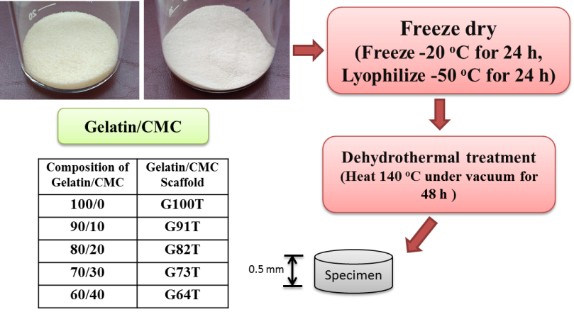
Figure 1: Schematic diagram of 0.8 wt% (w/w) gelatin/CMC scaffold preparation.
    - Degradation of Gelatin-CMC scaffold
The enzyme lysozyme was purchased from BIO BASIC INC, Canada. It was purified from chicken egg white into a lyophilized powder. It was white powder with moisture less than 6.0%. Its molecular mass was 14,307 Da and isoelectric point (pi) of 11.35. The enzyme was active over a broad pH range (6.0-9.0). This research used this enzyme for gelatin/CMC scaffold degradation. An enzyme concentration was reported in enzyme units (u) per ml. The selected concentration of enzyme was 31.2 u/ml (0.1 mg/ml PBS) (Pek et al. 2004). The gelatin/CMC scaffold with various conditions were placed in 24-well culture plate and the enzyme solution was added with volume of 2 ml per well. Then, it was incubated in oven at 37 ºC. After 0.5, 1, 1.5, 3, 9, 15, 24, 36 and 48 h, the scaffolds were removed and rinsed with DI water to remove the enzyme. Then, dried the scaffolds and weighed it. The weight remain of the scaffold after degradation was calculated by the following equation (1):
Weight remain (%) =$100-\left[\frac{\left({\text{W}}_{0}-{\text{W}}_{f}\right)}{{\text{W}}_{0}}×100\right]$ (1)
Where: ${\text{W}}_{0}$ is initial weight of the scaffold
${\text{W}}_{f}$ is final weight of the scaffold
    - Determination of swelling ratio
The swelling ratio of gelatin/CMC scaffolds was investigated. The gelatin/CMC scaffold in all conditions were placed in a PBS buffer at 37 ºC for 2 h to swell and denature the gelatin and CMC. PBS buffer within the pores was expelled by pressing the swollen scaffolds between sheets of kimwipe tissue paper with placed the scaffold on each side of paper for 5 s. The scaffold was weighted and the weight was recorded as wet weight. The swelling ratio of gelatin/CMC scaffold was calculated by the following equation (2) (Pek et al. 2004):
Swelling ratio = $\frac{\left({\text{W}}_{w}-{\text{W}}_{d}\right)}{{\text{W}}_{d}}$ (2)
Where: ${\text{W}}_{d}$ is initial weight of the scaffold
${\text{W}}_{w}$ is wet weight of the scaffold
  - Results
    - In vitro biodegradation of gelatin/CMC scaffolds
The gelatin/CMC scaffolds was shown in figure 2. The appearance and average size of G100T (figure 2(a)) was similar to G82T (figure 2(b)). The average diameter and height of all gelatin/CMC conditions were similar compared to pure gelatin scaffold with average diameter was from 11.71$±$0.22 mm to 13.92$±$0.14 mm and average height was from 4.28$±$0.09 mm to 5.26$±$0.25 mm as shown in table 1. The G73T showed the lowest value in both diameter and height. All gelatin/CMC scaffolds in various conditions were compared on in vitro degradation by lysozyme. In this study, gelatin/CMC scaffolds with all conditions were incubated in lysozyme in PBS solution at 37 ºC for 0.5, 1, 1.5, 3, 9, 15, 24, 36 and 48 h. The results showed that all gelatin/CMC conditions were completely degraded after 36 hours as illustrated in figure 3. The degradation of the scaffolds which added the CMC in a condition of G91T, G82T and G73T showed the appropriate degradation rate with completely degraded after 36 hours. While, pure gelatin scaffold (G100T) and gelatin/CMC scaffold in a condition of G64T were completely degraded after 9 hours.
At the initial time of degradation (table 2), scaffold G100T occurred the weakest in structure with weight remain of 18.34% at degradation time of 0.5 hour while scaffold G64T showed the weakest structure with weight remain of 10.56% at degradation time of 3 hours. The other scaffolds (G91T, G82T and G73T) showed the stronger in structure with can remain their weight of 27.50%, 31.67% and 38.18%, respectively after degraded in lysozyme for 3 hours.
(b)
(a)
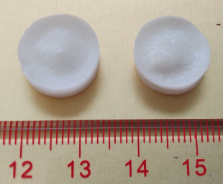
Figure 2: 0.8 wt% (w/w) of gelatin/CMC scaffolds (a) G100T and (b) G82T.
Table 1: Average diameter and height of 0.8 wt% (w/w) gelatin/CMC scaffolds (n=5).
Scaffolds | Average diameter (mm) | Average height (mm)
G100T | 13.88$±$0.33 | 4.96$±$0.29
G91T  G82T  G73T  G64T | 13.92$±$0.14  13.17$±$0.27  11.71$±$0.22  13.91$±$0.17 | 5.26$±$0.25  5.10$±$0.26  4.28$±$0.09  4.94$±$0.23

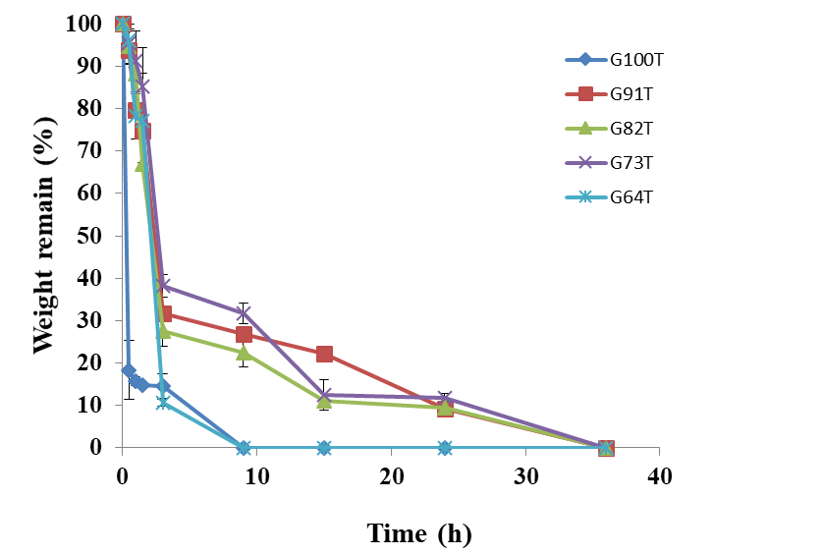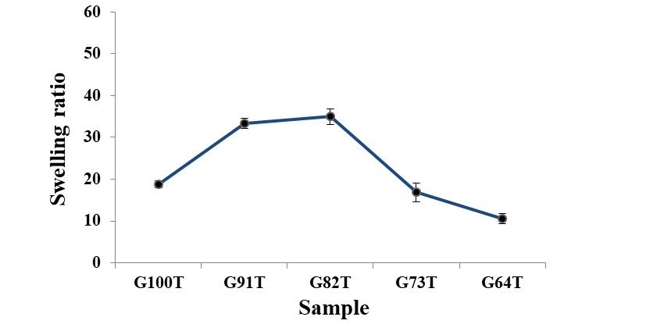
*
*
*
Figure 3: In vitro degradation behaviour of Figure 4: Swelling ratio of 0.8 wt% (w/w)
0.8 wt% (w/w) gelatin/CMC scaffolds. gelatin/CMC scaffolds (n=5) (*significant different p<0.05 relative to G100T).
Table 2: Weight remain (%) at initial time (0.5, 1, 1.5, and 3 hours) of 0.8 wt% (w/w) gelatin/CMC scaffolds.
Scaffolds | Degradation time (hour)
 | 0.5 | 1 | 1.5 |  | 3
G100T | 18.34 | 15.75 | 14.87 |  | 14.58
G91T  G82T  G73T  G64T | 93.87  94.63  95.54  96.05 | 79.77  88.23  91.18  78.22 | 74.91  66.96  85.28  77.11 |  | 31.67  27.50  38.18  10.56

    - Swelling ratio of gelatin/CMC scaffolds
Figure 4 illustrated the swelling ratio of all gelatin/CMC scaffolds. In overall, the swelling ratio of all scaffold conditions was from 10.55$±$1.26 to 34.96$±$1.81 as shown in table 3. According to the figure 4, the composition of gelatin and CMC at ratio 80:20 showed the highest value of water absorption compared to pure gelatin scaffold (18.82$±$0.83) with significant different. Increasing CMC resulted in collapsed structure. The G64T scaffold showed the lowest of swelling ratio with significant different compared to pure gelatin scaffold. The average swelling ratios of G82T and G64T were 34.96$±$1.81 and 10.55$±$1.26, respectively. The result of swelling ratio was consistency with the result of in vitro degradation in lysozyme. The G82T scaffold occurred the best value of swelling ratio and have an appropriate degradation rate. The G64T scaffold occurred the lowest value of swelling ratio with fast degradation rate.
Table 3: Swelling ratio of 0.8 wt% (w/w) gelatin/CMC scaffolds (n=5).
Scaffolds | Average swelling ratio | SD
G100T | 18.82 | 0.83
G91T  G82T  G73T  G64T | 33.36  34.96  16.83  10.55 | 1.27  1.81  2.28  1.26
  - Discussion
This results reported in this study concluded that increasing CMC into gelatin scaffolds at an appropriate content could be improved in biological and physical properties of scaffolds. The gelatin blended with CMC scaffolds at ratio of 80:20 (G82T) showed the highest value of the swelling ratio with significant different compared to pure gelatin scaffold. G82T scaffold also showed good degradation rate in lysozyme solution with could remain their structure and degraded completely after 36 hours that might suitable for skin regeneration. However, the scaffold G100T and G64T showed weak in its structure with gave a low value of swelling ratio and fast degradation rate with completely degraded after 9 hours which was not suitable for skin regeneration. This results suggested that improving gelatin scaffold by blending with CMC at the ratio of 80:20 and using thermal crosslinking technique might be applied for tissue engineering applications. Moreover, it could be suggested that CMC could be used as a scaffold strengthening at appropriate content. The degradation of the scaffolds would be increased if the CMC content was too much.
  - Conclusion
The scaffolds which made from gelatin blended with CMC in various conditions were studied in this research. In vitro degradation of all scaffold conditions was investigated by immersing in lysozyme in PBS solution at the desired time. The degradation results showed the best condition of gelatin/CMC ratio at 80:20 with completely degraded after 36 hours and showed the highest value of swelling ratio. It was found that too much of CMC content decreased in material strengthening. Increasing of CMC content at an appropriate content could be improved in biological and physical properties of scaffold. From the results, G82T could be used to design for skin tissue engineering applications.
Acknowledgments
This research conducted under the support of Department of Advanced Manufacturing Technology and Department of Manufacturing Engineering, Faculty of Engineering, Pathumwan Institute of Technology.
References
Baldino, L, Cardea, S & Reverchon, E 2015, ‘Natural aerogels production by supercritical gel drying’,
Chemical Engineering Transactions, vol. 43, pp. 739-744.
Biswal, DR & Singh, RP 2004, ‘Characterisation of carboxymethyl cellulose and polyacrylamide graft copolymer’, Carbohydrate Polymers, vol. 57, pp. 379-387.
Capitani, D, Porro, F & Segre, AL 2000, ‘High field NMR analysis of the degree of substitution in carboxymethyl cellulose sodium salt’, Carbohydrate Polymers, vol. 42, pp. 283-286.
Ferrari, PF, Aliakbarian, B, Palombo, D & Perego, P 2017, ‘Small diameter vascular grafts coated with gelatin’, Chemical Engineering Transactions, vol. 57, pp. 1441-1446.
Fisher, JP, Mikos, AG & Bronzino, JD 2007, ‘Tissue engineering’, CRC Press, Taylor & Francis Group.
Gonzalez, SS, Diban, N & Urtiaga, A 2018, ‘Hydrolytic Degradation and Mechanical Stablility of Poly(e-caprolactone)/Reduced Graphene Ozide Membranes as Scaffolds for In Viro Neural Tissue Regeneration’, Membranes, vol. 8, No.12.
Haugh, MG, Murphy, CM, McKiernan, RC, Altenbuchner, C & O’Brien, FJ 2011, ‘Crosslinking and Mechanical Properties Significantly Influence Cell Attachment, Proliferation, and Migration Within Collagen Glycosaminoglycan Scaffolds’, Tissue Engineering: Part A.
Hollinger, JO 2012, ‘An Introduction to Biomaterials’, 2nd ed., U.S.: CRC Press, Taylor & Francis Group, chapter 2, pp. 7-14.
Lee, SB, Kim, YH, Chong, MS, Hong, SH & Lee, YM 2005, ‘Study of gelatin-containing artificial skin V: fabrication of gelatin scaffolds using a salt-leaching method’, Biomaterials, vol. 26, pp. 1961-1968.
Ma, PX & Elisseeff, J 2006, ‘Scaffolding in Tissue Engineering’, Florida, U.S.: CRC Press, Taylor & Francis Group, chapter 1, pp. 3-10.
Ma, PX 2004, ‘Scaffolds for tissue fabrication’, Materialstoday, pp. 30-40.
Mim, LM & Sultana, N 2017, ‘Comparison on in vitro degradation of polycaprolactone and polycaprolactone/gelatin nanofibrous scaffold’, Malaysian Journal of Analytical Sciences, vol. 21, No. 3, pp. 627-632.
Olsen, D, Yang, C, Bodo, M, Chang, R, Leigh, S, Baez, J, Carmichael, D, Perala, M, Hamalainen, ER, Jarvinen, M & Polarek, J 2003, ‘Recombinant collagen and gelatin for drug delivery’, Advanced Drug Delivery Reviews, vol. 55, pp. 1547-1567.
Pek, YS, Spector, M, Yannas, IV & Gibson, LJ 2004, ‘Degradation of a collagen-chondroitin-6-sulfate matrix by collagenase and by chondroitinase,’ Biomaterials, vol. 25, pp. 473-482.
Wiwatwongwana, F & Promma, N 2015, ‘Evaluation of Gelatin/Carboxymethylcellulose Scaffolds Using Mooney-Rivlin Model’, KMITL Science and Technology Journal, vol. 15, no.2, pp. 70-79.

