CHEMICAL ENGINEERING TRANSACTIONS  VOL. 76, 2019 | A publication of
The Italian Association
of Chemical Engineering
Online at www.cetjournal.it
Guest Editors: Sauro Pierucci, Jiří Jaromír Klemeš, Laura Piazza
Copyright © 2019, AIDIC Servizi S.r.l.
ISBN 978-88-95608-73-0; ISSN 2283-9216

GAMEQ: Software for Teaching in Chemical Engineering
Riccardo Cafagnaª, Felipe E. M. Stamoglouª, Miguel V. F. N. Falcãoª, Ana L. B. Souza^{a,b}, Ewerton E. S. Calixto^{a,b}, Fernando L. P. Pessoa^{a,b*}
ªCentro Universitário SENAI CIMATEC, Av. Orlando Gomes, 1845, Piatã. Cep. 41.650-010. Savaldor. Bahia, Brazil
^{b}DEQ/EQ/UFRJ – Sala 209, Bloco E, Escola de Química, Centro de Tecnologia, Cidade Universitária, Ilha do Fundão, Universidade Federal do Rio de Janeiro, Rio de Janeiro – RJ, Brazil
fernando.pessoa@fieb.org.br
The use of gamification in chemical engineering is still scarce. This paper presents a gamification-base implementation applied to a chemical engineering course of SENAI CIMATEC University Center in Salvador State/Brazil. The technique is implemented in a game software called GAMEQ. The design of the gamification framework considers the sequence that a regular chemical engineer would follow that comes from access to the industry to the design and simulation of equipment. All these steps are accomplished using the game phase idea and the student is rewarded as he increases his level in the virtual industry. The results showed that the students considered this application positive and they demonstrated more interest in the course where the tool was used.
  - Introduction
Gamification is a good way to get the students attention as to improve their knowledge with an alternative method that can reach higher levels of real life situations, in which the student will experiment in the future, and “making activities more game-like”. (Werbach, K. 2014) De las Heras et al. (2018) presents the learning experience of the beta-tester – these are people who tested the game in an early version – get an interest on using gamification for training areas of chemical engineering. (de las Heras et al., 2018) It is perceptible that gamification could have a good place on the student development as a powerful tool. It can be seen with the game Green Chemistry made by Mellor which has chemical simulations and gamification elements that concern a balanced game design, besides an environment sustainability concept, getting more interest by their students (Mellor et al., 2018). In that way, GAMEQ offer an environment of a chemical industry, starting by the concept of security at work and then followed by a distillation tower, furnace and a pump. In addition, the game presents elements as quiz, quest, interactable non-player character and so forth. In this section, the focus is the distillation column, initially with flash calculations.
.
  - Development
This game was thought for students, who are joining the chemical engineering course, to be able to learn in an interactive and even playful way, increasing their knowledge and approaching them to chemical industry reality. Besides that, the framework proposed herein based on gamification learning process could be applied in other areas of knowledge.
The game has been developed using the Unity engine (2018.3.0f2 version), Unity Script and C# language. The major part of 3D models was created from scratch by using Blender and some were downloaded from free3d.com website with free license to use, credits are inside the game.
  - Game Components
There are many components attached to GAMEQ. It increases the game complexity which combines more than one element of gamification. These are only the strongest pillars because there are many other as level system, which stimulates the player to play and gain experience doing quests, mini jobs and systems that are going to be implemented. So, the first of them is the quiz, which can be used to evaluate the students and how much they learned by the game experience. The other two components are the chemical process simulation and the calculus in which equipment starting with the distillation tower, that is interesting having an almost real simulation of calculus that are made, for example, to separate substances, inside the game bringing the student closer to real situation. Figure 1 shows a diagram of GAMEQ`s architecture.
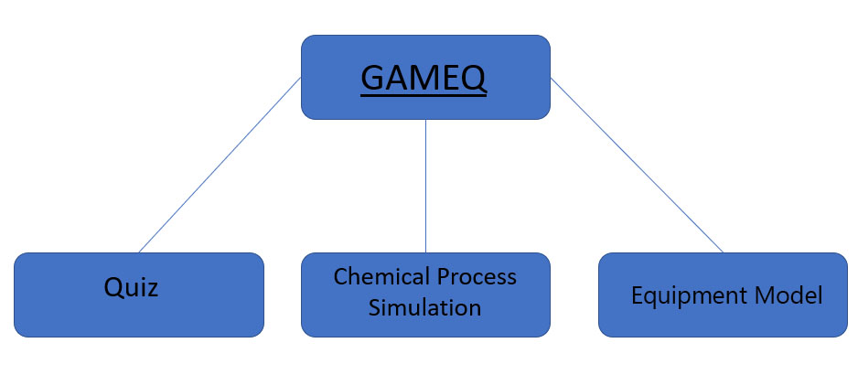
Figure 1: Components that model the game.
  - Phases of the Game
The first phase is the use and importance of IPE (Individual Protection Equipment) using as reference the Brazilian rules of security in the industry. (Regulamentadora N., 2003) In this initial part, the user will meet the secretary (Figure 2) that will explain how to behave in the chemical industry and will assign a mission of quiz that has to be answered to be completed and will update the first mission to reach the IPE room.
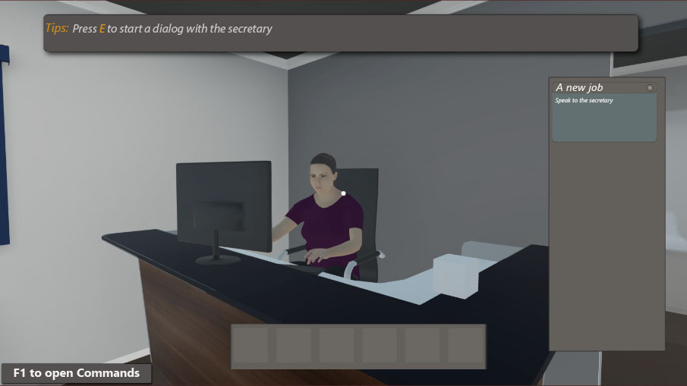
Figure 2: GAMEQ Gameplay: Secretary non-player character.
To talk to the secretary, you must use the ‘E’ keyword that’s been shown in the top side on the tips window. It will interact and show a dialog box as shown in figure 3. The student can choose an alternative, in this case the secretary asks if he knows what IPE is, if not will make a brief explain. This NPC is useful to get information about what must be done and other basic stuffs about the game.
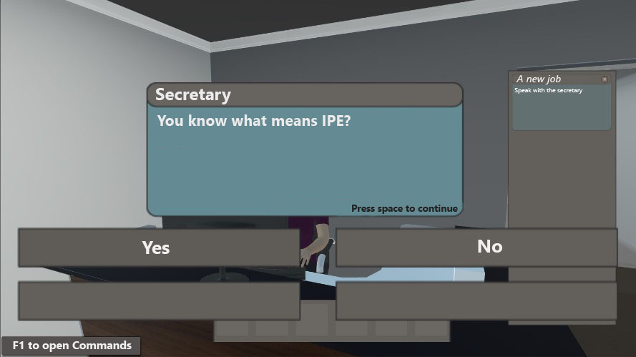
Figure 3: GAMEQ Gameplay: Dialog box interface with multiple choice.
Some chemical industries have a questionnaire that should be answered by visitors, so it was introduced in quiz form. The questions are related to the behaviours that need to be taken in the environment for the safety itself. This part appears right after the conversation with the secretary as a secondary mission to complete. Figure 4 illustrate the quiz layout.
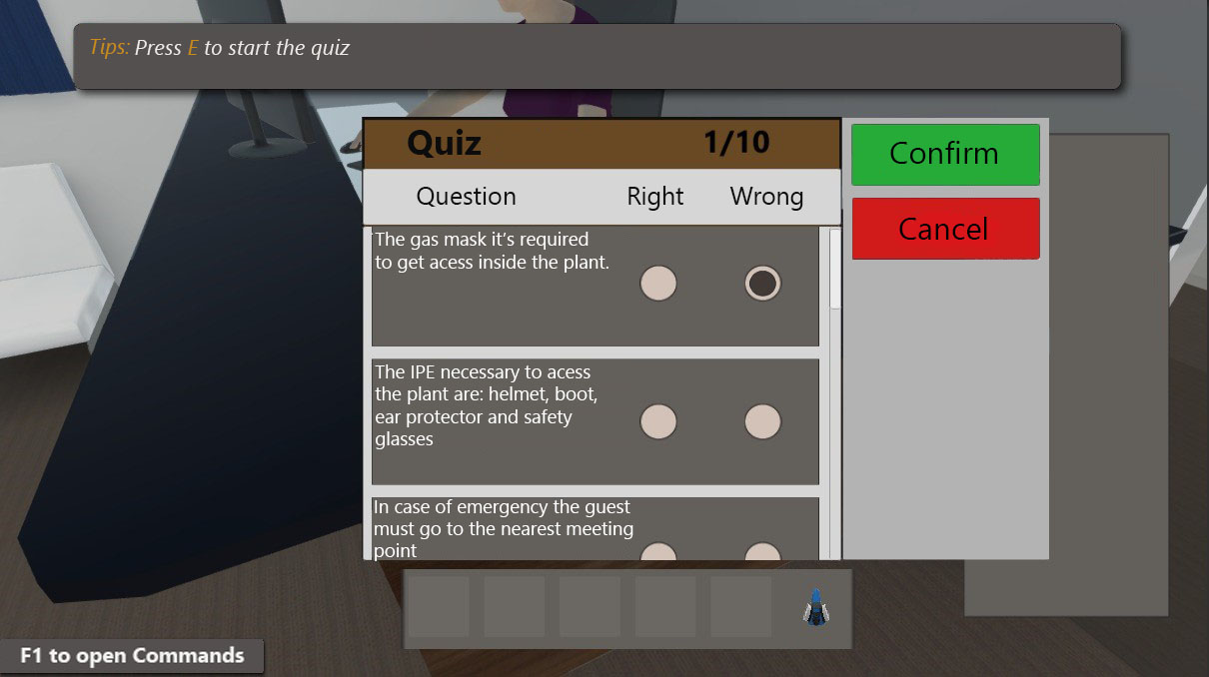
Figure 4: GAMEQ Gameplay: Quiz layout of the game.
Figure 5 shows the mission interface, which is simple and intuitive, and it can be opened with the shortcut ‘O’ keyword. The primary window is the biggest that can be closed and there is a secondary window that makes a summary of each mission. The user has the power to decide which quests he wants to be showed in this secondary window. On the primary, missions are placed by a list in the first block if clicked with the primary button of the mouse and it will update the second block with information about this quest. If clicked on the small circle next to the mission name, it will remove/add to the secondary list of missions.
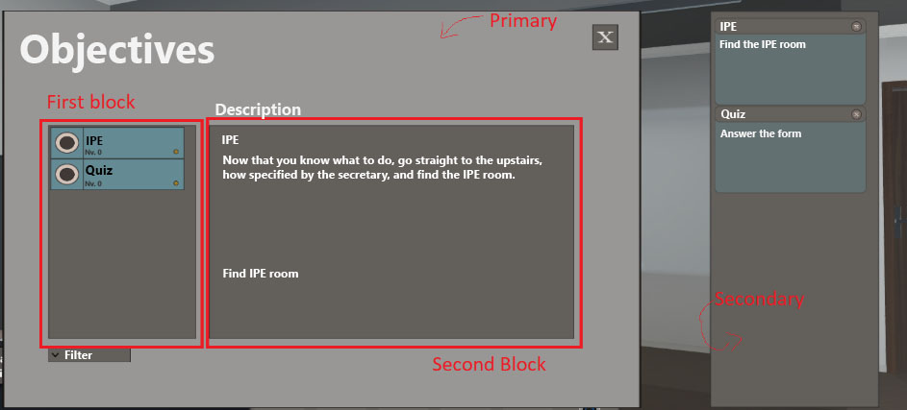
Figure 5: GAMEQ Gameplay: Mission interface with some annotations.
Figure 6 shows how the IPE are allocated. There are many wrong items between them so it’s not only about getting equipment randomly, it needs a little bit of knowledge and focus. A yellow arrow will appear on the item that the player is looking and when it interacts it appears on the left bottom side of the screen. Also, there is an equipment bar – this is a user interface element commonly used in games – that helps the player to know which equipment already he got.
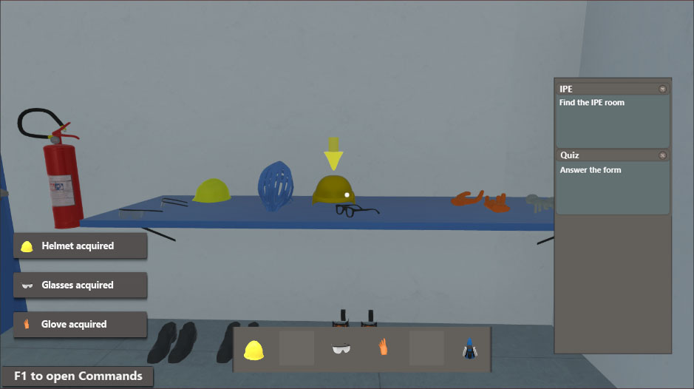
Figure 6: GAMEQ Gameplay: IPE selection.
Next step is to make the distillation tower starting with Flash towers and going ahead with more complex types, like distillation columns. There is an intuitive interface that the user can navigate between windows to change substances, to submit values of temperature and pressure to see if the separation has been successfully or if there is only gas or only liquid. The tower window shows the state of the equipment, sometimes it can break, and the player must fix it.
In this way, an interface was made to be navigable and self-explanatory as shown in Figure 7. There is a list of substances that are been dividing in two inputs field, one for temperature and another for pressure, so the student can make calculus to find dew and bubble points to see if it has success and got both liquid and gas.
The book "Introduction to the Thermodynamics of Chemical Engineering" has used to be the basis for performing the logic of calculations. (Smith et al, 2000) As it showed in figure 8, it will appear the respective equipment that are being used and will show what’s happening. In the example, the separation results on only fluids, so in the bottom there is a representation of a fluid. However, in the figure 9 can be see that there are both gas and fluid.

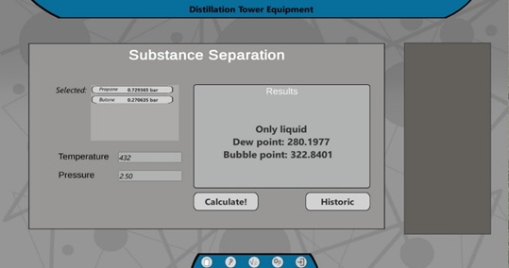
Figure 7: GAMEQ Gameplay: Substance Separation.
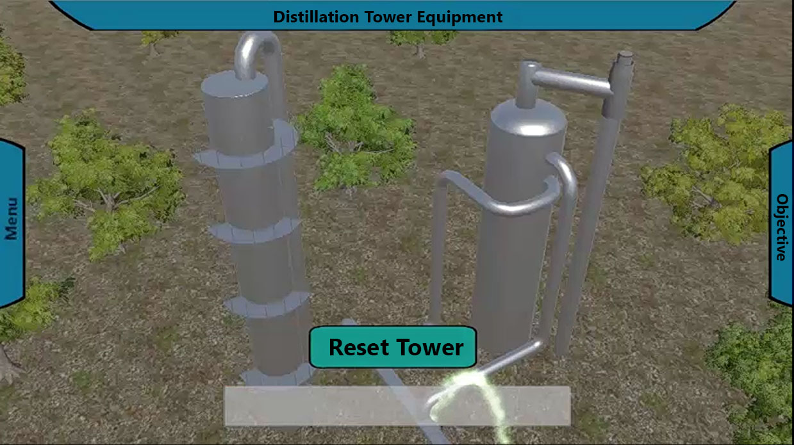
Figure 8: GAMEQ Gameplay: View of the tower behaviour (only fluid).
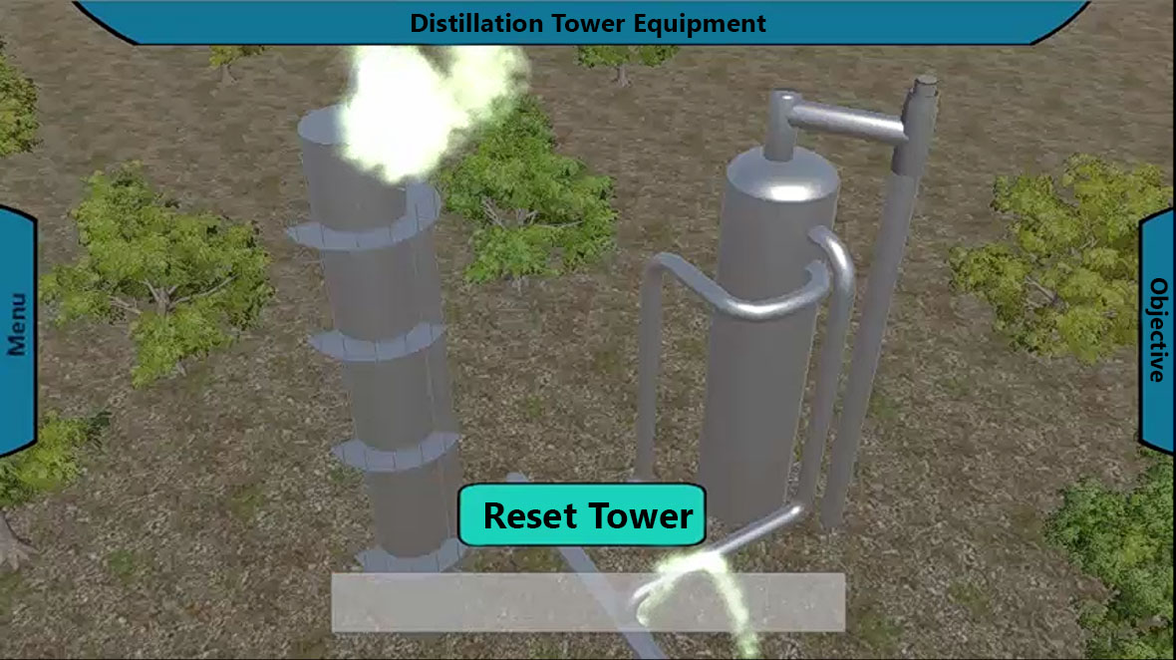
Figure 9: GAMEQ Gameplay: View of the tower behaviour (both fluid and gas).
Missions are essentially to orient the player to what he needs to do, them will gives experience to level up and it will be the level of experience in this area.

  - Conclusions
The gamification is a tool that increased the interest of the student, since the world trend is the use of active methodologies, with the use of smartphones, tablets, among other mobile technologies. The use of gamification in GAMEQ will encourage students to study and engage more in and out of the classroom and also causes a greater interest in studying content related to the discipline taught, in addition to having a greater interaction between them. It is worth mentioning that this project is under development and is intended to include all unit operations such as operations with furnaces, pumps, among others, and industrial cases for decision-making as in the case of the distillation tower which finds various procedure and equations that are used in industry. It is hoped to achieve software capable of training/teaching case studies for students and process industry operators in addition to implementing augmented and virtual reality to make learning more immersive.

References
Werbach, K. (2014). (Re) defining gamification: A process approach. In International conference on persuasive technology (pp. 266-272). Springer, Cham.
De las Heras S. C., Mansouri S. S., Cignitti S., Uellendahl H., Weitze C. L., Gernaey K. V., Krühne U. (2018). A Methodology for Development of a Pedagogical Simulation Tool used in Fermentation Applications. In Computer Aided Chemical Engineering, 44, 1621-1626.
Mellor, K. E., Coish, P., Brooks, B. W., Gallagher, E. P., Mills, M., Kavanagh, T. J., ... & Kostal, J. (2018). The safer chemical design game. Gamification of green chemistry and safer chemical design concepts for high school and undergraduate students. Green Chemistry Letters and Reviews, 11(2), 103-110.
Regulamentadora N. (2003). 6-NR-6. Equipamento de Proteção Individual-EPI, 4(3).
Smith, J. M., Van Ness, H. C., Abbott, M. M., & Queiroz, E. M. (2000). Introdução à termodinâmica da engenharia química. LTC.

