CHEMICAL ENGINEERING TRANSACTIONS  VOL. 76, 2019 | A publication of
The Italian Association
of Chemical Engineering
Online at www.cetjournal.it
Guest Editors: Sauro Pierucci, Jiří Jaromír Klemeš, Laura Piazza
Copyright © 2019, AIDIC Servizi S.r.l.
ISBN 978-88-95608-73-0; ISSN 2283-9216

DEVELOPMENT OF INTELLIGENT MODELS FOR THE PREDICTION THE DYNAMICS OF NONLINEAR PROCESS
Eric M. L. Luz, Brunno F. Santos*
A Department of Chemical and Material Engineering (DEQM). Pontifical Catholic University of Rio de Janeiro (PUC-Rio). Rua Marquês de São Vicente, 225 – Gávea, Rio de Janeiro – RJ, 22430-060, Brazil.

*bsantos@puc-rio.br
Abstract
The use of artificial intelligence (AI) techniques to address nonlinearity problems is gaining importance, mainly in context of industry 4.0. The present work was development of models based on artificial intelligence was performed to predict the concentration of cyclopentenol in a CSTR chemical reactor with the Van De Vusse kinetics. This reaction is known for its nonlinear behavior, which makes prediction difficult. Using simulations of this reactor in open and closed mesh combined with certain perturbations, a database was generated to train the models. The software MATLAB 2018a was used to implement the neural and the ANFIS systems. The input layer could be feed flow, feed temperature, heat provided by the thermal jacket, outlet temperature. The output were concentration of the component B and reactor temperature one step ahead. The models had good agreement, once presented remarkable performance reproducing the dynamics, obtaining R² values near to 1 and error index near to 0.
  - Introduction
In recent years, the use of artificial intelligence techniques to deal with nonlinearity problems has been gaining importance, especially in the current competitive world, where cost reduction may be the differential. In the works Yang et al. (2018), Zhou et al. (2018) and Tsai (2011), artificial intelligence techniques were used to solve nonlinear problems.

Predictive models involving process with chemical reaction can be difficult due to nonlinearity of chemical kinetics and the possibility of serial and parallel reactions. In this context, the CSTR chemical reactor with Van de Vusse kinetics is used as the standard nonlinear chemical process for the performance evaluation of controllers and predictive models. This reaction was studied in the Engell et al. (1993), Schäfer, et al. (2018) and Cassol et al. (2018).

    - Case Study - Van de Vusse Reactor
As described in more detail by Engell S.et al.,1993, the reaction occurs in a jacketed CSTR reactor, due to the exothermic nature of the reaction (Figure 1). In the Van de Vusse reaction, cyclopentenol (B) is produced from cyclopentadiene, with the formation of cyclopentanadiol (C) and dicyclopentadiene (D) as byproducts, according to the following reactions van de Vusse, J. G., 1964.
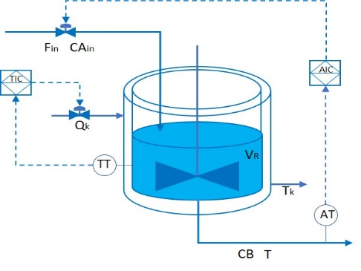 | 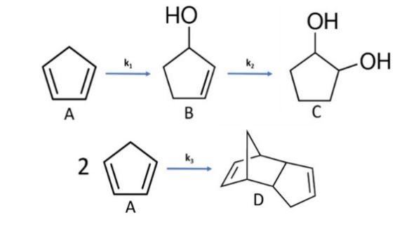
Figure 1: Van de Vusse CSTR reactor

Considering the constant density throughout the reactor and the ideal level control, for simplicity, the dynamics of the system is described by the following differential equations, resulting from the mass and energy balance of the reactor and the cooling jacket

Mass balance of component A:
$$\frac{dC_{A}}{dt}=\frac{F_{in}}{V_{R}}.\left[C_{Ain}-C_{A}\right]-k_{1}\left(T\right).C_{A}-k_{3}\left(T\right).{C_{A}}^{2}$$ | (1)
Mass balance of component B:
$$\frac{dC_{B}}{dt}=-\frac{F_{in}}{V_{R}}.C_{B}+k_{1}\left(T\right).C_{A}-k_{2}\left(T\right).C_{B}$$ | (2)
CSTR reactor energy balance:
$$\frac{dT}{dt}=\frac{F_{in}}{V_{R}}.\left[T^{in}-T\right]+\frac{k_{w}A_{R}}{ρ Cp V_{R}}. \left[T_{k}-T\right]-\frac{1}{ρ Cp}.\left[k_{1}\left(T\right).C_{A}.{∆H}_{1}+k_{2}\left(T\right).C_{B}.{∆H}_{2}+k_{3}\left(T\right).{C_{A}}^{2}.{∆H}_{3}\right]$$ | (3)
Thermal jacket energy balance:
$$\frac{dT_{k}}{dt}=\frac{Q_{k}}{ m_{k}{Cp}_{k}}+\frac{k_{w}A_{R}}{ m_{k}{Cp}_{k}}. \left[T-T_{k}\right]$$ | (4)

Tables 1 and 2 show the reaction kinetic parameters and reactor/jacket properties provided by Engell S.et al.,1993
Table 1: Parameters of the reactor  Parameters Value  Solution density (ρ) 0,9342 kg.L⁻¹  Heat capacity (Cp) 3,01 kJ.kg⁻¹.K⁻¹  Thermal conductivity (k_{w}) 4032 kJ.m⁻² .h⁻¹ K⁻¹  Thermal exchange area (A_{R}) 0,215 m²  Reactor volume (V_{R}) 10 L  Thermal jacket mass (m_{k}) 5 kg  Heat capacity jacket (Cp_{k}) 2,0 kJ.kg⁻¹.K⁻¹ | Table 2: Kinetic Reaction Parameters  Reaction k_{io} Eai ∆H_{ri}  $$A \underset{→}{k_{1}} B$$ 1,287 x 10¹² h⁻¹ -9758,3 K 4,2 kJ.mol⁻¹  $$B \underset{→}{k_{2}} C$$ 1,287 x 10¹² h⁻¹ -9758,3 K -11 kJ.mol⁻¹  $$2A \underset{→}{k_{3}} D$$ 9,043 x 10⁹ L.mol⁻¹h⁻¹ -8560 K -41,85 kJ.mol⁻¹

The behavior of the CSTR reactor with the van de Vusse kinetics at steady state is shown in Figure 2. The longitudinal and transverse profiles for certain temperatures and flow rates are shown in Figures 2.2 and 2.3, respectively.
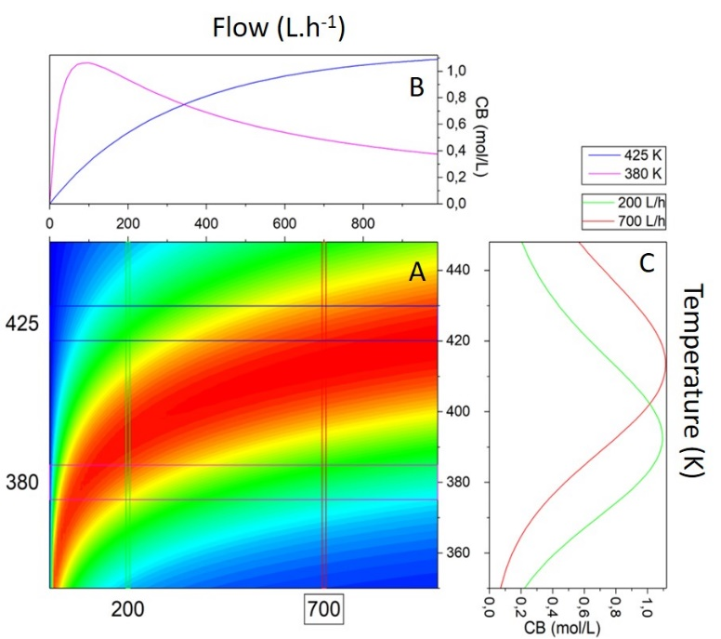
3
2
1
Figure 2: CB as a function of flow and temperature in the CA_{in} of 5.1 mol.L⁻¹

Analyzing Figure 2.1, the narrowing of the zone of higher concentration of compound B with increasing temperature was observed. With this increase, this optimal zone undergoes a displacement towards regions of greater flows. This behaviour is more easily identified by the cross section in the section of 200 and 700 L.h⁻¹ (Figure 2.3). Through the longitudinal cuts (Figure 2.2) the decrease of non-linearity with temperature increase is evident. The nonlinear profile is evidenced in the 380 K cut, where the curve is increasing until the flow rate of 100 L h⁻¹ and for larger flows it decreases.

  - Methodology
This process was studied by simulation, numerically integrating the nonlinear differential equations (equations 1 - 4). For the control system of CSTR reactor, two integrative proportional controllers (PI) were developed. One to control the concentration of component B and another to control reactor temperature, as shown in Table 3, where CB is the cyclopentenol concentration of the reactor outlet, T is the reactor temperature, Fin is feed flow and Qk is the heat removed from the reactor (Figure 1). These controllers were tuned according to the method of Ziegler-Nichols.
Table 3: Control system developed
Control system | Controlled variable | Variable manipulated | Operating Range
Control system CB | CB | Fin | 100 - 1600 L.h⁻¹
Control system T | T | Qk | 0 - 85000 kJ.h⁻¹

This process was submitted to systematic disturbances under different control conditions. The process variables obtained in these simulations were stored in a database. For the development of the predictive models, the database, containing the process input variables and their respective outputs, was divided into 3 groups: (70% for training, 15% for validation, 15% for testing).

For the development of the hybrid system ANFIS (Adaptive-Network-Based Fuzzy Inference System) was used toolbox “Fuzzy Logic Designer” by Matlab® 2018b. The fuzzy groups were established through the sub clustering of the toolbox. This method automatically groups the data according to their degree of similarity. This algorithm has as parameters: influence radius, squash factor, acceptation rate and rejection rate. To create the neural network, the toolbox "Neural Fitting (nftool)" was used. This toolbox allows you to choose the training algorithm, activation function, the number of neurons in the hidden layer and other parameters.
  - Results and Discussion
A neural network model (RNA) predicting the concentration of compound B was developed for comparative purposes. This network is composed of 4 neurons in the hidden layer and with the same 6 inputs of the ANFIS system. The network topology and training parameters are shown in Figure 3.

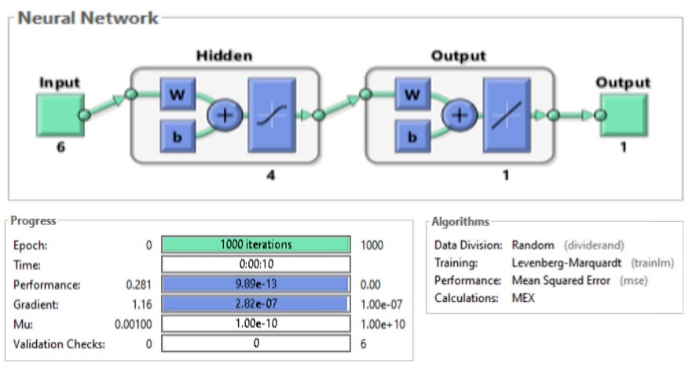
Figure 3: RNA topology and training parameters
This fuzzy inference system has 6 input variables (feed flow (Fin), feed temperature (Tin), concentration of cyclopentadiene in feed (CAin), heat withdrawn by the thermal jacket of the reactor (Qk), derived from the concentration of compost B at the instant (dCB / dt) and the concentration of B in the previous instant (CB (t-1)) and an output variable (the prediction of the cyclopentenol concentration at 3 instants ahead), according to Figure 4.

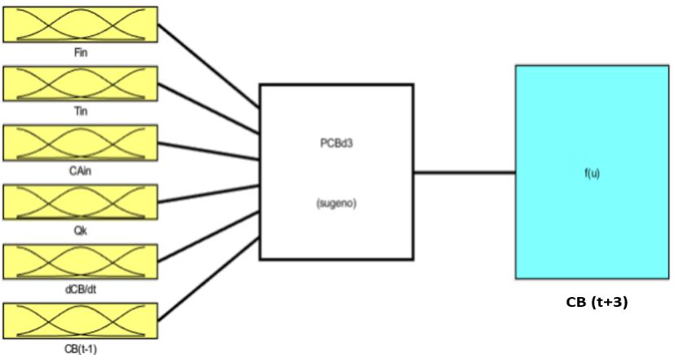  Figure 4: Fuzzy inference system for CB prediction | Table 4: Sub clustering parameters  Parameters Value  Influence 0.7  Squash factor 1.25  Acceptation 0.7  Rejection 0.15  Clusters 3 3 3 3 3 3
Table 5: Network training indices
Indexes | Value
Error training | 1.47x10⁻⁷
Error validation | 4.95x10⁻⁷
Error test | 1.48x10⁻⁷

The number of Fuzzy groups per variable, the number of rules and consequently the topology of the neural network in the ANFIS system was determined by the sub. clustering of the toolbox. The parameters of this clustering are described in Table 4.

Using the database obtained by previous simulations in closed meshes and others in open meshes, the network training of Figure 5 was performed. After a sequence of 15 training periods, the Fuzzy groups were presented in Figure 6. The data on training, testing and validation are given in Table 5.

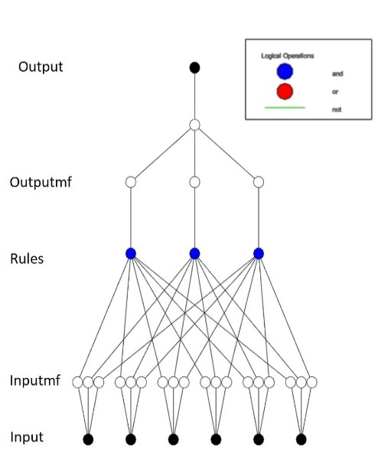  Figure 5: Neural network topology for the ANFIS system | F_{in} T_{in}  CA_{in} dCB Qk  CB_{(t-1)}  Figure 6: Fuzzy group obtained by sub clustering and training
The CA_{in} variable presented a symmetric division of the Fuzzy groups. The Fin and Qk entries were divided into shifted nearby sets. The variables dCB, CB (t-1) and Tin presented three similar Fuzzy groups. Probably these groups were generated tow copies due to a need of the algorithm of toolbox or to increase the degree of freedom of the system.

It can be observed the structure of the Fuzzy inference system in the neural network topology of Figure 5. Each input (the input variables) is connected to only three neurons of the next layer, responsible for the Fuzzy groups. The rules of inference are observed by the connection between the second (inputmf) and third layer (rules). Each blue neuron is connected only one of the neurons of the anterior layer cracks. The output of this network depends on the weighting of these three rules according to the activation of each Fuzzy groups, according to Figure 7.
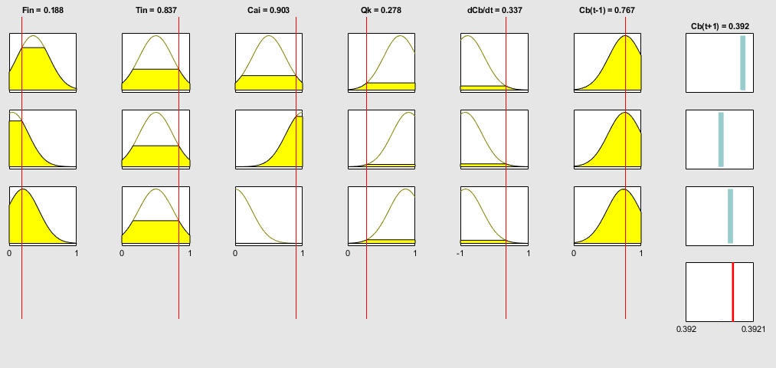
Figure 7: Example of activation of the ANFIS system

The real-time simulation with the predictions of the cyclopentenol concentration performed with the ANFIS system and with the artificial neural network is shown in Figure 8. The comparison between the concentration of component B at the time t and prediction of this concentration at time t+3 in Figure 9.
Figure 8: Simulation with CB predictions | Figure 9: Evaluation graph of the predictive models

Analyzing Figure 8, both models were able to predict the concentration of component B. In the initial overshoot, the model with neural networks obtained an oscillatory behavior with greater amplitude than the ANFIS system and the very concentration of B. For the purposes of application in control, this behavior may be interesting. These models intensify the error that would be generated by overshoot, making the performance of the controller more intense at this moment. The ANFIS predictive model obtained a correlation coefficient of 0.945 while the RNA model obtained a coefficient of 0.919.
  - Conclusions
In this work the performance of predictive models using artificial intelligence techniques was evaluated against a known chemical process benchmark, the CSTR reactor with Van de Vusse kinetics. The ANFIS and RNA models were able to predict the concentration of component B. The ANFIS system obtained a correlation coefficient of 0.945 while the RNA model obtained a coefficient of 0.919. These values allow the use of these models in predictive controllers and the development of virtual sensors.

References
Cassol, G. O., Campos, G. V. K., Thomaz, D. M., Capron, B. D. O., & Secchi, A. R. (2018). Reinforcement Learning Applied to Process Control: A Van der Vusse Reactor Case Study. Computer Aided Chemical Engineering, 44, 553–558. DOI:10.1016/B978-0-444-64241-7.50087-2
Engell S. and Klatt K. U., Nonlinear Control of a Non Minimum-Phase CSTR, Proceedings of the 1993 American Control Conference, IEEE Press:Piscataway, NJ, 1993, 2941
Magalhães, O. I. ,2010. Development of A Dynamic Real-Time Optimization System, Federal University of Rio de Janeiro, Coppe, Rio De Janeiro.
Schäfer, P., Bering, L. F., Caspari, A., Mhamdi, A., & Mitsos, A. (2018). Nonlinear Dynamic Optimization for Improved Load-Shifting Agility of Cryogenic Air Separation Plants. In Computer Aided Chemical Engineering (Vol. 44, pp. 547–552). DOI:10.1016/B978-0-444-64241-7.50086-0
Svaricek, F. (1995). Nonlinear Dynamic Control of a Non-Minimum-Phase CSTR. IFAC Proceedings Volumes, 28(14), 191–196. DOI10.1016/S1474-6670(17)46829-7
Tsai, S.-H. (2011). Robust H∞ control for Van de Vusse reactor via T–S fuzzy bilinear scheme. Expert Systems with Applications, 38(5), 4935–4944. DOI:10.1016/j.eswa.2010.09.158
van de Vusse, J. G. (1964). Plug-flow type reactor versus tank reactor. Chemical Engineering Science, 19(12), 994–996. DOI:10.1016/0009-2509(64)85109-5
Yang, X., Cui, R., & Dong, N. (2018). Acrylic Polymerization Process Control and MATLAB Simulation Based on Intelligent Adaptive Control, Chemical Engineering Transactions, 71, 763–768. DOI:10.3303/CET1871128
Zhou, B., & He, D. (2018). Research on Fire Risk Assessment of Chemical Tank Farm Based on Fuzzy Mathematics and Grey Relational Analysis, Chemical Engineering Transactions, 71, 793–798. DOI:10.3303/CET1871133

