|  |  |
| --- | --- |
| cetlogo ***CHEMICAL ENGINEERING TRANSACTIONS***  ***VOL. 76, 2019*** | A publication of  aidiclogo_grande |
| The Italian Association  of Chemical Engineering  Online at www.cetjournal.it |
| Guest Editors: Sauro Pierucci, Jiří Jaromír Klemeš, Laura Piazza  Copyright © 2019, AIDIC Servizi S.r.l. **ISBN** 978-88-95608-73-0; **ISSN** 2283-9216 | |

Custom-made Temporomandibular Joint Prosthesis: Computer Aided Modeling and Finite Elements Analysis

Anita G. Mazzoccoa, André L. Jardinia, Elifas L. Nunesb, Rubens M. Filhoa

aNational Institute of Biofabrication, School of Chemical Engineering, CP: 13083-852, Campinas, SP, Brazil.

bMedical School (FMB) of São Paulo State University (Unesp), CP: 18618-687, Botucatu, SP, Brazil.

anitagaia.mazzocco@gmail.com

Temporomandibular Joint (TMJ) is a bilateral joint that works to perform the main activities of speaking and chewing. Because of this cyclic loading, TMJ disorders are common and greatly affect the quality of life. For this reason, it becomes necessary to replace the non-functioning joint with a prosthetic device. Since the 1930s, different TMJ implants have been developed to restore the correct functioning of TMJ and improve patient quality of life. TMJ prosthesis is a two-component replacement device composed of a condyle, placed t mandible extremities, and a glenoid fossa, localized in temporal bone and these are fixed to healthy bone by screw. In recent years, thanks to technological advancement, TMJ replacement devices can be developed starting from specific tomographic data of each patient, calling them as custom-made prosthesis. The  
customization process is a computational process of Computer Aided Modeling (CAM) and Computer Aided Design (CAD). It starts from tomographic data to create a tridimensional model of patient mandible and skull, then, based on computational model, TMJ prosthesis is designed and finally it is fabricated by additive manufacture. Follow-up data available in literature show that the main unresolved problem of TMJ prostheses is a kinematics that is still different from the natural one, resulting in hypomobility of implanted condyle compared to the natural one. In this panorama, this study aims to show TMJ CAM customization process and to evaluate mechanical and kinematic response of a unilateral TMJ custom-made prosthesis through Finite Elements Analysis (FEA) with Ansys software. Bilateral bite to incisors and unilateral bite to molar are simulated and mechanical stress and strain generated are evaluated.

* 1. Introduction

A recent study of Lotesto (Lotesto *et al.*, 2017) about alloplastic total temporomandibular joint replacement (TMJ TJR) devices implanted by members of the American Society of Temporomandibular Joint Surgeons (ASTMJS) states that between 2005 and 2014 there was a relative high numbers of TMJ replacement surgery and that the demand will be increase in the following years. TMJ disease and malformations are common and aggravates patient quality of life and TMJ prosthesis represents end-stage solution. Successful replacement outcomes were collected and the TMJ device expected lifespan is about 10 years or more (Mercuri *et al.*, 2002). Starting from an interposing material to treat ankylosis, thanks to biomaterials evolution and technology development nowadays TMJ replacement is a two-component system fixed to the host bone by screws (De Meurechy e Mommaerts, 2018). The upper component replaces glenoid fossa and eminence in temporal bone and the lower replaces condyle at mandible extremity. Ideally TMJ prosthesis is made to restore form and function of replaced joint with longevity just like all patients life. To make it possible, replacement device must be osseointegrated, biocompatible, don´t produce wear debris, able to withstand dynamic loading and mimic TMJ kinematics. Thus, primary stability is necessary and perfect fitting has to be ensured at surgery time. Currently there are two FDA-approved devices: the stock Biomet/Lorenz Microfixation TMJ Replacement System and the custom-made TMJ Concepts Patient-Fitted Total TMJ Replacement System. The stock TMJ device is available in different size. Then, to fit patient anatomy, stock device could be bended or host bone be shimmed and reshaped. This increases the risk of failure for fatigue or micromotion occurring and it doesn’t allow osseointegration (Johnson *et al.*, 2017). Custom-made prosthesis is designed based on patient tomographic data and they are developed through CAD and CAM technology and fabricated by additive manufacturing.

In this study Finite Elements Analysis (FEA) is carried out with Ansys Workbench (Swanson Analysis, Canonsburg, PA, USA) software with the aims of evaluating mechanical effect of replacement device. Thus mechanical strain and stress produced on condyle prosthesis and on host bone are calculated in three different byte loading conditions. Bilateral bite, that is incisal clench (INC) and unilateral bite, such as right and left molar clench (RMOL and LMOL) are simulated, with a validated finite element model (Korioth e Hannam, 1994).

* 1. Materials and methods

2.1 Finite Element Model (FEM)

To create FEM (Finite Element Model), at first mandible computational solid model was constructed from computed tomographic data with SolidWorks (Dassault Systèmes, SolidWorks Corporation) and Magics 15.0 (Materialise, Belgium) software. Then, TMJ custom-made condylar prosthesis was designed on mandible model to perfect fit anatomy. Replacement device was fixed to host bone with four screws. Screws were modeled as cylinder of 2.7 mm diameter. In Ansys, screw contact was modeled as bonded to simulate bicortical locking fixation system and bone-implant contact as frictional with a friction coefficient of 0.3 (Shirazi-Adl *et al.*, 1993).

Whole FEM was discretized into tetrahedral elements (1019726 nodes and 699833 elements). Mandible was modelled as cortical bone characterized by isotropic and linear elastic material (Hsu *et al.*, 2011), elastic modulus of 13 GPa and Poisson ratio of 0.3. Based on Groning study, spongy bone can be neglected due to the difference of elastic modulus with cortical bone and the former being closer of neutral axis of mandible (Groning *et al.*, 2012). Also tooth material does not influence the stress calculated on the condyle, and so it is not modelled. TMJ condylar replacement device was implanted on the right mandibular ramus. Since we want to simulate a custom-made prosthesis manufactured with 3d printing, the material used is a Titanium alloy (Ti6Al4V) and its properties (110 GPa elastic modulus and 0.3 Poisson ratio) derived from mechanical characterization of Ti6Al4V ELI produced by DMLS (Direct Metal Laser Sintering) technology (Longhitano *et al.*, 2018). Fixation system is made with commercial Ti6Al4V ELI, characterized by elastic modulus of 120 GPa and Poisson ratio of 0.3.

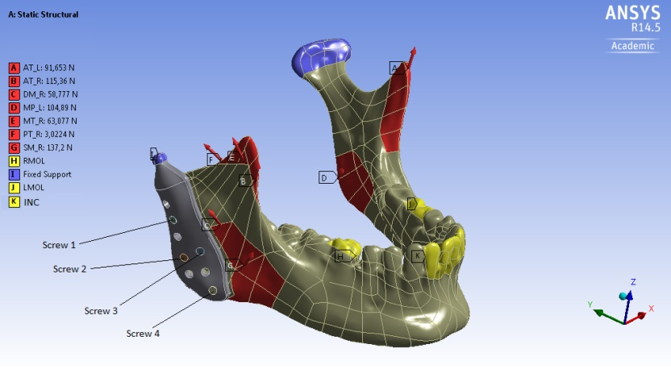

Figure 1: Finite Element Model of mandible and TMJ condylar prosthesis. Red colored objects correspond to muscle insertion areas (initials of muscles names explained in Table 1), blue to fully constrained areas and yellow to vertically constrained bite positions.

2.2 Muscular forces and boundary conditions

Muscular forces of the six masticatory muscles were applied on FEM based on previous validated model to simulate three different bite clench: Incisal Clench (INC), Right Molar bite (RMOL) and Left Molar bite (LMOL). Muscle insertion areas derived from Hylander book (Hylander, 2006) and magnitude and directions of forces from Korioth model (Korioth e Hannam, 1994). Figure 1 shows FEM with forces and boundary conditions acting on and Table 1 resumes muscular forces. The model was fully constrained at condyle extremities and vertical movement was constrained at four central incisors in case of INC, and at first right molar or first left molar, in case of RMOL and LMOL respectively.

Table 1: Muscular forces. All values derived from Korioth and Hannam (Korioth e Hannam, 1994). Masticatory muscles: SM = Superficial masseter; DM = Deep masseter; MP= Medial pterygoid; AT= Anterior temporalis; MT= Middle temporalis; PT= Posterior temporalis. Bite condition: INC incisal clench; RMOL right molar bite; LMOL left molar bite.

|  |  |  |  |  |  |  |  |  |
| --- | --- | --- | --- | --- | --- | --- | --- | --- |
| Bite  condition | Side | Direction forces | Muscular force (N) | | | | | |
|  |  |  | SM | DM | MP | AT | MT | PT |
| INC | Right | Fx | -15.77 | -11.58 | 66.26 | -1.88 | -1.27 | -0.63 |
|  |  | Fy | -31.91 | 7.60 | -50.72 | -0.56 | 2.87 | 2.59 |
|  |  | Fz | 67.40 | 16.08 | 107.85 | 12.49 | 4.80 | 1.43 |
|  | Left | Fx | 15.77 | 11.58 | -66.26 | 1.88 | 1.27 | 0.63 |
|  |  | Fy | -31.91 | 7.60 | -50.72 | -0.56 | 2.87 | 2.59 |
|  |  | Fz | 67.40 | 16.08 | 107.85 | 12.49 | 4.80 | 1.43 |
| RMOL | Right | Fx | -28.38 | -32.08 | 71.36 | -17.19 | -13.94 | -9.28 |
|  |  | Fy | -57.44 | 21.03 | -54.62 | -5.07 | 31.55 | 38.14 |
|  |  | Fz | 121.2 | 44.53 | 116.14 | 113.96 | 52.81 | 21.14 |
|  | Left | Fx | 23.65 | 26.73 | -50.97 | 13.65 | 14.16 | 6.13 |
|  |  | Fy | -47.87 | 17.53 | -39.02 | -4.03 | 32.03 | 25.21 |
|  |  | Fz | 101.10 | 37.11 | 82.96 | 90.54 | 53.61 | 13.98 |
| LMOL | Right | Fx | -23.65 | -26.73 | 50.97 | -13.65 | -14.16 | -6.13 |
|  |  | Fy | -47.87 | 17.53 | -39.02 | -4.03 | 32.03 | 25.21 |
|  |  | Fz | 101.10 | 37.11 | 82.96 | 90.54 | 53.61 | 13.98 |
|  | Left | Fx | 28.38 | 32.08 | -71.36 | 17.19 | 13.94 | 9.28 |
|  |  | Fy | -57.44 | 21.03 | -54.62 | -5.07 | 31.55 | 38.14 |
|  |  | Fz | 121.32 | 44.53 | 116.14 | 113.96 | 52.81 | 21.14 |

* 1. Results

For each bite condition FEA calculated: Von Mises stress and strain on mandibular bone; and Von Mises maximum stress on TMJ condylar prosthesis. FEA results are summarized in Table 2 and show in Figure 2.

Table 2: FEA results.

|  |  |  |  |
| --- | --- | --- | --- |
| Bite  condition | Mandibular bone | | Condylar Prosthesis |
|  | Max stress  (MPa) | Max strain  (mm/mm) | Max stress  (MPa) |
| INC | 72.89 | 7.41e-3 | 137.75 |
| RMOL | 114.43 | 1.19e-2 | 98.19 |
| LMOL | 45.82 | 4.86e-3 | 397.64 |

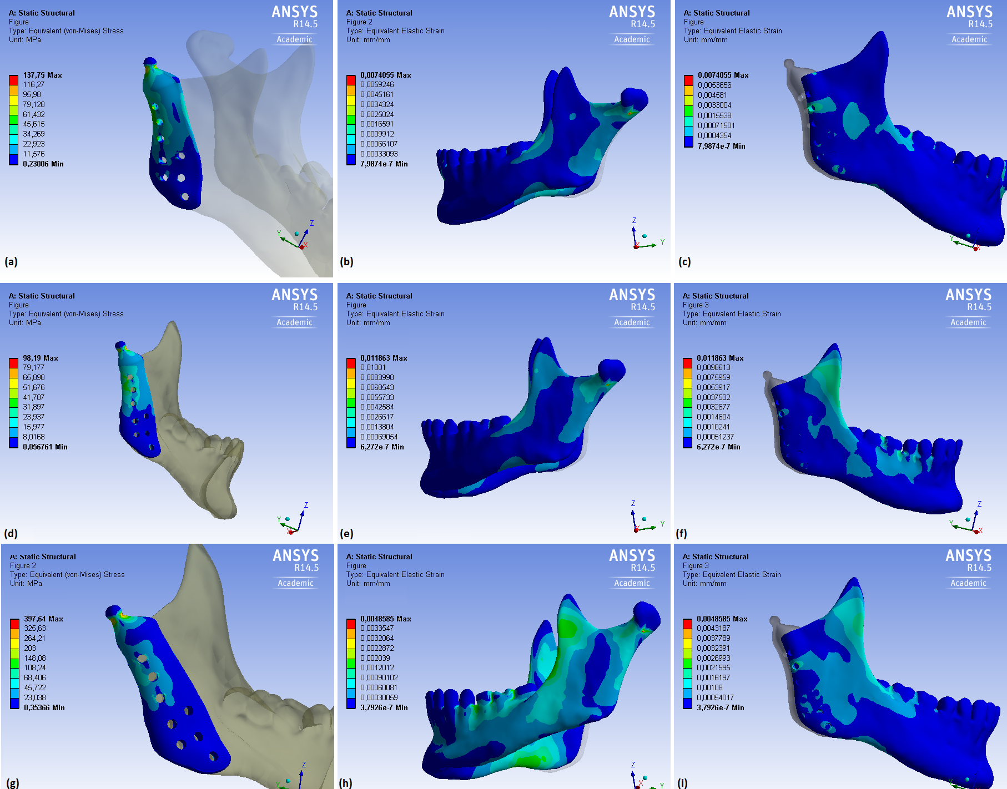

Figure 2: FEA results of three bite conditions simulated; a, d, g: Von Mises stress on TMJ condylar prosthesis; b, e, h: Von Mises strain on implant-bone contact areas; c, f, i: Von Mises strain on contralateral condyle.

* + 1. TMJ condylar prosthesis mechanical response

Subjected to three different type of bite loading, TMJ condylar prosthesis maximum stress occurs at condylar neck, on posterior and anterior slope. For LMOL bite loading, Von Mises stress is approximately 3 times higher than for INC loading and 4 times than for RMOL loading (Table 2). Stress around the screws on TMJ prosthesis is concentrated mostly around the first screw (Fig. 2a, d, g).

* + 1. Mandibular bone mechanical response

The analysis shows that maximum Von Mises stress occurs at condylar posterior slope of healthy contralateral joint (Fig. 2b, e, h). The highest value of maximum stress is calculated for RMOL bite condition, then INC shows a value corresponding to 3/5 of RMOL and for last LMOL corresponding to 2/5 of RMOL highest value. The maximum strain value shows the same trend of maximum stress (Table 2). Strain distribution pattern (Fig. 2-c, f, i) on mandibular bone in contact with TMJ prosthesis is similar in the three different bite conditions, characterized by a greater strain concentration around screws 1 e 4.

* 1. Discussion

Because of TMJ-based experimental literature of in vivo or in vitro measurement is lacking, previous studies showed that FEA is a reliable tool to understand and learn about TMJ mechanical behaviour (Rodrigues *et al.*, 2018). Therefore, in this study TMJ with unilateral condylar prosthesis subjected to three different bite loads was simulated to verify: if prosthetic components (condyle and screw) risk failure for fracture; and if strain generated in host bone due to replacement device promotes osseointegration.

TMJ disorder impairs joint function until only prosthesis can replace it and previous study estimates a decrease in masticatory muscle strength approximately of 50% (Mercuri *et al.*, 2007). Thus, it is important to remind that this FEA simulates healthy masticatory muscles to test mechanical response at worst. Moreover during replacement surgery lateral pterygoid muscle, responsible of protrusion and lateral movement, is removed and so lack of this muscle should be considered in unilateral clench results. In fact lateral pterygoid force value in LMOL and RMOL bite are about 30 N in x and y directions on the opposite side to bite one (Korioth e Hannam, 1994). The results of this study about TMJ condylar prosthesis show a critical loading of 397 MPa in case of LMOL bite. This result agrees with Huang study (Huang *et al.*, 2015) but maximum stress value is almost double because of Co-Cr-Mo alloy material used in Huang replacement device. Despite high value of stress calculated and considered as mentioned above, it is far from Titanium alloy typical yield stress of 800 MPa (Ackland *et al.*, 2015). Thus, FEA results of this study state that fracture on TMJ device is improbable to occur.

Maximum strain and stress on mandibular bone occurs at contralateral natural condyle. In agreement with literature, the muscular forces weakening of diseased TMJ causes an overload of the healthy contralateral joint, which presents all muscles and their natural insertion areas (Johnson *et al.*, 2017). In fact the lack of lateral pterygoid muscle leads to unilateral hypomobility and contralateral hypermobility (Zou *et al.*, 2018). The effect of replacement device on bone is studied with strain pattern on bone-implant contact area. In Figure 2c,f,i strain distribution shows maximum around first and last screw. This outcome coincides with previous study about fixation pattern and underlines again the importance of screw position to guarantee long-term stability (Hsu *et al.*, 2011). Around screws areas strain reaches a value of almost 2e-3 mm/mm. According to Robert theory (Roberts *et al.*, 2004), a range of 0.2-2.5e-3 mm/mm allows bone remodelling, once the lower and upper limits are exceeded, the bone undergoes resorption. This prevents osseointegration and increases the risk of failure for screw loosening and instability of replacement device. Therefore this study results shows that could occurred a bone ingrowth remodelling and so osseointegration of custom-made TMJ device.

Finally, worst results appear to occur with unilateral clench, on right or left molar. This outcome was also collected by Mercuri (Mercuri *et al.*, 2002). Poor results about lateral movements of TMJ with replacement device are due to the fact that TMJ kinematics is complex. In fact this joint is capable to make rotation and translation around three conventional axes and its movement depends on articular surface shape and masticatory muscles action, and thus it is less constrained than FEM. Thus the lack of lateral pterygoid and weakening of other muscles reduces replacement success in restore TMJ kinematics. Moreover TMJ is a bilateral or bicondylar joint, hence the two condyles move simultaneously or movement of one depends on the other (Lundberg, 2016). So unilateral replacement device causes contralateral overload and hypermobility and this can lead healthy joint to sicken in long-term.

* 1. Conclusion

In conclusion, this study shows that custom-made TMJ replacement device is reliable solution to treat TMJ disorder. Indeed, TMJ condylar prosthesis is able to withstand masticatory muscle in both unilateral and bilateral clench condition and strain pattern on custom-made implant-bone contact side on mandibular bone promotes osseointegration. Furthermore FEA is a valuable tool to study TMJ replacement mechanical behaviour. We conclude that TMJ replacement device research should aim to find a design solution to restores TMJ complex kinematics, particularly to the lack of lateral pterygoid muscle.

Acknowledgments

The authors wish to acknowledge the financial support provided by the Scientific Research Foundation for the State of São Paulo (FAPESP – Process 2008/57860-3) and National Council for Scientific and Technological Development (CNPq – Process 573661/2008-1).

References

Ackland D.C., Moskaljuk A., Hart C., Vee Sin Lee P., Dimitroulis G., 2015, Prosthesis Loading After Temporomandibular Joint Replacement Surgery: A Musculoskeletal Modeling Study, Journal of Biomechanical Engineering, 137, 4, 041001-041001-9.

De Meurechy N., Mommaerts M. Y., 2018, Alloplastic temporomandibular joint replacement systems: a systematic review of their history, International Journal of Oral and Maxillofacial Surgery, 47, 6, 743-754.

Groning F., Fagan M., O'Higgins P., 2012, Modeling the human mandible under masticatory loads: which input variables are important?, Anat Rec (Hoboken), 295, 5, 853-63.

Hsu J. T., Huang H.L., Tsai M.T., Fuh L.J., Tu M.G., 2011, Effect of screw fixation on temporomandibular joint condylar prosthesis, Journal Oral Maxillofacial Surgery, 69, 5, 1320-8.

Huang H. L., Su K.C., Fuh L.J., Chen M.Y., Wu J., Tsai M.T., Hsu J.T., 2015, Biomechanical analysis of a temporomandibular joint condylar prosthesis during various clenching tasks, Journal Craniomaxillofacial Surgery, 43, 7, 1194-201.

Hylander W., 2006, Functional Anatomy of the TMJ.

Johnson N. R., Roberts M.J., Doi S.A., Batstone M.D., 2017, Total temporomandibular joint replacement prostheses: a systematic review and bias-adjusted meta-analysis, Int J Oral Maxillofac Surg, 46, 1, 86-92.

Korioth T. W., Hannam A. G., 1994, Deformation of the human mandible during simulated tooth clenching, J Dent Res, 73, 1, 56-66.

Longhitano G. A., Larosa M. A., Jardini A. L., Zavaglia C. A. C, Ierardi M. C. F., 2018, Correlation between microstructures and mechanical properties under tensile and compression tests of heat-treated Ti-6Al–4V ELI alloy produced by additive manufacturing for biomedical applications, Journal of Materials Processing Technology, 252, 202-210.

Lotesto A., Miloro M., Mercuri L. G., Sukotjo C., 2017, Status of alloplastic total temporomandibular joint replacement procedures performed by members of the American Society of Temporomandibular Joint Surgeons, International Journal of Oral and Maxillofacial Surgery, 46, 1, 93-96.

Lundberg H. J., 2016, TMJ Biomechanics, Chapter in: Mercuri L. G. (Ed), Temporomandibular Joint Total Joint Replacement – TMJ TJR: A Comprehensive Reference for Researchers, Materials Scientists, and Surgeons, Cham: Springer International Publishing, 3-28.

Mercuri L. G., Edibam N. R., Giobbie-Hurder A., 2007, Fourteen-year follow-up of a patient-fitted total temporomandibular joint reconstruction system, J Oral Maxillofac Surg, 65, 6, 1140-8.

Mercuri L. G., Wolford L. M., Sanders B., White D., Giobbie-Hurder A., 2002, Long-term follow-up of the CAD/CAM patient fitted total temporomandibular joint reconstruction system, J Oral Maxillofac Surg, 60, 12, 1440-8.

Roberts W. E., Huja S., Roberts J. A., 2004, Bone modeling: biomechanics, molecular mechanisms, and clinical perspectives, Seminars in Orthodontics, 10, 2, 123-161.

Rodrigues Y. L., Mathew M. T., Mercuri L. G., da Silva J. S. P., Henriques B., Souza J. C. M., 2018, Biomechanical simulation of temporomandibular joint replacement (TMJR) devices: a scoping review of the finite element method, Int J Oral Maxillofac Surg, 47, 8, 1032-1042.

Shirazi-Adl A., Dammak M., Paiement G., 1993, Experimental determination of friction characteristics at the trabecular bone/porous-coated metal interface in cementless implants, J Biomed Mater Res, 27, 2, 167-75.

Zou L., He D., Ellis E., 2018, A Comparison of Clinical Follow-Up of Different Total Temporomandibular Joint Replacement Prostheses: A Systematic Review and Meta-Analysis, Journal of Oral and Maxillofacial Surgery, 76, 2, 294-303.