|  |  |
| --- | --- |
| cetlogo ***CHEMICAL ENGINEERING TRANSACTIONS***  ***VOL. 76, 2019*** | A publication of  aidiclogo_grande |
| The Italian Association  of Chemical Engineering  Online at www.cetjournal.it |
| Guest Editors: Sauro Pierucci, Jiří Jaromír Klemeš, Laura Piazza  Copyright © 2019, AIDIC Servizi S.r.l. **ISBN** 978-88-95608-73-0; **ISSN** 2283-9216 | |

Effect of the reaction volume on the formation of microparticles of the pequi oil (*Caryocar coriaceum* Wittm.) by complex coacervation

Williara Q. Oliveiraa, Antonio W. O. Araújoa, Nedio J. Wurlitzerb,\*, Maria S. R. Bastosb, Roselayne F. Furtadob

aFederal University of Ceará, Department of Food Technology. Fortaleza, Brazil.

bEmbrapa Agroindústria Tropical, Dra Sara Mesquita 2270, 60511-110, Fortaleza, Brazil.

nedio.jair@embrapa.br

The oil from Pequi pulp, also known as pequi oil (PO) is a promising bioactive for the food industry, and complex coacervation is a simple encapsulation method to improve its stability and use as a food ingredient. The high reaction volume used is considered a challenge to microcapsule production by coacervation process. Therefore, the objective of this study was to evaluate the effect of the reaction volume on the formation, morphology, size, yield, and efficiency of pequi microcapsules. The complex coacervation was performed with wall material composed by polymers (gelatin and gum arabic) and pequi oil as the core material. The oil was mixed with gelatin, added the polysaccharide and pH was adjusted to 3.5, to allow the microparticle formation. The reaction volume treatments T1, T2, T3, and T4, related to wall material concentration, were 0.39, 0.77, 0.58, and 1.16 g 100 mL-1, respectively. The results of zeta potential were close to zero, without differences related to the reaction volume. Optical microscopy showed that, regardless of volume, microparticles of pequi oil presented defined walls, mononuclear core and particle size from 2.71 up to 7.27 μm, adequate for food application. In a smaller reaction volume (T1 and T3), the coacervates were aggregated due to the increase of the chemical interactions; in higher volumes (T3 and T4) the microcapsules showed an inverse behavior. The yield ranged from 58.40 up to 63.42 %. The encapsulation efficiency exhibited high values ​​ranging from 90.05% ± 8.15 to 99.40% ± 0.21. The variation of reaction volume did not influence the formation of pequi oil microcapsules in the analyzed treatments, but the dispersion of the microcapsules changed. This study provided a new perspective on how the reaction volume influences the encapsulation by complex coacervation.

* 1. Introduction

The pulp oil from *Caryocar coriaceum* Wittm., also known as pequi oil (PO) has been called attention for presenting antioxidant benefits (Torres et al., 2016); hepatoprotective effect (Palmeira et al., 2016; Torres et al., 2016); improve cardiac function by virtue of the oleic acid and carotenoids present in its composition, anti-inflammatory and lipid-lowering effects (Figueiredo et al., 2016; Torres et al., 2016). However, if applied directly in the food matrix, it is susceptible to oxidative degradation by stress factors due to temperature, extreme conditions of pH, O2 and light, during the production chain or in storage; reducing the shelf-life and degradation of the sensorial and functional qualities (Holken et al., 2015).

Complex coacervation (CC), as well as other encapsulation techniques, is a method to prolong the stability of bioactive compounds, as well as controlling the core substance release, presenting promising benefits for the food industry (Holken et al., 2015). Specifically for CC, active core packing is attributed to the interaction between the protonated amino groups of the protein and carboxyl groups of the polysaccharide, predominantly resulting from electrostatic forces and other intermolecular interactions, such as Van der Walls and hydrophobic interactions (Turgeon et al., 2007). The formation of microcapsules by complex coacervation depends on the biopolymer concentration, molecular weight, proportion of the biopolymer pair, pH, agitation, ionic strength, temperature and others (Eghbal, Choudhary, 2018). In this sense, the majority of the studies with microcapsule formation by CC trace a system with a high reaction volume associated to a low biopolymer concentration (Duhoranimana et al., 2018). However, when increasing the scale of the microparticles production, the high reaction volume can be expensive, high equipment cost and waste amount, thus, reducing the viability of the technology.

Therefore, the objective of this study was to reduce the reaction volume associated with the increase in concentration, once the polymers amount in the system was fixed, evaluating the interference in the formation, morphology, process efficiency in pequi oil microcapsules.

* 1. Material and methods
     1. Material

The oil of pequi (Caryocar coriaceum Wittm.) was obtained in Crato, Ceará, Brazil. The polysaccharide gum arabic (GA) was purchased from Sigma-Aldrich and the gelatin (GE) 175H30 from Rousselout®. Analytical grade reagents were used. The experiments were performed at the Packaging Lab of Embrapa Tropical Agroindustry.

* + 1. Microcapsules preparation by complex coacervation

The treatments T1, T2, T3 and T4 were prepared, with 0.39, 0.58, 0.77 and 1.16 g mL-1 biopolymer concentration, respectively. The biopolymer was in a 1 GE: 1.5 GA proportion (w/w), and 0.5 g of pequi oil as the core material in all treatments. The methodology of complex coacervation followed the described by Timilsena et al. (2017). The pequi oil was emulsified with GE in a distilled water solution, 10,000 rpm for 3 min with an ultraturrax (IKA T25, Germany), and the gum arabic was dispersed separately. The two dispersions were mixed and the volume adjusted with distilled water up to the concentration of each treatment. The pH was adjusted to 3.5 with HCl (0.7 M), (this pH value was established in preliminary tests), to protein-polysaccharide complexation and the microcapsule were allowed to settle overnight, and after decantating, were centrifuged (10,000 rpm / 10 m ), and lyophilized in a LP-510 freezer-dryer (Liobrás, Brazil).

* + 1. Evaluation of efficiency and microcapsule parameters

Zeta (ζ): for each treatment (coacervate emulsion), the zeta values were determined using Zetasizer Nano ZS-3000 (Malvern Instruments, Malvern, UK).

Morphological characterization was performed with a Zeiss optical microscope (Zeiss Axio Imager.A2) coupled with a digital image acquisition system.

Particle size: the microcapsules mean diameter was calculated by image analysis using the ImageJ software, following the methodology Comunian et al. (2018), with modifications.

Yield (Y): the ratio between final weight (wf), after microcapsules freeze-drying, and the initial weight (wi) of gum arabic, gelatin and pequi oil, see eguation 1 (Huang et al., 2012).

|  |  |
| --- | --- |
| $$Y (\%)= \frac{w_{f}}{w_{i}}x 100$$ | (1) |

The encapsulation efficiency (EE), the amount of oil retained in the structure of the biopolymer matrix, was calculated with the use of Equation 2, being Ot the total amount and Os the surface oil. The oil analyses were performed with the methodology described by Bligh and Dyer (1959), adapted by Comunian et al. (2018). The surface oil analyses were performed without disruption of the dried microcapsules, while the total oil analyses were performed with disruption of the capsules.

|  |  |
| --- | --- |
| $$EE (\%)= \frac{{O_{t}-O_{s}}_{o}}{O_{t}}x 100$$ | (2) |

The experimental results were analyzed using the Statistica v. 8.0 (Statsoft Inc., USA), with variance analysis (ANOVA) and Turkey test, with a 5% significance level.

* 1. Results and discussion

In the steps of the complex coacervation, shown in Figure 1, the treatments (line A in the picture) shortly after the pH adjustment and turbidity can be observed caused by the progress of the precipitation process. The biopolymers expelled the intermolecular water, increasing the entropy of the system, leaving the solution clouded and then aggregated as a natural form of energy loss, decreasing entropy (Singh et al., 2007) and resulting in two heterogeneous regions - one poor and one rich in polymers (line B in the picture).

Greater or lesser reaction space for CC may present divergent arguments. It is known that the oil hinders the electrostatic interactions between the polymers (Gonçalves et al., 2018; Shi et al., 2018); the smaller and more emulsified the oil droplets in the system, the better the encapsulation. For this reason, the use of a large reaction volume is important because it increases the distance of the oil micelles, making coalescence difficult, which improves the encapsulation of the core compound. The opposite argumentation is that a smaller reaction volume decreases the space between charges, increasing the chances of interaction of the polymers.

In this study, the variation of the reaction volume after emulsion homogenization did not affect the formation of the precipitate complex at pH 3.5. Thus, it was observed that, in all the reaction volumes studied, there was precipitation of pequi oil microcapsules.

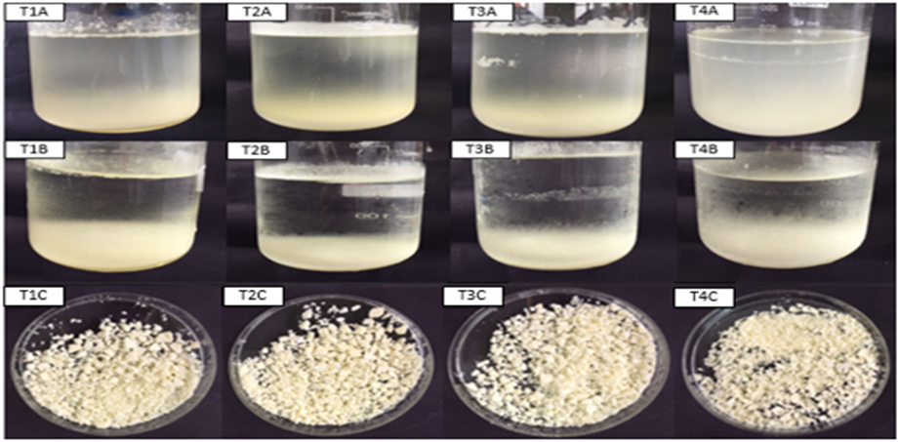

Figure 1: Treatments 1-4 (reaction volume of 200, 300, 400 and 600 mL), being line A: soon after pH correction up to 3,5; line B: after overnight; line C: after centrifugation and freeze-drying.

* + 1. Zeta (ζ)

The zeta potential results are presented in Table 1 and ranged from 0.20 to 0.65 (m / V), with no significant difference (p <0.05). When a zeta value is closer to zero, complex coacervation is considered ideal (Eghbal and Choudhary, 2018; Gonçalves et al., 2018). All treatments presented loads close to zero, indicating that the encapsulation of the samples was effective. Thus, it can be inferred that there was no direct relationship between the reaction volume variation and the zeta potential. The interactions between the biopolymer pairs occurred regardless of the reaction space. Specifically, T4, with higher reaction volume and lower concentration, had the highest interaction with a lower value of ζ. In turn, this suggests that low concentrations are sufficient to promote the formation of complex coacervates (Gulão et al., 2016). Yang et al., (2012) evaluated the interactions between gum arabic and fish gelatin and obtained similar results with 0.05% (w / v) polymers. In addition, Gulão et al., (2016), obtained similar results in complex coacervation with gum arabic and leucine, in concentrations of 0.03 to 0.15% (w / w) at pH of approximately 3.5.

* + 1. Morphological characterization

Figure 2 shows that treatments with pequi oil microcapsules predominantly formed mononuclear structures. Comunian et al. (2018) using gelatin and gum arabic to encapsulate opium and β-sitosterol seed oil by complex coacervation, obtained microparticles with circular morphology and defined walls, similar to the results of this research, differing only in the number of nuclei as echium microcapsules were polynuclear. Other studies also reported a rounded structure for the GE / GA complex, but multinucleated (Comunian et al., 2016). Ma et al. (2019) analyzed the effect of processing conditions on morphology during complex gelatin / gum arabic coacervation and obtained single nucleus microcapsules, similar to this study. The treatments with lower reaction volume (T1 and T2), with higher concentration of GE / GA, presented agglomeration, forming a macrosystem similar to a polynucleated structure. It is inferred, therefore, that the formation of this structure is a result of the increase in the concentration of the polymers, especially gelatin. Gonçalves et al. (2018) reported that as the total concentration of gelatin increases in the system, the charges of the surrounding molecules are neutralized and form a stable gel network. In T3 and T4 treatments, microcapsules are less crowded and irregular, similar to the structure reported by Hassana & Muhamad (2017). That is, the reaction volume did not interfere in the formation of the microcapsules, but in the chemical interaction force of the complex. Having a more aggregate or looser loading complex may be useful for a variety of purposes, for example, more agglomerated coacervates (resulting from lower reaction volumes) may be applied to more consistent foods such as yogurts, jellies and cottage cheese; coacervates that have high dispersibility (resulting from higher reaction volumes) can be applied to more fluid foods, such as juices, dairy drinks, fermented milk, among others.

Table 1: Results of encapsulation of pequi oil by complex coacervation

|  |  |  |  |  |  |  |
| --- | --- | --- | --- | --- | --- | --- |
| Treatment | Reaction volume (mL) | Concentration\*  (g 100 mL-1) | Zeta potential  (ζ) (m/V) | Yield (%) | Encapsulation Efficiency (%) | Microparticle size (μm) |
| T1 | 200 | 1.16 | 0.57 ± 0.12a | 58.40 ± 1.00a | 98.98 ± 0.72a | 3,15 ± 0,45 b |
| T2 | 300 | 0.77 | 0.65 ± 0.42a | 63.42 ± 0.46a | 90.05 ± 8.15a | 5,55 ± 0,21 ab |
| T3 | 400 | 0.58 | 0.39 ± 0.15a | 60.51 ± 2.17a | 99.40 ± 0.21a | 2,71 ± 0,24 b |
| T4 | 600 | 0.39 | 0.20 ± 0.22a | 59.32 ± 2.41a | 95.67 ±1.89a | 7,27 ± 1,73 a |

Note: \* Concentration of encapsulation material; results presented in means ± standard deviation; different superscript letters, in columns, differ statistically (p < 0.05) by Anova and Tukey test.

* + 1. Particle Size

Particle size is an important parameter to be discussed. For food applications, Lemetter et al. (2009) reported that, in order to avoid an unpleasant sensation in the mouth, the particle size should be below the sensory perception threshold, that is, in the range of 10-25 μm. Souza et al. (2018) reported that even visible particles can be projected when the goal is to prolong the bioactive release time.

Table 1 shows that the samples presented values ​​ranging from 1.73 to 2.71 μm, lower than those found by other authors when using gelatin and gum arabic (Mendanha et al., 2009). This is a positive factor, since small particles can lead to a lower perception of the core compound. Maner et al., (2018), using GE / GA to encapsulate metformin hydrochloride by complex coacervation, found size values ​​of 6.75 and 7.72 μm, relatively close to this work. The particle size results were not directly related to the reaction volume variation. However, it is important to note that, exceptionally, the sample with the highest reaction volume (T4) and lower biopolymer concentration also had a larger particle diameter, similar as reported by Eghbal and Choudhary (2018) and Gulão et al., (2016).

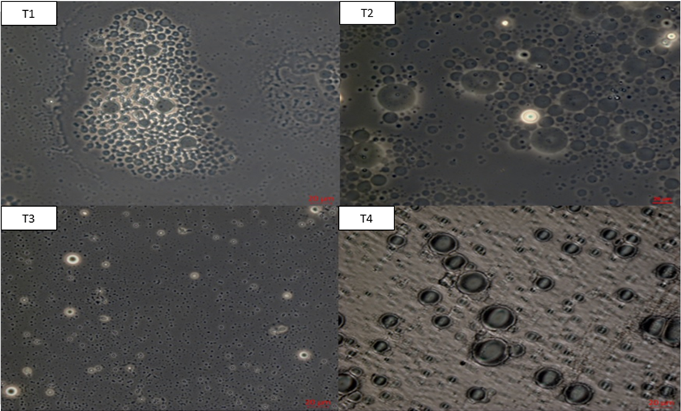

Figure 2 - Micrographs of microcapsules of gum arabic and gelatin with 0.5 g of pequi oil. (40x increase and a 20 μm scale)

* + 1. Yield

The yield results presented in Table 1 ranged from 58.40 to 63.42%, with no significant differences (p < 0.05) between treatments. The treatments with intermediate polymer concentrations (T2 and T3) presented, respectively, a higher yield, 63.42 ± 0.46 and 60.51 ± 2.14. Silva et al., (2017), encapsulating 1.0 and 2.0 g of pequi oil with gum arabic and chitosan, found yield values ​​(50-60%), close to this research. Chang et al. (2016), varying the canola and chitosan in ratios of 1: 2 to 6: 1, found yields of 20 to 35%, lower than this work. Shi et al. (2018) encapsulated krill oil by complex coacervation and obtained yields of 5-15%, well below those found in this research. No relationship was found between reaction volume and yield.

* + 1. Encapsulation Efficiency (EE)

The results of encapsulation efficiency were from 90.05% to 99.40 %, without differences (p < 0.05) between the samples. The efficiency is calculated by the difference between the core oil with that adsorbed in the external part of the complex (Silva et al., 2017). Thus, it can be inferred that regardless of the biopolymer concentrations tested, most of the encapsulated oil was retained within the microcapsules. In previous work using pequi oil, the authors obtained 89.29% ± 8.27 EE, which is lower than this research. Rutz et al., (2017), encapsulated palm oil using a biopolymer concentration of 5 mg.mL-1, and obtained encapsulation efficiency up to 99.51% when the samples were lyophilized, similar to the results of this study. Other authors have found EE smaller than those found in this study (Souza et al., 2018; Trucillo et al., 2017). Cruz et al., (2019) studying the relationship between encapsulation efficiency and polymer concentration concluded that the concentration increase is not always sufficient to ensure adequate encapsulation of the core. Therefore, as with the yield results, it was not possible to establish a relationship between reaction volume and encapsulation efficiency.

* 1. Conclusions

The results of this work allow us to conclude that the reaction volume variation does not significantly influence the precipitation of pequi oil microcapsules nor in yield, efficiency and particle size since they were within the standards desired for the process. Thus, the coacervated gelatin / arabic gum with lower reaction volume can effectively encapsulate pequi oil with high efficiency; however, it should be noted that more cohesive or less aggregated microcapsules may be crucial to success when employed in the food matrix. Therefore, this study provided a new perspective on how the reaction volume influences encapsulation by complex coacervation.

Acknowledgments

The present work was carried out with the support of the Coordination of Improvement of Higher Education Personnel - Brazil (CAPES) - Financing Code 001, project 832420 / 1999-9. The authors also thank Embrapa Agroindústria Tropical for the support and to Rousselout® for providing 175H30 gelatine for this study.

References

Chang P.G., Gupta R., Timilsena Y.P., Adhikari B., 2016, Optimisation of the complex coacervation between canola protein isolate and chitosan. Journal of Food Engineering, v. 191, p.58-66. dx.doi.org/10.1016/j.jfoodeng.2016.07.008.

Comunian T.A., Gomez-Estaca J., Furtado R.F., Conceição G.J.A., Moraes I.C.F., Castro I.A., Trindade C.S.F., 2016, Effect of different polysaccharides and crosslinkers on echium oil microcapsules. Carbohydrate Polymers, v. 150, p.319-329. dx.doi.org/10.1016/j.carbpol.2016.05.044.

Comunian T.A., Nogueira M., Scolaro B., Thomazini M, Furtado R.F., Castro I.A., Trindade C.S.F., 2018,. Enhancing stability of echium seed oil and beta-sitosterol by their coencapsulation by complex coacervation using different combinations of wall materials and crosslinkers. Food Chemistry, v. 252, p.277-284. dx.doi.org/10.1016/j.foodchem.2018.01.121.

Cruz M.C.R., Dagostin J.L.A., Perussello C.A., Masson M.L., 2019, Assessment of physicochemical characteristics, thermal stability and release profile of ascorbic acid microcapsules obtained by complex coacervation. Food Hydrocolloids, v. 87, p.71-82. dx.doi.org/10.1016/j.foodhyd.2018.07.043.

Duhoranimana E.; Yu J.; Mukeshimana O.; Habinshuti I.; Karangwa E.; Xu X.; Muhoza B.; Xia S.; Zhang X., 2018, Thermodynamic characterization of Gelatin-Sodium carboxymethyl cellulose complex encapsulating Conjugated Linoleic Acid (CLA). Food Hydrocolloids, v. 80, p.149-159. dx.doi.org/10.1016/j.foodhyd.2018.02.011.

Eghbal N., Choudhary R., 2018, Complex coacervation: Encapsulation and controlled release of active agents in food systems. LWT, v. 90, p.254-264. dx.doi.org/10.1016/j.lwt.2017.12.036.

Figueiredo P. R. L., Oliveira I.B., Santana-Neto J.B., Oliveira J.A., Ribeiro L.B., Viana G.S.B., Rocha T.M., Leal L.K.A.M., Kerntopf M.R., Felipe C.F.B., Coutinho H.D.M., Menezes I.R.A., 2016, Caryocar coriaceum Wittm. (Pequi) fixed oil presents hypolipemic and anti-inflammatory effects in vivo and in vitro. Journal of Ethnopharmacology, v. 191, p.87-94. dx.doi.org/10.1016/j.jep.2016.06.038.

Gonçalves N.D., Grosso C.R.F., Rabelo R.S., Hubinger M.D., Prata A.S., 2018, Comparison of microparticles produced with combinations of gelatin, chitosan and gum Arabic. Carbohydrate Polymers, v. 196, p.427-432. doi.org/10.1016/j.carbpol.2018.05.027.

Gulão E.S., Souza C.J.F., Andrade C.T., Garcia-Rojas E.E. Complex coacervates obtained from peptide leucine and gum arabic: Formation and characterization. Food Chemistry, v. 194, p.680-686, Mar. 2016. Elsevier BV. doi.org/10.1016/j.foodchem.2015.08.062.

Hassana N.D, Muhamad I.I, 2017, Drying and preservation of phytochemicals from Elateriospermum tapos seed oil using combination of freeze drying and microwave technique. Chemical Engineering Transactions, v. 56, p.1003-1008. Doi.org/10.3303/CET1756168

Lemetter C. Y. G., Meeuse F. M., Zuidam N. J., 2009, Control of the morphology and the size of complex coacervate microcapsules during scale-up. Aiche Journal, v. 55, n. 6, p.1487-1496. doi.org/10.1002/aic.11816.

Ma T., Zhao H., Wang J., Sun B., 2018, Effect of processing conditions on the morphology and oxidative stability of lipid microcapsules during complex coacervation. Food Hydrocolloids, v. 87, p.637-643. doi.org/10.1016/j.foodhyd.2018.08.053

Mendanha D.V., Ortiz S.E.M., Favaro-Trindade C.S., Mauri A., Monterrey-Quintero E.S., Thomazini M., 2009, Microencapsulation of casein hydrolysate by complex coacervation with SPI / pectin. Food Research International, v. 42, n. 8, p.1099-1104. doi.org/10.1016/j.foodres.2009.05.007

Rutz J.K., Borges C.D., Zambiazi R.C., Crizel-Cardozo M.M., Kuck L.S., Noreña C.P.Z., 2017, Microencapsulation of palm oil by complex coacervation for application in food systems. Food Chemistry, v. 220, p.59-66. doi.org/10.1016/j.foodchem.2016.09.194

Shi L., Beamer S.K., Yang H., Jaczynski J., 2018, Micro-emulsification/encapsulation of krill oil by complex coacervation with krill protein isolated using isoelectric solubilization/precipitation. Food Chemistry, v. 244, p.284-291. doi.org/10.1016/j.foodchem.2017.10.050

Silva L.C., Nascimento M.A., Mendes L.G., Furtado R.F., Costa J.M.C., Cardoso A.L.H., 2017, Optimization of cashew gum and chitosan for microencapsulation of pequi oil by complex coacervation. Journal of Food Processing and Preservation, v. 42, n. 3, p.1-8. doi.org/10.1111/jfpp.13538

Singh S.S., Aswal V.K., Bohidar H.B., 2007,Structural studies of agar–gelatin complex coacervates by small angle neutron scattering, rheology and differential scanning calorimetry. International Journal Of Biological Macromolecules, v. 41, n. 3, p.301-307. doi.org/10.1016/j.ijbiomac.2007.03.009

Souza C.J.F., Costa A.R., Souza C.F., Tosin F.F.S., Garcia-Rojas E.E., 2018, Complex coacervation between lysozyme and pectin: Effect of pH, salt, and biopolymer ratio. International Journal Of Biological Macromolecules, v. 107, p.1253-1260. doi.org/10.1016/j.ijbiomac.2017.09.104

Timilsena Y.P., Wang B., Adhikari R., Adhikari B., 2017, Advances in microencapsulation of polyunsaturated fatty acids (PUFAs) -rich plant oils using complex coacervation: A review. Food Hydrocolloids, Melbourne, v. 69, p.369-381. doi.org/10.1016/j.foodhyd.2017.03.007

Torres L.R.O., Santana F.C., Torres-Leal F.L., Melo I.L.P., Yoshime L.T., Matos-Neto E.M., Seelaender M.C.L., Araújo C.M.M., Cogliati B., Mancini-Filho J., 2016, Pequi (Caryocar brasiliense Camb.) Almond oil attenuates carbon tetrachloride-induced acute hepatic injury in rats: Antioxidant and anti-inflammatory effects. Food And Chemical Toxicology, v. 97, p.205-216. doi.org/10.1016/j.fct.2016.09.009

Turgeon S.L., Schmitt C., Sanchez C., 2007, Protein-polysaccharide complexes and coacervates. Current Opinion In Colloid & Interface Science, Québec, v. 12, n. 4-5, p.166-178. doi.org/10.1016/j.cocis.2007.07.007

Trucillo P., Campardelli R., Reverchon E., 2017, Operative Parameters Optimization Production of Liposomes for the Encapsulation of Hydrophilic Compounds Using a New Supercritical Process. Chemical Engineering Transactions, v. 57, p. 799-804. [doi.org/10.3303/CET1757134](https://doi.org/10.3303/CET1757134)

Yang Y., Anvari M., Pan C., Chung D., 2012, Characterization of interactions between fish gelatin and gum arabic in aqueous solutions. Food Chemistry, v. 135, n. 2, p.555-561. doi.org/10.1016/j.foodchem.2012.05.018