|  |  |
| --- | --- |
| cetlogo ***CHEMICAL ENGINEERING TRANSACTIONS***  ***VOL. 76, 2019*** | A publication of  aidiclogo_grande |
| The Italian Association  of Chemical Engineering  Online at www.cetjournal.it |
| Guest Editors: Sauro Pierucci, Jiří Jaromír Klemeš, Laura Piazza  Copyright © 2019, AIDIC Servizi S.r.l. **ISBN** 978-88-95608-73-0; **ISSN** 2283-9216 | |

Nitrogen-doped carbon Nanodots/PMMA nanocomposites for solar cells applications

Francesco Amatoa, Michele Cacioppoa, Francesca Arcudia, Maurizio Pratoa,b,c, Melina Mituod, Elizabeth G. Fernandesd, Marcelo N. P. Carreñoe, Inés Pereyrae, Julio R. Bartolif,\*

aDepartment of Chemical and Pharmaceutical Sciences, INSTM UdR Trieste, University of Trieste, Via Licio Giorgieri 1, 34127 Trieste, Italy.

bCarbon Nanobiotechnology Laboratory, CIC biomaGUNE, Paseo de Miramón 182, 20014 Donostia-San Sebastián, Spain. cBasque Foundation for Science, Ikerbasque, 48013 Bilbao, Spain.

d Department of Metallurgical and Materials Engineering, University of S. Paulo - USP, Av. Prof. Mello Moraes, 2463, 05508-030 S. Paulo, Brazil

eNew Materials and Devices Group, Department of Electronic Systems Engineering, University of S. Paulo - USP, Av. Prof. Luciano Gualberto - Travessa 3, 158, 05508-150 S. Paulo, Brazil

fDepartment of Materials Engineering and Bioprocess, School of Chemical Engineering, State University of Campinas -Unicamp, Av. Albert Einstein 500, 13084-852 Campinas, Brazil

[bartoli@unicamp.br](mailto:bartoli@unicamp.br)

Carbon Nanodots (CNDs) are a novel class of nanocarbons that consist of discrete, quasi-spherical nanoparticles with sizes below 10 nm. Besides, due to their low cost, environmentally friendly and low toxicity, CNDs could substitute traditional semiconductor quantum dots (QDs), generally top luminescent materials, but usually made of heavy metals. A very interesting property of CNDs is their tunable emission, characterized by multi-fluorescence colors under varied excitation wavelengths. Photoluminescent CNDs properties give them potential applications in areas such as biomedicine, bioimaging, catalysis, optoelectronics and solar concentrators. Luminescent solar concentrators (LSC) are usually thin plates or sheets made of transparent polymers, such as poly(methyl methacrylate) (PMMA), doped with photoluminescent species. Direct and diffuse incident sunlight is absorbed by these species and the emitted visible light is guided through the polymer to be collected by attached solar cells, increasing their efficiency. CNDs are promising candidates as luminescent doping species for PMMA in preparing hybrid materials, which could be an advantageous and innovative alternative for solar cells applications. In this work, highly fluorescent nitrogen-doped CNDs (NCNDs) were prepared following a simple and controllable synthetic approach under microwave irradiation (MW). Arginine and ethylenediamine were used as carbon and nitrogen precursors and water as reaction medium. The MW parameters were optimized (240°C, 26 bar, 200 W, 180 sec) to obtain the desired properties of the final material, in terms of optical performance. Nanocomposites of NCNDs/PMMA were prepared by solution blending, with 0.1 wt.% and 0.01 wt.% of NCNDs, followed by film casting. The down conversion fluorescence behavior of NCNDs and NCND/PMMA nanocomposites were characterized by Photoluminescence spectroscopy. A broad emission peak at 356 nm was observed for the NCNDs when excited at 300 nm and the fluorescence peaks shift from 356 to 474 nm as excitation varies from 300 to 420 nm. On the other hand, the fluorescence of the NCNDs in the PMMA matrix showed significant broad emission at around 450 nm when excited between 300 and 320 nm.

* 1. Introduction

Carbon Nanodots (CNDs) were accidently discovered during the purification of single-walled carbon nanotubes through preparative electrophoresis (Xu et al., 2004); once they were exposed to ultraviolet excitation showed fluorescence emission in the visible spectrum. Since then, CNDs turn into an emerging class of carbon nanostructures distinguished by their fluorescent properties, low toxicity, good biocompatibility, cheap and plentiful nature (Sun *et al.*, 2006; Silva et al., 2011; Wang and Hu, 2014; Arcudi *et al.* 2016,). Improvement in the fluorescence efficiency of the CNDs can be obtained by doping with nitrogen. Amino acids are abundant and inexpensive sources of carbon and nitrogen for these applications (Xu et al., 2012; Jiang et al. 2013). Arcudi *et al.* (2016) prepared small and highly fluorescent nitrogen-doped carbon nanodots (NCNDs) using a bottom-up approach through microwave-assisted hydrothermal synthesis, starting from abundant and inexpensive precursors such as arginine and ethylenediamine. These NCNDs have an average size of ca. 2.5 nm, a narrow size distribution, various functional groups and emissive domains on each dots, which results in multi-fluorescence colors under different excitation wavelenghts. The NCNDs emit in the blue region of the visible spectrum, and the photoluminescence spectra showed that the emission shifts from 356 to 474 nm when the excitation wavelength changes from 300 to 420 nm and the fluorescence intensity decreased as the peak red shifts Arcudi *et al.* (2016). Zhang *et al.* (2018) developed a fluorescence probe for selective recognition of metal ions, from heavy metal pollution, by using carbon dots as sensing element and quantum dots (CdSe) as an internal standard emission. Dordević *et al.* (2018) synthesized chiral CNDs by means of arginine, or citric acid, and (*R,R*) or (*S,S*) *trans*-cyclohexanediamine under microwave-assisted hydrothermal conditions. These CNDs were used as templates for the formation of chiral supramolecular porphyrin assemblies, showing that it is possible to use and transfer the chiral information to other molecules. Therefore, photoluminescent carbon dots have been attracting great attention because of their potential applications in areas such as bioimaging, biosensor, controlled drug delivery, optoelectronic devices, solar cells, photocatalysis and renewable-energy technologies (Wang and Hu, 2014; Arcudi *et al.* 2016; Rigodanza *et al.,* 2018).

On the other hand, polymeric nanocomposites often exhibit enhanced properties derived from the synergistic effect of the matrix properties and the homogeneous dispersed nanofiller components, namely if the nanoparticles dimensions reach the molecular levels of polymer chains (Alexandre and Dubois, 2000; Fischer, 2003). Nowadays, notable industrial applications rely on the use of polymer nanocomposites, using usually particles in the form of nanosheets, nanofibres or nanotubes that are prepared by *in situ* polymerization, solution or melt blending. Improvements on mechanical, thermal and flammability properties were found with layered minerals, such as clays (Gilman, 1999; Hasegawa *et al*., 2003; Zhao *et al.,* 2005; Dimos et al, 2017; Prado and Bartoli, 2018); besides electrical properties using carbon nanostructures, as carbon nanotubes or graphene nanoplatelets (Jia *et al.,* 1999; Ruiz-Hitzky *et al*, 2016; Mir *et al*., 2016; Bressanin *et al*, 2018; Colman *et al*. 2018).

Poly(methyl methacrylate), PMMA, is an amorphous polymer that occupies an intermediate categorized position between commodities and engineering thermoplastics, due to its relative low cost and good mechanical strength, weathering resistance and optical transmittance. Polymer nanocomposites of PMMA/NCNDs with fluorescence properties have potential applications in polymeric optical devices such as Light-Emitting Devices (LED), Luminescent Solar Concentrators (LSC), Dye-Sensitized Solar Cells (DSC) and Organic Solar Cells (OSC) (Wang et al., 2014). LEDs were fabricated with free-standing luminescent films of NCNDs embedded into PMMA, where the polymer matrix provides not only mechanical support, but also disperses the NCNDs preventing solid state quenching (Kwon et al., 2013). LSCs are made of transparent polymeric materials doped with luminescent species. When the LSCs are coupled to photovoltaic cells, the sunlight incident photons are absorbed by these species which emit visible light through the polymer to the solar cells, increasing their efficiency (Reisfeld et al., 1988). In general, the LSC luminescent species are organic dyes or inorganic quantum dots (Zhou et al. 2015; Waldron et al., 2017), which present disadvantages due to the photodegradation of the organic dyes or the toxicity of inorganic elements. Recently, new LSCs materials were reported using NCNDs as luminescent species embedded in PMMA matrix (Li et al., 2017; Gong et al., 2018). The NCND were prepared by microwave-assisted pyrolysis of citric and urea aqueous solution. The photoluminescence spectra of NCNDs in ethanol solutions showed emission spectra centered at around 435 nm when excited at 365 nm. The power conversion efficiency of the solar cell coupled to the LSC slab increased from 1.48% to 2.63% for blank PMMA and NCND/PMMA containing 0.08 wt% of NCNDs, respectively. Finally, Choi et al. (2017) prepared amphiphilic carbon quantum dots by microwave-assisted pyrolysis of citric acid and 4,7,10-trioxa-1,13-tridecanediamine (TTDDA), showing strong blue fluorescence in methanol under UV excitation and promising properties as top down-converting layer for crystalline silicon solar cells, since a 2% enhancement of cell efficiency was achieved by incorporating a carbon dot top layer.

In this work, nanocomposites of NCND/PMMA were prepared by solution blending method, followed by film casting, by using the NCNDs previously reported by Arcudi et al. (2016). The down conversion fluorescence behavior of NCNDs and NCNDs/PMMA nanocomposites were characterized by photoluminescence spectroscopy, revealing high potential as low cost, stable and non-toxic luminescent polymeric materials for forthcoming works on the fabrication of solar concentrators or converting top-layers for silicon solar cells.

* 1. Materials and methods

L-Arginine (Fluorochem, ≥98%) and ethylenediamine (Sigma-Aldrich, ≥99.5%), were used as carbon and nitrogen sources for the synthesis of the NCNDs, without prior purification. Ultrapure water (Milli-Q) was used for all the experiments. The synthesis was carried out in a microwave oven (CEM Discover-SP) under controlled conditions of temperature, pressure and time. The aqueous solution of NCNDs was dialyzed against pure water through a dialysis membrane for 2 days (500-1000 Da cutoff, Float-A-Lyzer G2) and lyophilized using a bench top freeze-dryer (LaboGene ScanVac CoolSafe) (Arcudi *et al.*, 2016).

The NCNDs/PMMA nanocomposites were prepared by solution blending processes. PMMA pellets (Plexiglas V052, Arkema), oven dried at 65 °C overnight, were either dissolved in methacrylate monomer (MA) (Sigma-Aldrich) or in chloroform (Sigma-Aldrich). Alcoholic suspensions of NCNDs, from 0.01 % to 1 % by mass of PMMA, were added to the PMMA solutions. PMMA/NCNDs nanocomposites films were prepared by solution casting in saturated conditions of their respective solvents.

Photoluminescence (PL) spectra of NCNDs in aqueous solution and PMMA/NCND nanocomposites films were measured at room temperature with the fluorescence spectrophotometers Cary Ellipse-Varian and Horiba Fluorolog 3, respectively, at excitation wavelengths from 300 to 440 nm and 600 nm/min scan speed.

* 1. Results and Discussion
     1. Synthesis of fluorescent NCNDs

The NCNDs were obtained via microwave (MW)-assisted hydrothermal synthesis by using L-arginine (87.0 mg) and ethylenediamine (33.0 μL), 1:1 mol/mol ratio) as precursors and water as reaction medium (100 μL). After the heating process (240 °C, 26 bar, 200 W and 180 s,), the reaction mixture changes color from transparent to brown, as a result of the formation of NCNDs (Figure 1-a). The NCNDs solution was diluted with Milli Q water and filtered through a 0.1 μm microporous membrane (Millipore, JHWP) to remove large particles or aggregates (Figure 1b). The aqueous solution of NCNDs emitted strong blue luminescence (Figure 1-c) under a 365 nm UV lamp.

a) 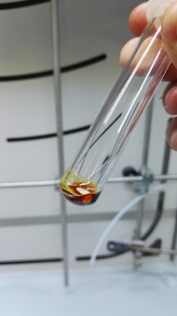 b) 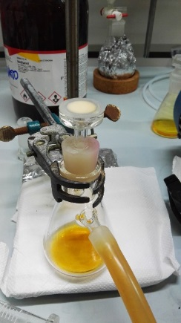 c) 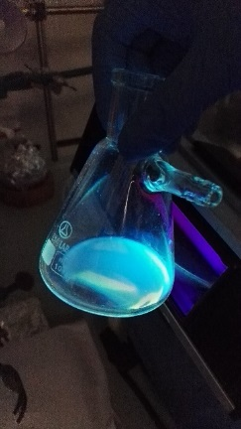

*Figure 1: Aqueous solution of NCND after: MW synthesis (a), filtration (b) and under 365 nm UV light (c)*

* + 1. Nanocomposites of PMMA/NCNDs

The PMMA/NCNDs nanocomposites were prepared by solution blending processes, using two distinct solvents for PMMA: (i) chloroform and (ii) methacrylate monomer (MA).

(i) Solution blending with chloroform:

The NCNDs are highly soluble in polar solvents, such as methanol or ethanol, but PMMA is soluble in non-polar solvents, such as chloroform. In order to obtain a homogenous suspension of NCNDs in the PMMA solution, various ratio of chloroform/methanol were investigated for NCNDs (1.55 mg), under ultrasonic bath stirring, resulting the 2:1 (v/v) as the better ratio. This transparent suspension was exposed to a 365 nm UV lamp showing the characteristic blue fluorescence. Several suspensions with NCNDs (1.55 mg) were prepared and following its addition to solutions containing chloroform and PMMA in a 3/1 ratio (v/m) at room temperature, under ultrasonic bath stirring, to get different amount of NCNDs relative to PMMA (1 wt%, 0.5 wt% and 0.01 wt%). Transparent self-standing films of PMMA/NCND were prepared via solution casting on Petri dishes, slowly pouring (drop-by-drop) the PMMA/NCNDs suspension with a pipette, at room temperature. A PMMA solution (without NCNDs) was also prepared as reference, following the same procedure.

ii) Solution blending with MA monomer:

PMMA pellets were dissolved in MA (2.62 g PMMA for 25 mL MA, 1/ 9 ratio) at 50 °C under magnetic stirring for 1 h and ultrasonic bath for 10 min. The NCNDs were dispersed in ethanol (1.0 mL) at the content of 0.1 wt% (2.62 mg) related to PMMA, under ultrasonic bath stirring for 2 min. Then, the suspension of NCNDs was added to the PMMA-MMA solution and left overnight under magnetic stirring. A PMMA-MA solution was also prepared as reference, following the same procedure. PMMA/NCNDs films were prepared via solution casting on microscope glass slides, slowly pouring (drop-by-drop) the PMMA/NCNDs suspension with a pipette. The samples were left to dry in vapor-saturated ambient of MA, at room temperature and overnight. A PMMA-MA casting film (without NCNDs) was also prepared as reference, following the same procedure.

* + 1. Photoluminescence of NCNDs and PMMA/NCND nanocomposites

The fluorescence spectra at different excitation wavelengths of the aqueous solutions of NCNDs are shown in Figure 2. A broad emission peak at 356 nm was observed when the sample was excited at 300 nm wavelength and the fluorescence peak shift from 356 to 474 nm as the excitation wavelength changes from 300 to 420 nm. Emission peak intensity decreased as the peak red shifts. The excitation dependence of photoluminescence of NCNDs is due to the different state energy levels of several functional groups on the surface of NCNDs (NH2, NH, OH, CH, C=O, C-O-C) because their optical properties are affected by the competition among different emission centers and traps (Arcudi *et al*., 2016).

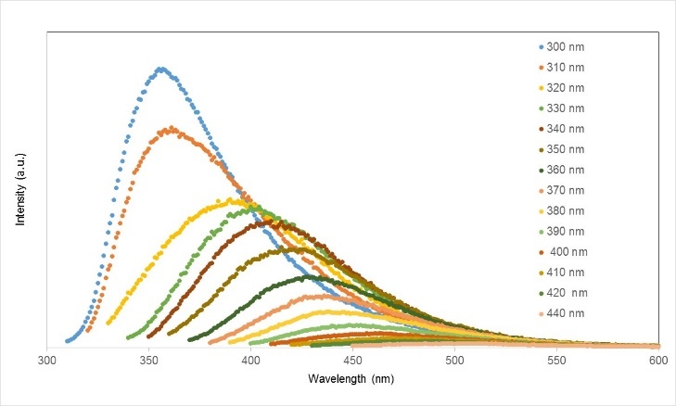

*Figure 2: FL spectra of the NCNDs in water at excitation wavelengths from 300 to 440 nm.*

The fluorescence spectra of the PMMA/NCND nanocomposite film with 0.1 wt% of NCNDs content are shown in Figure 3. When the nanocomposite film is excited from 300 to 320 nm wavelength, it was observed a broad emission peak around 450 nm without any shift. However, no emission peaks were observed for excitations above 330 nm. Therefore, the solid-state photoluminescence analysis showed a different fluorescent behavior when NCNDs were embedded in the PMMA matrix. Likely, this could be related to some matrix effect, amount of nanoparticles or quality of their dispersion in the PMMA, which could result in quenching or modification of the emissive domains on each dot.

.

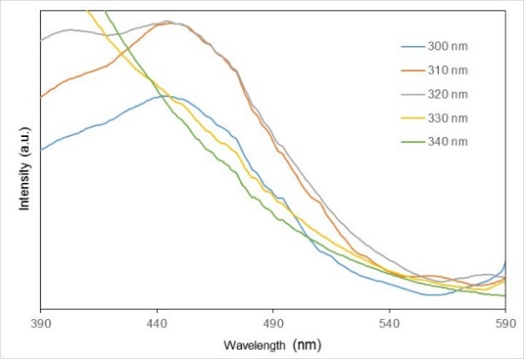*Figure 3: FL spectra of PMMA/NCND-0.1 wt% nanocomposite film at excitation wavelengths from 300 to 340 nm.*

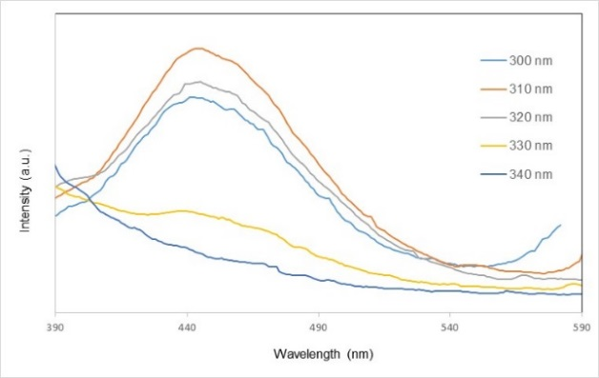

*Figure 4: FL spectra of the PMMA/ NCND-0.01 wt% nanocomposite film at excitation wavelengths from 300 to 340 nm.*

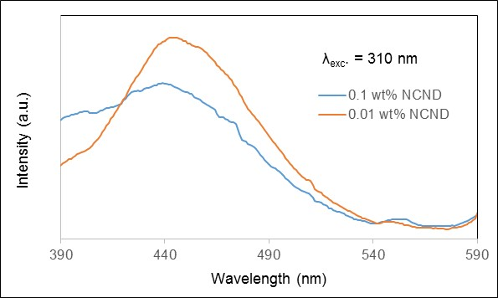

*Figure 5: FL spectra of PMMA nanocomposite films with 0.1 wt% and 0.01 wt.% of NCNDs, excited at 310 nm.*

Fluorescence spectra of the PMMA/NCND nanocomposite film with 0.01 wt% NCNDs are shown in Figure 4. Again, a broad emission peak around 450 nm was observed when excited from 300 to 320 nm wavelength, but a low intensity band was detected at 330 nm excitation. Higher fluorescence intensities were measured in the nanocomposite with a 10 times lower content of NCNDs, as showed for the 310 nm excitation wavelength in Figure 5. On reducing the concentration of NCNDs in the polymer matrix, the first evidence seems to be a higher fluorescence intensity; this hypothesis could be verified by an optimization on the control of the NCNDs concentration in the polymer and the relative set-up of the experiment. Quenching phenomena could be also occur, since carbon dots can act as electron donors or acceptors in their excited state (Cadranel *et al*., 2018). Besides, the photostability of NCNDs was confirmed, as FL measurements of the nanocomposite film (0.01 wt% NCNDs) were done one year later their preparation.

The luminescence of NCNDs in the visible range from 400 to 450 nm, when excited from 300 to 330 nm, could be exploited to improve External Quantum Efficiency (EQE) in photovoltaic cells, as novel materials for luminescent solar collector or cell top layer, converting UV to visible light. Silicon based solar cells show poor light harvesting performance under UV irradiation leading to poor quantum efficiencies in the UV region (Tsai *et al*., 2016). Most of the incident UV photons produce photogenerated carriers (electron-hole pairs) near the surface, which could easily recombine with defect sites in the depletion region, intermediary zone of the p-n junction in the solar cell where electric current is generated. Thus, NCNDs could facilitate the down-conversion effect on silicon cells. More long-wavelengths photons (in the visible light) can be absorbed and excite carriers in the depletion region for immediate photogenerated carrier separation due to the built-in electric field, leading to increased photovoltaic effect (Tsai *et al*., 2016; Choi *et al*., 2017).

* 1. Conclusions

NCNDs were synthetized using low cost ad non-toxic precursors by using a simple and controllable method under microwave irradiation.PMMA/NCNDs nanocomposites were prepared by solution blending, with 0.1 wt.% and 0.01 wt.% of NCNDs, obtaining solvent casting films. The fluorescence of the NCNDs in the PMMA matrix showed significant broad emission at around 450 nm when excited between 300 and 320 nm, being more intense for the nanocomposite with the lower content of NCNDs (0.01 wt.%). These novel PMMA/NCNDs nanocomposites are promising candidates for silicon solar cells, converting UV into visible light in order to improve the efficiency of a photovoltaic cell.

**Acknowledgements**

The authors are very grateful to Dr. Luka Ðorđević (UNITS), Prof. José F. Chubaci, Gilson Goveia (IF/USP), Prof. Manoel Cid Sanches, Carlos A. S. Ramos, Igor Y. Abe (PSI/EPUSP), Profa. Wang S. Hui, Dr. Emerson R. Soares, Mariane Y. T. Oide (PMT/EPUSP), Luís A. Duarte (IQ/Unicamp), Marco C. P. Soares (FEM/Unicamp), João B. M. R. Neto, Luiz G.L. Germiniani (FEQ/Unicamp), CNPq, CAPES and FAPESP.

**References**

Alexandre, M., Dubois, P., 2000, Polymer-layered silicate nanocomposites: preparation, properties and uses of a new class of materials. Materials Science Engineering, 28, 1-36.

Arcudi, F., Dordevic, L., Prato, M., 2016, Synthesis, Separation, and Characterization of Small and Highly Fluorescent Nitrogen-Doped Carbon NanoDots, Angewandte Chemie International Edition, 55, 2107-2112.

Bressanin, J.M.; Assis, V.Jr., Bartoli, J.R, 2018, Electrically conductive nanocomposites of PMMA and carbon nanotubes prepared by in situ polymerization under probe sonication, Chemical Papers, 72, 1799–1810.

Cadranel, A., Strauss, V., Margraf, J.T., Winterfeld, K.A., Vogl, C., Đorđević, L., Arcudi, F., Hoelzel, E., Jux, N., Prato, M., Guldi, D.M., 2018, [Screening Supramolecular Interactions between Carbon Nanodots and Porphyrins](https://pubs.acs.org/doi/10.1021/jacs.7b12434),  [Journal of the American Chemical Society,140, 3, 904-907](https://pubs.acs.org/action/showCitFormats?doi=10.1021%2Fjacs.7b12434).

Choi, Y., Jo, S., Chae, A., Kim, Y.K., Park, J.E., Lim,D., Park, S.Y.,In, I., 2017, Simple Microwave-Assisted Synthesis of Amphiphilic Carbon Quantum Dots from A3 / B2 Polyamidation Monomer Set; ACS Applied Materials & Interfaces , 9, 27883-893.

Colman, M.M.E.; Canesqui, M.A, Tasic, L; Bartoli, J.R., Moshkalev, S., 2018, Flexible Conductive Films Fabricated Using Exfoliated Graphite and Nanocellulose, Colman MME, Canesqui MA2, Tasic L, Bartoli JR and Moshkalev S., Trends in Textile Engineering & Fashion Technology, v. 4, 1.

Dimos, K., Arcudi, F., Kouloumpis, A., Koutselas, I.B., Rudolf, P., Gournis, D., Prato, M., 2017, Top-down and bottom-up approaches to transparent, flexible and luminescent nitrogen-doped carbon nanodot-clay hybrid films, Nanoscale, 9, 10256–10262.

Ðorđević, L., Arcudi, F., D’Urso, A., Cacioppo, M., Micali, N., Bürgi, T., Purrello, R., Prato, M., 2018, Design principles of chiral carbon nanodots help convey chirality from molecular to nanoscale level, Nature Communications, 9:3442, 1-8.

Esteves da Silva, J. C. G. and Gonçalves, H. M. R, 2011, Analytical and bioanalytical applications of carbon dots, Trends in Analytical Chemistry, 30, 8.

Fischer, H., 2003, Polymer nanocomposites: from fundamental research to specific applications, Materials Science and Engineering C, 23, 763–772

García, P. F. and Aranda, P., 2016, Clay-Graphene Nanoplatelets Functional Conducting Composites, Advanced Functional Materials, 26, 7394–7405

Gilman, J.W., 1999, Flammability and thermal stability studies of polymer layered-silicate (clay) nanocomposites, Applied Clay Science, 15, 31–49.

Gong, X., Ma, W., Li, Zhong, L., Li, W., Zhao, X., 2018, Fabrication of high-performance luminescent solar concentrators using Ndoped carbon dots / PMMA mixed matrix slab, Organic Electronics, 63, 237-243.

Hasegawa, N., Okamoto, H., Kato, M., Usuki, A., Sato, N., 2003, Nylon 6/Na–montmorillonite nanocomposites prepared by compounding Nylon 6 with Na–montmorillonite slurry, Polymer, 44, 2933–2937.

Jiang, J., He, Y., Li, S., Cui, H., 2012, Amino acids as the source for producing carbon nanodots: microwave assisted one-step synthesis, intrinsic photoluminescence property and intense chemiluminescence enhancement, Chemical Communication, 48, 9634 –9636.

Jia Z, Wang Z, Xu C, Liang J, Wei B, Wu D, Zhu S, 1999, Study on poly(methyl methacrylate)/carbon nanotube composites, Materials Science Engineering: A, 271, 395–400.

Kwon, W, Do, S., Lee, J., Hwang, S., Kim, J.K., Rhee, S-W, 2013, Freestanding Luminescent Films of Nitrogen-Rich Carbon Nanodots toward Large-Scale Phosphor-Based White-Light-Emitting Devices, Chemistry of Materials, 25, 1893−1899.

Li, Y., Miao, P.; Zhou, W., Gong J.; Zhao, X.; 2017, N-doped carbon-dots for luminescent solar Concentrators, Journal of Materials Chemistry A, 5, 21452-459.

Prado, B.R.; Bartoli, J.R, 2018, Synthesis and characterization of PMMA and organic modified montmorillonites nanocomposites via in situ polymerization assisted by sonication, Applied Clay Science, 160,132-143

Mir S.M., Jafari S.H., Khonakdar H.A., Krause B., Pötschke, P., Qazvinide N.T., 2016, A promising approach to low electrical percolation threshold in PMMA nanocomposites by using MWCNT-PEO predispersions, Materials & Design, 111, 253–262.

Reisfeld, R., Eyal, M., Chernyak, V., Zusman, R., 1988, Luminescent Solar Concentrators Based on Thin Films of Polymethylmethacrylate on a PMMA Support, Solar Energy Materials,17, 549-455.

Rigodanza, F., Ðorđević, L., Arcudi, F., Prato, M., 2018, Customizing the Electrochemical Properties of Carbon Nanodots by Using Quinones in Bottom-Up Synthesis, Angewandte Chemie International Edition, 57, 5062 –5067

Ruiz-Hitzky, E., Sobral, M.M.S., Gómez-Avilés, A., Nunes, C., Ruiz, C., 2016, Clay-Graphene Nanoplatelets Functional Conducting Composites, Advanced Functional Materials, 26, 7394–7405

Tsai, M.-L.; Tu, W.-C.; Tang, L.; Wei, T.-C.; Wei, W.-R.; Lau, S.P.; Chen, L.-J.; He, J.-H., 2016, Efficiency Enhancement of Silicon Heterojunction Solar Cells via Photon Management Using Graphene, Quantum Dot as Downconverters, Nano Letters, 16, 309−313.

Waldron, D.L., Preske, A., Zawodny, J.M, Krauss, T.D., Gupta, M.C., 2017, PbSe quantum dot based luminescent solar concentrators, Nanotechnology, 28, 095205, 1-6.

Wang, Y.; Hu, A., 2014, Carbon quantum dots: synthesis, properties and applications, Journal of Materials Chemistry C, 2, 6921-6939.

Xu, X., Ray, R., Gu, Y., Ploehn, H.J., Gearheart, L., Raker, K., Scrivens, W.A., 2004, Electrophoretic Analysis and Purification of Fluorescent Single-Walled Carbon Nanotube Fragments, Journal of the American Chemical Society, 126, 12736–12737.

Sun, Y.-P. , Zhou, B., Lin, Y., Wang, W., Fernando, K.A.S., Pathak, P., Meziani, M. J., Harruff, B.A., Wang, X., Wang, H., 2006, Quantum-Sized Carbon Dots for Bright and Colorful Photoluminescence, Journal of the American Chemical Society, 128, 7756–7757

Xu, Y., Wu, M., Liu, Y., Feng, X.-Z., Yin, X-B., He, X.-W., Zhang, Y.-K., 2013, Nitrogen-Doped Carbon Dots: A Facile and General Preparation Method, Photoluminescence Investigation, and Imaging Applications, Chemistry: A European Journal, 19, 2276–2283.

Zhang L., Chang J., Su R., Huang R., Qi W., He Z., 2018, Carbon dots and quantum dots-based nanohybrid as a ratiometric fluorescent probe for fe3+ and phytic acid sensing , Chemical Engineering Transactions, 70, 2065-2070.

Zhao, J., Morgan, A.B., Harris, J.D., 2005, Rheological characterization of polystyrene clay nanocomposites to compare the degree of exfoliation and dispersion, Polymer, 46, 8641–8660.

Zhou, W., Wang, M.C., Zhao, X., 2015, Poly (methyl methacrylate) (PMMA) doped with DCJTB for luminescent solar concentrator applications, Solar Energy, 115, 569-576.