|  |  |
| --- | --- |
| cetlogo ***CHEMICAL ENGINEERING TRANSACTIONS***  ***VOL. 76, 2019*** | A publication of  aidiclogo_grande |
| The Italian Association  of Chemical Engineering  Online at www.cetjournal.it |
| Guest Editors: Sauro Pierucci, Jiří Jaromír Klemeš, Laura Piazza  Copyright © 2019, AIDIC Servizi S.r.l. **ISBN** 978-88-95608-73-0; **ISSN** 2283-9216 | |

Analysis of Particle Growth Kinetic of Pea Protein Isolate in Fluidized Bed by In-Line Monitoring of Particle Size

Juliana G. Rosaa, Mariana F. Ávilaa, Raul F. Nascimentob, Osvaldir P. Tarantoa,\*

aSchool of Chemical Engineering, University of Campinas, Albert Einstein Ave., 500, Campinas, SP, Brazil

bSchool of Food Engineering, University of Campinas, Monteiro Lobato Street, 80, Campinas, SP, Brazil

val@feq.unicamp.com

Nowadays, there is a demand for products with good nutritional, technological and sensory characteristics. In this context, vegetable protein isolates, as pea protein, has been studied as a substitute to the soy protein, since it has higher levels of essential amino acids and vitamins. These powders are obtained commonly by spray drying that can modify the protein structure and that produces fine particles. So, to improve physicochemical properties, other processes, as agglomeration in fluidizing bed, could be used. The aim of this work was to study the influence of binder solutions characteristics on particle growth kinetics using an in-line particle size monitoring by spatial filter velocimetry. Two different acacia gum solutions (0.7 and 20.0 % w/w) were used as liquid binder. The operating conditions used were drying air temperature of 75 °C and binder flow rate of 3.0 mL/min. Atomization air pressure and atomization nozzle height were kept constant at 7.0 psi and 0.3 m, respectively. Fluid bed agglomeration was a useful method to produce instant pea protein concentrate powder under the operating conditions studied. This process produced larger particles, free-flow improved and shorter wetting time. The binder solution with higher concentration and more viscous provided a more pronounced particle growth and higher process yield. The in-line particle size monitoring was useful to observe the particle growth kinetics and the operating conditions influence on the growth kinetics and particle growth rate in fluidized bed agglomeration. It also was possible to observe that the particle growth rate oscillated during the process showing that the particle size growth results from a positive balance between agglomeration and break.

* 1. Introduction

Food industry search for alternative proteins to replace animal proteins and derivatives from wheat and soy are a reality. In this context, pea protein has been highlighted since it has a higher content of some amino acids such as lysine and tryptophan than cereals, and a lower content of trypsin inhibitors than soybean (Shevkani et al., 2015), being considered a food with of high nutritional value and low allergenicity (Lam et al., 2018). Different processes can be used to do the pea protein extraction such as alkaline extraction, isoelectric precipitation and membrane separation (Boye et al., 2010). Following the extraction process, the powdered protein is obtained by the concentrated extract spray drying. However, this process produces finer, cohesive particles that present poor handling and reconstitution properties (Fuchs et al., 2006).

Fluid bed agglomeration is a recognized process used to improve the properties of powdered materials. This process is widely used in pharmaceutical and food industries to increase the particle size, improving its flowability, handling and reconstitution properties. It is a complex and at the same time versatile process as it allows drying or cooling processes to occur simultaneously with increasing the particle size (Turchiuli et al., 2013) The quality of the agglomerated product depends both on the process parameters and on the characteristics of the binder used (Iveson et al., 2001). The agglomeration efficiency and the process parameters influence can be analyzed by the granule growth kinetics, since the increase of the particle is the main objective of the agglomeration process.

The aim of this work was to analyze, by the granule growth kinetics and the properties of the agglomerated material, ~~how~~ if the viscosity of the binder solution affects the agglomeration of the pea protein. The spatial filter velocimetry (SFV) technique using Parsum probe, a proven technique for particle size monitoring during fluidized bed agglomeration process (Silva and Taranto, 2015; Wiegel et al., 2016), was used in this work. The binders used were acacia gum solutions at different concentrations, since acacia gum does not reduce the pea protein nutritional value as it is a natural dietary fiber.

* 1. Material and Methods
     1. Material

Commercial pea protein isolate (PPI) (CA Gramkow®, Brazil) was used as raw material for all the agglomeration experiments. The PPI moisture content is below 8.00 % and it contains above 80.0 % of protein, 1.12 % of fibers, 7.88 % of lipids, 0.28 % of carbohydrates, according to producer. The binder aqueous solutions were prepared using acacia gum (Spraygum BB, Nexira Brasil Comercial, Brazil) at two different concentrations 0.7 and 20.0 % (w/w) and at room temperature (± 27 °C).

* + 1. Characterization of raw and agglomerated pea protein isolate

The raw material median particle size was measured by laser diffraction (Mastersizer 3000, MAZ3000 Malvern Instruments, Malvern, UK). The median particle size during the agglomeration process was evaluated by Parsum IPP70 probe (Chemnitz, Germany) that employs the spatial filter velocimetry (SFV) technique to measure size of the particles. The SFV technique uses the chord length distributions to express granule size. The chord measured is the distance between two points on the edge of the projected particle surface as it passes through a laser beam.

The PPI density was evaluated in triplicate by helium gas pycnometry (Micromeritics, AccuPyc 1330).

Powder flow characteristic was determined by the Carr index (ICarr) values, as described by Turchiuli et al. (2005) from the bulk (ρb) and tapped (ρt) densities, as shown in Eq (1). The assays were done in triplicate and the results were statistically analyzed by Tukey’s test, at a significance level of 0.05.

|  |  |
| --- | --- |
| $$I_{Carr} \left(\%\right)= \left[{\left(ρ_{t}- ρ_{b} \right)}/{ρ_{t}}\right].100$$ | (1) |

The powder flowability could be very good if ICarr < 15, good if 15 < ICarr < 20, fair if 20 < ICarr < 35, bad if 35 < ICarr < 45 and very bad if ICarr > 45.

The wetting time was the time required for the complete wetting and immersion of 3.0 g of the sample in 70 mL of water at room temperature (± 27 ºC) (Hogekamp and Schubert, 2003).

The wet basis moisture content (Xw.b.) was measured for the raw material and during the agglomeration process using a halogen moisture analyzer (HR83, Mettler Toledo, USA). The parameters used at the moisture analyzer were previously calibrated by comparison with the values obtained at 105 ºC for 24 h.

* + 1. Characterization of binder solutions

The rheological behavior of acacia gum solutions was determined using a rheometer (Haake Mars III, Thermo Fisher Scientific, USA) with a cone and plate geometry at 25 ºC. The experimental data were fitted to the Herschel-Bulkley model, Eq (2), a generalized equation that presents the yield stress parameter (σ0) (Steffe, 1996).

|  |  |
| --- | --- |
| $$σ= σ_{0}+K{\left(\dot{γ}\right)}^{n}$$ | (2) |

The binder solutions surface tension was determined by tensiometer (Du Noüy-Sigma 701, KSB Instruments, Finland) according to Wilhelmy plate method at room temperature (± 27 ºC). The value of the surface tension was the mean of 20 measurements, the results were statistically analyzed by Tukey’s test, at a significance level of 0.05.

* + 1. Equipment and agglomeration process

Agglomeration experiments were performed in a rotating pulsed fluidized bed (RPFB) constructed from transparent acrylic Plexiglas®. The bed pressure-drop, the air temperature, and the air relative humidity were monitored and recorded by a data acquisition system and processed in the LabVIEW 8.6TM software. Details of the equipment and the data acquisition system are described by Andreola et al. (2016a).

Two agglomeration experiments were performed, in duplicate, to evaluate the influence of binder solutions characteristics on particle growth kinetics and particle growth rate of PPI. The binder solution concentrations used were 0.7 % and 20.0 % (w/w), for test condition 1 and test condition 2, respectively. Besides the binder solution concentration, all the others operational conditions were the same, according to Nascimento et al. (2018): 0.2 kg of raw material, drying air temperature at 75 °C, the fluidizing air velocity at 0.39 m/s, binder flow rate at 3.0 mL/min, nozzle height at 0.3 m, pulsation frequency at 4 Hz, atomizing air pressure at 7.0 psi and binder amount at 76 mL.

The median particle size in volume (D50v) was monitored in-line using a probe that employs the SFV principle. Details of the equipment, its accessories and methodology were described by Silva and Taranto (2015). The ring buffer size used in the Parsum measurements, 5000 particles, was chosen based in previous works at the same equipment, according to Andreola et al. (2016b) and Rosa et al. (2018). The particle growth kinetic was analyzed using the data obtained by, an appropriate software, Inline Particle Probe 7.14, that record the particle size data and sent it to LabVIEWTM 8.6 software via OPC server protocol, this procedure was developed by Silva and Taranto (2015).

* 1. Results and discussion
     1. Characterization of binder solutions

Binder solutions characteristics and the Herschel-Bulkley model parameters are shown at Table 1 and the rheological behavior are shown at Figure 1. The apparent viscosity tends to remain constant at shear rates above 100 s-1, so it was calculated as the mean of values obtained above this value. The lower concentration solution, 0.7 % (w/w), approached to the Newtonian behavior and the solution of 20.0 % (w/w) exhibited non-Newtonian behavior, especially for low shear rates. Apparent viscosity and yield stress were higher to the 20.0 % (w/w) solution.

Table 1: Herschel-Bulkley model’s parameters and apparent viscosity of acacia gum binder solutions.

|  |  |  |  |  |  |  |
| --- | --- | --- | --- | --- | --- | --- |
| Binder concentration (% (w/w)) | η (mPa.s) | Superficial tension (mN/m) | Herschel-Bulkley model parameters | | | |
| σ0 (mPa) | k (mPa.sn) | N | r2 |
| 0.7 | 1.1 ± 0.0 | 55.58 ± 0.98 | 2.4 ± 0.6 | 1.0 ± 0.0 | 1.02 ± 0.01 | 1.000 |
| 20.0 | 31.2 ± 0.4 | 47.78 ± 0.66 | 61.6 ± 12.3 | 39.6 ± 1.1 | 0.95 ± 0.00 | 1.000 |

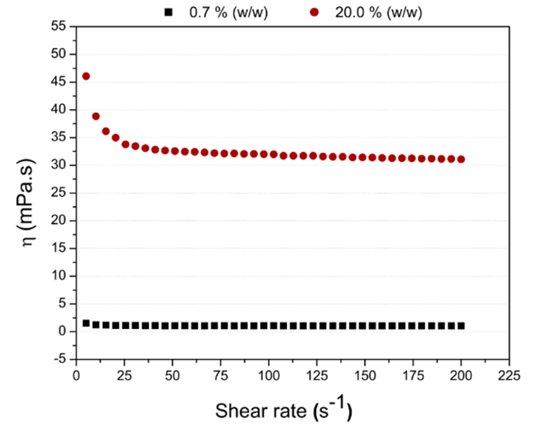

Figure 1: Apparent viscosity as a function of the shear rate for acacia gum solutions at 25ºC.

* + 1. Agglomeration process and particle growth kinetic

The PPI density was 1.2659 ± 0.0035 g/cm3 and its characteristic sizes D10v, D50v and D90v were 33.30 ± 0.17; 81.00 ± 0.61 e 181.92 ± 1.93 μm, respectively. The raw material fluidization behavior could be classified as pertaining to Geldart group A and the minimum fluidizing air velocity (vmf) was equal to 0.31 m/s.

The agglomeration tests were reproducible, and the two acacia gum solutions were efficient binder for the PPI, as shown in Figure 2. The PPI median particle size (D50v) was 297.5 ± 6.2 µm to the agglomerations processes with 0.7 % (w/w) solution and 370.7 ± 7.1 µm to the agglomerations processes with 20.0 % (w/w) solution. The increase in particle size was relatively higher than that observed by Dacanal and Menegali (2010) for of soy protein agglomeration using maltodextrin solutions (10 and 50 %) and similar to that observed by Andreola et al., 2016 for rice protein using hydrolyzed collagen solution (10 and 30 %) as binder.

The binder solution concentration increase promoted a larger increase on PPI particle size. Several factors can affect the adhesion strength between the particles and their growth, the binder solution viscosity and interfacial parameters that involve the binder surface tension are among the main factors (Hemati et al., 2003). The agglomeration process involves the wetting of the particles followed by the collision between moist particles which may aggregate together or simply rebound. The rebound ratio will be lower for more viscous binders that are able to dissipate the kinetic energy for successful aggregation (Tan et al., 2006). For the studied conditions, the increase in the gum acacia concentration resulted on a small change at the binder solution surface tension as shown at Table 1. So, the largest particle increase, when a 20.0 % (w/w) binder solution was used, was attributed to the increase at the binder solution viscosity. Similar behaviors were observed for rice protein concentrate agglomeration when the hydrolyzed collagen solution concentration increased from 10 % to 30 % (w/w) (Andreola et al., 2016b) and also for the agglomeration of soy protein isolate with maltodextrin solutions when the concentration increased from 0 to 10 % (w/w) (Dacanal and Menegalli, 2010).

Agglomeration kinetics that presents the median particle size evolution for each of the agglomeration conditions tested are shown in Figure 2. It is possible to observe that the increase at binder solution concentration modified the particle growth behavior. In the tests using a binder solution with a concentration equal to 0.7 % (w/w), the growth was continuous and less accentuated than in that test in which a binder solution with a concentration equal to 20.0 % (w/w). When the most concentrated binder solution was used, the growth rate was high during almost all the process and decrease in the last minutes. In addition, a small breakage of the granules can also be observed. This behavior may indicate that a bead boundary size has been reached for these conditions.

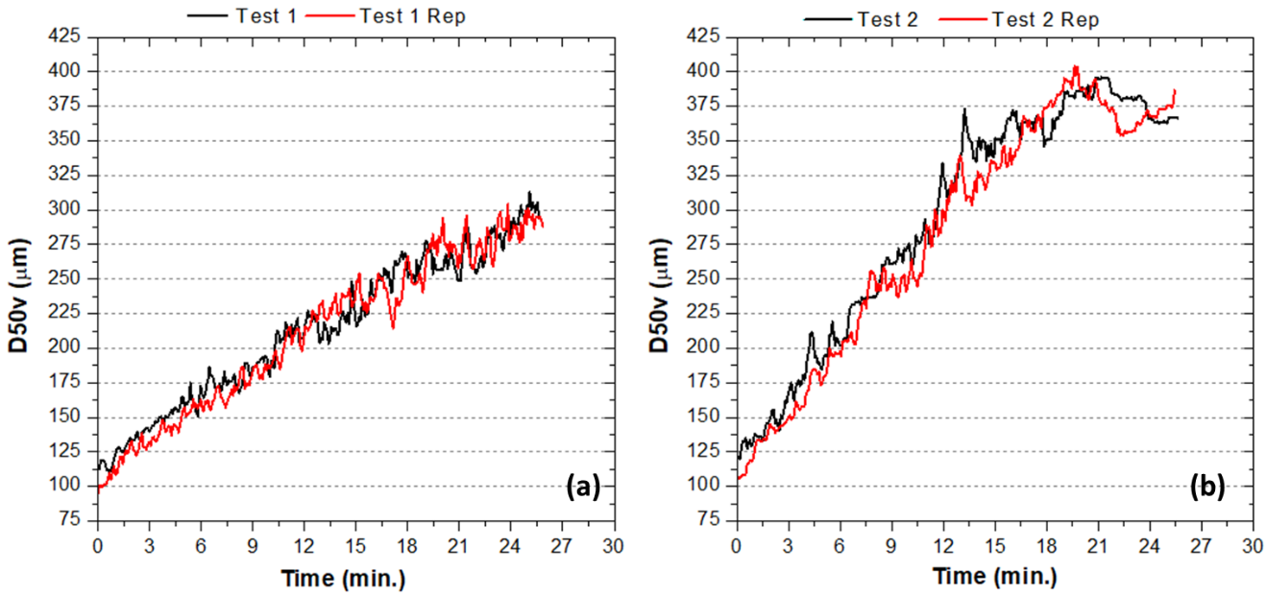

Figure 2: Growth kinetics of the PPI particles for (a) test 1, with 0.7 % (w/w) solution and (b) test 2, with 20.0 % (w/w) solution.

The process yield was 44.7 ± 3.2 % when the 0.7 % (w/w) binder solution was used and 61.3 ± 3.6 % for the agglomeration processes with the 20 % (w/w) solution. Thereby, the increase at the binder solution concentration provided higher yield. The faster increase at the particle size for the test 2 explains this result, since the main material loss factor was the entrainment of the fine particles. This higher particle growth rate reduces faster the amount of very fine particles and thus decreases the amount of material entrained. It is possible to notice that for the test 1 more than 60.0 % of the particles are smaller than 150 µm, and for the test 2, at the same time, particles smaller than 150 µm corresponds to just over 40.0 %.

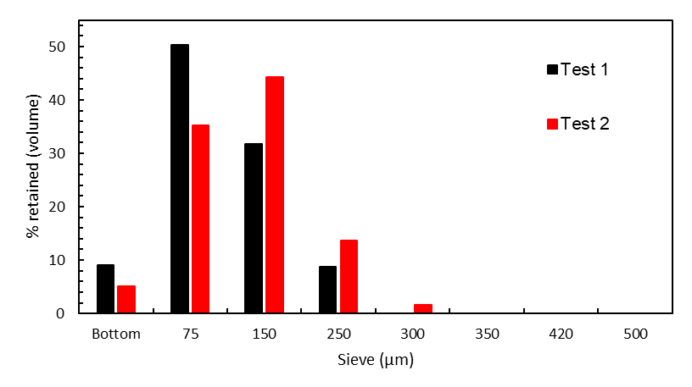

Figure 3: Particle size distributions at fractions and the cumulative curve obtained by Parsum probe after 3 minutes process agglomeration for (a) test 1 and (b) test 2.

* + 1. Characterization of raw and agglomerated pea protein isolate

The material moisture content, ICarr and flowability for the raw and agglomerated PPI are shown at Table 2 and Figure 4. The moisture content varied according to the test conditions used. The agglomeration process with less concentrated solution produced granules with moisture above the limit established by the raw material supplier. The high moisture content may reduce the material stability during the storage. This could be bypassed with a drying period shortly after the end of the of the binder solution sprinkling. In contrast, when using more concentrated solution the material moisture was within the limit and lower than the raw material moisture, even though there is no drying period after spraying the binder solution. The PPI flowability level changed from fair to very good for the agglomerated produced on both conditions. In this way, the binder solution concentration did not influence this product characteristic. Similar result was found for the flowability by Andreola et al. (2016a). The PPI obtained during the agglomeration with 0.7 % solution showed shorter wetting time but the reduction in wetting time was also quite significant for the agglomerate with 20.0 % solution when compared to the wetting time of the raw PPI.

Table 2: Properties of raw and agglomerated pea protein isolate.

|  |  |  |  |  |
| --- | --- | --- | --- | --- |
| Material | X (% (w.b.)) | ICarr (%) | Flowability | wt (s) |
| Raw PPI | 7.81 ± 0.14a | 23.5 ± 2,7a | Fair | 300 |
| Agglomerated test 1 | 9.35 ± 0.32b | 13.0 ± 1.1b | Very good | 6 |
| Agglomerated test 2 | 6.94 ± 0.11c | 13,2 ± 1.5b | Very good | 3 |

X: moisture content; ICarr: Carr index; wt: wetting time. Mean values in the same column with different letters are significantly different (p < 0.05).

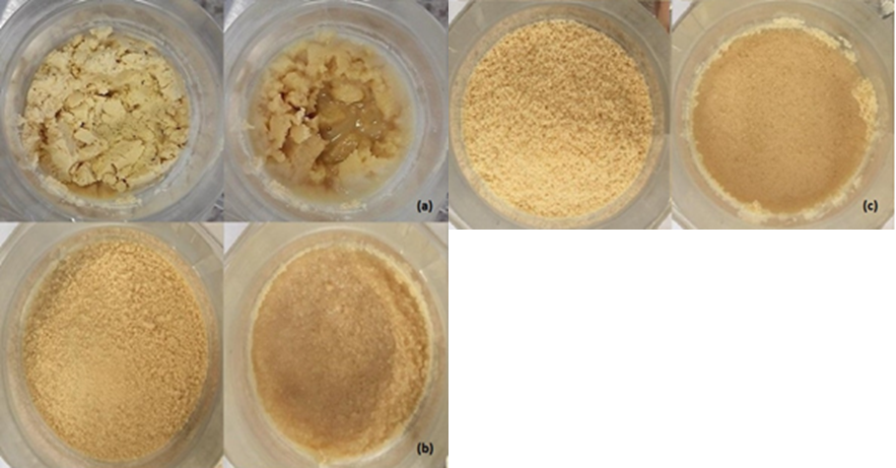

*Figure 4: Wetting time tests for (a) raw PPI and (b) agglomerated test 1 and (c) agglomerated test 2.*

* 1. Conclusions

The process and binder solutions used proved to be efficient for PPI agglomeration. The use of more concentrated solution favors the particle growth kinetics and the final mean particle size, since the 20.0% w/w solution produced agglomerates 25% higher than the 0.7% w/w one. However, it is important to emphasize that the concentration of the solution limits by the quality of the formed spray drops, in our experimental set-up, since as the concentration increases, the viscosity also increases . The agglomeration process with 20.0 % solution was also more advantageous than the one using 0.7 % solution, because even in the absence of a drying period it produced granules with adequate moisture for storage. This means a saving of energy and time in the processing of this material. The agglomerated material had good flow properties and a short wetting time.

Acknowledgments

This study was supported by grants and fellowships from CAPES (Coordenação de Aperfeiçoamento de Pessoal de Nível Superior), CNPq (Conselho Nacional de Desenvolvimento Científico e Tecnológico). Our Acknowledgments to the Instituto Federal do Espírito Santo (Ifes) for the support and encouragement.

References

Andreola K., Silva C.A.M., Taranto O.P., 2016a, Agglomeration and drying of rice protein concentrate in a rotating pulsed fluidized bed: in-line monitoring of particle size, 20th International Drying Symposium, Gifu, Japan.

Andreola K., Silva C.A.M., Taranto O.P., 2016b, Production of instant rice protein concentrate by rotating pulsed fluidized bed agglomeration using hydrolyzed collagen solution as binder, Chemical Engineering Transactions, 49, 6.

Boye J.I., Aksay S., Roufik S., Ribéreau S., Mondor M., Farnworth E., Rajamohamed S.H., 2010, Comparison of the functional properties of pea, chickpea and lentil protein concentrates processed using ultrafiltration and isoelectric precipitation techniques, Food Research International, 43, 537–546.

Dacanal G., Menegalli F., 2010, Selection of operational parameters for the production of Instant soy protein isolate by pulsed fluid bed agglomeration, Powder Technology, 203, 565–573.

Fuchs M., Turchiuli C., Bohin M., Cuvelier M.E., Ordonnoud C., Peyrat-Maillard M.N., Dumoulin E., 2006, Encapsulation of oil in powder using spray drying and fluidised bed agglomeration, Journal of Food Engineering, 75, 27–35.

Hemati M., Cherif R., Saleh K., Pont V., 2003, Fluidized bed coating and granulation: influence of process-related variables and physicochemical properties on the growth kinetics, Powder Technology, 130, 18–34.

Hogekamp S., Schubert H., 2003, Rehydration of food powders, Food and Science Technology International, 9, 223–235.

Iveson S.M., Litster J.D., Hapgood K., Ennis B.J., 2001, Nucleation, growth and breakage phenomena in agitated wet granulation processes: a review, Powder Technology, 117, 3–39.

Lam, A.C.Y., Can Karaca A., Tyler R.T., Nickerson M.T., 2018, Pea protein isolates: Structure, extraction, and functionality, Food Reviews International, 34, 126–147.

Nascimento R.F., Andreola K., Rosa J.G., Taranto O.P., 2018, Improvement of pea protein isolate powder properties by agglomeration in a fluidized bed: comparison between binder solutions, 21st International Drying Symposium, Valencia, Spain, 1431–1438.

Rosa J.G., Nascimento R.F., Andreola K., Taranto O.P., 2018, Influence of drying conditions on the acacia gum particle growth in fluidized bed agglomeration: in-line monitoring of particle size, 21st International Drying Symposium, Valencia, Spain, 1439–1446.

Shevkani K., Singh N., Kaur A., Rana J.C., 2015, Structural and functional characterization of kidney bean and field pea protein isolates: a comparative study, Food Hydrocolloids, 43, 679–689.

Silva C.A.M., Taranto O.P., 2015, Real-time monitoring of gas-solid fluidized bed granulation and coating process: evolution of particle size, fluidization regime transitions, and psychometric parameters, Drying Technology, 33, 1929–1948.

Steffe J.F. (Ed), 1996, Rheological Methods in Food Process Engineering, Freeman Press, East Lansing, MI, USA.

Tan H., Salman A., Hounslow M., 2006, Kinetics of fluidised bed melt granulation I: the effect of process variables, Chemical Engineering Science, 61, 1585–1601.

Turchiuli C., Eloualia Z., El Mansouri N., Dumoulin E., 2005, Fluidised bed agglomeration: agglomerates shape and end-use properties, Powder Technology, 157, 168–175.

Turchiuli, C.; Smail, R.; Dumoulin, E., 2013, Fluidized bed agglomeration of skim milk powder: Analysis of sampling for the follow-up of agglomerate growth. Powder Technology, v. 238, 161-168.

Wiegel, D., Eckardt, G., Priese, F., Wolf, B., 2016. In-line particlesize measurement and agglomeration detection of pelletfluidized bed coating by spatial filter velocimetry. PowderTechnol. 301, 261–267.