|  |  |
| --- | --- |
| cetlogo ***CHEMICAL ENGINEERING TRANSACTIONS***  ***VOL. 76, 2019*** | A publication of  aidiclogo_grande |
| The Italian Association  of Chemical Engineering  Online at www.cetjournal.it |
| Guest Editors: Sauro Pierucci, Jiří Jaromír Klemeš, Laura Piazza  Copyright © 2019, AIDIC Servizi S.r.l. **ISBN** 978-88-95608-73-0; **ISSN** 2283-9216 | |

Study of the integrated product recovery by gas stripping for the ABE fermentation with a fed-batch fermenter

Giorgia De Guido\*, Gabriele Lodi, Laura A. Pellegrini

Dipartimento di Chimica, Materiali e Ingegneria Chimica “G. Natta”, Politecnico di Milano, Piazza Leonardo da Vinci 32, I-20133 Milano, Italy

giorgia.deguido@polimi.it

Because of the growing demand for renewable fuels, the production of butanol through acetone-butanol-ethanol (ABE) fermentation of lignocellulosic biomasses has been recently attracting an increasing research interest.

The major limit for an industrial-scale production of bio-butanol is the high separation cost, due to the presence of other fermentation products and to its low final concentration in the broth. In fact, the microorganism used in the ABE fermentation suffers from product inhibition leading to a low ABE final concentration in a batch process. The application of an integrated product recovery technique able to remove butanol during fermentation is a viable solution to solve the problem and to improve the economics of the ABE fermentation.

In this context, gas stripping has been proven to be an effective separation technique, able to reduce the inhibition of the microorganism and, therefore, to increase the process productivity.

However, gas stripping usually removes a large amount of water together with butanol and requires a higher energy input, because of its lower butanol selectivity, in comparison with other separation techniques. To improve the performances of the integrated fermentation-gas stripping process for butanol production, optimization of gas stripping and fermenter conditions, and a better understanding of its effects on the ABE fermentation is needed.

This study deals with the synthesis of a process configuration for the integrated recovery of butanol from a fermentation unit operated in a fed-batch mode, in which the product is recovered from the fermentation broth by means of nitrogen gas stripping and is, subsequently, fractionated in a distillation train. For the studied configuration, a detailed simulation of the integrated recovery process including the fed-batch fermenter and the downstream separation train has been performed. The simulation results have been used to evaluate the effect of the integrated product recovery on the process productivity and on the total energy consumption, which has been quantified through the net equivalent fuel approach. Finally, the performances of the integrated process have been compared with the ones obtained with a traditional batch fermentation, in order to assess the potential of the proposed process solution.

* 1. Introduction

Butanol represents a promising biofuel, offering several advantages respect to other biofuels produced by fermentation (e.g., ethanol) (Lodi and Pellegrini, 2016). In addition to that, it is also an important building block of chemicals (Salemme et al., 2016). It can be produced via a petrochemical route or through fermentation. At the beginning, the latter way, known as acetone-butanol-ethanol (ABE) fermentation, was the main route for butanol production. Then, it was mainly replaced by the other one because of increasing substrate costs and the availability of the much cheaper petrochemically-derived butanol. However, in recent years the need for producing fuels and chemicals from renewable resources to face the climate challenge (Rossetti et al., 2017) has led to a renewed interest in the ABE fermentation. Since n-butanol production by conventional batch fermentation is limited as a result of its cytotoxic effects, numerous techniques for ABE recovery have been investigated and integrated with ABE production by fermentation to address this limitation. Among them, gas stripping is an easily implemented and effective recovery technique (Diez-Antolinez et al., 2018).

If the *in-situ* gas stripping technique is considered, an inert carrier gas (typically a mixture of H2 and CO2) must be used to maintain anaerobic conditions. However, attention should be paid if CO2 is used as stripping agent, since it can dissolve in the fermentation broth and cause a decrease of its pH, which plays a key role in the ABE fermentation. Gas stripping can also be performed *ex-situ* in a piece of equipment external to the fermenter: this represents a better process solution because of the higher performances that can be achieved in a multi-stage rather than in a single-stage unit. The aim of this work is to assess the performances of its integration with fed-batch cultures, which is recommended in the literature (Ezeji et al., 2004) to solve two toxicity problems, i.e. one for substrate inhibition and the other one for butanol inhibition. For this purpose, the whole process has been properly modelled and the downstream separation of the fermentation products by a five-column distillation train has been simulated, considering two case studies: in the first one only the condensate from the stripping column is fed to the downstream separation scheme, whereas in the second one also the broth remained in the fermenter is further processed. Process performances have been, then, assessed by means of an energy analysis based on the equivalent fuel approach and compared with those of a classic batch fermentation, either integrated or not with gas stripping, that can be found in the literature (Lodi et al., 2018).

* 1. Process description

Figure 1 shows the scheme of the ABE production by fermentation integrated with a gas stripping product-recovery system with N2. At a time when the microorganism starts to be inhibited by the solvents, the fermentation broth is withdrawn from the fermenter and subject to gas stripping in a column, where the ABE mixture is stripped by N2. At the bottom of the column, the fermentation broth depleted of the stripped components is obtained, which is then recycled back to the fermenter. On the contrary, at the top of the stripper a vapour stream consisting of N2 and of the stripped components is withdrawn, which is cooled down to 3°C to condense the latter components and separate them from N2. The stripping agent is recycled back to the bottom of the column, after being heated-up to its operating temperature and after being mixed with a N2 make-up stream (to replace its losses in the condensed stream). The configuration of the integrated fermentation-stripping process is similar to the one taken into account in a previous work (Lodi et al., 2018): however, in this case the global composition of the condensate does not fall in the liquid-liquid demixing region, so that no phase separation occurs and a liquid phase only (termed “Condensate” in Figure 1) is obtained. The stripping column has ten theoretical stages and a G/L ratio of 0.5 has been considered since in a previous work (Lodi and Pellegrini, 2016) it was proven to maximize the total recovery of the stripped components.

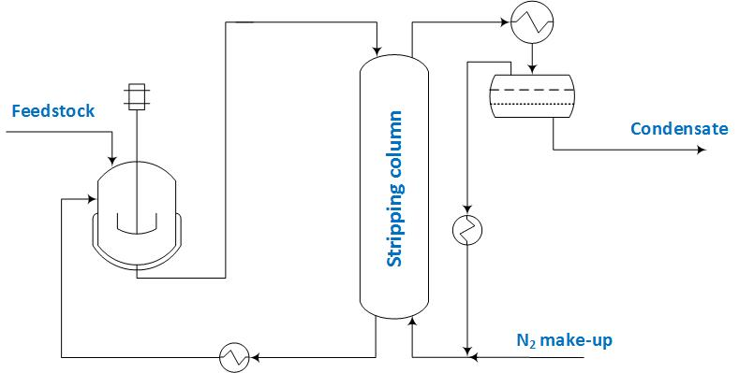

Figure 1: Scheme of the integrated process, including the fermenter and the stripping column

In the fed-batch mode, at two different intervals when the sugar concentration reached 10 g/L, it was brought up to its initial value by adding a concentrated sugar solution to the reactor. Therefore, the entire integrated fermentation-stripping process is divided into three intervals (referred to as “runs” in the following).

The liquid phase leaving the integrated fermentation-stripping process after each run is assumed to be collected in storage tanks. Each component is, then, recovered by further processing the liquid in a distillation train operated in continuous mode. This section has been simulated on the basis of the scheme described by Mariano et al. (2011), which is illustrated in Figure 2. The two case studies investigated in this work (referred to as “Case 1” and “Case 2” in the following) differ because of the composition of the FEED stream entering the beer column shown in Figure 2. A detailed description of the setup of the whole separation scheme can be found in a previous literature work (Lodi et al., 2018). It is important to mention here that acetone, ethanol and butanol are obtained at a purity level of, respectively, 99.5%, 85% and 99.8% (on a mass basis).

* 1. Methods
     1. Process modeling

The process studied in this work can be split into two sections, namely the integrated fed-batch fermentation-gas stripping system, and the distillation train for product fractionation, operated continuously. The first section, which represents a non-conventional unit, has been modeled by means of an in-house Fortran routine. On the other hand, since the second section comprises conventional unit operations, it has been simulated using the commercially available simulation software Aspen Plus® V9.0(AspenTech, 2016). As for the thermodynamic characterization of the system, the Non-Random Two-Liquid (NRTL) model (Renon and Prausnitz, 1968) and the Redlich-Kwong Equation of State (Redlich and Kwong, 1949) have been used for computing the activity coefficient in the liquid phase and the fugacity coefficient in the vapour phase, also using properly regressed parameters (Lodi et al., 2017).

The reactor has been modelled according to the kinetic scheme proposed by Mulchandani and Volesky (1986), which takes into account the inhibition due to butanol and butyric acid.

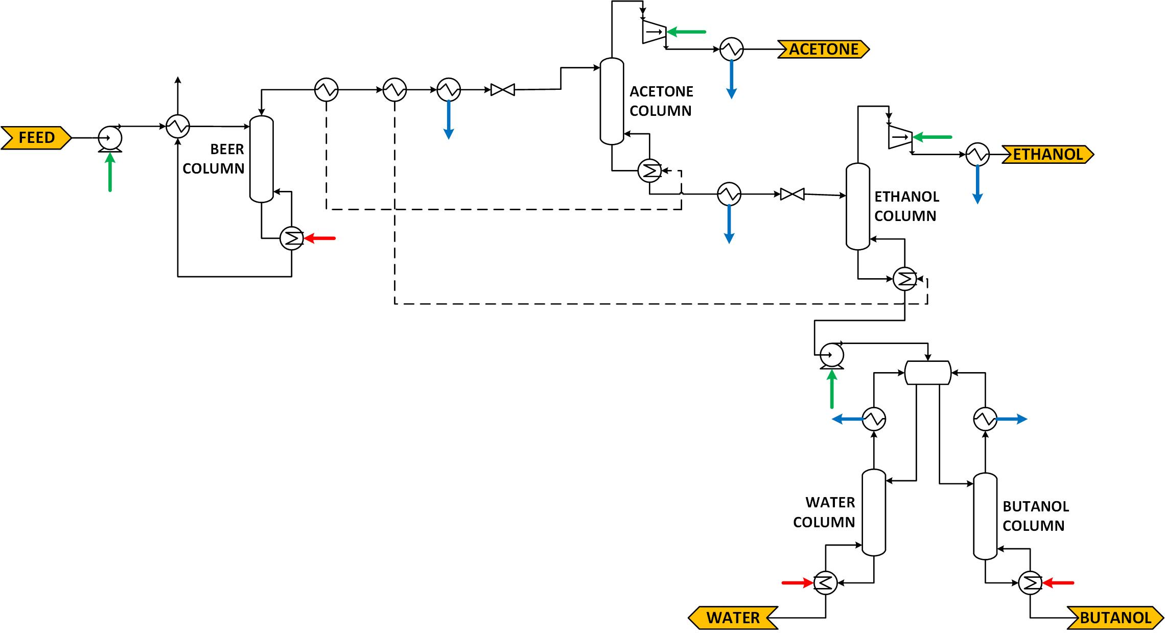

Figure 2: Scheme of the distillation train used for the separation of the ABE mixture recovered by gas stripping (Case 1) also mixed with the fermentation broth (Case 2): green arrows denote electrical energy requirements, red arrows denote heat duties, blue arrows denote cooling duties

The reactor model equations are of the form given by Eqs(1)-(2), in which *ri,k* and *Ci* denote, respectively, the rate of reaction *k* (*NR* denotes the number of reactions occurring in the fermenter) for the *i*-th component (i.e., the microorganism, substrate, butyric acid, acetic acid, butanol, acetone, ethanol and water) and its concentration inside the reactor, *ρ* stands for the broth density (assumed to be 1015 g/L), *MWi* is the molecular weight of the *i*-th component, and *V* refers to the fermenter volume, assumed not to be constant in this work. The two parameters *ηi* and *Df*, respectively, denote the components removal functions and the dilution factor, which have been used to model the integrated scheme shown in Figure 1, thus modifying the material balance equations with respect to the ones that apply to a classic batch fermenter.

|  |  |
| --- | --- |
|  | (1) |
|  | (2) |

The dilution factor corresponds to the ratio between the volumetric flow rate withdrawn from the reactor and the reactor volume. It follows from its definition that if the dilution factor is zero, Eq(1) reduces to the one that characterizes the behavior of a classic batch reactor. Its value has been determined so that the concentration of n-butanol in the reactor never exceeds 10 g/L (Roffler et al., 1987) during fermentation. This threshold value has been chosen to allow for a comparison with the results presented in other literature works (Lodi et al., 2018).

The gas stripping process has been assumed to be instantaneous and to remove only the volatile components (namely, acetone, butanol, ethanol and water), as reported in the literature by Ezeji et al. (2003). To account for their removal by gas stripping, a removal function (defined as the ratio between the molar flow rate in the condensed phase and that in the broth entering the stripping column) has been determined following the same procedure described by Lodi et al. (2018).

The ordinary differential equation system, consisting of Eq(1) written for each considered component and Eq(2), has been solved in Fortran using the DLSODES solver from ODEPACK (Hindmarsh, 1983).

The mass of each component in the fermentation broth inside the reactor during the *j*-th fermentation run, *mFj,i*, is computed according to Eq(3), in which *CFj,i* represents the concentration of component *i* in the fermentation broth during the *j*-th fermentation run and *VFj* is the fermenter volume (the subscript ‘F’ refers to the fermenter) during the *j*-th fermentation run.

|  |  |
| --- | --- |
|  | (3) |

Then, the mass flowrates, *Sj,i*, of the components removed from the reactor by gas stripping (the subscript ‘S’ refers to the stripping) during the *j*-th fermentation run are computed as:

|  |  |
| --- | --- |
|  | (4) |

The solvents stripped during the process are condensed and the obtained aqueous phase is, then, collected in storage tanks. The final mass of each component in the storage tanks is computed integrating its mass flowrate over the *j*-th fermentation run time, according to Eq(5).

|  |  |
| --- | --- |
|  | (5) |

As previously stated, the downstream ABE separation process has been simulated in the Aspen Plus® V9.0 (AspenTech, 2016) environment, using the same specifications as in previous literature works (Lodi et al., 2018) for the columns.

* + 1. Energy analysis

To assess the performances of the process under investigation in this work, the equivalent fuel approach has been applied. It consists in determining the amount of butanol equivalent to certain cooling/heating duty and electric power that must be supplied to or can be recovered from the process.

Heating is required in the integrated fermentation-gas stripping process section for heating up either the N2 to be recycled to the stripping column, and the liquid bottom product withdrawn from its bottom and recycled to the reactor. Moreover, heating is also required in the downstream separation train (Figure 2) at the reboiler of the beer column, of the water column and of the butanol column. All these requirements have been considered to be met by means of low-pressure steam and the equivalent amount of n-butanol has been determined according to Eq(6), where *ηboiler* and *LHV* stand, respectively, for the boiler efficiency (0.8) and for the fuel lower heating value (33.11 MJ/kg).

|  |  |
| --- | --- |
|  | (6) |

Cooling at low-temperature (down to 3 °C) is required to condense the solvents recovered at the top of the stripping column. This has been considered to be accomplished by a proper refrigeration cycle. The procedure followed to determine the amount of equivalent butanol is the same as that described by Lodi et al. (2018). The reader can refer to this literature work also for all the parameters involved in the calculations and for the equation used to compute the amount of butanol equivalent to the electric energy to be supplied to compressors and pumps in the separation train.

* 1. Results

In this section the results obtained from the simulation of the two case studies investigated in this work are presented. The values of the dilution factor for each of the three runs the integrated fermentation-gas stripping process consists of are 0.4 h-1, 0.53 h-1, and 0.74 h-1, respectively. Figure 3 illustrates the concentration profile inside the reactor for the integrated process.

The gas stripping process begins after 12 h, when the butanol concentration reaches its toxic level, which remains almost constant due to the continuous removal by gas stripping. The first run is completed in 20.3 h. Then, the fermenter is fed with a concentrated sugar solution to bring the sugar concentration back to its initial value. After that, two more runs are carried out, with solvents removal by means of gas stripping operated since the beginning. The duration of these two runs is, respectively, 17.6 h and 12.7 h.

As previously stated, the fermentation products stripped during the process are condensed, collected in storage tanks and sent to the downstream distillation train, either by themselves or together with the broth remained in the reactor. In the former case, the feed stream to the beer column contains 2.3 mol% butanol, whereas in the latter case it is more diluted and contains 1 mol% butanol (see Table 1).



Figure 3: Concentration profiles obtained from the modelling of the integrated fed-batch fermentation-gas stripping process: (— · —, violet) sugar, (∙∙∙∙, black) biomass, (– – –, light blue) acetic acid, (– – –, orange) butyric acid, (–––, green) acetone, (–––, red) butanol, (–––, blue) ethanol

Table 1: Composition (mole fractions) of the stream fed to the separation scheme illustrated in Figure 2: Case 1 refers to the composition of the liquid phase collected in the integrated fermentation-gas stripping process, and Case 2 to that of the liquid stream resulting from mixing it with the broth remained in the reactor

|  |  |  |
| --- | --- | --- |
| Component | Case 1 | Case 2 |
| Acetone | 0.0167 | 0.0089 |
| Butanol | 0.0233 | 0.0101 |
| Ethanol | 0.0020 | 0.0009 |
| Water | 0.9580 | 0.9801 |

The results in terms of butanol productivity (t/y) and energy consumption are summarized in Table 2, and can be compared with those reported in a previous paper (Lodi et al., 2018) for a classic (i.e., not integrated with any solvents recovery technique) fermentation scheme and for a batch fermentation process integrated with gas stripping. The productivity is more than doubled in this case, reaching a higher value in Case 2, since also the butanol remained in the fermenter is recovered. The butanol equivalent to the energy requirements related to the gas stripping process is equal to 21,612 kg/h and is the same for the two case studies considered in this work. On the contrary, the distillation train used to further separate the solvents recovered by gas stripping together with the broth remained in the fermenter (Case 2) requires a higher energy input than in Case 1. However, the specific energy consumption (expressed in kg of equivalent butanol per kg of produced butanol) is lower in Case 2, due to the higher amount of produced butanol. Both case studies are characterized by higher energy consumptions in comparison with the integrated batch fermentation process analysed by Lodi et al. (2018), though they allow reaching a higher productivity (respectively, by 14 % and 35 %).

* 1. Conclusions

Considering the renewed interest in the production of butanol via the ABE fermentation route and the need for overcoming the inhibitory effect due to butanol by the application of solvents recovery techniques, this work has presented an analysis of the performances of the fermentation process, operated in the fed-batch mode, integrated with gas stripping using nitrogen. The energy requirements of the process have been determined on the basis of the net equivalent fuel approach, considering also the downstream distillation train for separating the recovered solvents for two case studies: the case in which only the solvents withdrawn at the top of the stripping column are further separated, and the case in which also the solvents contained in the broth remained in the reactor undergo a further separation. The obtained results have suggested that the application of the gas stripping as an integrated recovery technique to the fed-batch fermentation allows increasing the process productivity by 14-35 % in comparison with a classic batch fermentation process integrated with gas stripping. However, this occurs at the expense of an increase in the whole process energy demand, which amounts to 1.69-1.88 kg of equivalent butanol per kg of produced butanol, respect to a specific consumption of 1.29 kg/kg required by the integrated batch fermentation-gas stripping process.

Table 2: Process performances in terms of productivity and energy consumption for the two case studies investigated for the fed-batch ABE fermentation process integrated with gas stripping

|  |  |  |
| --- | --- | --- |
|  | Case 1 | Case 2 |
| Butanol productivity, t/y | 104,265 | 123,585 |
| Butanol equivalent, kg/h, to the energy requirements of the distillation train | 2,890 | 4,512 |
| Butanol equivalent, kg/h, to the total (integrated fermentation-gas stripping and downstream distillation) energy requirements | 24,502 | 26,123 |
| Specific butanol equivalent, kg/kg, to the total energy requirements | 1.88 | 1.69 |

References

AspenTech, 2016, Aspen Plus®, Burlington, MA, United States.

Díez-Antolínez R., Hijosa-Valsero M., Paniagua-Garcíaa A.I., Gómez X., 2018, In Situ Two-Stage Gas Stripping for the Recovery of Butanol from Acetone-Butanol-Ethanol (ABE) Fermentation Broths, Chemical Engineering Transactions, 64, 37-42.

Ezeji T.C., Qureshi N., Blaschek H.P., 2003, Production of acetone, butanol and ethanol by Clostridium beijerinckii BA101 and in situ recovery by gas stripping, World Journal of Microbiology and Biotechnology, 19, 595–603.

Ezeji T.C., Qureshi N., Blaschek H.P., 2004, Acetone butanol ethanol (ABE) production from concentrated substrate: reduction in substrate inhibition by fed-batch technique and product inhibition by gas stripping, Applied Microbiology and Biotechnology, 63, 653-658.

Hindmarsh A.C., 1983, ODEPACK, a systematized collection of ODE solvers, in: R.S. Stepleman, et al. (Ed.), North-Holland, Amsterdam, 1 IMACS transactions on scientific computation, vol. 1, 55-64.

Lodi G., Pellegrini L.A., 2016, Recovery of Butanol from ABE Fermentation Broth by Gas Stripping, Chemical Engineering Transactions, 49, 13-18.

Lodi G., De Guido G., Pellegrini, L.A., 2017, Recovery of butanol from ABE fermentation broth by gas stripping: Process simulation and techno-economic evaluation, in: 25th European Biomass Conference and Exhibition (EUBCE 2017), pp. 1034-1041.

Lodi G., De Guido G., Pellegrini, L.A., 2018, Simulation and energy analysis of the ABE fermentation integrated with gas stripping, Biomass and Bioenergy, 116, 227-235.

Mariano A.P., Keshtkar M.J., Atala D.I., Maugeri Filho F., Wolf Maciel M.R., Maciel Filho R., Stuart P., 2011, Energy requirements for butanol recovery using the flash fermentation technology, Energy Fuels, 25, 2347-2355.

Mulchandani A., Volesky B., 1986, Modelling of the acetone-butanol fermentation with cell retention, The Canadian Journal of Chemical Engineering, 64, 625-631.

Redlich O., Kwong J.N., 1949, On the thermodynamics of solutions. V. An equation of state. Fugacities of gaseous solutions, Chemical Reviews 44, 233-244.

Renon H., Prausnitz J.M., 1968, Local compositions in thermodynamic excess functions for liquid mixtures, AIChE Journal, 14, 135-144.

Roffler S., Blanch H.W., Wilke C.R., 1987, Extractive fermentation of acetone and butanol: process design and economic evaluation, Biotechnology Progress, 3, 131-140.

Rossetti I., Compagnoni M., De Guido G., Pellegrini L.A., Ramis G., Dzwigaj S., 2017, Ethylene production from diluted bioethanol solutions, The Canadian Journal of Chemical Engineering, 95, 1752-1759.

Salemme L., Olivieri G., Raganati F., Salatino P., Marzocchella A., 2016, Analysis of the energy efficiency of some butanol recovery processes, Chemical Engineering Transactions, 49, 109-114.