|  |  |
| --- | --- |
| cetlogo ***CHEMICAL ENGINEERING TRANSACTIONS***  ***VOL. 76, 2019*** | A publication of  aidiclogo_grande |
| The Italian Association  of Chemical Engineering  Online at www.cetjournal.it |
| Guest Editors: Sauro Pierucci, Jiří Jaromír Klemeš, Laura Piazza  Copyright © 2019, AIDIC Servizi S.r.l. **ISBN** 978-88-95608-73-0; **ISSN** 2283-9216 | |

Application of conventional and novel low-temperature CO2 removal processes to LNG production at different CO2 concentrations in natural gas

Giorgia De Guido\*, Laura A. Pellegrini

Dipartimento di Chimica, Materiali e Ingegneria Chimica “G. Natta”, Politecnico di Milano, Piazza Leonardo da Vinci 32, I-20133 Milano, Italy

giorgia.deguido@polimi.it

Future energy scenarios forecast an increase in the global energy demand. To meet that, although renewable energy resources will be the fastest growing ones, fossil fuels will remain the main source of energy. Natural gas, in particular, is considered an effective short to mid-term bridge fuel to a low-carbon future, as an environmentally-friendly fuel. These factors have led to consider the exploitation of those low-quality natural gas reserves that were left undeveloped in the past because of the high H2S and/or CO2 content and the absence of technologies suitable for their profitable exploitation.

In recent years, many studies have been carried out to develop new technologies that make the production of natural gas from these reserves economically viable: the most promising technologies have turned out to be the low-temperature ones. However, no research has been carried out on the performances of the whole LNG (liquefied natural gas) production process, requiring the coupling between the acid gas removal step and the liquefaction one.

This work aims at studying the energy demand of the purification and liquefaction of several acid natural gas streams composed of methane and CO2, which differ from each other because of the CO2 content.

The conventional amine chemical absorption process, where MethylDiEthanolAmine (MDEA) is used as solvent, is compared with a recently developed dual pressure low-temperature distillation process (DCCDTM) for CO2 removal from natural gas. Downstream of the acid gas removal step, the Propane Precooled Mixed Refrigerant (C3MR) technology has been considered for the liquefaction of natural gas. The aim is to understand whether there is an advantage related to the coupling of a low-temperature purification technology with the liquefaction of the sweet natural gas in terms of energy consumptions and efficiency of the overall process.

The results of the simulations performed in Aspen HYSYS® V9.0 are utilized to carry out the energy analysis (based on the net equivalent methane method), and the exergy analysis (based on the second-law efficiency). The handouts allow assessing which is the most convenient acid gas removal technology for LNG production, depending on the CO2 content in the raw natural gas.

* 1. Introduction

The energy transition towards a zero-carbon energy sector poses several new challenges. Renewable energy is the fastest-growing energy source (BP, 2018), accounting for 40% of the increase in primary energy. However, the ever-increasing world energy demand makes it difficult to provide sufficient energy while, at the same time, phasing out fossil energy. Among fossil fuels, natural gas (NG) grows much faster than either oil or coal, being an environmentally-friendly fuel supported by the continuing expansion of liquefied natural gas (LNG), increasing the availability of gas globally. As a result, sub-quality (particularly because of the high acid gas content) and remote gas reserves that were left undeveloped in the past are now considered for exploitation. The conventional technologies currently available for acid gas removal from natural gas are not the most suitable ones to treat these natural gas fields because, as the acid gas content increases, the energy penalty of the purification step increases as well. Despite the different technologies currently available (De Guido et al., 2017), in recent years novel ones (mainly low-temperature/cryogenic ones) have been proposed for a profitable exploitation of these low-quality gas reserves. The growing importance of NG is accompanied by that of LNG, which is the preferred method of transportation over long distances, i.e. greater than 3500 km (Lim et al., 2013), and is becoming a viable, environmentally-friendly alternative to marine fuel oil for ship propulsion (Iannaccone et al., 2018). In order to produce LNG, NG must be intensively purified from its contaminants, such as CO2 that would freeze at the low temperatures the liquefaction process is carried out. Therefore, the development of low-quality NG reserves for LNG production poses new challenges to the gas processing industry, requiring novel technologies for CO2 removal from NG and the adjustment of the liquefaction process, currently designed for a purified NG stream coming from a conventional acid gas removal process and, thus, at ambient temperature or higher.

The aim of this work is to compare an established CO2 removal technology (i.e., chemical absorption with a MDEA aqueous solution containing 40 wt% MDEA) with a novel one based on low-temperature distillation (known as DCCDTM) for the purification of NG in view of LNG production. Then, the C3MR process has been considered for liquefaction downstream each CO2 removal process. A previous work (Pellegrini et al., 2019) studied this for a real NG mixture with a fixed CO2 concentration. However, one may wonder: how does the CO2 content in raw NG affect the comparison? Therefore, the analysis presented in this work takes into account different CO2 contents to understand which is the breakeven point between the two NG purification technologies. Simulations have been performed in Aspen Hysys® V9.0 (AspenTech, 2016) and the comparison has been carried out by means of an energy analysis based on the net equivalent methane approach (Pellegrini et al., 2018), and on an exergy analysis.

* 1. Methods
     1. Acid gas removal

The scheme of the acid gas removal unit (AGRU) is shown in Figure 1 for the MDEA case and in Figure 2 for the DCCDTM case. In both cases, the feed stream has been assumed to be a binary mixture of CH4 and CO2 at 35°C and 50 bar, available at 5000 kmol/h. The CO2 content has been varied in the range 10-70 % on a molar basis. Moreover, the target purity for the NG exiting the AGRU has been fixed at 50 ppm of CO2 (reaching sometimes slightly lower values in the MDEA case), as recommended for LNG production to avoid freezing problems (GPSA, 2004). As for the CO2 stream separated in the AGRU, it has been further processed when separated from NG by chemical absorption in order to obtain it as a liquid under pressure (i.e., 50 bar), which makes it more readily suitable for further applications, such as for Enhanced Oil Recovery (Mazzoccoli et al., 2013). Thus, the CO2 withdrawn wet and at low pressure from the top of the Regenerator has been sent to an inter-refrigerated compression train (made up of three stages) to bring it at the desired final conditions. For the simulation of the chemical absorption process, the Acid Gas – Chemical Solvents property package available in Aspen Hysys® V9.0 (AspenTech, 2016) has been used: it is based on the Electrolyte Non-Random Two Liquid thermodynamic model and involves all the equilibrium and kinetic reactions required for rigorous calculations (Dyment and Watanasiri, 2015). The internal configuration has been setup in accordance with the information found in the literature (Pellegrini et al., 2019). Moreover, a rich loading of 0.45 moles of CO2 per mole of MDEA has been chosen and the lean loading has been assumed to be 1/100 of the rich loading (Pellegrini et al., 2015) by changing the specification on the duty at the reboiler of the solvent regeneration column. Simulations have been performed using the Advanced Modelling mode, which uses the rigorous rate-based modelling technique.

As for the novel technology illustrated in Figure 2, it consists of a low-temperature distillation process carried out in two columns operated at different pressures (namely, 50 bar for the HP Column and 40 bar for the LP Column) to by-pass the solid-liquid-vapour locus of the CH4-CO2 system. A detailed description of it can be found in the literature (Pellegrini, 2014): process specifications have been assigned on the basis of the available information and simulations have been performed in Aspen Hysys® V9.0 (AspenTech, 2016), using the Soave-Redlich-Kwong (Soave, 1972) Equation of State.

* + 1. Liquefaction

For the simulation of the liquefaction process downstream each AGRU, the APCI Propane Precooled Mixed refrigerant (C3MR) has been considered as the most widespread one. A detailed explanation about it is given by Venkatarathnam (2008). Since the optimization of the liquefaction step is out of the scope of this work, the configuration presented by Venkatarathnam (2008) has been taken as reference. However, the composition and the flow rate of the mixed refrigerant, as well as the flow rate of the propane in the pre-cooling step, have been adjusted for each case study in order to have a minimum temperature approach of 3 °C in heat exchangers. Moreover, some changes have been also made in the case of the purified NG obtained in the DCCDTM case, to make the liquefaction process suitable to treat a NG stream at low-temperature (i.e., -87 °C): in this case, the NG stream enters the liquefaction process bypassing the pre-cooling step with propane.

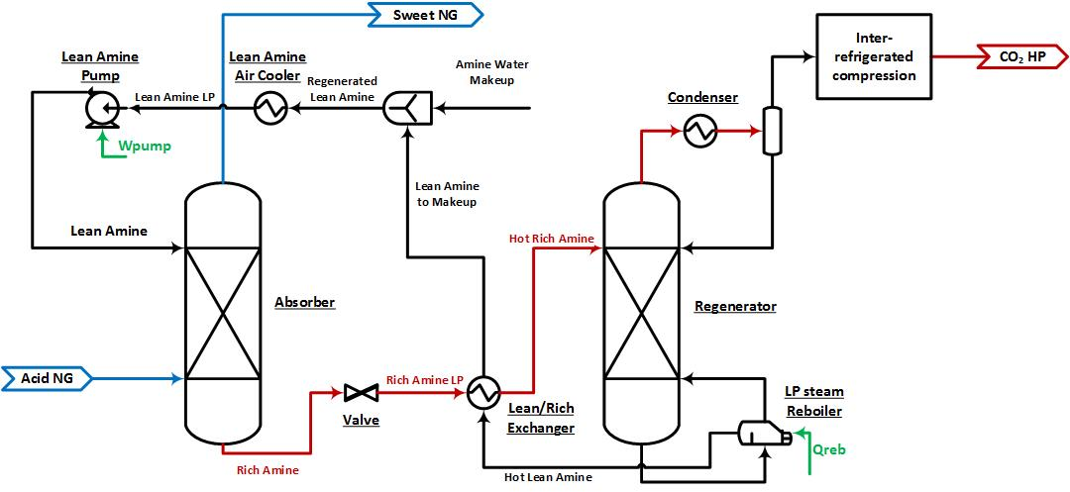

Figure 1: Scheme of the MDEA process

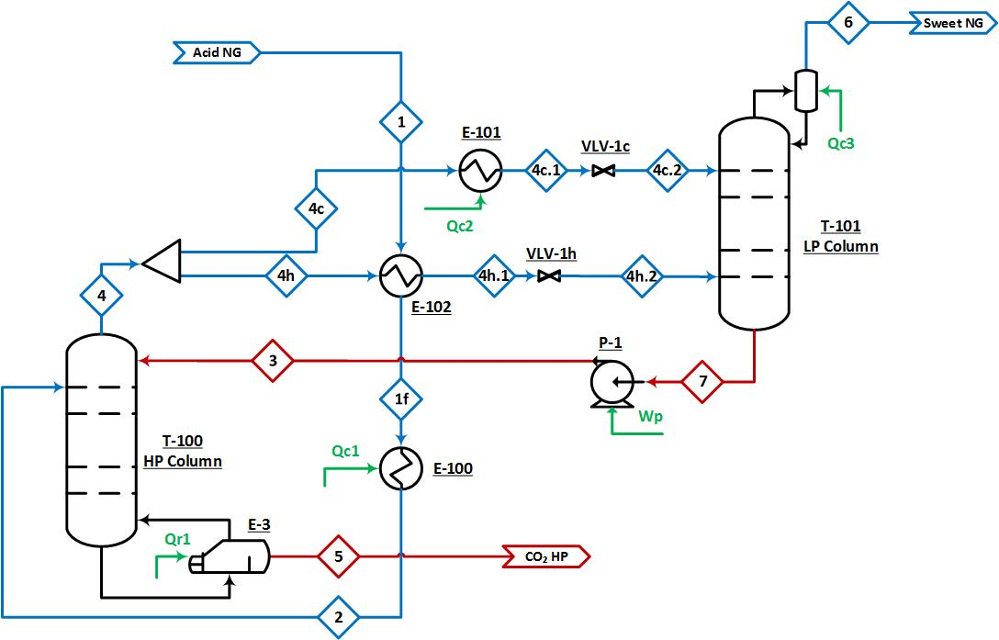

Figure 2: Scheme of the DCCDTM process

* + 1. Energy and exergy analysis

The performances of the processes analysed for LNG production, comprising the AGRU (either by MDEA absorption or by low-temperature distillation) and the liquefaction process, have been evaluated by means of an energy and an exergy analysis. The energy analysis is based on the net equivalent methane approach, which is detailed in a previous work (De Guido et al., 2018), where also all the involved parameters can be found. Results of the energy analysis are reported in the next section in terms of specific energy consumption (SEC) defined, Eq(1), as the ratio between the flow rate of equivalent methane and that of the methane processed in the plant.

|  |  |
| --- | --- |
|  | (1) |

As for the exergy analysis, it helps accounting for the quality of different energy forms through the property called exergy, which is the maximum possible work that a system delivers as it undergoes a reversible process from the specified initial state to that of the environment. The exergy analysis involved the calculation of the exergy of inlet and outlet process streams, of the exergy associated with a work transfer and of that associated with a heat transfer. As for the exergy of process streams, it has been assumed to be the sum of the physical and chemical exergy, neglecting nuclear effects, magnetism, electricity and surface tension, and also neglecting kinetic and potential exergies, which are generally not relevant in chemical processes. The reader can refer to Kotas (1985) for more details about this. The second-law efficiency has been used to compare the different case studies considered in this work: it is defined according to Eq(2), where the exergy recovered is given by the difference between the total outlet, *out*, and inlet, *in*, material exergy, and the exergy supplied is the sum of the exergy associated with the total work transfer (*W*) and heat transfer (*Q*). The data required for the calculation of each term have been taken from the process simulator.

|  |  |
| --- | --- |
|  | (2) |

* 1. Results
     1. Energy analysis

Restricting the attention to the AGRU only, results are illustrated in Figure 3a as a function of the CO2 content (mol%) in the NG feed stream for the two technologies.

a) b)

Figure 3: Specific energy consumption (SEC) at different CO2 contents in the NG feed stream for: a) the MDEA process (solid red line) and for the DCCDTM process (dashed green line); b) the overall (AGRU + liquefaction) process

The energy requirements of the MDEA process are related to: the reboiler of the solvent regenerator, the pump for solvent recycle, the CO2 compression train and the cooling duty required to bring the CO2 stream to the desired final conditions. As for the DCCDTM process, the energy requirements are related to the need for pre-cooling the feed stream to its dew-point temperature, for cooling the liquid stream fed to the LP Column and for providing the cooling duty at the condenser of the LP Column, as well as to the pump that increases the pressure of the reflux stream to the HP Column. Figure 3a shows that, by increasing the CO2 content in the NG feed stream, the energy consumption of each AGR technology increases, and this occurs at a higher rate in the case of the conventional technology. The increase for the DCCDTM process seems to be linear at low CO2 concentrations and, then, it exhibits an exponential increase. This can be explained considering the way the two main energy contributions increase: on the one hand, there is the cooling duty required at the condenser of the LP Column, which accounts to a higher extent at low CO2 concentrations and increases linearly with the CO2 content in the NG feed stream; on the other hand, there is the duty required for cooling down the stream fed as liquid to the LP Column, which exhibits an exponential increase and becomes more important at high CO2 concentrations. Therefore, the results illustrated in Figure 3a prove the advantage of using a low-temperature technology for the exploitation of NG reserves characterized by a high CO2 content.

As for the liquefaction process, the SEC is not affected by the CO2 content in the NG feed stream. This is quite obvious, considering that, as it increases, both the net equivalent methane required for liquefaction and the methane in the NG feed stream decrease proportionally to each other. Moreover, the liquefaction of the NG purified in the DCCDTM process turns out to be less energy-intensive (its SEC amounts to 2.4 % of the processed methane, against 4.7 % for the MDEA case), thanks to the synergy between the temperature levels at which both the AGRU and the liquefaction are operated, which allows using less refrigerant.

Therefore, by combining the results obtained from the energy analysis applied to the AGRU and to the downstream liquefaction, it follows that the SEC for the overall process has the same trend as that shown for the AGRU only in Figure 3a, shifted towards higher values (Figure 3b) because of the contribution related to the liquefaction step. It is interesting to point out that, when the CO2 removal is carried out by MDEA absorption, the energy consumption related to liquefaction is much higher than that related to the AGRU at low concentrations in the NG feed stream (Figure 4a), but the reverse occurs at high CO2 concentrations. On the contrary, if NG is purified through the DCCDTM process, at low CO2 concentrations in the NG feed stream the energy consumption is almost equally split between the AGRU and the liquefaction step (Figure 4b), but for high CO2 contents the one related to the AGRU never reaches the amount required in the MDEA case.

 a)  b)

Figure 4: Share of energy requirements for the AGRU and liquefaction: a) AGR by MDEA absorption; b) AGR by the DCCDTM process

* + 1. Exergy analysis

Results of the exergy analysis for the AGRU using the two technologies taken into account in this work are illustrated in Figure 5.



Figure 5: Second-law efficiency for the MDEA process (solid red line) and for the DCCDTM process (dashed green line) at different CO2 contents in the NG feed stream

It is possible to observe that the trend as a function of the CO2 content in the NG feed stream is different for the two cases, with that for the DCCDTM technology that reaches a maximum at about 40 mol% CO2 and is, however, always higher than that for the MDEA case, which exhibits a decreasing trend in the whole investigated range. An analysis of the different terms that contribute to the definition of the second-law efficiency has suggested that the maximum trend observed in the DCCDTM case is due to the variation of the difference between the total outlet and inlet material exergy of the process at increasing CO2 content in the NG feed stream.

Considering, then, the liquefaction process, the second-law efficiency is not affected by the CO2 content in the NG feed stream, and it is always higher in the DCCDTM case for the same reasons previously explained.

Therefore, summing up the results discussed above separately for the AGRU and for the liquefaction section, it is possible to infer that the efficiency of the overall plant (comprising the AGRU and the liquefaction) has a trend similar to that shown in Figure 5 for the AGRU only.

* 1. Conclusions

In this work, two CO2 removal technologies (namely, conventional MDEA absorption and a novel dual pressure low-temperature distillation scheme known as DCCDTM) combined with the C3MR liquefaction process have been analysed to asses their performances for different CO2 concentrations in the natural gas feed stream, ranging from 10 to 70 % on a molar basis. The performances of the resulting schemes simulated in Aspen Hysys® V9.0 have been assessed by means of an energy and an exergy analysis. For both the MDEA and DCCDTM processes, the specific net equivalent methane consumption increases with the increase of the CO2 concentration (from 2.7% to 55.8% for the MDEA case, and from 2.7% to 9.9% for the DCCDTM one), at a higher rate in the former case. The DCCDTM technology applied to CO2 removal down to levels suitable for LNG production results to be less energy-demanding and to have a higher second-law efficiency (up to 37%) in the whole investigated range of CO2 concentrations. On the contrary, this parameter has no influence on the downstream liquefaction process, which turns out to be less energy-demanding and more efficient when coupled with the low-temperature AGR technology. Thus, considering the overall results, it is possible to state that, using a low-temperature CO2 removal technology when NG must be purified to obtain LNG the breakeven point between it and the conventional MDEA absorption process lies below a CO2 inlet concentrations of 10 mol%, reducing the energy consumptions related to the entire process, to a higher extent as the CO2 concentration reaches very high values. This certainly requires further studies, aimed at optimizing the liquefaction processes that are currently properly designed considering a feed stream at ambient or higher temperatures, so that they can treat a purified natural gas stream already available at low temperature.

References

AspenTech, 2016, Aspen Hysys®, Burlington, MA, United States.

BP, 2018, BP Energy Outlook 2018 edition, BP p.l.c., London, UK.

De Guido G., Pellegrini L.A., Besagni G., Inzoli F., 2017, Acid gas removal from natural gas by water washing, Chemical Engineering Transactions, 57, 1129-1134.

De Guido G., Fogli M.R., Pellegrini L.A., 2018, Effect of heavy hydrocarbons on CO2 removal from natural gas by low-temperature distillation, Industrial and Engineering Chemistry Research, 57, 7245-7256.

Dyment and Watanasiri, 2015. Acid Gas Cleaning using Amine Solvents: Validation with Experimental and Plant Data, AspenTech white paper, Aspen Technology Inc., Bedford, MA, USA.

GPSA Engineering Data Book, 2004, 12th ed., Tulsa, OK, USA.

Iannaccone T., Landucci G., Cozzani V., 2018, Inherent Safety Assessment of LNG Fuelled Ships and Bunkering Operations: a Consequence-based Approach, Chemical Engineering Transactions, 67, 121-126.

Kotas T.J., 1985, The Exergy method of Thermal Plant Analysis, Butterworths, Anchor Brendon Ltd, Tiptree, Essex, UK.

Lim W., Choi K., Moon I., 2013, Current Status and Perspectives of Liquefied Natural Gas (LNG) Plant Design, Industrial and Engineering Chemistry Research, 52, 3065-3088.

Mazzoccoli M., De Guido G., Bosio B., Arato E., Pellegrini L.A., 2013, CO2-mixture properties for pipeline transportation in the CCS process, Chemical Engineering Transactions, 32, 1861-1866.

Pellegrini, 2014, Process for the removal of CO2 from acid gas, Patent WO 2014/054945 A2.

Pellegrini L.A., Langè S., Baccanelli M., De Guido G., 2015, Techno-economic Analysis of LNG Production Using Cryogenic vs. Conventional Techniques for Natural Gas Purification, 12th Offshore Mediterranean Conference and Exhibition, 25-27 March 2015, Ravenna, Italy.

Pellegrini L.A., De Guido G., Langé S., 2018, Biogas to liquefied biomethane via cryogenic upgrading technologies, Renewable Energy, 124, 75-83.

Pellegrini L.A., De Guido G., Valentina V., 2019, Energy and exergy analysis of acid gas removal processes in the LNG production chain, Journal of Natural Gas Science and Engineering, 61, 303-319.

Soave G., 1972, Equilibrium constants from a modified Redlich-Kwong equation of state, Chemical Engineering Science, 27, 1197-1203.

Venkatarathnam G., 2008, Cryogenic Mixed Refrigerant Processes. Springer Science+Business Media, LLC, New York, NY, USA.