|  |  |
| --- | --- |
| cetlogo ***CHEMICAL ENGINEERING TRANSACTIONS***  ***VOL. 76, 2019*** | A publication of  aidiclogo_grande |
| The Italian Association  of Chemical Engineering  Online at www.cetjournal.it |
| Guest Editors: Sauro Pierucci, Jiří Jaromír Klemeš, Laura Piazza  Copyright © 2019, AIDIC Servizi S.r.l. **ISBN** 978-88-95608-73-0; **ISSN** 2283-9216 | |

Dynamic Flexibility Analysis of a Distillation Column

Alessandro Di Pretoroa,b, Ludovic Montastrucb, Xavier Jouliab, Flavio Manentia,\*

aPolitecnico di Milano, Dipartimento di Chimica, Materiali e Ingegneria Chimica «Giulio Natta», Piazza Leonardo da Vinci 32, 20133 Milano, Italy

bLaboratoire de Génie Chimique, Université de Toulouse, CNRS/INP/UPS, Toulouse, France

flavio.manenti@polimi.it

Flexibility analysis is a step of process design procedure that is often skipped; sometimes a sensitivity analysis is performed with features similar to the flexibility one but in general they don't overlap. The latter indeed usually has the purpose of assessing the operability range of an already designed system, while the former can be introduced during the design phase and can critically lead our decision making. Therefore, the vast majority of process equipment often results to be sized according to the operating conditions, that is perturbations, when present, can seriously decrease the effectiveness of the process. Moreover, even when performed, the flexibility analysis refers to steady state conditions, that is it doesn't take into account the pathway of the variables from one operating condition to another one. Before stabilizing at the new steady state value, process variables can go outside and come back in the feasibility boundaries several times while oscillating, seriously compromising the good proceeding of the operation. Anyway this behaviour cannot be detected by mean of common steady states simulations or standard optimal design; an ad hoc dynamic simulation and an associated dynamic flexibility study are needed in order to correctly assess the versatility of the designed plant. The first purpose of this paper is to provide basic tools to become more confident with flexibility analysis in general, in particular the dynamic one that has rarely been discussed in literature. Then, the application of this methodology to the most common separation operation, i.e. distillation, is briefly introduced with a simple case study since almost no one before has dealt with it. Finally, steady state and transient results are compared in order to highlight differences and similarities between the two and to understand how such an analysis, if performed a priori, could have changed the design decision making. The simple debutanizer system was intentionally selected to show how, even for an ideal system, dynamics cannot be neglected. Results show indeed that process design based on steady state flexibility analysis considerably underestimates the optimal sizing required by the equipment extending this way the transient to elapse in order to restore the desired specifications, causing a corresponding off-spec production and a subsequent profit loss.

* 1. Introduction

Equipment design in process engineering is usually performed referring to nominal operating condition by minimizing the total costs. However, this procedure may have poor sense when stable conditions during the operation are difficult to be attained due to the high likelihood of inlet perturbations (Grossmann and Morari, 1983). Under these conditions even an optimally designed system can seriously underperform impeding the specifications to be achieved and letting the process be unprofitable.

In these cases a combined flexibility and economic based optimization could provide an a priori tool during the design phase to select the best compromise between a convenient and adaptable equipment sizing and configuration as proved by Di Pretoro et al (2019).

The existence of a range of operating conditions nonetheless doesn’t imply the system is able to smoothly operate and switch between them. This is the typical process control job but standard flexibility assessment is performed under steady state conditions, that is it neglects the controllability and dynamics of the process. In order to fill this gap a dynamic modelling (or simulation) is required as well as process control loops design. After that a dynamic flexibility assessment can be performed by considering the system variables as a function of time as well as the feasibility domain that will turn from a well-defined region in the uncertain variables space into a semi-infinite region in the uncertain variables x time space.

Two cases are then possible:

* The operating point doesn’t considerably cross the feasibility boundaries: dynamics and control have poor impact on the operation and the resulting dynamic flexibility index has about the same value as the steady state one;
* The operating point substantially crosses at least once the feasible boundaries: the design is not the good one to ensure the operability of the process and its controllability may be at risk. Thus the resulting index is considerably different from the steady state one.

In conclusion, the main goal of this paper is the comparison between dynamic and steady state flexibility assessment and the introduction of process control in a multi-objective optimal design of a distillation column.

* 1. Case study and methodology

The selected case study is a debutanizer column inspired by the one proposed by Hoch et al. (1995) whose steady state flexibility analysis and economic assessment have been already pointed out by Di Pretoro et al. (2019) with ProSim process simulator.  
It consists of a standard distillation column with total condenser and partial reboiler, one feed at an intermediate stage and no intermediate withdrawal or heat fluxes.  
Feed properties, design variables and uncertain parameters are listed here below in Tables 1, 2 and 3.

Table 1: Feed properties

|  |  |  |
| --- | --- | --- |
| Property | Value | Unit |
| Partial molar flowrate |  | mol/s |
| Propylene | 0.055 |  |
| Propane | 0.053 |  |
| n-Butane (lk) | 6.863 |  |
| n-Pentane (hk) | 2.743 |  |
| Temperature | Bubble | °C |
| Pressure | 15\*105 | Pa |

Table 2: Column design variables

|  |  |  |  |
| --- | --- | --- | --- |
| Variable | Symbol | Value | Unit |
| Rectification stages | Nr | 9 | 1 |
| Stripping stages | Ns | 10 | 1 |
| Column diameter | Dcol | 0.762 | m |
| Condenser area | Acond | 50.00 | m2 |
| Reboiler area | Areb | 28.00 | m2 |
| Top pressure | Ptop | 4\*105 | Pa |

Table 3: Uncertain parameters

|  |  |  |  |  |
| --- | --- | --- | --- | --- |
| Parameter | Symbol | Value | Expected deviation | Unit |
| Butane flowrate | F4 | 6.863 | ± 0.686 | mol/s |
| Pentane flowrate | F5 | 2.743 | ± 0.274 | mol/s |
| Condenser heat transfer coefficient | Ucond | 473.77 | ± 47.38 | W/m2/K |
| Cooling water temperature | Tw | 20.00 | ± 2.00 | °C |
| Reboiler heat transfer coefficient | Ureb | 552.90 | ± 55.29 | W/m2/K |
| Max vapor velocity | Gf | 0.38 | ± 0.038 | m/s |
| Min vapor velocity | Gw | 0.13 | ± 0.013 | m/s |

While the separation specifications are:

* Temperature of the most sensitive stage (16th): 96.85 °C;
* Pentane recovery ratio in the bottom stream: 0.97.

To perform the steady state flexibility assessment the flexibility index (FSG) proposed by Swaney and Grossmann (1985) has been used. It is defined as the maximum fraction of the expected deviation that can be accommodated by the system. The mathematical formulation is given by:

|  |  |
| --- | --- |
| $$F_{SG}=\max_{}{δ}$$ | (1) |
| $$s.t.\max_{θ∈T(δ)}{}\min_{z}{}\max_{j∈J}{f_{j}(d,z,θ)≤0}$$ | (2) |
| $$s.t.χ(d)=h\left(d,z,θ\right)=0$$ | (3) |
| $$δ≥0$$ | (4) |
|  | (5) |

where θ represents the uncertain parameters, d the design variables, z the control variables, f the feasibility region (defined by the most constraining inequalities among the set of the fj active ones), h are the equality constraints and finally δ the fraction of the expected deviation defining the hyperrectangle T.

It graphically represents the minimum among the maximum fractions of the hyperrectangle sides' lengths that is bounded by the feasible zone as shown in Figure 1.

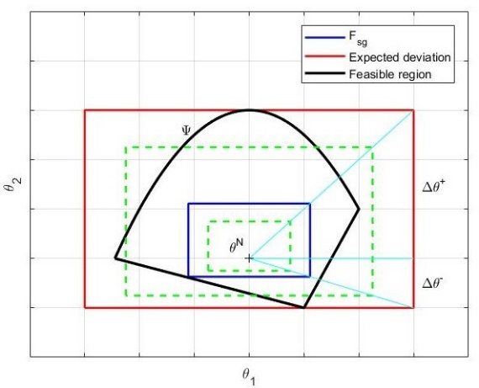

Figure 1: Swaney and Grossmann flexibility index

The dynamic flexibility assessment has been performed by the dynamic flexibility index proposed by Dimitriadis and Pistikopoulos (1995) hereinafter referred to as DF. The definition of the Dynamic Flexibility follows the path of the FSG considering the uncertain and control parameters namely θ and z as a function of time, therefore the dynamic flexibility index evaluation problem becomes:

|  |  |
| --- | --- |
| $$DF(d)=\max_{}{δ}$$ | (6) |
| $$s.t.χ(d)=\max_{θ(t)∈T(δ,t)}{}\min_{z(t)∈Z(t)}{}\max_{j∈J,t∈[0,H]}{f_{j}(d,x\left(t\right),z\left(t\right),θ\left(t\right),t)≤0}$$ | (7) |
| $$s.t.χ(d)=h\left(d,x\left(t\right),z\left(t\right),θ\left(t\right),t\right)=0$$ | (8) |
| $$x(0)=x_{0}$$ | (9) |
| $$δ≥0$$ | (10) |
|  | (11) |
|  | (12) |

Qualitatively, the Dynamic Flexibility index (DF) represents the largest scaled deviation of the uncertain parameter profile that the design can tolerate while remaining feasible within the horizon considered.

This means that, while the steady state flexibility analysis is performed based on the new steady state process variables values after a step perturbation, the dynamic flexibility analysis is based on the most constraining process variables values along the whole pathway (i.e. maximum and minimum oscillation peaks).

Column dynamic simulation has been carried out with the software DYNSIM Dynamic Simulation® by Schneider Electric. Soave-Redlich-Kwong has been selected as EoS; 1.5 bar steam and 20 °C cooling water have been used as external duties. The control loop configuration is listed in Table 4; Cohen-Coon method was used for controllers tuning.

Table 4: Controlled and manipulated variables

|  |  |  |
| --- | --- | --- |
| Controlled variable | Manipulated Variable | Controller |
| Inlet flowrate | Inlet flowrate | PI |
| Condenser level | Distillate flowrate | PI |
| Reboiler level | Bottom flowrate | PI |
| Condenser Pressure | Cooling water duty | PI |
| Pentane recovery ratio | Reflux ratio | PID |
| Stage 16 temperature | Reboiler steam duty | PI |

* 1. Results and discussions

Starting from the steady state condition, a step perturbation has been input for each deviation value. The two possible cases mentioned in the introduction are represented in Figure 2.

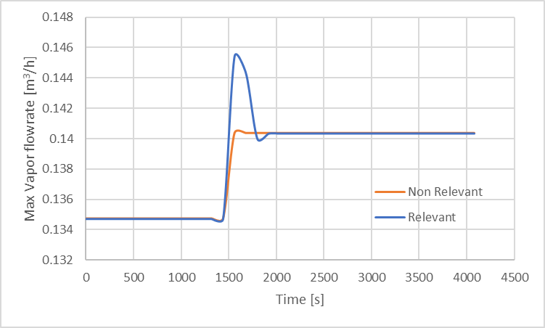

Figure 2: Dynamic closed-loop step perturbation response

The orange line shows non relevant dynamics for the output variable that moves almost without any oscillation to the new steady state. On the other hand the blue line, that is the one related to the debutanizer case study, is characterized by a much higher peak of the vapor flowrate with respect to the new steady state value; this phenomenon results in a considerable underestimation of the design variable when neglecting the dynamics of the process.

Therefore, based on each utilities value, condenser and reboiler sizes, that is their heat transfer area, have been assessed. Then, according to the maximum and minimum vapour flowrate inside the column, the corresponding column maximum and minimum column diameters have been evaluated as well (column height was already fixed by the number of stages).

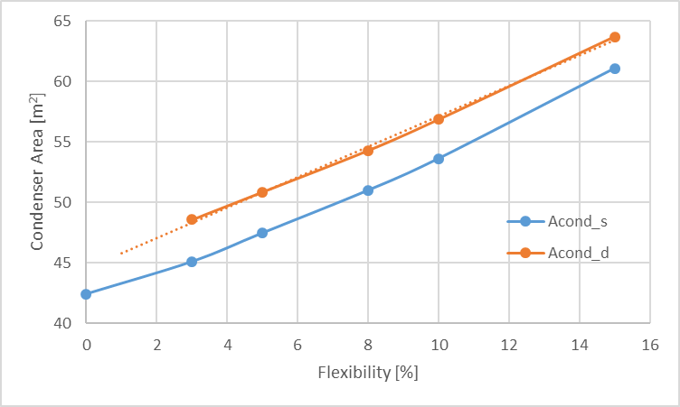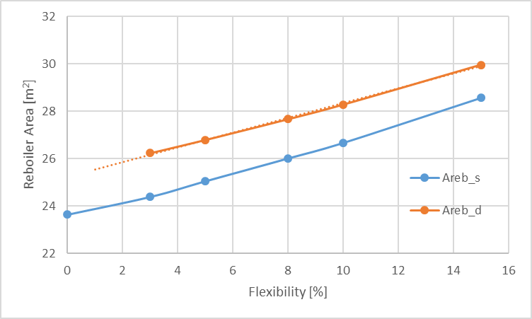

Figure 3: Condenser (a) and reboiler (b) area vs flexibility

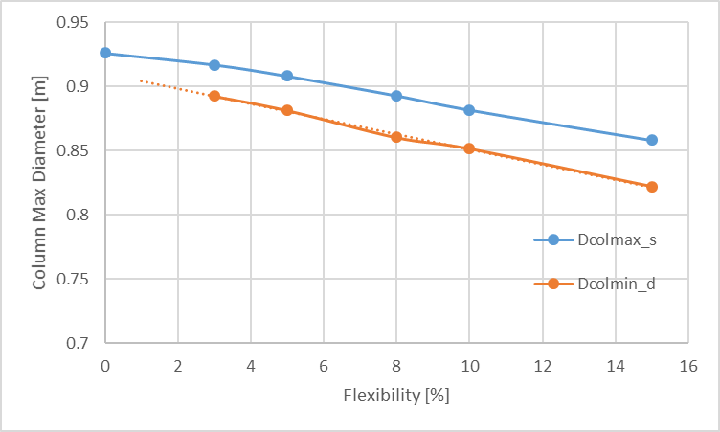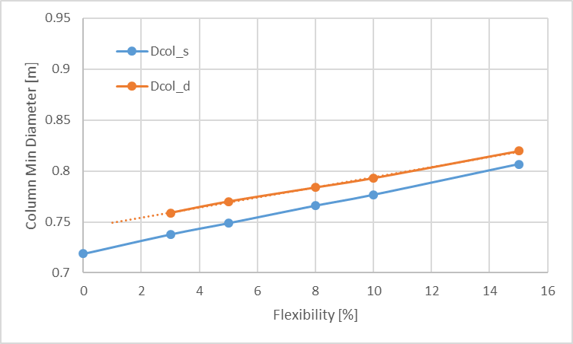

Figure 4: Maximum (a) and minimum (b) column diameter vs flexibility

Figures 3 and 4 shows the trend of the aforementioned variables with respect to flexibility, i. e. the simultaneous deviation of each uncertain parameter. The blue line is referred to the design variable calculated for the new steady state condition while the orange line is related to the variable calculated for the maximum (minimum when referred to the weeping condition) peak value. Having the two flexibility indexes a deterministic nature, these trends result to be linear as explained by Di Pretoro et al.

Dealing with a convex domain, the solutions of the flexibility problem lie on a vertex of the hyperrectangle. Namely they correspond to the uncertain parameters deviation as shown in the Table 5 here below.

Table 5: Hyperrectangle solution vertexes

|  |  |  |  |  |  |  |  |
| --- | --- | --- | --- | --- | --- | --- | --- |
| Design Parameter | F4 | F5 | Ucond | Tw | Ureb | Gf | Gw |
| Minimum column diameter | + | + |  |  |  | - |  |
| Maximum column diameter | - | - |  |  |  |  | + |
| Condenser heat transfer area | + | + | - | + |  |  |  |
| Reboiler heat transfer area | + | + |  |  | - |  |  |

For the condenser area, reboiler area and minimum column diameter critical conditions are achieved because of overfed column and underperforming equipment while for the maximum diameter, i.e. weeping conditions, criticalities are present in case of underfeeding as expected according to the physics of the problem.

Moreover, it can be noticed that not all the uncertain parameters are related to every design constraint. This condition allows to decouple some of them that are independent in order to substantially reduce the dimension of the problem. This procedure makes the constrained optimization much simpler from a computational point of view.

After that, for each design variable the corresponding maximum withstood deviation and the overall Fsg and DF indexes can be assessed as listed in Table 6.

Table 6: Equipment vs maximum allowed deviation

|  |  |  |
| --- | --- | --- |
| Design Parameter | Steady | Dynamic |
| Minimum column diameter | 7% | 4% |
| Maximum column diameter | 32% | 22% |
| Condenser heat transfer area | 7% | 4% |
| Reboiler heat transfer area | 14% | 9% |
| Fsg | 7% |  |
| DF |  | 4% |

Fsg and DF result then to be respectively 7% and 4%. The most constraining design variables are minimum column diameter (corresponding to flooding condition) and condenser area while the less restrictive ones are the maximum column diameter (i.e. weeping condition) and the reboiler area.

Even if the selected case study doesn’t apparently show particular complexity, it highlights that for simple systems as well there exists an appreciable design parameters underestimation while considering the final conditions only rather than the whole transient.

The dynamic constrained domain is always much smaller than the steady state one since in the traditional flexibility analysis the maximum withstood deviations are always overestimated by more than one third undermining the operability of the process.

More important than the values themselves, that are intrinsically case related, is the sizing trend (and then the costs trend) that results to be linear with respect to flexibility. If the flexibility analysis is performed on an existing column nothing but being aware of the operability boundaries can be done. On the other hand, if dynamic flexibility analysis is performed during the design phase, the engineer can decide, according to the perturbations likelihood, how much oversizing (that is additional costs) should be considered in order to avoid the risk of non-operable system under perturbated conditions. In particular, for the debutanizer case study we have smooth linear trends, therefore this trade-off is rather subjective but for different systems or different flexibility indexes additional considerations could be made.

Moreover, it is worth highlighting that for a 15% deviation the maximum column diameter and the minimum one result in the same value, that means this is the maximum flexibility value that can be achieved with a single diameter distillation column. If higher flexibility is required a column with different diameter for the rectifying and stripping section should be designed with an additional cost. With an a priori steady state flexibility analysis the crossing point between these two lines shifts to 20%, providing a confidence interval considerably larger than the real one and increasing operability perception during the design phase.

* 1. Conclusions

In conclusion an a priori dynamic flexibility analysis allows the decision maker to have a much more reliable overview on the process behaviour under perturbated operating conditions and on the real additional costs to be afforded in order to ensure the operability of the process not only once the steady state has been attained but during the whole duration of the operation.

References

Dimitriadis V. D., Pistikopoulos E. N., 1995, Flexibility Analysis of Dynamic Systems, Industrial & Engineering Chemistry Research, 34.12, 4451–62.

Di Pretoro A., Montastruc L., Manenti F., Joulia X., Flexibility Analysis of a Distillation Column: Indexes Comparison and Economic Assessment, Computers & Chemical Engineering (February 2019) – https://doi.org/10.1016/j.compchemeng.2019.02.004

Hoch P. M., Eliceche A. M., Grossmann I.E., 1995, Evaluation of Design Flexibility in Distillation-Columns Using Rigorous Models, Computers & Chemical Engineering, 19, S669–74.

Grossmann I. E., Morari M., 1983, Operability, Resiliency, and Flexibility: Process Design Objectives for a Changing World, Design Research Center, Carnegie-Mellon University, Department of Chemical Engineering.

Swaney R. E., Grossmann I. E., 1985, An Index for Operational Flexibility in Chemical Process Design. Part I: Formulation and Theory, AIChE Journal, 31, 621–30.