|  |  |
| --- | --- |
| cetlogo ***CHEMICAL ENGINEERING TRANSACTIONS***  ***VOL. 76, 2019*** | A publication of  aidiclogo_grande |
| The Italian Association  of Chemical Engineering  Online at www.cetjournal.it |
| Guest Editors: Sauro Pierucci, Jiří Jaromír Klemeš, Laura Piazza  Copyright © 2019, AIDIC Servizi S.r.l. **ISBN** 978-88-95608-73-0; **ISSN** 2283-9216 | |

Microstructural features of ternary powder compacts

Zhanibek Akhmetova, Aidana Boribayevaa, Zhazira Berkinovaa, b, Assiya Yermukhambetovaa, b, Boris Golmana\*.

aDepartment of Chemical and Materials Engineering, School of Engineering, Nazarbayev University, 53 Kabanbay Batyr Ave., Astana, 010000, Kazakhstan

bNational Laboratory Astana, Nazarbayev University, 53 Kabanbay Batyr Ave., Astana, 010000, Kazakhstan

\* boris.golman@nu.edu.kz

In this study the microstructure features of ternary powder compacts of different size ratios and various volume fractions are investigated. Particle compacts are generated by particle growth model using a discrete element method approach. The particles of three different sizes are placed randomly without overlap in a 3D box at given volume fractions. Then, the particle sizes increase to reach the desired particle size. The microstructural properties of powder compacts are analysed using a radical Voronoi tessellation. The obtained results confirm that microstructural characteristics of powder compacts are influenced by size ratios and volume fractions of large, medium and small components of the ternary mixture.

* 1. Introduction

Microstructural characterization of materials plays a large role in solving different existing issues in materials research, physics and chemistry of solid states etc.. In particular, rechargeable lithium (Li)-ion batteries technology is found in numerous applications and is the leading contender for transportation applications. In these applications, high-power performance and low-cost solutions are required (Bruce et al. 2012, Chu et al. 2012). Thus, to increase the energy density using the state-of-the-art lithium battery technologies the ratio of active material over the total battery weight is raised by making the electrode thicker or denser (Malifrage et al. 2018). However, by packing more material in thick electrodes, the effect of the porous electrode morphology on energy power becomes more pronounced, as it gives rise to the lithium-ion diffusion limitations across the electrode and, thus, may reduce the battery lifetime. In order to be able to model the electrode microstructure accurately, it is necessary to acknowledge the particulate nature of such structures.

An important element in the understanding of particulate nature of electrode is the description of local arrangement of the particles and their interactions. This element can be described through the statistical properties of Voronoi cells related to each particle. The tessellation approach based on Voronoi diagrams proved to be a powerful method to model and investigate particle packings in different applications (Rycroft, 2009).

In Yi et al., 2012 the radical tessellation of ternary mixture was employed to study the packing structure, and it was shown that the packing properties are strongly dependent on the volume fractions of each component of a mixture.

Randrianalisoa and Baillis (2014) applied the Voronoi tesselation method to dense packing of spheres to get the topological information needed to feed analytical thermal models. The authors generated the packing structures by applying the Discrete Element Method (DEM) under artificial gravity. They concluded that the radical tessellation can be successfully used to model different properties of multi-sized packings and assist in the development of a predictive method to describe the effect of the particle size distribution on the structural properties of the packing of particles.

In this study, the radical Voronoi tessellation is performed to the analysis of packing structure of polydisperse particles compact generated by DEM with different size ratio and volume fraction by applying the growth rate method.

* 1. Methodology

The assessment of the packing structure of particle compacts involved several steps: 1) packing compact generation by DEM; 2) Voronoi tesselation on the structures; 3) analysis of Voronoi statistical data and correlation to the structural properties.

DEM was used to generate the compacts of polydisperse spherical particles. The simulations were carried out within a 3D-box with the sides of ten times the largest particle diameter in both x and y directions and 3.0 m in a z direction. The boundary conditions were periodic along x- and y-axes and fixed along the z-axis. Using periodic boundaries reduces the wall effect on particle compaction. The growth rate method was applied to generate the packing structure (Giménez et al., 2018).

Initially, a ternary mixture of spherical particles of specified composition with sizes reduced by a factor of 0.6 of desired ones was randomly distributed in the 3D-box without any overlaps. As the simulation process started, the particles were allowed to grow until they reach the desired size. The growth rate was controlled to avoid excessive particle overlap. The particle growth was carried out for 50,000 time steps and, then, the simulation continued for another 20,000 steps to relax the particle structure in such a way, that particles have a more stable position in the box.

Application of the growth rate method permits to achieve the desired packing density of particle compact without using the drag and gravitational forces. Thus, a stable system can be formed without performing any compression of the particles. As the result the final compact structure by growth rate method would differ from the one formed by gravitational deposition method. (Gimenez and et al., 2018). The ternary particle mixtures of two size ratios Case A 1:2:4 and Case B 1:2:8, with varying volume fractions were used in the simulations.

An open-source software package LIGGGHTS was utilized to generate the compacts of ternary particle mixtures employing DEM. The input parameters for DEM simulations are summarized in Table 1.

Table 1: Input values for simulating the packing of ternary mixtures of spheres.

|  |  |
| --- | --- |
| Parameters | Value |
| Particle size, r (mm) | 2x4x8 and 2x4x16 |
| Size ratio | 1x2x4, 1x2x8 |
| Particle density, ρ (kg/m3) | 2500 |
| Number of particles, N | 5000-70000 |
| Poisson ratio, ơ | 0.45 |
| Time step (s) | 1.0e-5 |
| Young’s modulus, Y (N/m2) | 5.e6 |

The packing density of the powder compact was calculated by taking into account the overlap of spherical particles with each other and the walls. The sample of powder compact used for the analysis was cut from the 3D box by decreasing the length, depth, and height of the box by 25% to avoid wall effect.

A radical Voronoi tessellation was used for the analysis of the packing structure of particle compacts. The open-source software package voro++ was adopted to carry out the tessellation and divide the compact into Voronoi cells as well as to compute cell parameters, i.e. cell volume, number of faces, total surface area, and others (Rycroft, 2009). The Voronoi tessellation divides the compact porous space into cells in such a way that each cell in the form of polyhedron contains only one particle, and there is no overlap between cells. The open-source software POV-Ray was used to visualize the structure of packed compact and its Voronoi network.

* 1. Results and Discussion

The results from DEM generation are summarized in Table 2. Fig.1 illustrates Voronoi tesselation for the highest and lowest packing densities for both cases A and B.

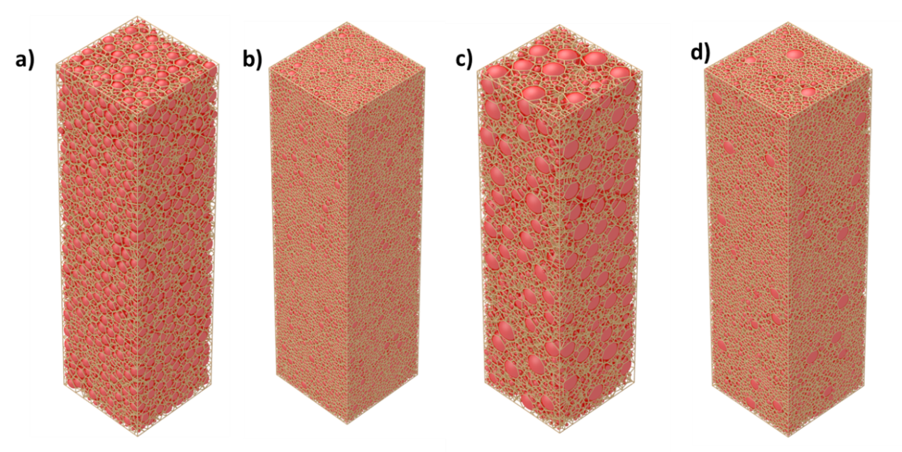

Figure 1. Voronoi tessellation a) Case A 1:2:4, A1, low packing density; b) Case A 1:2:4, A6, high packing density; c) Case B 1:2:8, B2, low packing density; d) Case B 1:2:8, B4, high packing density

Table 2: Packing density and structural properties of ternary powder compact

|  |  |  |  |  |  |  |  |  |  |  |  |
| --- | --- | --- | --- | --- | --- | --- | --- | --- | --- | --- | --- |
| **Case A 1:2:4** | **№** | **Volume fractions** | | | **Packing density** | **Case B 1:2:8** | **№** | **Volume fractions** | | | **Packing density** |
| **xl** | **xm** | **xs** | **xl** | **xm** | **xs** |
| A1 | 90% | 5% | 5% | 0.754 | B1 | 90% | 5% | 5% | 0.744 |
| A2 | 80% | 10% | 10% | 0.762 | B2 | 80% | 10% | 10% | 0.760 |
| A3 | 70% | 15% | 15% | 0.767 | B3 | 70% | 15% | 15% | 0.757 |
| A4 | 60% | 20% | 20% | 0.776 | B4 | 60% | 20% | 20% | 0.779 |
| A5 | 50% | 25% | 25% | 0.777 | B5 | 50% | 25% | 25% | 0.763 |
| A6 | 40% | 30% | 30% | 0.777 | B6 | 40% | 30% | 30% | 0.763 |
| A7 | 30% | 35% | 35% | 0.775 | B7 | 30% | 35% | 35% | 0.766 |
| A8 | 20% | 40% | 40% | 0.774 | B8 | 20% | 40% | 40% | 0.767 |
| A9 | 10% | 45% | 45% | 0.773 | B9 | 10% | 45% | 45% | 0.768 |

In both cases A and B the lowest packing density is observed for the sample with 90:5:5 volume fraction, however, in case A the change in particle density with volume fraction occurred more slowly and then remained nearly constant. In case B, the rate of change in packing density with volume fractions is more visible compare to case A volume fraction. The highest packing density of 0.779 was achieved in sample B4 with 60% of large particles, 20% of medium and small particles for the particle size ratio 1:2:8 due to optimum proportion of large to medium and small particles’ sizes. Regarding optimization of the volumetric fractions for maximizing the packing density, it can be seen that both volume fraction and initial size ratio are important.

Further, to analyse the packing characteristics of DEM generated structures the following statistical data was considered from the radical tessellation : 1) the polyhedron face related properties: the number of edges, e, perimeter, L, and area, A, of polyhedron face; 2) the polyhedron related properties: the number of faces, f, surface area, S, and volume, V, per polyhedron.

The main indicators arising from the cell analysis - topological properties, the widely used in the structural analysis parameters, i.e. the number of edges and the number of faces and metric properties, i.e. volume per polyhedron, surface area are compared as the corresponding probability distributions functions for various volume fractions and size rations.

In this study a similar approach to Yi et al, 2012 was applied, thus for each property *x* its mean value for the whole packing was considered , denoted as *⋖x⋗*, and that for each component i namely devoted ⋖*xi*⋗ where *i* = L (large particles), M (medium particles) and S (small particles).

$〈x〉= \sum_{i}{n_{i}〈x_{i}〉}$ (1)

The probability density for each component, *p(xi),* as well as for the total probability density for one property are calculated is*p(x).*

$p\left(x\right)= \sum_{i}{n_{i}p(x_{i})}$ (2)

Fig. 2 shows the distribution of the number of faces per polyhedron for Case A and B. The trend observed in this study for the effect of volume fractions on the probability distributions functions of face number is similar to what was described in (Yi et al. 2012). The three peaks occur in all functions although in the Case A when the proportion of the large particles increases the peak height that corresponds to the small component becomes lower and vice versa for the proportion of small particles is increased. A different pattern is observed for the Case B, where the ratio of the large component was twice higher compare to case A. The number of faces in case B has increased dramatically compare to case A, the two peaks corresponding to medium and small components are less visible and close to each other.

Fig. 3 shows the probability distributions of the number of edges as functions of volume fractions nearly constant and does not change with size ratio, the similar pattern was observed in Yi et al. 2012 on ternary mixtures,. In general, the overall mean numbers of faces and edges are in the same range for different size ratios and volume fractions, however the metric properties for each component varies significantly with volume fractions.

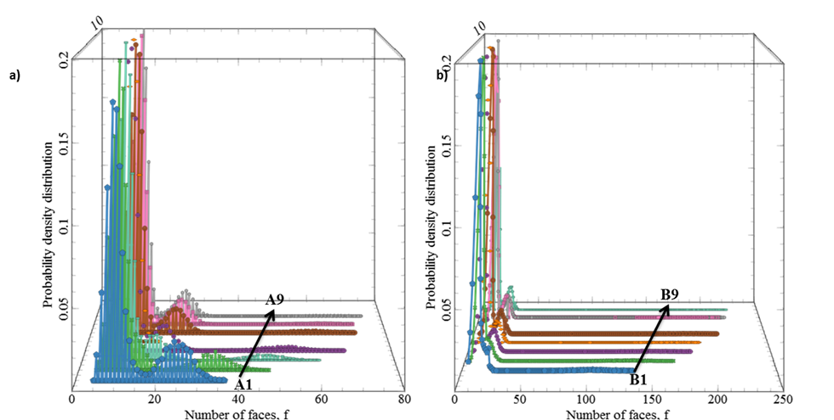

*Figure 2. Distributions of face number per polyhedron for a) Case A 1:2:4 b) case B 1:2:8*

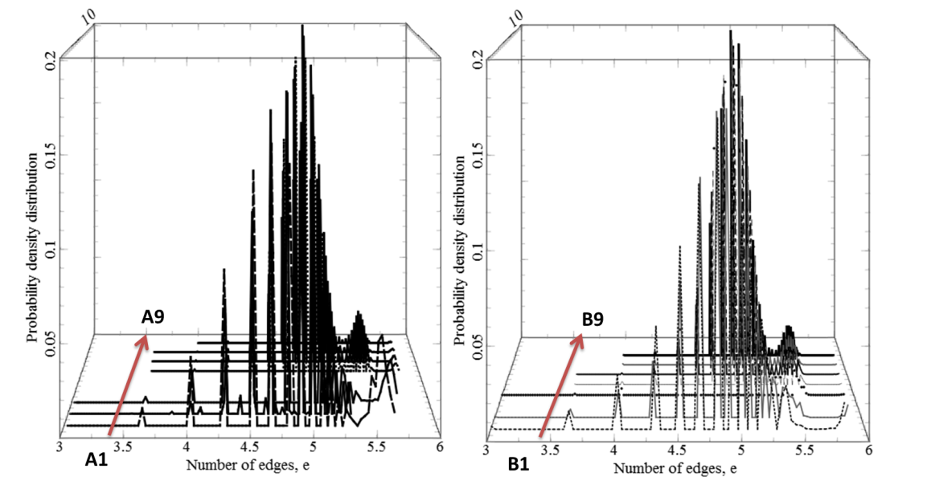

*Figure 3. Distributions of edge number per polyhedron for a) Case A 1:2:4 b) Case B 1:2:8*

The distributions of cell volumes are shown in Fig. 4 with three peaks in both cases. Each peak corresponds to small, medium or large components in ascending order and are distinguishable from each other in Case A. An increase in the volume fraction increases the peak of the respectful component and thus the other peaks are moving correspondingly. In Case B three peaks can still be observed, but the third peak is less visible. The two other peaks are close to each other and do not tend to move with varying the volume fractions.

Thus, the structural properties of ternary system depend not only on the volume fraction as it was previously demonstrated by Yi et al. 2012 with the particle ratio of 1:1.8:3, but also on the change of particle size ratio. Moreover, the dependence on the volume fraction is becoming less observable with the increasing ratio of dominating large component (from 1:2:4 to 1:2:8 of small, medium and large components correspondingly).

Fig. 5 and 6 summarize the mean values of number of faces as a function of volume fractions for Case A and Case B, respectively. It can be observed that for the Case B with greater volume fraction of small component the number of faces for the large component is significantly higher compare to the Case A.

This is due to the higher number of small particles surrounds the large particles of greater sizes, thus more interactions per each cell resulting in more faces per polyhedron of large component. Based on the above discussion, there is a strong dependence between properties of radical tessellation and volume fractions of ternary mixture, and this dependence is also affected by the particle size ratio.

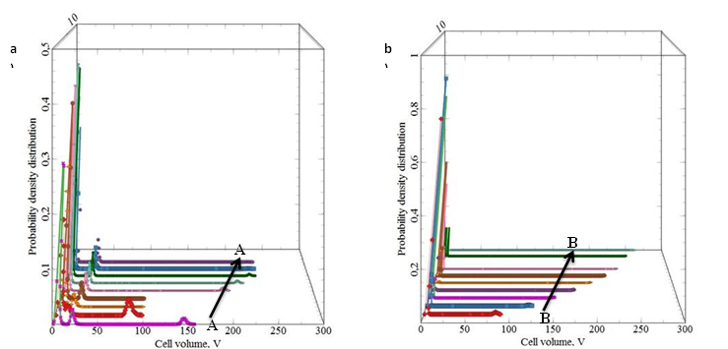

*Figure 4. Distributions of polyhedron –related metric properties, polyhedron volume for a) Case A 1:2:4 b) case B 1:2:8*

*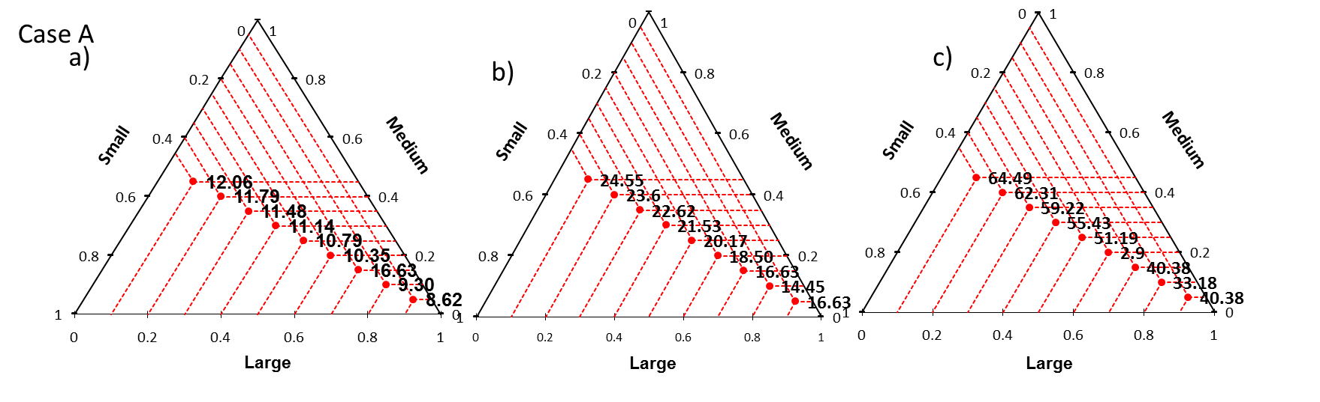Figure 5. Number of faces per polyhedron of a) small components; b) medium components c) large components as a function of volume fractions Case A (1:2:4)*

*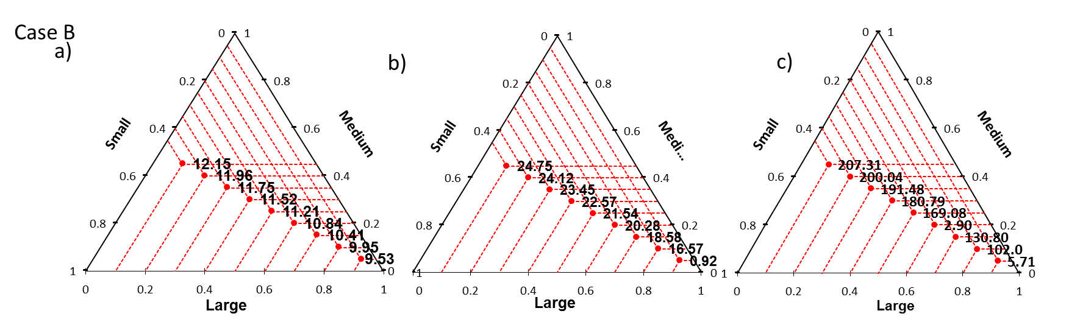*

*Figure 6. Number of faces per polyhedron of a) small components; b) medium components c) large components as a function of volume fractions Case B (1:2:8)*

* 1. Conclusions

Relatively few studies have examined the geometric properties of ternary powder compact with different volume fractions of particles with various sizes. In this paper microstructural features of ternary powder compacts of spheres with two different size ratios 1:2:4 and 1:2:8 were analysed through the statistical properties of their Voronoi cells. The packing compacts were generated by DEM with growth rate method that allows eliminating the particles compression due to artificial forces arising in gravitational deposition method. The overall mean numbers of faces and edges of Voronoi cells are in the same range for different size ratios and volume fractions, however the metric properties for each component varies significantly with volume fractions. The mean values are affected by the particle size ratios as well as by the volume fractions. These results can further help in understanding of the packings of particles and provide structure models for evaluating transport properties of these packings.

Acknowledgments

This research was partially funded under the program BR05236789 “Innovative Materials and Systems for Energy Conversion and Storage”; by the Ministry of Education and Science of the Republic of Kazakhstan.

References

Annic C., J. Troadec, A. Gervois, J. Lemaître, M. Ammi, et al., 1994, Experimental study of radical tesselations of assemblies of discs with size distribution. Journal de Physique I, EDP Sciences, 4 (1), pp.115-125.

Antwerpen W. Van, Du Toit C. G., and Rousseau P. G., 2010, A review of correlations to model the packing structure and effective thermal conductivity in packed beds of mono-sized spherical particles, Nuclear Engineering and Design, V. 240, 1803-1818

Bruce P. and Freunberger S., 2012, Li-O2 and Li-S batteries with high energy storage, Nat. Mater., vol. 11, 19–30.

Chu, S., Majumdar A.. 2012, Opportunities and challenges for a sustainable energy future, Nature 488, 294–303.

Gimenez C.S, Finke B., Nowak C., Schilde C., Kwade A., 2018, Structural and mechanical characterization of lithium-ion battery electrodes via DEM simulations, Advanced Powder Technology, 29, 2312–2321

Malifarge, B. D. and Delacourt C., 2018, Experimental and Modeling Analysis of Graphite Electrodes with Various Thicknesses and Porosities for High-Energy-Density Li-Ion Batteries, J. Electrochem. Soc. 2018 volume 165, issue 7, A1275-A1287.

Randrianalisoa J. and Baillis D.,2014, Thermal conductive and radiative properties of solid foams: Traditional and recent advanced modelling approaches, C. R. Physique, V. 15, 683–695.

Rycroft C. 2009, VORO++: A three-dimensional Voronoi cell library in C++, Chaos 19,041111 .

Yi Y. L., Dong K.J., Zou R.P., Yu A.B., 2012, Radical tessellation of the packing of ternary mixtures of spheres, Powder Technology, 224, 129-137.