 CHEMICAL ENGINEERING TRANSACTIONS  VOL. 76, 2019 | A publication of  
The Italian Association
of Chemical Engineering
Online at www.cetjournal.it
Guest Editors: Sauro Pierucci, Jiří Jaromír Klemeš, Laura Piazza
Copyright © 2019, AIDIC Servizi S.r.l.
ISBN 978-88-95608-73-0; ISSN 2283-9216

Evaluation of Metal Affinity of Lanthanum using different alternative bio/adsorbent materials
Talles B. Costaª, Meuris G. C. da Silvaª, Melissa G. A. Vieiraª*
ªUniversity of Campinas, School of Chemical Engineering, Albert Einstein Avenue, 500, 13083-852 Campinas, Brazil
*melissagav@feq.unicamp.br

Over the past few decades, the removal and recovery of Lanthanum (La) has received great economic and environmental interest due to its high market prices, along with several industrial applications. Recently, with the increasing demand for rare-earth compounds with high purity, the separation and purification of these elements has gained expressive attention. The bio/adsorption has been considered an alternative for the recovery of these elements, due to their simplicity, low cost and efficiency in the recovery of rare earth ions in low concentrations. In this study, particles produced from a blend of sericin and alginate crosslinked by proanthocyanidins (SAPAs); calcined Verde-lodo clay and calcined Bofe clay; aquatics macrophytes Salvinia natans and Pistia Stratiotes, were used to remove lanthanum ion from aqueous solutions. The simulation of speciation diagrams as functions of pH was performed using Hydra/Medusa software and the pH was adjusted and controlled during the experiments to values between 4.5 and 5.0. The affinity tests study were performed in batch systems at concentration of 1.0 and 3.0 mmol L⁻¹ La³⁺. In the experiments with concentration of 1.0 mmol L⁻¹ La³⁺, all bio/adsorbents evaluated presented a high removal percentage (>96%). The removal percentage and adsorption capacity of lanthanum ion from aqueous solution by bio/adsorbents materials varied between 53.47 to 98.26% and 0.154 to 0.243 mmol g⁻¹ at the concentration of 3.0 mmol L⁻¹ La³⁺, respectively. The results indicated that the material with the greatest values of removal percentage and adsorption capacity for lanthanum ions was the particles of sericin and alginate crosslinked by proanthocyanidins (82.66 % and 0.243 mmol g⁻¹).
  - Introduction
The rare-earth metals (REMs) consist of 17 elements, 15 belonging to the series of lanthanides and two pseudo lanthanides (Sc and Y) (Vijayaraghavan and Balasubramanian, 2010; Iftekhar, et al., 2018). The application of REMs, particularly lanthanides, has increased due to their numerous applications that contribute to important sectors of society (Tadjarodi et al., 2015). Among REMs, lanthanum is one of the most abundant and reactive elements and has attracted special attention. Current applications of lanthanum as a pure element or in association with other compounds involve super alloys, catalysts, special ceramics and organic synthesis (Awwad et al., 2010). Lanthanum is used in many industries, such as oil refineries (Olmez et al., 1991), semiconductor (Triyoso et al., 2008) and ceramic industries (Cai et al., 2008) and the effluents from these industries are often associated with high concentrations of this metal. Therefore, there is a scope for recovering the lanthanum from these effluents.
Different conventional methods have been proposed for the removal and recovery of REMs, such as solvent extraction (Kim et al., 1997), chemical precipitation, ion exchange (Xiong et al., 2008; Ponou et al., 2014) and bio/adsorption (Sadovsky et al., 2016; Gao et al., 2018). Among these separation processes for REMs removal and recovery, bio/adsorption has been reported due to its efficiency, simplicity, selectivity, eco-friendly and economical technique, especially for the effluent treatment and recovery of La (Das and Das, 2013; Sadovsky et al., 2016).
The mechanisms involved in rare-earth metals accumulation on bio/adsorption sites are numerous and it is a complicated process. In most cases, metal binding proceeds through electrostatic interaction, surface complexation, ion-exchange, and precipitation, which can occur individually or combined (Oliveira et al., 2011). The types of bio/materials, properties of metal solution chemistry, ambient/environmental conditions such as pH, influence the mechanism of rare-earth metal bio/adsorption (Das and Das, 2013).
Clays are potential metals adsorbent materials due to their high adsorption capacities, high surface areas, mechanical stability and various structural and surface properties (Bekçi et al., 2006). The application of aquatic macrophyte as a bioadsorbent presents some advantages, such as being a low-cost and locally available material. They are easy to grow in a wide range of temperature and pH. Moreover, many works have shown the high affinity of the metal ions by aquatic macrophytes in adsorption processes (Lima et al., 2011).
Sericin, on the other hand, is a macromolecular, globular, water soluble protein that consists of 18 kinds of amino acids, mostly serine and aspartic acid. Sericin accounts for 20 to 30% of total mass of silkworm cocoons (Bombyx mori) and is deposited in successive layers on the fibroin fibers, which corresponds to 70 to 80% of the cocoon weight, which ensures the cohesion of the cocoon formation by holding the fibers together (Padamwar and Pawar, 2004; Zhang, 2002). This protein is a waste material from silk industries (Aramwit et al. 2012). Despite being a waste, it has interesting characteristics (Zhang, 2002; Aramwit et al., 2012), including easy crosslinking and blending with other polymeric materials, which may result in biodegradable products with improved properties (Dash et al. 2009). Alginate is a linear polysaccharide formed by two types of monomers: β-D-mannuronic and α-L-guluronic acid (Yang et al., 2011). This polysaccharide is abundant in the cell wall of brown algae (Alnaief et al., 2011) and is widely used due to its non-toxicity, biodegradability, high biocompatibility and ability to transform into gel when in multivalent cations presence (Daemi and Barikani, 2012; Cuadros et al., 2015).
Therefore, this study aims to evaluate the alternative bio/adsorbent materials (sericin and alginate particles crosslinked by proantocyanidins, calcined Verde-lodo clay, calcined Bofe clay, aquatics macrophytes Salvinia natans and Pistia Stratiotes) in metal affinity tests with rare-earth metal lanthanum (La³⁺), in order to explore its bio/materials adsorptive capacities.
  - Materials and Methods
    - Preparation of sericin and alginate particles crosslinked by proantocyanidins
Bombyx mori cocoons were provided by Bratac Silk Mills Company, Brazil, and sericin/alginate particles chemically crosslinked by proantocyanidins (SAPAs) were prepared according to the methodology reported by Santos et al. (2018). Briefly, the cocoons were cleaned, cut into pieces, washed, dried, and used for sericin extraction in autoclave (120 °C ~ 1.0 kgf cm⁻² ~ 40 min). High molecular sericin solution (25.0 g L⁻¹), obtained by freezing/thawing method, was mixed to sodium alginate (20.0 g L⁻¹) and proanthocyanidins (25.0 g L⁻¹). The blend was dripped into cross-linking solution of Ca(NO₃)₂.4H₂O (6.4 % m/V) to instantly form SAPAs. The produced particles were dried at a continuous flow oven at 40 °C, and then they were thermal crosslinked at 100 °C for 24 h.
    - Clay preparation
The Verde-lodo and Bofe bentonitic clays, from Boa Vista, Paraíba, Brazil, were obtained in its raw form. All clay varieties were sieved in Tyler sifters to achieve the medium particle size of 0.855 mm. The clays were calcined in a muffle at 500 ºC for 24 h, in order to increase the material stability (Cantuaria et al., 2014).
    - Aquatics macrophytes preparation
The aquatic macrophytes Salvinia natans and Pistia Stratiotes were cultivated and collected by the CPAA (Research Center in Environmental Aquaculture) of State University of Paraná, Brazil. After collection, the biomasses were washed and dried at 55 ºC for 24 h. After that, the biomasses were sieved and fractions measuring 0.855 mm were collected and used in experiments.
    - Metal speciation study
The metal solution was prepared by dissolving the metal salt of La(NO₃)₃.6H₂O in ultrapure water. The metal speciation study was simulated with the help of the Hydra-Medusa Software (Puigdomenech, 2004) with a concentration of 1.0 and 3.0 mmol L⁻¹. Metal speciation diagrams are useful for identifying different species of metals and their compounds, as a function of pH.
    - Metal Affinity tests
The affinity of bio/adsorbent materials (SAPAs, Verde-lodo bentonite clay, Bofe bentonite clay, aquatic macrophytes Salvinia natans and Pistia Stratiotes) for lanthanum ion was performed by adding 0.5 g of bio/adsorbent and 50 mL of metal solution (0.97 ± 0.00 and 2.91 ± 0.03 mmol L⁻¹) into Erlenmeyer flasks (125 mL) under batch conditions. The assays were conducted in a shaker incubator (Lab Companion Jeio Tech, Korea), under fixed agitation (200 rpm) and at room temperature (25.0 ± 0.5 °C) for 24 h. At the end, the samples were collected, centrifuged at 4,000 rpm for 10 min, filtrated through a millex syringe 0.22 μm, and measured in a Shimadzu UV-VIS spectrophotometer by means of the xylenol orange method at 575 nm (Mukherji et al., 1966). According to this method, aliquots of 2 mL of the clear supernatant were mixed with 3 mL of a 4.5 × 10⁻⁴ mol L⁻¹ xilenol orange solution; a final volume of 10 mL was completed with a buffer solution (acetic acid/sodium acetate) of pH 5.6, and measured in the spectrophotometer. The adsorption capacity, q_{e} (mmol g⁻¹), and the removal percentage, %R (%), were determined by Eq (1) and Eq (2), respectively.
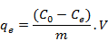 | (1)
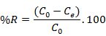 | (2)
In which, C₀ is the initial concentration (mmol L⁻¹), C_{e} is the equilibrium concentration (mmol L⁻¹), V is the solution volume (L) and m is the mass of bio/adsorbent material (g).
  - Results and discussion
The speciation diagrams as function of pH for lanthanum metal with concentration 1.0 and 3.0 mmol L⁻¹, were obtained by Hydra-Medusa Software (Puigdomenech, 2004). The choice of low concentrations aims to evaluate processes that can take care of the removal of metallic ions in concentration ranges in which conventional processes are not technically and economically feasible. In Figure 1, these diagrams are presented.

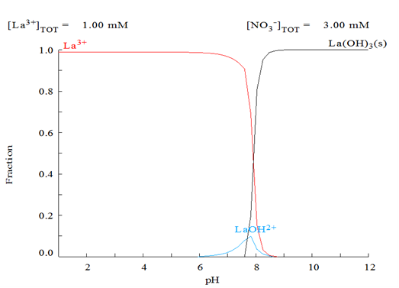
(a)
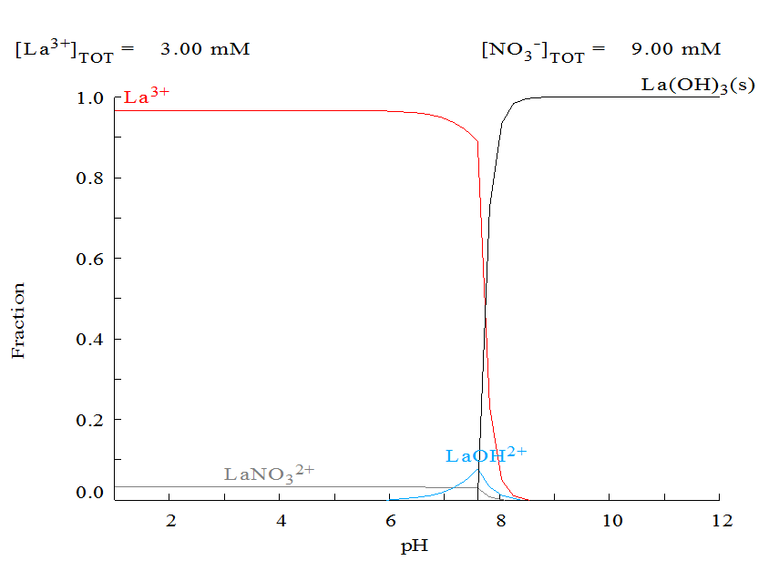
(b)
Figure 1: Metallic speciation diagrams of lanthanum (La³⁺) at concentrations: (a) 1.0 and (b) 3.0 mmol L⁻¹.
From Figure 1, it can be observed that the soluble ionic fraction of lanthanum occurs at pH lower than 8.0, at both concentrations (1.0 and 3.0 mmol L⁻¹). The speciation diagrams of lanthanum indicate that from the pH 6.0 theformation of the La(OH)²⁺ ionic chemical species occurs and from 7.6, the precipitated species La(OH)₃(s) begins to be formed in solution (Diniz and Volesky, 2005). In order to evaluate the bio/adsorption of lanthanum metal in affinity tests, the pH was adjusted and controlled during the experiments to values between 4.5 and 5.0. In this pH range it is safe to state that only the lanthanum ionic species (La³⁺) are present. In addition, a literature review was accomplished to investigate the pH that can be used to perform the metallic affinity tests for lanthanum metal. For the adsorption experiments of lanthanum previously reported, the pH was adjusted to values between 4.5 and 5.0 (Palmieri et al., 2002; Vijayaraghavan et al., 2010; Torab-Mostaedi et al., 2015).
Metal affinity tests were performed in order to find the best bio/adsorbent for lanthanum among the materials evaluated. The removal percentage (%R) and adsorption capacity (q_{e}) varied according the material and the results are presented in Figure 2.

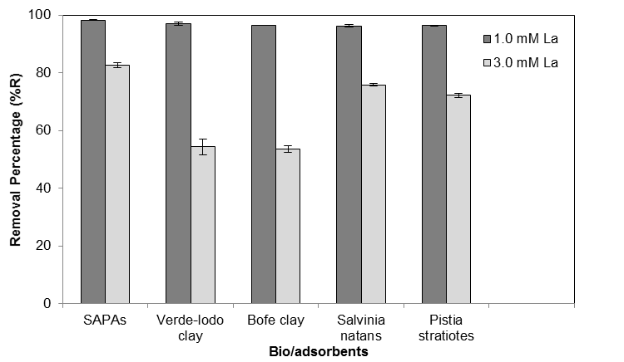
(a)
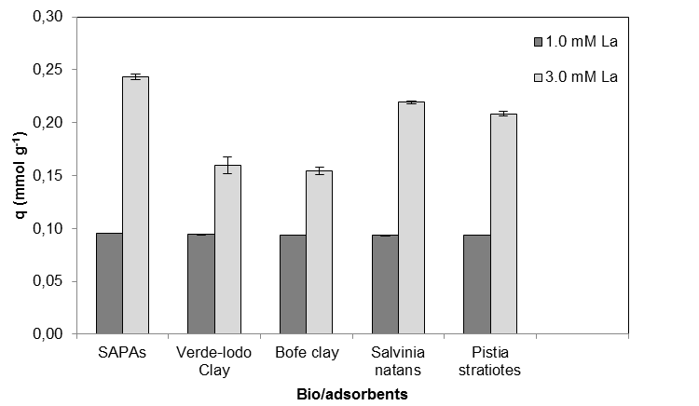
(b)
Figure 2: Affinity of metal ion La³⁺ by bio/adsorbents expressed in percentage removal (a) and capacity adsorption (b).

As shown in Figure 2, for the affinity assays conducted at the initial concentration of 1.0 mmol L⁻¹ La³⁺, all bio/adsorbents evaluated presented a high percentage of removal (>96%). For the assays at the initial concentration of 3.0 mmol L⁻¹ La³⁺, bio/adsorbents materials presented the following order of metallic affinity: SAPAs > Salvinia natans > Pistia stratiotes > Verde-lodo bentonite clay > Bofe bentonite clay.
The clay materials presented reasonable efficient removal values, 54.32 ± 2.73 and 53.47 ± 1.19%, for Verde-lodo and Bofe bentonitic clays, respectively. For adsorption of lanthanum using the aquatic macrophytes, the results obtained were comparatively satisfactory, with removal percentage values of 72.17 ± 0.64 and 75.87 ± 0.30, for Salvinia natans and Pistia stratiotes, respectively. The SAPAs presented the best results observed for lanthanum, 82.66 ± 0.92%, higher than all other bio/adsorbents varieties. This can be attributed to the hydroxyl, carboxyl and amide groups present on SAPAs surface (Dash et al., 2009; Santos et al., 2018), which may be involved in the uptake of lanthanum.
Similarly, Silva et al. (2017) evaluated the affinity of sericin and alginate particles crosslinked by poly(ethylene glycol) diglycidyl ether for precious metals adsorption and obtained removal percentages of 99.38, 88.63, 66.35, and 61.31% for gold, palladium, platinum, and silver metals, respectively. Santos et al. (2018), on the other hand, verified that sericin and alginate particles crosslinked by proanthocyanidins showed higher removal percentages of 99.6 and 88.3%, whereas particles crosslinked by polyvinyl alcohol presented removal percentages of 96.2 and 95.6%, for the noble metals gold and palladium, respectively.
  - Conclusions
By analyzing the results obtained for the affinity tests, it can be concluded that the bio/adsorbent materials studied presented good removal and, therefore, good capacity of adsorption for lanthanum. The removal percentage was greater than 96% at the initial concentration of 1.0 mmol L⁻¹ La³⁺, regardless the bio/adsorbent. The SAPAs proved to be the most efficient, with removal above 82% for the initial concentration of 3.0 mmol L⁻¹ La³⁺, and may be a promising alternative as a bioadsorbent in the removal and recovery of lanthanum. The sericin and alginate particles are economically interesting, being low cost, renewable, and abundant, besides adding value to waste material from silk processing in textile industries. Moreover, its high affinity for lanthanum enables its use in the recovery of rare-earths metals.
Acknowledgments
The authors thank the BRATAC Company for providing the silkworm cocoons and FAPESP (Proc. 2017/18236-1) for the financial support.
References
Alnaief, M., Alzaitoun, M. A., García-González, C. A., Smirnova, I., 2011, Preparation of biodegradable nanoporous microspherical aerogel based on alginate, Carbohydrate Polymers, 84, 1011 – 1018.
Aramwit, P.; Sirtientong, T.; Srichna, T., 2012, Potencial applications of silk sericina a natural protein from textile industry by-products, Waste Management and Research, 30, 217 – 224.
Awwad, N., Gad, H., Ahmad, M., Aly, H., 2010, Sorption of lanthanum and erbium from aqueous solution by activated carbon prepared from rice husk, Colloids and Surfaces B: Biointerfaces, 81, 593 – 599.
Bekci Z., Seki Y., Yurdakoc M.K., 2006, Equilibrium studies for trimethoprim adsorption on montmorillonite KSF, Journal of Hazardous Materials, 133, 233 – 242.
Cai, Z., Xing, X., Li, L., Xu, Y., 2008, Molten salt synthesis of lead lanthanum zirconate titanate ceramic powders, Journal of Alloys and Compounds, 454 – 466.
Cantuaria, M. L., Almeida Neto, A. F., Nascimento, E. S., Santos, O. A. A., Vieira, M. G. A., 2014, Removal of Silver Ions on Calcined Verde-lodo Bentonite Clay: Equilibrium Study, Chemical Engineering Transactions, 39, 667 – 672.
Cuadros, T. R., Erices, A. A., Aguilera, J. M., 2015, Porous matrix of calcium alginate/gelatin with enhanced properties as scaffold for cel culture, Journal of Mechanical Behavior of Biomedical Materials, 46, 331 – 342.
Daemi, H., Barikani, M., 2012, Synthesis and characterization of calcium alginate nanoparticles, sodium homopolymannuronate salt and its calcium nanoparticles, Scientia Iranica, 19, 2023 – 2028.
Das, N., Das, D., 2013, Recovery of rare earth metals through biosorption: An overview, Journal of Rare Earths, 31, 933 – 943.
Dash, B. C., Mandal, B. B., Kundu, S. C., 2009, Silk gland sericin protein membranes: Fabrication and characterization for potential biotechnological applications, Journal of Biotechnology, 144, 321 – 329.
Diniz, V., Volesky, B., 2005, Biosorption of La, Eu and Yb using Sargassum biomass, Water Research, 39, 239 – 247.
Gao, S., Luo, T., Luo, W., 2018, A novel and efficient method on the recovery of nanosized CeO₂ in Ce³⁺ wastewater remediation using modified sawdust a adsorbent, Journal of Colloid and Interface Science, 512, 629 – 637.
Iftekhar, S., Ramasamy, D. L., Srivastava, V., Asif, M. B., Sillanpaa, M., 2018, Understanding the factors affecting the adsorption of Lanthanum using different adsorbents: A critical review, Chemosphere, 204, 413 – 430.
Kim, J. S., Lee, C. H., Han, S. H., Suh, M. Y., 1997, Studies on complexation and solvente extraction of lanthanides in the presence of diaza-18-crown-6-di-isopropionic acid, Talanta, 45, 437.
Lima, L. K. S.; Kleinübing, S. J.; Silva, E. A.; Silva, M. G. C., 2011, Removal of chromium from wastewater using macrophyte Lemna as biosorbent. Chemical Engineering Transactions, 25, 303 – 308.
Mukherji, A. K., 1966, Simultaneous spectrophotometric determination of thorium and the rare earths with Xylenol Orange, Microchemical Journal, 11, 243 – 254.
Oliveira, R. C., Jouannin, C., Guibal, E., Garcia Jr, O., 2011, Samarium(III) and praseodymium(III) biosorption on Sargassum sp.: Batch study. Process Biochemistry, 46, 736 – 744.
Olmez, I., Sholkovitz, E. R., Hermann, D., Eganhouse, R. P., 1991, Rare Earth elements in sediments off Southern Califórnia: a new anthropogenic indicator, Environmental Science & Technology, 25, 310 – 316.
Padamwar, M. N., Pawar, A. P., 2004, Silk sericin and its application: A review, Journal of Scientific and Industrial Research, 63, 323 – 329.
Palmieri, M. C., Volesky, B., Garcia, O., 2002, Biosorption of lanthanum using Sargassum fluitans in batch system. Hydrometallurgy, 67, 31 – 36.
Ponou, J., Wang, L.P., Dodbiba, G., Okaya, K., Fujita, T., Mitsuhashi, K., Atarashi, T., Satoh, G., Noda, M., 2014, Recovery of rare earth elements from aqueous solution obtained from Vietnamese clay minerals using dried and carbonized parachlorella, Journal of Environmental Chemistry Engineering, 2, 1070 – 1081.
Puigdomenech, I., 2004, Chemical Equilibrium Diagrams. Sweden: Inorganic Chemistry Royal Institute of Technology (KTH).
Sadovsky, D., Brenner, A., Astrachan, B., Asaf, B., Gonen, R., 2016, Biosorption potential of cerium ions using Spirulina biomass, Journal of Rare Earths, 34, 644 – 652.
Santos, N. T. G., Silva, M. G. C., Vieira, M. G. A., 2018, Development of novel sericin and alginate-based biosorbents for precious metals removal from wastewater, Environmental Science and Pollution Research, 1 – 15.
Silva, T. L., Meinerz, V. H., Vidart, J. M. M., Gimenes, M. L., Vieira, M. G. A., Silva, M. G. C., 2017, Metallic affinity of toxic and noble metals by particles produced from sericin, alginate and poly-(ethylene glycol), Chemical Engineering Transactions, 56, 1903 – 1908.
Tadjarodi, A., Jalalat, V., Zare-Dorabei, R., 2015, Adsorption of La (III) in aqueous systems by N-(2-hydroxyethyl) salicylaldimine-functionalized mesoporous sílica, Materials Research Bulletin, 61, 113 – 119.
Torab-Mostaedi, M., Asadollahzadeh, M., Hemmati, A., Khosravi, A., 2015, Biosorption of lanthanum and cerium from aqueous solutions by grapefruit peel: equilibrium, kinetic and thermodynamic studies, Research on Chemical Intermediates, 41, 559 – 573.
Triyoso, D.H., Gilmer, D.C., Jiang, J., Droopad, R., 2008, Characteristics of thin lanthanum lutetium oxide high-k dielectrics, Microelectronic Engineering, 85, 1732.
Vijayaraghavan, K., Sathishkumar, M., Balasubramanian, R., 2010, Biosorption of lanthanum, cerium, europium, and ytterbium by a brown marine alga, Turbinaria conoides, Industrial & Engineering Chemistry Research, 49, 4405 – 4411.
Vijayaraghavan, K., Balasubramanian, R., 2010, Single and binary biosorption of cerium and europium onto crab shell particles, Chemical Engineering Journal, 163, 337 – 343.
Xiong, C.H., Liu, X.Z., Yao, C.P., 2008, Effect of pH on sorption for RE(III) and sorption behaviors of Sm(III) by D152 resin, Journal of Rare Earths, 26, 851.
Yang, J. S., Xie, Y. J., He, W., 2011, Research progress on chemical modification of alginate: A review, Carbohydrate Polymers, 84, 33 – 39.
Zhang, Y. Q., 2002, Applications of natural silk protein sericin in biomaterials, Biothchnology Advances, 20, 91 – 100.

