|  |  |
| --- | --- |
| cetlogo ***CHEMICAL ENGINEERING TRANSACTIONS***  ***VOL. 76, 2019*** | A publication of  aidiclogo_grande |
| The Italian Association  of Chemical Engineering  Online at www.cetjournal.it |
| Guest Editors: Sauro Pierucci, Jiří Jaromír Klemeš, Laura Piazza  Copyright © 2019, AIDIC Servizi S.r.l. **ISBN** 978-88-95608-73-0; **ISSN** 2283-9216 | |

ANALYIS OF LIQUID MIXING AND SOLID DISSOLUTION FOR PHARMACEUTICAL MANUFACTURING IN STIRRED TANKS

Francesco Malutaa,\*, Giuseppina Montanteb, Alessandro Pagliantia

aDepartment of Civil, Chemical, Environmental and Materials Engineering, University of Bologna, via Terracini 34, 40131 Bologna, Italy

bDepartment of Industrial Chemistry “Toso Montanari”, University of Bologna, via Terracini 34, 40131 Bologna, Italy

francesco.maluta2@unibo.it

This work concerns solid-liquid mass transfer in stirred tanks and is focused on the analysis of experimental data collected during the dissolution of different solid materials in laboratory and industrial equipment. The times required for the solid dissolution and for the liquid mixing are considered, since they are key parameters of the operation. The adoption of literature correlations, which are proved to be applicable for the estimation of the two characteristic times in different applications, is suggested for obtaining useful indications on the dissolution operation depending on the equipment scale, coupling the approaches suggested so far for the analysis of liquid blending and solid dissolution processes. Available literature data concerning particle dissolution in pharmaceutical processes are taken for the models assessment. The applicability of the proposed method to the dissolution of powders for the home care industry is also considered. The outcome of this investigation can be adopted as a simple guideline for the selection of the operating conditions of the stirred vessels and for a proper choice of the solid size as a function of the vessel scale.

* 1. Introduction

Mixing and dissolution are essential unit operations in the pharmaceutical industry (Hörmann et al., 2011) for the production of liquid dosage forms and for the characterization of solid dosage drugs (Wang and Armenante, 2016). Additional research contributions in this field can help in addressing several basic questions arising in the scale up from lab scale to manufacturing vessels (Koganti et al., 2010), with positive impacts also in other sectors where powder dissolution plays a significant role, such as in the food (Aliakbarian et al., 2017) and in the home care industries (Mutch et al., 2019).

Solid dissolution and liquid mixing during solid dissolution are strongly related, since the concentration of the dissolved material in the liquid phase affects the mass transfer driving force and ultimately the mass transfer rate. As a result, liquid mixing during dissolution might be either uninfluential or important, depending on the solid size and the vessel scale. In order to consider the two processes and their possible interactions, the characteristic times of the two processes are specifically considered in this work.

The current knowledge on solid-liquid mixing covers several aspects. Many useful investigations have been carried out for example on the solid distribution in baffled (Fajner et al., 2008) and unbaffled stirred vessels (Tamburini et al., 2017), on the liquid mixing time in dilute and dense solid-liquid systems (Paglianti et al., 2017), on the experimental (Montante et al., 2012) and numerical (Derksen, 2012) determination of solid-liquid flow fields and turbulent characteristics.

Solid dissolution in stirred tanks has been comparatively less widely investigated with respect to liquid mixing, but for both operations literature correlations for the estimation of the characteristic times have been identified based on experimental data collected in a variety of conditions. In the following, selected correlations are considered. Modifications for taking into account the specific geometrical features of stirred tanks adopted in pharmaceutical and home care applications are not applied, since in most cases industrial equipment are not as thoroughly characterised as the laboratory scale stirred tanks, making it impossible to accurately account for the unconventional geometry effects on the characteristic variables included in the correlations, such as the impeller power number. As a difference with previous investigations, the calculation and the comparison of the liquid mixing time and the solid dissolution time considered in the following concern pharmaceutical and home care production processes.

* 1. Methods

The liquid mixing time for achieving the x% homogeneity level of a passive tracer, tm,x, in turbulent single phase baffled stirred tanks can be estimated by the well-known correlation of Grenville and Nienow (2004) for tm,95 adding the widely accepted hypothesis that the tracer concentration decays exponentially being the blending a first order process (Magelli et al., 2013). The resulting correlation reads as:

$t_{m,x}=\frac{5.2}{N_{p}^{1/3}N}{\left(\frac{T}{D}\right)}^{2}\frac{\ln\left(1-x/100\right)}{\ln\left(1-0.95\right)}$ (1)

where T is the tank diameter, D is the impeller diameter, Np is the impeller power number and N is the impeller speed.

The time required to achieve the dissolution of the x% of the initial solid material, td,x, is obtained following Nienow and Miles (1978) and considering the mass transfer coefficient very weakly dependent on particle size (Carletti et al., 2018), as:

$t_{d,x}=\frac{ρ_{s}(1-α{)d}_{p}^{2}}{Sh{ D}_{j} 2 \left(C_{sat}-C_{∞}\right)}\left(1-\sqrt[3]{\frac{\left(100-x\right)}{100}}\right)$ (2)

where s is the solid density, dp is the initial solid size, Dj is the molecular diffusivity of the material and the mass transfer driving force is given by the difference between the dissolved material concentration in the saturated liquid solution, Csat, and the material concentration in the bulk of the liquid phase, C∞. In order to take into account also the case of porous granules, in Eq(2) the void fraction of the particles, , is included here, that was not considered previously since the correlations were developed for compact materials only.

In the following, the Sherwood number, Sh, is estimated by the correlation recently proposed by Carletti et al. (2018), as:

$Sh=2+ {0.0096 Re}_{p}^{2/3} {Ar}^{0.16} {Sc}^{1/3}$ (3)

where the Archimedes number, Ar, and the Schmidt number, Sc, have the usual meaning and the particle Reynolds number, Rep, is defined as ${Re}_{p}={πNDd_{p}ρ_{l}}/µ$.

The correlations were derived mainly from data collected in standard geometry stirred vessels. In addition, Eq(1) is based on data collected in single phase stirred tanks and its applicability for estimating the liquid mixing during solid dissolution has been recently assessed only in the case of salt particle dissolution in conventional geometry stirred tanks (Montante et al., 2018). Therefore, a specific evaluation is required for assessing the applicability of Eqs(1)-(3) to the estimation of the liquid mixing time and the solid dissolution time dependency on the geometrical characteristics and working conditions of stirred vessels adopted in the fields of pharmaceutical manufacturing.

* 1. Results and discussion

The applicability of the selected literature correlations for the estimation of the liquid mixing time during the solid dissolution and the solid dissolution time in stirred tanks is checked in the following using experimental data available in the open literature as a benchmark. Since the attention is focused on pharmaceutical manufacturing, the data reported in the works by Koganti et al., (2010) and Lin et al. (2015) are considered. In addition, the results reported by Cao et al. (2016) concerning solid powder for home care industry are also adopted for widening the range of the investigated conditions. In all cases, the achievement of the 95% liquid homogeneity level and of the 95% solid dissolution is considered.

Koganti et al. (2010) provided the liquid mixing time of a methylparaben solution and the solid dissolution time of propylparaben particles of volume weighted size equal to 179 m, that corresponds to the area weighted size of 23 m, in non-standard unbaffled stirred tanks provided with two off-centred impellers at laboratory (2L) and at industrial scales (4m3). The geometry of the two vessels was similar, but not identical. The final concentration of the dissolved propylparaben was much less than the saturation solubility.

As shown in Figure 1, despite the uncertainties due to the specific geometry, the dependency of the mixing time on the impeller speed is well accounted for by Eq(1), as the experimental mixing time data collected by Koganti et al. (2010) in the large scale tank filled at 2.5 m3, equal to 55 s at N=45 rpm and 27 s at N=75 rpm, are well predicted. It is worth observing that in Eq(1) the impeller power number of a single PBT in an unbaffled stirred tank equal to 0.643 is used, as suggested by Armenante et al. (1997), due to the lack of more specific data.

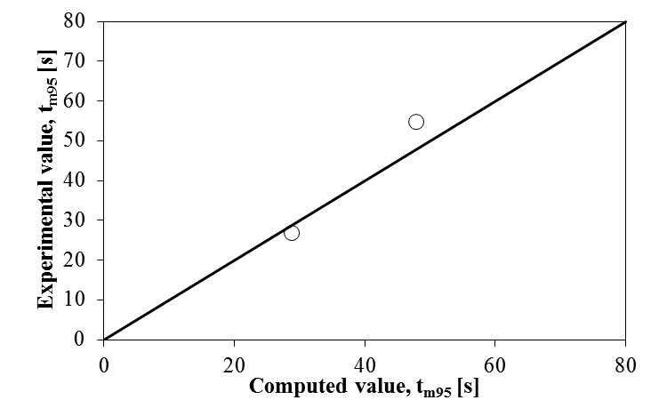

Figure 1: Comparison between the experimental data of Koganti et al. (2010) and the computed values of the mixing time.

The comparison between the experimental values of the dissolution time and the computed results obtained by Eqs(2) and (3) is shown in Figure 2(a). The model constants are adopted without modifications with respect to those provided in the original investigations, therefore the unbaffled configuration effect, if any, is not accounted for.

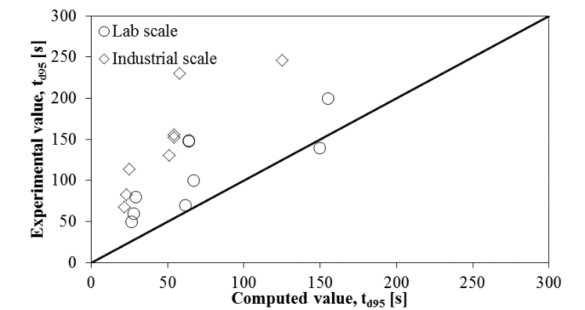

(a)

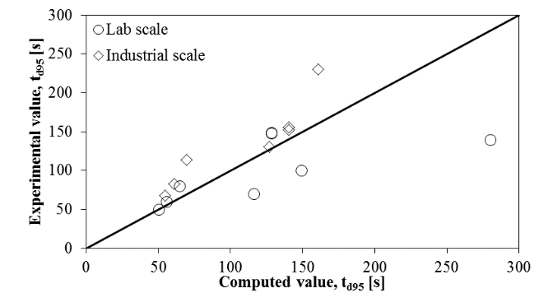

(b)

Figure 2: Comparison between the experimental data of Koganti et al. (2010) and the computed values of the dissolution time. (a) Eq(3), (b) Eq(4).

A significant different agreement is obtained for the two scales. The discrepancies, which are larger for the 4 m3 vessel, might be due to possible air ingestion from the liquid free surface that can take place particularly at industrial scale, considering the position and the Reynolds number of the upper impeller. Additional reasons might be due to the different weight of the liquid mixing time with respect to the dissolution time in the two scales under consideration and to a different characteristic liquid velocity dependency for unbaffled stirred tanks with respect to baffled ones. In particular, combining the results of Nagata (1975) and Ramírez-Gómez et al. (2015), that showed that ratio between liquid flow number and power number is constant, and the results of Scargiali et al. (2013), that reported a dependency of Np on the rotational Reynolds number to the power of -0.3, Eq(3) can be empirically modified in order to account for this specific feature of unbaffled tanks, neglecting the term 2, it becomes:

$Sh=0.166 \left[{{Re}_{p}\left(\frac{ND^{2}ρ}{μ}\right)}^{-0.3}\right] {Ar}^{0.16} {Sc}^{\frac{1}{3}}$ (4)

As can be observed in Figure 2(b), by Eq(4) the scatter between the experimental and the computed data is reduced. In the following, Eq(4) will not be used, since it should be validated more extensively.

The experimental data by Lin et al. (2015) relevant to the dissolution of Dimethyl fumarate particles of 710-1000 m size in Type II dissolution test stations at N=100rpm are analysed and shown in Figure 3. Also in this case, the estimation of the dissolution time is not accurate, but the correlations allow to obtain meaningful data for comparing different conditions and for assessing the relative importance of mixing and dissolution.

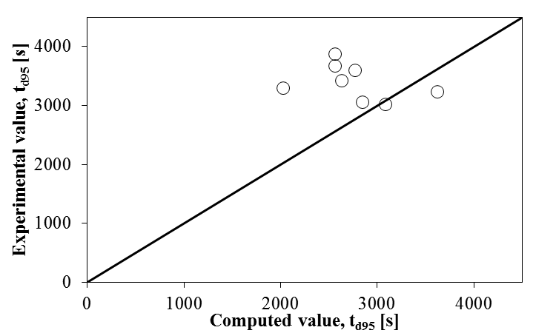

Figure 3: Comparison between the experimental data of Lin et al. (2015) and the computed values of the dissolution time.

Finally, the same correlations are applied to the cases investigated by Cao et al. (2016), who adopted a dissolution testing apparatus PTWS 610 for the dissolution of Na2CO3 particles of a wide size range (50-1400 m) and two different narrower size ranges (355-425 m and 425-600 m) of a multi-ingredients powder, named Pandora. As a difference with the other particles considered so far, that are compact, both the size cuts of the Pandora particles were characterized by a porosity  of 0.41. The experimental dissolution time data are plotted against the computed values in Figure 4. The comparison between the results shown in Figure 4 clearly demonstrates that the equation suggested by Carletti et al. (2018), provides an acceptable estimation of the dissolution time for both the Pandora and the Na2CO3 particles, without introducing any adjustable parameters to take into account for the specific geometry of the dissolution apparatus.

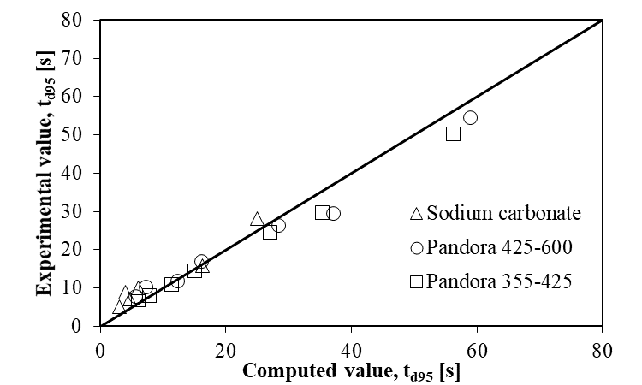

Figure 4 Comparison between experimental data of Cao et al. (2016) and computed values of the dissolution time.

Being the selected correlations able to provide a reasonable estimate of the two characteristic times, although to a different extent depending on the specific case, some considerations can be made on the effect of tank and particle sizes on the dissolution process.

In order to show the usefulness of the a-priori adoption of the correlations considered above, the example of standard geometry tanks stirred by a single Rushton turbine providing equal power, P, per unit mass of the stirred liquid, P/ $ρ_{L}$ V is considered.

In Figure 5, the effect of the particle and tank sizes on the dissolution of NaCl in water is shown and the significant variation with the vessel size is apparent. Indeed, the ratio between the two characteristic times suggests that the boundary between the conditions for which the dissolution is unaffected or influenced by the liquid mixing depends on a combination of the two parameters. It is worth noticing that increasing the tank size, in a dissolution process working with a constant specific power input, the mixing time could be longer with respect to the time required for the solid dissolution. In Figure 6 the effect of the impeller speed and particle size in a vessel of constant size is reported. It is interesting to notice that below a critical value, the particle size does not affect the characteristic time of the process, because the liquid mixing time is longer than the time necessary for dissolving the particles.

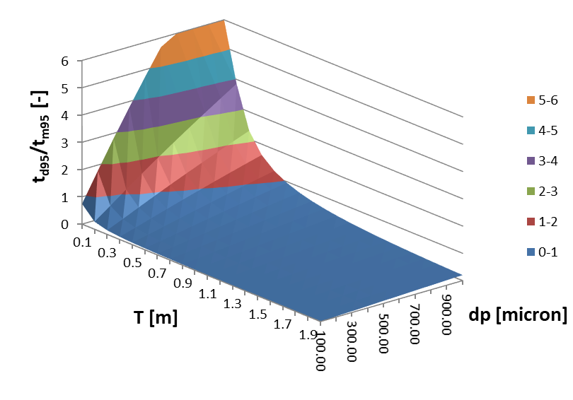

Figure 5. Ratio between the solid dissolution time and the liquid mixing time as a function the particle size and the tank size. P/LV=0.16W/kg.

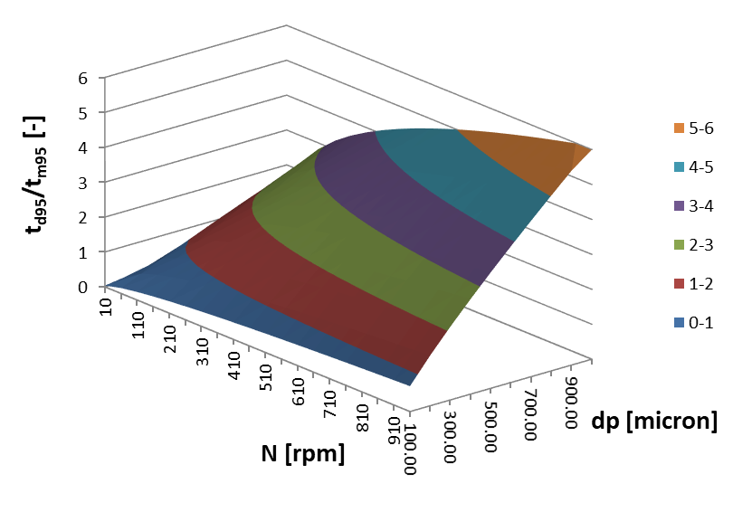

Figure 6. Ratio between the solid dissolution time and the liquid mixing time as a function the particle size and the impeller speed. T=0.48 m.

* 1. Conclusions

In this work, an analysis on the dissolution process for pharmaceutical manufacturing has been carried out based on two different characteristic times, the liquid mixing time, that is the time necessary for reducing the dissolved material inhomogeneity below a critical value, and the dissolution time, that is the time necessary for dissolving the solid particles. The analysis highlights that by available literature correlations the two characteristic times can be estimated with a different level of accuracy, depending on the availability of reliable values of the correlation parameters, which are often not collected for industrial geometry stirred tanks. Based on the available literature data, at least a rough estimation of the liquid mixing time can be obtained by the Grenville and Nienow (2004) correlation, while the dissolution time can be computed following Nienow and Miles (1978) and using the equation suggested by Carletti et al. (2018) for the mass transfer coefficient estimation. The ratio between the above-mentioned characteristic times is not constant, but depends on the particle size and the tank scale. In particular reducing the particle size, at the same power input, the dissolution time is reduced, while the mixing time does not change. This observation has important effects on the industrial processes, because reducing the particle size below a critical value does not influence the characteristic time of the process when it is controlled by the mixing time. Moreover, working at the same specific power input the relative importance of dissolution and mixing time changes with the scale. In particular, increasing the tank size the dissolution time decreases while the mixing time increases. This means that in large tanks the assumption of homogeneous concentration in the liquid phase is not satisfied and for a correct simulation of the process the local concentration of the dissolved salt should be adopted.

References

Aliakbarian B., Casazza A.A., Nani A., Perego P., 2017, Production of chocolate powdered beverage with enhanced instant properties, Chemical Engineering Transactions, 57, 877-882.

Armenante P.M., Luo C., Chou C-C., Fort I., Medek J. 1997, Velocity profiles in a closed, unbaffled vessel: comparison between experimental LDV data and numerical CFD predictions, Chemical Engineering Science, 52, 3483-3492.

Cao H., Amador C., Jia X., Li Y., Ding Y., 2016, A modelling framework for bulk particles dissolving in turbulent regime, Chemical Engineering Research and Design, 114, 108-118.

Carletti C., Bikic S., Montante G., Paglianti A., 2018; Mass transfer in dilute solid−liquid stirred tanks, Industrial and Engineering Chemistry Research, 57, 6505-6515.

Derksen, J.J., 2012, Highly resolved simulations of solids suspension in a small mixing tank, AIChE Journal, 58, 3266-3278.

Fajner D., Pinelli D., Ghadge R.S., Montante G., Paglianti A., Magelli F., 2008, Solids distribution and rising velocity of buoyant solid particles in a vessel stirred with multiple impellers, Chemical Engineering Science, 63, 5876-5882.

Grenville R.K., A.W. Nienow, 2004, Blending of miscible liquids in E.L. Paul, V.A. Atiemo-Obeng, S.M. Kresta (Eds.), Handbook of Industrial Mixing: Science and Practice, Wiley-Interscience, Hoboken, NJ (Chapter 9).

Hörmann T., Suzzi D., Khinast J.G., 2011, Mixing and dissolution processes of pharmaceutical bulk materials in stirred tanks: Experimental and numerical investigations, Industrial and Engineering Chemistry Research 50, 12011-12025.

Koganti V., Carroll F., Ferraina R., Falk R., Waghmare Y., Berry M., Liu Y., Norris K., Leasure R., Gaudio J., 2010, Application of modeling to scale-up dissolution in pharmaceutical manufacturing AAPS PharmSciTech, 11, 1541-1548.

Lin P.Y., Lee H.L., Chen C.W., Lee T., 2015, Effects of baffle configuration and tank size on spherical agglomerates of dimethyl fumarate in a common stirred tank, International Journal of Pharmaceutics 495, 886-894.

Magelli F., Montante G., Pinelli D., Paglianti A., 2013, Mixing time in high aspect ratio vessels stirred with multiple impellers, Chemical Engineering Science, 101, 712-720.

Montante G., Paglianti A., Magelli F., 2012, Analysis of dilute solid-liquid suspensions in turbulent stirred tanks, Chemical Engineering Research and Design, 90, 1448-1456.

Montante G., Carletti C., Paglianti A., 2018, Liquid Homogenization and Solids Dissolution in Stirred Tanks, Proceedings of The 16th European Conference on Mixing – Mixing 16 9-12 September 2018, Toulouse, France, paper 186, pp. 1-4.

Mutch G.A., Hapgood K.P., Shen R., Selomulya C., 2019, An investigation on the dissolution qualities of foam granulated products, Powder Technology, 343, 693-704.

Nagata S. 1975, Mixing Principles and applications John Wiley & Sons Inc.

Nienow A.W., Miles D., 1978, The effect of impeller/tank, configurations on fluid-particle mass transfer, The Chemical Engineering Journal, 15, 13-24.

Paglianti A., Carletti C., Montante G., 2017, Liquid Mixing Time in Dense Solid-Liquid Stirred Tanks, Chemical Engineering and Technology, 40, 862-869.

Ramírez-Gómez R., García-Cortés D., Martínez-de Jesús G., Gonzales-Brambila M.M., Alonso A., Martínez-Delgadillo S.A., Ramírez-Muñoz J., 2015, Performance Evaluation of Two High-Shear Impellers in an Unbaffled Stirred Tank, Chemical Engineering and Technology, 38, 1519-1529.

Scargiali F., Busciglio A., Grisafi F., Tamburini A., Micale G., Brucato A., 2013, Power consumption in uncovered unbaffled stirred tanks: Influence of the viscosity and flow regime, Industrial and Engineering Chemistry Research, 52, 14998-15005.

Tamburini, A., Scargiali, F., Micale, G., Brucato, A., 2017, Particle distribution in unbaffled stirred vessels, Chemical Engineering Transactions, 57, 1315-1320.

Wang B., Armenante P.M., 2016, Experimental and computational determination of the hydrodynamics of mini vessel dissolution testing systems, International Journal of Pharmaceutics, 510, 336-349.