|  |  |
| --- | --- |
| cetlogo***CHEMICAL ENGINEERINGTRANSACTIONS***  ***VOL. 76, 2019*** | A publication of  aidiclogo_grande |
| The Italian Association  of Chemical Engineering  Online at www.aidic.it/cet |
| Guest Editors:Sauro Pierucci,Jiří Jaromír Klemeš, Laura Piazza  Copyright © 2019, AIDIC ServiziS.r.l. **ISBN**978-88-95608-73-0;**ISSN** 2283-9216 | |

Impact of ventilation on indoor air quality: singular behaviour of formaldehyde

Florent Carona,b\*, Romain Guicharda, Laurence Roberta, Marie Verrieleb, Frédéric Thevenetb

aFrench Institute of Research and Safety (INRS), Department of Process Engineering, Rue du Morvan, CS 60027, 54519 Vandoeuvre-lès-Nancy Cedex, France

bIMT Lille Douai, University of Lille, SAGE, 59000 Lille, France

[florent.caron@inrs.fr](mailto:florent.caron@inrs.fr)

Combined with material emission, ventilation has a direct impact on volatile organic compound (VOC) concentrations in indoor environments. In this work, the impact of ventilation on various VOC emission rates relative to wood particleboard is assessed experimentally in a 128 L chamber. Ventilation characteristics have been varied (i) between 2.5 and 5.5 h-1 for the air exchange rate and (ii) between 0 and 1.8 m.s-1 for the air velocity in the vicinity of wood particleboards. Based on the results, the air velocity over the surface of the material is found to have no impact on emission of the eight VOCs monitored. However, our experimental work separate out the reduction of VOC concentration by dilution and the potential emission rate increment when air exchange rate is increased. For most VOC, increasing air exchange rate only induces a concentration reduction by dilution. But, formaldehyde exhibits a singular emission behaviour: the decrease in formaldehyde concentration with increasing air exchange rate is limited compared to other VOCs and the formaldehyde emission rate is observed to increase as a function of the air exchange rate. The input of new air thus appears to promote formaldehyde emission from the solid material. Given these results, IAQ prevention strategies have to take into account the specific behaviour of formaldehyde.

* 1. Introduction

Indoor Air Quality (IAQ) is a growing topic of interest in research given the average time spent in indoor environments and the impacts on human health. Indeed, human beings spend between 80 and 90 % of their lifetime in indoor environments such as the home, the work place or public transportation (Zhang et al., 2012). Moreover, indoor pollutants are known to be responsible for skin irritations, dizziness, and tiredness as well as damage to pulmonary functions (Yoon et al., 2010). Given (i) the various kinds of indoor surfaces, (ii) the numerous indoor sources of pollutants and (iii) the diversity of physical and chemical processes, IAQ is a complex issue. Of the various known indoor pollutants, Volatile Organic Compounds (VOC) have received particular attention as they are ubiquitous in indoor air (Wolkoff & Nielsen, 2001). Indoor concentrations of VOC are simultaneously affected by both the sources of emission and the ventilation. This work focuses on the influence of ventilation on VOC emissions from a typical indoor material.

According to Hult et al. (2015), two characteristics of ventilation play a key role in establishing steady-state concentrations of VOCs in indoor air: (1) the air exchange rate and, (2) the air velocity in the vicinity of a solid material surface. Air exchange usually allows VOC concentrations to be reduced by extraction and dilution of the pollutants (Gennaro et al. 2014), and VOC concentrations will therefore tend to increase if the ventilation does not balance indoor VOC emission sources (Shang et al., 2016). Field measurements carried out by Robert et al. (2018) in sports stores showed a consistent decrease in indoor VOC concentrations with a higher ventilation rate. However, formaldehyde was the only VOC to follow an opposite trend. In addition, from field observations, Hun et al. (2010) evidenced that formaldehyde concentration was not dependent on the air exchange rate. These findings imply that an enhancement of the emission rate offsets the decease of indoor formaldehyde concentration via a dilution effect. Other authors have observed a positive impact of the air exchange rate on emission rates of VOCs such as formaldehyde (Offermann & Hodgson, 2011). Hun et al. (2010) suggest that the air velocity in the vicinity of the surface of emissive material could in some cases promote the emission of VOCs from the solid material. However, no publish studies have explicitly highlighted or clarified the impact of ventilation on VOC emission in laboratory experiments. Some studies have attempted to investigate the impact of air velocity on VOC emission in FLEC (Field and Laboratory Emission Cell) (Wolkoff, 1997) but they were unable to clearly discriminate the respective roles of air exchange and air velocity. The purpose of this study is therefore to evaluate the emission behaviour of VOCs emitted from a particleboard into an experimental chamber under different ventilation conditions and, to assess the respective impacts of the air exchange rate and air velocity on the VOC emission rates.

* 1. Materials and methods
     1. Experimental well-mixed chamber

In this work, all experiments were carried out using a 128 L ventilated experimental chamber of dimensions 0.8x0.4x0.4 m (Figure 1), at a temperature of 21 ± 1 °C and a relative humidity of 50 ± 5 %. Temperature and relative humidity conditions were continuously monitored and controlled using a probe placed inside the chamber. The inlet and the outlet ports of the chamber present circular sections with a diameter of 0.04 m and are located on opposite faces of the chamber (Figure 1). The main axes of the inlet and outlet ports are located 0.055 m from the top and 0.055 from the bottom of the experimental chamber respectively, as reported in Figure 1. The clean air flow introduced into the chamber is controlled by mass flow controllers. Conservation flow between the inlet and the outlet is ensured by a system composed of mass flow controllers and a vacuum pump that maintains a constant outlet flow equal to the inlet flow. The use of mass flow controllers provides a control on the air exchange rate, while a mixing fan is used to regulate the mixing of air inside the experimental chamber, which can be regarded as a well-mixed reactor. The mixing fan is fixed to the ceiling of the chamber and positioned directly in the axis of the inlet flow at a distance of 0.1 m from the inlet port.

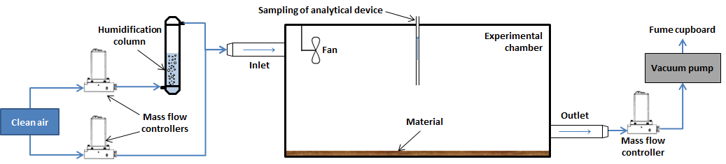

Figure 1: Schematic representation of the experimental bench encompassing a 128 L well-mixed experimental chamber.

* + 1. Selected material

This paper focuses on a wood particleboard with a waterproof coating. The wood panel of 0.795x0.395 m with a thickness of 0.015 m is placed inside the experimental chamber with only one face of the panel exposed. Before experiments, wood particleboards being the same origin are stored in plastic foil.

* + 1. Analytical device

Volatile Organic Compounds emitted from the wood particleboard are monitored using an online Selected Ion Flow Tube - Mass Spectrometer (SIFT-MS). An air flow rate of 25 mL/min is continuously sampled by the analytical device from the center of the homogeneous air volume within experimental chamber. For measurement, the volume sampled is negligible compared to the air volume of the chamber. However, this analytical device only allows the monitoring of specific ions that have been defined in the analytical method prior to the experiment. Therefore, air samples have been collected from chamber onto sorbent cartridges to screen the diversity of C6-C16 VOCs and carbonyl compounds emitted by the selected material. Chromatographic analyses allow addressing the main VOCs emitted from the wood particleboard that are: acetone, acetaldehyde, formaldehyde, propanal, butanal, pentanal, hexanal, pinene, limonene, carene, camphene and phellandrene. Since the principle of mass spectrometry is to separate compounds according to their mass, the mass resolution of the SIFT-MS device does not allow the discrimination of the different terpenes emitted from the wood panel. In the following section, terpene is used to designate the sum of emitted terpenoid VOCs.

* + 1. Measurement of air velocities

First, to provide an assessment of the air velocities in the vicinity of the surface of the selected material, air velocity magnitude measurements are carried out following fifteen locations homogeneously dispatched on the horizontal plane at 5 mm above the surface of the material. Measurements are performed using a hot wire anemometer under different conditions of air exchange rate and fan speed.

* + 1. Experimental protocols

Before loading the experimental chamber with wood particleboard, the volume of chamber is renewed with clean air and blank measurements are performed to determine the background concentration of VOCs. The monitoring of VOC concentration by SIFT-MS begins as soon as the material is placed inside the experimental chamber. The experimental chamber is then left until the equilibrium of VOCs between the gas phase and the material surface is reached. The tests are carried out in a random order and the first test is repeated. In the following of the paper, the steady state concentration corresponds to the average concentration measured over 20 minutes when equilibrium between the gas phase and the material surface has been reached for 1 hour. Thus, the emission rate is calculated from the steady state concentration, the air exchange rate and the loading factor.

The first series of tests assess the impact of the air velocity on the steady state concentration of the eight VOC monitored. The air exchange rate of 4.5 h-1 is fixed and the average of air velocity in the vicinity of the material surface is varied as follows: 0; 0.5; 1.0; 1.4 and 1.8 m.s-1. Then, the second series of tests assess the impact of the air exchange rate on the emission of the eight VOC monitored. An average air velocity in the vicinity of the material surface of 0.5 m.s-1 is imposed while the air exchange rate is varied: 2.5; 3.5; 4.5 and 5.5 h-1.

* 1. Results and discussion
     1. Air velocities distribution

Air velocity measurements have been undertaken over the surface of material. The gathered results allow making a map describing air velocity profiles in the vicinity of the surface of material for any fan speeds and air exchange rates. The Figure 2 represents a map of the surface of the material showing the measured air velocities as a function of the location in the experimental chamber for three different air exchange rates at a constant fan speed inducing heavy air mixing.

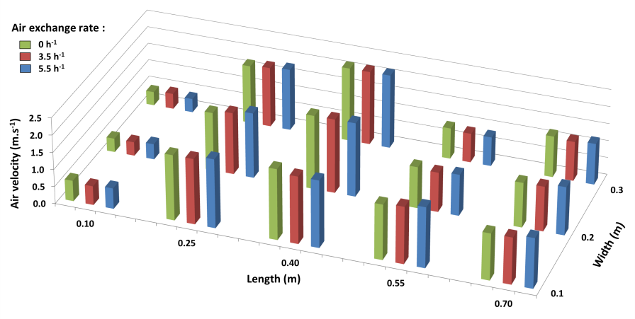

Figure 2: Measured air velocity (m.s-1) as a function of length (m) and width (m) of the surface of material plate for air exchange rate of 0; 3.5 and 5.5 h-1 at a constant fan speed. Inlet and outlet are both located at a width of 0.2 m and respectively at a length of 0 m and 0.8 m.

From the air velocity profiles, the same airflow pattern has been observed over the surface of material whatever the air exchange rate. No impact of air exchange rate has been observed on the air velocity over the surface of material (Figure 2). Therefore, the mixing fan speed controls the air velocity in the vicinity of the particleboard. The main benefit of the experimental bench is that the air exchange rate and the air velocity in the vicinity of the surface of the material can be controlled independently of each other. Finally, the average air velocity in the vicinity of the material surface has been determined under different fan speed conditions.

* + 1. Impact of the air velocity on the VOC emission

These consecutive tests are carried out without changing the particleboard. But, since particleboard is a finite source of VOCs, a natural depletion has been observed throughout the series of tests. In order to avoid biased results, a correction has been applied to the data according to the method proposed by Harb et al. (2018). The VOC depletion of particleboard is considered as constant during the series of tests. The Figure 3 represents the steady state concentration of the eight VOCs monitored as a function of the measured average air velocity magnitude in the vicinity of the surface of material at a constant air exchange rate of 4.5 h-1.

 

Figure 3: Steady state concentrations (ppb) of the eight main VOCs emitted from a particleboard as a function of the air velocity in the vicinity of the material surface (m.s-1) at a constant air exchange rate. Uncertainties correspond to the standard deviation calculated from the measurements of steady state concentration.

These results demonstrate that the air velocity over the material surface does not have a significant impact on the steady state concentrations of VOCs (Figure 3). The emission rate of the eight VOCs emitted by the wood particleboard therefore remains constant regardless of the air velocity in the vicinity of the material surface. Thus, the VOC emission is regarded as being controlled by diffusion within the particleboard since increased air velocity over the material surface may have an impact on the VOC emission rate for VOC emission controlled by mass transfer in the boundary layer (Knudsen et al., 1999). The impact of the air velocity on the VOC emission mainly depends on the combination of the VOC properties and the type of the emissive material.

* + 1. Impact of the air exchange rate on the VOC emission

The impact of the air exchange rate on the VOC emission is represented in Figure 4 encompassing two histograms depicting the steady state concentration of VOCs as a function of air exchange rate.

 

Figure 4: Steady state concentration (ppb) of the eight main VOCs emitted from a particleboard as a function of the air exchange rate (h-1) at a constant air velocity. Uncertainties correspond to the standard deviation calculated from the measurements of steady state concentration and the variability in the use of different panels.

Unlike the previous series of tests, correction of data with regard to the VOC depletion of particleboard is not possible because of an inconstant depletion rate generated by the variation in the air exchange rate. In this way, one wood particleboard is used per experimental test. The VOC depletion of particleboard is negligible over the duration of a single test. However, there is a need to evaluate the material variability that is performed by testing three different material plates under identical experimental conditions. From the same batch of wood panels, the variability in the use of different panels is lower than 8 % except for terpenes with 21.3 %.

As shown in Figure 4, it exists a significant impact of the air exchange rate on the steady state concentration of VOCs. The VOC concentrations are reduced by percentage comprised between 42 and 58 % as the air exchange rate increases from 2.5 to 5.5 h-1. This finding was expected given the results from the literature showing the impact of the air exchange rate on the VOC concentration. In contrast, the formaldehyde concentration is less impacted (42 %) by the air exchange rate than other VOCs. The singular emission behaviour of formaldehyde is presented in section 3.3. Figure 5 represents the VOC emission rate as a function of the air exchange rate for the eight monitored VOCs.

** **

Figure 5: Emission rates (µg.m-2.h-1) of the eight main VOCs emitted from a particleboard as a function of air exchange rate (h-1). Uncertainties correspond to the standard deviation calculated from the measurements of steady state concentration and the variability in the use of different panels.

According to the Figure 5, the emission rate of seven VOC is not significantly impacted by the air exchange rate while the emission rate of formaldehyde increases by 25 % as the air exchange rate increases from 2.5 to 5.5 h-1. These results highlight that formaldehyde has a singular emission behaviour compared to other VOCs emitted from the same solid material. In addition, it appears that formaldehyde emission could be controlled by mechanisms different from other VOCs. The VOC emission from a solid material is controlled by a combination of diffusion within the material and mass transfer across the boundary layer in different proportions (Wolkoff, 1997). The specific case of formaldehyde emission is discussed in the following section.

* + 1. Singular behaviour of formaldehyde

The Figure 6 represents the influence of air exchange rate on formaldehyde steady state concentrations and formaldehyde emission rates.

 

Figure 6: Formaldehyde concentration (ppb) and formaldehyde emission rate (µg.m-².h-1) as a function of the air exchange rate (h-1). Uncertainties correspond to the standard deviation calculated from the measurements of steady state concentration and the variability in the use of different panels.

As discussed earlier, the formaldehyde concentration is reduced in a lower extent than other VOCs when the air exchange rate increases. Moreover, the emission rate of formaldehyde increases by 25 % as the air exchange rate increases from 2.5 to 5.5 h-1 (Figure 6). The formaldehyde concentration and emission rate are linked to the air exchange rate by a linear relationship. The fresh air input would promote the formaldehyde emission from the solid material. The increase of formaldehyde emission could be induced by a larger concentration gradient across the boundary layer between surface of material and ambient air (Offermann & Hodgson, 2011).

* 1. Conclusions

The air velocity over the surface of a material is usually dependent on the air exchange rate (Wolkoff, 1997). The experimental bench presented in this study allows us adjust air exchange rate and air velocity independently of each other while maintaining the same airflow organization in the vicinity of the surface of the material. The assessment of the impact of air velocity on VOC emissions shows that the air velocity has no significant effect on steady state VOC concentrations. Moreover, the influence of the air exchange rate on the emission rate highlights the singular behaviour of formaldehyde. The formaldehyde emission rate is positively correlated to the air exchange rate. These results provide a new insight on the mechanisms governing VOC emissions. Finally, the enhancement of formaldehyde emission rate as a function of the air exchange rate leads to be careful and to take into account the singular behaviour of formaldehyde when establishing IAQ prevention strategies based on the ventilation.

References

Gennaro G., Gennaro L., Mazzone A., Forcelli F., Tutino M., 2014, Indoor air quality in hair salons: screening of volatile organic compounds and indicators based on health risk assessment, Atmospheric Environment, 83, 119-126.

Harb P., Locoge N., thevenet F., 2018, Emissions and treatment of VOCs emitted from wood-based construction materials: Impact on indoor air quality, Chemical Engineering Journal, 354, 641-652.

Hoffermann J.F., & Hodgson A. T, 2011, Emission rates of volatile organic compounds in new homes, Proceeding Indoor Air 2011, 12th International Conference on Indoor Air Quality and Climate, 5-10 of June 2011 in Austin, USA.

Hult E.L., Willem H., Price P.N., Hotchi T., Russel M.L., Singer B.C., 2015, Formaldehyde and acetaldehyde exposure mitigation in US residences: in-home measurements of ventilation control and source control, Indoor Air, 25, 523-535.

Hun D.E., Corsi R.L., Morandi M.T., Siegel J.A., 2010, Formaldehyde in residences: long-term indoor concentration and influencing factors, Indoor Air, 20, 196-203.

Knudsen H.N., Kjaer U.D., Nielsen P.A., Wolkoff P., 1999, Sensory and chemical characterization of VOC emissions from building products: impact of concentration and air velocity, Atmospheric Environment, 33, 1217-1230.

Robert L., Guichard R., Kingler J., Mandin C., Cochet C., 2018, Impact of ventilation on IAQ in a sports store, Poster presented in International Congress Roomvent & Ventilation 2018, 2-5 of June 2018 in Espoo, Finland.

Shang Y., Li B., Baldwin A.N., Ding Y., Yu W., 2016, Investigation of indoor air quality in shopping malls during summer in western China using subjective survey and field measurement, Building and Environment, 108, 1-11.

Wolkoff P., 1997, Impact of air velocity, temperature, humidity and air on long-term VOC emissions from building products, Atmospheric Environment, 32, 2659-2668.

Wolkoff P., & Nielsen G.D., 2001, Organic compounds in indoor air-their relevance for perceived indoor air quality?, Atmospheric Environment, 35, 4407-4417.

Yoon H.I., Hong Y.-C., Cho S.-H., Kim H., Kim Y.H., Sohn J.R., Kwon M., Park S.-H., Cho M.-H., Cheong H.-K., 2010, Exposure to volatile organic compounds and loss of pulmonary function in the elderly, European Respiratory Journal, 36, 1270-1276.

Zhang Y., Deng Q., Qiand H., Mo J., 2012, Research advance report of indoor environment and health in China, Fist Edition of China Architecture and Building Press, Beijing, China.