 CHEMICAL ENGINEERING TRANSACTIONS  VOL. 76, 2019 | A publication of  
The Italian Association
of Chemical Engineering
Online at www.cetjournal.it
Guest Editors: Sauro Pierucci, Jiří Jaromír Klemeš, Laura Piazza
Copyright © 2019, AIDIC Servizi S.r.l.
ISBN 978-88-95608-73-0; ISSN 2283-9216

Study of Production Performance and Safety Analysis of Ammonia Fertilizer Process Using Aspen Plus
M. Tanvir Sowgath^{a,}*, I. M. Mujtaba ^{b}
ªDepartment of Chemical Engineering, Bangladesh University of Engineering and Technology (BUET), Dhaka, 1000, Bangladesh
^{b}Department of Chemical Engineering, Faculty of Engineering & Informatics, University of Bradford, West Yorkshire BD7 1DP, UK
Email: mstanvir@che.buet.ac.bd
Natural gas (NG) based chemical fertilizers such as urea, ammonia help increasing the overall food productions of Bangladesh. In general, NG consumption has increased in different industries over the years thus affecting the availability of it. In addition, the quality of NG has changed over the decades in Bangladesh. To better understand the impact of these changes on the ammonia plant, the performance via ammonia process modelling and simulation is considered here. The process model is developed based on the Ashugonj Fertilizer & Chemical Company Ltd (AFCCL) plant process data of Bangladesh. The preliminary safety study is also carried out for this process using Aspen Plus. The preliminary result shows that due to lower carbon content and lower heating value of the current NG, NG consumption has increased in Primary Reformer (PRF), Secondary Reformer (SRF) and different fuel systems to maintain the 3:1 ratio of hydrogen to ammonia in the ammonia synthesis section.

Keywords: Production Performance, Simulation; Ammonia Process; Aspen Plus, Fertiliser, Fire Load.
  - Introduction
Chemical fertiliser has been a significant part in the increase of national food production of agro-based Bangladesh. The consumption of chemical fertiliser in Bangladesh steadily increased since 1951 (Jahangir, 2000) in-line with the increase in population and food demand. However, Bangladesh had been experiencing from chronic food deficiencies due to the unplanned plant shutdown (political and other reasons) of fertiliser industries. A satisfactory and timely supply of fertiliser is essential to sustain the food production at the expected level.
NG is the main fuel for electricity and industrial production in Bangladesh. NG composition is not maintained by the NG supplier due to various reasons among them depletion of country’s NG reserve. Heat content of NG changes with NG composition and other parameters (Sowgath, 2011) which affects the quality of NG affecting the amount of NG required in a process. Lack of NG supply and lack of fuel quality also leads to unexpected shutdown of the production and more even some industries operate only several months for a year (Safi, 2017). Quader (2003 and 2009) shows that NG consumption per ton of urea fertiliser production increases due to the decrease in NG fuel quality. AFCCL is one of the largest NG based Urea Fertilizer Plant in Bangladesh (BCIC, 2016). It has a total installed capacity of 306900 MT Ammonia /Year and 528000 MT Urea /Year. Kibria, (2003) shows that NG consumption increased over the years compared to the design value supplied by the AFCCL plant general contractor Foster Wheeler Limited (FWL) UK back in 1981 due to NG quality and expiration of equipment lifespan old.
Incidents in Urea Fertilizer Factory Limited (UFFL), Bangladesh in 1974 and 1991 affected control room occupants that led to increased number of fatalities along with property damage (Rahman et al., 2014). All failures have certain consequences and impacts on the adjacent area of UFFL. Plant operation at acceptable safety levels is critically important for process industries and surrounding localities. Due to the above incidents, several safety related studies (Razia, 2016) were carried out by the Chemical Engineering Department, BUET with collaboration with the chemical industries, Industrial Safety Board, The Institution of Engineers, Bangladesh and Bangladesh National Authority of CWC, Armed Force Division Bangladesh.
In such situations, current change in ammonia plant performance needs to be understood to achieve efficient and safer plant operation. Simultaneous process design and safety assessment eliminate process hazards in early stage of the process operation and reducing the necessity form controlling it (Suardin, 2007). Rahman et al., (2014) shows that optimum facility layout reduces toxic release hazard and increased the profitability by studying ammonia process design and safety assessment simultaneously. Process simulator such as Aspen Plus played an active role in improving the chemical process operation (Sofia et al., 2013) and process safety (Janošovský, 2017) in recent days. Aspen Plus Safety tool capture any updates from the simulation automatically to assess design and safety within Aspen Plus environment simultaneously. Safety Analysis tools in Aspen Plus 8.8 or above version provides methodologies to quantify the required venting capacity to protect a vessel against overpressure due to the fire contingency (Aspen Plus, 2016).
In this work, a process model for the ammonia section of the AFCCL plant is developed within Aspen Plus to study the plant performance and safety scenario.
  - Ammonia Fertilizer section of AFCCL Plant
The ammonia plant model consists of several unit operations such as desulphurization, reforming, CO conversion, CO₂ removal taken from (Aspen, 2006) and different plant parameters and operating data is used to study the process. Various assumptions and minor modifications (Such as NH₃ converter is considered separately from NH₃ synthesis loop and so on) are made to simplify the process. RKS-BM model physical property package is chosen and in simulation environment different unit model is used to develop the model Aspen Plus. The AFCCL flowsheet within Aspen plus is shown in Figure 1. After simulation environment, safety environment entered study different Fire safety. The pressure relief device used to control different hazard due to overpressure. Pressure build-up and temperature increase in the vessel cause rupture and subsequently, escalates the situation critical. The Required Relieving Flow is the maximum allowable flow rate at relieving conditions that needs to be relieved to prevent the equipment failure. Pressure safety valve (PSV) acts as a safety barrier to prevent Boiling Liquid Expanding Vapor Explosion and maintain required relieving flow. Several physical phenomena are essential to predict equipment failure and design PSV. In Aspen plus safety environment, different PSV valves are connected in the outlet of the stream of that unit to study different load due to overpressure. Also temperature and pressure are defined in the equipment tab to study different fire scenario.
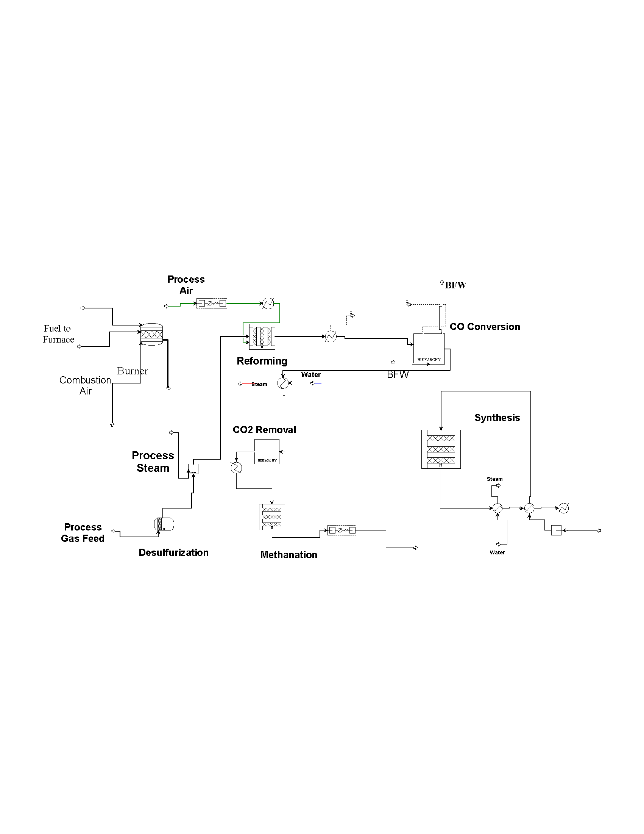
Figure 1: AFCCL ammonia process plant within Aspen Plus
    - Process description
Raw materials for the AFCL ammonia plant are natural gas, process air and H₂O. NG from Titas and Hobgonj is passed through a knockout drum, filtration unit pre-heater and divides into two steams- fuel and process NG. The process gas is heated using Superheated Medium Pressure Steam to attain 390 ºC. To remove this Sulphur the process gas is passed through the Desulphurization reactor (DGR) which contains three catalyst beds. The temperature of the DGR outlet is 380 ºC. It is then mixed with 39.2 bar 495 ºC process steam in the ratio of 1: 3.8, which is the inlet stream of the PRF. PRF contains mainly unreacted CH₄, H₂, CO₂, CO, unreacted steam and other hydrocarbons. Eq (1) and Eq (2) reactions take place in the PRF.
(1)
(2)
In the Secondary Reformer (SRF), process air is added to obtain the N₂ for the NH₃ synthesis reaction. The Eq(3), Eq(4) and Eq(5) reactions in the SRF are assumed to be carried out in three reactors in series. Process air is added to the combustion zone. Process gas form the PRF enters the SRF. SRF adjusts the amount of the H₂ and N₂. The temperature of the outlet gas stream from the SRF is 939⁰C and it contains 3% CH₄ and the rest amount of CO, CO₂, H₂, N₂, H₂O, etc.
; | (3)
 | (4)
 | (5)
After reforming section, the reformed gas passes through the gas cooler to conversion section. At first CO is converted to CO₂ in the High Temperature Shift (HTS) and Low Temperature Shift (LTS) section. The HTS reactions at 350ºC and 32 bar are Eq.(6) and Eq.(7):
(6)
(7)
The LTS reactions are Eq.(8) and Eq.(9):
(8)
(9)
After conversion of CO to CO₂, CO₂ is absorbed by Benfield solution. CO₂ is regenerated in Desorber where it is supplied to urea plant.
Benfield Solution absorber Section reaction is shown in Eq.(10).
(10)
Regeneration section is shown in Eq.(11).
(11)
Remaining CO, CO₂ in the process gas is fed to the methanator to convert them into CH₄ and shown in Eq.(12) and Eq.(13).
(12)
(13)
After methanator, scrubbed syn gas is fed to the ammonia synthesis reactor (known as Haber-Bosch process). Ammonia is synthesized at high pressure and low temperatures from Nitrogen and Hydrogen according to Le Chatelier principle. This is shown in Eq. (14)

(14)

  - Result and Discussion
    - Model validation and performance study
Table 1 shows the NG composition during the design basis (during commissioning) and operating data presented by Kibria, (2003). The raw material composition and product specification from real plant (design basis) are very close to simulation result (Table 3). After validating the model at the designed condition, feed specification is changed to the present NG composition (Table 2). The plant was originally designed based on NG composition which is different than the current NG composition. The different yield of different section is presented in Table 2.
    - Safety study
Rahman (2014) identified PRF, SRF, HTS and ammonia reactor as the major critical process units of overpressure and toxic release. In this paper, the operating temperature and pressure are the relieving temperature and pressure for fire load calculation. An overall decrease in fire load also indicates lowered calorific value and the amount of combustible. Table 6 shows the required relieving flow through the safety devices to prevent fire in the vessel for operating temperature and pressure.
Table 1: Natural Gas Composition (Kibria, 2003).
NG Composition | CH₄ | C₂H₆ | C₃H₈ | C₄H₁₀ | N₂ | Total Carbon | Carbon Content Percent
Design Case | 97.20% | 1.8% | 0.5% | 0.2% | 0.3% | 103.1 | 38.59%
Present Case | 98.13% | 1.4% | 0.01% |  | 0.43% | 100.9 | 37.92%

Table 2: Operating data of reforming units of AFCL and comparison of the actual outlet composition with the Aspen Plus calculated composition
Parameter | Plant Data  (Design Case) | Simulation Results  (Design Case) | Simulation Results  (Present Case)
DGR inlet temperature | 390ºC | 390ºC | 390ºC
DGR outlet temperature/ PRF inlet temperature | 380ºC | 370ºC | 370ºC
PRF inlet temperature | 380ºC | 380ºC | 380ºC
PRF outlet temperature/ SRF inlet temperature | 809ºC | 810ºC | 811
SRF outlet temperature | 939ºC | 957ºC | 962
SRF CH₄ gas composition | 0.3% | 0.8438% | 0.748%
SRF CO gas composition | 13% | 12.94% | 12.84%
HTS inlet temperature | 350ºC | 350ºC | 350ºC
HTS outlet temperature | 416ºC | 423ºC | 423ºC
HTS CO gas composition | 3% | 2.99% | 2.91%
LTS inlet temperature | 207ºC | 207ºC | 207ºC
LTS outlet temperature | 225ºC | 225ºC | 225ºC
LTS CO gas composition | 0.3% | 0.29% | 0.279%
Methanator inlet temperature | 320ºC | 320ºC | 320ºC
Methanator outlet temperature | 351ºC | 351ºC | 351ºC
Methanator composition |  | 0%CO and 0%CO₂, 0.96% CH₄ | 0%CO and 0%CO_{2,} 0.0.88% CH₄
Inlet gas H₂/N₂ ratio ammonia converter |  | 2.78 | 2.74
Ammonia recycled from separator (Assumed) |  | 16.24% | 16.24%
Ammonia converter inlet temperature | 313.7ºC | 313.7ºC | 313.7ºC
Ammonia converter outlet temperature | 370ºC | 370ºC | 370ºC
Ammonia converter NH₃ composition |  | 40.34% NH3 | 40.53%

Table 4: Comparisons of different plant production scenarios due to different NG composition
Composition | ZFCL |  | CUFL |  | PUFF |  | NGFF
 | PRF inlet | SRF outlet | PRF inlet | SRF outlet | PRF inlet | SRF outlet | PRF inlet | SRF outlet
CH₄ | 98.24% | 0.3 | 90.64 | 0.25 | 99.5 | 0.3 | 95 | 0.7
C₂H₆ | 1.44 | 0 | 3.26 | 0 | 0 | 0 | 3.1 | 0
C₃H₈ | 0.01 | 0 | 0.77 | 0 | 0 | 0 | 0.7 | 0
C₄H₁₀ | 0 | 0 | 0.57 | 0 | 0 | 0 | 0.2 | 0
CO | 0 | 12.08 | 0 | 12.83 | 0 | 11.4 | 0 | 7
CO₂ | 0.01 | 8.04 | 0.48 | 7.75 | 0.21 | 9.08 | 0.6 | 12
H₂ | 0 | 56.89 | 2.88 | 56.39 | 0 | 57 | 0 | 59.7
N₂ | 0.3 | 22.42 | 1.88 | 22.5 | 0 | 21.93 | 0.4 | 20.6
Ar | 0.01 | 0.27 | 0.01 | 0.28 | 0.28 | 0.28 | 0 | 0
H₂/N₂ Ratio |  | 2.54 |  | 2.51 |  | 2.60 |  | 2.90

Table 5: Study of Ammonia Converter for Input Temperature 180 ºC and ammonia inlet composition 4.5E-02
H₂/N₂ Ratio | 2.9 |  | 2.7 |  | 2.6 |  | 2.54
Reactor | Model (°C) | Model (y_{NH3}) | Model (°C) | Model (y_{NH3}) | Model (°C) | Model (y_{NH3}) | Model (°C) | Model (y_{NH3})
1st Converter In | 180.00 | 4.50E-02 | 180.00 | 4.50E-02 | 180.00 | 4.50E-02 | 180.00 | 4.50E-02
1st Bed In | 466.65 | 4.50E-02 | 466.65 | 4.50E-02 | 466.65 | 4.50E-02 | 466.65 | 4.50E-02
1st Bed Out | 524.44 | 1.00E-01 | 526.01 | 1.01E-01 | 526.77 | 1.01E-01 | 527.10 | 1.01E-01
1st Bed Δ | 57.79 | 5.51E-02 | 59.36 | 5.55E-02 | 60.12 | 5.57E-02 | 60.45 | 5.58E-02
3rd Bed Out | 454.73 | 1.62E-01 | 455.94 | 1.63E-01 | 456.51 | 1.63E-01 | 456.75 | 1.63E-01

Table 6: Process units fire load for different case
Process Unit | Scenario | Relieving Temperature  (ºC) | Relieving Pressure  (barG) | Required Relieving Flow  (kg/hr)
Primary reformer | Design Case | 810.2 | 37.84 | 1.062x10⁵
 | Present Case | 811.1 | 37.84 | 1.058 x10⁵
Secondary reformer | Design Case | 956.6 | 36.65 | 1.747 x10⁵
 | Present Case | 962.5 | 36.65 | 1.743 x10⁵
Ammonia Converter | Design Case | 370 | 377.1 | 6.663 x10⁴
 | Present Case | 370 | 377.1 | 6.631 x10⁴

Table 7: Process units Fire load for different case
Process Unit | Scenario | Relieving Temperature  (ºC) | Relieving Pressure  (barG) | Maximum Wall Temperature  (ºC) | Fire Load/ Relieving Flow  (kg/hr) | Exposed  Area  (m²)
Primary reformer | Design Case | 1031 | 37.84 | 1100 | 63.87 | 19.44
 | Present Case | 1032 | 37.84 | 1100 | 62.50 | 19.44
Secondary reformer | Design Case | 1206 | 36.65 | 1250 | 33.39 | 19.44
 | Present Case | 1214 | 36.65 | 1250 | 26.61 | 19.44
Ammonia Converter | Design Case | 504.6 | 377.1 | 593.3 | 493.8 | 19.44
 | Present Case | 504.6 | 377.1 | 593.3 | 495.4 | 19.44
Table 7 shows the unwetted API 521 fire load. PSVs and rupture discs maintain a relatively constant pressure and avoid a rupture in the pressure vessel. According to API Standard 521, ﬁre exposure is aﬀecting the unwetted part of the pressure vessel the convective heat transfer of the gas is not suﬃciently large enough to transfer the heat of the ﬁre away from the vessel wall. Blowdown valve will lower the pressure of the vessel below the operating conditions unwetted part of the pressure vessel. In the equipment, design parameters need to change for protection against fire. Insulation, vessel wall thickness, and other design parameters need to be addressed.
  - Conclusions
A process model for the ammonia section of the AFCCL plant is developed and validated using Aspen plus to study the plant performance under conditions different from the original design conditions. Process safety becomes major concern due to extreme high (low) temperatures and pressures operation in NH₃ Plant. Simultaneous assessment of design and safety is carried out within Aspen Plus environment for real process data. Despite those limitations on model development, several contributions can be highlighted below:
- A systematic comparison of an ammonia plant performance due to feed composition change within Aspen Plus is studied.
- Four critical units are considered for fire load calculation. From fire load safety study, relieving flow is decreased due to current NG composition has lower calorific values.
- From fire load point of view, reformer has higher fire load. Very little change in NG composition may create hazards. Outlet temperature in PRF and SRF are found to increase.
- Methane and CO composition after SRF decreases.
- H₂/N₂ ratio is decreased due to change in NG composition
- The model can be used for steady state simulation as well as different safety scenario.
In a conclusion, the results from this investigation show that significant change in NG composition change will have significant effect of the overall performance. Replacement of the different tube bundle of burner, heat exchanger and change catalyst in the sysnthesis converter will necessary for the optimal NG consumption as well as overall performance and safer operation.
References
Ahmed S.S., 2017, Fuel Options for Bangladesh-2017, Journal of Chemical Engineering, IEB, 30 (1), 27-31.
ASPEN, 2016, Aspen Plus V8.8 User Guide, < https://www.aspentech.com > accessed 24.07.2017.
BCIC, 2016, Ashugonj Fertilizer & Chemical Company Ltd., BCIC
< http://dfms.bcic.gov.bd/index.php/production-report > accessed 23.11.2003.
Jahngir S.M., 2000, A Study of The Influence of Pressure, Temperature, Steam/Natural Gas Ratio on Reforming Process for Ammonia Production, M.Sc. Thesis, Bangladesh University of Engineering and Technology (BUET), Dhaka, Bangladesh.
Kibria G., 2003, Optimization of Natural Gas Consumption in Zia Fertilizer Company Limited, Ashugonj Fertilizer & Chemical Company Ltd (AFCCL) Report, Ashugonj, Brahmanbaria. Bangladesh.
Quader A.K.M.A., 2009, Strategy for developing fertilizer sector in Bangladesh for sustainable agriculture, Chemical Engineering Research Bulletin, 13(2), 39-46.
Quader A.K.M.A., 2003, Natural gas and the fertilizer industry, Energy for Sustainable Development, 7(2), 40-48.
Rahman S. M. T., Salim M. T., Syeda S.R., 2014, Facility Layout Optimization of an Ammonia Plant Based on Risk and Economic Analysis, Procedia Engineering, 90, 760-765.
Razia, S.S., 2016, Lessons Learned in Chemical Safety: Bangladesh Perspective, <http://eesri.org/wp-content/uploads/2016/04/Lessons-Learned-in-Chemical-Safety-Bangladesh-Perspective.pdf> accessed 02/04/2019
Suardin, J., Sam Mannan M., El-Halwagi M., 2007, The integration of Dow's fire and explosion index (F&EI) into process design and optimization to achieve inherently safer design, Journal of Loss Prevention in the Process Industries, 20 (1), 79-90.
Sofia D., Giuliano A., Barletta D., 2013, Techno-Economic Assessment of Co-gasification of Coal-Petcoke and Biomass in IGCC Power Plants, Chemical Engineering Transactions, 32, 1231-1236.
Sowgath M.T., Hossain Z.M., Kawsher S., 2011, Maximising the Heat Content of Sales Gas at Kailashtilla Gas Processing Plant, Chemical Engineering Transactions, 24, 313-318.

