 CHEMICAL ENGINEERING TRANSACTIONS  VOL. 76, 2019 | A publication of  
The Italian Association
of Chemical Engineering
Online at www.cetjournal.it
Guest Editors: Sauro Pierucci, Jiří Jaromír Klemeš, Laura Piazza
Copyright © 2019, AIDIC Servizi S.r.l.
ISBN 978-88-95608-73-0; ISSN 2283-9216

Development and in-vitro evaluation of the extended release valsartan from sericin and alginate beads
Emanuelle D. Freitas, Renata B. da Silva, Sara R. Deldotti, Gabrielly A. Marzola, Meuris G. C. da Silva, Melissa G. A. Vieira*
School of Chemical Engineering, University of Campinas, UNICAMP, 13083-825, Campinas – SP, Brazil
melissagav@feq.unicamp.br
Valsartan, a type 1 selective receptor for angiotensin, is primarily used in the treatment of hypertension and, in a minority, to treat coronary artery disease and heart failure. Among its adverse effects, it can be mentioned malaise, dizziness and headache. Furthermore, in the conventional form of release, it may cause patient non-compliance with treatment and need for multiple dosages, which lead to the possibility of reduction in therapeutic efficiency. To avoid these disadvantages, the present work aimed at the production of valsartan particles for delayed and extended release of the drug. The composition of the particles was based on the polymer blend of sericin and alginate. Sericin, present in the cocoons of the Bombyx mori silkworm, is a water soluble globular protein discharged into effluent from the silk industry. Its chemical structure allows it to be used for the formation of blends with other polymers, aiming at the improvement of its properties. Alginate, which was commercially obtained, is a polysaccharide obtained from brown algae, widely used in pharmaceutical applications. In order to evaluate the incorporation of valsartan into the aforementioned polymer blend, formulations with alginate only and formulations with different amounts of alginate initially added were developed. The evaluation was accomplished by means of incorporation efficiency and in vitro dissolution tests in simulated gastrointestinal environment. Sericin was shown to increase both the drug incorporation efficiency and the release time in enteric media. The best result was obtained for the formulation composed of the sericin and alginate blend, with the lowest amount of alginate. An 82.75 ± 2.61 % incorporation efficiency and extended release (about 28 hours) was achieved.
  - Introduction
The most common forms of drug release include the conventional form, or also called immediate release. Immediate release of a drug can lead to disadvantages of rapid absorption of the drug, accompanied by possible side effects. As a consequence, the desired therapeutic effect may not be achieved, as well as the patient's commitment to treatment. An alternative is the so-called modified drug release, in which it is possible to obtain a better control of drug release in the body (Ding, 2016).
Valsartan, a drug belonging to the angiotensin II type 1 receptor antagonist family, is widely used in the treatment of hypertension. This drug works by reducing blood pressure and contraction of vascular smooth muscle, stimulating vasodilatation and allowing protection against vascular dysfunction. As main side effects, stand out malaise, dizziness, headache, migraine and fatigue. In addition, it deserves attention because it is part of the antihypertensive drugs, which are usually used for a long period by most patients. Such characteristics make it a promising active ingredient for application in modified drug release (Siddiqui et al., 2011).
To obtain the modified release dosage form, one of the alternatives is the use of polymer matrices, which have shown excellent delivery properties (Freiberg and Zhu, 2004). One type of polymeric blend, which has been studied for pharmaceutical application, involves sericin and sodium alginate. The use of the blends, replacing the individual polymers, aims to improve its properties and extend its application (Silva et al., 2017).
Sericin is a natural protein fiber present in the cocoons of the silkworm Bombyx mori, composing 20 – 30 % of the cocoons. Although it has been widely discarded in silk industry waste in recent decades, it has more recently been investigated for its excellent properties such as UV resistance, antioxidant, antibacterial and biodegradability (Rangi and Jajpura, 2015). Alginate is a polysaccharide present in the cell wall of brown algae, composed of subunits of guluronic acid and manuronic acid. In the presence of divalent ions, it presents the ability to form gels, which allows the production of beads for pharmaceutical application. In addition, it presents interesting properties for this field, such as bioadhesion, biocompatibility and immunogenicity (Tønnesen and Karlsen, 2002).
The sericin and alginate blend has been investigated for the incorporation of different drugs, such as diclofenac sodium (Vidart et al., 2018), ketoprofen (Freitas et al., 2018a) and ibuprofen (Freitas et al., 2018b). All of the above drugs are part of the group of non-steroidal anti-inflammatory drugs. In the present study, a new class of drugs is evaluated with the antihypertensive valsartan. This is because previous studies have shown that not all drugs are favorable to incorporation into the aforementioned blend (Vidart et al., 2017).
Thus, the main objective of this work was to evaluate the incorporation of valsartan into the sericin and alginate blend. For this, formulations were produced only with alginate and with the blend, varying the proportion of the components. Such formulations were evaluated through incorporation efficiency and release into acidic and enteric media.
  - Experimental section
    - Materials
Sericin used in the assays was experimentally obtained from cocoons of the Bombyx mori silkworm. The cocoons were kindly provided by the Bratac Silk Mills Company (Londrina - PR, Brazil). Sodium alginate was commercially obtained from Sigma-Aldrich (St. Louis - MO, USA). The active pharmaceutical ingredient, valsartan, was purchased from Purifarma (São Paulo - SP, Brazil). The reagents used in the experimental tests were of analytical grade, as calcium chloride from AnidrolTM (Diadema - SP, Brazil) and hydrochloric acid and tribasic sodium phosphate from DinâmicaTM (Diadema - SP, Brazil). For the preparation of solutions, ultrapure water was used (Reverse Osmosis, Gehaka, Brazil).
    - Sericin extraction
In order to extract sericin, the methodology reported by Silva et al. (2016) was followed. For this, the cocoons were cleaned and cut, with the aid of tweezers and scissors, in pieces of about 1 cm². The small pieces of cocoons were washed in tap water and rinsed with ultrapure water to remove any impurity, and dried in an oven at 45 °C. In order to perform the extraction in water, a high temperature and pressure method was used. Autoclave (AV-18, Phoenix, Brazil) at 120 °C, 1 kgf/cm² for 40 min was used in the proportion of 40 g of dry cocoons for each liter of water.
The extracted sericin was separated from the fibroin by filtration and kept in a closed container for 24 h at room temperature to stabilize the protein granules. In order to concentrate sericin, cryo-concentration of the solution was also performed following the methodology of freezing/thawing at room temperature (Silva et al., 2014). After this step, the sericin solution was filtered and the higher molar mass granules were separated and heated (120 ° C, 1kgf / cm²) to resolubilize. The concentration of this solution was adjusted to 25 g/L (2.5 % w/V).
    - Drug incorporation and Particles production
To prepare the polymer blend, the 2.5 % (w/V) sericin solution was heated (120 °C, 1 kgf/cm²) for 10 min and kept under stirring in Ultraturrax (T18, IKA, USA) at 4000 rpm until reaching the temperature of 55 °C. At that time, the alginate was added in different proportions, as shown in Table 1, and the solution was stirred at 4000 rpm until complete homogenization. After this, the drug was added and stirred until homogenization, initially at 4000 rpm and, at the end, at 8000 rpm (Vidart et al., 2016). In parallel, formulation with alginate and drug in water was produced in order to verify the effect of sericin. All formulations followed the amounts shown in Table 1.
Table 1: Composition of the valsartan formulations, in % (w/V).
Formulation | Sericin | Alginate | Valsartan
V1 | 2.5 | 1.0 | 2.0
V2 | 2.5 | 2.8 | 2.0
V3 | - | 2.8 | 2.0

The drug concentration was set at 2.0 % (w/V) according to the result obtained by Vidart et al. (2018), as well as the alginate concentration of 2.8 % (w/V), which presented the best results obtained by those authors. The variation of the amount of alginate in formulation V1 aimed to evaluate the effect of this parameter, with the value of 1 % (w/V) of alginate.
The particle production followed the drip method followed by ionic gelling, based on the gelling property of the alginate in the presence of divalent ions. For this, solutions were dripped in 3 % (w/V) CaCl₂ solution using a peristaltic pump (77201-60, Cole-Parmer, Masterflex L/S, USA) and under constant magnetic stirring (TE-0851, Tecnal, Brazil). After dripping, the particles were taken to shake in jar test (JT-203, Milan, Brazil) and held at 100 rpm for 30 min. At the end, the particles were washed with deionized water and dried at room temperature.
    - Incorporation efficiency and Drug Loading
The incorporation efficiency and drug loading were determined by the same experimental procedure. 100 mg of particles were added to 500 ml of buffer solution (pH 6.8) and kept in suspension for 24 h. The suspension was then sonicated (LS-9.5DA, LimpSonic, Brazil) and subsequently filtered on a qualitative filter. The concentration of valsartan was determined by UV-vis spectrophotometer at the wavelength corresponding to the drug (248 nm). The incorporation efficiency and drug loading were determined by Eq (1) and Eq (2) (Akram and Kabir, 2016).
$$Incorporation efficiency= \frac{Actual concentration of drug }{Theoretical concentration of drug} . 100$$ | (1)
$$Drug Loading= \frac{Mass of drug in particles}{Mass of particles} . 100$$ | (1)
Where $Actual concentration of drug$ was experimentally determined and $Theoretical concentration of drug$ was determined based on the amount of drug initially added to the formulation.
    - In-vitro dissolution study
Dissolution assays of the obtained formulations were performed in simulated acid and enteric media using USP dissolution apparatus I (UDT-814-6, Logan, USA) at 50 rpm and 37 ± 0.5 °C. A quantity of particles equivalent to 160 mg of drug was added to the baskets and kept in contact for 2 h with 900 mL of acidic solution (0.1 M HCl) and subsequently maintained in contact with 900 mL of phosphate buffer solution (pH 6.8). At the enteric stage, aliquots were withdrawn at predetermined times, with replacement of the fresh medium. The concentration of valsartan was determined by UV-vis spectrophotometer at 248 nm.
  - Results and Discussion
    - Incorporation efficiency
The incorporation efficiency establishes the actual amount of material incorporated in relation to the material quantity initially added to the formulation (Piacentini, 2016). The incorporation efficiencies of valsartan formulations are shown in Figure 1.
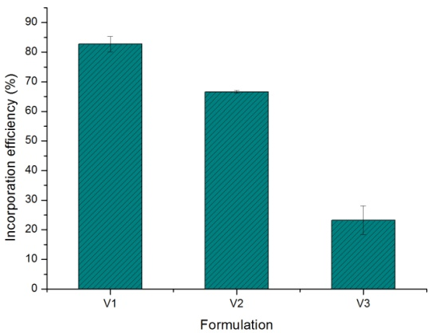
Figure 1: Incorporation efficiencies of the valsartan formulations.
It can be seen from Figure 1 that the lowest incorporation was obtained for the alginate-only formulation, V3 (23.21 ± 4.85 %), indicating the importance of adding sericin to the formulations. Sericin prevents the greatest loss of raw material during process of particle production, which may be related to its crosslinking with alginate. The structure of sericin, composed mainly of strong lateral polar groups, such as hydroxyls, carboxylates and amino groups, makes possible its strong ionic crosslinking to the alginate, inhibiting the exit of the drug during the production of the particles. In the case of alginate-only formulations the same strong cross-linking is not observed (Zhang, 2002).
Comparing the formulations V1 and V2, composed of the blend of sericin and alginate, with different amounts of alginate, it is observed that the lower amounts of alginate provided the greatest incorporation efficiency (82.75 ± 2.61 %). The analysis here is similar to that of the V3 particle. Again, sodium alginate appears to interfere with the incorporation efficiency, allowing for greater loss of drug. Thus, greater amounts of alginate reduce the ionic crosslinking ability of the blend, reducing the amount of incorporated material.
    - Drug loading
Drug loading refers to the amount of drug present in a given mass of particles. This parameter depends directly on the interactions between the drug, the carrier matrix and the surrounding medium. The drug loading results obtained for the V1 - V3 formulations are shown in Figure 2.
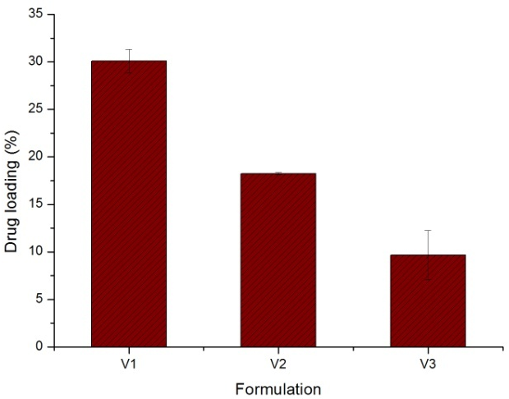
Figure 2: Drug loading obtained for the V1, V2 and V3 formulations.
It can be seen that the same behavior of the incorporation efficiency was observed for drug loading. The worst result was obtained for the formulation containing only alginate (9.67 ± 2.61 %) and the best drug loading was obtained for the formulation composed of the blend with the lowest amount of alginate (30.09 ± 1.21 %). High drug loading values contribute to achieving a high level of drug per particle and thus the necessary therapeutic effect. Regarding the V1 and V2 formulations, higher drug loading in V1 was expected since this is the one with the highest initial drug fraction.
    - In-vitro dissolution study
The particles obtained for the formulations V1, V2 and V3 were subjected to dissolution tests on simulated gastric and enteric media. In the acidic step, after 2 h, the releases shown in Table 3 were obtained.
Table 3: Release of valsartan in acid medium.
Formulation | Drug release (%)
V1 | 8.32 ± 0.46
V2 | 10.73 ± 0.10
V3 | 8.41 ± 0.33

It can be observed that, with the exception of formulation V2, both V1 and V3 presented gastro resistant characteristics, with release of less than 10% in acid medium (USP XLI, 2018). This feature is necessary to prevent side effects of the drug in the gastric environment, in addition to allowing its release at the site of action.
In the second stage of dissolution, the particles were contacted with buffer solution simulating the enteric medium. Figure 3 shows the dissolution curves obtained.
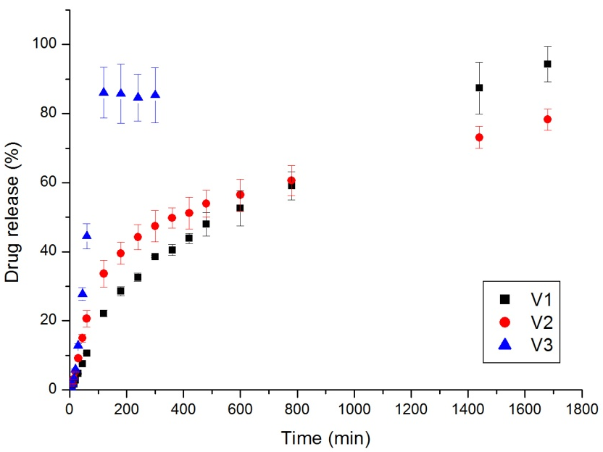
Figure 3: In-vitro dissolution curves obtained for the V1, V2 and V3 formulations.
The V3 formulation, which presented the worst results of incorporation efficiency, was also the one that presented the worst dissolution curve. Its release showed stabilization after only 120 min of assay, reaching the maximum value of about 85 %. This profile is not appropriate because it is closer to that reached by pharmaceutical forms of immediate release.
Subsequently, for the remaining formulations, the assay was performed for a total of 28 h. Both V1 and V2 formulations presented dissolution profiles with prolonged characteristics confirming the contribution of sericin to achieving such profile. As with incorporation efficiency, the strong crosslinking between sericin and alginate has been shown to contribute to improved control of valsartan release. However, in the case of formulation V2, in addition to not presenting gastrointestinal trait, it showed maximum release of about 80 % in 28 h. In the case of formulation V1, 94 % of the release was reached after 28 h, presenting the best dissolution profile. In view of the result for formulation V3, composed only of alginate, the best release for V1, which has the least amount of alginate, was to be expected, demonstrating once again the importance of using sericin.
  - Conclusions
The sericin and alginate blend was evaluated for incorporation of valsartan, through the production of alginate-only particles and particles with the blend, varying the initial amount of alginate. Sericin presented fundamental importance in the incorporation efficiency, drug loading and dissolution profile. Alginate-only particles showed the lowest efficiency and drug loading, besides rapid release. The best results were obtained for the particles formed by the blend and with the lowest amount of alginate. In this case, the main objectives of the work were achieved, obtaining a gastro-resistant formulation and extended drug release, composed of 2.5 % (w/V) sericin, 1.0 % (w/V) alginate and 2.0 % (w/V) valsartan.
Acknowledgments
The authors acknowledge the financial support received from SAE/Unicamp, CNPq (Proc. 301401/2016-0) and FAPESP (Proc. 2015/13505-9 and 2016/05007-1) and the supply of cocoons by BRATAC Company.
References
Akram F., Kabir T., 2016, Characterization of Gliclazide-Loaded Combination of Polymer Microspheres Prepared by Emulsification Solvent Evaporation Method, Scholars Academic Journal of Pharmacy, 5(8), 309 – 316.
Ding H., 2016, Modified-Release Drug Products and Drug Devices, Chapter In: L Shargel, A B C Yu (Eds.), Applied Biopharmaceutics and Pharmacokinetics, 7th ed, McGraw-Hill Education, USA, 567 – 613.
Freiberg S., Zhu X.X., 2004, Polymer microspheres for controlled drug release, International Journal of Pharmaceutics, 282, 1 – 18.
Freitas E.D., Rosa P.C.P., Silva M.G.C., Vieira M.G.A., 2018a, Development of sericin/alginate beads of ketoprofen using experimental design: Formulation and in vitro dissolution evaluation, Powder Technology, 335, 315 – 326.
Freitas E.D., Vidart J.M.M., Silva E.A., Silva M.G.C., Vieira M.G.A., 2018b, Development of mucoadhesive sericin/alginate particles loaded with ibuprofen for sustained drug delivery, Particuology, 41, 65 – 73.
Piacentini E., 2016, Encapsulation Efficiency, Chapter In: E Drioli, L Giorno (Eds.), Encyclopedia of Membranes, Springer, Berlin, Heidelberg, 623 – 759.
Rangi A., Jajpura L., 2015, The Biopolymer Sericin: Extraction and Applications, Journal of Textile Science & Engineering, 5(1), 1 – 5.
Siddiqui N., Husain A., Chaudhry L., Alam M.S., Mitra M., Bhasin P.S., 2011, Pharmacological and Pharmaceutical Profile of Valsartan: A Review, Journal of Applied Pharmaceutical Science, 1(4), 12 – 19.
Silva T.L., Silva Jr A.C., Ribani M., Vieira M.G.A., Gimenes M.L., Silva M.G.C., 2014, Evaluation of Molecular Weight Distribution of Sericin in Solutions Concentrated via Precipitation by Ethanol and Precipitation by Freezing/Thawing, Chemical Engineering Transactions, 38, 103 – 108.
Silva T.L., Silva Jr. A.C., Vieira M.G.A., Gimenes M.L., Silva M.G.C., 2016, Biosorption study of copper and zinc by particles produced from silk sericin – alginate blend: evaluation of blend proportion and thermal cross-linking process in particles production, Journal of Cleaner Production, 137, 1470 – 1478.
Silva T.L., Vidart J.M.M., Silva M.G.C., Gimenes M.L., Vieira M.G.A., 2017, Alginate and Sericin: Environmental and Pharmaceutical Applications, Chapter In: E Shalaby (Ed.), Biological Activities and Application of Marine Polysaccharides, Vol 1, In Tech, 57 – 85.
Tønnesen H.H., Karlsen J., 2002, Alginate in Drug Delivery Systems, Drug Development and Industrial Pharmacy, 28(6), 621 – 630.
USP – United States Pharmacopeia XLI, 2018, The United States Pharmacopeial Convention Incorp.
Vidart J.M.M., Freitas E.D., Nakashima M., Santos R.D.J., Rosa P.C.P., Gimenes M.L., Silva M.G.C., Vieira M.G.A., 2017, Evaluation of Incorporation Efficiency of Drugs in Sericin/Alginate Particles, Chemical Engineering Transactions, 57, 1429 – 1434.
Vidart J.M.M., Silva T.L., Rosa P.C.P., Vieira M.G.A., Silva M.G.C., 2018, Development of sericin/alginate particles by ionic gelation technique for the controlled release of diclofenac sodium, Journal of Applied Polymer Science, 135(12), 45919.
Zhang Y-Q., 2002, Applications of natural silk protein sericin in biomaterials, Biotechnology Advances, 20, 91 – 100.

