Label-free Impedimetric Immunosensors for sensitive detection of Aflatoxin B1 in food
Francesca Malvanoª, Donatella Albanese*ª, Roberto Pilloton^{b}
ªDepartment of Industrial Engineering, University of Salerno, Via Giovanni Paolo II, 132, Fisciano (SA), Italy;
^{b}Insititute of Crystallography of the National Council of Research (CNR), 00015 Monterotondo Scalo (RM), Italy;
dalbanese@unisa.it

Aflatoxin B1 (AFB1) is one of the mycotoxins highly resistant to food processing that enters the food chain and provide a threat to human health. In this paper, different immobilization techniques of the monoclonal anti-AFB1 on gold electrodes were tested and compared, in order to develop a label-free immunosensor able to detect AFB1 amount imposed by European legislation for adult and infant foods. Different materials, coupled with Electrochemical Impedance Spectroscopy as transduction technique, were used to improve immunosensors analytical parameters, such as linear range, sensitivity and limit of detection. Through the use of ferrocene molecules, the immunosensor showed linearity in the range 0.01-10 ng/mL and the lowest limit of detection (0.01 ng/mL), allowing the possibility to use it in a wide range of food products, including infant foods.

- Introduction
Aflatoxins are a group of mycotoxins produced by Aspergillus flavus and Aspergillus parasiticus, which can be found in a large variety of food and animal feed. Among them, Aflatoxin B1 (AFB1) is the most abundant and has been classified as a carcinogenic substance of group 1 by the International Agency for Research on Cancer (IARC) (Amida et al., 2004; Mollea et al., 2015). In the European Union, the acceptable limits established by Commission Regulation (EC) N° 1881/2006 for AFB1 in various foodstuff are ranged from 8 μg/kg for groundnuts to 0.1 μg/kg for dietary foods intended specifically for infants. Several methods for the detection of AFB1 have been established including thin-layer chromatography (TLC), high-performance liquid chromatography (HPLC) and enzyme-linked immunosorbent assay (ELISA) (Adanyi et al., 2007). Although sensitive and accurate, most of these methods require expensive equipment and extended clean-up steps. Among immunoassay techniques, which are faster and cheaper, electrochemical biosensors may be a good alternative due to their fast, simple and low-cost detection capabilities for biological binding events and their possibility to the application in situ. In particular, affinity biosensors coupled with the Electrochemical Impedance Spectroscopy (EIS) as a label – free transduction technique, represent an optimum choice for food analysis performed quickly and in real time, by studying the change in electrical properties of the electrode surface, directly linked to the immuno-interaction between the antibody and its antigen (Bacher et al., 2012; Owino et al., 2007).
This study focuses on the comparison among different immobilization techniques of the monoclonal anti-AFB1 on gold electrodes, in order to develop a label-free impedimetric immunosensor able to detect AFB1 amount imposed by European legislation for adult and infant food products. Finally, in order to highlight the AFB1 detection capability of the best developed immunosensors, food matrices were analysed and the results were compared with those obtained with specific ELISA kit for AFB1 detection.

- Experimental Section
2.1 Reagents
Cysteamine (95%), Glutaraldehyde solution (C₅H₈O₂, 50 wt% in H₂0), Ferrocene carboxylic acid (>97%), 4-mercaptobenzoic acid (MBA, 99%), 2-(N-morpholino) ethanesulfonic acid (MES >99.5% purity), N-Hydroxysucciminide (NHS, 99%), N-(3- Dimethylaminopropyl)-N′-ethylcarbodiimide hydrochloride (EDC, >99%), Sulfuric acid (H2SO4, 99.9% ), Ethanolamine (NH2CH2CH2OH, >99.5%), Potassium hexacyanoferrate (III) (K₃Fe(CN)₆, >99% ), Ethanol (>99.8%) were purchased from Sigma-Aldrich (Milano, Italy). Potassium ferrocyanide (K₄Fe(CN)₆) was obtained from Carlo Erba reagent (Milano, Italy). Anti-Aflatoxin B1 antibody (anti-AFB1) (1 µg/mL) was purchased from Microtech and Aflatoxin B1 were obtained from LKT Laboratories (Saint Paul, USA), while Protein A/G (5 mg/mL, 59.7 kDa, >98%) was obtained from BioVision Inc. (San Francisco, USA). NaH₂PO₄, Na₂HPO₄ and KCl used in the preparation of phosphate buffered saline (PBS: 0.1 M KCl, pH 7.4) were received from Sigma Aldrich (Milano, Italy).

  - Apparatus
The electrochemical measurements were carried out with a computer – controlled Autolab PGSTAT 204 Potentiostat (Metrohm), equipped with an Impedance module (FRA32M); the experimental data were analysed with Nova software (Metrohm). Gold thin-film single-electrodes, based on a three-electrode layout (working/auxiliary/reference) and a working electrode of 1 mm, were purchased from Micrux Technologies (Oviedo, Spain).

  - Immunosensor manufacturing
Before antibody immobilization, gold electrodes were cleaned by an electrochemical treatment (6 min) at 1.7 V vs. Ag/AgCl as reference electrode in 0.05 M sulfuric acid (Sannini et al., 2015). Different immobilization designs were adopted for the immunosensors developed:
- Anti-AFB1 on electrochemical deposited cysteamine layer (Au-Cys- anti-AFB1);
- Anti-AFB1 on cysteamine and ferrocene layer (Au-Cys-Ferrocene- anti-AFB1);
- Oriented anti-AFB1 on MBA self-assembled monolayer (Au-MBA-Protein A/G- anti-AFB1);
- Not oriented anti-AFB1 on self-assembled monolayer (Au-MBA- anti-AFB1);

For the deposition of cysteamine (designs a – b), the procedure described by Malvano et al. (2017b) was carried out. Briefly, cysteamine water solution was dropped on the electrode surface and a constant potential of 1.2 V was applied for 20 min; after the electrode was thoroughly rinsed with water, to remove physically adsorbed cysteamine. For the first immobilization (design a), glutaraldehyde solution (5%) (v/v) was dropped on cysteamine-modified electrode for 1 h. After that, the modified electrode was covered with two concentrations (1 μg/mL – 2 μg/mL) of anti-AFB1 solution for 30 min at room temperature. Finally, the unreacted sites were blocked with 1 M ethanolamine. For the second design of immobilization (design b), ferrocene carboxylic acid solution was added to the cysteamine – modified electrode, according to Malvano et al. (2018). After that, cysteamine 20 mM was re-dropped overnight on the electrode surface. The link between cysteamine and anti-AFB1 was carried out through glutaraldehyde solution (5%) (v/v); finally, ethanolamine was used to block unreactive sites. For both immobilization procedures, at the end of each step, the electrode was rinsed with PBS. The immobilization of anti-AFB1 in an oriented (design c) and not-oriented (design d) procedure was carried out according to Malvano et al. (2016a). A constant potential of 1.2 V for 20 min was applied to the gold electrode dropped with 30 mM MBA ethanol solution; then the electrode was dipped in a solution EDC and NHS in 100 mM MES buffer (pH 7.4) for 2 h. In the oriented immobilization design (c), Protein A/G was dropped on the modified electrode and left to react for 1 h. In the not oriented immobilization (d), the antibody was added after the activation of carboxylic groups with EDC/NHS. Then, the electrode was rinsed in PBS to remove unbound antibodies and finally the unreacted active sites were blocked with ethanolamine solution.

  - Experimental Measurements
EIS was used to characterize each step of the electrode modification and the immuno-interaction. For the electrochemical impedance studies, a sinusoidal alternating current (AC) potential (10mV) in the frequency range from 0.1 to 10⁵ Hz was superimposed to 0.00 V direct current (DC) potential (on working electrode vs. reference electrode); the measurements were performed in a solution of 1 mM ferri/ferrocyanide redox couple (K₃Fe(CN)₆/K₄Fe(CN)₆, 1:1) in PB, as background electrolyte, at room temperature. The impedance data were plotted in the form of Nyquist plots, where the complex impedance is displayed as the sum of real (Z^{I}) and imaginary components (Z^{II}), and in the form of Bode diagram, where the total impedance of the system (Z) is plotted versus frequency. Experimental spectra were fitted with a proper equivalent circuit using the facilities of FRA32M (Nova Software). Cyclic voltammetry measurements (CV) were also used to monitor the layer by layer construction of the immunosensors design: they were performed from -0.6 to 0.6 V vs. reference electrode with a scan rate of 0.05 V/s; the redox couple used for the CV was the same as that used for impedance measurements. For AFB1 measurements, 300 μL of solution at different concentrations were dropped onto the electrode working area and incubated for 30 min.
  - Preparation of food sample
The preparation of powdered milk for infant and beer samples was according to the procedure described in ELISA kit for Aflatoxin B1 detection (Elabscience Biotechnology, Houston, Texas, USA). As powdered milk, two grams of crushed homogenate were added in 10 mL of 70% methanol solution, oscillated for 5 min and centrifuged at 4000 rpm/min for 10 min at room temperature. 0.5 mL of supernatant were added to 0.5 mL of deionized water and mixed fully. Beer samples were firstly stirred thoroughly to remove CO₂; then 2 mL of sample were added to 1 mL of deionized water. 7 mL of methanol solution were added to the sample and oscillated for 5 min. 0.5 mL of mixed sample liquid were added to 0.5 mL of deionized water and mixed fully.
Before the extraction procedure, milk and beer samples were spiked with known concentrations of AFB1 in order to obtain 0.1 ppb, 0.3 ppb, 0.5 ppb, 1 ppb, 2 ppb. For the detection, 50 μL of each sample were analysed by immunosensor and ELISA kit and the results were compared.
- Results and Discussions
3.1 Immunosensor development and optimization of experimental conditions
Because the performance of an immunosensor depends on the immunoreaction between the antigen and the antibody, the optimization of the amount of anti-AFB1, that affect the capability of the antibody to detect the target in the range of interest, is a crucial step in the immunosensor construction. Thus, two different amounts of monoclonal anti-AFB1 (1μg/mL, 2 μg/mL) were immobilized on the cysteamine – modified gold electrode. The surface modification of the Au electrodes for the preparation of AFB1 immunosensors was monitored using EIS (figure 1a) and CV (figure 1b).

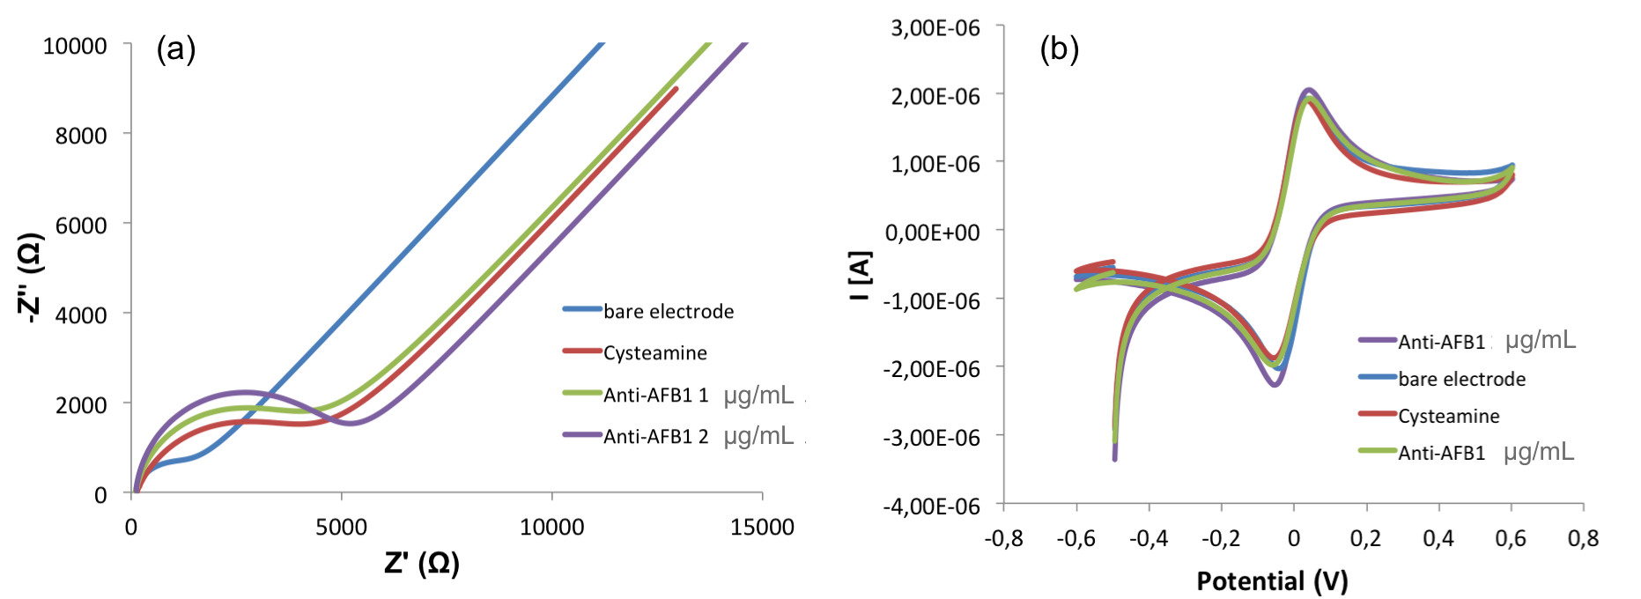
Figure 1: (a) Cyclic voltammograms in 1mM K₃Fe(CN)₆/K₄Fe(CN)₆ and (b) EIS responses after each step of immunosensors construction with different amount of Anti-AFB1.
As result of the immobilization on the electrode surface of cysteamine and the addition of anti-AFB1, the diffusion of the redox probe close to the electrode surface was reduced, causing a significant decrease of the anodic and cathodic peaks, due to the reversible interconversion of K₃Fe(CN)₆/K₄Fe(CN)₆ (Malvano et al., 2017a). In according to voltammetric responses, Nyquist plots showed an increase of impedance at each step of immunosensors construction, due to the blocking layer coating on electrode surface, which became thicker with the assembly procedure. In particular, impedance increases with the increasing of anti-AFB1 concentration pointing out the immobilization of the higher number of antibodies on the electrode surface. With the aim to verify the formation of immunocomplex, increasing concentrations of Aflatoxin B1were put in contact with the developed immunosensors. For both anti-AFB1 amounts, the increasing of AFB1 concentrations causes an increase of the semicircle diameters of Nyquist plots (figure 2), which correspond to the charge transfer resistance R_{ct} of the Randle’s Circuit used for data fitting.
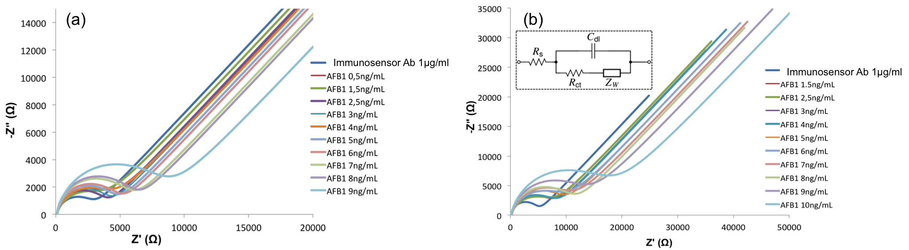Figure 2: Nyquist plots of immunosensors after interaction with different AFB1 concentrations: (a) Anti-AFB1:1 μg/mL; (b) Anti-AFB1:2 μg/ml. The inset corresponds to the equivalent circuit used to fit impedance spectra.

The R_{ct} parameter was used to evaluate the analytical performances of the two immunosensors; in particular, ΔR_{ct}% was plotted versus the concentration of AFB1 in order to calibrate the developed immunosensors. ΔR_{ct}% values were calculated by the following equation:
$∆R_{ct}\%=\frac{R_{ct\left(AFB1\right)}-R_{ct\left(anti-AFB1\right)}}{R_{ct\left(anti-AFB1\right)}}*100$ (1)
where R_{ct(anti-AFB1)} is the value of the electron transfer resistance when anti-AFB1 is immobilized on the electrode surface and R_{ct(AFB1)} is the value after the immunocomplex formation. The calibration curves of immunosensors are shown in figure 3.
Figure 3: Calibration curves of immunosensors developed with Anti-AFB1 1μg/mL and 2μg/mL.

Even if higher amount of anti-AFB1 result in higher signals, the immunosensors with lower anti-AFB1 concentration (1μg/mL) showed a lower limit of detection (LOD) equal to 0.5 ng/mL, than the other one (1.5 ng/mL), calculated as the sum of average blank solution and three times the standard deviation. Hence, 1μg/mL was chosen as the optimal anti-AFB1 concentration for the further improvement of the analytical performance of the immunosensor.

  - Comparison among different immobilization designs
In order to develop an immunosensor able to detect the lowest AFB1, equal to 0.1 μg/kg and imposed by European legislation for infant foods, the immobilization designs (b-d) of monoclonal anti-AFB1 were tested and compared. Also, in this case the construction of the different immunosensors was investigated by EIS showing an increase of the total impedance after the formation of the single layer, which hinder the redox probe on the electrode surface (Malvano et al., 2016b). When the developed immunosensors react with increasing concentration of AFB1, also in these cases an increase of charge transfer resistance was registered from the impedimetric analysis. The results are shown in the figure 4, where the fitting of Nyquist plots data by the Randle circuit highlight an increase in the R_{ct} values which are proportional to the increase of analyte concentration.

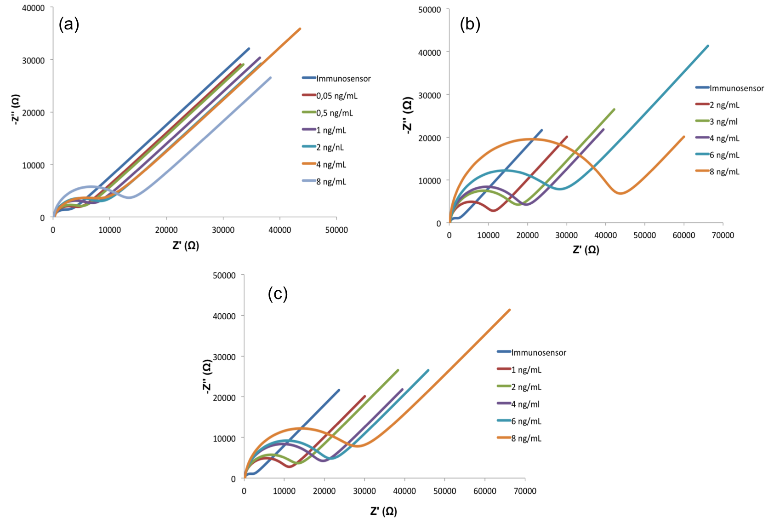
Figure 4: Nyquist plots of immunosensors after interaction with different AFB1 concentrations: Cys+Ferrocene+Cys+anti-AFB1+EtNH2 (a) MBA+anti-AFB1+EtNH2 (b), MBA+ProteinA/G+EtNH2+anti-AFB1 (c)

The analytical parameters reached for the developed immunosensors are summarized in Table 1.

Table 1: Comparison among analytical parameters of developed immunosensors
Schematic Biosensor Assembly | Linear Range  [ng/mL] | LOD  [ng/mL] | Sensitivity  [ΔR_{ct}%/(ng/mL)]
Au-Cys-anti-AFB1 | 0.5-10 | 0.42 | 20.33
Au-Cys-Ferrocene- anti-AFB1 | 0.01-10 | 0.01 | 19.39
Au-MBA-ProteinA/G- anti-AFB1 | 1-6 | 0.82 | 23.66
Au-MBA- anti-AFB1 | 2-9 | 1.84 | 38.78

The results highlighted the highest sensitivity obtained with the anti-AFB1 oriented immobilization but the lowest limit of detection (0.01 ng/mL) measured with the ferrocene layer, that increases the conductivity of the modified electrode surface allowing estimating smaller variations of impedance (Malvano et al., 2018).

  - Analysis of real samples
The immunosensor developed on cysteamine-ferrocene layer, that showed a good sensitivity and the lowest LOD, was used to analyse powered milk for infant and beer samples spiked with known concentrations of AFB1. The amount of AFB1 detected in food samples by immunosensor and ELISA kit was reported in Table 2.

Table 2: AFB1 results in powered milk for infant and beer samples obtained by ELISA kit and immunosensor.
Sample | Spiked concentration  [ppb] | Immunosensor |  | ELISA Kit
 |  | Found concentration  [ppb] | Recovery  [%] | Found concentration  [ppb] | Recovery  [ppb]
Powdered Milk  for infant | 0.10 | 0.11±0.01 | 110.00±4.24 | 0.11±0.01 | 110.00±7.07
 | 0.50 | 0.47±0.05 | 94.00±11.30 | 0.52±0.03 | 104.00±5.66
 | 1.00 | 0.97±0.85 | 97.00±8.49 | 0.92±0.15 | 102.00±1.40
 | 2.00 | 2.03±0.03 | 101.50±1.40 | 1.98±0.63 | 99.00±3.18
Beer | 0.10 | 0.13±0.01 | 130.00±14.10 | 0.12±0.01 | 120.00±7.07
 | 0.50 | 0.52±0.04 | 104.00±8.49 | 0.53±0.01 | 106.00±2.83
 | 1.00 | 1.05±0.07 | 105.00±7.07 | 0.94±0.04 | 98.50±4.24
 | 2.00 | 2.06±0.12 | 103.00±5.66 | 1.96±0.07 | 98.00±4.54

Taking into consideration the dilution factors used for the AFB1 detection in food matrices that can range from 5 to 20, the developed immunosensor shows a detection limit of 0.05 and 0.2 μg/kg respectively, highlighting its potential as a highly capable device for fast Aflatoxin B1 measurement in infant and adult food products.
- Conclusions
Label-free impedimetric immunosensors based on different immobilization techniques of monoclonal anti-AFB1 on gold electrodes have been presented in this work. The comparison among the immobilization procedures analysed underlines the advantages of the oriented one which, allowing a higher number of antibodies, reaches a very high sensitivity; however, the use of ferrocene molecules as electron-transferring mediator improve the electrical properties of the system, resulting in the lowest limit of detection (0.05 ppb) showing the proposed immunosensor as a highly capable analytical device for a fast AFB1 measurement in a wide range of food products, including foods for infant.

References
Adanyi N., Levkovets I.A., Rodriguez-Gil S., Ronald A., Varadi M., Szendro I., 2007. Development of immunosensor based on OWLS technique for determining Aflatoxin B1 and Ochratoxin A, Biosensors and Bioelectronics, 22, 797-802.
Amida N., Micheli M., Palleschi G, 2004. Electrochemical immunosensor for determination of aflatoxin B₁ in barley, Analytica Chimica Acta, 50, 159-164.
Bacher G., Pal S., Kanungo L., Bhand S., 2012. A label-free silver wire based impedimetric immunosensor for detection of aflatoxin M1 in milk, Sensors and Actuators B: Chemical, 168, 223-230.
Kim E., Kim K., Yang H., Kim Y.T., Kwak J., 2003. Enzyme-Amplified Electrochemical Detection of DNA Using Electrocatalysis of Ferrocenyl-Tethered Dendrimer, Analytical Chemistry, 75, 5665-5672.
Malvano F., Pilloton R., Albanese D., 2018. Sensitive detection of Escherichia Coli O157:H7 in food products by impedimetric immunosensors, Sensors, 18, 2168.
Malvano F., Albanese D., Pilloton R., Di Matteo M., Crescitelli, A., 2017a. A new label-free impedimetric affinity sensor based on chiolinesterase for detection of organophosphorus and carbamic pesticides in food sample: Impedimetric versus Amperometric detection, Food Bioprocess Technology, 10, 1834-1843.
Malvano F., Albanese D., Pilloton R., Di Matteo M., 2017b. A new label-free impedimetric aptasensor for gluten detection, Food Control, 79, 200-206.
Malvano F., Albanese D., Crescitelli A., Pilloton R., Esposito E., 2016a. Impedimetric Label-Free Immunosensor on Disposable Modified Screen-Printed Electrodes for Ochratoxin A, Biosensors, 6,33.
Malvano F., Albanese D., Pilloton R., Di Matteo M., 2016b. A highly sensitive impedimetric label free immunosensor for Ochratoxin measurement in cocoa beans, Food Chemistry, 212, 688-694.
Mollea C., Bosco F., 2015. Mycotoxins: Are They Perceived as a Serious Threat for the Human Health?, Chemical Engineering Transactions, 44,133-138.
Owino J.H.O., ignaszak A., Al-Ahmed A., Naker O.G.L., Alemu H., Ngila J.C., Iwuoha E.I., 2007. Modelling of the impedimetric responses of an aflatoxin B1 immunosensor prepared on an electrosynthetic polyaniline platform, Analytical and Bioanalytical Chemistry, 388, 1069-1074.
Sannini A., Albanese D., Malvano F., Crescitelli A., Di Matteo M., 2015. An Amperometric Biosensor for the Determination of Lactic Acid During Malolactic Fermentation, Chemical Engineering Transactions, 44, 283-288.

