CHEMICAL ENGINEERING TRANSACTIONS  VOL. 76, 2019 | A publication of
The Italian Association
of Chemical Engineering
Online at www.cetjournal.it
Guest Editors: Sauro Pierucci, Jiří Jaromír Klemeš, Laura Piazza
Copyright © 2019, AIDIC Servizi S.r.l.
ISBN 978-88-95608-73-0; ISSN 2283-9216

A DEEP LEARNING APPROACH ON INDUSTRIAL PYROLYSIS REACTOR MONITORING
Wenbo Zhuª, Yibin Zhan^{b}, Jose A.Romagnoli^{a,*}
ª Department of Chemical Engineering, Louisiana State University, Baton Rouge, Louisiana, 70803, United States
^{b} Shanghai SupeZET Engineering Technology Corp,.Ltd, 268 Linxin Rd NO.3, Shanghai, 200335, China
jose@lsu.edu
The pyrolysis process monitoring is always challenging due to the high operating temperature inside a fired furnace. To obtain better understanding of the pyrolysis reactors, we proposed a monitoring framework that builds upon thermal photography to provide a detailed view inside the fired furnace. Based on the infrared photos, the convolutional neural network is introduced into the monitoring framework to automatically recognize tube regions from the photos. In this work, a segmentation network is proposed based on the U-Net and ResNet-50 frameworks, by which the precise temperature and shape information on tube regions can be extracted from the raw photos. After extracting the important monitoring measurements, a control limit is drawn by the adaptive k-nearest neighbor method to detect abnormal conditions. The testing result indicates that the proposed monitoring framework provides in-depth information of the reactor and detailed fault diagnosis to process operators.
  - Introduction
In chemical industries, pyrolysis reactors are important components used for producing lower molecular weight hydrocarbons from heavier hydrocarbons in fired furnaces. Olefins, such as ethylene and propylene are primarily manufactured from naphtha cracking process (I. Amghizar, 2017). To ensure the operation of such process is safe and efficient, monitoring the process is of paramount importance, while in practice, monitoring the pyrolysis process is always challenging, due to the high temperature around the cracking area where normal sensors can hardly be implemented. Thus, infrared thermography can be a practical solution to provide in-depth information of the pyrolysis process inside the fired furnace, from which many operational conditions including tube coking, tube deformation and temperature overheating can be simply observed.
To automatically analyze these photos, feature engineering can be a solution to process them in a batch. In terms of feature engineering, it derives non-redundant information from raw data to discover the knowledge of the system. Feature engineering plays a key role in the image-based monitoring system that provides informative feature from high-dimensional image data and draws right decision about the process operation. Typically, there are two major approaches used in feature engineering: model-driven and data-driven. Model-driven approaches build features based on the first principle that uses physical theories to link the observation with the essence, while such approaches generally require experienced researchers to derive mathematical expression and labor-intensive experimental validations. On the other hand, data-driven approaches circumvent above drawbacks using statistics and machine learning algorithms to extract feature directly from raw data. In recent years, a number of works (L. H. Chiang, 2000; W. Li, 2000; W. Zhu, 2018) have been proposed that applied multivariate statistics and machine learning algorithms in process monitoring.
Beyond traditional data-driven methods, the rapid development of deep learning (DL) has brought huge breakthroughs in the feature engineering area. The origin of DL approaches can be traced back to the artificial neural network method in 1980s, while the current DL methods utilize multiple layers of neural network to extract both high-level and low-level features. In the areas of image analysis and natural language processing, DL approaches have achieved best records in many benchmarks and have been widely applied in many daily life applications (A. Esteva, 2017; D. Silver, 2017; K. He, 2015; V. Mnih, 2015).
In this work, DL approaches are introduced into the proposed monitoring framework for temperature and shape monitoring of the pyrolysis tubes inside the furnace. Multiple infrared cameras are installed at different angles inside the fired furnace, from which infrared photos are recorded. To effectively analyze the infrared photos, a pixel-wise tube segmentation network is developed based on combination of the ResNet-50 network and U-Net framework. The proposed segmentation network is able to automatically identify tube regions from the raw photos, by which the precise temperature and shape of the pyrolysis tubes can be precisely monitored. The adaptive k-nearest neighbor (AkNN) (W. Zhu, 2018) method is opted to draw the control limits for abnormal conditions detection.
  - Background
In the recent development of deep learning, the convolutional neural networks (CNN) have brought huge breakthroughs in the image processing area, including classification, detection and segmentation. The origin of the CNN can be traced back to Fukushima’s “neocognitron” approach (K. Fukushima, 1982). In the following years, an error-oriented backpropagation method was introduced to the convolutional networks by Rumelhart et al (D. E. Rumelhart, 1985) and LeCun et al (Y. LeCun, 1989) for characters recognition. While in 1990s, the raise of support vector machine (SVM) suppressed the development neural network approaches. After 20 years of deprecation, the CNN models (Krizhevsky, 2012) beaten the SVM approaches in the 2012 annual ImageNet Large Scale Visual Recognition Challenge (ILSVRC) (J. Deng, 2009). Since that, more powerful CNN models such as VGG (K. Simonyan, 2014) and ResNet (K. He, 2016) have been proposed consecutively, which bed to the boom of the industry-wide artificial intelligence. A number of applications have been developed in recent years, from medical applications (A. Esteva, 2017) to construction inspection (A. Zhang, 2017; K. Gopalakrishnan, 2017).
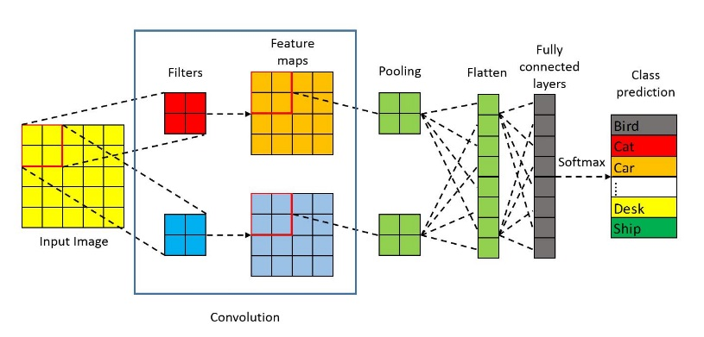
Figure 1: A convolutional neural network prototype
Figure 1 gives a typical CNN model for image classification. In the CNN models, multiple layers of convolution and pooling operations are stacked to learn the features from detailed pixels to the overall content in the image. In terms of the convolution operation, it uses a number of filters sliding over the input data and generating invariant local features. The convolution operation offers a better generalization capacity by taking advantage of local connectivity and weight sharing to reduce the overfitting phenomenon. After the convolution operation, the subsequent operations are nonlinear activation and pooling operation to refine the learned features. By repeating above steps, the processed feature maps are flattened and fed into the softmax function for final classification prediction.
    - ResNet
The residual network (ResNet), proposed by He et al. (K. He, 2016), is one of the most widely used framework in image processing area. In the ResNet, the residual block is developed to replace the plain CNN architecture. In each residual block, a skipping connection is utilized to provide the identity mapping of the input, by which a gradient highway is created to relieve the degradation problem. In terms of degradation in the CNN, it is observed in training a very deep network that the accuracy gets saturated and then degrades rapidly with the increasing of network depth. With the adoption of residual architecture, the ResNet outperforms other plain networks such as VGG network (K. Simonyan, 2014), meanwhile the amount of parameters to be learned in the network is dramatically reduced.
    - Image Segmentation Models
Before the raise of DL approaches, image segmentation methods were mainly based on hand-crafted features combined with simple classifiers (J. Shotton, 2009; Z. Tu, 2010; B. Fulkerson, 2009). Since 2014, DL-based segmentation methods have been proposed using the powerful CNN models. Fully convolutional network (FCN) (J. Long, 2015) is an approach that is able to generate dense class predictions for each pixel on the image. In the FCN approach, a pre-trained VGG network is opted as the feature extractor for image data and the pixel-level predictions are generated by upsampling and concatenating the intermediate feature maps. Coarse predictions from deeper layers in the VGG net are upsampled by bi-linear interpolation and concatenated with fine predictions from lower layers to improve the pixel-level details. As the first work using CNN in sematic segmentation, many follow-up works follow the similar idea that combines the high-level features with the low-level features to generate high quality pixel-level segmentations.
  - Proposed Method
    - Photo Segmentation
Based on the image transmitted from the infrared cameras installed on the furnace, the most important step is to identify and recognize the pyrolysis tube areas from the raw photos. Hence, the first part of the monitoring framework is a tube region segmentation module which can correctly identify tube regions from the bulk background. To effectively train a DL model, in this work, a pre-trained 50-layer ResNet (K. He, 2016) is selected as the base of the segmentation model by considering the accuracy and parameter size of the model. Based on the feature extracted from the ResNet, the segmentation model implementation is simply followed Long’s approach (J. Long, 2015), where the final prediction layers (the fully connected layer and the softmax layer) are substituted with convolutional layers. While in the feature decoding stage, it is noticed that Ronneberger’s U-Net approach (O. Ronneberger, 2015) is a more effective implementation, where extra feature channels are used to allow the model to propagate high resolution context information. A better segmentation results are reported using U-Net, particularly on cases with limited amount of data samples. To ensure the best segmentation performance, trial-and-error method was used to confirm the feature layer selection, where layer conv1, conv2_3 and conv5_3 are finally chosen to provide features for segmentation decoding (see Fig 2). The proposed model is then trained on collected dataset, which is generated from 24 infrared photos by sampling and augmenting these photos.

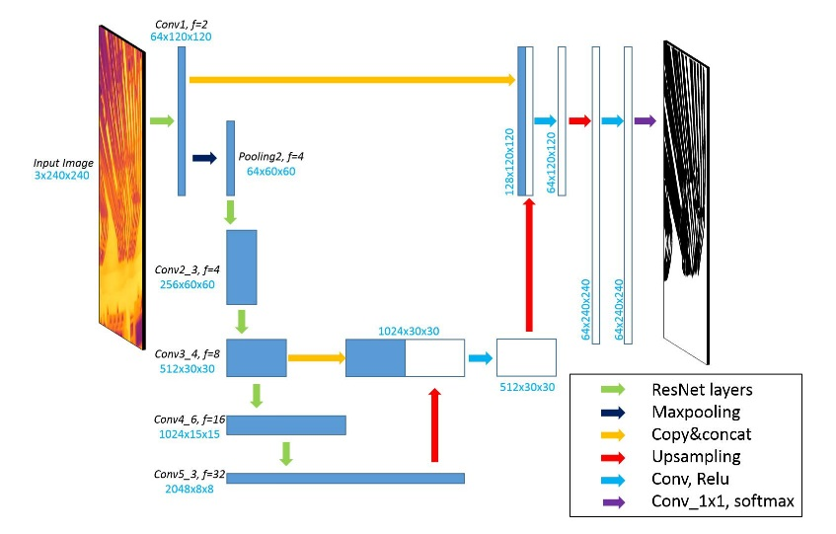
Figure 2: The proposed infrared photo segmentation network
    - Overall Framework
To establish a comprehensive monitoring framework, the starting point of this work is the raw temperature measurement matrix (denoted as $T_{ref}$) from the infrared camera. The RGB-colored infrared photos can be generated from the temperature matrix, from which the proposed image segmentation model can identify the tube regions from the photos. The predicted tube regions are expressed by a binary matrix, $Y_{t}$ at time step t, where 0 represents the background and 1 represents the targeted tube areas.
For the shape monitoring, moving window approach is utilized to continuously store tube region predictions from previous time steps, where the moving window is denoted as ${\overline{Y}}_{mw}$. Thus, the shape changing over time can be simply calculated by the difference between ${\overline{Y}}_{mw}$ and current prediction $Y_{t}$. The sum of the squared error (SSE) can be used to characterize this difference.

$$SSE\left({\overline{Y}}_{mw},Y_{t}\right)=\sum_{i}{\sum_{j}{{\left({\overline{Y}}_{mw}^{ij}-Y_{t}^{ij}\right)}^{2}}}$$ | (1)

Besides the shape monitoring, the surface temperature also be calculated as follows:
$$T_{tube}=T_{ref}⊙{\overline{Y}}_{mw}$$ | (2)
Where $⊙$denotes the component-wise multiplication. To improve the robustness of the model, the moving window prediction, ${\overline{Y}}_{mw}$ is used instead of the current prediction,${ Y}_{t}$, in order to reduce the noise level. After obtaining the tube surface temperature information, two important measurements are monitored in this work, the average temperature and the maximum temperature on the tube surface, which provide different scales of statistical information from the local to the overall conditions.
Based on the calculated temperature and shape changing information from the processed infrared photos, the overall performance can be monitored by multivariate statistic methods. Due to the existence of coking in the pyrolysis tubes, the operation condition can be slowly drifting. Hence, in this work, the adaptive k-nearest neighbor (AkNN) (W. Zhu, 2018) is chosen to draw the thresholds for determination of normal and faulty conditions. Figure 3 illustrates the overall monitoring framework.
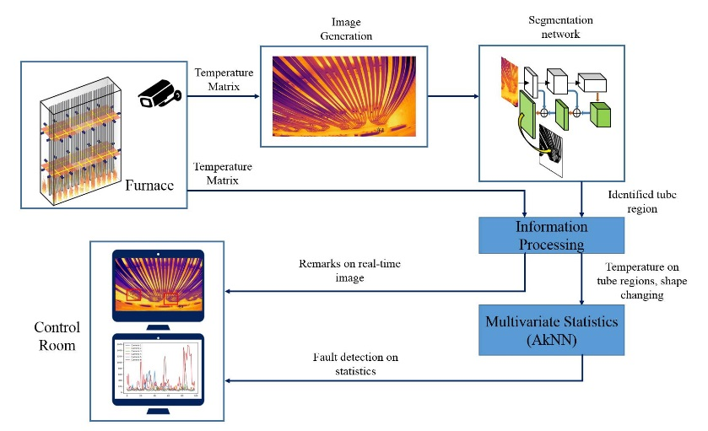
Figure 3: The overall monitoring framework for both shape and temperature monitoring.
  - Results and Discussion
The segmentation model is implemented in Tensorflow (M. Abadi, 2016) in Python 3.6 environment. After training on a single graphics processing unit (GPU), the results of the segmentation network can be visualized in Figure 4, where tube regions can be clearly segmented from the raw infrared photos. The processing time for a set of 6 infrared photos is less than 2 seconds with the assistance of a GPU.
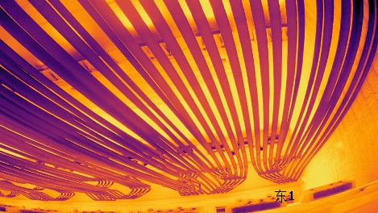  a | 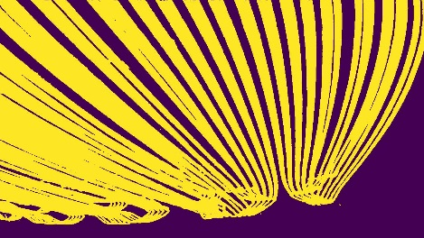  b
Figure 4: A demonstration of the segmentation results. (a) The raw infrared photos. (b) The segmentation results. The tube area is colored in yellow and the background is colored in purple.
Using the trained segmentation network, then the key measurements including the shape changing and temperature information on the tube surface can be extracted (see Figure 5a-c). To automate the abnormal detection process, the AkNN method can be implemented by training it with the first 50 data samples. The determined threshold can then be used to monitor the following 100 samples as testing. The monitoring results are summarized in Figure 5d. From the monitoring results, a huge peak can be noticed at time step 125. The abnormal condition detected at this time step was validated with plant engineer that the root cause of this condition is the improper flame control sending the flame too high and wrapping around the tube. Therefore, through the brief testing of our framework, the proposed monitoring framework works well using the infrared cameras.
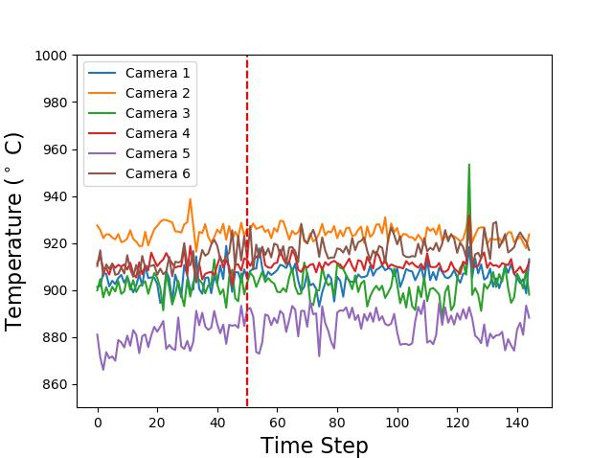  a | 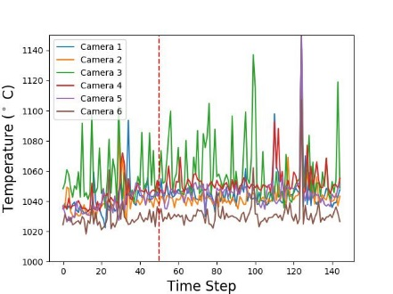  b
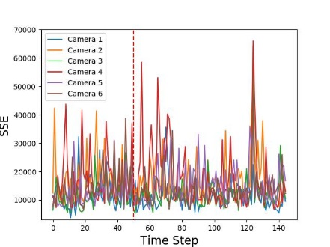  c | 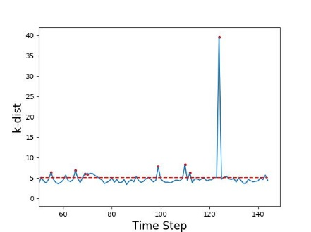  d
Figure 5: Monitoring results from the proposed framework. (a) Averaged tube temperature. (b) Maximum tube temperature. (c) SSE for shape monitoring. (d) Fault detection results from the AkNN method. The first 50 data samples are used to train the AkNN method, while the rest 100 are testing samples.
  - Conclusion
An image based monitoring framework was proposed using thermal photography in this paper. This work successfully introduced state-of-the-art deep learning techniques into industrial process monitoring. A segmentation network was proposed for automatically identify tube regions from the raw infrared photos. Based on the segmentation results, key measurements such as shape changing and temperature information can be extracted. Using these measurements, the control limits are drawn by the adaptive k-nearest neighbor method to raise alarms for abnormal conditions. The proposed framework was tested on operational data from an ethylene cracking unit, where the detected abnormal conditions satisfy with the records from the plant operators. The total processing time at each time step is about 3 seconds, which allows it in online monitoring. The overall results indicate that the proposed image-based monitoring strategy provides a valid alternative for cracking process monitoring. It is also expected that the rapid growth of deep learning can bring further benefits into industrial applications that can improve process efficiency and safety.

References
A. Esteva, B. K. R. A. N. J. K. S. M. S. H. M. B. a. S. T., 2017. Dermatologist-level classification of skin cancer with deep neural networks. Nature, pp. vol. 542, no. 7639, p. 115.
A. Zhang, K. C. W. B. L. E. Y. X. D. Y. P. Y. F. Y. L. J. Q. L. a. C. C., 2017. Automated pixel-level pavement crack detection on 3d asphalt surfaces using a deep-learning network. Computer-Aided Civil and Infrastructure Engineering, pp. 32(10):805-819.
B. Fulkerson, A. V. S. S., 2009. Class segmentation and object localization with superpixel neighborhoods. Computer Vision, 2009 IEEE 12th International Conference, pp. 670-677.
D. E. Rumelhart, G. E. H. a. R. J. W., 1985. Learning internal representations by error propagation. California Univ San Diego LaJolla Inst for Cognitive Science.
D. Silver, J. S. K. S. I. A. A. H. A. G. T. H. L. B. M. L. A. B., 2017. Mastering the game of go without human knowledge. Nature, pp. vol. 550, no. 7676, p. 354.
I. Amghizar, L. A. V. K. M. V. G. a. G. B. M., 2017. New trends in olefin production. Engineering, pp. vol. 3, no. 2, pp. 171-178.
J. Deng, W. D. R. S. L. L. K. L. a. L. F.-F., 2009. Imagenet: A large-scale hierarchical image database. Computer Vision and Pattern Recognition, pp. 248-255.
J. Long, E. S. T. D., 2015. Fully convolutional networks for semantic segmentation. Proceedings of the IEEE conference on computer vision and pattern recognition, pp. 3431-3440.
J. Shotton, J. W. C. R. a. A. C., 2009. Textonboost for image understanding: Multi-class object recognition and segmentation by jointly modeling texture, layout, and context. International Journal of Computer Vision, pp. 81(1):2-23.
K. Fukushima, S. M., 1982. Neocognitron: A self-organizing neural network model for a mechanism of visual pattern recognition. Competition and cooperation in neural nets, pp. 267-285.
K. Gopalakrishnan, S. K. K. A. C. A. A., 2017. Deep convolutional neural networks with transfer learning for computer vision-based data-driven pavement distress detection. Construction and Building Materials, p. 157:322{330.
K. He, X. Z. S. R. a. J. S., 2015. Delving deep into rectifiers: Surpassing human level performance on imagenet classification. Proceedings of the IEEE international conference on computer vision, p. 1026{1034.
K. He, X. Z. S. R. a. J. S., 2016. Deep residual learning for image recognition. Proceedings of the IEEE conference on computer vision and pattern recognition, pp. 770-778.
K. Simonyan, A. Z., 2014. Very deep convolutional networks for largescale image recognition. arXiv preprint .
Krizhevsky, A. I. S. G. E. H., 2012. Imagenet classification with deep convolutional neural networks. Advances in neural information processing systems, pp. 1097-1105.
L. H. Chiang, E. L. R. &. R. D. B., 2000. Fault detection and diagnosis in industrial systems. Berlin, Germany: Springer Science & Business Media..
M. Abadi, P. B. J. C. Z. C. A. D. J. D. M. D. S. G. G. I. M. I. e. a., 2016. Tensorflow: A system for large-scale machine learning. OSDI, pp. volume 16, pages 265{283.
O. Ronneberger, P. F. T. B., 2015. U-net: Convolutional networks for biomedical image segmentation. International Conference on Medical image computing and computer-assisted intervention, pp. 234-241.
V. Mnih, K. K. D. S. A. A. R. J. V. M. G. B. A. G. M. R. A. K. F. G. O., 2015. Human-level control through deep reinforcement learning. Nature, pp. vol. 518, no. 7540, p. 529.
W. Li, H. H. Y. S. V.-C. a. S. J. Q., 2000. Recursive pca for adaptive process. Journal of process control, pp. vol. 10, no. 5.
W. Zhu, W. S. a. J. R., 2018. Adaptive k-nearest-neighbor method for process. Industrial & Engineering Chemistry Research, pp. vol. 57, no. 7, pp. 2574-2586.
Y. LeCun, B. J. D. D. H. R. H. W. H. L. J., 1989. Backpropagation applied to handwritten zip code recognition. Neural computation, pp. 541-551.
Z. Tu, X. B., 2010. Auto-context and its application to high-level vision tasks and 3d brain image segmentation. IEEE Transactions on Pattern Analysis and Machine Intelligence, pp. 32(10):1744-1757.

