 CHEMICAL ENGINEERING TRANSACTIONS  VOL. 76, 2019 | A publication of  
The Italian Association
of Chemical Engineering
Online at www.cetjournal.it
Guest Editors: Sauro Pierucci, Jiří Jaromír Klemeš, Laura Piazza
Copyright © 2019, AIDIC Servizi S.r.l.
ISBN 978-88-95608-73-0; ISSN 2283-9216

Thermodynamic Evaluation of Reactive Yellow Dye Removal Using Malt Bagasse as Biosorbent
Bruna C. da Silva, Adriane Zanutto and Juliana M. T. A. Pietrobelli*
Departamento de Engenharia Química, Universidade Tecnológica Federal do Paraná. Av. Monteiro Lobato, s/n – km 04, CEP 84016-210, Ponta Grossa – PR, Brasil.
julianapietrobelli@utfpr.edu.br
The sorption of pollutants present in watery solutions is an advantageous alternative in relation to the common treatment of effluents, since it reduces the need for techniques that involve the generation of sludge. In the case of biosorption, the sorbent materials generally are of low cost and can be waste or industrial by-products of natural origin. Therefore, the objective of this work was to evaluate the biosorption of the Yellow Reafix B2R 134% dye using a by-product of the brewing industry (malt bagasse) as biosorbent from the analysis of the influence of contact time, temperature and obtaining of the thermodynamic parameters in batch system. The results pointed a similar behavior for the three working temperatures evaluated. The removal process was considered endothermic (13.3822 kJ mol⁻¹), with increase of the solid/liquid interface disorder during the biosorption (0.0468 kJ mol⁻¹ K⁻¹), spontaneous (-874.15 to -1818,24 kJ mol⁻¹) and with activation energy of 35.64 kJ mol⁻¹, what characterizes a sorption of the physical type. In general, the results show that in front of the thermodynamic aspects the malt bagasse has potential in the treatment of effluents containing reactive yellow dye.
  - Introduction

The discharge of dyes in water is associated with various productions, such as textiles, paper, plastics and leather. As a result, water contaminated with dyes has become a major environmental concern (Caprariis et al., 2018). Among the methods used to treat this effluent are the sorption processes, which basically consist of transferring the dye from the liquid form to a residue which occupies a much smaller volume in the solid form. When well designed, the sorption processes have high efficiency and attractiveness, especially when using low cost sorbent materials.
Since there are several agroindustries in Brazil that manufacture basic products, many solid wastes are generated (Rubio et al., 2018). One of the solid residues generated in large quantities is the malt bagasse, from the beer making process. Usually this residue is used in animal feed, but due to its high moisture content, it requires special logistics as it can spoil quickly.
Therefore, the aim of this work is to evaluate the biosorption, which is a type of sorption process characterized by the use of low cost solid residues as biosorbents, of the dye from textile industries Yellow Reafix B2R 134% (YR-B2R) using malt bagasse as biosorbent, considering the influence of contact time, temperature and thermodynamic parameters in a batch system.
For the design and use of biosorption processes is necessary the prior knowledge of parameters such as: residence time, work temperature and characteristics of interaction between the species of the system (sorbent and biosorbent) (Ho e McKay, 1999). The residence time refers to the contact time required for the removal of the pollulant by the sorbent to be effective (generally this time is called equilibrium time). The work temperature, in its turn, influences the distribution of equilibrium in the system, since it affects the attraction and repulsion forces between the molecules. For this reason, it is an important operational condition to be established. Already the energy of interaction between the species of the system will indicate the possibility of recovery of the pollutant and regeneration of the biosorbent. These are important considerations in sorption processes, since it aims at the possibility of reuse of the materials and not only the transfer of the pollutant to a new phase, whit the consequence of generation more waste (Marin et al., 2015).
The analysis of the biosorption process at different temperatures is important to know if there is a significant difference in the final result, considering whether the expenditure necessary to rise or not the temperature would be viable in relation to the cost-benefit. In addition, the thermodynamic analysis allows the determination of parameters such as: enthalpy, entropy, Gibbs free energy and activation energy. Using for this the van’t Hoff linearized equation, sorption equilibrium constant, thermodynamic relation and Arrhenius equation.
Therefore, the objective of this work is to evaluate the influence of temperature on the removal of Yellow Reafix B2R dye in aqueous solution, as well as to obtain the thermodynamic parameters: enthalpy, entropy and Gibbs free energy. And with these data get the minimum energy required for sorption to occur, called activation energy.
  - Materials and Methods
    - Biomass preparation
The biosorbent selected for the trials was the malt bagasse, shown in Figure 1. The biomass was supplied by a microbrewery located in the region of Ponta Grossa/PR. Due to the high moisture content on receipt, the biomass underwent a drying process at 303 K in a greenhouse with renovation and circulation of air for 96 hours. After drying, the residue was ground in a macro knife mill to obtain particles of homogeneous sizes.
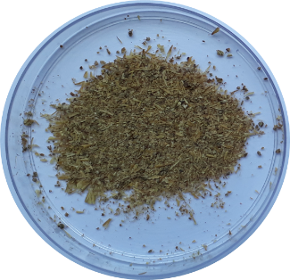
Figure 1: Malt bagasse
    - Solutions preparation and calibration curve
The sorbate used in the tests, YR-B2R presented in the Figure 2, is a textile dye of the reactive class. The synthetic solution were prepared from the dissolution of the dye in distilled water and the pH adjusted by the addition of aliquots of acid (HCl) and basic solutions (NaOH). In order to quantify the dye concentration in solution used the calibration curve, prepared from standard solutions dye (12.5 to 100 mg L⁻¹) and the corresponding absorbances when subjected to readings in Ultraviolet-Visible (UV-Vis) in spectrophotometer. The readings in UV-Vis were performed at 410 nm, corresponding to the higher wavelength of the solution of YR-B2R.

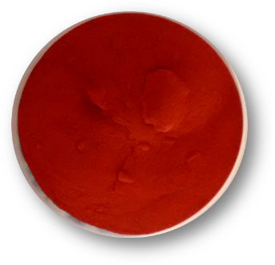
Figure 2: Yellow Dye Reafix B2R 134%
    - Biosorption assays
The biosorption in batch system consisted of contact between 0.30 g of biosorbent (malt bagasse) and 50 mL of sorbate (YR-B2R) at 75 mg L⁻¹. Based on previously studies performed (Zanutto et al., 2015), the operating conditions were established. Samples were adjusted to pH 2, maintained under shaking at 130 rpm in a rotary shaking incubator. After determined contact time, aliquots of the samples were centrifuged at 3000 rpm for 10 minutes. Then the dye concentration was obtained from the UV-Vis readings and the calibration curve. The amount of sorbate removed by the biomass was calculated by Equation 1.

$$q_{e}=\frac{V(C_{0}-C_{e})}{m_{s}}$$ | (1)

Being q_{e} the amount of sorbate in the solid phase (mg g⁻¹), V the volume of solution (L), m_{s} the mass of biosorbent (g), C₀ and C_{e} the initial concentration and of equilibrium of the dye (mg L⁻¹), respectively. The efficiency of the malt bagasse in the biosorption was determined by the removal percentual, as represented by Equation 2.

$$Removal \left(\%\right)=\frac{\left(C_{0}-C_{e}\right)}{C_{0}}.100$$ | (2)

The amount of sorbate removed was evaluated in different contact times (0 to 1440 minutes), in the temperatures of 303.15, 313.15 and 323.15 K. Figure 3 represents a schematic for the biosorption assay realized in batch.

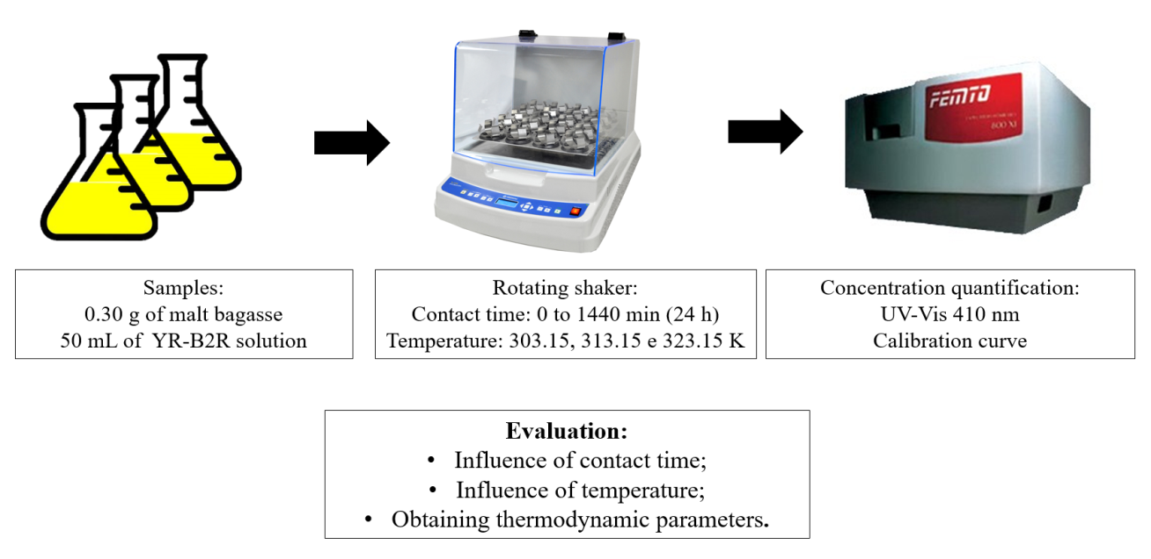
Figure 3: Schematic for the biosorption assay
  - Results and Discussion
    - Influence of contact time and temperature on removal
The removal obtained of YR-B2R by the malt bagasse in function of contact time can be observed in Figure 4. The experiments were done in triplicate and the standard deviation is indicated at each point in the figure.
The behavior for the three working temperatures (303.15, 313.15 and 323.15 K) was similar. In the initial instants the sorption was fast, with 65, 76 and 80% in the first 15 minutes. It was followed by a slower period until reached equilibrium of the system in 360 minutes (6 hours), with removal of 93, 90 and 92%, respectively.
Figure 4: Effect of contact time and temperature on YR-B2R removal by malt bagasse
It was verified that for the evaluated bands the temperature did not cause significant influence. This fact allows the use of the technique in lower temperature conditions, aiming at lower energy consumption, without harm the efficiency of the treatment. In the same way that the fast sorption in the initial instants favors the application of the technique in industrial systems, where the levels required for treatment are reasonable and fast. In the works developed by Fontana et al. (2015) and Rafael (2016) using the malt bagasse, the same behavior was observed, with the equilibrium time reached in 150 minutes and 32 hours for the dyes Orange Solimax TGL and Black Reafix Super 2R, respectively.

    - Thermodynamic Evaluation
The biosorption of the YR-B2R dye by malt bagasse in different temperatures makes it possible to obtain the thermodynamic parameters associated to the removal. The equations presented in Table 1 were used to determine the enthalpy ΔHº_{ads} (kJ mol⁻¹), entropy ΔSº_{ads} (kJ mol⁻¹ K⁻¹) and Gibbs free energy ΔGº_{ads} (kJ mol⁻¹). These parameters were obtained by the linear relation between ln kd versus 1/T of the van’t Hoff equation (Khattri and Singh, 1999).
Table 1: Relations to obtain the thermodynamic parameters
Relations |  | Equation | Plot
Van’t Hoff linearized equation | $${\ln{k}}_{d}=\frac{-∆H_{ads}^{°}}{R}\frac{1}{T}+\frac{-∆S_{ads}^{°}}{R}$$ | (3) | $ln k_{d}$ vs. $\frac{1}{T}$
Sorption equilibrium constant | $$k_{d}=\frac{q_{e}}{C_{e}}$$ | (4)
Thermodynamic relation | $$∆G_{ads}^{°}=-RT\ln{k_{d}}$$ | (5)

Being T the temperature (K) and R the universal constant of gases (8.314 J mol⁻¹ K⁻¹). The amount of sorbate removed and the dye concentration remaining in the fluid phase (q_{e} e C_{e}, respectively) corresponding to the equilibrium time can be seen in Table 2. The calculated thermodynamic parameters are also shown in this table.

Table 2: Equilibrium and thermodynamic parameters
Temperature (K) | q_{e} (mg g⁻¹) | C_{e} (mg L⁻¹) | k_{d} (L g⁻¹) | ΔH°_{ads} (kJ mol⁻¹) | ΔS°_{ads} (kJ mol⁻¹ K⁻¹) | ΔG°_{ads} (kJ mol⁻¹)
303.15 | 11.1315 | 7.8691 | 1.41 | 13.3822 | 0.0468 | -874.15
313.15 | 11.2874 | 7.1626 | 1.58 |  |  | -1184.12
323.15 | 11.4652 | 5.8272 | 1.97 |  |  | -1818.27

According to the results, the positive value of the enthalpy indicates that the biosorption ocurred by an endothermic process, that is, the increase in temperature favored the removal. The positive value for entropy indicates that the distribution of sorvate in the biosorbent (solid phase) is more disorded than the distribution in solution (Esmaeli et al., 2013; Gupta and Rastogi, 2008; Qaiser et al., 2009). The decrease of Gibbs free energy point a spontaneous and favorable process, indicating that the biosorption does not require any external energy to occur (Paiva et al., 2014). In addition to these parameters, it is also possible to determine the activation energy, E_{a} (kJ mol⁻¹), which refers to the minimum energy for sorption to occur. To determine it, it is necessary to use the Arrehnius equation and to have knowledge of the kinetic constants, k (g mg⁻¹ min⁻¹), referring to each working temperature. These constants are obtained from the adjustment of kinetic models to the biosorption data at different contact times. For the removal of the YR-B2R dye by malt bagasse (under the same operating conditions presented in the present study) the biosorption rate is best represented by the kinetic model of pseudo-second order (Zanutto et al., 2015), which provides the kinetics constants shown in Table 3.
Table 3: Kinetic constants and equation for the activation energy
Arrhenius equation | Equation | k (g mg⁻¹ min⁻¹) |  |  | Plot
 |  | 303.15 K | 313.15 K | 323.15 K
$$\ln{(k)}=\ln\left(A\right)-\frac{E_{a}}{RT}$$ | (6) | 0.01758 | 0.03631 | 0.04193 | $\ln{(k)}$ vs. $\frac{1}{T}$

Since A is the Arrhenius constant (g mg⁻¹ min⁻¹), the linear relation between ln k versus 1/T gives the activation energy of 35.64 kJ mol⁻¹. According to Aksu and Tezer (2005), sorption of the physical type involves weaker binding forces between species (sorbate and biosorbent) com E_{a} of 5 to 40 kJ mol⁻¹. While in chemical sorption the interaction between the species is of a stronger nature (E_{a} of 40-800 kJ mol⁻¹). Therefore, for the present study an indicative of physical sorption is verified. This fact allows the recovery of sorbate and regeneration of the biosorbent without the need for higher energy levels for desorption, because it involves weaker interactions between species (Banerjee e Chattopadhyaya, 2017).
Similar parameters were also identified by researchers who used alternative materials in the biosorption of textile dyes. As for example, Banerjee and Chattopadhyaya (2017) and Sheufele et al. (2016), who used sawdust powder and sugarcane bagasse in the removal of the dyes Yellow Acid 23 (Tartazine) and Blue Reactive 5G, respectively.
  - Conclusions
The biosorption of YR-B2R by malt bagasse presented high removal even at the initial moments of contact, with 65, 76 and 80% in the first 15 minutes, for the temperatures of 303.15 K, 313.15 K and 323.15 K, respectively. Followed by a slower period until catch up the system equilibrium in 360 minutes (6 hours), with removal of 93, 90 and 92%, respectively. The temperature did not offer significant influence in the removal, with this, smaller energy conditions can be used without compromising the biosorption efficiency. The process presented an indicative of endothermic biosorption, spontaneous and favorable, with increased randomness in the solid-solution interface. The sorption can also be characterized as physical, which favors dye recovery and biomass regeneration without the need of high energy levels. In this way, it is verified that the malt bagasse in front of the thermodynamic aspects has potential in the treatment of effluents containing reactive yellow dye.

References

Aksu Z., Tezer S., 2005, Biosorption of reactive dyes on the green alga Chlorella Vulgaris. Process Biochemistry, 40, 347–1361.
Banerjee S., Chattopadhyaya M.C., 2017, Adsorption characteristics for the removal of a toxic dye,
tartrazine from aqueous solutions by a low cost agricultural by-product, Arabian Journal of Chemistry, 10, S1629–S1638.
Caprariis B., Filippis P., Petrucci E., Scarsella M., 2018, Activated Biochars Used as Adsorbents for Dyes Removal, Chemical Engineering Transactions, 65, 103-108.
Esmaeli A., Jokar M., Kousha M., Daneshvar E., Zilouei H., Karimi K., 2013, Acid dye wastewater treatment onto marine macroalga, Nizamuddina zanardi (phylum: ochrophyta), Chemical Engineering Journal, 217, 329-336.
Fontana K.B., Chaves E.S., Sanchez J.D.S., Watanabe E.R.L.R., Pietrobelli J.M.T.A., Lenzi G.G, 2016, Textile dye removal from aqueous solutions by malt bagasse: Isotherm, kinetic and thermodynamic studies, Ecotoxicology and Environmental Safety, 124, 329-336.
Gupta V.K., Rastogi A., 2008, Biosorption of lead from aqueous solutions br green algae Spirogyra species: kinetics and equilibrium studies, Journal of Hazardous Materials, 2, 29-35.
Ho Y.S., McKay G., 1999, Pseudo-second order model for biosorption processes. Process Biochemistry, 34, 451-465.
Khattri S.D., Singh M.K., 1999, Colour removal from dye wastewater using sugar cane dust as an adsorbent. Adsorption Science & Technology, 17, 4, 269-282, 1999.
Marin P., Borba C.E., Módenes A.N., Oliveira S.P.D., Passaia N., Figueiredo L.S., 2015, Avaliação do efeito da temperatura, pH e granulometria do adsorvente na adsorção do corante Azul Reativo 5G, Engevista, 17, 1, 59-68.
Rafael H., 2016, Biosorption of textile dye Black Reafix Super 2R by malt bagasse, Master’s Dissertation, Polytechnic Institute of Bragança, Bragança, PT.
Rubio A.J., Silva I.Z., Gasparotto F., Paccola E.A.S., Silva C.N., Emanuelli I.P., Bergamasco R., Yamaguchi N.U., 2018, Removal of Methylene Blue Using Cassava Bark Residue, Chemical Engineering Transactions, 65, 751-756.
Sheufele F.B., Módenes A.N., Borba C.E., Ribeiro C., Espinoza-Quiñones F.R., Bergamasco R., Pereira N.C., 2016, Monolayer-multilayer adsorption phenomenological model: kinetics, equilibrium and thermodynamics, Chemical Engineering Journal, 284, 1328-1341.
Zanutto A., Silva B. C., Duarte E.R., Almeida L.N.B., Pietrobelli J.M.T.A., 2015, Avaliação cinética do bagaço de malte na remoção do corante amarelo reativo, In: 21st Congresso brasileiro de engenharia química em iniciação científica, Campinas, São Paulo: Blucher, BR.

