|  |  |
| --- | --- |
| cetlogo ***CHEMICAL ENGINEERING TRANSACTIONS***  ***VOL. 76, 2019*** | A publication of  aidiclogo_grande |
| The Italian Association  of Chemical Engineering  Online at www.cetjournal.it |
| Guest Editors: Sauro Pierucci, Jiří Jaromír Klemeš, Laura Piazza  Copyright © 2019, AIDIC Servizi S.r.l. **ISBN** 978-88-95608-73-0; **ISSN** 2283-9216 | |

Comparison of Particle Size Distributions of Reference Particles by Using Different Measuring Methods

Yasushige Mori

Department of Chemical Engineering and Materials Science, Doshisha University, 1-3 Tatara Miyakodani, Kyotanabe 610-0321 Japan

ymori@mail.doshisha.ac.jp

Particle size analysis is most fundamental analysis to powder technology. However, the validation or calibration of particle size analysis, especially the laser diffraction (LD) method, was not often carried out due to the difficulty to prepare the well-known sample. For example, the validation of LD method need spherical reference particles, of which size distribution is better to have a range over one decade of size. As this request, the Association of Powder Process Industry and Engineering, Japan distributed three kinds of standard reference particles (SRP) of spherical barium titanate glass; their size ranges are 1 – 10 μm, 3 – 30 μm and 10 – 100 μm. Those particles are also fitted to the reference particles in JIS Z 8900-1 Standard.

In this paper, the particle size distribution (PSD) based on volume of SRP which was converted from the number-based PSD of SRP measured by a scanning electron microscope (SEM) was compared with PSD measured by LD instruments, which was conducted by the Technical Group of Measurement and Control in APPIE. PSD results measured by LD instruments were almost same as each other. PSD by LD method was slightly different from PSD measured by SEM. This discrepancy was discussed by using by a flow type image analysis method which could measure the size of particles in the aqueous solution. It was found that sample particles could not be dispersed completely in the aqueous solution even if using dispersing instruments such as an ultrasonic bath, and that this influence was not serious to the PSD result when using the suitable operating condition of ultrasonic bath.

* 1. Introduction

Laser diffraction (LD) method is one of the most popular in particle size analysis due to the shorter measurement time and the better repeatability than the other techniques (Allen, 1997, Merkus, 2009). The principle of LD method is that light scattered from particles in a collimated laser beam is collected by an array of detectors in the focal plane with the collecting lens. Because the light intensity scattered from one spherical particle can be calculated by the Fraunhofer and Mie equations, which depend on particle size, refractive indexes of particle and medium, and the scattering angle, diffraction and scattering pattern of the assembly of particles could be obtained if the volume-based particle size distribution (PSD) is known. Hence, the measured diffraction and scattering pattern has to be deconvoluted to estimate PSD using the calculated light-scattering pattern of the single particle (Xu, 2000).

As an instrument of LD method has a particulate dispersing device, such as a sample loading tank with mixer and/or ultrasonic device for suspension or an aerosol generator, PSD measured is affected from not only optical detector configuration and calculation procedure but also sample loading system into the measuring zone, where particle segregation may sometimes occur. This is one of the reasons why reference material of spherical particles with over one-decade size is needed for the validation of LD method instruments. The distribution of the reference particles is important for not only LD method but also other particle size analysis methods, because measured particle size is different for each measuring method due to the different theory to obtain PSD. However, At least for spherical particle sample, the measured particle size should be obtained the almost same value, even if using different measuring methods. Form such background, the Association of Powder Process Industry and Engineering, Japan (APPIE) distributed the standard reference particles consisted of barium titanate glass from April 2004, whose size ranged from 1 µm to 100 µm.

However, even using those reference particles, the most important point is how to disperse particles almost completely. The dispersion state of particles in liquid phase could not investigate by the electron microscopy, but can be detected by a flow particle image analysis method. In this study, the good dispersion conditions of the standard reference particles were reported using by the flow particle image analysis method. And then PSDs were performed by LD method under the good dispersion condition at the round robin test joined with seven manufactures and distributors, and were compared with PSD counted by a scanning electron microscope (SEM).

* 1. Experimental
     1. Reference particles

The reference particle for this study was used one of the standard particles distributed by APPIE, whose size range is around 1 – 10 μm (referred as MBP 1-10). MBP 1-10 particles was measured by SEM for over 20,000, and the number-based PSD was obtained. The density of MBP 1-10 was 4,190 kg m-3 measured by liquid immersion method (Auto True Denser, Seishin). The real part of refractive index was estimated as 1.93 from the result of large-sized-particles measured by the immersion refractometer (Nippon Chikagaku Co. Ltd., wave length: 589 nm). The aspect ratio was obtained 1.063 by measuring 500 particles from SEM images, which means almost spherical.

* + 1. Determination of good dispersion conditions

FPIA-3000 (Sysmex) was used as the instrument of a flow particle image analysis, where the moving particles in a liquid was detected by the charge coupled device, and both size and shape distribution data were stored (Ohkawa et al., 2013). Usually particle size was calculated as the projected area diameter, and the shape was evaluated as the circularity. The dispersed condition was determined by this circularly distribution, which was obtained form 6,000 particles images dispersed in the solution by different preparation conditions.

* + 1. Round robin test by LD method

Technical Group of Measurement and Control in APPIE asked for the manufacturers and distributors of the instruments by LD method in Japan to join the round robin test using MBP 1-10 sample. Seven companies listed in Table 1 with the name of the instruments had joined in this round robin test. The wave length of the laser installed in the instrument was also listed in Table 1. The imaginary of refractive index was recommended as zero, because particles are transparent and spherical, and their surface is smooth.

Table 1: List of companies and instruments joined the round robin test

|  |  |  |  |
| --- | --- | --- | --- |
| Manufacture | Distributor | Instrument | Wave length of laser [nm] |
| Beckman Coulter | Beckman Coulter | LS 13 320 | 450, 600, 700, 900 |
| Horiba | Horiba | LA-950 | 405, 650 |
| Malvern | Malvern | Mastersizer 2000 | 466, 633 |
| Microtrac | Microtrac-Bell | MT3300 EX | 780 |
| Seishin | Seishin | LMS-350 | 670 |
| Shimadzu | Shimadzu | SALD-2200 | 680 |
| Sympatec | Japan Laser | HELOS & RODOS + QUIXEL | 633 |

* 1. Results and discussion
     1. Dispersion condition

Good dispersed particle suspension can be obtained by adding dispersing agent and/or using an agitating device such as an ultrasonic bath. When a dispersing agent is used, however, the surface tension of the solution decreases and the tiny bubbles appear in the help of ultrasound. Sodium hexametaphosphate (HMP-Na) was used as a dispersing agent. 0.2 wt% HMP-Na solution was tested how many bubbles appear when using ultrasonic device. Table 2 shows number of bubbles in the solution of 0.35 μL measured by FPIA-3000. The ultrasonic irradiating conditions were that for 3 minutes by 100 W, 37 kHz ultrasonic bath at the preparation step, and that using the hon type ultrasonic device of 2 W, 30 kHz mounted in loading vessel of FPIA-3000 during measurement step. When the ultrasonic device was used during measurement step, tiny bubbles were produced, which means the produced bubbles should be considered for the calculation of PSD. To obtain the good dispersion condition, the alternative conditions could be tried, that is the suspension sample is prepared without a dispersing agent and/or without sonication.

Table 2: Number of generated bubbles in HMP-Na solution due to ultrasonic irradiation

|  |  |  |  |
| --- | --- | --- | --- |
| Before loading | | no irradiation | irradiation |
| During measurement | no irradiation | 5 | 51 |
| irradiation | 162 | 176 |

First, MBP 1-10 powder was dispersed in only deionized water using 100 W, 37 kHz ultrasonic bath for 3 minutes, and then number-based PSD was measured by FPIA-3000 without sonication, due to concerns about the contamination of fine bubbles. Figure 1 shows the scatter diagram of the relationship between particle size and circularity. MBP 1-10 particles were spherical, then the circularity should be over 0.95. Particle size should be deviated at 1 to 10 μm considering PSD measured by SEM. However, there were many particles having the circularity less than 0.95. Those particles were observed for the aggregated particles as shown in Figure 2. This observation resulted the diluted solution for measuring in FPIA-3000 called “Particle Sheath” solution, which contained mainly 150 mM NaCl, might be not suitable. This could be explained that the particles were aggregated easily in the solution with high electrolyte concentration. The diluted solution using in FPIA-3000 was changed from the original “Particle Sheath” solution to deionized water, and the ultrasonic device was used during PSD measurement. Figure 3 shows the scatter diagram of MBP 1-10 particles dispersed in deionized water under this condition. The aggregation of particles almost disappeared, but something with below 1 μm size was observed, which could be estimated as bubbles.



particle size [ μm ]

0.25

1.0

10

50

circularity

0.5

1.0

Figure 1: Scatter diagram of MBP 1-10 particles dispersed in deionized water measured by FPIA-3000 without sonication during measurement

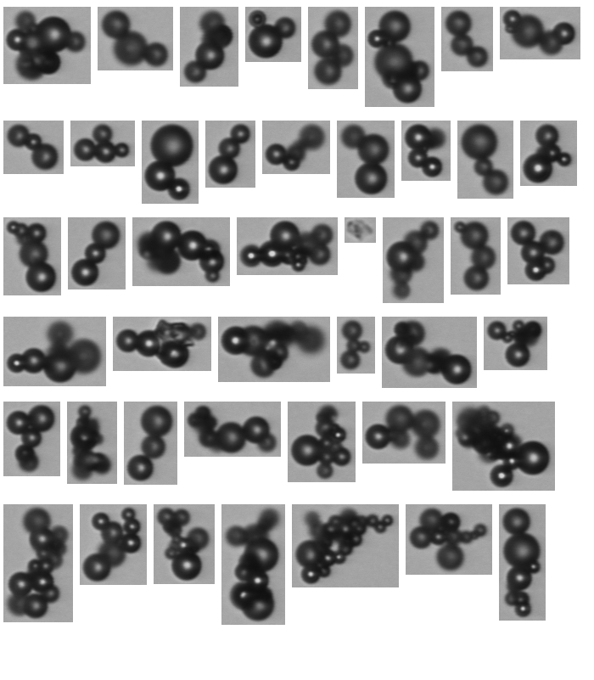

Figure 2: Image of aggregated particles captured by CCD device in FPIA-3000 during measurement of the sample for the condition of Figure 1

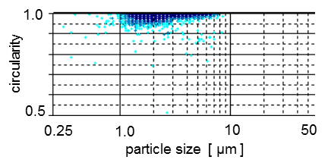

*Figure 3: Scatter diagram of MBP 1-10 particles dispersed in deionized water measured by FPIA-3000 with sonication during measurement*

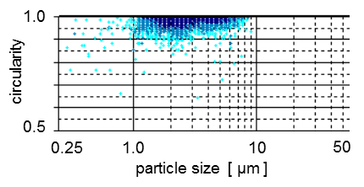

*Figure 4: Scatter diagram of MBP 1-10 particles dispersed in HMP-Na solution measured by FPIA-3000 without sonication during measurement*

Second trial procedure was that the suspension was prepared with HMP-Na dispersing agent and using magnetic stirrer agitating device instead of the ultrasonic bath. So many aggregated particles were observed when the measurement carried out without sonication. Then the next condition, where the ultrasonic bath was used at the preparation step and the sonication at the measurement step was stopped, was taken. The scatter diagram in this case is shown in Figure 4. The indications blow 1 μm size were more comparing with the result in Figure 3. The tiny bubbles were produced by a dispersing agent with sonication. So that the good dispersion condition could be concluded that MBP 1-10 powder was dispersed in deionized water using 100 W, 37 kHz ultrasonic bath for 3 minutes, and the measurement by FPIA-3000 carried out using deionized water as the diluted solution with sonication.



Figure 5: Number-based and volume-based PSDs measured by FPIA-3000 and SEM

* + 1. PSD measured by FPIA and SEM

Figure 5 shows the comparison of number-based and volume-based PSDs measured by FPIA-3000 and SEM. PSDs calculated by both methods can be compared directly, because both methods had the same measuring principle, that is counting method (number-based PSD) and determining the projected area diameter as size. Number-based PSD of FPIA-3000 indicated more small sized particles were counted in the case of SEM. The difference of both PSDs was not serious, that is the MBP 1-10 power dispersed almost completely in the deionized water at the above condition in preparation and measurement steps. But this little discrepancy could be explained that some fragments were observed in image captures in FPIA-3000, which might be came from the break of glass beads due to sonication, and also some tiny bubble might be contained. The volume-based PSDs was calculated from number-based PSD assuming particles were spherical. The difference between both PSD was increased.

* + 1. Round robin test

Considering the good dispersion condition for FPIA-3000, the preparation condition of the round robin test for LD method was determined as follows: The distilled water or deionised water was used for the dispersing medium. About 1 g of MBP 1-10 powder was taken in the 100 mL-beaker, and then the beaker was tilted this time, so that the sample would be gathered in the corner of the beaker. Water of a few mL was added to the sample bit by bit, until the surface of the particle got wet. And then water of total 50 mL was added to the sample agitating by using such as a spatula or a glass rod for a few minutes. The beaker contained this suspension was dipped in the 100 W ultrasonic bath and irradiated ultrasonic wave of 37 kHz for 3 minutes. The suspension prepared by the above procedure was fed into a sample loading tank of a measuring LD method instrument, until the sample concentration in the loading tank became to the measurement condition level determined by the equipment. The agitation by a spatula or a glass rod sometime needed during sample loading operation to prevent particle segregation. The use of an ultrasonic apparatus in a measuring instrument was effective for keeping good dispersion state of sample.

The volume-based PSDs measured by LD methods were somewhat deviated each other, but PSD calculated by number-based PSD of SEM was located in the middle of PSDs measured by LD methods, as shown in Figure 6. The sonication condition was taken different condition in some of instruments, although most tests were followed to the preparation, measurement and calculation conditions mentioned above. Using different real part of refractive index of particles from measured value (1.93) was sometimes reasonable, because the refractive index depends on wave length of light. The light wave length of 589 nm was not mounted on the instrument as a laser, and then the value of the refractive index at the wave length of a laser was not known exactly, but estimated near figures. Although there were many considering points before evaluating PSD, any significant deviation could not observe in Figure 6. When looking in detail, many instruments showed PSD moved to larger-size side. This means particles could be aggregated, and then large particles detected more.



Figure 6: PSDs of MBP 1-10 powder measured by seven LD instruments, FPIA-3000 and SEM

Table 3: Measuring conditions of LD method instruments

|  |  |  |  |
| --- | --- | --- | --- |
| Instrument No. | sonication at preparation | sonication at measurement | refractive index of particles |
| A | 135 W, 3 min. | no | 1.93 + 0.0 *i* |
| B | 100 W, 3 min. | no | 1.93 + 0.0 *i* |
| C | 100 W, 3 min. | no | 1.93 + 0.0 *i* |
| D | 41 W, 3 min | no | 2.0 + 0.0 *i* |
| E | 30 W, 3 min. | no | 1.9 + 0.0 *i* |
| F | 50 W, 1 min. | yes | 1.93 + 0.0 *i* |
| G | 100 W, 3 min. | no | 1.93 + 0.0 *i* |

* 1. Conclusions

One of the standard reference particles of spherical barium titanate glass, MBP 1-10, which was produced by the Association of Powder Process Industry and Engineering, Japan, and determined in JIS Z 8900-1 Standard, was tested for finding good dispersion condition in solution by using the flow particle image analysis method. And that condition was found as MBP 1-10 powder was dispersed in deionized water using 100 W, 37 kHz ultrasonic bath for 3 minutes. Using this dispersion condition, the round robin test of LD method was carried out. The volume-based PSDs measured by LD methods agreed well with PSD calculated from number-based PSD counted by SEM images.

Acknowledgments

The author thanks to them who joined the round robin tests for their measurement efforts and providing the data.

References

Allen T., 1997, Particle Size Measurement. Vol. 1. 5th Ed. Chapman & Hall, London.

Merkus H. G., 2009, Particle Size Measurement, Springer.

Mori Y., Yoshida H., Masuda H., 2007, Characterization of reference particles of transparent glass by laser diffraction method, Particle and Particle Systems Characterization, 24, 91-96.

Ohkawa T., Uchino T., Sasakura D., Miyazaki Y., Kagawa Y., 2013, Particle condition change in emulsion admixture evaluated by in situ flow particle imaging analysis, Chemical and Pharmaceutical Bulletin, 61, 333-339.

Xu R., 2000, Particle Characterization: Light Scattering Methods, Kluwer Academic Publishers, Dordrecht.