|  |  |
| --- | --- |
| cetlogo ***CHEMICAL ENGINEERING TRANSACTIONS***  ***VOL.*** | A publication of  aidiclogo_grande |
| The Italian Association  of Chemical Engineering  Online at www.aidic.it/cet |
| Guest Editors:  Copyright © AIDIC Servizi S.r.l. **ISSN** 2283-9216 | |

Organic fraction of municipal solid waste conversion into Polyhydroxyalkanoates (PHA) in a pilot scale anaerobic/aerobic process

Francesco Valentinoa\*, Laura Lorinia, Paolo Pavanb, David Bolzonellac, Mauro Majonea

aDepartment of Chemistry, “La Sapienza” University of Rome, P.le Aldo Moro 5, 00185 Rome, IT

bDepartment of Environmental Science, Informatics and Statistics, Via Torino 155, 30170 Venezia Mestre, IT

cDepartment of Biotechnology, University of Verona, Strada Le Grazie 15, 37134 Verona, IT

\*corresponding author: francesco.valentino@uniroma1.it

In recent years, the attention to organic wastes as a new feedstock for the production of PHA is increased based on the idea that this is the only way to reduce their high cost and to increase their sustainability. For this reason, a pilot platform has been designed to produce PHA from the source-sorted organic fraction of municipal solid waste (OFMSW). The cost-effective system consists in the three-steps anaerobic-aerobic process: the fermentation step was performed in a 200 L CSTR (OLR 20.0 kgVS/m3.d, HRT 3.3 d) in thermophilic conditions (55°C). The VFA-rich mixture was used for the two following aerobic steps: a first sequencing batch reactor (SBR, 100 L) for the production of functionalized PHA-producing biomass (mixed consortium, MMC), and a second batch reactor (50 L) for production of PHA and its maximization inside cell walls. The SBR was operated at 1.2-2.5 kgCOD/m3.d as OLR, and HRT of 1 d (equal to SRT); dynamic feeding regime (feast-famine) was used for consortium selection.

The fermentation conditions allowed obtaining a significant COD conversion into VFA. Acetic, propionic and butyric acids accounted for more than 80% of total VFA and the relative yield was 0.45 ± 0.03 CODVFA/VS. The necessary buffering capacity was provided by anaerobic digestate addition, which increased the system alkalinity (2.8 ± 0.2 gCaCO3/L at pH 5.75). In SBR, a strong selective pressure favouring PHA-accumulating organisms was easily reached, as demonstrated by the short feast-to-cycle length ratio (often below 0.12). In the second aerobic accumulation reactor, the biomass was able to accumulate up to 49% gPHA/gVSS. Both aerobic steps were performed without temperature (T) control, avoiding additional consumption of energy; the applied OLR was chosen based on biomass kinetic in order to have a constantly short feast phase and a stable selection/enrichment of PHA-accumulating consortium.

* 1. Introduction

The increasing amount of European food waste production, which approximately accounts for 90 million tons per year, requires innovative solutions for their treatment and disposal different from landfilling practises that have become more expensive and restrictive in the last years (Pfaltzgraff et al., 2013). The possibility to recover added value products from biowaste is a strategy for both decreasing the cost of disposal and facing the problems related to their increasing production (Lieder and Rashid 2016). With particular references to the urban scenario, the produced biowastes can have great variability in composition, but in general they are characterized by high moisture content and biodegradability. These important features are favoured by an efficient system of source separate collection, which increases the biological fraction of biowastes and it makes easier their valorisation with biological process (and not only via anaerobic digestion or composting) (Girotto et al., 2015). More innovative biotechnologies are able to produce value added biopolymer, in particular the family of polyhydroxyalkanoates (PHA), through a combined anaerobic-aerobic approach by using fermentable and renewable organic feedstock (Villano et al., 2010; Valentino et al., 2015).

PHA are biodegradable thermoplastic polyesters produced from specific bacteria strains, within their cell walls as carbon and energy stored source. Nowadays, the industrial PHA production processes are based on pure cultures cultivation in sterile conditions (Chen, 2010), which cause an increase in production cost (5.0-8.0 €/kg). Therefore, PHA are still not cost-competitive with the marketed fossil fuel based polymers (Gholami et al., 2016). The technology of mixed microbial culture (MMC) allows reducing the PHA production costs: PHA-accumulating organisms can be selected from the typical activated sludge coming from the wastewater treatment by applying aerobic dynamic feeding (ADF) condition. This MMC selection can be obtained through alternating feeding periods (feast and famine), with fermented feedstock rich in volatile fatty acids (VFA). The VFA are taken up very fast by PHA accumulating bacteria in the feast phase, where they are converted into PHA, which in turn is used as carbon source to gain a competitive advantage during the subsequent famine phase, where no longer VFA are available. In the last decade, many studies have described PHA production by MMC by using different types of organic waste, and with the typical three-step anaerobic-aerobic process (Valentino et al., 2017). More recently, the PHA production from urban biowaste, and in particular the organic fraction of municipal solid waste (OFMSW), has been described at pilot scale (Valentino et al., 2018). The effect of temperature (T) on process performances has been only preliminary discussed and in this study, this process parameter has been related to the biomass storage properties (rate and yield) and overall polymer process productivity.

* 1. Materials and Methods

The renewable feedstock was the OFMSW coming from door-to-door collection of Treviso municipality. A screw-press was used for its pre-treatment and homogenization and the squeezed liquid fraction used in this work had the following features: total solids (TS) 280 ± 44 g/kg, volatile solids (VS) 250 ± 33 g/kg, chemical oxygen demand (COD) 906 ± 58 g/kg, nitrogen 27 ± 3 gTKN/kgTS and phosphorus 4.0 ± 0.2 g/kgTS, COD/N/P ratio 100/2.9/0.4.

The adopted process scheme complies a unit consisting in a Continuous Stirred Tank Reactor (CSTR) for OFMSW fermentation. After a solid/liquid separation unit, the VFA-rich liquid stream was then conveyed to the two following aerobic stages: a Sequencing Batch Reactor (SBR) for biomass selection/enrichment under feast-famine regime; and a batch accumulation reactor for PHA production, as typically made in previous lab-scale experiments (Valentino et al., 2014).

* + 1. Anaerobic stage for OFMSW fermentation

The fermentation process was performed by using a 200 L CSTR, at a hydraulic retention time (HRT) of 3.3 d (equal to sludge retention time, SRT), average organic loading rate (OLR) of 20 kg VS/m3.d under thermophilc T (55°C). The acidic environment (pH 5.0-5.6) was maintained by the digestate recirculation from a parallel thermophilic anaerobic digester (Valentino et al., 2018). The process was considered sufficiently stable and under steady state after consistent VFA production was reached. Solubilisation and fermentation yield (YVFA) were determined with respect to the features of initial unfermented feedstock, in particular total COD and VS.

The downstream solids separation was conducted by means of a coaxial filter bag (5.0 μm porosity) equipped centrifuge. The VFA-rich liquid fraction was intended to the use in the aerobic PHA line.

* + 1. Aaerobic stages for MMC selection/enrichment and PHA production

The MMC cultivation was performed in a 140 L working volume SBR, which was initially inoculated with thickened activated sewage sludge from Treviso WWTP. The SBR run was conducted for approximately 90 days, by maintaining the same HRT or SRT (1.0 d) and cycle length (6 h). The reactor was equipped with linear membrane blowers (Bibus EL-S-250), which operated as oxygenation and stirring system. The pH and T were continuously measured but not controlled. The pH evolved steadily (8.0-8.7) in the whole SBR operation; the T in the aerated medium changed seasonally from a maximum of 28°C (early September) to a minimum of 16°C (mid December). The applied OLR was initially equal to 3.4 g soluble COD/L.d (CODSOL), and then decreased to 2.0 g CODSOL/L.d. The OLR was regulated based on the feast phase length, which was identified by the dissolved O2 concentration profile, daily recorded for each SBR cycle (Valentino et al., 2014). The SBR was also characterized by measurements of biomass, as volatile suspended solids (VSS), and of PHA concentrations as reported elsewhere (Valentino et al., 2018). For PHA quantification, the sludge was treated immediately after sampling with a NaClO solution (5% of active Cl2); then, PHA was extracted, hydrolyzed and esterified to 3-hydroxyacyl methyl esters, and determined by gas-chromatography. The specific PHA production rate (related to the non-polymer biomass, XA) and yield were calculated as described in Valentino et al. (2014). The storage potential of the selected biomass was exploited through fed-batch accumulation tests, which were performed at the same T and pH of the SBR. The fermented stream was dosed with a multi-spikes strategy via dissolved O2 concentration control. The sludge in the batch reactor was sampled at the beginning and at the end of the test for analytical determinations of CODSOL, VSS and PHA, analyzed as described in Valentino et al. (2018). The polymer content in the biomass was calculated by dividing the PHA concentration by the VSS concentration; the storage yield was given by the ratio between the produced PHA (expressed as COD) and the removed CODSOL.

* 1. Results and discussion
     1. Thermophilic OFMSW fermentation

In the frame of PHA production by MMC, the fermentation process must be performed in order to maximize the CODVFA/CODSOL ratio, since the presence of non VFA solubilized COD may affect the following aerobic selective pressure (Valentino et al., 2017). Moreover, the VFA distribution must remain as stable as possible during the entire operation since a stable VFA spectrum implies a reproducible PHA monomers microbial synthesis and a certain stability in physical and mechanical PHA properties (Morgan-Sagastume et al., 2015).

The pH fermentation value was maintained between 5.0 - 5.5 under a pH-controlled fermentation strategy: the recirculation of digestate (as described in Valentino et al., 2018) increased the alkalinity of the fermented feedstock (2.8 ± 0.2 gCaCO3/L at pH 5.75), avoiding a pH decrease and excluding the necessity of chemicals addition for pH control.

Process stability in terms of VFA production was achieved nearly in two weeks of operation (approximately 4.0 HRTs). The VFA production started immediately and it achieved a maximum peak (22.3 g CODVFA/L) at day 9 (2.7 HRTs). Under steady state, the fermented stream exhibited a VFA concentration of 16.2 ± 0.5 g COD/L, with an average VFA/CODSOL ratio of 0.90 ± 0.02, almost six times higher than initial value (0.16 ± 0.09). The COD solubilisation and VFA yield were affected by low fluctuations, consistently to what has been observed on VFA quantification. Under steady state, the COD solubilization was 0.21 ± 0.02 CODSOL/CODTOT; the fermentation yield was 0.45 CODVFA/VS and 0.30 ± 0.02 CODVFA/CODTOT, respectively on volatile solids and total COD.

The VFA composition of the fermented stream was primarily dominated by butyric (37.2 ± 0.4% COD basis), acetic (23.4 ± 0.3%), propionic (13.2 ± 0.2%), valeric (10.9 ± 0.5%) and caproic (9.6 ± 0.1%) acids. Lower levels of isobutyric (3.56 ± 0.07%), isovaleric (1.44 ± 0.06%) and isocaproic (0.70 ± 0.04%) acids were also revealed. Indeed, the prevalence of VFA with even number C-atoms (especially butyric and acetic acid) was net compared to VFA with odd number C-atoms (propionic, valeric etc..). In terms of possible composition, the synthetized PHA has to be consist primarily of 3-hydroxybutyrate (HB) monomer instead of the 3-hydroxyvalerate (HV) (Morgan-Sagastume et al., 2010).

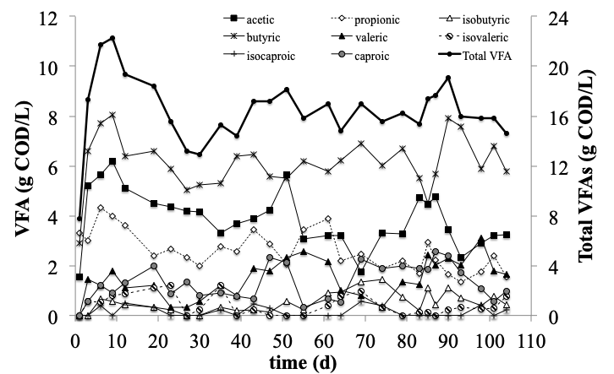

*Figure 1. Evolution of VFA produced in the CSTR acidic fermenter.*

* + 1. Aerobic stages for biomass selection/enrichment and PHA accumulation

The PHA-storing MMC has been produced and enriched by exposing the biomass to cyclic conditions of feast and famine. The soluble COD was alternately abundant or scarce at different times in the bioreactor. This simple strategy allowed adapting the microorganisms to survive and grow with cyclical lack of carbon source (famine), and compete when external substrates were available (feast). The biomass enrichment depends on many process parameters such as the SRT (Dionisi et al., 2001), OLR (Villano et al., 2010), feeding frequency (Moralejo-Garate et al., 2013; Valentino et al., 2014) and T (Jiang et al., 2011). Even though a multi-parametric model to predict the performance of the selection reactor has not yet been developed, it is largely recognized that a low feast-to-aerobic reaction time ratio plays a pivotal role for an effective MMC selection with significant PHA storage capacity (Valentino et al., 2017). On average, the literature suggests an efficient selective pressure starting from 20% to lower values of feast phase length with respect to the overall aerobic reaction time. This threshold was generally related to selection reactors (SBR) operating at medium or high OLR (4.0-8.0 g CODSOL/L d) by using synthetic feedstock. In the study herein proposed, the VFA concentration achieved in the fermented streams did not allow performing the SBR at such OLR, which was set in the range 2.0-3.4 g CODSOL/L d. Therefore, under these OLR, the feast phase length was chosen to be around 14% h/h, a reasonable value for a performing MMC selection. This value was the targeted objective and it was easily achieved in less than 7.0 SRTs after inoculum. The initial OLR was 3.4 ± 0.2 g CODSOL/L d and the operating T of SBR was between 27-28°C. Over the course of operation, from early September to mid December, the T of the system decreased even though three different periods were isolated and characterized by a narrow range of T variation (maximum 3.0°C). The first period (average T 26.2 ± 0.9°C) coincided to the achievement of the pseudo steady-state (after one week of operation) and it lasted for 21 days. The stability of this period was confirmed by the low variation of the feast phase, which average value was 13.8 ± 1.9 % (h/h). Indeed, the culture was selected with a robust and stable selective pressure, exhibiting a solids concentration of 1.41 ± 0.02 g VSS/L. The progressive decreased of the T led to a decrease of the process kinetics; in fact, temporary extension of the feast phase was observed (up to 24% h/h). In order to avoid the prolonged feast, with consequent loss of the selective pressure, the applied OLR was progressively decreased, until the 14% of feast phase length was reached again. The transition period lasted 10 days approximately; afterwards, the process was maintained stable for a second period of 25 days, with average feast phase of 14.1 ± 1.9 % under the new OLR of 2.75 ± 0.2 g CODSOL/L d. The lower quantified VSS level (1.24 ± 0.03 g VSS/L) was consistent with the lower applied OLR. In this period, the maximum and minimum recorded T were 23.2°C and 20.4°C respectively; on average, the operating T was equal to 21.8 ± 0.9°C. When the system became less manageable in terms of feast phase length stability, the applied OLR was modified in order to achieve a new stationary phase. As previously observed, the further T decrease negatively affected the substrate uptake rate since an immediate prolonged feast phase length was observed. In order to restore the fixed operating condition (14% h/h), the OLR was progressively decreased up to 2.04 ± 0.3 g CODSOL/L d, which was the value under pseudo-steady state. This last period of stability was maintained for more than 20 days at an average T of 17.1 ± 0.6°C, with feast phase length value (14.3 ± 1.1 %) similar to those previously monitored. Lower OLR corresponded to lower VSS (1.02 ± 0.04 g VSS/L). Figure 2A shows the trend of OLR applied for MMC selection as a function of the operating T in the three periods of process stability; the feast phase length was maintained approximately constant and similar in the three conditions.

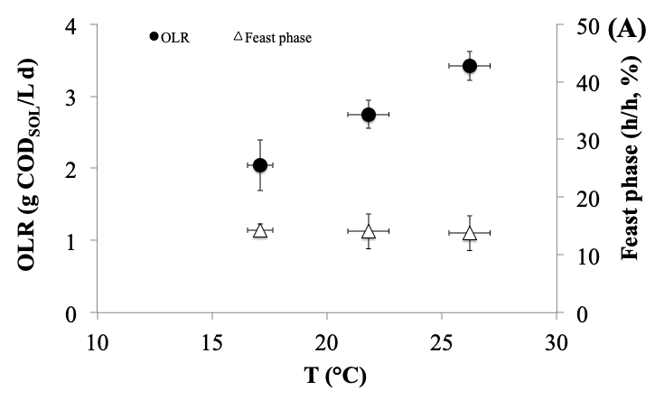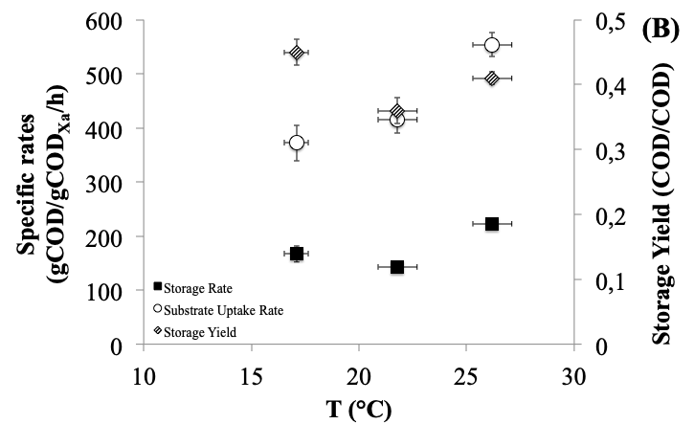

Figure 2. Feast phase length and applied OLR under different process temperature (A); storage and substrates consumption specific rates and storage yield at different process temperature (B).

Therefore, a good selective pressure for PHA-producing microorganisms was maintained also at operating T lower than 20°C. This finding is not often reported in the literure body, where the process T is generally controlled around 25°C (Kourmentza et al., 2017).

Recently, the influence of T on the production of PHA-storing biomass was evaluated within a practical case study (De Grazia et al., 2017). The produced biomass accumulated PHA to between 60 and 65%, g PHA/g VSS for all temperatures tested, from 15°C to 30°C. In agreement to this study, the MMC PHA production process has been demonstrated to bo adaptable within a predicted range for seasonal T fluctuation.

It was interesting to observe how the T affected the specific substrate uptake rate (-qSfeast) more than the specific storage rate (qPfeast). The (-qSfeast) decreased almost linearly from 554 ± 22 to 372 ± 20 g CODPHA/g CODXa/h (by 33%) as T decreased from 26.2 ± 0.9 to 17.1 ± 0.6 °C. However, the same monotonic trend was not observed for (qPfeast), which variation was at lower extent and not statistically correlated with the T changing. As matter of fact, lower T appeared to be in favour of the storage response, since the higher storage yield (i.e., the fraction of the removed CODSOL converted into polymer) was obtained at the lower temperature investigated (YP/Sfeast 0.45 ± 0.02 CODPHA/CODSOL). This was in agreement with De Grazia and co-workers (2017); the authors demonstrated that COD consumption rates was more strongly affected by an increase in temperature than PHA storage, and the storage yields were predicted to decrease with increasing temperatures. Therefore, apart from the process kinetics (for both COD consumption and PHA synthesis), the MMC-PHA production can be more efficient at lower temperatures from a substrate utilization perspective.

The storage ability of the sludge selected in the SBR was evaluated in the fed-batch accumulation tests, which were performed at the same temperatures of those monitored in SBR. The main quantified parameters are reported in table 1. The data reflected what previously observed in SBR; the storage performances were not statistically correlated with the T. Even though an average T of 26.2°C led to a better results with respect to intermediate T (21.8°C), a lower T was even more performing since the final storage yield (YP/Sbatch) and PHA biomass content were the highest achieved: 0.44 ± 0.03 CODPHA/CODSOL and 0.49 ± 0.02 g PHA/g VSS respectively. The initial specific storage rate was higher at the lower and higher temperatures explored: these values described the performance at the beginning of the accumulation tests (approximately the first two hours); any possible effect related to the PHA saturation was not taken into account. Over the course of the tests, those rates was not maintained since the PHA content in the biomass progressively increased. However, at lower T, the storage response was maintained more efficient in terms of substrates utilisation, as demonstrated by the highest final yield.

Table 1: Main parameters of the storage performance quantified in the accumulation tests

|  |  |  |  |  |
| --- | --- | --- | --- | --- |
| Parameters | Unit | Operating Temperature | | |
| 17.1 ± 0.6°C | 21.8 ± 0.9°C | 26.2 ± 0.9°C |
| Storage yield (YP/Sbatch) | CODPHA/CODSOL | 0.44 ± 0.03 | 0.33 ± 0.04 | 0.38 ± 0.05 |
| Storage rate (qPbatch) | mg CODPHA/g CODXa/h | 214 ± 47 | 167 ± 24 | 231 ± 33 |
| PHA biomass content | g PHA/g VSS | 0.49 ± 0.02 | 0.38 ± 0.02 | 0.42 ± 0.04 |
| HB:HV content | g (%) | 87:13 | 89:11 | 89:11 |
| PHA productivity\* | g PHA/L d | 1.17 ± 0.1 | 1.09 ± 0.07 | 1.34 ± 0.1 |

\*related to the selection and accumulation aerobic reactors

By considering both SBR and accumulation reactors in sequence, the process polymer productivity was calculated as the the amount of produced PHA per unit of overall volume of both reactors and per unit of time. Even though the storage response was better express at lower T, the higher PHA productivity was obtained at 26.2°C (1.34 ± 0.1 g PHA/L d). This result is related to the OLR applied in SBR, which affects the biomass productivity. Generally, biomass productivity in the SBR almost linearly increased at increasing OLR (Villano et al., 2010; Valentino et al., 2014). When the OLR has been decreased from 3.42 to 2.04 g CODSOL/L d, the biomass level decreased from 1.41 to 1.02 g VSS/L. In practice, the increase of biomass production counterbalanced the lower efficiency of substrate utilization with respect to the better efficiency exhibited at 17.1°C (e.g. storage yield).

* 1. Conclusions

The outcomes of this pilot scale study suggests a broad range in the practical reliability of MMC-PHA production technology in parallel to the valorisation of urban bio-waste. The thermophilic fermentation of the OFMSW produced a VFA-rich stream approximately at 0.90 as CODVFA/CODSOL ratio. This key characteristic makes this stream usable for PHA synthesis since it enhances the selective pressure by reducing the growth of non PHA-storing organisms. In the aerobic process steps, the soluble COD conversion into intracellular PHA was more efficient at temperature below 20°C, even though PHA productivity was higher at higher T. However, the process was technically feasible over the T range explored. Indeed, saving energy is possible if the aerobic process steps are performed without T control.

Business model adapted to a particular bio-waste production scenario may help for bioprocess design together with operations to adapt for temperature shifts in PHA production process as a route to bio-resource recovery from urban organic waste management services.

Acknowledgments

The authors gratefully acknowledge the Italian National Institute for Insurance against Accidents at Work (Istituto Nazionale per l’Assicurazione contro gli Infortuni sul Lavoro, INAIL) for financial support of this research, in the frame of national Call BRIC 2013-2015 (ID15).

References

Chen G.Q. (Ed), 2010, Plastic from bacteria, In: Natural functions and applications. Microbiology monograph. Springer.

De Grazia G., Quadri L., Majone M., Morgan-Sagastume F., Werker A., 2017, Influence of temperature on mixed microbial culture polyhydroxyalkanoates production while treating a starch industry wastewater, Journal of Environmental Chemical Engineering, 5, 5067-5075.

Dionisi D., Majone M., Tandoi V., Beccari M., 2001, Sequencing Batch Reactor: influence of periodic operation on performance of activated sludges in biological wastewater treatment, Industrial & Engineering Chemistry Research, 40, 5110-5119.

Gholami A., Mohkam M., Rasoul-Amini S., Ghasemi Y., 2016, Industrial production of polyhydroxyalkanoates by bacteria: opportunities and challenges, Minerva Biotechnologica, 28, 59-74.

Girotto F., Alibardi L., Cossu R., 2015, Food waste generation and industrial uses: A review, Waste Management, 45, 32-41.

Jiang Y., Marang L., Kleerebezem R., Muyzer G., van Loosdrecht M.C.M., 2011, Effect of temperature and cycle length on microbial competition in PHB-producing sequencing batch reactor, ISME Journal, 5, 896-907.

Kourmentza C., Plácido J., Venetsaneas N., Burniol-Figols A., Varrone C., Gavala H.N., Reis M.A.M., 2017, Recent Advances and Challenges towards Sustainable Polyhydroxyalkanoate (PHA) Production, Bioengineering 2017, 4, 55.

Lieder M., Rashid A., 2016, Towards circular economy implementa- tion: a comprehensive review in context of manufacturing industry, Journal of Cleaner Production, 115, 36-51.

Moralejo-Gárate H., Palmeiro-Sánchez T., Kleerebezem R., Mosquera-Corral A., Campos J.L., van Loosdrecht M.C.M., 2013, Influence of the cycle length on the production of PHA and polyglucose from glycerol by bacterial enrichments in sequencing batch reactors, Biotechnology & Bioengineering, 110, 3148-3155.

Morgan-Sagastume F., Hjort M., Cirne D., Gérardin F., Lacroix S., Gaval G., Karabegovic L., Alexandersson T., Johansson P., Karlsson A., Bengtsson S., Arcos-Hernández M.V., Magnusson P., Werker A, 2015, Integrated production of polyhydroxyalkanoates (PHAs) with municipal wastewater and sludge treatment at pilot scale, Bioresource Technology, 181, 78-89.

Pfaltzgraff L.A., Cooper E.C., Budarin V., Clark J.H., de Bruyn, M., 2013, Food waste biomass: a resource for high-value chemicals, Green Chemistry, 15, 307-314.

Valentino F., Beccari M., Fraraccio S., Zanaroli G., Majone M., 2014, Feed frequency in a Sequencing Batch Reactor strongly affects the production of polyhydroxyalkanoates (PHAs) from volatile fatty acids, New Biotechnology, 31, 264-275.

Valentino F., Morgan-Sagastume F., Fraraccio S., Corsi G., Zanaroli G., Werker A., Majone M., 2015, Sludge minimization in municipal wastewater treatment by polyhydroxyalkanoate (PHA) production, Environmental Science & Pollution Research, 22, 7281-7294.

Valentino F., Morgan-Sagastume F., Campanari S., Villano M., Werker A., Majone M., 2017, Carbon recovery from wastewater through bioconversion into biodegradable polymers, New Biotechnology, 37, 9-23.

Valentino F., Gottardo M., Micolucci F., Pavan P., Bolzonella D., Rossetti S., Majone M., 2018, Organic Fraction of Municipal Solid Waste Recovery by Conversion into Added-Value Polyhydroxyalkanoates and Biogas, ACS Sustainable Chemistry & Engineering, 6, 16375-16385.

Villano M., Lampis S., Valentino F., Vallini G., Majone M., Beccari M., 2010, Effect of hydraulic and organic loads in Sequencing Batch Reactor on microbial ecology of activated sludge and storage of polyhydroxyalkanoates, Chemical Engineering Transactions, 20, 187-192.