CHEMICAL ENGINEERING TRANSACTIONS  VOL. 76, 2019 | A publication of
The Italian Association
of Chemical Engineering
Online at www.cetjournal.it
Guest Editors: Sauro Pierucci, Jiří Jaromír Klemeš, Laura Piazza
Copyright © 2019, AIDIC Servizi S.r.l.
ISBN 978-88-95608-73-0; ISSN 2283-9216

Simulation-Based Optimization and Control of a Natural Gas Liquids Recovery Unit
Jorge Chebeirª, Santiago D. Salasª, Jose A. Romagnoli^{a,}*
ªLouisiana State University, Cain Department of Chemical Engineering, 3307 Patrick F. Taylor Hall, Baton Rouge, LA, U.S.A
*jose@lsu.edu
In this work, a simulation-based optimization framework is proposed to determine key decision variables that achieve the most appropriate design and operation of a NGL recovery unit. The approach consists on the integration of different software including the process simulator Aspen HYSYS® and MATLAB®. Aspen HYSYS® contains the high-resolution model of a conventional NGL recovery structure in steady state conditions while MATLAB® is the platform containing the optimization algorithm. Given the complexity of the problem, a differential evolution algorithm is employed for optimization. Results provide recommendations about dimensions and operating conditions to maintain the unit above its economic threshold. Additionally, a dynamic model of the resulting conventional structure permits to test different control structures. Dynamic controls are developed to ensure the smooth transition between the different optimal operating conditions. The main objective is to assess a control scheme capable of guaranteeing robustness and performance during operation.
  - Introduction
During the last decade, the energy sector has been impacted by the so-called “shale gas revolution”, especially in the United States. The technological advancements developed in drilling and multi-stages fracturing have allowed the access to enormous volumes of gas trapped in the shale formations of the country. This has generated a rapid increase in the production of natural gas with a tectonic impact on virtually all the segments of the value chain of this energy commodity. Since then, the infrastructure required for the transportation and processing of the raw gas has been studied. However, the sudden increment in gas supply with a prevalent flat demand has caused a depression on natural gas prices. In this context, the separation of the heavier hydrocarbons, referred as natural gas liquids (NGL), from the raw gas has turned into a critical operation which aims to maintain positive financial perspectives of these endeavours.
NGL (ethane, propane, butanes and natural gasoline) are the most valuable components of natural gas, and numerous separation structures have been proposed for economic extraction. Some reviews of the different existing NGL recovery processes have been proposed by Manning and Thompson (1991), Arnold and Stuart (1999), and Kidnay and Parrish (2006). The extraction process of NGLs typically includes Joule-Thompson (JT) expansion, refrigeration using propane or mixed refrigerants in a chiller and turbo-expansion (Manning and Thompson, 1991). Among the numerous recovery structures, it is possible to mention the conventional process and some variants of this structure such as the cold residue recycle (CRR) process and the gas subcooled process (GSP). Each of these recovery processes have different advantages and disadvantages and their applicability depends on the requirements of the operator.
In the present work, the focus is located in the conventional process structure to recover NGL and its optimal design and operation. An optimization framework, inspired in the work developed by Salas et al. (2017), is implemented to determine the relevant decision variables including operational temperatures, pressures and the total number of trays in the demethanizer among others to maximize the profitability of the unit. This framework encompasses two major features: a process simulation model (high-resolution model) and a metaheuristic optimization algorithm. Once determined the optimal conditions of the conventional NGL recovery unit, the second step is to establish realistic control structures. This is accomplished by developing a dynamic model based on the results of the optimization framework. Perturbations of operating conditions are performed to test the robustness of the control architecture.
  - Techno-Economic Optimization Framework
In the proposed framework, the process simulator Aspen HYSYS V.9 is integrated with MATLAB r2015a through ActiveX. HYSYS contains the high-resolution model of the NGL recovery process, which embraces complex mass and energy balances. Similarly, MATLAB contains a heuristic evolutionary optimization algorithm, the techno-economic analysis and the process constraints (e.g., temperature constraints to avoid temperature crossing in the gas-gas heat exchangers). The process is optimized such that a transition from steady to dynamic state is feasible with minimum variations. Figure 1 depicts the optimization framework and the main components. Notice that to avoid the loss of connectivity and the stop of computation an exception module is included. The components of the framework are explained in more detail in Section 3 and 4.
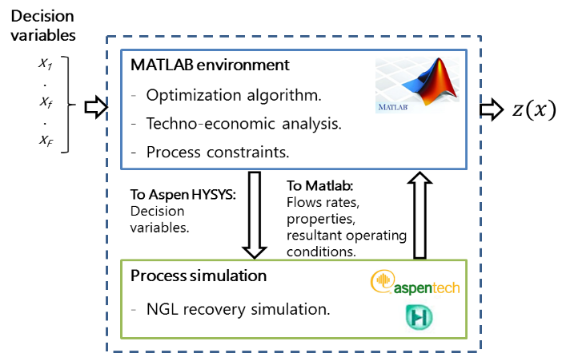
Figure 1: Model-based techno-economic optimization framework.
  - NGL Recovery Unit Simulation
    - Process Description
The conventional NGL recovery process is modelled in Aspen HYSYS at steady-state (Figure 2). The different components of the recovery unit are based on the work of Chebbi et al. (2010), and Kherbeck and Chebbi (2013).

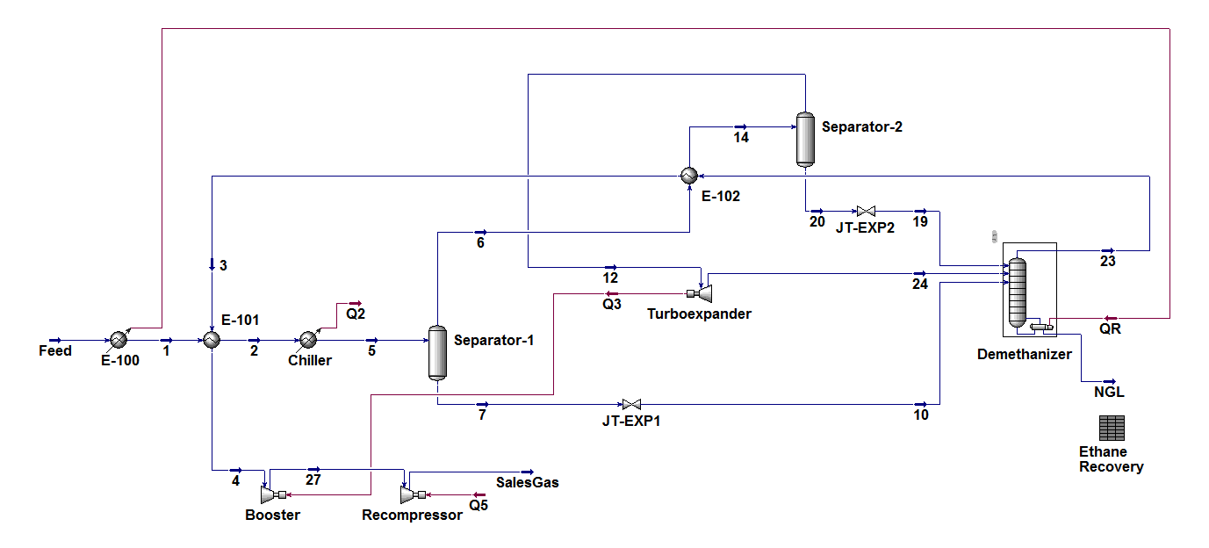
Figure 2: Simulation of conventional NGL recovery unit implemented in HYSYS.
In the conventional process, the feed is first cooled by transferring the duty to the reboiler of the demethanizer column. Then, a further cooling of the feed is achieved by a heat exchange with the residue gas coming from the top of the column. After these two cooling stages, the pre-cooled feed is sent to a chiller to reach a temperature close to -40 °C. A first separation of liquids is produced in Separator-1 and the gas coming from the top is cooled by heat exchange with the overhead of the demethanizer. A second separation occurs in the so-called “cold separator” (Separator-2), which is located right before the demethanizer unit. The resulting gases are transported to the turboexpander where an expansion takes place before their transportation to the demethanizer unit. The liquids leaving both Separator-1 and Separator-2 are expanded by JT expansion, and transported to the column. An energy integration is produced between the turboexpander and the recompressor located at the outlet stream of the NGL recovery unit. The separation of the NGL in the column is generated based on a pre-established recovery of the lighter NGL components (ethane).
    - Process Simulation Parameters
To analyze the efficacy of the proposed optimization framework, two case studies are proposed based on variations in the composition of the feed gas. Case Study I considers a low content of NGL while Case Study II considers a higher content of NGL. These inlet characteristics among others utilized in the HYSYS simulation of the process at steady-state are presented in Table 1.
Table 1: Parameters considered in the process simulation.
 | Case Study I (Lean Gas) | Case Study II (Rich Gas)
Fluid Package | Peng-Robinson
Inlet Pressure | 6002 kPa
Inlet Temperature | 308 K
Inlet Flow | 4980 kgmol/hr
Inlet Composition N2 | 0.01 | 0.01
Inlet Composition CH4 | 0.93 | 0.69
Inlet Composition C2H6 | 0.03 | 0.15
Inlet Composition C3H8 | 0.015 | 0.075
Inlet Composition C4H10 | 0.009 | 0.045
Inlet Composition C5H12 | 0.003 | 0.015
Inlet Composition C6H14 | 0.003 | 0.015
Residue Gas Pressure | 4000 kPa | 4000 kPa
NGL Pressure | 1450 kPa | 1450 kPa
Efficiency of compressors & turboexpader | 75% | 75%
  - Optimization Environment
    - Differential Evolution Algorithm
The differential evolution (DE) algorithm, developed by Storn and Price (1997), is a heuristic optimization strategy suitable for nonlinear and non-differentiable problems similar to the optimization of the conventional NGL recovery unit. Its simple implementation, speed and robustness makes it applicable for high-resolution models. The DE has demonstrated proficiency when compared with other heuristics (Salas et al., 2018). The DE involves the evolution of a population of solutions using operators such as mutation, crossover, and selection. The initial population follows a uniform distribution over the solution domain. Each solution vector, in the population, is the target vector in one generation. For each target vector, the mutation operator generates a new parameter vector referred as the mutated vector by adding a weighted difference between two population vectors to a third vector. These three vectors are selected randomly and must differ from the target. A scaling factor $β$ controls the amplification of the differential variation between the second and the third randomly chosen vectors. Selecting $β$ randomly improves convergence, especially for noisy objective functions (Price et al., 2006). In the crossover, a uniform arrangement builds trial vectors from values replicated from two different vectors. Finally, the vector with the best cost function is selected as the target vector for the next generation.
In this study, the crossover rate was 0.7, and $β$ was randomly selected between [0.2, 0.8]. A total of 40 generations with a population size of 25 generated sufficient simulations. In total, 10 evaluations are performed.
    - Optimization Problem
The optimization problem is written as the maximization of the annualized profitability as in Eq. 1.
$\max{profit}=\left(\sum_{CH_{4}, NGL}{revenue}-OPEX-AF∙CAPEX\right)$ (1)
where, $AF={\left[i{\left(1+i\right)}^{t}\right]}/{\left[{\left(1+i\right)}^{t}-1\right]}$
$i$ is the interest rate per year and $t$ the lifespan of the unit. For this study an interest rate of 0.1 and lifespan of 20 years is selected. The decision variables are searched within a solution domain. For the computation of the $OPEX$ and $CAPEX$ , the criteria and parameters are considered as proposed by Turton et al. (2012).
$OPEX=0.18∙CAPEX+1.23∙(RMC+UC)$ (2)
$CAPEX=1.18∙\left(\sum_{e=1}^{E}{C_{BM,e}}\right)∙\left({{CEPCI}_{2017}}/{{CEPCI}_{Base}}\right)$ (3)
where, $RMC$ and $UC$ are the raw material cost and the utility cost, respectively. $C_{BM,e}$ is the bare module cost for each equipment e. ${CEPCI}_{2017}$ and ${CEPCI}_{Base}$ are the chemical engineering plant cost index for year 2017 and base year (2001).
  - Dynamic Simulation
Once the optimal design variables of the conventional NGL recovery unit are determined through the optimization framework, a dynamic process simulation is modelled to analyze different control structures. In this study, the optimal design of the Case Study I (Lean Gas) is considered for the development of the dynamic model.
    - Control Structure
During operation, the objective is to optimize the profit while meeting the product specifications and satisfying other operational constraints. Expected changes in prices, feed rate, etc., will lead to changes in the optimum operating point, and thus in the control objectives. Nevertheless, for the sake of this study, it is assumed that the operational objectives are the same as obtained by the optimization framework. The proposed control structure developed for the conventional NGL recovery system is shown in Figure 3.
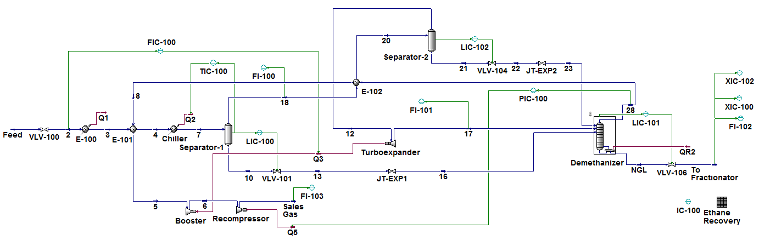
Figure 3: Dynamic simulation (HYSYS) of conventional NGL recovery unit with different control structures.
The specific loops are described as follows: 1. Feed flow rate is controlled by manipulating the power to the turboexpander; 2. Column pressure is controlled by manipulating power to the sales gas recompressor, which discharges into a 4000 kPa pipeline; 3. The temperature in the first separator is controlled by manipulating the refrigerant duty in the chiller; 4. The levels in the two separators are controlled by manipulating valves in the liquid lines from the drums; 5. Liquid level in the column reboiler is controlled by manipulating the bottoms.
  - Results and discussion
    - Optimization framework
Optimal decision variables are enlisted in Table 2. In the case of the number of trays for the demethanizer, the lean gas selects a lower number when compared with the rich gas. Moreover, the rich gas seeks the maximization of the NGL recovery because of the higher revenues it generates. In the case of the lean gas, the recovery plays a secondary role because it seeks to increase the profitability by adjusting other operational conditions which optimized the use of the operational expenditures.
Table 2: Results for evaluated case studies.
Decision variable | Domain | Units | Case Study I (Lean Gas) | Case Study II (Rich Gas)
Chiller inlet temperature | [-20, 5] | °C | 3.62 | 4.69
Chiller outlet temperature | [-40, -20] | °C | -40 | -40
Separator-02 inlet temperature | [-70, -40] | °C | -62.94 | -62. 21
Demethanizer pressure (head) | [1000, 2000] | kPa | 1790.0 | 1111.57
Demethanizer trays | [20, 30] | - | 28 | 30
NGL recovery | - | % | 79.20% | 88.53%
Mean profit | - | MMUSD/year | 17.59 | 133.66

    - Dynamic Performance
After implementing the different control structures, perturbations in the inlet flow are performed to test the response of the system. Figure 4 depicts the responses for a 10% step increase in the set-point (red dashed line) of the feed flow controller. It takes about 15 min to bring the feed flow rate (blue line with markers) up to the new throughput and produce more gas and NGL (see FI-102 and FI-103). Both the bottoms NGL product and sales gas possess a rapid transient. Other variables such as the overhead pressure (see PIC-100), the Separator-1 temperature (see TIC-100) and the liquid level in the reboiler possesses a longer transient of about 35-37 min.
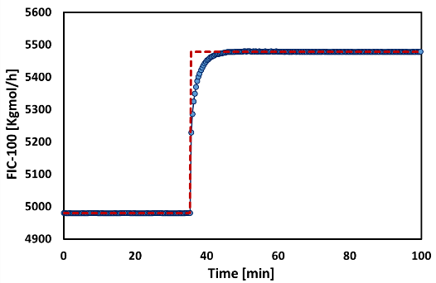 | 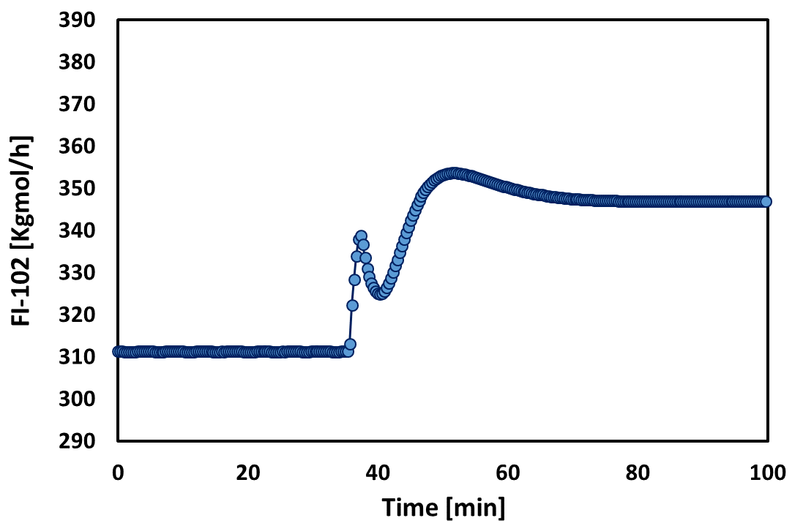
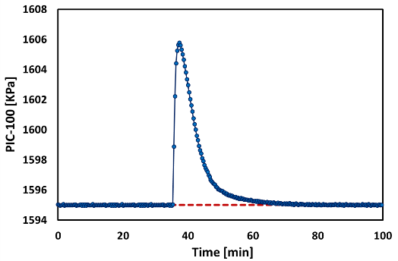 | 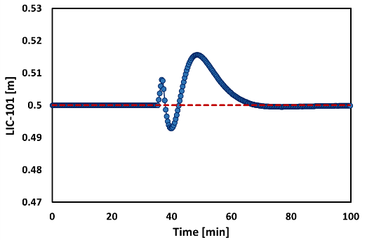
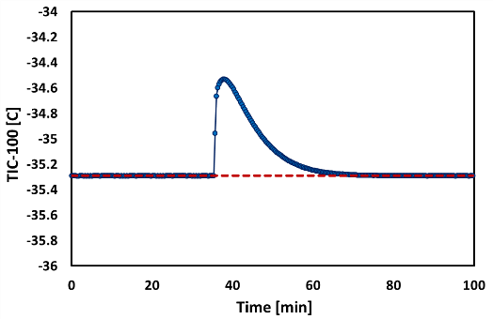 | 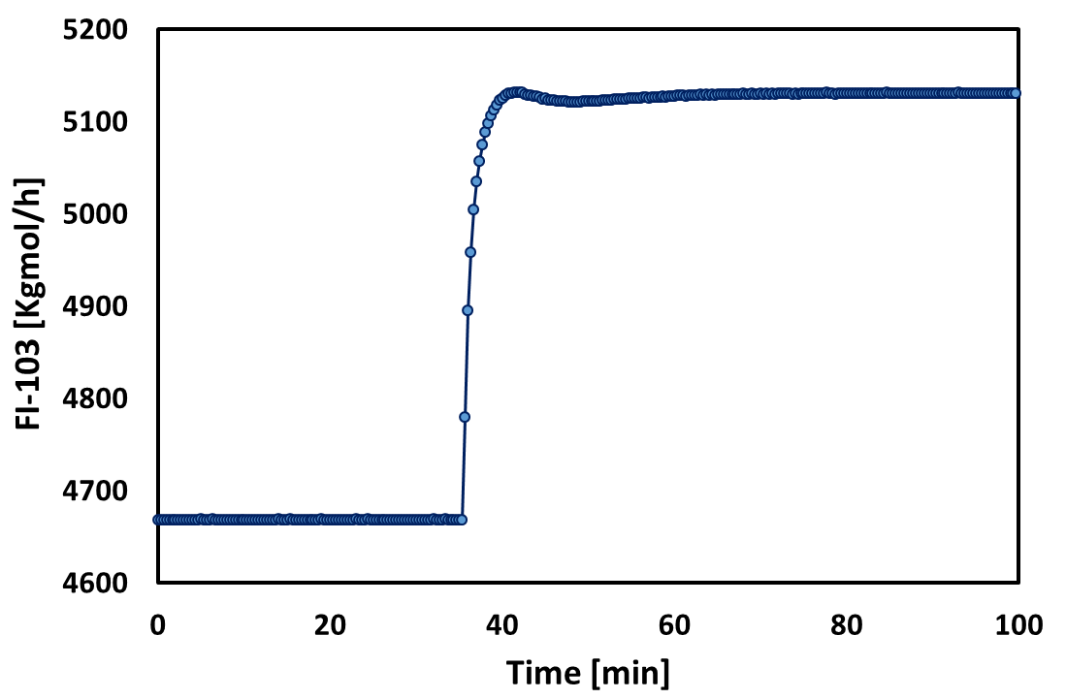
Figure 4: Dynamics of different control structures and variables for an increase of 10% in the inlet flow.
Another interesting test is to verify is the level of impurity in the bottoms product during the transient when a step increase of 10% is produced in the feed. It is considered for the unit operation a maximum content of 0.02 of in mole fraction of methane in the NGL product. Figure 6 depicts the impact of the disturbance in the feed flow rate in the compositions of methane (XI-101) and ethane (XI-100) in the NGL product.
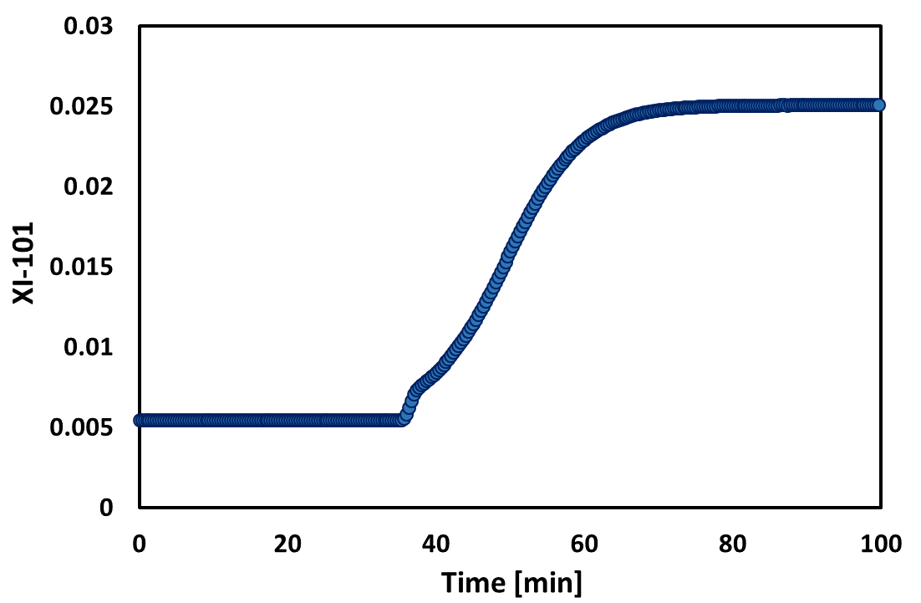 | 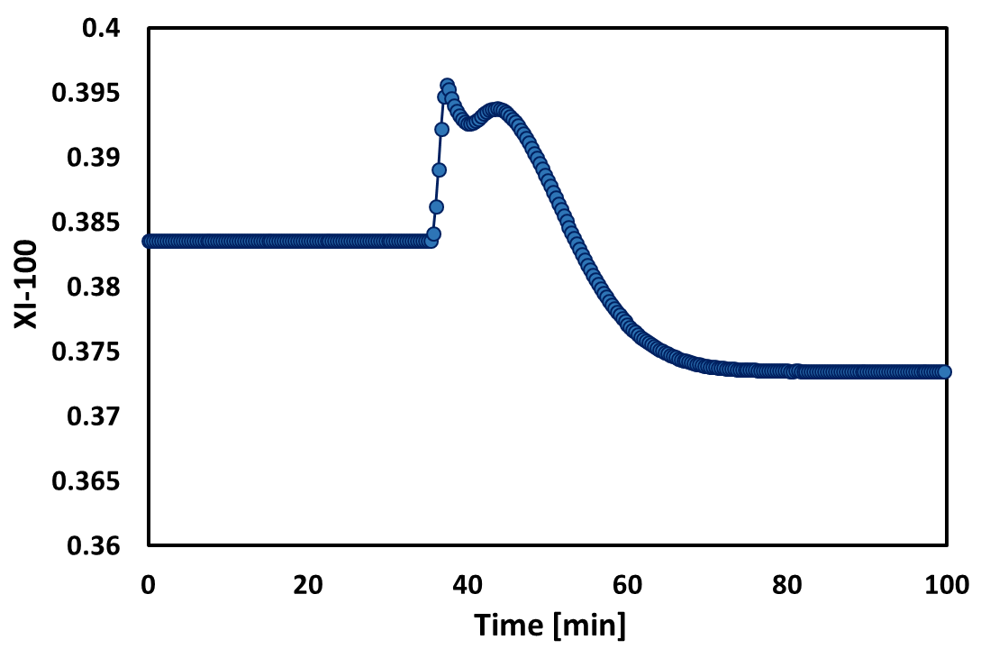
Figure 5: Variations of methane and ethane in NGL product for an increase of 10% in the inlet flow.
As can be observed, an increase of 10% in feed flow increases the level of impurity (methane) in the NGL stream. After the transient, the product contains almost 3.6 times the maximum allowed amount of methane. Additionally, the content of ethane decreases about 2%, which is not as significant as the increase of impurity.
  - Conclusions
In this work, an integrative approach is presented for the determination of the optimal design conditions for the operation of a conventional NGL recovery unit. A process simulation is coupled with a metaheuristic algorithm to construct a techno-economic optimization framework. Two case studies are analysed to determine the optimal design and operating conditions. The relevance of the NGL content in the raw gas is observed in the higher profits generated in the rich gas case study. Based on the optimal design variables obtained by the proposed framework, a dynamic process simulation is performed to incorporate different control structures and evaluate the effects of altering the normal operating conditions of the inlet feed. Results showed that the transient to reach the new steady state is achieved relatively fast in the case of the output flows and controllers. The impact of increasing the feed on the bottoms product is also analysed. The level of impurity is strongly affected. Future work should focus on the implementation of control systems that avoid or minimize the detrimental effects of inlet disturbances in product quality. In addition, other types of NGL recovery processes as well as the utilization of other more advanced control structures could be implemented.
Acknowledgments
Support on PSE LSU group and the Cain Department of Chemical Engineering at Louisiana State University is gratefully acknowledged.
References
Chebbi, R., Al-Amoodi, N. S., Jabbar, N. A., Husseini, G. A., & Al Mazroui, K. A., 2010, Optimum Ethane Recovery in Conventional Turboexpander Process. Chemical Engineering Research and Design, 88(5-6), 779–787.
Kherbeck, L., Chebbi, R., 2015, Optimizing Ethane Recovery in Turboexpander Processes. Journal of Industrial and Engineering Chemistry, 21, 292-297.
Kidnay, A. J., Parrish, W. R., & McCartney, D. G. (Ed.), 2011, Fundamentals of Natural Gas Processing. CRC press, Columbus, USA.
Manning, F.S., Thompson, R.E. (Ed), 1991, Oilfield Processing of Petroleum, PennWell Publishing Company, Tulsa, USA.
Price, K., Storn, R. M., & Lampinen, J. A., 2006, Differential evolution: a practical approach to global optimization. Springer Science & Business Media.
Salas, S. D., Chebeir, J., Tronci, S., Baratti, R., & Romagnoli, J. A., 2018, Real-Time Nonlinear State Estimation in Polymerization Reactors for Smart Manufacturing. In Computer Aided Chemical Engineering (Vol. 43, pp. 1207-1212). Elsevier.
Salas, S. D., Geraili, A., & Romagnoli, J. A., 2017, Optimization of renewable energy businesses under operational level uncertainties through extensive sensitivity analysis and stochastic global optimization. Industrial & Engineering Chemistry Research, 56(12), 3360-3372.
Storn, R., & Price, K., 1997, Differential evolution–a simple and efficient heuristic for global optimization over continuous spaces. Journal of Global Optimization, 11(4), 341-359.
Turton R., Bailie R.C., Whiting W.B., Shaewitz J.A., Bhattacharya D. Analysis Synthesis and Design of Chemical Processes, Prentice Hall: Upper Saddle River, NJ. 2012

