|  |  |
| --- | --- |
| cetlogo ***CHEMICAL ENGINEERING TRANSACTIONS***  ***VOL. 76, 2019*** | A publication of  aidiclogo_grande |
| The Italian Association  of Chemical Engineering  Online at www.aidic.it/cet |
| Guest Editors: Sauro Pierucci, Jiří Jaromír Klemeš, Laura Piazza  Copyright © 2019, AIDIC Servizi S.r.l. **ISBN** 978-88-95608-73-0; **ISSN** 2283-9216 | |

Green Bioremediation of Iron Ions by Using Fungal Biomass

Bruna de A. Martinsa, Matheus T. N. S. Limab, Debora L. C. Barretoa, Jacqueline A. Takahashia,\*

aDepartament of Chemistry, Institute of Exact Sciences, Universidade Federal de Minas Gerais. Av. Antonio Carlos, 6627, CEP 31270-901, Belo Horizonte, MG, Brazil

bDepartment of Food Science, Faculty of Pharmacy, Universidade Federal de Minas Gerais. Av. Antônio Carlos, 6627, CEP 31270-901, Belo Horizonte, MG, Brazil

jat@qui.ufmg.br

The increased production of iron ore in recent decades to support the growing demand for steel for various industrial applications has been a challenging matter concerning environmental issues. However, since iron is an economically important metal there is a growing industrial interest to reduce the impact of its exploration in the environment. This concern did not avoid the biggest environmental disaster of Brazil’s history in 2015 when disruption of a mining dam in the city of Mariana (Minas Gerais State) released sediments of iron ore extraction to an affluent of an important watershed. Situations like this have awaked the demand for the development of new alternatives to minimize environmental problems and to remove contaminants present in aqueous matrices. Bioremediation is an innovative green process to treat water contaminated with organic and inorganic pollutants. It is a fast, efficient, and relatively inexpensive alternative when traditional chemical treatment is not the first choice, due to the interference of the latter with aquatic life. Bioremediation techniques are based on the use of fungi or bacteria (alive or deactivated), as well as agricultural by-products, as organic filters, which act by capturing metallic ions and other pollutants through adsorption or another mechanisms of chemical interaction. These filters can be easily obtained from renewable resources making the process economically viable. In this work, two species of filamentous fungi, *Penicillium janthinellum* and *Syncephalastrum racemosum*, were investigated for their capacity to remove iron present in aqueous matrices aiming at the development of a tailor-made filter for iron bioremediation. The fungi were grown for 10 and 12 days for biomass formation, respectively. The respective biomasses were recovered by filtration and subjected to aqueous solutions containing iron ions. The process was followed taking five aliquots in the first hour and then each 24 h for four days. Optimization was evaluated by varying the water content of bioremediation agents utilized (fresh or processed dry biomass) and also by exchanging the biomass for a fresh one after periods of 24, 48, and 72 h. Iron present in the aqueous matrices before and after bioremediation was quantified by atomic absorption. Results were very encouraging, with the dry biomass of *P. janthinellum* removing approximately 50 % of iron present in the aqueous matrices after only 1 h of contact time. After 72 h of the process, both microorganisms achieved more than 90 % of iron ions removal regardless of the type of biomass utilized in the process. The results proved that this approach is a simple and fast alternative for decontamination of water matrices contaminated with iron, with the positive aspect of the easiness of fungal cultivation, and the high yields of biomass produced. In addition, since this process does not alter the physicochemical properties of the treatment site, it stands out as a sustainable green technique to deal with processing of dynamic environments.

* 1. Introduction

Water is an essential natural resource for every living organism as well as for various industrial processes. Water bodies contamination with organic or inorganic pollutants have been a source of concern due to various severe effects over trophic chains and the emergence of many diseases indexed to processes as the bioaccumulation of metals, for instance (Song et al., 2013). Metallurgical and mining activities along with the natural leaching process of the ground contribute to increasing the number of metals in natural water sources (Aly et al., 2013). In 2015, a disruption of a mining dam in the city of Mariana (Minas Gerais, Brazil) reached the Rio Doce hydrographic basin with more than 50 million m3 iron-rich wastewater, affecting the homeostasis of the ecological system. This incident reduced the biodiversity and productivity of near bound soil and extended its effects along several kilometers of the hydrographic basin (Segura et al., 2016).

Iron is an essential element for nearly all forms of life (Abbaspour et al., 2014). However, while its lack can cause anemia, its overload leads to severe health problems in humans (Wang & Xia, 2015). Iron is able to pile up in the trophic chains causing damage to organic systems due to its oxidation potential (Oberholster et al., 2012). The application of physicochemical treatments to wastewaters, although effective, is usually expensive and, sometimes, ecologically damaging (Soares & Soares, 2012). Conventional treatments expend high amounts of chemical reagents that many times may even be inefficient when applied in environments having low concentrations of metals and/or high quantity of organic matter (Malik, 2004).

Combining chemical and biological treatments is an efficient way to treat wastewater. Bioremediation is a technological green tool to reduce contaminants in polluted matrixes (Kumar et al., 2011). This ecotechnology makes use of the adaptive diversity of microorganisms and plants to biotransform and/or bioaccumulate xenobiotic compounds with the aim of restoring the environmental quality and achieve ecological balance. Nonetheless, its reliability and efficiency are well known and the increase of sites requiring remediation and the costs at maintaining treatment stations are factors that corroborate with bioremediation importance (Islam & Datta, 2015).

Many microorganisms have been characterized in the literature by their capacity of biosorption and biotransformation xenobiotic compounds (Pinto et al., 2012), including bacteria (Liu et al., 2014), algae (Kousha et al., 2012), and fungi (Malik, 2004). Filamentous fungi present some features that make them especially efficient for bioremediation applications (Harms et al., 2011) and are known by their adaptive capacity of colonizing and tolerating different substrates (Sen & Charaya, 2012). Many recent studies aim to apply microorganisms for organic residues treatment (Leow et al., 2018). Several genera of fungi have been studied and demonstrated great results of *Penicillium* species in treating solutions contaminated with heavy metals like cadmium and copper (Martins et al., 2016). In addition, filamentous fungi grow faster and cheaper than plants used in bioremediation (Dominguete & Takahashi, 2018). They have a large superficial area (Bajgai et al., 2012) and usually require low amounts of the substrate to develop metabolic routes able to biodegrade xenobiotic compounds. The main process of metal bioremediation by fungi is the adsorption process though negatively charged fungi cell membranes, binding metal ions over the cellular structure (Malik, 2004). Negatively charged chemical groups can be found all over the mycelium structure (Horisberger & Clerc, 1988). As a charge dependent process, adsorption suffers influence of pH, temperature, ions nature traits as size and charge and by the metabolism of fungi (i.e. the capacity of modulating the media in order to overlap the unfavorable conditions of the environment) (Ahalya et al., 2006).

Multicellular eukaryotic filamentous fungus *Penicillium* (Ascomycota) is a worldwide distributed fungal genus known as cosmopolitans and generalist organisms with high economic importance in the production of food and pharmaceutical active molecules such as drugs and enzymes (Carvalho et al., 2010; Lucas et al., 2010). *Penicillium* species usually grow very fast forming a mycelial structure with a complex hyphae organization that spreads on a large area. Nevertheless, they are halotolerant, therefore, very suitable for the bioremediation of wastewaters that may contain high levels of dissolved salts (Leitão, 2009). *Syncephalastrum* is also a genus of soil born filamentous fungi from tropics with characteristic cylindric sporangiophore and cottonous and voluminous colonies. Detoxification of organic polycyclic chemicals by *S. racemosum* has been studied along the last decades (Sutherland, 1992). Other biotechnological applications as the lipolytic and the production of chitosan have been also studied for this species (Amorim et al., 2003).

The aim of this work was to evaluate the bioremediation potential of two species of fungus from *Penicillium* and *Syncephalastrum* genera in aqueous matrixes containing iron. The effect of both fresh and dry biomass on the bioremediation process was also investigated.

* 1. Materials and methods
     1. Microorganisms

Microorganisms used in this study, *Penicillium janthinellum* (NRRL35451) and *Syncephalastrum racemosum* (NRRL2496), are deposited in the Laboratory of Biotechnology and Bioassays (LaBB, Universidade Federal de Minas Gerais, Brazil). Each species was cultivated in potato dextrose agar (PDA) (Fluka Analytical) and incubated at 28 ± 2 °C for seven days to reactivate the colonies and to allow profuse sporulation.

* + 1. Biomass preparation

After reactivation of the fungal species, the biomasses were obtained culturing the fungi in 200 mL of dextrose potato broth (PDB) (KASVI, Brazil), in 500 mL Erlenmeyer flasks of the same diameter. Each test tube containing the fungi was filled with 3 mL of sterile distilled water and the spore solutions obtained were poured into the flasks containing sterile potato dextrose broth. After 10 days of cultivation of *P. janthinellum* (faster growth) and 12 days of *S. racemosum* (slower growth), the biomasses produced were vacuum filtered, and their masses were standardized, to perform the bioremediation experiments. Dry biomasses were obtained after drying fresh biomasses in an oven (2 h at 100 ºC). Since *S. racemosum* produces less biomass than *P. janthinellum*, the quantity of biomass utilized in each experiment was about 0.5 g for *P. janthinellum* and 0.3 g for *S. racemosum* of dry biomasses and about 2.3 g for *P. janthinellum* and 1.3 g for *S. racemosum* of fresh biomasses.

* + 1. Iron bioremediation essay

Bioremediation experiment was carried in pH 5.5 (natural pH), in triplicate, under stirring (130 rpm), at room temperature (25 ± 3 ºC). In Erlenmeyer flasks of 250 mL, were added 100 mL of aqueous solution of iron sulfate heptahydrate (FeSO4.7H2O) (Fmaia, Brazil) with iron ion concentration of 50 mg/L. Fresh or dry biomass was added to three flasks containing iron solution. For each experiment, five aliquots of 4 mL were collected in the first hour (5, 10, 20, 40, and 60 min) and one aliquot every 24 hours, for four days. For saturation evaluation, biomass exchange was performed every 24 hours, three times, only in the experiments utilizing fresh biomass. Each aliquot was filtered, digested with 1 mL of nitric acid (HNO3) (65%) (Anidrol, Brazil), and analyzed by Flame Atomic Absorption Spectroscopy (FAAS) (routine method, 248.3 nm, 5.0 mA, Air-C2H2; VARIAN AA240FS) for iron quantification.

* + 1. Statistical analysis

The variance of the means was evaluated applying ANOVA test considering p < 0.05. The identification of significantly different means was evaluated by Tukey test implemented by Minitab 18.

* 1. Results and Discussion

Fungal biomass iron bioremediation capacity was compared over the application of fresh and dried treatments using biomass of the filamentous fungi species, *P. janthinellum,* and *S. racemosum*. Both species have distinct biomass appearance. *P. janthinellum* presents compact biomass while *S. racemosum* presents a voluminous cotton-like colony. Their fresh aspects as well as after being oven-dried can be observed in Figure 1. Filamentous fungi biomasses have great importance in the industrial treatment of effluents since fungi membrane presents naturally negatively charged groups able to make chemical interactions in the adsorptive process, working as a natural trap for metallic cationic ions (Malik, 2004).

*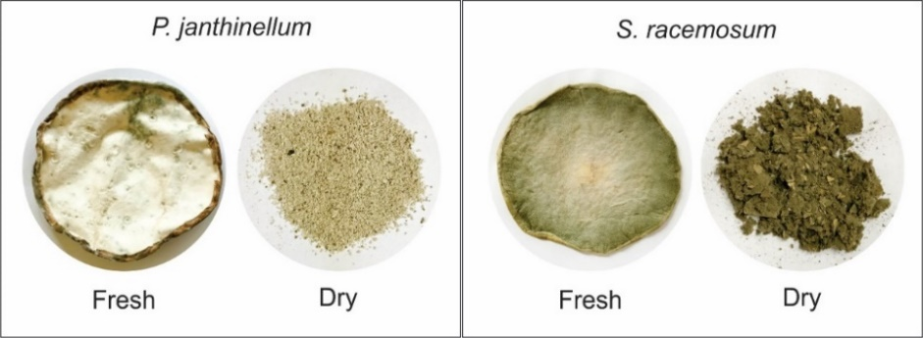*

Figure 1: Aspect of fresh and oven-dried biomasses of P. janthinellum and S. racemosum.

In the first set of experiments, bioremediation rates were determined during the first hour of contact between fungal biomass and iron ions. Percent iron removal was determined and results were compiled in Figure 2. Both species showed similar behavior, with greater variability within treatments than among species. For both species, there is a statistically significant tendency in the increment of iron removal along the first hour of treatment regardless of the use of fresh or dry biomass. However, drying and pulverizing fungal biomass resulted in better biomass-metal interaction. A statistically significant difference (p < 0.05) was observed between the activity of fresh and dry biomass of *P. janthinellum* achieving 23.2 ± 3.7 % and 49.7 ± 2.4 % of iron removal after 60 min, respectively. *S. racemosum* presented similar capacity for iron removal, achieving 39.1 ± 2.6 % and 45.4 ± 4.3 % when fresh and dry biomass were utilized (60 min). When compared to *P. janthinellum*, *S. racemosum* showed amore homogenous pattern of iron removal along the time between both biomass treatments, with no statistics difference after 40 and 60 min within and between biomass treatments (p > 0.05). According to these results, a relation can be established between the biomass morphology and the efficiency of iron removal. Since adsorption is an area-dependent mechanism, *S. racemosum*, being more voluminous, contributed with a larger adsorptive area both in the fresh and dry treatments. On the other hand, the compact structure of the fresh biomass of *P. janthinellum* demonstrated a lower efficiency contrasting to the fine powder-like dry biomass achieved after processing.

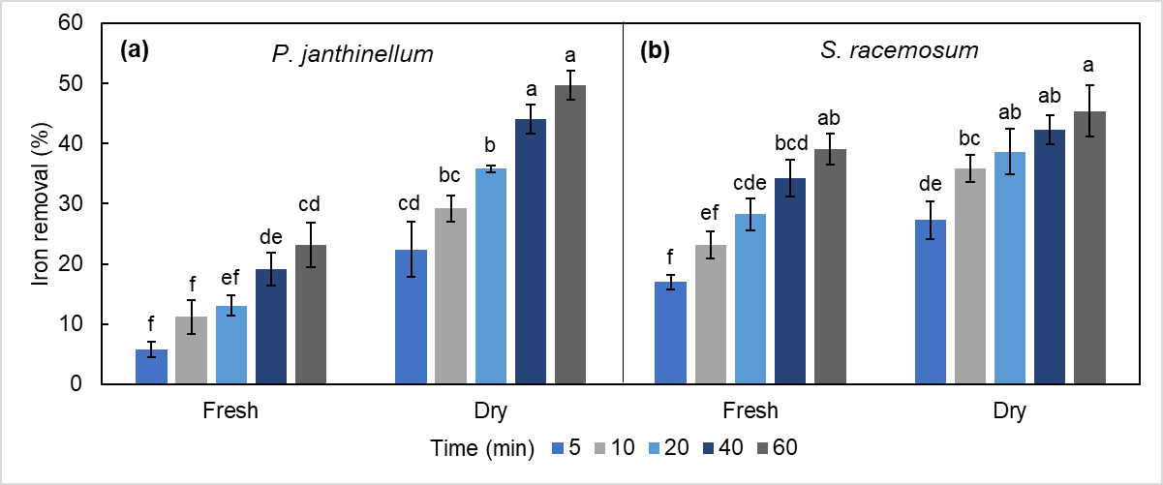

Figure 2: Iron removal percentages over 60 min by fresh and dry biomasses of (a) P. janthinellum and (b) S. racemosum. Columns with different letters are significantly different within the same species (ANOVA, Tukey test, p < 0.05).

The second set of experiments was executed for evaluation of the bioremediation capacity after 1 h of the experiment as well as the biomass saturation process along 96 h and percent iron removal can be observed in Figure 3. After the first 24 h, removal of iron from the aqueous environment increased, when compared to the first hour of treatment, independently of the species utilized. Higher percentages of iron ions removal were observed for the fresh biomass of *P. janthinellum* and *S. racemosum* (95.5 ± 1.3 % and 79.3 ± 4.7 %, respectively), in relation to the dry ones (89.9 ± 0.4 % and 68.8 ± 0.4 %, respectively). From 48 h of bioremediation, adsorption by both fresh and dry material was similar (p > 0.05). In terms of absolute values, *P. janthinellum* presented stabilization with 48 h, while for *S. racemosum* the adsorption process continued until 72 h. Regarding the exchange of biomass every 24 h during the four days of an experiment to evaluate biomass saturation, high removal percentages were achieved in the first 24 h and the difference between the two methodologies on subsequent days was not significant. Therefore, biomass saturation did not influence bioremediation in the experiments.

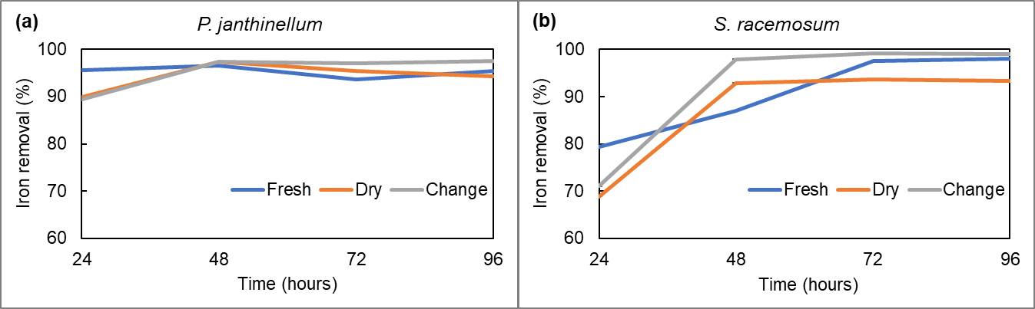

Figure 3: Iron removal percentages between 24 and 96 h with fresh and dry biomasses of (a) P. janthinellum and (b) S. racemosum.

In general, both microorganisms studied presented noticeable percentages of iron ions removal in the different states of the biomass (fresh or dry). Literature shows the effectiveness of using other non-pathogenic microorganisms as iron ions removal agents, such as the inoculum of the bacterium *Desulfovibrio marrakechensis*, which promoted removal of above 87.6 % in a solution containing 55 mg/L for Fe2+ after incubation in anaerobic bottles for seven days (Zhao et al., 2018).

The use of microorganisms as adsorbent materials, besides efficient, consists of green methodologies, since biomasses are biodegradable materials and the process involves minimum amounts of organic solvents (Martins et al., 2016). Physical processes such as filtration are not applicable in this situation, where the metal is dispersed in solution, and chemical processes such as flotation, although also very efficient, may generate secondary pollution due to the reagents used, requiring water recycling operations within the process (Jiang & Xu, 2017), thus increasing the difficulty and costs of treatment. Aiming industrial applications, the use of fresh biomass as a filter may be more interesting, due to the faster and lower cost of its production. Dry biomass used in the form of sachets, for example, becomes an attractive alternative in water pre-treatment, where adsorption is necessary for a short period. In this way, it can be inferred that in a few hours a satisfactory result can be obtained in the decontamination of environments, and may be sufficient depending on the iron content to be removed. Removal of higher contents of this metal ion would be also possible with the use of this biodegradable filter for a long time until reaching the biomasses saturation limit.

* 1. Conclusions

This work opens possibilities for the creation of filters for the removal of metallic ions of industrial, agricultural, or even domestic wastewaters using fresh or dry biomasses of *P. janthinellum* and *S. racemosum*. Both species proved efficiency in the accumulation of iron ions dispersed in solution on their surface (more than 90 % of removal, after 72 h, for both treatments). The form of treatment is highlighted depending on the speed required for the process and can be tailored for recovering water quality in situations like the previously referred disruption of a mining dam in Mariana city (Brazil). Bioremediation may even be a choice process to be used due to advantageous in relation to other processes like the low-cost of fungal biomass production and application of the green chemistry environmental principles.

Acknowledgments

The authors thank Brazilian Funding Agencies Conselho Nacional de Desenvolvimento Científico e Tecnológico (CNPq, Fellowship 304922/2018-8), Coordenação de Aperfeiçoamento de Pessoal de Nível Superior (CAPES), and to Fundação de Amparo à Pesquisa do Estado de Minas Gerais (FAPEMIG, Process APQ-02604-16), for financial help and scholarships.

References

Abbaspour N., Hurrell R., Kelishadi R., 2014, Review on iron and its importance for human health, Journal of Research in Medical Sciences: The Official Journal of Isfahan University of Medical Sciences, 19, 164.

Ahalya N., Kanamadi R.D., Ramachandra T.V., 2006, Biosorption of iron (III) from aqueous solution using the husk of *Cicera rientinum*, Indian Journal of Chemical Technology,13, 122–127.

Aly W., Williams I.D., Hudson M.D., 2013, Metal contamination in water, sediment and biota from a semi-enclosed coastal area, Environmental Monitoring and Assessment, 185, 3879–3895.

Amorim R.V.S., Melo E.S., Carneiro-da-Cunha M.G., Ledingham W.M., Campos-Takaki G.M., 2003, Chitosan from *Syncephalastrum racemosum* used as a film support for lipase immobilization, Bioresource Technology, 89, 35–39.

Bajgai R.C., Georgieva N., Lazarova N., 2012, Bioremediation of chromium ions with filamentous yeast *Trichosporon cutaneum* R57, Journal of Biology and Earth Sciences, 2, B70–B75.

Carvalho S.A., Coelho J.V., Takahashi J.A., 2010, Screening filamentous tropical fungi for their nutritional potential as sources of crude proteins, lipids and minerals, Food Science and Technology International, 16, 315–320.

Dominguete L.C.B., & Takahashi J.A., 2018, Filamentous fungi as source of biotechnologically useful metabolites and natural supplements for neurodegenerative diseases treatment, Chemical Engineering Transactions, 64, 295–300.

Harms H., Schlosser D., Wick L.Y., 2011, Untapped potential: exploiting fungi in bioremediation of hazardous chemicals, Nature Reviews Microbiology, 9, 177–192.

Horisberger M., & Clerc M.F., 1988, Ultrastructural localization of anionic sites on the surface of yeast, hyphal and germ-tube forming cells of *Candida albicans*, European Journal of Cell Biology, 46, 444–452.

Islam R., & Datta B., 2015, Fungal diversity and its potential in environmental clean up, International Journal of Research, 2, 815–825.

Jiang W.-L., & Xu H.-F., 2017, Treatment and recycling of the process water in iron ore flotation of Yuanjiacun iron mine, Journal of Chemistry Hindawi, 2017, 1–8.

Kousha M., Daneshvar E., Sohrabi M.S., Jokar M., Bhatnagar A., 2012, Adsorption of acid orange II dye by raw and chemically modified brown macroalga *Stoechospermum marginatum*, Chemical Engineering Journal, 192, 67–76.

Kumar A., Bisht B.S., Joshi V.D., Dhewa T., 2011, Review on bioremediation of polluted environment: A management tool, International Journal of Environmental Sciences, 1, 1079.

Leitão A.L., 2009, Pontential of *Penicillium* species in the bioremediation field, International Journal of Environmental Research and Public Health, 6, 1393–1417.

Leow C.W., Fan Y.V., Chua L.S., Muhamad I.I., Klemeš J.J., Lee C.T., 2018, A review on application of microorganisms for organic waste management, Chemical Engineering Transactions, 63, 85–90.

Liu Z., Cui F., Ma H., Fan Z., Zhao Z., Hou Z., Liu D., 2014, The transformation mechanism of nitrobenzene in the present of a species of cyanobacteria *Microcystis aeruginosa*, Chemosphere, 95, 234–240.

Lucas E.M.F., Machado Y., Ferreira A.A., Dolabella L.M.P., Takahashi J.A., 2010, Improved production of pharmacologically-actives sclerotiorin by *Penicillium sclerotiorum*, Tropical Journal of Pharmaceutical Research, 9, 365–371.

Malik A., 2004, Metal bioremediation through growing cells, Environment International, 30, 261–278.

Martins L.R., Lyra F.H., Rugani M.M.H., Takahashi J.A., 2016, Bioremediation of metallic ions by eight *Penicillium* species, Journal of Environmental Engineering, 142, C4015007-1–C4015007-8.

Oberholster P.J., Myburgh J.G., Ashton P.J., Coetzee J.J., Botha A.M., 2012, Bioaccumulation of aluminium and iron in the food chain of Lake Loskop, South Africa, Ecotoxicology and Environmental Safety, 75, 134–141.

Pinto A.P., Serrano C., Pires T., Mestrinho E., Dias L., Teixeira D.M., Caldeira A.T., 2012, Degradation of terbuthylazine, difenoconazole and pendimethalin pesticides by selected fungi cultures, Science of the Total Environment, 435, 402–410.

Segura F.R., Nunes E.A., Paniz F.P., Paulelli A.C.C., Rodrigues G.B., Braga G.U.L., Pedreira Filho W.R., Barbosa Júnior F., Cerchiaro G., Silva F.F., Batista B.L., 2016, Potential risks of the residue from Samarco's mine dam burst (Bento Rodrigues, Brazil), Environmental Pollution, 218, 813–825.

Sen S., & Charaya M.U., 2012, Screening of nickel-tolerant microfungi for bioremediation, Progressive Agriculture, 12, 63–68.

Soares E.V., & Soares H.M., 2012, Bioremediation of industrial effluents containing heavy metals using brewing cells of *Saccharomyces cerevisiae* as a green technology: A review, Environmental Science and Pollution Research, 19, 1066–1083.

Song D., Jiang D., Wang Y., Chen W., Huang Y., Zhuang D., 2013, Study on association between spatial distribution of metal mines and disease mortality: A case study in Suxian District, South China, International Journal of Environmental Research and Public Health, 10, 5163–5177.

Sutherland J.B., 1992, Detoxification of polycyclic aromatic hydrocarbons by fungi, Journal of Industrial Microbiology, 9, 53–61.

Wang X., & Xia T., 2015, New insights into disruption of iron homeostasis by environmental pollutants, Journal of Environmental Sciences, 34, 256–258.

Zhao Y., Fu Z., Chen X., Zhang G., 2018, Bioremediation process and bioremoval mechanism of heavy metal ions in acidic mine drainage, Chemical Research in Chinese Universities, 34, 33–38.