|  |  |
| --- | --- |
| cetlogo***CHEMICAL ENGINEERINGTRANSACTIONS***  ***VOL. 76, 2019*** | A publication of  aidiclogo_grande |
| The Italian Association  of Chemical Engineering  Online at www.cetjournal.it |
| Guest Editors:Sauro Pierucci,Jiří Jaromír Klemeš, Laura Piazza  Copyright © 2019, AIDIC Servizi S.r.l. **ISBN**978-88-95608-73-0;**ISSN** 2283-9216 | |

Thermodynamic model of geothermal resources for low-medium temperatures energy conversion process optimisation

Vitantonio Colucci\*a, Daniele Fiaschi a, Martina Levenib, Giampaolo Manfridaa, Lorenzo Talluria

a Industrial Engineering Department, Università degli studi di Firenze, Viale Morgagni 40, 50134 Firenze, Italy b Department of Industrial Engineering, University of Rome Niccolò Cusano, Via Don C. Gnocchi, 3 - 00016, Roma, Italy

\*vitantonio.colucci@unifi.it

Environmental and economic concerns are motivating manufacturers and public entities towards the use of renewable energy, which is continuously increasing its market penetration. Among the possible renewable energy resources, geothermal is particularly attractive compared to others such as solar and wind, mainly because of its continuity and dispatchability. Most studies in geothermal energy conversion systems model the resource as pure water or steam, while in reservoir simulations it is common practice to apply advanced geochemical modelling to estimate the long-term productivity. The presence of CO2 and saline equilibria may determine power plant optimisation conditions that differ from the ones which assume the resource as pure water or steam. The thermodynamic properties of the geothermal resource with high carbon dioxide (CO2) contents (1 to 8% in mass) within the 298 – 473 K temperature and 15 bar pressure are examined. The model applied focuses on the Equations of State (EoS) to be used in the calculation of the physical/thermodynamic properties of a mixture. The obtained results are validated through the comparison of different commercial software (UNISIM®, EES®, REFPROP®, TREND®). As an example, the Torre Alfina geothermal resource data (Middle Italy) are considered and the effects on the performance of a binary (ORC) geothermal power plant producing are examined in terms of energy and exergy efficiency. A sub-critical Iso-butane and a supercritical R134a power cycle are compared, and the advantages of the supercritical solution are demonstrated.

* 1. Introduction

Water and CO2 is a frequently occurring mixture in geothermal resources, in both cases of water and vapour- dominated reservoirs. The mix contains a wide range of concentrations, and CO2 is frequently coupled to other impurities and dissolved salts. The CO2- water mixture is challenging due to its polar nature, which induces difficulties because of their mutual influences during modelling. Physico-chemical properties of the mixture are essential in various industrial processes like oil recovery, geothermal power plants, carbon capture and storage and also supercritical extractions. Therefore, the knowledge of the thermo-physical properties of the CO2-water mixture is the key to the accurate design of efficient and reliable processes. The necessity of precise methods that contribute to having correct data in simulation programs represents a growth target for many companies in the short-mid-term (Hendriks et al., 2010). The phase equilibria of mixtures containing CO2, hydrocarbons, water and impurities like CH4, CO, H2O, H2S, N2 and O2 are also of particular importance in the petroleum and chemical industry (Dhima et al., 1999), (Tsivintzelis et al., 2011), where CO2 is injected into reservoirs to enhance oil recovery. The modelling and simulation of the phase equilibria for water and CO2 mixtures is an integral part of the analysis and detailed simulation of a geothermal power plant. Indeed, the selection of models has a significant impact on the decisions about process design, energy efficiency, economy and safety (Ibrahim et al., 2014). The results of the thermodynamic models to appropriately define the geothermal fluid were tested for a set of commercial or public-domain software. Pseudo-empirical equations of state for pure CO2 with simple structure just like *Span-Wagner* (Raimondi, 2014), *Redlich-Kwong* and *Peng-Robinson* EoS are typically accurate down to experimental error, at least in the temperature and pressure range for which they have been developed (Bjørner et al., 2016). However, some equations of state are difficult to extend to multicomponent systems. Even if the CO2 – water mixture has great importance in the process industry, no accurate thermodynamic modelling is used with classical EoS. For mixtures with CO2-low mass fraction (<2%) in a water-rich phase, alternatives can be the NIST REFPROP library or open-access codes such as TREND 3.0 (Span et al., 2016). Among state of the art are the Cubic-Plus-Association (CPA) and the Statistical Associating Fluid Theory (SAFT). The level of sophistication has a direct relationship with accuracy and computational software efficiency, which must be tailored to the specific conditions under investigation. The present work focuses on the thermodynamic modelling of CO2 – water mixtures referred to the Torre Alfina reservoir (Buonasorte et al., 1991 and 1988), and – in general – to the neighbouring region of Monte Amiata. The reservoir is characterised by an aquifer with a uniform 140 °C temperature, thanks to the presence of a well-developed convective circulation. The geothermal brine is mainly water, with a salinity of about 6 g/l and a weight CO2 content of about 2%. The data of the resource conditions are available on the website of the Italian Ministry of Economic Development (DCS-UNMIG, 2018) and through the documentation linked to the Environmental Impact Assessment available on the public web repository of the Ministry for the Environment and Protection of the Land and Sea. To evaluate the potential of different models CO2 –water mixtures, different models (UNISIM 3.rd order Mixture EoSs, EES, REFPROP and TREND 3.0) were tested over a wide range of conditions. The study mainly aims at identifying the correct model software to deal with the CO2- water mixture concerning similar geothermal fields.

* 1. Methodology
     1. Thermodynamic model – General assessment

The thermodynamic models adopted in this work are based on cubic Equations of State (EOS). The Peng-Robinson (PR) and Soave-Redlich-Kwong (SRK) are derived from the Van der Waals EOS, and they are commonly employed to represent the phase equilibria of hydrocarbon mixtures, as required by the petroleum industry. This classical cubic EOS is written in pressure explicit form as:

$P= \frac{RT}{v-b}- \frac{α\left(T\right)}{v\left(v+b\right)+b\left(v-b\right)}$ (1)

where v is the molar volume, $α\left(T\right)$ is the attraction parameter, b is the covolume and is calculated using the critical temperature (Tc) and the critical pressure (Pc) of the fluid:

$b=0,0778∙\frac{RT_{c}}{P_{c}}$ (2)

For non-polar molecules such as CO2, it is calculated by the Soave expression (Soave et al., 2010):

$α=α_{c}\left(T_{c},P_{c}\right)∙[1+m\left(1-T_{r}^{0,5}\right)]^{2}$ (3)

For polar molecules such as water, the Mathias – Copeman (MC) expression (Mathias et al., 1991) is used, according to the value of Tr. For the mixture, cubic EOSs utilise the Van der Waals mixing rules (Kwak and Mansoori, 1986):

$a_{mix}=\sum_{i}{\sum_{j}{x_{i}x_{j}a_{ij}}}$ (4)

$b_{mix}=\sum_{i}{\sum_{j}{x_{i}x_{j}b_{ij}}}$ (5)

where the cross energy $a_{ij}$ and cross-volume $b_{ij}$ parameters are calculated as:

$a_{ij}={\left(a_{i}a_{j}\right)}^{0,5}(1-k_{ij})$ (6)

$b_{ij}=\frac{1}{2}(b_{i}+b_{j})(1-l_{ij})$ (7)

The binary interaction parameters were taken from the Unisim® software database (Honeywell, 2017) after comparing them with literature data. SRK and PR EOSs typically are not accurate for mixtures containing polar compounds such as water (Bjørner, 2016). Substantial improvements were made to thermodynamic models over the last few years. The most advanced ones are based on the perturbation theory for compounds containing hydrogen, initially developed by Wertheim. When analysing the properties of geothermal mixtures, other models such as Cubic Plus Association (CPA; Kontogeorgis et al., 1996), PR-Twu and SRK-Twu have been identified in addition to the PR and SRK. The CPA model combines the SRK cubic EOS with an association term similar to that of SAFT (Bjørner et al., 2016). The CPA model can be written as the sum of two terms, based on the contributions of attractive and repulsive forces (SRK term) and hydrogen bonding interactions. The generated function is defined as:

$Ψ=Ψ^{phys}+Ψ^{assoc}$ (8)

The CPA function ($Ψ$) is:

$Ψ=\frac{α^{res}}{RT}=\int_{0}^{ρ}{(Z-1)\frac{dρ}{ρ}}$ (9)

Where $α^{res}$ is the molar residual Helmholtz energy, R is the gas constant, T is the temperature, $ρ$ is the molar density and Z is the compressibility factor. $α^{res}$ is defined as the difference between the Helmholtz energy of a mixture and that of a mixture of ideal gases at the same temperature, density and composition.The key p arameter in the association term is XAi, the mole fraction of the component. The general expression for the association contribution is:

$Ψ^{assoc}=\sum_{i}{x_{i}}\sum_{A}{(\ln{X^{Ai}}-\frac{X^{Ai}}{2}+\frac{1}{2})}$ (10)

$X^{Ai}$ can be estimated for a binary system as:

$X^{Ai}=\frac{1}{1+ρ\sum_{i}{x_{j}\sum_{B}{X^{Bj}Δ^{AiBj}}}}$ (11)

In which are involved the effective cross association volume, cross association energy and the association strength between the two components.

The kij uses a simple temperature dependence, referred to the reference temperature of 25 °C. In Unisim®, the binary parameters kij are determined from phase – equilibrium data regressions and the values of kij in the data bank can be different than those used with other models, such as SRK.

* 1. Results and discussion
     1. Water - CO2  properties: comparison among different models

The first check on the accuracy of different models was run for pure fluids (water and carbon dioxide). Using Unisim® and a cubic EOS SRK approach, and implementing the constants of Mathias-Copeman (MC) in the model for geothermal chemicals, the relative errors for two relevant pure-fluid properties (the saturation pressure and the phase-change enthalpy) are reported for CO2 and H2O in Figure 1. The reference data were calculated using the high-accuracy property data available through the EES software (Klein, 2017).

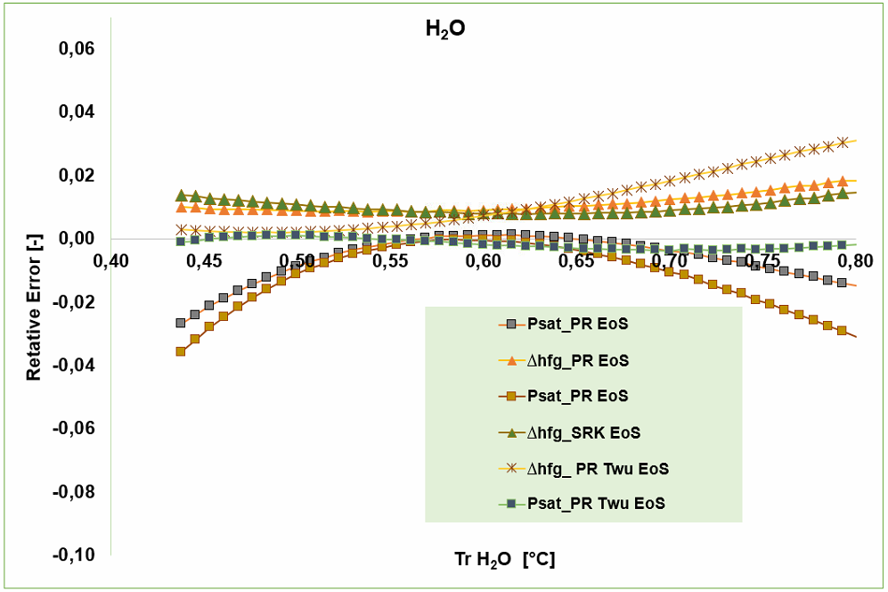

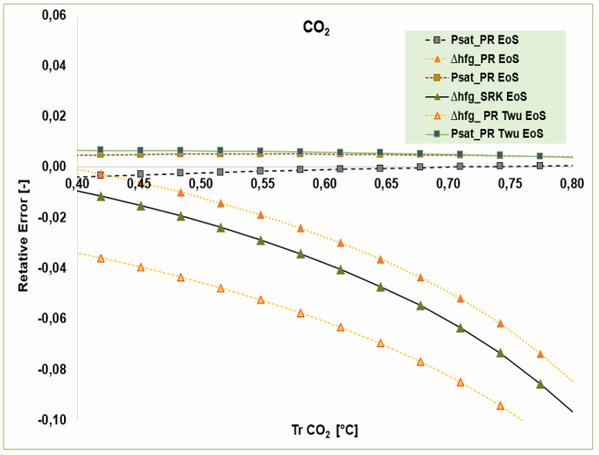

*Figure 1: UNISIM SRK-MCrelative errors for vapour pressure and phase change enthalpy for CO2 and water.*

The different EOS models for the CO2-water mixture were then evaluated within a range of low – medium pressures (1-44 bar), corresponding to conditions of the liquid phase at the temperature and carbon dioxide concentrations typical of the Torre Alfina geothermal resource.

The accuracy of calculation on mixture properties using a cubic EOS depends on the parameters adopted for pure substances and on the mixing rules. After having compared several thermodynamic models for the mixture, Unisim®, EES®, Refprop® and TREND 3.0 were retained as the possible best candidates for this specific geothermal resource.

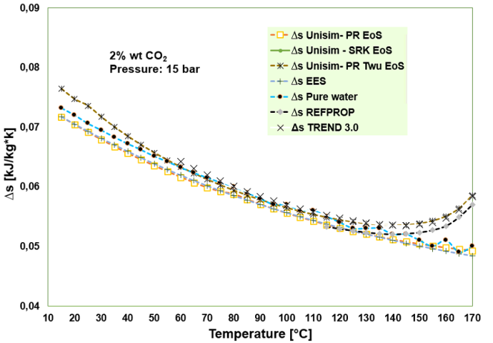

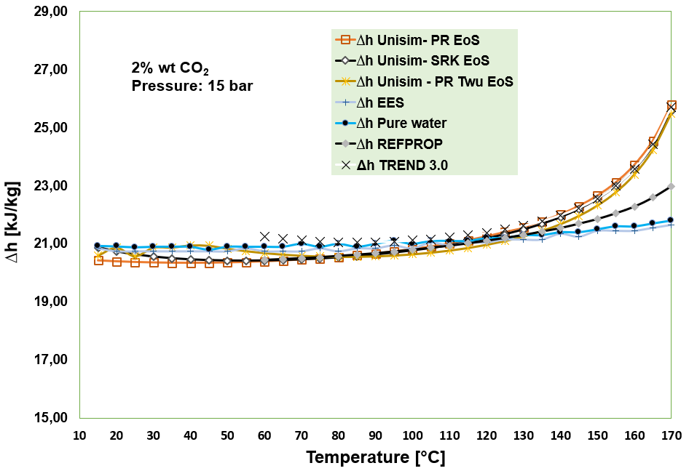

|  |  |
| --- | --- |
|  |  |

*Figure 2: Comparison of Δh and Δs of the 2% mass CO2 – water mixture for a ΔT = 5°C with different thermodynamic models, from 10 °C to 170 °C*

In Figure 2, the variations of enthalpy and entropy for a fixed *ΔT = 5°C* are compared in the whole liquid phase temperature range. The average error is less than 2%. Compared to pure water, even small concentrations of carbon dioxide influence the model results when the temperature gets close to the saturation conditions. Most models follow the same trends, and the effects of mixture enthalpy and entropy are satisfactory also in the critical temperature region for CO2. Investigations extended to CO2 mass fractions above 4% indicated that the CPA and SRK-Twu EoS achieve the best results under these conditions.

**3.2 Torre Alfina power plant case study**

The Torre Alfina (TA) area is a well-documented prospective geothermal site, selected by the Italian Ministry of Economic Development (MISE, 2019) as a suitable location to promote the development of new geothermal power plants with reduced environmental impact. The Italian national regulatory guidelines limit the power production of these pilot plants to 5 MWe. Therefore, the present study investigates a 5 MWe power plant on the Castel Giorgio-Torre Alfina site. The resource condition at the power plant inlet is sub-cooled liquid at about 140°C, 15 bar, and 2% CO2 content (Buonasorte et al., 1988).

To analyse the influence of CO2 content of the geothermal fluid on the power and efficiency of the future ORC power plant, a thermodynamic model was realised in EES environment (Klein and Nellis, 2012), with CO2-water mixture properties of the geothermal resource taken from Unisim® libraries. Figure 3 displays the ORC power plant layout, as well as the thermodynamic cycles and the heat exchanger composite curves. A sub-critical Iso-butane cycle and a supercritical R134a cycle were considered, this last to evaluate the benefits of utilising a supercritical cycle with a dominant liquid geothermal resource. In fact, conceptually the supercritical cycle allows better matching of the heat transfer curves; therefore, it could achieve higher values of energy and exergy efficiency compared to the sub-critical iso-butane cycle. The results (Table1, reporting the optimized conditions adjusting PupORC for each CO2 content, obtained fixing the minimum pinch point temperature difference at 5K) indicate that the influence of CO2 content in the geothermal fluid is not negligible, as it affects both the energy and exergy efficiencies. The energy efficiency is marginally affected by the CO2 content, with an increasing trend after a local minimum for 0.5% CO2 in the investigated range (0-8% CO2 in mass), which is due to the slightly higher heat input, derived from the higher mass flow rate of the resource. Also, the exergy efficiency displays a minimum (this time at 2% CO2), which is motivated by the higher exergy input to the cycle: in fact, the increase of CO2 content in the mixture modifies the thermodynamic properties, increasing the specific enthalpy marginally and lowering the entropy. The trend is similar for the supercritical R134a ORC cycle, which shows an advantage concerning the sub-critical iso-butane case of about two efficiency points for energy efficiency and nine efficiency points for the exergy efficiency.

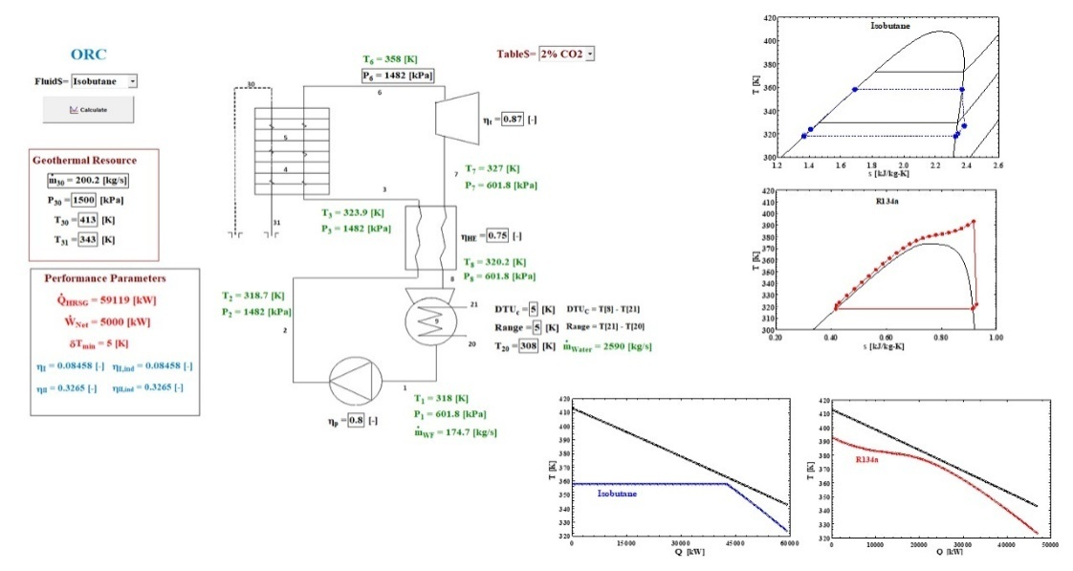

*Figure 3: Torre Alfina ORC power plant schematic, thermodynamic cycle and heat transfer curves*

*Table 1: Performance parameters of subcritical and supercritical simulations*

|  |  |  |  |  |  |  |  |
| --- | --- | --- | --- | --- | --- | --- | --- |
| **Isobutane – subcritical conditions** | | | | | | | |
| %CO2 |  |  |  |  |  |  |  |
| NO CO2 | 59326 | 200.7 | 89.09 | 19.41 | 8.43 % | 35.75% | 1477 |
| 0.5% CO2 | 59353 | 201.8 | 88.7 | 19.3 | 8.24 % | 35.71% | 1476 |
| 1% CO2 | 59187 | 200.8 | 92.55 | 19.2 | 8.45 % | 33.94% | 1480 |
| 2% CO2 | 59119 | 200.2 | 100.3 | 23.83 | 8.46 % | 32.65% | 1482 |
| 3% CO2 | 58631 | 198.3 | 108.1 | 31.54 | 8.53 % | 32.92% | 1495 |
| 4% CO2 | 58465 | 197.6 | 115.9 | 39.26 | 8.55 % | 33.02% | 1500 |
| 5% CO2 | 58336 | 196.9 | 123.7 | 46.98 | 8.57 % | 33.10% | 1503 |
| 6% CO2 | 57822 | 195 | 130.5 | 53.77 | 8.65 % | 33.40% | 1518 |
| 7% CO2 | 57692 | 194.4 | 130.1 | 53.27 | 8.67 % | 33.48% | 1522 |
| 8% CO2 | 57564 | 193.8 | 129.7 | 52.76 | 8.69 % | 33.56% | 1525 |
| **R134a – supercritical conditions** | | | | | | | |
| %CO2 |  |  |  |  |  |  |  |
| NO CO2 | 47149 | 159.5 | 89.09 | 19.41 | 10.60% | 44.98% | 4744 |
| 0.5% CO2 | 47148 | 160.3 | 88.7 | 19.3 | 10.60% | 44.95% | 4744 |
| 1% CO2 | 47005 | 159.5 | 92.69 | 19.18 | 10.64% | 42.66% | 4718 |
| 2% CO2 | 46909 | 158.8 | 100.4 | 23.81 | 10.66% | 41.12% | 4701 |
| 3% CO2 | 46777 | 158.2 | 108.1 | 31.54 | 10.69% | 41.27% | 4675 |
| 4% CO2 | 46653 | 157.7 | 115.9 | 39.26 | 10.72% | 41.38% | 4649 |
| 5% CO2 | 46537 | 157.1 | 123.7 | 46.98 | 10.74% | 41.49% | 4622 |
| 6% CO2 | 46427 | 156.6 | 130.5 | 53.77 | 10.77% | 41.60% | 4595 |
| 7% CO2 | 46323 | 156.1 | 130.1 | 53.27 | 10.79% | 41.70% | 4568 |
| 8% CO2 | 46226 | 155.6 | 129.7 | 52.76 | 10.82% | 41.79% | 4540 |

* 1. Conclusions

In the present work, different possible models of CO2 – water mixtures, based on different real-fluid EOS and mixture interaction models, were investigated. Reference middle Italy geothermal fields (located between southern Tuscany and Latium) were examined, having a typically high CO2 content up to 8%. The reference case was the specific Torre Alfina geothermal site (2% mass CO2, 15 bar wellhead pressure, 140°C). Several different possible EoS and mixing rules, implemented by proprietary calculation tools within different modelling environments, were compared for a range of CO2 mass concentrations (1 to 8%), in the 288 – 443 K and 1 – 44 bar temperatures and pressures ranges respectively, corresponding to CO2 dissolved in the liquid phase. The average relative errors in the calculations of entropy and enthalpy functions were generally less than 2%; however, even small concentrations of CO2 in the mixture can influence the results to some extent. In general, a marginal increase in performance was found at increasing concentrations of CO2: the influence of CO2 content in the geothermal fluid resulted in being very small for thermal efficiency but more relevant for exergy efficiency, with a minimum condition found at 2% CO2 content, which is determined by the different exergy of the resource at power plant inlet.

The comparison between the performance achieved with two 5 MWe binary cycles, a supercritical R134a and a subcritical Isobutane, evidenced the attractiveness of the former, due to the better matching of the resource – working fluid heat transfer curves.

Acknowledgements

Validation of CO2 properties over a full range of possible resource conditions is a task of the H2020 GECO project (Grant Agreement n° 818169).

References

Bjørner, M. G., & Kontogeorgis, G. (2016). Thermodynamic modelling of CO2 mixtures. Kgs. Lyngby: Technical University of Denmark (DTU).

Buonasorte, G., Cataldi, R., Pandelli, E., Fiordalisi, A. The Alfina 15 well: Deep Geological data from Northern Latium (Torre Alfina Geothermal area) (1991).

Buonasorte, G.,Cataldi,R., Ceccarelli, A. et al. Ricerca ed esplorazione dell’area geotermica di Torre Alfina

(Lazio). Boll.Soc.Geol.It. (1988).

Dhima, A., de Hemptinne, J.-C., and Jose, J.Solubility of Hydrocarbons and CO2 Mixtures in Water under High Pressure Ind. Eng. Chem. Res. 38(8), 3144-3161 (1999).

Hendriks, E., Kontogeorgis, G.M., Dohrn, R., de Hemptinne, J.C., Economou, I.G., Zilnik, L.F., Vesovic, V.,

2010. Industrial requirements for thermodynamics and transport properties. Ind. Eng. Chem. Res., 49(22), 11131–11141.

Honeywell International. Unisim® Design, Simulation Basis Reference Guide (2017) A1-A79

Ibrahim, M., Skaugen, G., Ertesvag, I.S., Haug-Warberg, T. Modelling CO2- water mixture thermodynamics using various equations of state (EoSs) with emphasis on the potential of the SPUNG EoS. ChemicalEngineering Science 113:22–34 (July 2014)

Klein, S.A., Nellis, G.F., Mastering EES, f-Chart software, 2017

Kontogeorgis, G.M., Voutsas, E., Yakoumis, I,& Tassios, D.P. (1996). An Equation of State for associating

Fluids. Ind.Eng.Chem.Res., 35, 4310.

Kwak, T.Y., Mansoori, G.A. Van Der Waals mixing rules for cubic equations of state. Applications for supercritical fluid extraction modelling. Chemical Engineering Science, Volume 41, n°5 (1986) 1303.1309

Mathias, P.M., Klotz, H.C., Prausnitz, J.M. Equation of state mixing rules for multicomponent mixtures: the

problem of invariance. Fluid Phase Equilibria, Vol 67, (1991) 31-44

Ministero dello sviluppo economico – DGS-UNMIG <http://unmig.mise.gov.it/unmig/geotermia/inventario.asp>

(Accessed February 14, 2018).

Ministero dello sviluppo economico – DGS-UNMIG <http://unmig.mise.gov.it/unmig/geotermia/pozzi/pozzi.asp>

(Accessed February 14, 2018).

Ministero dello sviluppo economico, Titoli minerari ed impianti, available at: <https://unmig.mise.gov.it/index.php/it/dati/cartografia/titoli-minerari-e-impianti>, last accessed 04/02/2019.

Raimondi. L. CO2 transportation with pipelines- model analysis for steady, dynamic and relief simulation.

Chemical Engineering Transactions, vol.36, 2014.

Soave, G., Gamba, S., Pellegrini, L.A. Predicting binary interaction parameters of hydrocarbons and related

compounds. Fluid Phase Equilibria 299 (2010) 285-293

Span, R., Eckermann, T., Herrig, S., Hielscher, S., Jager, A., Thol, M. (2016): TREND. Thermodynamic

Reference and Engineering Data 3.0. Lehrstuhl fuer Thermodynamik, Ruhr-Universitaet Bochum.

Tsivintzelis, I., Kontogeorgis, G. M., Michelsen, M. L., and Stenby, E. H. Modeling phase equilibria for acid gas

mixtures using the CPA equation of state. Part II: Binary mixtures with CO2. Fluid Phase Equilib. 306(1), 38

– 56 (2011).