|  |  |
| --- | --- |
| cetlogo ***CHEMICAL ENGINEERING TRANSACTIONS***  ***VOL. 76, 2019*** | A publication of  aidiclogo_grande |
| The Italian Association  of Chemical Engineering  Online at www.cetjournal.it |
| Guest Editors: Sauro Pierucci, Jiří Jaromír Klemeš, Laura Piazza  Copyright © 2019, AIDIC Servizi S.r.l. **ISBN** 978-88-95608-73-0; **ISSN** 2283-9216 | |

Development of a low-cost digital image correlation system to evaluate the behaviour of thermoplastics at large deformation

Ayrton A. C. Pereira\*, José R. M. d’Almeida

aChemical and Materials Engineering Department, Pontifícia Universidade Católica do Rio de Janeiro, Rua Marquês de São Vicente, 255 – Gávea – 22453-900, Rio de Janeiro, RJ, Brazil.

pereira.ayrton@gmail.com

Among the main optical methods digital image correlation (DIC) can be highlighted. Although DIC development is relatively recent, the advantages offered by this method make it equally competitive with other classical optical techniques that suffer from intrinsic limitation. The need for global field measurements is especially true in situations where the loading conditions create a heterogeneous strain field. Thus, DIC has been presented as the most adequate measurement technique for studying the behavior of polymeric materials exposed to large deformation. As a consequence of their inherent characteristics, polymers have been increasingly used in engineering applications, especially thermoplastics. Allied to its low density, which provides a considerable weight reduction and an increase of efficiency in many applications, polymers also have easy processability and good mechanical properties. Thus, a precise knowledge of polymers behavior is needed in order to improve their use capabilities. Despite DIC consistent evolution, especially in the image acquisition system, it is still an inaccessible optical measurement technique due to the high price of digital processing and image correlation software. Therefore, the present work aims to develop a low-cost digital image correlation (DIC) system to evaluate thermoplastic behavior at large deformations. In order to improve the discussion three different types of polymers were tested: high density polyethylene (PE-HD), polypropylene (PP) and polyvinyl chloride (PVC).

* 1. Introduction

DIC is characterized by being a simple and reliable optical technique for full-field measurements. In principle, DIC technique measures the displacement field by images acquired at different stages of loading (Wittevrongel, Badaloni, Balcaen, Lava, & Debruyne, 2015). Depending on what is going to be measured and the geometry of the object to be measured, DIC has evolved into three different segments: (i) 2D-DIC, used for full-field measurements on the plane, (ii) 3D-DIC, which is more robust than 2D-DIC making use of a stereo configuration of the cameras and allowing full-field measurements on non-flat surfaces, and (iii) V-DIC, which enable volumetric measurements (Sutton, Orteu, Schreier, & Reu, 2012).

Although 2D-DIC is limited to measurements in the plane, this is one of the most popular measurement techniques (Pan, Qian, Xie, & Asundi, 2009). Some intrinsic advantages of 2D-DIC make it immensely attractive in full-field measurements like its simple experimental setup, its minimal experimental environment requirements and its ability to perform measurements within a wide range of resolutions and different sensitivities (Grédiac, Hild, & Pineau, 2012; Khoo, Karuppanan, & Tan, 2016; Pan et al., 2009; Sutton et al., 2012; Wittevrongel et al., 2015).

During the last decades, DIC methodology has been immensely investigated and significantly improved, having its computational complexity reduced and its accuracy increased, thus causing an expansion in its universe of applications (Grédiac et al., 2012; Jin, Jang, & Yi, 2018; Pan et al., 2009; Wittevrongel et al., 2015). DIC can be used for full-field measurements from microscopic to macroscopic scale, from simple to complex geometries, under controlled laboratory conditions to severe field conditions, and from common metal to peculiar composites (Grédiac et al., 2012; Park, Yoon, Kwon, & Park, 2017).

The proper identification of the mechanical properties of different types of materials requires appropriate deformation measurement techniques. The need for full-field measurements is especially true in situation where the loading conditions create a heterogeneous complex strain field in the sample. Regarding this, DIC has been presented as the most adequate measurement technique for the investigation of polymeric materials behaviour at large deformations. The macromolecular structure of polymers leads then to present a unique behaviour, especially at large deformations. As polymers have more complicated deformation and failure mechanisms, the experimental results must be especially reliable, depending on the precise measurement of the strain (Kidd, Zhuang, & Ravichandran, 2012; Nunez, Bernal, Mauledoux, & Aviles, 2017). Although until yield most of the polymers deform homogeneously, after this, due to necking, the strain field becomes heterogeneous, making the use of classical measurement experimental techniques, such as extensometry, inadequate (Dudescu, 2015).

Although DIC has experienced a prominent evolution, especially in the image acquisition system due to the advent of higher resolution and lower cost cameras, it is still a not accessible measurement technique due to the high price of commercial digital image processing solutions. Despite the fact that there are a variety of free software that offer a bunch of different modules of processing and correlation, the development of solutions for the measurement of materials that show high ductility is still incipient, delivering a robustness, in most cases, insufficient for a reliable evaluation of the mechanical behaviour. Thus, there is a gap for the development of cost-effective DIC systems for the evaluation of polymers at large deformations.

Therefore, the present work aims to develop a low-cost digital image correlation (DIC) system to evaluate thermoplastic behavior at large deformations. The DIC system was basically composed by a semiprofessional DSLR camera, a zoom lens and a personal computer. Acquired images were processed by a free digital image processing software, ImageJ, and displacement and strain filed were calculated using GOM Correlate.

* 1. Materials and methods
     1. Specimens preparation

In order to analyze the general mechanical behavior presented by thermoplastic polymers, three polymers were selected for testing, high density polyethylene (PE-HD), polypropylene (PP) and polyvinyl chloride (PVC). The polymers were purchased from *Incomplast* in the form of rectangular plates with 2 m of length, 1 m of width and 1 mm of thickness. From the plates, a total of 15 specimens were machined, five for each type of polymer, according to ASTM D638.

The use of DIC technique requires that specimen surface exhibits a random texture. None of the machined specimen exhibited a surface with such characteristics. Thus, spray painting method was used. It was difficult to reach an adequate speckle pattern. Preliminary tests were performed to check paints adhesion. *Colorgin Plastic White* and *Suvinil Multipurpose Black* spray paints were used. Even taking all the care of cleaning specimen surface prior to the application of the paint, waiting the minimal time of drying between coats, and using different spray conditions, the resulting speckle pattern did not show the adhesion and toughness required at large deformation, detaching from specimen surface and reducing to tiny particles when drawn.

As the machined specimens naturally had a white surface, it was decided to ignore the application of the white paint and directly spray the black paint onto the specimen surface immediately after cleaning. Although the reproduction of the same pattern in all tested specimens was stated as a primary objective, the control over spraying was difficult and in the end each specimen presented almost a singular speckle pattern. As the black paint was sprayed partially covering the specimen surface, the particles adhered to the surface had greater freedom of movement according to specimen deformation. Thus, the lack of adhesion and toughness exhibited previously by black and white coat were overcome, reaching a speckle pattern that remained fixed and mutual dependent of the specimen surface even at large deformations. Even far from the ideal contrast, the obtained texture was sufficient for the process of image correlation, making possible to obtain the strain field.

* + 1. Experimental Setup

Figure 1 shows the experimental setup used for 2D-DIC. All devices were selected considering a compromise between cost, flexibility and image quality. For the acquisition of digital images, *Nikkon D3400* semiprofessional DSLR camera and zoom lens *AF-S DX Nikkor 18-105 mm f/3.5-5.6 ED VR* have been selected. Considering commercial cameras, DSLR semiprofessional cameras are those that present a better balance between the three attributes previously highlighted. Semiprofessional cameras allow a creative control on several acquisition parameters compared to compact cameras and, although do not reach similar image quality compared to professional cameras, they are able to obtain suitable images for the DIC analysis while being substantially cheaper. In terms of flexibility, zoom lens allow the use of different focal lengths from wide-angle (18 mm), providing a wider viewing angle and covering most of the scene, to long-focus (105 mm), resulting in a narrower viewing angle and greater details of the object of interest, offering a wide field of application. Although zoom lens cannot achieve the image quality of prime lens, the high-performance of the optical system of the selected lens featuring an ED (Extra-low Dispersion) glass element and an aspherical lens element, is able to guarantee high resolution and contrast, while minimizing astigmatism and other forms of distortion, making the selected lens competitive in quality. A good lighting can be as important as the acquisition system. Thus, two *Ourolux SuperLED* lamps with 8W each and 6500K cold white color were used.

Prior to image acquisition, special care was taken with the correct alignment and positioning of the various devices. From the geometric relations that need to be guaranteed in 2D DIC, it can be highlighted the correct alignment between (i) camera and specimen, (ii) specimen and testing machine and (iii) light sources and specimen. The camera shall have its optical axis positioned perpendicular to specimen surface, reducing possible effects caused by out-of-plane motion, and aligned to the center of the region of interest, minimizing the contribution of lens distortion that increase as the object of interest moves away from the center of the image. Perpendicularity between the camera and specimen surface was guaranteed by using a laser and a mirror following the procedure described by Gao et. al (Gao, Xu, Su, & Zhang, 2016). For camera and region of interest alignment *DigiCamControl* software was employed. Equally to the procedure of centering the optical axis of the camera with region of interest, real time images captured by *DigiCamControl* were used for align specimen and testing machine. In addition to the alignment of the camera with specimen and the specimen with testing machine, the spatial distribution of light sources may interfere significantly in image quality. The two LED lamps were arranged symmetrically in front of the testing machine, with their bulbs adjusted to the sides of the testing machine column and with a slope of 40º to the bench. With this arrangement it was possible to achieve a good diffusion of light over the while testing area, without shadows, reflections or gradients of light in the specimen.

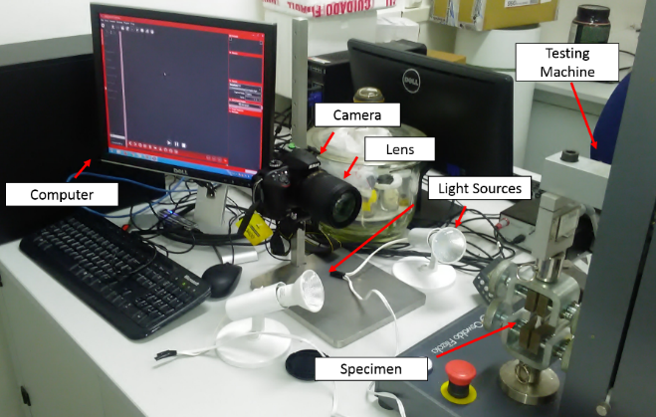

Figure 1.Experimental setup.

* + 1. Mechanical test and image acquisition

After the adequate preparation of the test specimens and the correct positioning and alignment of the devices, the specimens were submitted to tensile test. The tensile test was performed in *Oswaldo Filizola Universal Testing Machine* (AME-2kN) according to ASTM D638. The control over the entire test was performed using *DynaView Standard ProM* allowing the record of the load throughout the testing time. Specimens were subjected to a constant test speed of 10 mm/min at room temperature (23ºC) and 50% relative humidity. In order to improve the alignment and minimize the effect of possible gaps between testing machine components, a preload of 30N was applied. An initial distance of 70 mm between grips was adopted. It is important to note that not all the materials were brought to rupture. PVC specimens were the only ones to break. PP and PE-HD specimens exhibited high ductility, reaching the maximum displacement allowed by the testing machine, which caused the test to be forcibly stopped before specimen’s rupture.

To obtain the strain field, images were captured concomitantly with tensile test. *DigiCamControl* was used for image acquisition. To reach optimal exposure, camera’s internal photometer was employed and aperture priority (A) programming mode was selected. Aperture and ISO were set to f/3.5 and ISO100 respectively. Approximately 400 images were captured for each specimen with a frame rate of 0,67Hz.

* + 1. Processing and image correlation

The main objectives of image processing were to convert the captured image file format so that it could be read by the correlation software and to optimize the size of the captured images, giving agility to the whole process of digital image correlation. For images file format conversion *IrphanView* software was used. For the subsequent crop of the region of interest and 8-bit conversion, the *ImageJ* software was employed. It is important to emphasize that although the final processed image size was drastically reduced compared to the raw image, the quality loss was minimal.

For digital image correlation, *GOM Correlate* software was used. Although it is a commercial software, *GOM Correlate* provides free tools for 2D DIC that supports the evaluation of digital image series or movie files. It is important to note that prior to the use of *GOM Correlate*, completely freeware solutions, such as *NCorr* and *DICe* (*Digital Image Correlation engine*) were tried to be used for digital image correlation. However, neither of them presented satisfactory results, having difficulties to generate the mesh and subsequent calculation of strain field at large deformations.

Due to the heterogeneous strain field formed during necking, preference was given to smaller subset sizes. As a result of the uniqueness of the speckle pattern obtained at each specimen surface, different subset sizes were used. Basically, the subset size was defined according to the characteristics of the mesh obtained. Subset sizes that led to “problematic” meshes, with voids or irregular borders, were discarded. In all tests, the software default configuration was used to obtain the final mesh. In order to calculate the deformation, a surface component was created in order to obtain the strain filed in the gage section, and a longitudinal extensometer was simulated to depict the strain measurements obtained if a classical measurement technique have been employed (Figure 2).

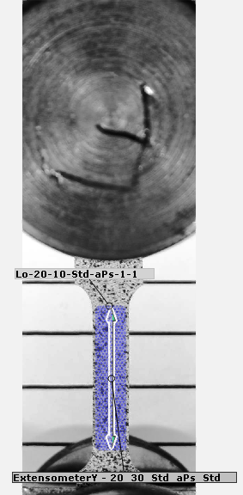

Figure 2. Surface component created and longitudinal extensometer simulated.

* 1. Results and discussions

Figure 3 shows the tensile behavior of polymers tested in terms of true stress and true strain. It was clear the difference between the measurements obtained by the simulation of the longitudinal extensometer and the DIC technique. Although for small deformations, there was no distinction between the strain obtained for both methods, after yielding, the data obtained by the extensometer showed a more abrupt stress drop compared to the data achieved by 2D-DIC. The inconsistency in the measurements can be associated with neck initiation. With neck formation there is an appearance of a localized strain field. Although DIC can monitor this phenomenon closely, measuring the localized strain with accuracy and precision, extensometer only allows the calculation of the mean strain obtained across the gage length, reflecting a minor strain compared with the DIC technique. It is important to emphasize that with the propagation of the neck, due to the continuous application of the load, at the end, a homogeneous strain field was one more time obtained and extensometer and DIC measurements met again.

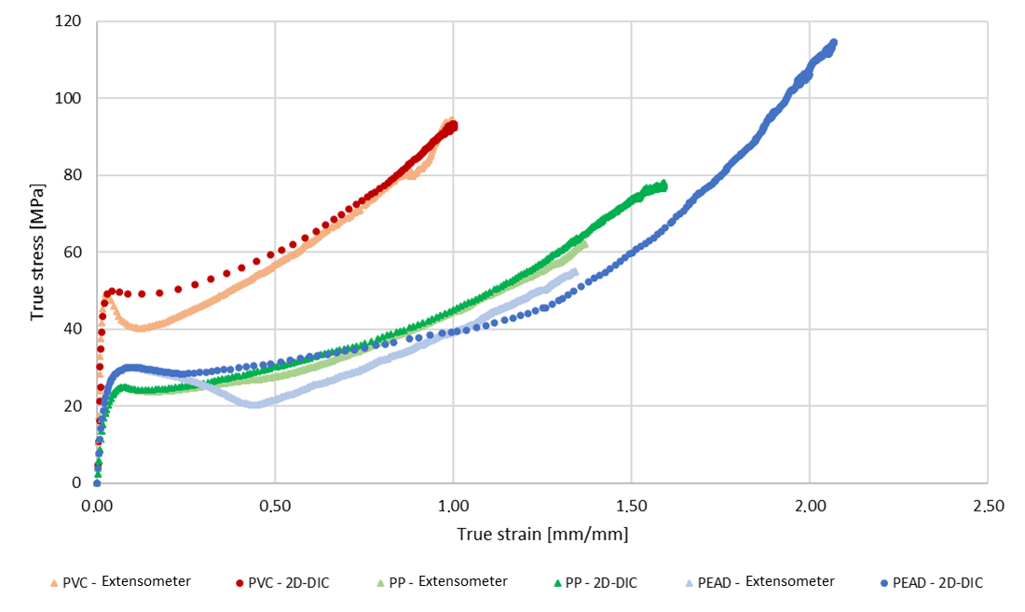

Figure 3. True stress-strain curves for PVC, PP and PE-HD. Darker curves were obtained by 2D-DIC, while lighter curves were measured by the longitudinal extensometer.

The polymers exhibited a markedly different behavior. PVC presented a greater stiffness compared to PP and PE-HD, while PP and PE-HD showed a remarkedly ductility. PVC exhibited a pronounced stress peak at yield, while PP and PE-HD showed a less abrupt yield transition. PVC, PP and PE-HD are semicrystalline polymers as so are extremely dependent on the test temperature. PP and PE-HD have relatively low glass transition temperature (-125ºC for PE-HD and -30ºC for PP (Wypych, 2012)) compared to the test temperature (T = 23ºC), thus presenting a rubber-like behavior, while PVC has a relatively high glass transition temperature (50ºC (Wypych, 2012)) compared to the test temperature (T=23ºC), exhibiting the behavior of a glassy polymer.

Figure 4a shows the macroscopic behavior exhibited by PVC. As the PVC was the only polymer tested that was leaded to rupture, it presented all the deformation stages characteristic of a semicrystalline polymer: elastic deformation, yielding, cold-drawing and strain hardening. At low deformations, the polymer has deformed homogeneously following Hooke’s Law. As the elongation proceeded, there was a reduction in the cross-section resulting in a strain localization and a sharp increase of strain rate, which leaded to the formation of a neck. Neck initiation is usually associated with yielding. During cold-drawing the neck stopped to become thinner at a localized spot and started to propagate through all the specimen. It is important to note that before the neck consumed all specimen gage length, second neck was formed at the top of specimen cross section. Propagating in opposite directions, the necks met near the center of the specimen giving rise to a homogeneous strain field. Then finally strain hardening takes place and the specimen failure.



**(a)**



**(b)**

Figure 4. (a) Strain rate obtained along the tensile test by the simulated extensometer, critical section and the direct displacement of testing machine grips. (b) Macroscopic mechanical behaviour of PVC samples obtained along the tensile test.

Figure 4b shows the strain rate obtained along the entire tensile test. To illustrate the constant displacement speed imposed to the specimen by the testing machine along the test, the strain rate associated with testing machine were also presented. It can be seen that both extensometer and 2D-DIC has leaded to the same measurement of strain rate at the beginning of the test. Although the measurements were the same, it was lower compared to the machine imposed strain rate. This misfit may be a consequence of gaps and components compliance of the testing machine, resulting in a delay in the mechanical behavior shown by the specimen. As soon as the neck initiated and the strain became localized, the measurements between extensometer and 2D-DIC were completely dissociated. While the extensometer measured the mean strain rate imposed on the entire system equivalent to the testing machine, the 2D-DIC was able to depict the localized increase in strain rate due to neck initiation. It can be verified that the maximum strain rate was reached when the neck stabilized and a minimum cross section was reached. With the subsequent neck propagation, strain rate measured by DIC decreased continuously until a minimum level. An offset from extensometer and testing machine results was maintained. Near the end of the tensile test, the measurements performed by the extensometer and 2D-DIC met again.

* 1. Conclusions

The low-cost 2D-DIC system has proved to be adequate to evaluate thermoplastics at large deformation. The developed DIC system was composed mainly by a *Nikkon D3400* semiprofessional DSLR camera and a zoom lens *AF-S DX Nikkor 18-105 mm f/3.5-5.6 ED VR*. A pair of LED lamps were used to illuminate the specimens and a special care was taken with the correct positioning and alignment of DIC components. *GOM Correlate software* was used for digital image correlation and evaluation of the strain fields. 2D-DIC showed a superior capacity in describing the intrinsic behavior exhibited by the different polymers tested compared to extensometer. All deformation stages could be portrayed and macroscopic mechanical behavior analyzed. PP and PE-HD showed a rubber-like behavior, while PVC exhibited characteristics of a glassy polymer.

Acknowledgments

This work was supported by the Brazilian funding agencies, Conselho Nacional de Desenvolvimento Científico e Tecnológico (CNPQ) and Coordenação de Apefeiçoamento de Pessoal de Nível Superior.

References

Dudescu, M. C., 2015, Optical Methods in Experimental Mechanics of Solids. Technical University of Cluj-Napoca, Cluj-Napoca, Romania.

Gao, Z., Xu, X., Su, Y., Zhang, Q., 2016, Experimental analysis of image noise and interpolation bias in digital image correlation, Optics and Lasers in Engineering, 81, 46–53.

Grédiac, M., Hild, F., Pineau, A. (Eds.), 2012, Full-Field Measurements and Identification in Solid Mechanics, John Wiley & Sons, New York, USA.

Jin, Z., Jang, C., Yi, Y., 2018, Application of digital image technology in material property test, Chemical Engineering Transactions, 66, 919-924.

Khoo, S.-W., Karuppanan, S., Tan, C.-S., 2016, A review of surface deformation and strain measurement using two-dimensional digital image correlation, Metrology and Measurement Systems, 23(3), 461–480.

Kidd, T. H., Zhuang, S., Ravichandran, G., 2012, In situ mechanical characterization during deformation of PVC polymeric foams using ultrasonics and digital image correlation, Mechanics of Materials, 55, 82–88.

Nunez, D., Bernal, A., Maledoux, M., Aviles, O., 2017, Analysis of mechanical behavior of a device made of poly L lactide acid for reconstruction of phalanx fracture, Chenical Engineering Transactions, 57, 1357-1362.

Pan, B., Qian, K., Xie, H., Asundi, A., 2009, Two-dimensional digital image correlation for in-plane displacement and strain measurement: a review, Measurement Science and Technology, 20(6), 1–17.

Park, J., Yoon, S., Kwon, T. H., Park, K., 2017, Assessment of speckle-pattern quality in digital image correlation based on gray intensity and speckle morphology, Optics and Lasers in Engineering, 91, 62–72.

Sutton, M. A., Orteu, J. J., Schreier, H. W., Reu, P., 2012, Introduction to digital image correlation: Best practices and application, Experimental Techniques, 36(1), 3–4.

Wittevrongel, L., Badaloni, M., Balcaen, R., Lava, P., Debruyne, D., 2015, Evaluation of Methodologies for Compensation of out of Plane Motions in a 2D Digital Image Correlation Setup, Strain, 51(5), 357–369.

Wypych, G., 2012, Handbook of Polymers. Handbook of Polymers, Elsevier, Toronto, Canada.