|  |  |
| --- | --- |
| cetlogo ***CHEMICAL ENGINEERING TRANSACTIONS***  ***VOL. 76, 2019*** | A publication of  aidiclogo_grande |
| The Italian Association  of Chemical Engineering  Online at www.cetjournal.it |
| Guest Editors: Sauro Pierucci, Jiří Jaromír Klemeš, Laura Piazza  Copyright © 2019, AIDIC Servizi S.r.l. **ISBN** 978-88-95608-73-0; **ISSN** 2283-9216 | |

Fostering value creation in the Oil & Gas Industry through safety-related investments

Stefano Milanese\*, Emanuele Salvador, Stefano Decadri, Riccardo Ratti, Michele Piola

Arthur D. Little S.p.A., Corso Monforte 54, 20122 Milan (Italy)

\*milanese.stefano@adlittle.com

Oil & Gas companies have suffered in recent years due to low oil prices and high volatility; the consequent impact in revenues has led to increasing pressure on investments throughout the sector.

In addition, in some regions (e.g. developed countries) the issue of asset ageing is emerging, to a point that Companies search for ways to increase asset life far beyond its original design life.

Lastly, increasingly stringent regulations and best practices require continuous improvements in safety standards such as Seveso III (2012/18/EU), energy efficiency and emission levels (European Commission, 2018).

Therefore, Oil & Gas companies are now facing a challenging choice, as far as old assets are concerned:

* decommissioning and shut down, or
* implementation of large investments into plant upgrade and/or revamping.

In such a complex context, it is essential to adopt structured approaches and methodologies to support management decision-making process, particularly in selecting and prioritizing investment options that will create value for Companies in the future.

The paper will present a value-based approach for the evaluation of investment options in Oil & Gas Plants, based on a probabilistic method to determine the benefits associated to safety-related investments, to be prioritized according to associated costs. The approach was implemented in a leading multinational company, with over than 10 sites in Europe, where an extensive SIL (Safety Integrity Level) analysis program has been developed and deployed.

* 1. Introduction

In the recent years, the Oil & Gas context – both Upstream and Downstream – faced several changes due to limited resources, assets ageing (Oil&Gas UK, 2014) and stringent standards. Following the price drop in mid-2014, Brent has firstly gone above $70 in early 2018 and later drop down to around $60 in November, remaining extremely volatile.

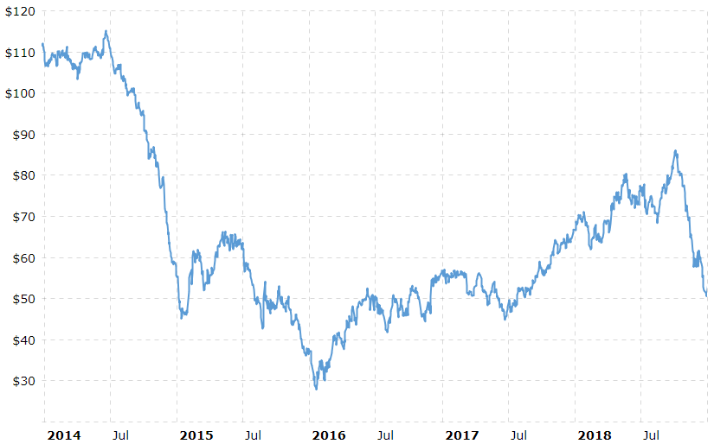

Figure 1: Brent Oil prices between January 2014 and November 2018 (Macrotrends, 2018)

At the same time, assets in many companies, especially in Europe, have already exceeded their design life: many strategic processes have been in operation for well over 50 years, since the 1960’s and 1970’s. For reference, process equipment generally has an average design life of 25 years, while the life of control, electrical and instrumentation systems may be considerably shorter, between 10 and 15 years (Henry, 2011).

Furthermore, an increasing attention to the needs and wishes of Stakeholders (employees, Clients, Communities, Authorities) has led to stricter safety and environmental requirements. Reputation has assumed a key role in developing a good relationship with the communities surrounding an installation and with local and National Authorities. These requirements were reflected in the modifications to the European Seveso Legislative Framework (2012/18/EU) and related National applications (e.g. D.lgs.2015/105 in Italy).

On one hand, industries directly dependent on oil prices such as O&G and Petrochemicals are wary of planning long-term investments, due to the general instability; on the other hand, major expenses are required to upgrade aging equipment with more efficient, safer and standard-compliant assets.

Companies are searching for methods to maintain the current assets for as long as possible, e.g. with Asset Integrity Management techniques. Hought et al. (2013) showed a benchmark of different methodologies, while Milanese et al. (2017) proposed a novel approach; national authorities such as the Health and Safety Executive have supported the sharing of best practices to manage plant ageing (Horrocks et al., 2006).

When that is not possible, investments should target the most pressing issues, using Cost – Benefit approaches.

Experience shows that it is sometimes difficult to see the benefits of major investments in Process Safety, because they are related to a reduction of the costs of an accident (fewer lost lives, less damaged equipment, smaller clean up), as opposed to increased production margins. Therefore, a structured Cost – Benefit approach can help Upper Management understand the reasoning behind investments in this area and approve them.

The presented Cost – Benefit methodology was developed for a major petrochemical company with over 10 Sites in Europe and more than 5 million tons of petrochemical products and polymers manufactured in 2016. The analysis stemmed from a previous extensive assessment of Safety Integrity Level across all Sites of the Company, which is resumed in the following Chapter.

* 1. SIL analysis

The SIL (Safety Integrity Level) analysis assesses the risks deriving from failures of Safety Instrumented Functions (SIF), in compliance with IEC 61508 ed. 2.0 (IEC 61508, 2010)and IEC 61511 ed. 2.0 (IEC 61511, 2016) requirements. Law does still not require the implementation of these standards, nevertheless the Company strategically decided to work towards compliance before they were required to. The complete assessment was developed over 7 years in three key phases: SIL Allocation; SIL Verification; SIL Optimisation.

* + 1. SIL Allocation

The SIL Allocation Study was carried out on all plants of all sites of the Client (over 5,500 SIF) identifying the reliability requirements for each SIF, applying the Risk Graph methodology as described in IEC 61508 ed. 2.0 (IEC 61508, 2010).

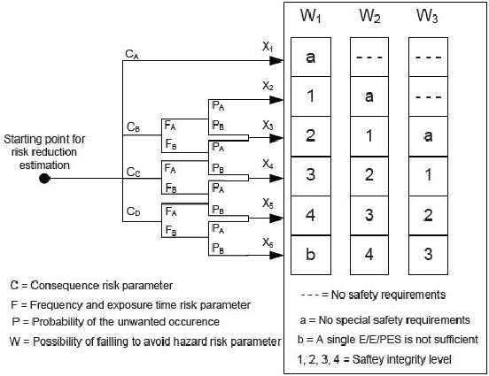

Figure 2: Example of Risk Graph methodology (Ben Yaghlane, 2011)

For each SIF, the methodology considered the accident scenario consequences should that function not exist / work properly.

Three risk graph categories were defined: one for safety consequences, considering the number of injured people; one for environmental consequences, taking into account “intangible” parameters such as the visibility of the release from outside the Site; one for production consequences, including the direct cost of the substitution of damaged assets and the loss of profit due to shutdown period between the accident and the installation of a replacement.

The main result of the SIL Allocation Study was to assign a value of Allocated SIL to all the analysed SIFs. The value is between 1 and 4; when no special safety requirement was needed, the allocated SIL value was SIL a.

Table 1: Safety Integrity Level values (IEC 61508, 2010)

|  |  |  |
| --- | --- | --- |
| SIL Level | Risk Reduction on Demand | Probability of Failure on Demand for SIF |
| 1 | >10 | <10-1 (<10 %) |
| 2 | >100 | <10-2 (<1 %) |
| 3 | >1,000 | <10-3 (<0.1 %) |
| 4 | >10,000 | <10-4 (<0.01 %) |

* + 1. SIL Verification

For all the SIFs whose Allocated SIL was 1 or above (about 3,000), a SIL Verification Study was performed, aiming to ensure that the actual function reliability was consistent with the requirements of the SIL Allocation.

This step was carried out collecting the technical data (e.g. failure rates, manufacturer model, reliability certificates, etc.) for all the elements of the SIFs, which were grouped in:

* Sensors: all necessary instruments and transmitters that detect parameters outside the Basic Control Process System range of operation, including their voting logic (e.g. 2 out of 3)
* Logic Solvers: the calculators that convert the received signals into actions, including cabling, redundancies, intrinsic safeties and I/O bus ports.
* Final Elements: all the elements the SIFs act upon (e.g. valves, motor switches), including their voting logic



Figure 3: Schematic of a SIF: In blue, the sensor and cabling, in red the Safety Logic Solver, in yellow the Final Elements with their relays

Using a dedicated product-oriented database and software, the PFD (Probability of Failure on Demand) was calculated. This parameter indicates what the probability for the function to fail is, once its use is required.

With this methodology, a verified SIL was assigned (See Table 1); if it was equal or higher than the allocated SIL, the SIF was considered “Verified” and no further actions were required.

If the verified SIL is lower than the allocated SIL, further actions were required to close the reliability gap.

* + 1. SIL Optimisation

The SIL Optimisation Study was only performed on those SIFs where verified SIL < allocated SIL, i.e. about 1,500. The SIFs were reviewed using the LOPA (Layer of Protection Analysis) methodology. The key difference was the addition of “enabling factors”, allowing a further detailed review than the Risk Graph analysis.

When this review could not close the gap (i.e. as per about 1,000 SIFs), improvement actions were defined during workshops with Site process, maintenance and instrumentation engineers. Actions could focus on:

* Elimination of the scenario (hazard);
* Reduction of the estimated frequency associated to one or more causes of the accident scenario;
* Reduction of the estimated consequence magnitude, be it related to safety, environment and/or financial;
* Improvement of the reliability of the existing Safety Instrumented Function (SIF Upgrade);
* Introduction of new IPLs (Independent Protection Layers).

Among these, the SIF Upgrade assumed particular importance: i.e. the substitution of the least reliable links of the Initial Element – Logic Solver – Final Element chain to improve its overall reliability.

Whenever possible, multiple actions for each SIF were proposed. Each was assigned an overall yearly cost based on a CAPEX (Capital Expenditure) and an OPEX (Operational Expenditure) as shown in Eq (1).

|  |  |
| --- | --- |
| $$Annual cost of the improvement action=OPEX+ \frac{CAPEX}{Depreciation period} \left(\frac{€}{y}\right)$$ | (1) |

Improvement actions were then ranked considering:

* Scenario elimination probability
* Risk reduction magnitude
* Minor impact on the costs / organization (at the same conditions)
* Quick wins (e.g. improvement actions that require limited investments, while having an immediate effect).
  1. Cost-Benefit methodology

At the end of the SIL Optimisation phase, for each SIF with a gap between allocated SIL and verified SIL an improvement action was chosen, its cost was estimated and its priority was ranked. The ranking was proven useful to prioritize improvement actions for the same SIF or for SIFs within the same Plant.

The application of the improvement actions would carry benefits, that could be estimated as the difference between the “as-is” scenario (Current Risk, RC), Eq (2) and the “to-be” scenario (Mitigated Risk, RM), Eq(3).

|  |  |
| --- | --- |
| $$R_{C}=\frac{W*M}{{10}^{({SIL}_{V}+\sum_{i}{{IPL}_{i}})}}* φ_{EF} \left(\frac{€}{y}\right)$$ | (2) |
| $$R_{M}=\frac{W*M}{{10}^{({SIL}_{V}+\sum_{i}{{IPL}_{i}})}}* φ_{EF}*α \left(\frac{€}{y}\right)$$ | (3) |
| $$Benefit= {R_{C}- R}_{M}=\frac{W*M}{{10}^{\left({SIL}_{V}+\sum_{i}{{IPL}_{i}}\right)}}* φ_{EF}*\left(1- α\right)\left(\frac{€}{y}\right)$$ | (4) |

Where:

* W is the Frequency of the accident (1/y)
* M is the Magnitude (€)
* SILV is the verified SIL (0 through 4)
* IPLi is the reduction factor due to an independent protection layer i (e.g. an independent alarm) (as a log10)
* φEF is a coefficient of the reduction generated by the Enabling Factors (0 < φ < 1)
* α is a coefficient of the reduction generated by the improvement action (0 < α < 1)

Two values were therefore calculated: one is the Cost – Benefit Ratio CBR, Eq (5):

|  |  |
| --- | --- |
| $$CBR= \frac{Cost}{Benefit}$$ | (5) |

The CBR represents a dimensionless indication of the investment convenience, which can be estimated for every SIF, Plant and Site. A lower CBR means the investment is more easily justified (higher benefits and smaller costs). The second parameter is the Weighted Cost Benefit Ratio WCBR, Eq (6):

|  |  |
| --- | --- |
| $$WCBR= {CBR}_{Plant}*\frac{{Investment}_{Plant}}{{Investment}_{Site}}$$ | (6) |

The WCBR, calculated at Plant level, weighs the Plant CBR considering the fraction of the Site investment required. A low WCBR indicates that a certain Plant requires limited investments compared to the overall investments needed for the entire Site, and can therefore be a “quick win”.

* 1. Results

The main result of the overall SIL Study was a list of suggested investments with an estimated comprehensive value of 2.5 M€/year, for 10 years. Overall safety, environmental (including reputation) and production benefits represented estimated savings of 57 M€/y, i.e. a CBR of 4.41 %, for the entire Company. The value estimations were based on specific workshops, which were carried on in all the Company Sites, involving personnel typically belonging to maintenance, production and HSE functions.

Table 2 and Figure 3 shows the results for one Site.

Table 2: Key results from one Site

|  |  |  |  |  |
| --- | --- | --- | --- | --- |
|  | Plant 1 | Plant 2 | Plant 3 | Plant 4 |
| No. SIFs requiring investments | 39 | 2 | 35 | 7 |
| Plant investment | 112.7 k€ | 6 k€ | 21.8 k€ | 18.7 k€ |
| Plant investment  (% of the Site investment) | 71 % | 4 % | 14 % | 12 % |
| Plant Benefits | 4,299 k€ | 21.2 k€ | 595.5 k€ | 247.5 k€ |

Figure 3: Key CBR results from one Site

The calculated WCBRs are lower than 2 %, showing that investments are balanced across all Site Plants.

Based on Plant CBRs, a reasonable resource allocation would be achieved starting to invest in Plant 1 and 3, followed by Plant 4. Plant 2 shows the worst Cost – Benefit ratio and therefore should be last.

* 1. Conclusions

A probabilistic approach for Cost Benefit Analysis for major investments across multiple Plants and Sites was presented. The structured Cost – Benefit approach showed several advantages, in particular:

* It helped with the selection of investments and their prioritization
* It defined objective criteria to compare costs and benefits at Plant, Site and Companywide level
* It facilitated the development of a structured investment Plan over time
* It assessed the current implementation of specific Process Safety elements inside Sites and Plants

In addition to this, it is worth noting that the SIL analysis carries additional benefits on its own, that are not included in the deriving Cost – Benefit Analysis:

* Mapping of critical SIFs and optimisation of resource allocation
* Optimisation of predictive maintenance planning and replacement of obsolete components
* Certification of the correct application of international standards (IEC 61511 and IEC 61508) through accredited tools
* Encouragement of economies of scale for supplies and maintenance plans
* SIL analysis as proof of solid risk management to external verification bodies (e.g. fire departments, insurance and authorities)
* Improvement of Company’s reputation
* Implementation of a Digital System including SIL results, so as to enable a dynamic data analysis, both for Management and operating activities

The method was tested on a real-life application and presented to the Client; an overall CBR of 4.41 % showed the viability of these investments, while detailed results were used to orientate budget allocation.

Future developments of the methodology may include a more detailed estimation of CAPEX and OPEX, e.g. working more closely with purchasing departments, and the application to other Companies.

References

Attuazione della direttiva 2012/18/UE relativa al controllo del pericolo di incidenti rilevanti connessi con sostanze pericolose, 2015, D. Lgs. 2015/105

Ben Yaghlane B., Simon C., Ben Hariz N., 2011, Evidential Risk Graph Model for Determining Safety Integrity Level, NATO Science for Peace and Security Series - E: Human and Societal Dynamics, 88, 204 – 221

European Commission, 2012, Directive 2012/18/EU of the European Parliament and of the Council of 4 July 2012 on the control of major-accident hazards involving dangerous substances, amending and subsequently repealing Council Directive 96/82/EC Text with EEA relevance, 2012/18/EU

European Commission, 2018 – Communication from the Commission to the European Parliament, the European Council, the Council, the European Economic and Social Committee, the Committee of the Regions and The European Investment Bank, A Clean Planet for all – A European strategic long-term vision for a prosperous, modern, competitive and climate neutral economy, COM(2018) 773

Henry N.S., 2011, Managing Deterioration and Integrity of Ageing Assets, Hazards XXII: Process Safety and Environmental Protection Symposium Series, 156, 646–648.

Horrocks, P., Mansfield D., Parker K., Thomson J., Atkinson T., Worsley J., 2009, Plant ageing – Managing Ageing Plant, A Summary Guide for the Health and Safety Executive

Hought J., Fowler A., Grindrod S., A Benchmarking Study on Asset Integrity and the Issues of Ageing Plant in the Chemical Industry and the Challenges of PSM Implementation across Global Sites, Chemical Engineering Transactions, 31, 289–294

IEC 61508 (all parts), 2010, Functional safety – Functional safety of electrical/electronic/programmable electronic safety-related systems, ed. 2.0

IEC 61511 (all parts), 2016, Functional safety – Safety instrumented systems for the process industry sector, ed. 2.0

Macrotrends, 2018, Brent Crude Oil Prices – 10 Year Daily Chart <https://www.macrotrends.net/2480/brent-crude-oil-prices-10-year-daily-chart>, accessed 03.12.2018

Milanese, S., Salvador E., Decadri S., Ratti R., 2017, Asset Integrity Management System (AIMS) for the Reduction of Industrial Risks, Chemical Engineering Transactions, 57, 283–288

Oil&Gas UK, 2014, Guidance on Ageing and Life Extension Aspects of Electrical, Control & Instrumentation Equipment, 1 (HS084)