|  |  |
| --- | --- |
| cetlogo ***CHEMICAL ENGINEERING TRANSACTIONS***  ***VOL. 76, 2019*** | A publication of  aidiclogo_grande |
| The Italian Association  of Chemical Engineering  Online at www.cetjournal.it |
| Guest Editors: Sauro Pierucci, Jiří Jaromír Klemeš, Laura Piazza  Copyright © 2019, AIDIC Servizi S.r.l. **ISBN** 978-88-95608-73-0; **ISSN** 2283-9216 | |

Determination of the Degree of Accumulation of Heavy Metals in Macrophytes from the Bogota River in Colombia

Laura T. Castro, Lizeth DC. Molina,\*

Facultad de Ingeniería, Universidad de La Salle, Cra 2 No. 10-70, Bogotá, Colombia

ldcmolina@unisalle.edu.co

This paper presents the degree of heavy metals accumulation in existing Macrophytes in the water of the Bogota River to establish the potential of native species for the phytoremediation of contaminated aquatic ecosystems. The research was developed in four phases. The first one refers to the characterization of heavy metals in the water of the Bogota River in the study area; in the second phase it was determined the most abundant macrophytes species; in the third one, a preliminary determination of accumulation of heavy metals in the 3 dominant species using energy dispersive X-ray spectroscopy coupled to scanning electron microscopy (EDS-SEM) was then made. In the fourth phase, once it was selected the species with the greatest accumulation, an in vitro propagation under certain optimal nutrient conditions took place. Finally using a new measurement of EDS-SEM, it was determined the degree of accumulation of heavy metals. The results indicate that in the Bogota River, there are important concentrations of Zinc (Zn), Total Iron (Fe) and Chromium (Cr), which are associated with the industrial sector of the area. Also, it was determined that the most abundant species of macrophytes were *Polygonum punctatum*, *Eichhornia crassipes* and *Myriophyllum aquaticum* which showed characteristics of hyperaccumulating plants of Aluminum (Al) and Iron. Among them, *Eichhornia crassipes* stands out for its variety of accumulated metals, which is why, after the in vitro propagation and final analysis in EDS-SEM, it is concluded that it is an ideal species for phytoremediation of water bodies affected by iron, copper (Cu) and tin (Sn).

1. **Introduction**

Heavy metals are major environmental pollutants and their toxicity is the cause of increasing concern due to their accumulation and persistence in the environment. High level of heavy metals can often be attributed to anthropogenic influences such as agricultural runoff, mining activities, [and] industrial waste effluents (Akkajit et al., 2018). Through phytoremediation it is achieved the reduction and/or elimination of the concentration of various pollutants such as heavy metals, based on biochemical processes carried out by plants (Nuñez et al., 2004), both terrestrial and aquatic (Macrophytes). Although all plants possess the ability to absorb a huge variety of metals, most of them only absorb essential concentrations for their survival and development. Those that can tolerate and absorb high concentrations of certain metals, receive the name of accumulating or hyperaccumulating plants (Pineda, 2004). The main challenge of phytoremediation is the selection of appropriate hyperaccumulating plants to transfer heavy metals to the plant, so that contamination could be ecologically treated and the plant itself did not get affected (Chen, 2018). Hyperaccumulating plants are those able to accumulate more than 1000 mg of Co, Cu, Ni and Pb per kg of dry matter; more than 10000 mg kg-1 of Mn and Zn, and more than 100 mg kg-1 of Cd (Jara et al., 2014) in some tissue of its aboveground biomass (Becerra et al., 2007). However, there are natural or improved species which can accumulate concentrations of heavy metals between 2-4% of its dry weight (Peña et al., 2013).

1. **Study area**

The study area corresponds to the upper Bogota River basin; along a transect of 44.7 kilometers between Villapinzón - Tocancipá. This River originates in the Guacheneque Moorland, in the northeastern region of the Department of Cundinamarca, on the Cordillera Oriental of the Colombian Andes (Alcaldía Mayor de Bogotá, 2008). One of the characteristics of the upper basin is the existence of heavy metals, among them; the one of greatest impact is the chromium corresponding to the dumping of the wastes from the tanning industries of the municipality of Villapinzón (CAR, 2006). In the study area, they were selected 3 points of sampling, considering the criteria of accessibility and proximity to populated centers, Villapinzón (P1), Suesca (P2) and Tocancipá (P3), they are identified in Figure 1.

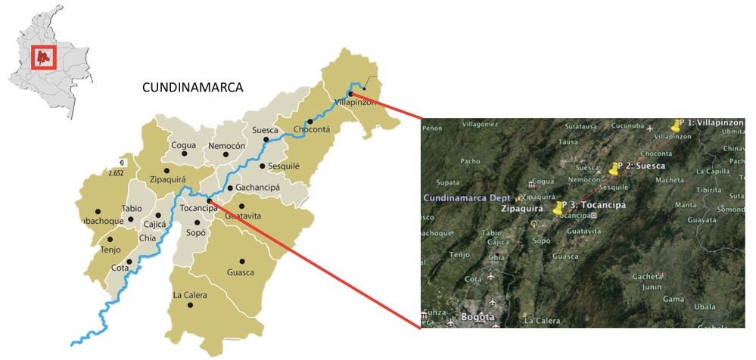

*Figure1: Study Area. Location of sampling points.*

1. **Methodology**

The research was conducted in four phases. In the first one, it is determined the concentration of heavy metals associated with industrial activities present in the area by taking a simple sample at each sampling point. Metals such as Al, Cd, Cu, Cr and Total Fe, Mn, Ni, Pb and Zn were analyzed with the methods SM 3030 H, 3111 D, A.A. Flame.

All through the second phase, in order to select the most abundant Macrophytes species, it was determined the species and number of individuals existing in areas of 2 m by 2 m every 40 cm, from the bank of the River toward the inside of itself.

During the third phase, the predominant Macrophytes species are analyzed in a preliminary procedure by energy dispersive X-ray spectroscopy coupled to scanning electron microscopy (EDS-SEM) to select the specie that presents greater accumulation of heavy metals in natural environment. The analysis was performed in the aerial tissue from the plant, specifically in leaves, stems and petioles.

In the last phase, several specimens of the species with greater accumulation were acquired from a local plant sales outlet. 4 tests of in vitro propagation with tap water were made for a period of 21 days, adding doses of 10, 20, 30 and 40 drops of earthworm Humus as a nutrient in order to select the dose that allowed a better development of the plant. Then, a final in vitro propagation took place in 200 ml of water taken from the river, specifically from the point of predominance of the species, plus 1,800 ml of distilled water and the addition of the optimal nutrient dose. After 21 days, the plant was analyzed with EDS-SEM to determine the degree of accumulation of heavy metals.

1. **Results and Discussion**
   1. **Chemical characterization of the study area**

Table 1 shows the concentrations of the heavy metals obtained in the three sampling points. The comparison with the maximum values allowed for the uses of water for human and domestic consumption with conventional treatment, preservation of flora and fauna, agricultural use of quality regulations for the upper basin of the Río Bogotá (CAR, 2006)., show that Cr levels are high in P1 while the Fe levels are high in P1, P2 and P3.

*Table 1. Concentration in mg/L of heavy metals in the study area.*

|  |  |  |  |  |
| --- | --- | --- | --- | --- |
| Element | P1 | P2 | P3 | Quality regulation for  Bogotá River |
| Cd | < 0.002 | < 0.002 | < 0.002 | 0,01 |
| Zn | 0.02 | 0.011 | 0.015 | 0,01 |
| Cu | < 0.008 | <0.008 | <0.008 | 0,1 |
| Cr | **0.121** | 0.031 | 0.032 | 0,05 |
| Fe | **0.899** | **1.73** | **3.22** | 0,1 |
| Mn | 0.021 | 0.031 | 0.056 | 0,1 |
| Ni | < 0.011 | < 0.011 | <0.011 | 0,01 |
| Pb | < 0.01 | <0.01 | < 0.01 | 0,01 |
| Al | 0.151 | 0.756 | 2.97 | 5 |

* 1. **Abundance of macrophytes especies**

They were Found 6 species of macrophytes (Figure 2), resulting in *Polygonum punctatum*, *Eichhornia crassipes*, and *Myriophyllum aquaticum* being the three most abundant ones illustrated in Figure 3.

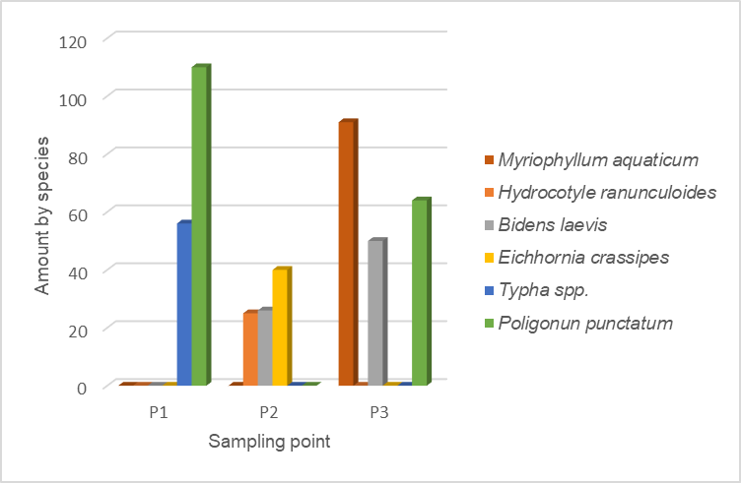

*Figure 2: Macrophytes found in the study area.*



***(a)***

***(b)***

***(c)***

*Figure 3: predominant Macrophytes in the study area. a. Polygonum punctatum; b. Eichhornia crassipes; c. Myriophyllum aquaticum*

* 1. **Preliminary analyses of EDS-SEM**

Table 2 indicates the content of heavy metals accumulated by the three most abundant Macrophytes species. Even if the Mg, Ba and Al are light metals, their reading with EDS-SEM is given including their environmental importance. This analysis was performed on the collected species from their natural environment, so the results are taken as a benchmark of their behavior in the Bogota River and not as final results due to the fact that plants can absorb and release continuously elements present in the environment interfering with the results. For the *Polygonum punctatum* and *Myriophyllum aquaticum* species, the analysis was performed in leaves and stem. In *Eichhornia crassipes*, the petiole was analyzed since this species has no stem.

According to the values reported, these three species are considered hyperaccumulating of Al and Fe. *Eichhornia crassipes* presents the highest degree of hyperaccumulation of Al and *Polygonum punctatum* stands out for its ability to hyperaccumulate Fe. Even though, the three species accumulated Mg, none reported enough percentages to be considered hyperaccumulator of Mg, which is the reason to deduce that the presence of this element is associated to its absorption as a macronutrient (Galán and Romero, 2008). In the case of Cr, contaminant characteristic of the study area, *Polygonum punctatum* was the only species presenting absorption in its inner stem.

*Table 2. Accumulation of metals in abundant species.*

|  |  |  |  |  |  |  |  |  |  |
| --- | --- | --- | --- | --- | --- | --- | --- | --- | --- |
| Element | *Polygonum punctatum*  Weigh (%) | | | *Eichhornia crassipes*  Weigh (%) | | | *Myriophyllum aquaticum*  Weigh (%) | | |
| Leave | Outer stem | Inner  stem | Leave | Inner petiole | Outer petiole | Leave | Outer stem | Inner stem |
| Al | 5.29 | 0.76 | 1.45 | 0.58 | 0.41 | 6.31 | 2.49 | 4.49 | 2.27 |
| Fe | 16.64 | - | 31.55 | 0.83 | - | 27.24 | 28.00 | 1.42 | - |
| Mg | 0.48 | 0.39 | 0.95 | - | 1.12 | 1.04 | - | 0.65 | 0.85 |
| Mn | - | - | 5.13 | - | - | - | - | 4.62 | - |
| Cu | - | - | 1.14 | 1.49 | 1.07 | 0.81 | - | - | - |
| Cr | - | - | 4.45 | - | - | - | - | - | - |
| Ba | - | 19.90 | - | 45.34 | - | - | - | - | - |
| Ag | - | - | - | - | 22.18 | - | - | - | - |
| Ti | - | - | - | - | - | 28.32 | 0.58 | - | 0.64 |

Regarding the parts of the plant with greater capacity for absorption, values differ for each species. It is observed that the species of *Polygonum punctatum* has ability to accumulate greater variety of metals in its stem being the concentration values of Fe the ones standing above in the outer stem and Ba in the inner stem. *Eichhornia crassipes* accumulates greater variety of metals in the petiole; however, it has the highest percentage of Ba in its leaves. *Myriophyllum aquaticum* has a greater variety of metals in the outer stem, although the outstanding values of Fe are present in the leaves.

In conclusion, the species *Polygonum punctatum* excels by its values of hyperaccumulation of Fe, Mn and Cr, and the species *Eichhornia crassipes* stands out for having the highest values of hyperaccumulation of Al, Ba, Ag and Ti. Therefore, *Eichhornia crassipes* is the species chosen for the in vitro propagation and final determination of heavy metals.

* 1. **In vitro propagation**

In the Table 3 it is indicated the morphological behavior of the plant from 4 trials with different doses of nutrients.

*Table 3. Morphological behavior of Eichhornia crassipes*

|  |  |  |  |  |  |
| --- | --- | --- | --- | --- | --- |
| Doses of nutrients (drops) | Condition of the plant | Number of petioles | Length  cm | Number of leaves | Number of roots |
| 10 | Initial | 4 | 3.5 | 4 | 4 |
| Final | 4 | 3.5 | 2 | 3 |
| 20 | Initial | 5 | 4 | 4 | 7 |
| Final | 5 | 4 | 4 | 9 |
| 30 | Initial | 6 | 8 | 4 | 6 |
| Final | 6 | 8 | 4 | 21 |
| 40 | Initial | 6 | 7 | 4 | 5 |
| Final | 4 | 7 | 3 | 19 |

It is observed that with doses of 10 and 40 drops there is a negative impact on the plant due to the loss of leaves and petioles, which are considered inadequate doses for a proper development. As for trials with doses of 20 and 30 drops, the plant did not suffer any negative impacts, however, the dose of 30 drops of nutrients has a positive effect on the plant due to the growing of 15 new roots, and therefore it is considered the optimal dose for the next in vitro propagation.

* 1. **Final results with EDS-SEM**

Table 4 presents the results of the analysis of EDS-SEM carried out to the selected specie. It can be appreciated that *Eichhornia crassipes* species is capable of hyperaccumulate a wide variety of heavy metals; 8 heavy metals were reported to be accumulated over a range of 2-4% of weight using the EDS-SEM, meaning, the plant hyperaccumulate all heavy metals found. Fe, Cu and Sn percentages stand out, exceeding even the ranges established by Peña et al., (2013) and Jara et al., (2014). The Fe values reported in Table 1, in P1, P2 and P3, show that this plant represents a viable phytoremediation alternative to control the presence of this contaminant in the Bogotá River. On the other hand, although the Cu values found in P1, P2 and P3 are not significant, the hyperaccumulation of this metal in *Eichonna crassipes* indicates its suitability for the treatment of other bodies of water affected with this pollutant.

*Table 4. Accumulation of heavy metals in Eichhornia crassipes*

|  |  |  |  |  |  |  |
| --- | --- | --- | --- | --- | --- | --- |
| Element | *Eichhornia crassipes* Weigh (%) | | | | | |
| Leave | Rhizome | Old root | Outer petiole | Inner petiole | New root |
| Al | 2.33 | - | - | 1.12 | 7.83 | 4.52 |
| Fe | 17.60 | 87.19 | - | 10.43 | 5.92 | 18.77 |
| Mg | - | - | - | - | 1.61 | - |
| Cu | - | - | 26.57 | 47.94 | 35.52 | - |
| Cr | - | - | - | - | - | 2.76 |
| Ti | - | - | - | 3.77 | - | - |
| Zn | - | - | 4.26 | 14.24 | - | - |
| Co | - | - | 9.26 | - | - | - |
| Sn | - | - | 61.18 | - | - | - |
| Ni | - | - | 3.75 | - | - | - |

This species can absorb Zn, Co and Ni although the levels of Zn and Ni do not present pollution problems in the study area. The accumulation results (Table 4) show that *Eichhornia crassipes* is within the category of hyperbioaccumulation for Fe (5-85%) and lower proportion for Cr (2-4%). Therefore, this plant has potential for the phytoremediation of water courses affected by heavy metals, such as Bogotá River. On the other hand, Al are also significant considering hyperaccumulating specie for this light metal. Mg values as found, however, are associated with the nutritional requirements of the plant.

This aquatic species presents greater absorption particularly of heavy metals in the part of the plant submerged in water, that is, rhizome and roots, and less on the leaves. The rhizome was able to accumulate a single element, Fe; however, it reported the highest percentage of accumulation of all parts of the plant. Roots showed accumulation of a greater variety of metals, 5 in total; from those, the ones showing higher values were Sn in the old root and Fe in the new ones. The petioles also reported important values of accumulation, being noted the absorption of Cu in this part of the plant. A scheme of accumulation of *Eichhornia crassipes* is presented in Figure 4. According to Peña et al. (2013), due to its accumulation capacity in percentage in weight, the species of macrophytes *Eichhornia* *crassipes* is considered hyperaccumulating of Fe, Sn and Al; and in agreement with Jara et al. (2014), it is hyperaccumulating of Co, Cu, Ni and Zn, for its accumulation in mg kg-1.

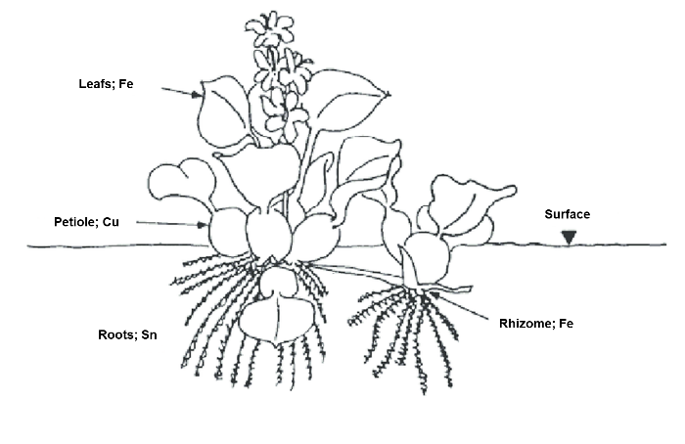

*Figure 4: Accumulation of heavy metals in the parts of the macrophytes Eichhornia crassipes.*

1. **Conclusions**

The most abundant species in the study area are *Polygonum punctatum*, *Eichhornia crassipes*, and *Myriophyllum aquaticum*. These three species were hyperaccumulating of Al and Fe, in the preliminary analysis of EDS-SEM, with values exceeding the range of 2-4% of weight in dry tissues. *Polygonum punctatum* is the species standing out because of its hyperaccumulation values of Fe, Mn and Cr, and *Eichhornia crassipes* stands out as the species having the highest values of hyperaccumulation of, Ba, Ag and Ti. Therefore, the species *Eichhornia crassipes* is chosen for the in vitro propagation and final determination of heavy metals.

*Eichhornia crassipes,* finally propagated in vitro, is a species able to hyperaccumulate a wide variety of heavy metals; its potential for accumulation of Fe, Cu, Cr, Ti, Zn, Co, Sn and Ni was identified, in ranges > 2 - 4% of weight for Fe, Sn and Al; > 100 mg kg-1 for Co, Cu and Ni, and > 10000 mg kg-1 for Zn. In *Eichhornia crassipes* the concentrations of Fe, Cu and Sn stand out, making it an ideal species for phytoremediation of bodies of water affected by these pollutants, having a greater capacity of absorption in the growing down parts submerged in water, that is, rhizome and roots.

Although copper is an essential micronutrient for plants at higher concentrations they can become toxic. Copper contamination is commonly associated with nickel and zinc and is usually due to the release of a variety of sources including electroplating, mining, urban sewerage, foundries, tanneries, textile industry and chemical industries (Mokthar, et al, 2011) (Dhir, 2013) (Naaz, et al, 2018).

1. **References**

Akkajit P., Jaileak K., Suteersak T., Prueksakorn K., 2018, Assessment of heavy metals in sediment at Saphan Hin, Phuket, Chemical Engineering Transactions,63, 301-306.

Alcaldía Mayor de Bogotá, 2008, Calidad del sistema hídrico de Bogotá.   
<ambientebogota.gov.co/documents/24732/3987336/Calidad+del+sistema+hidrico+de+Bogot%C3%A1.pdf> accessed 10.12.2018.

Alcaldia Municipal de Suesca, 2002, Sistema de documentación e información municipal.   
<cdim.esap.edu.co/BancoMedios/Documentos%20PDF/suescacundinamarcaeot2002.pdf> accessed 07.12.2018.

Alcaldia Municipal de Villapinzón, 2000, Sistema de documentación e información municipal <http://cdim.esap.edu.co/BancoConocimiento/V/villapinzon\_-\_cundinamarca\_-\_eot\_-\_2000/villapinzon\_-\_cundinamarca\_-\_eot\_-\_2000.asp > accesed 08.12.2018.

Becerra C., García M., Monterroso C., 2007, Aplicación de plantas hiperacumuladoras de níquel en la fitoextracción natural: el género *Alyssum L.,* Revista Científica y Técnica de Ecología y Medio Ambiente*,* 16(2), 26-43.

CAR, 2006, Acuerdo Número 43 del 17 de Octubre de 2006.  
<www.car.gov.co/uploads/files/5ada10b9602b4.pdf> accessed 10.12.2018.

Chen Z., 2018, On selection of remediation plants for heavy metal polluted soil, Chemical Engineering Transactions*,* 66, 649 - 654.

Dhir B., 2013, Phytoremediation: Role of aquatic plants in environmental clean-up. New Delhi: Springer, India 51 – 64.

Galán H., Romero A., 2008, Contaminación de suelos por metales pesados, Revista de la sociedad española de mineralogía, 10, 48 - 60 .

Jara E., Gómez J., Montoya H., Chanco M., Mariano M., Cano N., 2014, Capacidad fitorremediadora de cinco especies altoandinas de suelos contaminados con metales pesados, Revista Peruana de Biología*,* 21(2), 145-154.

Mokhtar H., Morad N., Fizri F. F. A., 2011, Phytoaccumulation of Copper from Aqueous SolutionsUsing Eichhornia Crassipes and Centella Asiatica, International Journal of Environmental Science and Development, 2(3), 205.

Naaz, M., Dutta, A., Kumari, S., Farooqui S., 2018. Bioaccumulation, Phytoremediation and Kinetics of Uptake of Heavy Metals (Copper and Zinc) by Eichhornia crassipes, Research & Reviews: Journal of Ecology, 2(1), 1-9.

Nuñez R., Vong Y., Borges R., Olguín E., 2004, Fitorremediación: Fundamentos y Aplicaciones, Revista Ciencia*,*  69 - 82.

Peña E., Madera C., Sánchez J., Medina J., 2013, Bioprospección de plantas nativas para su uso en procesos de biorremediación: Caso *Helicona psittacorum* (Heliconiacea), Revista Academica Colombiana,37(145), 470-481.

Pineda R., 2004, Presencia de hongos micorrízicos arbusculares y contribución de glomus Intraradices en la absorción y translocación de cinc y cobre en girasol (*Helianthus annuus L*.) crecido en un suelo contaminado con residuos de mina, Universidad de Colima, Colima, México.

Rehman A., Kim M., Reverberi A., Fabiano B., 2015, Operation parameter Influence on heavy metal removal from metal plating wastewater by electrocoagulation process, Chemical Engineering Transactions*,* 43, 2251 – 2256.