|  |  |
| --- | --- |
| cetlogo CHEMICAL ENGINEERING TRANSACTIONS  ***VOL. 76, 2019*** | A publication of  aidiclogo_grande |
| The Italian Association  of Chemical Engineering  Online at www.aidic.it/cet |
| Guest Editors: Sauro Pierucci, Jiří Jaromír Klemeš, Laura Piazza  Copyright © 2019, AIDIC Servizi S.r.l. **ISBN** 978-88-95608-73-0; **ISSN** 2283-9216 | |

Immobilization of *Actinobacillus succinigenes* in alginate beads for succinic acid production

Alessia Ercole, Francesca Raganati\*, Piero Salatino, Antonio Marzocchella

Dipartimento di Ingegneria Chimica, dei Materiali e della Produzione Industriale – Università degli Studi di Napoli Federico II, P.le V. Tecchio 80, 80125 Napoli – Italy

francesca.raganati@unina.it

Nowadays the succinic acid (SA) - a C-4 dicarboxylic acid - is considered as one of the most promising platform chemicals produced from renewable resources via fermentation. Enhancement of the SA fermentation efficiency and productivity may take advantages from immobilized cultures..

This work reports the immobilization of *Actinobacillus succinogenes* cells in calcium alginate beads. Glucose was used as carbon source for the fermentation. A parallel fermentation test with free cells was carried out to assess the advantages of the immobilization technology.

The immobilization in alginate beads was proved to be an effective technique for SA production by *A. succinogenes*. The fermentation performances of the immobilized cells were higher than those of the free cells. In particular, at initial glucose concentrations of 40 g/L the maximum productivity in immobilized cells fermentation (0.77 g/Lh) is more than twice that measured for free cells (0.32 g/Lh).

* 1. Introduction

The worldwide consumption of fossil resources has increased the interest in alternative routes for sustainable production of commodities. The development of highly efficient and cost-effective biorefineries is a prerequisite for the transition from today’s fossil-based economy towards a bio-based economy. The succinic acid (SA) is a precursor for many chemicals in the food, pharmaceutical, cosmetic, and plastics industries.

Historically, prices for petroleum-based SA range between US$ 5/kg and US$ 9/kg. In 2013, these prices were reported to be between US$ 2.40/ kg and US$ 2.60/kg, while those for bio-based succinic acid were in the range of US$ 2.86/kg to US$ 3.00/kg, depending on the supplier and on the chemical specification. The main current production route is through oxidation of n-butane to produce maleic anhydride, which is then hydrogenated and hydrolyzed (Klein et al., 2017).

The industrial development of bio-based SA is currently considered as the fastest growing market towards the bio-economy era. The market for succinic acid in 2011 was 40000 tonnes and is expected to rise to approximately 600000 tonnes by 2020. Most of this growth is forecast to come from the use of succinic acid as a building block for the development of bio-based markets (Klein et al., 2017).

Microbial production of SA at high fermentation efficiency can be achieved using wild strains, such as bacteria isolated from anaerobic environments (e.g. cow stomach). *Actinobacillus succinogenes* has been used for the production of SA using a wide spectrum of feedstocks: lignocellulosic based materials, food supply chain wastes, and industrial waste streams. *A. succinogenes* is characterized to produce SA at relatively high concentration by converting a wide spectrum of hexoses, pentoses, mono-, and di-saccharides under anaerobic conditions (Ferone et al., 2016).

The key factors for the industrial process success to produce SA via the biotechnological route include: i) the selection of a SA-producing microorganism; ii) the selection of the feedstock, cheap and easy to be pretreated/hydrolyzed to produce C5 and C6 sugars; iii) the development of high throughput bioreactor; iv) the development of an efficient recovery process for succinic acid.

A strategy to enhance the fermentation efficiency is the application of high-cell concentration bioreactors. In particular, immobilized cultures are a promising technology. Indeed, immobilized cultures have many advantages with respect to free-cell cultures: i) high fermentation yield: ii) re-cycle of the biocatalysts; iii) continuous processing; iv) high tolerance of the microbial to inhibitors.

The production of SA using immobilized cultures of *A. succinogenes* has been investigated by Corona-Gonzàlez et al. (2014) by adhesion or entrapment on various supports such as zeolite, agar and poly-acrylamide hydrogel. They reported a production of SA of 43.4 g/L using glucose as single carbon source by entrapping cells in agar beads. Yan et al. (2014) produced 55.3 g/L of SA with immobilized cells of *A. succinogenes* on a cotton cloth in a continuous fiber bed bioreactor using glucose as substrate. Immobilized cultures of *A. succinogenes* on alginate beads were tested by Alexandri et al. (2017) obtaining a final SA concentration and yield of 35.4 g/L and 0.61 g/g, respectively, using spent sulfite liquor as fermentation medium.

Present study reports the production of SA via microbial fermentation by entrapping the producing strain *A. succinogenes* in alginate beads. The comparison of the fermentation performances with those assessed for free cell cultures is also reported.

* 1. Materials and Methods
     1. Microorganism and media

*Actinobacillus succinogenes* DSM 22257 was supplied by DSMZ. Stock cultures were reactivated according to the procedure suggested by the supplier. Reactivated cultures were stored at −80 °C (Ferone et al.,2018)

The thawed cells were inoculated in 15 mL Hungate tubes containing 12 mL of Brain Heart Infusion broth (BHI, from Sigma-Aldrich). Cells were grown in anaerobic conditions for 24 h at 37 °C and the agitation was provided by a rotary shaker (150 rpm). Then, the precultures were inoculated into fermentation bottles. The feeding medium consisted of: 5 g/L Yeast Extract (nitrogen source), 1 g/L NaCl, 0.3 g/L Na2HPO4, 1.4 g/L NaH2PO4, 1.5 g/L K2HPO4, 0.2 g/L. MgCl2, CaCl2 and sugars were prepared separately as concentrated stocks, sterilized by filtration and supplemented aseptically to the autoclaved medium. MgCO3 was supplied to the fermentation medium (indirect CO2 source) as suspended solid at initial concentration of 30 g/L. The medium was sterilized in autoclave (121 °C, 20 min) (Ferone M. et al, 2017).

* + 1. Alginate beads preparation

The 2% w/v Na-alginate solution was prepared by dissolving sodium alginate powder in distilled water and then sterilized in autoclave (121°C, 10 minutes). Polymer/cell suspension was formed by mixing 20% (v/v) of precultures after 24 h of incubation with the Na-alginate solution (Rakin et al., 2010). This solution was gassed with oxygen-free nitrogen to maintain anaerobic conditions (Kheyrandish et al., 2015) and this solution was added drop by drop through a syringe into a solution containing 2% (w/v) CaCl2. The resulting beads with a diameter approximately between 3 to 4 mm, were washed with 2% CaCl2 solution and stored in 2% CaCl2 solution at 4°C (Wu and Wisecarver, 2015).

* + 1. Fermentation with alginate beads

Batch fermentations were carried out in duplicates (the data reported in the figures and tables are the mean values: the standard error was always lower than 5 %) in flasks with total volume of 1 L and working volume of 200 mL. Before their addition into the fermentation broth the immobilized cells were washed twice with distilled water, in order to remove the free cells. The immobilized biocatalyst was introduced into the fermentation broth placed in flasks under aseptic conditions. The flasks were sealed with a cotton plug and placed in an orbital shaker at 37°C and 150 rpm. Samples were collected every 3 hours during the fermentation period and after each one the fermentation broth was gassed with oxygen-free-nitrogen to maintain anaerobic conditions.

The fermentation was characterized in terms of pH, sugar conversion, acid production and cell growth. In particular, the following parameters were evaluated:

* overall sugar conversion (ξS), the ratio between the sugar converted and the initial sugar (S0 - S)/S0;
* sugar-to-product “i” yield coefficient (Yi/S), the ratio between the produced mass of product “i” (cells or succinic acid) and the related decrease of the substrate mass.;
* SA specific productivity (WSA), the ration between the SA concentration and the fermentation time.
* the specific growth rate (μ). It was estimated at the beginning of the exponential phase as the slope of the biomass concentration (X) versus time curve on a log scale;
* the maximum specific succinic acid production rate ($r_{SA}^{max}$). It was estimated at the onset of the SA production as the slope of the SA concentration versus time curve, divided by the cells concentration measured.
  + 1. Fermentation with free cells

Fermentation tests with free cells were carried out using the same mass of cells (8% (v/v) suspension of actively growing precultures in flasks with total volume of 1 L and working volume of 200 mL) as that used in the immobilized beads. The experiments were carried out under the same experimental conditions with glucose as carbon source. Experiments with free cells were carried out in duplicates (the data reported in the figures and tables are the mean values: the standard error was always lower than 5 %).

Fermentations were carried out at 37 °C without pH control, and the agitation was provided by a rotary shaker (150 rpm). The batch tests were characterized in terms of pH, sugar conversion, acid production and cell growth (Ferone et al., 2019.) Measurements were worked out to assess the parameters reported in section 2.3.

* + 1. Analytical method

The concentration of soluble species was measured in the liquid phase after spinning down the cells by centrifugation (13000g, 10 min). Sugar and organic acid concentrations were measured by means of a high-performance liquid chromatography (HPLC) (HP1260 working station system—Agilent Technologies, USA) equipped with a cation-exclusion column (REZEX-Organic Acids; 300 mm × 7.8 mm, 9 µm; Bio-Rad Chemical Division, Richmond, CA). Analytes were detected by diode array detector (Agilent Technologies, G1315D) and refractive index (Agilent Technologies, G1362A). H2SO4 5 mM was used as mobile phase at 0.6 mL/min flow rate at room temperature. The injection volume was 20 µL.

Cell density was determined by measuring the absorbance at 660 nm (Cary-Varian mod. 50 scan UV-VIS spectrophotometer); calibration tests indicated that the optical density is proportional to *A. succinogenes* dry mass under the operating conditions tested, in particular 1 OD corresponded to 0.377 gDM/L.

To determine the entrapped biomass concentration inside the alginate beads, 5 mL of 0.2 mol/L sodium citrate was added to 20 washed beads. Sodium citrate chelated the calcium which bound the alginate, releasing the cells previously entrapped (Stuckey and Stuckey, 2015). The solution was centrifuged and the pellet was dissolved in a lower volume of distilled water to measure the absorbance at 660 nm.

* 1. Results
     1. Comparing immobilized cells and free cells fermentation

The comparison between immobilized and free cells fermentation was carried out setting glucose initial concentration to 40 g/L while the inoculum content was kept constant for both tests so that results could be compared. Tests with immobilized cells were made with 250 g/L of beads. Production of SA with immobilized and free cells is shown in Fig. 1; the time to reach the maximum concentration of SA was reduced with cells entrapped in alginate beads compared to free cells because immobilized cells are adapted, whereas free cells show a lag phase and require time to initiate acid production (Galazzo and Bailey, 1990). Additionally, it is likely that the pH within the alginate beads decreased, thereby increasing cellular metabolism. pH decreases due to increased proton permeability in the cytoplasmic membrane, which induces a higher ATP consumption and increases metabolism (Galazzo and Bailey, 1990). Moreover, it is shown that higher production of SA was obtained compared to free cells. In particular, 6.5% increase in succinic acid production was obtained when immobilized cells system was used instead of free cells system.

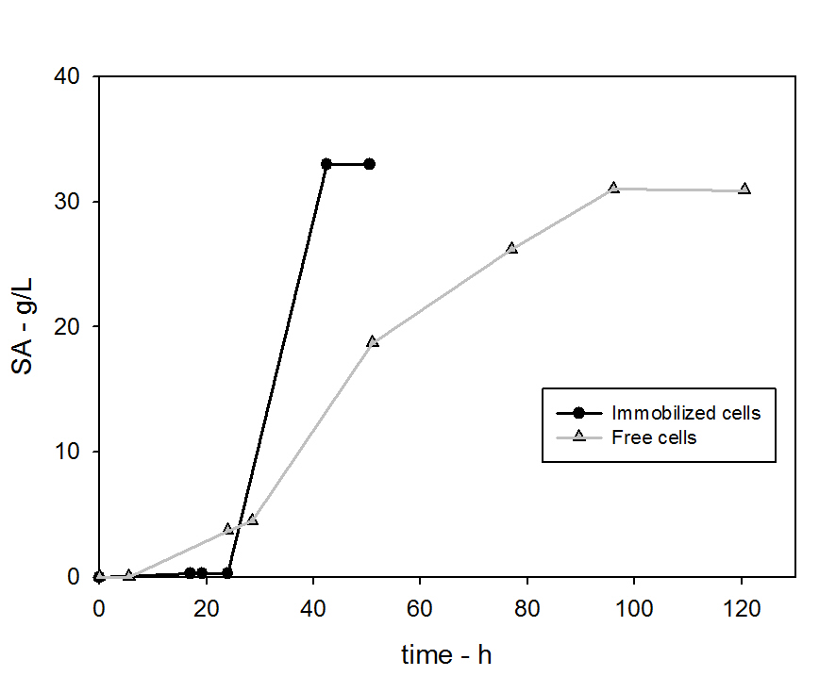

Figure 1: SA production at initial glucose concentration of 40 g/L in immobilized and free cells fermentation tests

Table 1 reports the maximum SA productivity and the specific SA production rate achieved in the two systems and it is clear that immobilized cells were characterized by higher performances than free cells. Higher production of SA was obtained due to cell retention within agar beads and sufficient diffusion of nutrients through the beads, which have appropriate particle size, porosity and thickness as well as good mechanical stability (Galaction et al., 2011; Dishisha et al., 2012; Angelova et al., 2000). Different reports have shown increased metabolic activity of immobilized cells in comparison to free cells (Dishisha et al., 2012; Angelova et al., 2000). Particularly, Shindo et al. (1993) reported that SA production was threefold higher with immobilized *Saccharomyces cerevisiae* due to increased metabolic activity, resulting in increased conversion of isoleucine to SA.

|  |  |  |
| --- | --- | --- |
|  | Immobilized cells | Free cells |
| μ - h-1 | 0.22 | 0.14 |
| YX/G - gDM/g | 0.06 | 0.05 |
| $r_{SA}^{max}$- g/gDMh | 0.82 | 0.74 |
| YSA/G - g/g | 0.87 | 0.78 |
| WSA MAX - g/Lh | 0.77 | 0.32 |
| ξS - | 1 | 0.95 |

Table 1: Relevant kinetic parameters: specific growth rate, biomass yield, succinic acid production rate on gram of cells, SA yield, maximum SA productivity and glucose conversion in immobilized and free cells fermentation.

Fig. 2 reports the cell concentration for the free-cells and for the immobilized-cells system. It is evident that the immobilization of cells had a significant effect on cell growth. In particular immobilized cells show a shorter lag phase and a higher maximum cell concentration when compared to free cells. Moreover, table 1 reports the specific growth rate for free and immobilized systems; the immobilized cells had a specific growth rate 70 % higher than the free cells.

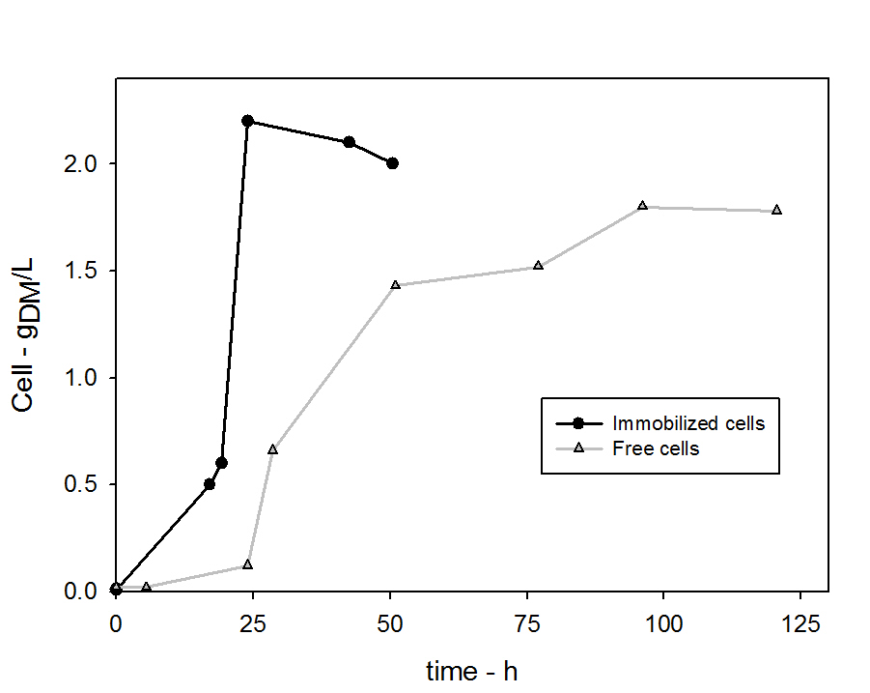

Figure 2: Time-resolved measurements of the concentration of A. succinogenes cells in immobilized and free cells fermentation

Fig. 3 reports the glucose consumption in immobilized and free cells fermentation tests. It is evident that in both cases glucose was completely consumed but immobilized cells reduced of 70 hours the conversion time. This was due to the increased metabolic activity of the immobilized cells.

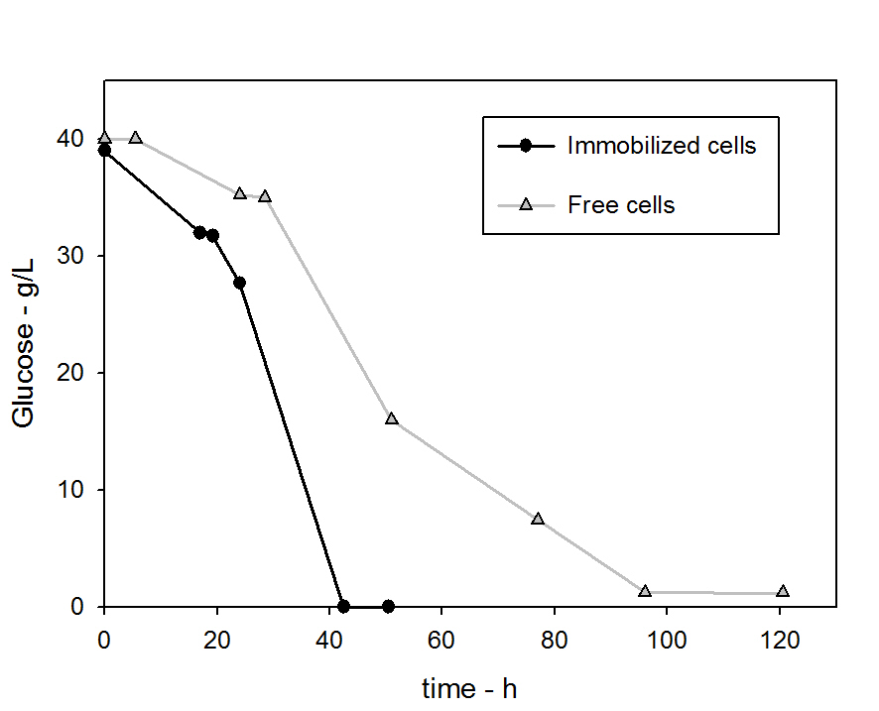

*Figure 3: Time resolved profiles of glucose consumption in immobilized and free cells fermentation tests*

Table 2 reports the final concentration and yield of the most abundant by-products of the fermentation: acetic and formic acid. Their concentrations were much lower than SA (always below 7.5 g/L). A higher concentration of formic and acetic acid in free cells fermentation tests was observed in comparison with immobilized cells tests; that is because final SA concentration in free cells tests was lower than the one obtained in immobilized cells tests (Bradfield and Nicol, 2014).

|  |  |  |  |  |
| --- | --- | --- | --- | --- |
|  | Formic Acid | | Acetic Acid | |
|  | Concentration g/L | Yield  g/g | Concentration g/L | Yield  g/g | |
| Immobilized Cells | 1.7 | 0.05 | 3 | 0.08 | |
| Free Cells | 5.2 | 0.13 | 7.5 | 0.19 | |

*Table 2: final concentration and yield of formic and acetic acid in immobilized and free cells fermentation.*

* 1. Main remarks

Based on these results, it can be concluded that immobilization in alginate beads is an effective technique for SA production by *A. succinogenes*. Glucose was the sugar used as substrate with the initial concentration set to 40 g/L. The performance of immobilized and free cells fermentation were compared: SA production, glucose consumption and cell growth were faster in immobilized cells system of about 70 hours with respect to free cells system; moreover the maximum SA productivity in immobilized cells was twice the one obtained with free cells.

Therefore, immobilization in calcium alginate beads could be an attractive commercial alternative because yield, productivity and final concentration of SA increased in comparison with free cells fermentation. This leads to the conclusion that this immobilization technique could be used for repeated fed-batch and continuous production of succinic acid as long as process optimization is carried out.

Acknowledgments

The study was supported by the Ministero dell’Istruzione, dell’Università e della Ricerca project BDevelopment of green technologies for production of BIOchemicals and their use in preparation and industrial application of POLImeric materials from agricultural biomasses cultivated in a sustainable way in Campania Region —BIOPOLIS^ PON03PE\_00107\_1/1.

References

Alexandri M., Papapostolou H, Stragier L.,Verstraete W., Papanikolaou S., Koutinas A.,2017. Succinic acid production by immobilized cultures using spent sulphite liquor as fermentation medium, Bioresource Technology, 238, 214-222.

Angelova M.B., Pashova S.B., Slokoska L.S., 2000, Comparison of antioxidant enzyme biosynthesis by free and immobilized *Aspergillus niger* cells, Enzyme Microb. Technol., 26, 544–549.

Bradfield M., Nicol W., 2014, Continuous succinic acid production by *Actinobacillus succinogenes* in a biofilm reactor: Steady-state metabolic flux variation, Biochemical Engineering Journal, 85, 1-7.

Corona-González R.I., Miramontes-Murillo R., Arriola-Guevara E., Guatemala- Morales G., Toriz G., Pelayo-Ortiz C., 2014, Immobilization of *Actinobacillus succinogenes* by adhesion or entrapment for the production of succinic acid, Bioresource Technology, 164, 113-118.

Dishisha T., Alvarez M.T., Hatti-Kaul R., 2012, Batch and continuous propionic acid production from glycerol using free and immobilized cells of *Propionibacterium acidipropionici*, Bioresource Technology, 118, 553–562.

Ferone M. ,Raganati F.,Olivieri G., Salatino P., Marzocchella A., 2016, Succinic acid production from hexoses and pentoses by fermentation of *actinobacillus succinogenes*, Chemical Engineering Transactions, 49, 211-216.

Ferone M., Raganati F.,Olivieri G., Salatino P., Marzocchella A., 2017, Biosuccinic Acid from Lignocellulosic-Based Hexoses and Pentoses by *Actinobacillus succinogenes*: Characterization of the Conversion Process, Applied Biochemistry and Biotechnology. 183, 1465-1477.

Ferone M., Ercole A., Olivieri G., Salatino P., Marzocchella A., 2018. Continuous succinic acid fermentation by *Actinobacillus succinogenes* in a packed bed reactor, Biotechnology for Biofuels, 11, 138.

Ferone M. ,Raganati F.,Olivieri G., Salatino P., Marzocchella., 2019. Continuous succinic acid fermentation by *Actinobacillus Succinogenes*: assessment of growth and succinic acid production kinetics, Applied Biochemistry and Biotechnology, 187, 782-799.

Galazzo J.L., Bailey J.E., 1990, Growing *Saccharomyces cerevisiae* in calcium-alginate beads induces cell alterations, which accelerate glucose conversion to ethanol. Biotechnol. Bioeng., 36, 417–426.

Galaction A.I., Lenuta-Kloetzer R.R., Vlysidis A., Webb C., Turnea M., Cascaval D., 2011, External and internal glucose mass transfers in succinic acid fermentation with stirred bed of immobilized *Actinobacillus succinogenes* under substrate and product inhibitions, J. Microbiol. Biotechnol., 21, 1257–1263.

Klein, B.C., Silva, J.F.L., Junqueira, T.L., Rabelo, S.C., Arruda, P.V., Ienczak, J.L., Mantelatto, P.E., Pradella, J.G.C., Junior, S.V., Bonomi, A., 2017, Process development and techno- economic analysis of bio-based succinic acid derived from pentoses integrated to a sugarcane biorefinery, Biofuels, Bioprod. Biorefining, 132–153.

Kheyrandish M., Asadollahi M.A., Jeihanipour A., Doostmohammadia M., Yazdi H.R., Karimi K., 2015, Direct production of acetone–butanol–ethanol from waste starch by free and immobilized *Clostridium acetobutylicum*, Fuel, 142, 129-133.

Rakin M., Mojovic L., Nikolic S., 2010, Bioethanol production by immobilized *Sacharomyces cerevisiae* *var.* *ellipsoideus* cells, African Journal of Biotechnology, 8, 464-471

Shindo S., Sahara H., Koshino S., 1993, Relationship of production of succinic acid and methyl citric acid pathway during alcohol fermentation with immobilized yeast, Biotechnol. Lett. 15, 51–56.

Stuckey D.M.A., Stuckey D.C., 2015, Maximizing the production of acetone-butanol in an alginate bead fluidized bed reactor using *Clostridium acetobutylicum*, Journal of Chemical Technology & Biotechnology, 56, 83-89.

Wu K., Wisecarver K., 1992, Cell immobilization using PVA crosslinked with boric acid, Biotechnol. Bioeng., 39:447–9.

Yan Q., Zheng P., Dong J.J., Sun Z.H., 2014, A fibrous bed bioreactor to improve the productivity of succinic acid by *Actinobacillus succinogenes*. J. Chem. Technol. Biotechnol., 89, 1760–1766.