|  |  |
| --- | --- |
| cetlogo ***CHEMICAL ENGINEERING TRANSACTIONS***  ***VOL. 76, 2019*** | A publication of  aidiclogo_grande |
| The Italian Association  of Chemical Engineering  Online at www.cetjournal.it |
| Guest Editors: Sauro Pierucci, Jiří Jaromír Klemeš, Laura Piazza  Copyright © 2019, AIDIC Servizi S.r.l. **ISBN** 978-88-95608-73-0; **ISSN** 2283-9216 | |

Simple Control Systems for Set-Point Control of Dissolved Oxygen Concentration in Batch Fermentation Processes

Donatas Levisauskas, Rimvydas Simutis, Vytautas Galvanauskas,   
Renaldas Urniezius\*

Department of Automation, Kaunas University of Technology, Kaunas LT-51367, Lithuania

\* renaldas.urniezius@ktu.lt

Dissolved oxygen concentration (DOC) is one of the most important technological parameters of fermentation processes influencing the physiological state of microorganisms’ cultures, production of desired products and reproducibility of desired processes. However, automatic set-point control of DOC in batch and fed-batch fermentation processes is not a trivial control task, as the resulting dynamic parameters (gain coefficient, time constant and time delay) of the control channel “agitation speed – DOC” vary over a wide range, and the ordinary PI or PID controllers with fixed tuning parameters are insufficient for accurate control of DOC during the entire control course. In this text, two control approaches have been proposed for coping with the problems of nonlinear and non-stationary dynamics of the DOC control process.

* 1. Introduction

Some of the developed DOC adaptive control systems are based on process models (Levisauskas et al., 2016; Levisauskas, 1995). Practical realization of the above systems requires knowledge and time expenses to develop the process model (Dong et al., 2017) and model-based adaptation algorithm. Therefore, these systems are not yet attractive for existing industrial installations in daily control engineering practice, unless the process model is known beforehand in the case of industrial applications with limited substrate feeding solutions (Urniezius et al., 2018) or predicted dynamic model of microbial concentration is based on the neural network (Grossi et al., 2018). There are DOC control systems presented (Kuprijanov et al., 2009), in which simple gain scheduling algorithms are applied for PID (PI) controller’s adaptation. In the above systems, the oxygen uptake rate (OUR) is estimated on-line and applied as a gain scheduling parameter. Realization of these control systems requires that the bioreactor system is equipped with a gas analyzer or OUR online estimation by a soft sensor using bioreactor’s mass transfer coefficient (kLa) parameters. In Hwang et al. (1991), a DOC control system is presented, in which the PID controller adaptation is based on the on-line processing of the control action and the DOC feedback signals. Statistical parameters of the control system signals (the DOC error covariance, the average value of the error and the control variable covariance) for controller parameters adaptation are estimated from moving windows and applied in a heuristic rule. From the practical realization point of view, this control system seems to be attractive, as it does not require any additional measurements and is based on the analysis of internal signals in the closed loop only.

In this paper, the authors have investigated performance of two simple DOC adaptive control systems, practical realization of which does not require additional hardware and software as compared with the ordinary control systems realized in commercial controllers.

* 1. Mathematical model for simulation of the DOC dynamics

In the simulation experiments, the controlled process was simulated by using the following state model (Levisauskas et al., 2016):

|  |  |
| --- | --- |
| $\frac{dQ_{air}}{dt}=\frac{1}{T_{Q}}\left(Q_{air_set}-Q_{air}\right)$, $\frac{dN}{dt}=\frac{1}{T_{N}}\left(N_{set}-N\right)$ | (1) |
| $$\frac{dc_{do}}{dt}=-OUR_{ν}\frac{c_{do}}{K_{c}+c_{do}}+αN^{β}Q_{air}^{γ}\left(\frac{y_{O2}}{H}-c_{do}\right)$$ | (2) |
| $$\frac{\text{d}{\text{y}}_{O2}}{dt}=\frac{Q_{air}}{V}\left(\frac{1}{ε}-1\right)\left(0.21-y_{O2}\right)-αN^{β}Q_{air}^{γ}\left(\frac{1}{ε}-1\right)\left(\frac{y_{O2}}{H}-c_{do}\right)v_{\text{mmol}}$$ | (3) |
| $\frac{da_{el}}{dt}=\frac{1}{T_{\text{el1}}}\left(\text{100}\frac{Hc_{do}}{0.21}-a_{el}\right)$, $\frac{dc_{el}}{dt}=\frac{1}{T_{\text{el2}}}\left(a_{el}-c_{el}\right)$ | (4) |

where $Q_{air}$ is air supply rate, L s-1; is set value of air supply rate, L s-1; is stirring speed, s-1; is set value of stirring speed (control variable), s-1; is fraction of oxygen in exhaust gas, -; *OUR*V is volumetric oxygen uptake rate unlimited by DOC, mmol L-1 s-1; is DOC in absolute units, mmol L-1; is auxiliary variable, %; $c_{el}$ is signal from DO electrode, %; *H* is Henry‘s constant, L mmol-1; *v*mmol is volume of 1 mmol of gas, L mmol-1; , , , are time constants of air supply system, motor-stirrer system, and DO electrode, respectively, s; $ε$ is gas holdup in the gas-liquid dispersion, -.

The model equations (1) represent dynamics of air supply and stirring systems, respectively, equations (2), (3) stand for mass balances on oxygen in liquid and gaseous phases, respectively, and equations (4) represent second-order dynamics of DO electrode. Parameters of the model equations are taken within the ranges reported by Villadsen et al. (2011). Development of the above model is detailed in (Levisauskas et al., 2016).

Values of the model parameters are given in Table 1.

Table 1: Values of the model (1)-(4) parameters and the state variable initial conditions.

|  |  |  |  |  |
| --- | --- | --- | --- | --- |
| *H*=0.7906 L mmol-1 |  | *TN*=1 s | =0.2 | (0)=0.2099 |
| *K*c=0.00265 mmol L-1 |  | *V*=45 L | *v*mmol=0.0224 L mmol-1 | (0)=10 % |
| =10 s |  | =0.0015 | (0)=2.0 L s-1 | (0)=10 % |
| =2 s |  | =2.0 | (0)=0.1 s-1 |  |
| *TQ*=1 s |  | =0.15 | (0)=0.0266 mmol L-1 |  |

As the real measurements of DOC are corrupted by noise, the measurements in the simulation studies of the control system were simulated by adding white Gaussian noise:

|  |  |
| --- | --- |
| $$c_{el_m}\left(k\right)=c_{el}\left(k\right)+σ·Randn$$ | (5) |

where $c_{el_m}$ is measured value of DOC; $σ$ is standard deviation estimated from real measurements ($σ$ = 0.1 %), $Randn$ is a number from Gaussian random numbers sequence with zero mean and unit variance; $k$ denotes an index of discrete measurement point.

In the simulation experiments, time profile of the oxygen uptake rate (, mmol s-1; ) variation, presented in Figure 2a, is chosen to simulate close to realistic operating conditions in batch cultivation process. Time discretization step of the adaptation and the control algorithms was set .

* 1. DOC control system, in which adaptation of PI controller parameters is based on the feedback signal analysis

In the controller adaptation algorithm, two statistical parameters of feedback signal calculated on-line from moving window are used:

|  |  |
| --- | --- |
| 1) average absolute deviation | (6) |
| 2) average value of the error $O_{ff_set}\left(k\right)=c_{set}-c_{el_{ave}}\left(k\right)$ | (7) |

The above statistical parameters are applied for on-line tuning of the controller gain using the following heuristic rule:

|  |  |
| --- | --- |
| $IF D_{abs_{ave}}\left(k\right)> D_{max} THEN K\left(k\right)=K\left(k-1\right)-α·(D_{abs_ave}\left(k\right)-D_{max})$ $$IF O_{ff_set}\left(k\right)> O_{ff_set_max} THEN K\left(k\right)=K\left(k-1\right)+α·\left(O_{ff_{set}}\left(k\right)-O_{ff_set_max}\right)$$ $$ELSE K\left(k\right)=K\left(k-1\right)$$ | (8) |

where $K$ is controller gain coefficient, $D_{max}$ is threshold value of the average absolute deviation, $O_{ff_set_max}$ is threshold value of the average value of error, $a$ is a tuning parameter. Integration constant *Ti* of the PI controller was not changed during the controlled process. Block-diagram of the DOC control system is presented in Figure 1.

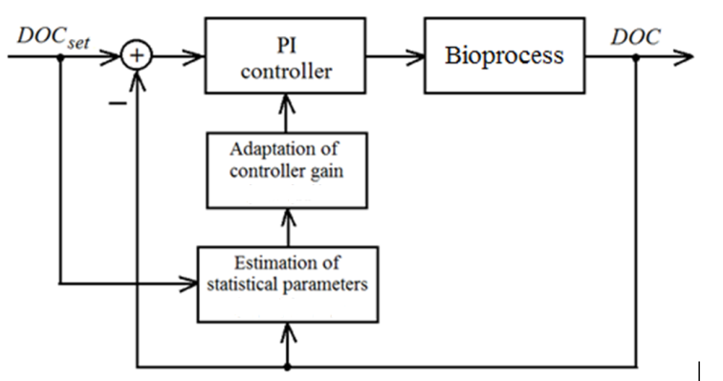

Figure 1: Block-diagram of the DOC control system

There are multiple possible technological or specific growth control related reasons on why DOC set-point has to be changed. Controlled oxygen limitation is one of the example scenarios. It should be stressed that changing of the DOC set-point during the controlled process distorts the data in moving window and, therefore, the statistical parameter estimates, on which the controller adaptation is based. So, the adaptive control system based on feedback signal statistical parameters is preferable to control the DOC at constant set-point only.

The applied controller gain adaptation strategy is to keep the two performance indices: average absolute deviation and the off-set under desired levels. However, manipulation of the controller gain may act the above performance indices in opposite directions. It can be noticed that at high OUR changing rates the off-set of DOC from a set-point emerges. At the above state of the controlled process, the adaptation rule increases the controller gain to eliminate the off-set, however, the higher gain simultaneously increases instability, i.e., an amplitude of the oscillations. Therefore, choice of the threshold values of the above indices in the adaptation rule influences a tendency of the controller gain adaptation during fed-batch cultivation course. A suitable width of moving window and value of the coefficient $a$ in the tuning rule (8) was determined from early simulation experiments. In the simulation experiments, performance of the adaptive control system was investigated at various threshold levels of the maximum absolute deviation and the maximum off-set. Values of the tuning parameters are given in Table 2.

Table 2: Values of the control system tuning parameters

|  |  |
| --- | --- |
| Parameter | Value |
| Integration constant of PI controller *Ti* | 50 s |
| Length of moving window $Tw$ | 200 s |
| Maximum average absolute deviation $D_{max}$ | 0.15 % |
| Maximum average off-set $O_{ff_set_max}$ | 0.02 % |
| $$a$$ | 1.5 |

The simulation experiments show that the investigated DOC control system with the proper values of the tuning parameters provides reliable adaptation of controller gain and stable performance. It was found that performance of the control system is not very sensitive to variations of the control system tuning parameters in wide ranges around the most suitable values (up to 15-20 %).

Simulation results of the control system performance are shown in Figure 2. For comparison, performance of the ordinary control system with constant gain ( s-1 %-1) of PI controller is presented in Figure 2d.

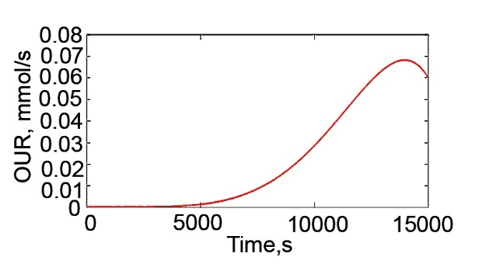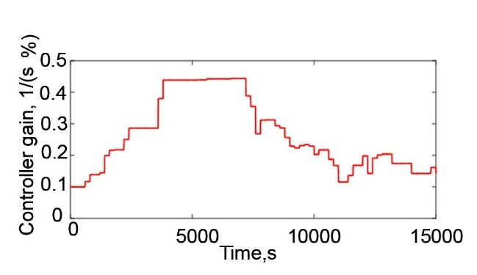

(a)

(c)

(d)

(b)

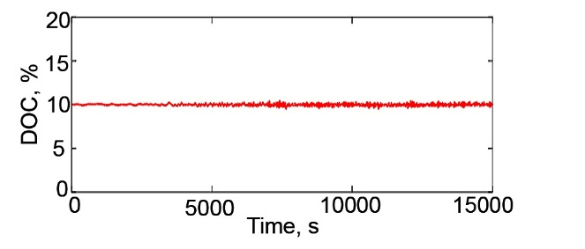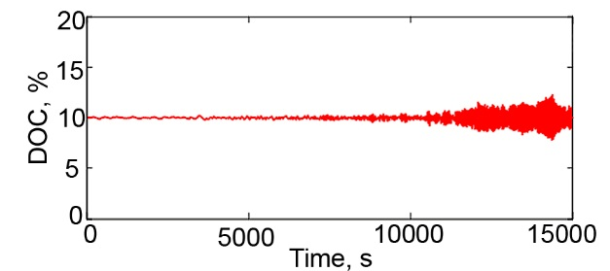

Figure 2: Adaptive control system output: (a) time profile of OUR, (b) adaptation of controller gain. (c) the DOC controlled at 10 % set-point, (d) ordinary PI control

As mentioned above, the proposed adaptive control system based on the feedback signal statistical parameters is preferable, when the DOC is controlled at a steady set-point. The process disturbances are to be relatively small and do not distort significantly the statistical parameters used in the controller adaptation algorithm. Such assumptions are reasonable for the low and medium density cell cultivation processes.

However, in high cell density cultivation processes (typically when the biomass concentration of 50 g L-1 or higher is reached), extremely large disturbances of the DOC may occur. Typically, the disturbances take place at time points when anti-foam solution is added to cultivation medium to avoid intensive foaming, which deteriorates important instrumentation of bioreactor and spoils the cultivation process. Therefore, the foam reduction procedures are commonly used in high density cell cultivation processes.

* 1. DOC control system, in which adaptation of PI controller parameters is based on the controlled variable disturbances in closed-loop system

For processes with significant disturbances, other methods of controller adaptation shall be used. These methods generally employ transient responses of control system for on-line tuning of controller parameters (Åström and Hägglund, 2006). Analysis of the existing methods has shown that the adaptation method proposed by Rotach (1973) is well suited for the DOC controller adaptation in the high density cell cultivation processes. The method includes analysis of transient responses of the closed-loop control system and application of approximate tuning rules for adaptation of controller gain *K* and integration constant *Ti* in order to achieve rational decay ratio *0.1<d<0.25* (ratio between two consecutive peaks of the DOC signal after disturbance) and settling time *Ts* (the time before the disturbance response remains within 10 % of its steady-state value) of the controlled process. The above adaptation method was originally developed for controller adaptation based on analysis of the control system set-point step response; however, our investigation has shown that it can be also reasonably applied for system disturbance-based controller adaptation.

The PI controller adaptation algorithm realized in the above control system can be summarized as follows:

1. After an anti-foam agent is added into bioreactor, the DOC control system reacts to this disturbance and the transient responses of the control system are used for estimation the damping $D=1-{A_{2}}/{A_{1}}$ 
    and the oscillation period *T* of the response curve (see Figure 3b).
2. Based on the above parameter values, an auxiliary parameter *T/Ti* is estimated and correction coefficients for the controller gain *α*k and the integration constant *α*i are defined from the diagrams developed by Rotach (1973).
3. Improved values of the controller gain *K* and the integration constant *Ti* for the next time interval *k+1* are estimated using the following iterative equations:

|  |  |
| --- | --- |
| *K (k+1)=α*k *· K(k); Ti(k+1)=α*i*· Ti(k)* | (9) |
| Block-diagram of the adaptive control system is presented in Figure 3a. |  |

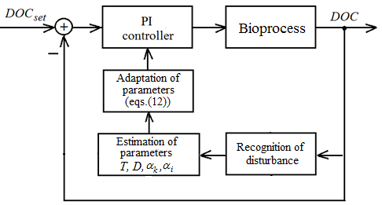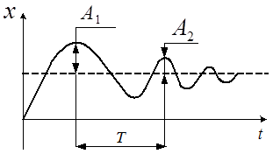

(a)

(b)

Figure 3: Block-diagram of the DOC adaptive control system based on the transient response of closed loop system (a), schema of the procedure for estimation of peak magnitudes A1 and A2 for damping D and oscillation period T (b)

An efficiency of the above controller adaptation method is investigated when controlling the DOC in high density cell cultivation process. In the simulation experiments, the process model (1)-(4) was used. The performance of proposed adaptive DOC control system is presented in Figure 4a,b.

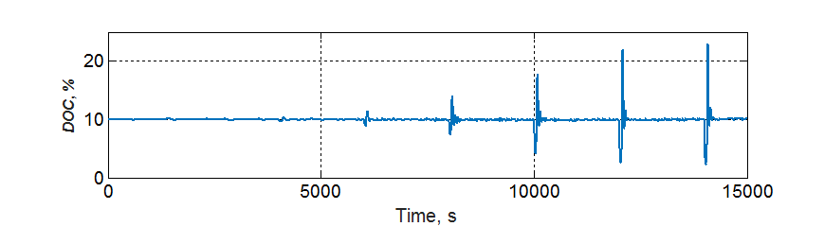

(a)

(b)

Figure 4: Simulation results of the adaptive PI control system performance (a) controlled process and controller’s gain adaptation (b) output

The following assumptions were made for simulation of the DOC dynamics and transient responses of the high density cell cultivation process:

* OUR in the high density cultivation process is 3 times higher as compared with an ordinary cultivation process, *OURHD (t)= 3·OUR(t)*;
* Starting from the time point t=4000 s, every 2000 s an anti-foam agent is added into the bioreactor. This action extremely reduces the oxygen transfer capacity in bioreactor for 30 seconds (parameter α in the model equations (2),(3) is reduced to *0.3· α* for this time interval);
* Transient responses of the control system are used to estimate the parameter *D*, the oscillation period *T*, the auxiliary parameter *T/Ti* and the correction coefficients *αk , αi* . The controller parameter values of the conventional control system (*K=0.3* s-1%-1*, Ti=50* s) are chosen to provide the best available performance using the ordinary PI controller with constant parameter values.

Analysis of the simulation results of cultivation process at significant disturbances shows that in the late phases of cultivation process the adaptive controller decreases the decay ratio *d* from 45 % (in the conventional system) to 15 % (in the adaptive system). Also, the settling time *Ts* in these cultivation phases is reduced from 200 seconds (in conventional system) to 160 seconds (in adaptive system). The presented results prove efficiency of the DOC adaptive control system and potential of implementation for the DOC control in high density cell cultivation processes. Interestingly, from the simulation results, one can see that the adaptation curve of controller gain *K* has a profile Figure 4b like that of the adaptive controller gain obtained in the control system discussed in the previous section of the paper Figure 2b. However, as it was mentioned above, the 1st adaptation method is not suitable for the high density cell cultivation process because of extreme disturbances in the DOC control loop.

* 1. Conclusions

The two simple adaptive PI control systems have been developed and investigated for controlling the DOC in batch and fed-batch fermentation processes. The both control systems demonstrate stable performance and improvement of the DOC control accuracy as compared with the ordinary PI control system.

The adaptive control system based on feedback signal statistical analysis requires minimum *a priori* knowledge about the controlled process and can be realized in many commercial controllers. It can be applied for controlling DOC at steady set-point in standard batch and fed-batch fermentation processes under ordinary conditions.

The adaptive control system based on disturbance analysis in closed-loop system can be applied for controlling DOC in high density cell cultivation processes, in which significant disturbances of the DOC occur due to periodic addition of the anti-foam agents.

Acknowledgments

This research was funded by the European Regional Development Fund according to the supported activity “Research Projects Implemented by World-class Researcher Groups” under Measure No. 01.2.2-LMT-K-718.

References

Åström K.J., Hägglund T., 2006, Advanced PID Control. ISA-The Instrumentation, Systems, and Automation Society. Research Triangle Park, NC 27709.

Dong B., Ge Y., Zhu H., Wang J., Zhu Y., 2017 Dec 1, Research on Dissolved Oxygen Control during Biological Sewage Treatment. Chemical Engineering Transactions, 62:1231-6.

Grossi C.D., Fileti A.M., Santos B., 2018 Jun 1, Neural Model to Describe Microbial Concentration in the Bioreactor for Biosurfactant Production Using Waste Substrate. Chemical Engineering Transactions, 65:481-6.

Hwang Y.B., Lee S.C., Chang H.N., Chang Y.K., 1991 Mar 1, Dissolved oxygen concentration regulation using auto-tuning proportional-integral-derivative controller in fermentation process. Biotechnology Techniques, 5(2):85-90.

Kuprijanov A., Gnoth S., Simutis R., Lübbert A., 2009 Feb 1, Advanced control of dissolved oxygen concentration in fed batch cultures during recombinant protein production. Applied microbiology and biotechnology, 82(2):221-9.

Levisauskas D., 1995 Feb 1, An algorithm for adaptive control of dissolved oxygen concentration in batch culture. Biotechnology techniques, 9(2):85-90.

Levisauskas D., Simutis R., Galvanauskas V., 2016 Jan 1, Adaptive set-point control system for microbial cultivation processes. Nonlinear analysis-modelling and control, 21(2):153-65.

Rotach V.Y., 1973, Calculation of Dynamics of Industrial Control Systems (in Russian; Raschet dinamiki promyshlennykh sistem regulirovaniya). Moscow, Energia.

Urniezius R., Galvanauskas V., Survyla A., Simutis R., Levisauskas D., 2018 Oct 11, From Physics to Bioengineering: Microbial Cultivation Process Design and Feeding Rate Control Based on Relative Entropy Using Nuisance Time. Entropy, 20(10):779.

Villadsen J., Nielsen J., Lidén G., 2011, Bioreaction Engineering Principles, Boston, MA: Springer US.