 CHEMICAL ENGINEERING TRANSACTIONS  VOL. 76, 2019 | A publication of  
The Italian Association
of Chemical Engineering
Online at www.cetjournal.it
Guest Editors: Sauro Pierucci, Jiří Jaromír Klemeš, Laura Piazza
Copyright © 2019, AIDIC Servizi S.r.l.
ISBN 978-88-95608-73-0; ISSN 2283-9216

Effects of Straw and Biogas Co-firing on the Combustion Characteristics
Inesa Barminaª, Antons Kolmickovs^{a,*}, Raimonds Valdmanisª, Maija Zakeª, Harijs Kalis^{b}, Uldis Strautins^{b}
ª Instutute of Physics, University of Latvia, 32 Miera Street, Salaspils-1, LV-2169, Latvia
^{b} Institute of Mathematics and Informatics, University of Latvia, 29 Raina boulevard, Riga, LV-1459, Latvia
antons.kolmickovs@lu.lv
In this study, effects of straw co-firing with a renewable fuel – low heating value biogas – on the combustion characteristics, heat output from the device and composition of flue gas, are studied and analyzed with the aim to achieve more efficient use of straw for energy production. The study combines experimental research and mathematical modelling of the processes developing at co-firing of straw pellets with a low heating value biogas, which consists of 60 % methane and 40 % CO₂. The complex research of the effects of straw co-firing on the gasification and combustion characteristics suggests that the increase of the biogas supply from 0 up to 1.35 l/min (additional heat input up to 0.4 kW) stabilizes the after-flame stage of the combustion of straw pellets, thus completing the burnout of volatiles, increasing the average value of the axial flow velocity, the flame temperature and the heat output from the device by about 25 – 30 %. The mathematical modelling of the straw co-firing with biogas is provided with account of variations of combustible volatiles by increasing the biogas supply into the experimental setup. A mathematical model of the combustion dynamics when co-firing straw with the biogas flame flow has been developed using the environment of MATLAB package. For the mathematical modelling, a system of dimensionless parabolic type partial differential equations was used to describe the formation of the 2D compressible reacting swirling flow, the variations of the mass fraction of volatiles, flame species and flame temperature at thermo-chemical conversion of volatiles. Results of the numerical simulation were analyzed considering the processes developing downstream the combustor.
  - Introduction
The rapidly increasing global warming strengthens the requirements for local heat producers to limit the use of fossil fuels for heat production by providing a more effective use of renewable energy sources for energy production to mitigate climate changes. The researchers in Denmark, United Kingdom and other EU countries continue their extensive studies concerned the more intensive use of local plant biomass resources, especially agricultural waste, e.g., straw, which is considered as an important fuel for future advanced power/heating stations (Rathmann et al., 1995). However, the relatively low net heating value, the high nitrogen and ash contents can cause an excessive production of NO_{x}, CO and the problems related to the boiler operation stability (Olsson, 2012). Nowadays these problems restrict the utilization of straw for the heat energy production. To minimize the negative effects, the co-firing of straw with a fossil solid fuel (Pedersen et al., 1996; Barmina et al., 2018a), propane (Barmina et al., 2017b), or with natural gas (Overgaard et al., 2015; Agbor, 2015) has been studied to assess the feasibility of the straw co-firing for the improved use of straw for heat energy production with the reduced greenhouse carbon (CO₂), NO_{x}, CO, GHG emissions and ash. For this reason, heat producers will increasingly practice the burning of fuel mixtures, partially replacing fossil fuels (coal, natural gas) with local renewable fuels (wood, straw). That have the advantage regarding the CO₂ neutrality and fossil fuel economy, which reserves are limited and rapidly deplete. Today the co-firing of biomass with fossil fuels has become a common and mature technology for energy production. However, only a few studies have been carried out to find out additional options for the co-firing of straw with biogas and to estimate the advantages and disadvantages of this process. In this context, the complex experimental research, mathematical modelling and numerical simulation of the processes developing at the wheat straw co-firing with biogas have been carried out with the aim to find out the main factors affecting the thermal decomposition of straw, the combustion efficiency, the heat energy production and the flue gas composition.
  - Experimental
Effects of the wheat straw gasification/co-firing with a biogas, which is composed of CH₄ (60 %) and CO₂ (40 %), were studied using a batch-size experimental setup with an average heat power up to 1.5 kW (Barmina et al., 2017b). The estimation of the low heating values (LHV) of the biogas and straw, respectively, 17.6 MJ/kg and 17.3 MJ/kg, suggests that they are comparable. The main parts of the setup are a biomass gasifier filled with straw pellets, two water-cooled sections of the combustion chamber and a gas burner which ensures the co-firing of straw with the biogas. The biogas burner provides a heat flux onto the upper layer of straw pellets. It initiates the thermal decomposition of straw and sustains the combustion of volatiles. The biogas supply (q_{bio}) in the test experiments was varied from 0.99 l/min up to 1.35 l/min, thus varying the additional heat input into the setup from 0.39 kW up to 0.45 kW, which corresponds to 27–36 % of the total heat output from the device. To assess the effect of the biogas co-firing on the thermo-chemical conversion of straw, the experimental study involved complex measurements of the main gasification and combustion characteristics using the experimental methodology described in Barmina et al. (2018a). The methodology supposes combined measurements of the straw weight loss rate (dm/dt) at the thermal decomposition of pellets, of the composition of volatiles entering the combustor, of the axial and tangential flow velocities, of the flame temperature, of the heat power of the device, of the total produced heat energy per mass of burned solid fuel, and of the flue gas composition at different rates of the additional heat input by the biogas flame flow.
  - Result and discussion
The results of previous studies show that the thermo-chemical conversion of wheat straw when co-firing it with solid (Barmina et al., 2018a) or gaseous (Barmina et al., 2017b) fuels is a very complex process which involves a series of reactions and is strongly influenced by the elemental and chemical composition of biomass (Barmina et al., 2018a), determining the thermal decomposition of straw, the formation, ignition and combustion of volatiles. The thermal decomposition of straw at its co-firing with a biogas results in complex variations of the weight loss of straw pellets at different stages of the straw thermo-chemical conversion, depending on the biogas supply rates. During the primary pre-combustion stage (t = 500 – 1,000 s), the increase of the biogas supply into the gasifier slows down the weight loss rate of straw pellets and, as a result, decreases the release of combustible volatiles (Figure 1a, 1b). During the self-sustaining burnout of volatiles (t = 1,000 – 2,600 s), increasing the biogas supply into the gasifier results in a slight increase of the weight loss rate of straw pellets (by about 6 %) with a correlating increase of the volume fraction of the combustible volatiles (CO, H₂) produced at thermal decomposition of straw (Figure 1a, 1b).
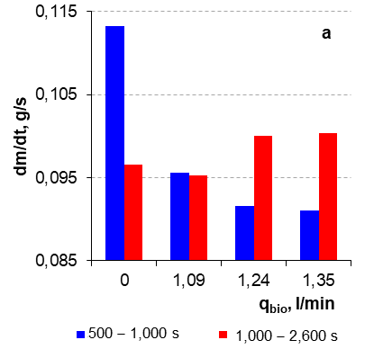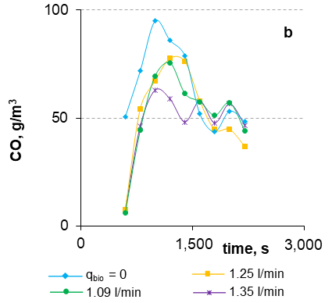
Figure 1: Effect of the biogas supply rate variations on the average values of the straw weight loss rate (a) and on the kinetics of release of combustible volatiles entering the combustor (b).
A similar effect of the biogas supply on the kinetics of volatile formation is deduced from the results of the FTIR spectrum analysis of the gasification gas composition. These results confirm that the co-firing of straw with the biogas results in a slight delay of the volatile formation at the primary pre-combustion stage (t = 500 – 1,000 s), with the enhanced and more lasting formation of volatiles at t > 1,000 s (Figure 2, a-d). The analyzed IR absorption wavelengths of the CH₄, CO₂, C₂H₄, C₂H₂ components are 3,017; 668; 950; 732 cm⁻¹ accordingly.
. 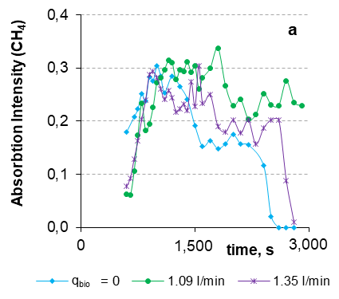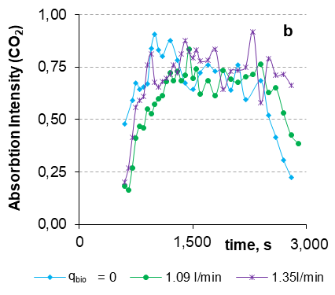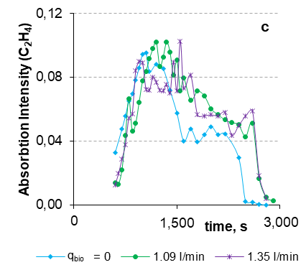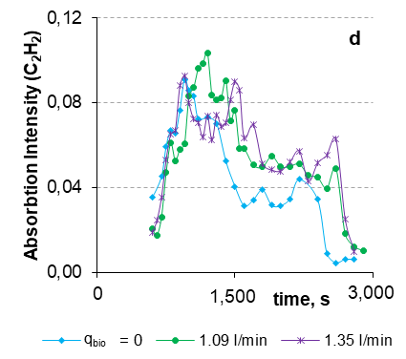
Figure 2: Effect of the biogas supply rate variations on the kinetics of volatiles formation at the gasifier outlet when co-firing straw with biogas.
The most pronounced variations of the main flame characteristics (flow velocity and flame temperature) were observed during the self-sustaining burnout of volatiles (t = 1,000 – 2,600 s), when co-firing of straw pellets with biogas results in the increase of the straw weight loss rate (Figure 1a), with the enhanced release of the combustible volatiles (Figure 2). Increasing the biogas supply into the device up to 1.35 l/min during this stage of straw co-firing, the average value of the axial flow velocity at the flame base (L/D = 1.5) increases from 0.195 m/s to 0.31 m/s, while the average flame temperature (L/D = 2.7) increases from 860 K up to 970 K. Moreover, by analogy with time-dependent variations of the absorption intensity of volatiles (Figure 2), the time-dependent variations of the flame temperature at different rates of the biogas supply confirm a more lasting volatiles burnout. Along with the effect of biogas co-firing on the axial flow velocity and on the flame temperature, the variations of the setup heat power and total produced heat energy per mass of burned straw pellets were observed (Figure 3a, 3b). By analogy with the kinetics of volatiles formation at the gasifier outlet (Figure 2) and time-dependent variations of the flame temperature, increasing the biogas supply into the device results in the more lasting heat output from the experimental setup (Figure 3a), completing burnout of carbon monoxide by about 30 − 50 % during the char conversion stage of straw (Figure 3c) and increasing the total produced heat energy by ~32 % at the thermo-chemical conversion of straw (Figure 3b). The complex measurements of the main flame characteristics as well as the flue gas composition suggest that the co-firing of straw with biogas improves the combustion process by decreasing the air excess ratio and the mass fraction of CO in the products at the final stage of char conversion (t > 2,600 s), whereas it increases the volume fraction of carbon-neutral CO₂ emissions in the products (Figure 3c, 3d).
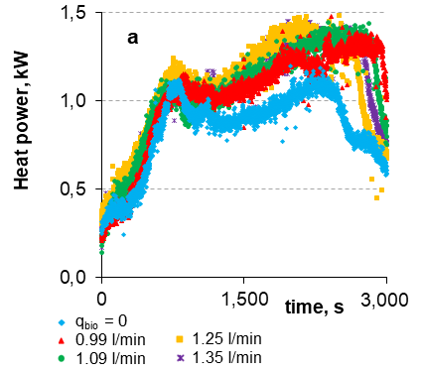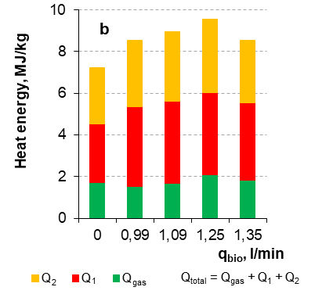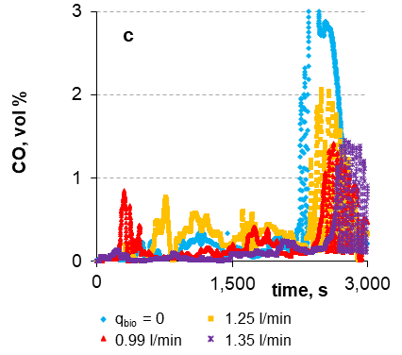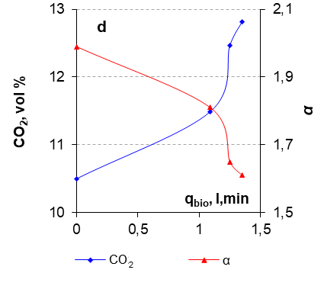
Figure 3: Effect of the biogas supply rate variations on the heat power of the setup (a), on the average values of the total produced heat energy per mass of burned solid fuel (b), on the time-dependant variations of the CO volume fraction in the flue gas (c), on the average values of the CO₂ volume fraction and on the air excess ratio (alpha) in the flue gas (d) when co-firing wheat straw with biogas.
  - Results of mathematical modelling and numerical simulation
For the mathematical modelling, a system of dimensionless parabolic type partial differential equations was used to describe the formation of the 2D compressible reacting swirling flow, the variation of the mass fraction of the combustible volatiles (CO, H₂) downflow in the reaction zone and the main parameters of the flame flow during the combustion of these volatiles.
A mathematical model for the combustion of volatiles downstream the combustor has been developed using MATLAB with the account of variations in CO, H₂ supply into the combustor by varying the biogas input into the setup. The results of the numerical simulation were analyzed considering two exothermic second chemical reactions developing at the combustion of the volatiles (Westley, 1980; Douglas et al., 1956):
H₂ + OH → H₂O + H | (1)
CO + OH → CO₂ + H | (2)
The chemical reactions Eq(1, 2) were used for mathematical simulation of the combustion process of the main volatiles produced at the biomass thermal decomposition when co-firing wheat straw pellets with the biogas. The input data (Table 1) for the simulation taken from the physical experiment are the average values of the molar density of the volatiles C’₁ (H₂) and C’₅ (CO) at different straw co-firing regimes with variation of biogas amounts supplied into the combustor.
Table 1: Input data of average values of the molar density of the combustible volatiles (H₂ and CO) for numerical simulation by varying the biogas supply into the combustor (q_{bio}).
q_{bio} | 0 l/min | 1.00 l/min | 1.17 l/min | 1.23 l/min
C’₁ (H₂), mol/m³ | 1.500 | 1.525 | 1.475 | 1.490
C’₅ (CO), mol/m³ | 1.689 | 1.853 | 1.854 | 1.717
In the mathematical model, the mass fractions of the reactants at the combustor inlet are presented as C_{k}, where k is the reactant or the product number from 1 to 6, where C₁ is H₂, C₂ – OH, C₃ – H₂O, C₄ – H, C₅ – CO and C₆ is CO₂. In respect to the Eq(1, 2) described mechanism, one can assume C₁ + C₂ + C₅ = 1, whereas the mass fractions of the products are C₃ = C₄ = C₆ = 0.
In addition to reactions Eq(1, 2), two other exothermic reactions Eq(3, 4) for the combustion of volatiles with account of the three reactants C₁ (CO), C₂ (O₂), C₄ (H₂) and two main products C₃ (CO₂), C₅ (H₂O) (without OH, H) were considered in the mathematical model (Martinez, 2018).
2 H₂ + O₂ → 2 H₂O | (3)
2 CO + O₂ → 2 CO₂ | (4)
At the inlet of the combustor, the conditions C₁ + C₂ + C₄ = 1 and C₃ = C₅ = 0 are fulfilled, where C₁ is H₂, C₂ – O₂, C₃ – H₂O, C₄ – CO, and C₅ is CO₂. The following dimensionless values were used for the mathematical modelling (Martinez, 2018): the heat effects q₁ = 11.20, q₂ = 5.48, the scaled activation energies δ₁ = δ₂ = 18.75, the scaled reaction-rates pre-exponential factors A₁ = 1.72·10⁸, A₂ = 3.37·10⁸.
For the mathematical modelling, a 2D axially symmetric ideal, laminar compressible swirling ﬂow with six chemical species of reactions Eq (1 − 4) developing downstream the coaxial cylindrical combustor of radius r₀ = 0.05 m and length z₀ = 0.1 m was used. The parameters z, r, t, T, u, w (length, radius, time, temperature, axial and radial components of velocity) are expressed in the dimensionless coordinates and, correspondingly, are normalized at the inlet (z = 0) by the radius r₀ at the time t₀ = r₀/U₀, where U₀ = 0.1 m/s is the normalized velocity, T₀ = 300 K is the temperature at the process start and V₀ = 3U₀. The approximation is based on the implicit ﬁnite difference and alternating direction (ADI) method (Douglas et al., 1956). The numerical results depending on (z, r, t) were obtained for 0 < z < 2; 0 < r < 1; 0 < t < 1.
Table 2: Numerical simulation of the values of the mass fractions of chemical species (C_{k, end}), maximum (T_{max}) and average (T_{av}) flame temperature, maximum axial (u_{max}) and radial (w_{max}) flow velocities versus the varying rate of biogas supply into the combustor inlet (t_{end} = 0.5 s; C_{2, end} = 0).
Species¹ | 0  l/min | 1.00  l/min | 1.17  l/min | 1.23  l/min | Species² | 0  l/min | 1.00  l/min | 1.17  l/min | 1.23  l/min
C_{1, start} ^{(H2)} | 0.370 | 0.380 | 0.370 | 0.370 | C_{1, start} ^{(H2)} | 0.375 | 0.381 | 0.368 | 0.373
C_{5, start} ^{(CO)} | 0.420 | 0.460 | 0.460 | 0.430 | C_{4, start} ^{(CO)} | 0.422 | 0.463 | 0.464 | 0.429
C_{2, start} ^{(OH)} | 0.210 | 0.160 | 0.170 | 0.200 | C_{2, start} ^{(O2)} | 0.203 | 0.156 | 0.168 | 0.198
C_{1, end} | 0.327 | 0.336 | 0.327 | 0.327 | C_{1, end} | 0.357 | 0.369 | 0.355 | 0.356
C_{5, end} | 0.195 | 0.294 | 0.279 | 0.215 | C_{4, end} | 0.312 | 0.364 | 0.355 | 0.318
C_{3, end} ^{(H2O)} | 0.082 | 0.067 | 0.068 | 0.215 | C_{3, end} ^{(H2O)} | 0.157 | 0.112 | 0.119 | 0.151
C_{4, end} ^{(H)} | 0.012 | 0.009 | 0.010 | 0.012
C_{6, end} ^{(CO2)} | 0.353 | 0.261 | 0.284 | 0.337 | C_{5, end} ^{(CO2)} | 0.173 | 0.155 | 0.171 | 0.175
u_{max} | 3.54 | 3.34 | 3.37 | 3.50 | u_{max} | 3.77 | 3.50 | 3.60 | 3.75
w_{max} | 2.51 | 2.49 | 2.49 | 2.50
T_{max} | 2.19 | 1.95 | 1.99 | 2.14 | T_{max} | 2.46 | 2.16 | 2.25 | 2.44
T_{av} | 2.07 | 1.86 | 1.89 | 2.02
¹ − values for the parameter obtained using the Eq(1, 2) chemical reaction mechanism.
² − values for the parameter obtained using the Eq(3, 4) chemical reaction mechanism.
Regarding the mechanism described by the Eq(1,2), the maximum values of the temperature T_{max}, flow component velocities u_{max}, w_{max}, mass fractions C_{k, end} of the species CO (C₅), H₂ (C₁), CO₂ (C₆), H (C₄) and averaged temperatures T_{av} are summarized in Table 2. The mass fraction of the reactant OH (C₂) decreases to zero by the time t_{end} = 0.5 s. The mass fraction of H₂ (C₁) decreased nearly to 0.04 and remained almost constant during the selected time for all simulated series depending on the biogas supply variations.
The results of the numerical simulation showed a strong decrease of the main combustion products (CO₂ and H₂O) for the biogas supply 1 l/min, with a slight increase of this parameters afterwards. The maximum and averaged temperature values as well as the flow velocity values also exhibited a strong decrease at the selected biogas supply rate. Although the gradual increase of the biogas supply improved the flame characteristics and the mass fraction of the main combustion products, the calculated data at straw co-firing with a maximum biogas supply of 1.23 l/min reached only the initial parameters related to straw combustion. Similar results were obtained with the 1D model using MATLAB routine “pdepe” for reactions Eq(1, 2). For reactions Eq(3, 4) it is shown that at this calculated time the mass fractions for H₂ (C₁) and CO (C₂) nearly decreased by 3−5 % and by 21−26 %, respectively, for all calculated series of the biogas/straw co-firing. Otherwise, the simulation of the variation of the main combustion parameters corresponds to the changes obtained using the Eq(1, 2) reaction mechanism.
  - Conclusions
As a result of the experimental study, it was found that the co-firing of straw and biogas accelerates the thermal decomposition of biomass, improves the burning of volatile biomass gasification products and increases up to 36 % the total amount of the heat collected from the experimental setup. The co-firing technology improves the main characteristics of the flame (temperature, air excess) as well as reduces the amount of harmful emissions into the atmosphere, especially at the final stages of char conversion.
The results of the mathematical modelling have shown that, in accordance with the data of the experimental study, the co-firing of wheat straw with biogas at the supply ratios below 1.23 l/min leads to the decrease of the flame temperature and its axial flow motion, decreasing along the burnout of CO and the formation of CO₂. The results of 1D and 2D modelling of the straw co-firing with biogas show that the maximum values of the products are obtained at the 1.23 l/min biogas supply rate, however, to improve the numerical simulation, higher values of the biogas supply rate should be considered in the next studies.
The consolidated results of this work prove that the additional heat from the biogas ﬂame allows controlling the thermal decomposition of straw pellets, the formation, ignition and burnout of the volatiles and the development of the combustion dynamics, thus completing the combustion of biomass and leading to cleaner heat energy production.
Acknowledgments
The authors would like to acknowledge the financial support from the European Regional Funding of the project No. 1.1.1.1/16/A/004.
References
Agbor E.U., 2015, Biomass Co-firing with Coal and Natural gas, Master’s thesis, University of Alberta, Department of Mechanical Engineering, Alberta, Canada.
Barmina I., Kolmickovs A., Valdmanis R., Zake M., 2017b, Co-firing of Straw with Electrodynamic Process Control for Clean and Effective Energy Production, EUBCE-17, 25th European Biomass Conference and Exhibition, 12–15 June 2017, Stockholm, Sweden, 579−592.
Barmina I., Kolmickovs A., Valdmanis R., Zake M., Kalis H., Strautins U., 2018a, Kinetic Study of Thermal Decomposition and Co-combustion of Straw Pellets with Coal, Chemical Engineering Transactions, 70, 247−252.
Douglas J., Rachford R., 1956, On the Numerical Solution of Heat Conduction Problems in Two and Three Space Variables, Transactions of the American Mathematical Society, 82 (2), 421−439.
Martinez I., 2018, Combustion Kinetics (set of lectures), 1−54 <webserver.dmt.upm.es/~isidoro/bk3/c15/Combustion%20kinetics.pdf> accessed 20.12.2018.
Olsson, M. 2006, Wheat Straw and Peat for Fuel Pellets – Organic Compounds from Combustion, Biomass Bioenergy, 30, 555−564.
Overgaard P., Larsen E., Friborg K., Hille T., Jensen P.A., Knudsen S., 2015, Full-scale Tests on Co-firing of Straw in a Natural Gas-fired Boiler, 1−6 <citeseerx.ist.psu.edu/viewdoc/summary?doi=10.1.1.561.1803> accessed 20.12.2018.
Pedersen L.S., Nielsen H.P., Kiil S., Hansen L.A., Dam-Johansen K., Kildsig F., Christensen J., Jespersen P., 1996, Full-scale Co-firing of Straw and Coal, Fuel, 75 (13), 1584−1590.
Rathmann O., Illerup J.B., 1995, Pressurized Thermogravimetric Reactivity Study of Wheat Straw Combustion and CO2-gasification, 210th ACS National Meeting, Division of Fuel Chemistry, Symposium on Biomass Fuels, Chicago, USA, Chapter In: American Chemical Society preprints of papers, 40 (3), 704-708.
Westley F., 1980, Table of Recommended Rate Constants for Chemical Reactions Occurring in Combustion, National Bureau of Standards, Chemical Kinetics information Centre, Washington DC, USA.
ANSWERS to 1st REVIEWER (should be deleted at final version of the manuscript)

- Are references written according to Harvard Style?:........................no
The references are formatted according to the style described at “CET template vol 70”. The is no mention about Harvard style. Nevertheless, the references have been double checked: article`s titles were capitalized, accessed date was corrected, few punctuation corrections have been made.
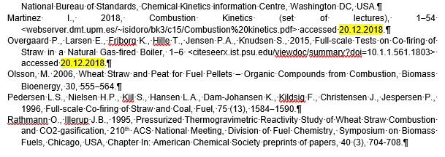
- English should be checked, there are grammatical errors and some words in the text.
The grammatical errors were checked and prevented by the English language specialist .

- It is a work of actuality but that presents very old citations and the only new ones are those of the same authors. You should look for other new ones that can support the research, the same authors mentioned in the text that has been working for a long time and is current in Europe.
Because of very limited volume of this paper almost all citations, which are provided in the introduction, gives only brief conceptual insight into research, provided by authors and other researchers in the field of biomass co-firing with solid and gaseous fuels. The only two citations, concerning mathematical analysis of the processes, refer to the research provided before 1990’s. The references section has been shortened because of the 6-page limit for the manuscript.

- It is low heating Value and not low calorific value
The lower heating value (also known as net calorific value) of a fuel is defined as the amount of heat released by combusting a specified quantity (initially at 25°C) and returning the temperature of the combustion products to 150°C. . Still, to be consistent and not to confuse the reader, the authors replaced this term for LHV.
https://www.sciencedirect.com/topics/engineering/lower-calorific-value
https://www.engineeringtoolbox.com/fuels-higher-calorific-values-d_169.html
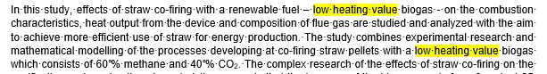
Lower and Higher Heating Values of Fuels | Hydrogen Tools
https://h2tools.org/hyarc/calculator-tools/lower-and-higher-heating-values-fuels
In present study higher heating value of straw is calculated from the data of elemental composition of straw using the regression equation proposed by Friedl et al. (Friedl, A.; Padouvas, H.; Rotter, H.; Varmuza, K. Prediction of heating values of biomass fuel from elemental composition. Anal Chim Acta 2005, 544, 191–198. 10.1016/j.aca.2005.01.041):

HHV = (3.55*C2-232*C-2230*H+51.2*C*H+131*N+20600)/1000, MJ/kg

where the elemental composition (C - carbon content, H - hydrogen content, N – nitrogen content and W-moisture) of softwood, wheat straw and peat biomass, were measured using the Vario Macro elemental analyzer (ELEMENTAR Analysensysteme, Germany) and analyzed according to the LVS EN 15104:2011 standard.

Lower (LHV) heating values of the pellets were calculated using the regression equation Obernberger I, and Thek. G. The Pellet Handbook. The production and thermal Utilisation of biomass pellets. London, Washington, 2010, p. 548.:
LHV = HHV *(1– W/100) – 2,447*W/100 – H/200*18.02*2.447×(1–W/100), MJ/kg
- The way of writing the experimental section is very confusing and not much is understood, with the aim of reducing the text to the maximum to comply with the rules of the journal the explanation given is very confusing for the reader. The equipment with which the experiments were performed is not described.
As the reviewer has been already mentioned, the manuscript text is limited for six pages, that is the reason the authors have decided to leave only the most urgent points of the experimental setup and also describe the variative parameters in the experiment, to focus on the biogas supply variation effect on the straw thermal decomposition an the combustion of the volatile matter. Thus, the authors gave the references to their previous works, there the experimental setup and the methodology of the experiment and measurements of the combustion/gasification characteristics are well and fully described in:

I. Barmina, R. Valdmanis, M. Zake, The effects of biomass co-gasification and co-firing on the development of combustion dynamics, Energy, Scopus, 2018, vol. 146, pp. 4 - 12. https://www.sciencedirect.com/science/article/pii/S0360544217307089, https://doi.org/10.3303/CET1870042.

Barmina I., Kolmickovs A., Valdmanis R., Zake M., Kalis H., Strautins U., 2018a, Kinetic Study of Thermal Decomposition and Co-combustion of Straw Pellets with Coal, Chemical Engineering Transactions, 70, 247−252.
Barmina I., Kolmickovs A., Valdmanis R., Zake M., 2017b, Co-firing of Straw with Electrodynamic Process Control for Clean and Effective Energy Production, EUBCE-17, 25th European Biomass Conference and Exhibition, 12–15 June 2017, Stockholm, Sweden, 579−592.

- The FTIR graphs are not shown anywhere, or the legends of the figures are misplaced
The absorption intensity of the specific VM component to time shows kinetics of the volatile matter formation process in the flame flows. It has been defined from the author’s and others previous works, that CO₂, CH₄, C₂H₂ and C₂H₄ can be described with 668, 3017, 732 and 950 cm⁻¹ IR absorption wave length accordingly. The method of FTIR analysis has been described at :
Zhao R., Yang N., Liu L., Duan R., Wang D., 2017, Characteristics of biomass gasification in flue gas by
Thermo-Gravimetry–Fourier Transform Infrared spectrometer (TG–FTIR) analysis, Chemical Engineering
Transactions, 61, 829-834. DOI: 10.3303/CET1761136., www.aidic.it/cet/17/61/136.pdf
which was cited and described in our previous work regarding co-combustion of solid biomass fuel https://www.aidic.it/cet/18/70/212.pdf .
Text have been supplemented with component’s characteristic wavelength.
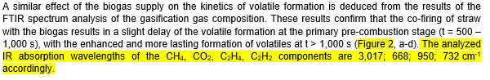

- The explanation of the model applied in MATLAB is confusing, the equations applied for the calculation of the yields and efficiency of the reactions are not shown.
Due to the restrictions of the manuscript length the authors were not able to provide full description of the mathematical model. The extended version of the description of the mathematical model of co-firing of gaseous fuel with solid biomass will soon can be found at yet the unpublished author’s manuscript of the 23th International Conference on Mathematical Modelling and Analysis (MMA2018) held in May 29 – June 1 of 2018th in Sigulda, Latvia.
