CHEMICAL ENGINEERING TRANSACTIONS  VOL. 76, 2019 | A publication of
The Italian Association
of Chemical Engineering
Online at www.cetjournal.it
Guest Editors: Sauro Pierucci, Jiří Jaromír Klemeš, Laura Piazza
Copyright © 2019, AIDIC Servizi S.r.l.
ISBN 978-88-95608-73-0; ISSN 2283-9216

Shortcut Distillation Model for Heat Integration
Keat Ping Yeoh, Pui Ying Lee, Chi Wai Hui*
Department of Chemical and Biological Engineering, The Hong Kong University of Science and Technology, Clear Water Bay, N.T., Hong Kong.
kehui@ust.hk
Distillation is a common process unit that requires substantial energy input. The energy input can be reduced by applying heat integration methods to the distillation system. A shortcut distillation model that does not require rigorous stage-by-stage calculation is proposed here to reduce computational difficulty. As traditional shortcut models utilizing the constant molar overflow (CMO) assumption are not sufficiently accurate for the study, the shortcut model used in this study utilizes a non-CMO assumption. A relation is derived from approximate material and energy balances to predict the change in liquid and vapour flows throughout the column. Coupled with material and energy balances over sub-sections and the entire column, the model can fully specify a distillation column. The model can be used for energy targeting in conjunction with heat integration models to simultaneously optimize the process. A case study was carried out on an air separation unit (ASU). Results of the case study showed that the energy required is 197 Wh per kg of pure O₂ produced. The results obtained are encouraging with close agreement when compared to an ASPEN simulation as the differences are below 2 %. However, the heat integration results of the MHEX from both the model and the ASPEN simulation showed a minimum temperature approach (DTmin) of almost 0. This is probably due to the usage of the ideal method where enthalpy calculation depends only on temperature.
  - Introduction
Distillation is a common unit operation in Chemical Engineering used to separate components and to obtain products of high purity. Many studies have been conducted on distillation systems with the aim of reducing energy consumption, such as the recent study by Zubir et al. (2019) which utilizes the driving force method to optimise the sequence and design of distillation columns to separate an aromatic mixture. While this study includes some elements of heat integration, it did not apply any energy targeting methods such as Pinch Analysis. A study published by Shahruddin et al. (2019) applied Pinch Analysis to a series of distillation columns to minimize the energy needed to separate an alcohol mixture. However, their method is sequential as the possible distillation sequences were simulated before the stream data were extracted for Pinch Analysis.
Simultaneous process optimisation of the distillation system and heat integration would most likely yield better results than a sequential method. One such study was conducted by Dowling & Biegler (2015), where they utilised rigorous distillation column models that require stage-by-stage calculation which are difficult to converge. Their study successfully identified high-quality solutions but requires significant computing power and time.
This paper aims to propose a shortcut distillation model with sufficient accuracy to be used in conjunction with a heat integration model for simultaneous optimisation. Shortcut distillation models which apply the constant molar overflow (CMO) assumption are not accurate enough. A shortcut distillation model found in the book by King (1980) uses the latent heat of vaporisation of each component to predict the change in flow throughout the rectifying and stripping sections. A similar concept is utilised by the shortcut distillation model proposed in this paper, with higher accuracy as observed in the case study presented. An Air Separation Unit (ASU) is used in the case study as it is a cryogenic process with distillation columns and a multistream heat exchanger. Heat integration in an ASU is important as refrigeration is costly. The optimisation is carried out using the shortcut distillation model and the Multi-M model proposed by Hui (2014), which can efficiently handle variable stream data and nonlinear constraints.
  - Methodology
    - Details of the case study
The flowsheet used in the case study is shown below. The model is implemented in GAMS 24.5 with the MINLP solver BARON. A compressor is used to compress the dry air feed to the pressure of the high pressure column (HP column). The compressed air is then cooled using cooling water before entering the multistream heat exchanger (MHEX), where it is cooled by the product streams of the low pressure column (LP Column). A side vapour stream is extracted from the bottom of the LP Column to prevent oxygen from being vaporised to the top of the column. The reboiler of the LP Column and condenser of the HP Column are coupled where the reboiler temperature is 3 K lower than the condenser temperature. The valves are used to flash the products of the HP Column to the pressure of the LP Column. The mixer recombines the streams exiting from the bottom of the LP Column.
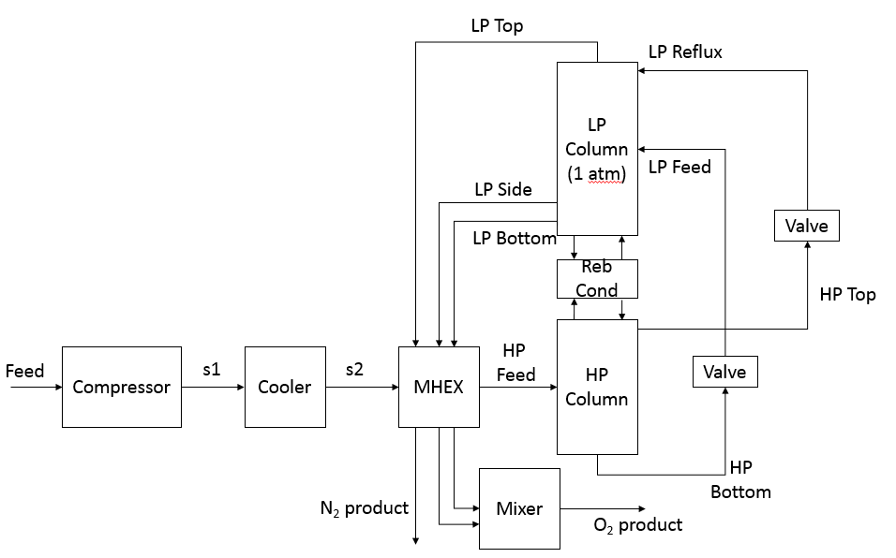
Figure 1: Flowsheet used in the case study
The feed condition, specifications of the equipment and some stream specifications used in the GAMS model are summarized here.
Table 1: Specifications of the process
Equipment | Specification | Stream | Specification
Compressor | Isentropic GPSA,  Efficiency = 100 % | Feed | 1 kmol/hr, T = 298.15 K, P = 1 atm, 0.79 mol % N₂, 0.21 mol % O₂
Cooler | Outlet T = 303.15 K | HP Bottom, HP Top, LP Bottom | Saturated Liquid
MHEX | DTmin = 10⁻⁷ | LP Top, LP Side | Saturated Vapour
Valve | Adiabatic, Outlet P = 1 atm | MHEX Cold Outlet Streams | Vapour

The objective of the study is to minimize the amount of compressor work needed per unit of pure oxygen produced.
    - Thermodynamic properties and assumptions used in the model
Ideal thermodynamic relations are used in the model. Formulae and coefficients to calculate enthalpy and heat of vaporisation were obtained from ASPEN Plus V9. Thermodynamic equations used are shown here, where Eq(1) is the extended Antoine equation used to calculate the saturated vapour pressure of a pure component, and Eq(2) is Raoult’s law. The symbol x represents the composition of the light key in the liquid phase, i.e. nitrogen, while y represents the composition in vapour. P is the system pressure. The vapour-liquid equilibrium can be calculated using Raoult’s Law. The heat of vaporisation can be calculated using Eq(3) and liquid enthalpy is calculated using Eq(4). The reference temperature, T_{ref} used is 298.15 K.
$$lnp_{i}^{*,l}=C_{1i}+\frac{C_{2i}}{T+C_{3i}}+C_{4i}T+C_{5i}\ln{T+C_{6i}T^{7i}}$$ | (1)
$$y_{i}P=x_{i}p_{i}^{*,l}$$ | (2)
$$∆H_{vap,i}=C1i{\left(1-\frac{T}{T_{c}}\right)}^{C_{2i}+C_{3i}\frac{T}{T_{c}}+C4i{\left(\frac{T}{T_{c}}\right)}^{2}+C_{5i}{\left(\frac{T}{T_{C}}\right)}^{3}}$$ | (3)
$$H_{liq,i}=C_{P,IG}\left(T-T_{ref}\right)-∆H_{vap,i}$$ | (4)
Ideal gas heat capacities were assumed to be constant, with a value of 29.105 kJ/kmol-K for N₂ and 29.103 kJ/kmol-K for O₂. Pressure drop is assumed to be zero across all equipment. Other assumptions used in the model include 100 % isentropic efficiency for the compressor and that heat capacity is constant within each stream in the MHEX. Pseudo streams have been defined to account for phase change where applicable.

    - Derivation of the non-CMO relation and distillation model used
Shortcut distillation column models define the section above the feed as the rectifying section, and the section below the feed as the stripping section. The component of higher volatility, also known as the light key, will be higher in purity at the top of the rectifying section and vice versa. The formulation for the shortcut distillation model to predict change in liquid and vapour flow is shown as follows, where L_{R} is the reflux flow, and L is the liquid flow at a point in the rectifying section. By convention, all compositions refer to that of the light key only. E represents the energy exchanged between the countercurrent vapour and liquid flow in the column. The term $C_{p,L}∆T+\frac{x_{D}+x}{2}Hvap_{N}$ represents the energy needed to vaporise one mole of nitrogen, by first raising the incoming liquid to the stage temperature, then vaporising it. Similarly, $C_{p,G}∆T+\frac{x_{D}+x}{2}Hvap_{O}$ is the energy needed to condense one mole of heavy key from the vapour, where the vapour first has to be cooled to the stage temperature. $\frac{x_{D}+x}{2}$ is a term to correct for the weightage of the H_{vap} term when the concentration of the light key is high at the top of the rectifying section. Eq(5) and Eq(6) show that the net decrease in liquid flow from L_{R} to L due to the light key vaporising and the heavy key condensing, and the decrease in light key content is due to nitrogen vaporising.
$$L_{R}-L=\frac{E}{C_{p,L}∆T+\frac{x_{D}+x}{2}Hvap_{N}}-\frac{E}{C_{p,G}∆T+\frac{x_{D}+x}{2}Hvap_{O}}$$ | (5)
$$L_{R}x_{D}-Lx=\frac{E}{C_{p,L}∆T+\frac{x_{D}+x}{2}Hvap_{N}}$$ | (6)
Dividing Eq(5) by Eq(6), and defining the ratio as a variable, A:
$$\frac{L_{R}-L}{L_{R}x_{D}-Lx}=1-\frac{C_{p,L}∆T+\frac{x_{D}+x}{2}Hvap_{N}}{C_{p,G}∆T+\frac{x_{D}+x}{2}Hvap_{O}}=A$$ | (7)
Similarly, in the stripping section, the relationship between the reboil rate and the vapour at a given vapour composition is given as follows:
$$\frac{V'-V_{B}}{V'y'-V_{B}y_{B}}=1-\frac{C_{p,L}∆T+\frac{(1-y')+(1-y_{B})}{2}Hvap_{N}}{C_{p,G}∆T+\frac{(1-y')+(1-y_{B})}{2}Hvap_{O}}=A$$ | (8)
The distillation columns used in the case study are non-standard distillation columns. The HP Column does not have a reboiler, instead, the feed is fed at the bottom of the column to provide a vapour source. Therefore, the HP Column feed must contain vapour. As the LP Column does not have a condenser, the distillate from the HP Column is fed to the top stage of the LP Column to act as a reflux. The bottom product of the HP Column is fed as usual to the middle of the LP Column. The following figure illustrates the configuration of the columns.
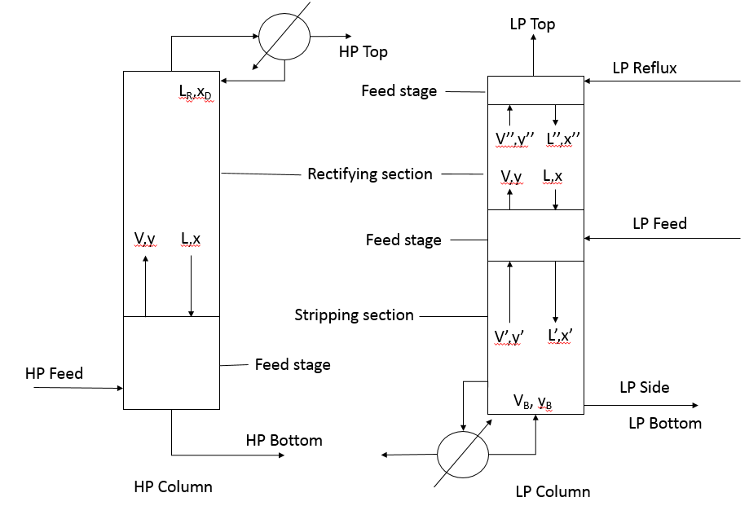
Figure 2: Configuration of distillation columns used
Energy, mass and component balances are conducted around each section, as well as on the overall column, with a tolerance set for the energy balance. Furthermore, flash calculations are performed around each feed stage, including the stage where the LP Reflux stream enters, ensuring that vapour and liquid exiting are in equilibrium. The value of A is allowed to vary in a narrow range to fulfil the material and energy balances.
    - Heat integration model and compressor model
The heat integration model used is an MINLP model, where binary variables and pseudo temperatures are used to accurately calculate the heat contribution of a stream above the Pinch i.e. qsoa for hot streams and qsia for cold streams. An overall energy balance is also conducted. The method is adapted from being used on heat exchanger networks (HEN) to be used in the MHEX here. The model used is formulated as follows, details can be found in Hui (2014) and Liang et al. (2018), as only the formulation for the hot streams is shown here.
$$\sum_{i∈H}{{CP}_{i,e}∙f_{i,e}\left(t_{i,e}^{in}-t_{i,e}^{out}\right)}=\sum_{i∈C}{{CP}_{i,e}∙f_{i, e}\left(t_{i, e}^{out}-t_{i, e}^{in}\right)} e∈E$$ | (9)
$${qsoa}_{j,e}≥{qsia}_{j,e} j∈I,e∈E$$ | (10)
$${qsoa}_{j,e}=\sum_{i∈H}{{CP}_{i,e}∙f_{i,e}\left({tp}_{i,j,e}^{in}-{tp}_{i,j,e}^{out}\right)} j∈I,e∈E$$ | (11)
$${qsia}_{j,e}=\sum_{i∈C}{{CP}_{i,e}∙f_{i,e}\left({tp}_{i,j,e}^{out}-{tp}_{i,j,e}^{in}\right)} j∈I,e∈E$$ | (12)
$${tp}_{i,j,e}^{in}≤t_{i,e}^{in}+{M1}_{i,j,e}^{in}\left(1-y_{i,j,e}^{in}\right) i∈I,j∈I,e∈E$$ | (13)
$$t_{i,e}^{in}≤{tp}_{i,j,e}^{in} i∈I,j∈I,e∈IE$$ | (14)
$${tp}_{i,j,e}^{in}≤t_{j,e}^{p}+{M2}_{i,j,e}^{in}∙y_{i,j,e}^{in} i∈H,j∈I,e∈E$$ | (15)
$$t_{j,e}^{p}≤{tp}_{i,j,e}^{in} i∈H,j∈I,e∈E$$ | (16)
$${tp}_{i,j,e}^{in}≤t_{j,e}^{p}-{∆T}_{e}^{min}+{M2}_{i,j,e}^{in}∙y_{i,j,e}^{in} i∈C, j∈I,e∈E$$ | (17)
$${tp}_{i,j,e}^{out}≥t_{i,e}^{out} i∈I,j∈I,e∈E$$ | (18)
$${tp}_{i,j,e}^{out}≥t_{j,e}^{p} i∈H,j∈I,e∈E$$ | (19)
$$t_{j,e}^{p}=t_{i,e}^{in} i∈H,j∈I,e∈E$$ | (20)

The work of the compressor was calculated using the following formula, where γ is the ratio of C_{p}/C_{v} and is approximately equal to 1.4 and R is the ideal gas constant:
$$W=\frac{F.R.T_{in}.γ}{γ-1}.\left({\left(\frac{P_{out}}{P_{in}}\right)}^{\frac{γ-1}{γ}}-1\right)$$ | (21)
  - Results and discussion of the case study
The results of the distillation and heat integration models were extracted and used to perform a simulation in ASPEN Plus. The specifications used in the simulation are shown below.
Table 2: Specifications used in the ASPEN simulation
Equipment | Specification
Compressor | Isentropic GPSA, Efficiency = 100 %, Outlet P = 4.694 bar
Cooler | Outlet T = 303.15 K
MHEX | HP Feed Temperature = 97.705 K
HP Column | No reboiler, Reflux Ratio = 0.978, Condenser P = 4.694 bar, 100 stages
LP Column | No condenser, Bottoms Rate = 0, LP Side Flow = 0.21 kmol hr⁻¹, Stage 1 P = 1 atm, 100 stages
Valves | Adiabatic, Outlet P = 1 atm

The results obtained from the GAMS model and ASPEN simulation are summarized in the table below. The work per unit mass of oxygen produced is within the optimized range mentioned by Dowling & Biegler (2015). This shows that the results obtained are reasonable although a different thermodynamic method is used.
Table 3: Comparison of results of the distillation model, work needed and ASPEN simulation
Stream | Model | ASPEN |  |  | Model |  |  | ASPEN
 | Flow/kmol hr⁻¹ |  |  | % difference | Composition, fraction N₂ |  |  |  | % difference
HP Feed | 1.000 | 1.000 |  | - | 0.79 |  |  | 0.79 | -
HP Top | 0.493 | 0.488 |  | 1.02 | 1.000 |  |  | 1.000 | 0.00
HP Bottom | 0.507 | 0.512 |  | -0.98 | 0.586 |  |  | 0.590 | 0.68
LP Top | 0.790 | 0.790 |  | 0.00 | 1.000 |  |  | 1.000 | 0.00
LP Side | 0.210 | 0.210 |  | - | 0.000 |  |  | 0.000 | 0.00
LP Bottom | 0.000 | 0.000 |  | - | 0.000 |  |  | 0.000 | 0.00
 |  |  | Model |  |  | ASPEN | % difference
LP Column Reboiler Duty/kJ hr⁻¹ |  |  | 4,709.14 |  |  | 4,709.38 | -0.01
HP Column Condenser Duty/kJ hr⁻¹ |  |  | -4,709.14 |  |  | -4,709.38 | -0.01
HP Column Condenser Temperature/K |  |  | 93.204 |  |  | 93.204 | 0.00
LP Column Reboiler Temperature/K |  |  | 90.204 |  |  | 90.204 | 0.00
Work/(Wh/kg O₂) |  |  | 197.07 |  |  | 196.85 | 0.11

The following table shows the heat integration results of the GAMS model and ASPEN simulation.
Table 4: Stream data extracted from the GAMS model
Type | Stream | Supply Temperature/K |  | Target Temperature/K |  | Duty/kW |  | Heat Capacity/kW K⁻¹
 |  | Model | ASPEN | Model | ASPEN | Model | ASPEN |  | Model | ASPEN
Hot | HP Feed | 303.15 | 303.15 | 98.13 | 98.13 | 1.657 | 1.658 |  | 0.008 | 0.008
Hot | HP Feed | 98.13 | 98.13 | 97.71 | 97.71 | 0.146 | 0.146 |  | 0.343 | 0.343
Cold | LP Top | 77.35 | 77.35 | 303.15 | 303.15 | 1.442 | 1.442 |  | 0.006 | 0.006
Cold | LP Side | 90.20 | 90.20 | 303.15 | 303.15 | 0.364 | 0.362 |  | 0.002 | 0.002

The Composite Curves obtained from the MHEX of the GAMS model is shown below. The hot utility needed is negligible and no cold utility is needed. It can be seen that the integration is tight.

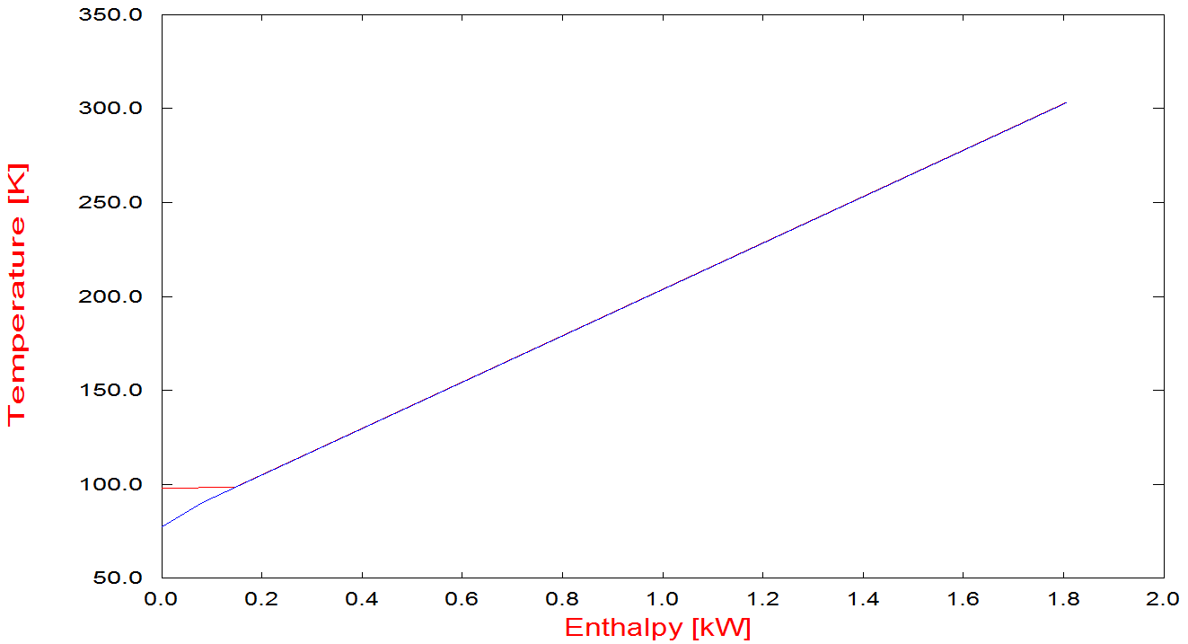
Figure 3: Composite curve of the MHEX as solved by the model
The results of the both the distillation and heat integration models are relatively close to that of Aspen’s, with the calculations being within 2 % agreement. The minimum temperature approach in the MHEX is close to 0. This could be due to the usage of the ideal method where enthalpy calculation depends only on temperature, and no additional cooling takes place due to throttling. Hence, the heat capacity and change in temperature of the hot stream at higher pressure and the cold stream at lower pressure are the same during heat exchange. Furthermore, all of the available energy from the cold streams is required to cool the HP Column feed, leading to the miniscule temperature approach.
  - Conclusions
Simultaneous optimisation of an ASU was carried out using a shortcut distillation model and an MINLP formulation for Pinch Analysis of a multistream heat exchanger. The case study showed that 197 Wh of energy is needed to produce 1 kg of pure O₂. Other than that, the stream results of the distillation model and heat integration model were in good agreement with those of ASPEN, with all results within a 2 % range of agreement. The results of the case study are encouraging and more configurations as well as rigorous property methods should be used with the models. In future, the number of stages can also be computed from the results.
Acknowledgments
The authors would like to thank the financial support from the Hong Kong Research Grants Council General Research Fund (RGC-GRF 16211117).
References
Aspen Plus. (2016). USA: Aspen Technology, Inc.
Dowling A. W., Biegler L. T., 2015, A framework for efficient large scale equation-oriented flowsheet optimization, Computers and Chemical Engineering, 72, 3-20.
Hui C. W., 2014, Optimization of heat integration with variable stream data and non-linear process constraints, Computers & Chemical Engineering, 65, 81-88.
Liang Y., Yeoh K. P., Pahija E., Lee P. Y., Hui C. W., 2018, Simultaneous Optimization of Multistream Heat Exchangers and Processes, Computer Aided Chemical Engineering, 43, 1293-1298.
Shahruddin M. Z., Tan X., Rahimi A. N., Zubir M. A., Zahran M. F. I., Ibrahim K. A., Hamid M. K. A., 2019, Thermal Pinch Analysis Application on Distillation Columns Sequence of 5-Component Alcohol Mixture, Chemical Engineering Transactions, 72, 271-276.
Zubir M.A., Islam Zahran M.F., Shahruddin M.Z., Ibrahim K.A., Abd Hamid M.K., 2019, Economic, Feasibility, and Sustainability Analysis of Energy Efficient Distillation Based Separation Processes, Chemical Engineering Transactions, 72, 109-114.

