|  |  |
| --- | --- |
| cetlogo ***CHEMICAL ENGINEERING TRANSACTIONS***  ***VOL. 76, 2019*** | A publication of  aidiclogo_grande |
| The Italian Association  of Chemical Engineering  Online at www.cetjournal.it |
| Guest Editors: Sauro Pierucci, Jiří Jaromír Klemeš, Laura Piazza  Copyright © 2019, AIDIC Servizi S.r.l. **ISBN** 978-88-95608-73-0; **ISSN** 2283-9216 | |

Differences in formation and oxidation of Colombian coal chars in air and oxy-fuel atmospheres

P. Debiagia\*, S. Heuerb, C. Ontydb, M. Schiemannb, T. Faravellic, C. Hasse a, V. Schererb

aInstitute for Simulation of Reactive Thermo-Fluid Systems, Technische Universität Darmstadt, Otto-Berndt-Str. 2, 64287 Darmstadt, Germany

bDepartment of Energy Plant Technology, Ruhr-University Bochum, Universitätsstraße 150, 44780 Bochum, Germany

cDipartimento di Chimica, Materiali e Ingegneria Chimica “Giulio Natta”, Politecnico di Milano, P.zza Leonardo da Vinci 32. 20133 Milano, Italy

debiagi@stfs.tu-darmstadt.de

The increasing interest towards more efficient and clean technologies, specially paying attention to CO2 neutral processes is encouraging the investigation of coal thermochemical conversion under oxy-fuel atmospheres (i.e. without N2). The process offers many advantages such as easy separation of the CO2 produced and low NOX/SOX emissions. While coal conversion in air is already well understood, full understanding of the influences of CO2-rich atmospheres is still required. A series of experiments in thermogravimetric analyser, drop-tube reactor and flat-flame burner were performed using a mid-range bituminous coal (Colombian coal) to understand the differences in the chars obtained after the pyrolysis step. Comparing the pyrolysis in N2 and CO2 atmospheres, significant differences were observed in the resulting chemical (composition) and physical properties of the chars, whereas mass loss was very similar for short residence times (< 130 ms). Afterwards, the chars obtained were submitted to oxidation and gasification, under several different operating conditions, in order to evaluate the difference in reactivity of these chars. Chars obtained under CO2 atmospheres revealed a lower reactivity, despite their higher surface area. These aspects cannot be explained and captured by a model which does not focus on some important details. In this paper, the results obtained in these experiments are summarized and discussed on the point of view of the POLIMI modelling approach for thermochemical conversion of solids. This model offers several advantages, such as being flexible to improvements, requiring simple experimental data of the fuel and offers an all-in-one solution for describing the kinetics of the whole process. The developments accounted for a wide range of experimental data, which allowed its calibration for several fuels, mostly in air combustion. It was first developed to describe the pyrolysis step, and later char oxidation/gasification was included in a simplified approach. The detailed mechanism of homogeneous gas phase reactions of the volatiles is also coupled. In order to extend the predictive capabilities of the model for oxy-fuel conditions, dedicated experiments must be considered for future improvements. In this work these missing effects are discussed, identifying the main necessary improvements, allowing this model to be extended and applied also for the designing of reactors that use oxy-fuel technologies.

* 1. Introduction

In 2015 coal was still one of the largest sources of primary energy with about 29 % of the total primary energy consumption and the main source of electrical energy with 41 % of the total produced, as well as one of the largest worldwide anthropogenic sources of carbon dioxide releases with about 50 % of the overall emissions from electricity production. Bituminous coals are intensively employed in power generation facilities in the USA and China, as they have relative high heating value. From the mining activity to final combustion emissions, coal can cause many environmental and health issues. To avoid these harmful consequences, many studies are directing efforts into the development of cleaner and more efficient technologies for coal combustion.

Oxy-fuel combustion (i.e. without N2) is of great interest as it allows downstream capture and storage of CO2, leading to low or even negative emissions. Important differences are encountered in pulverized coal combustion when the atmosphere is changed from air to oxy-fuel atmospheres, such as delayed flame ignition and reduced flame temperature as well as reduced NOX and SOX emissions. These changes can be partly explained by differences in heat transfer properties of nitrogen and carbon dioxide (density, heat capacity, thermal conductivity, O2 diffusivity and radiative properties). Further effects of the effect of oxy-fuel atmosphere on the char formation and combustion rate need to be investigated.

Many models to describe the thermochemical conversion of coals were proposed in the past decades. When considering complexity and level of details describing pyrolysis, the POLIMI model resides in the halfway between the very complex description adopted by the network models (e.g. CPD model [Fletcher et al, 1990]) and the extremely simplified one and two-step models. It was developed to offer a global description of coal conversion, and considers the differences in the fuel structure, rank and composition. The model comprehends coal devolatilization, char formation and oxidation and can be easily coupled with the gas-phase kinetic mechanism, which has been long developed by the same research group. This model approach has several advantages, such as being flexible to improvements and predictive in many aspects of the conversion process [Gentile et al, 2016]. The model summarizes the complex chemical structure of coal into a few reference structures commonly found in raw coal. Respecting the atomic mass balances, a coal sample is characterized by a proper linear combination of these structures, requiring only the elemental and proximate analysis of the fuel. The model offers an all-in-one solution for describing the kinetics of the whole process. Besides these advantages, the model was mostly developed and calibrated for air combustion conditions.

In the present work, the results of three test rigs – drop tube reactor (DTR), thermogravimetric analyzer (TGA) and flat flame burner (FFB) - for a medium rank bituminous Colombian coal in oxy-fuel atmosphere are investigated. This allowed the collection of experimental data in a wide range of conditions. Aiming to describe all the phenomena with a single model, this investigation discusses the results on the point of view of the POLIMI modelling approach for thermochemical conversion of solids, highlighting the aspects that are captured and the ones to be improved in order to obtain reliable predictions also in oxy-fuel conditions.

* 1. Experiments
     1. Materials

Experiments have been carried out with a medium rank bituminous Colombian coal. The fuel was milled, dried and sieved with the mesh sizes 90-106 μm, which corresponds to the upper limit of typical particle sizes in pulverized coal boilers. Such particle size allows the assumption of no internal temperature gradients. Proximate and ultimate analysis were carried out to reveal the fuel composition. Table 1 reports the proximate and ultimate composition.

Table 1: Analysis of the Colombian Coal (uncertainties reported in [Vorobiev et al., 2016]

|  |  |  |  |  |  |  |  |
| --- | --- | --- | --- | --- | --- | --- | --- |
| Proximate Analysis (wt.%) | | | Ultimate Analysis (daf wt.%) | | | | |
| Moisture | Ash (dry) | Volatiles (daf) | C | H | O | N | S |
| 2.0 | 4.8 | 40.9 | 79.0 | 5.4 | 12.9 | 1.8 | 0.9 |

* + 1. Test Rigs

Results from three different test rigs are considered in the present work. They have different features and together allow to investigate the thermochemical conversion of this coal in a broad range of conditions. The drop tube reactor, due to its characteristics, was also employed to produce significant amounts of char samples that were further used in the other test rigs. A brief description of the experimental setups is reported in the next section and further details are reported elsewhere for DTR, TGA [HEUER et al., 2016], and FFB [Vorobiev et al., 2016]. Another discussion of the experimental setups is present in Senneca et al. (2019).

Drop Tube Reactor

A laminar drop tube reactor was used for pyrolysis experiments at short residence times (<200 ms). A carrier gas of choice allows continuous particle feeding. Typical volume flow rates are in the range of 30–100 l/min (standard temperature and pressure STP); the gas is preheated to achieve high heating rates and constant conditions in the reactor. The maximum wall temperature is 1600 K which provides fast particle heating rates in the order of 104–105 K/s, typical for pulverized coal boilers. While the injection tube is fixed, a movable oil-cooled sampling probe with additional quench gas can be positioned at different distances from the particle inlet. Tests are run continuously with constant process parameters, such as gas flow, gas and wall temperature, particle flow rate and reaction distance. In each experiment char samples were collected and analyzed.

Thermogravimetric Analyzer (TGA)

Experiments were carried out in a NETZSCH 409-TG-DSC apparatus. In all the experiments, approximately 20 mg of char/coal sample was used and the gas flow rate was 200 ml/min (STP). In non-isothermal experiments, the sample was heated up in a reactive atmosphere of desired composition with a heating rate of 5 K/min to the final temperature and then held at this temperature for 30 min. In isothermal TG tests, the reaction temperature was reached in flowing argon, then the gas was switched to the desired composition and the sample was held at these conditions until complete burn off.

Flat Flame Burner

The experiments were carried out using a multi-element diffusion flat flame burner, located at the bottom of a cylindrical quartz glass chimney. The quartz chimney shields the reactant flow from entrainment of room air and provides optical access. Using mixtures of CH4, CO2, O2 and air, an oxy-fuel atmosphere consisting of 34% oxygen in the post-combustion flow and a N2-balanced atmosphere with 32% oxygen were created for the kinetics experiments. The water vapor content was around 20% in all atmospheres to simulate typical moisture contents in oxy-combustion with wet gas recirculation. Gas temperature profiles along the reactor centerline were measured with a thermocouple (30 μm wire) and corrected for radiation and convection losses. The substantial carrier gas flow of 0.5 slpm (N2 or CO2) was necessary for a stable operation of the particle dosing system, providing a particle heating rate of about 2×104 K/s. The heating-rate characteristics of this reactor is thus similar to that in the flash pyrolysis reactor. The camera setup consists of four intensified CCD cameras, which are used to simultaneously measure temperature, diameter, and velocity of individual burning particles. Different from the other test rigs, this one allows to track the conversion of single particles.

* 1. Kinetic Model

The network models typically require detailed data on the coal structure and molecular composition, while the PoliMi model assumes and merges all this structural information into four reference monomeric structures, namely COAL-1, COAL-2, COAL-3 and CHAR-C. Reported in Figure 1(A), a molecular structure and composition is assigned for each of these reference components, which represent boundary characteristics of coals. CHAR-C is pure carbon, representing larger aromatic clusters in graphitized structures, COAL-1 is rich in Hydrogen and contains no Oxygen, COAL-2 refers has similar composition to many bituminous coals, and finally COAL-3 represents a lignite rich in Oxygen. The Van Krevelen diagram in Figure 1(B) shows the atomic ratio of these reference species. Any coal whose composition falls within the triangular area can be characterized by simple linear combination.



Figure 1: (A) Structure and composition of the reference species of the POLIMI model. (B) Van Krevelen Diagram containing the reference species and the feasible characterization area.

The Colombian coal composition, reported in Table 1, was applied to characterize the coal sample in terms of the reference species of the POLIMI model, according to the procedure proposed by Sommariva et al. (2010). The resulting characterization is COAL-1/COAL-2/COAL-3 = 20.7/52.9/26.4 daf wt.% and shows a dominant presence of COAL-2, because of the higher H content compared to the average amount in bituminous coals.

The kinetic model is able to predict some characteristics of the coal conversion and the resulting chars, such as mass yield, elemental composition, ash content and reactivity under oxidative atmospheres. However, structural characteristics such as functional groups, specific surface area and porosity are not directly predicted by the kinetic model, requiring the coupling with a physical particle model for such description. The experiments were simulated using the operating conditions of each test rig (atmosphere, heating rate, final temperature, residence time), and using the kinetic mechanism reported in Sommariva et al. (2010). Complete formulation and kinetic constants of this mechanism is also available in Sommariva et al. (2010). The OpenSmoke++ framework was employed to simulate the reactor conditions.

* 1. Comparison of Experiments x Model Predictions

Drop Tube Reactor

First experiments were done at 1573 K, under Argon atmosphere, changing the position of the probe to collect samples with different residence times. Particle temperature along the reactor was obtained previously with CFD calculations and were here used as simulation input [Heuer et al., 2016]. Figure 2 compares some aspects of the experiments and model predictions. All the parameters compared show similar trends. Hydrogen content is overpredicted at all distances, while oxygen is well predicted. Model predictions are below the experimental amount of volatiles (mass loss) at longer residence times.



Figure 2: Comparison of experiments and predictions of chars obtained in the DTR, in Argon atmosphere, collected at different probe distance from the feeder. Mass loss, H/C and O/C mass ratios.

Figure 3 compares the characteristics observed experimentally and the model predictions for the chars obtained in the drop tube reactor, when the atmosphere composition was changed, keeping the probe in the same position. Argon and N2, besides having differences in heat capacity and thermal conductivity, did not affect significantly the mass loss, ash content and composition of the chars. As expected, the experiments in CO2 are not significantly different in terms of mass loss compared to the inert atmospheres, because of the very short residence time, avoiding significant char gasification. The experiments revealed that CO2 is capable of causing changes in the char structure and composition, as a significant drop in hydrogen content was noticed. Experiments in absence of oxygen were well predicted for mass loss and ash content by the model, while H/C and O/C ratios were over and underpredicted, respectively. Moreover, predictions of the CO2 effect in the H/C ratio point into the right direction, but are weaker then observed experimentally.

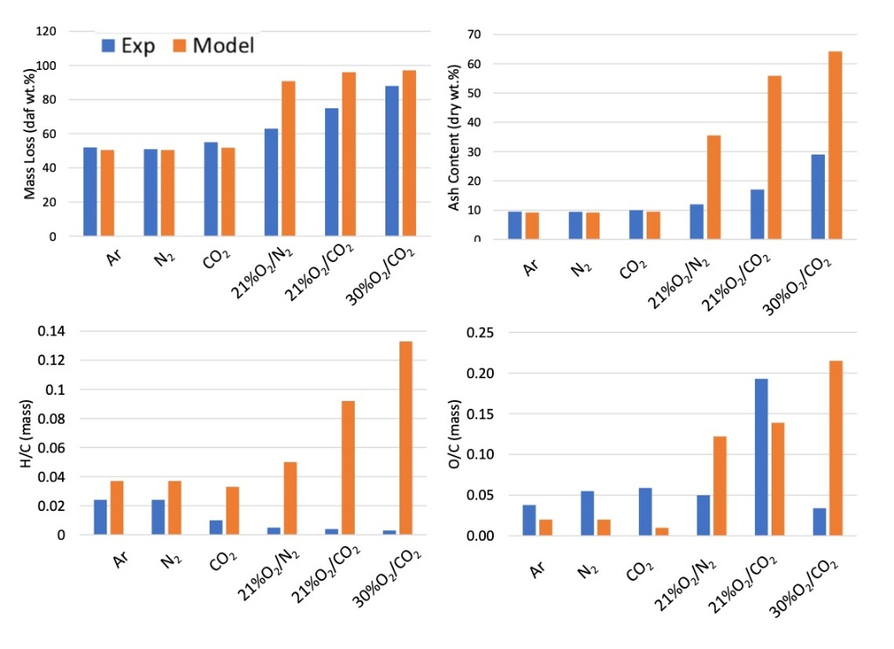

Figure 3 - Comparison of experiments and predictions of chars obtained in the DTR, in different atmospheres, fixed probe distance corresponding to particles residence time of 120-130 ms.

The experiments containing oxygen promoted partial conversion of the chars, consequently increasing mass loss, ash content and changing drastically the elemental composition into lower H/C ratio. Strangely, O/C ratio was much higher in the 21%O2/CO2 experiment. By switching from N2 to CO2, the effect of Boudouard reaction is noticed, increasing the mass loss from 63 to 75 daf wt.%. Keeping the O2/CO2 mixture and increasing the amount of oxygen to 30%, mass loss reached 88%. The model reacted in the same direction as the experiments for mass loss, but yielded an over-prediction in all cases. This can be explained by the natural delay in oxygen diffusion in the experiment, while the model was purely kinetic and does not account for this effect. Coupling heat and mass transfer effects would confirm this hypothesis or indicate that the model needs to be better calibrated for this coal and resulting char. Atomic ratios went in the wrong direction, showing an increase in hydrogen and oxygen contents. This is caused by the residual presence of metaplastic species [Sommariva et al., 2010], mostly G{COH2} and G{H2}. The oxidation/gasification reactions of these species are not present in the kinetic model, their release is only accounted by pyrolysis reactions, which take place on different time scales. The relevant deviation in composition is evident because most of the carbon content in char was already converted, remaining just a few percent of the initial mass of coal. Even though these deviations could be easily corrected by including their oxidation reactions, their amount is relatively insignificant comparing to the initial coal mass.

The DTR experiments reveal that changes in the model must necessarily account for the effects of CO2 in the char formation. For example, hydrogen content would drop in the presence of CO2, without affecting the previous agreement in air atmospheres, by increasing the rate of bimolecular reactions of CO2 with metaplastic species containing hydrogen and the species CHAR-H.

Thermogravimetric Analyzer (TGA)

The first set of comparisons in Figure 4 refer to the TGA (in air) of the raw coal and the chars produced in the DTR. The normalized mass loss is reported as a function of the temperature program. Raw coal shows a first devolatilization step, which is very well captured by the model predictions both in the onset temperature and amount of volatiles released (corresponding to the proximate analysis). The further mass loss refers to the char oxidation. The remaining fraction of mass loss from raw coal, after 700 K, refers to char oxidation, and can be directly compared with the TGA’s of chars. In fact, chars produced in inert atmospheres (N2 and Argon) produce chars with very similar conversion rates, also similar in reactivity to the oxidation segment in the raw coal. The char produced under CO2 atmospheres had a later onset temperature of oxidation and reach of the mass loss plateau (~70 K). The model predictions are similar for all the samples, showing that the model did not significantly responded, in terms of char reactivity, to the different atmospheres during pyrolysis in the DTR. Predictions have similar onset temperature compared to N2 and Argon chars, but slower overall conversion rate, reaching the plateau of mass loss at about 870 K (~70 K after the experiments). The opposite is observed in the comparison with CO2 char, where onset temperature is predicted with ~70 K of anticipation, and reaching the mass loss plateau with good agreement.

As stated in the DTR section, chars produced in CO2 atmosphere have significantly less hydrogen, and this fact agrees with their lower reactivity observed in the TGA experiments, as it is known that hydrogen atoms act as active sites in the heterogeneous reactions of char combustion [Debiagi, 2018]. Moreover, CHAR-H is the most reactive among the char species in the model, and it produces CHAR-C when consumed by CO2. Therefore, these changes would also lead to a slower overall char reactivity, converging to the desired results, both in the characteristics of char formed in the DTR and char oxidation in the TGA.

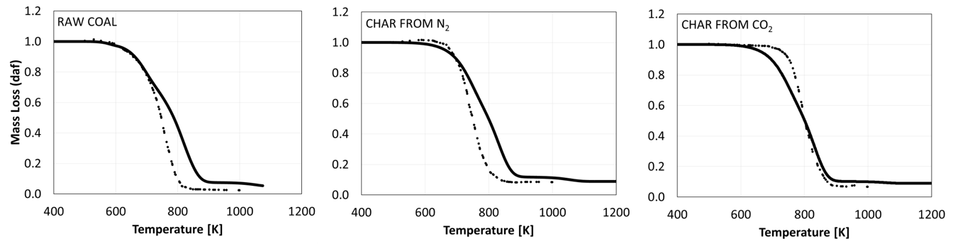

Figure 4: TGA, in air atmosphere heated at 5 K/min, of raw coal and chars produced in the DTR in different atmospheres (N2, Argon and CO2). Symbols are the experiments and lines are model predictions.

Flat Flame Burner

The chars produced in the DTR in N2 and CO2 atmospheres were oxidized in the FFB in air and oxy-fuel conditions. Atmosphere composition and particle temperature profile along the reactor was obtained from the experimental measurements and applied in the simulations. The experiments, reported in Senneca et al. (2019), and model predictions are compared in terms of the char conversion rate (df/dt [s-1]) along the degree of char conversion *f* (normalized) in Figure 5. The model agrees with experiments in several aspects but overpredicts the rate of conversion for all the test runs with one order of magnitude, showing the same deviation behavior of DTR comparisons for oxidative atmospheres. Lower reactivity of chars produced in CO2 could be observed. In the FFB, as well as in the DTR, total conversion of char is not attained by the model because of residual presence of the metaplastic species, and can be observed in Figure 5 (*f* stops increasing at about 0.95). An interesting fact is the lower peak of conversion rate for all cases in the oxy-fuel conditions, related to the lower peak in particle temperature. This fact can be explained by the endothermic nature of the CO2 gasification reactions that are taking place in parallel to the combustion. These reactions absorb energy keeping the particle at lower temperatures, resulting in lower global reactivities.



Figure 5: Rate of conversion (df/dt [s-1]) of chars along the char conversion degree (f) for oxidation in the FFB in oxy-fuel and air, of chars produced in the DTR in N2 and CO2.

* 1. Conclusions

The present work presented a critical comparison of the experimental data obtained for the same coal sample in different experimental apparatuses, highlighting that no conflicting results could be observed between them. The modelling approach shows general good agreement with many aspects of the experimental results, but highlights that some improvements must be done in order to account for the effects of oxy-fuel combustion, which can be done without compromising the previous agreements with other coals. The amount and rate of mass loss in the pyrolysis step was well predicted in all cases, but the char conversion step shows large deviations. In fact, the model considers this second step as volumetric reactions, implementing strong assumptions that are not able to well describe the process for all kinds of coals. These evidences lead to two solutions for better agreement of the predictions. The first is simply adjust the kinetic parameters, accounting for the reactivity of the char from this specific coal. The second, which brings more advantages, is improving the kinetics to a surface reacting model, which explicitly treats the variability of surface characteristics of different fuels. The Polimi model proves to be suitable choice for simulating coal combustion, providing an interesting level of details and flexibility. Nevertheless, there is space for improvements, which is the focus of future efforts to deliver a comprehensive kinetic model for the project SFB/Transregio 129 “Oxyflame”.

Acknowledgments

This work has been financed by the German Research Foundation (DFG) within the framework of the SFB/Transregio 129 “Oxyflame”

References (alphabetical order)

Debiagi P., Gentile G., Cuoci A., Frassoldati A., Ranzi E., Faravelli T., 2018, Yield, Composition and Active Surface Area of Char from Biomass Pyrolysis, Chemical Engineering Transactions, 65, 97-102.

Fletcher T. H., Kerstein A. R., Pugmire R. J., Grant D. M., 1990, Chemical percolation model for devolatilization. 2. Temperature and heating rate effects on product yields, *Energy & Fuels,* 4, 54-60.

Gentile G., Debiagi P., Cuoci A., Frassoldati A., Faravelli T., Ranzi E., 2016, A CFD Model for Biomass Flame-Combustion Analysis, Chemical Engineering Transactions, *50, 49-54*.

Heuer S., Senneca, O., Wütscher A., Düdder H., Schiemann M., Muhler M., Scherer V., 2016, Effects of oxy-fuel conditions on the products of pyrolysis in a drop tube reactor, Fuel Processing Technology, 150, 41-49.

Senneca O., Vorobiev N., Wütscher A., Cerciello F., Heuer S., Wedler C., ... & Scherer V., 2019, Assessment of combustion rates of coal chars for oxy-combustion applications, Fuel, 238, 173-185.

Sommariva S., Maffei T., Migliavacca G., Faravelli T., Ranzi E., 2010, A predictive multi-step kinetic model of coal devolatilization, Fuel, 89(2), 318-328.

Vorobiev N., Geier M., Schiemann M., Scherer V., 2016, Experimentation for char combustion kinetics measurements: bias from char preparation, Fuel Processing Technology, 151, 155-165.