|  |  |
| --- | --- |
| cetlogo ***CHEMICAL ENGINEERING TRANSACTIONS***  ***VOL. 76, 2019*** | A publication of  aidiclogo_grande |
| The Italian Association  of Chemical Engineering  Online at www.cetjournal.it |
| Guest Editors: Sauro Pierucci, Jiří Jaromír Klemeš, Laura Piazza  Copyright © 2019, AIDIC Servizi S.r.l. **ISBN** 978-88-95608-73-0; **ISSN** 2283-9216 | |

Analysis of Past Accidents Triggered by Natural Events in the Chemical and Process Industry

Valeria Casson Moreno\*, Federica Ricci, Riccardo Sorichetti, Alessio Misuri, Valerio Cozzani

Department of Civil, Chemical, Environmental, and Materials Engineering – DICAM, via U. Terracini 28, University of Bologna, Bologna, Italy

valeria.cassonmoreno@unibo.it

NaTech events (Natural Hazard Triggering Technological Disasters) are becoming an increasing concern in the Chemical and Process Industry (CPI). From a risk management standpoint, a better understanding of such events is of paramount importance. In this perspective, the analysis of past accidents is crucial, being almost the only source of information on the possible interactions between natural threats and CPI.

To this aim, the present work collected 438 past NaTechs that affected CPI, analysing the trends of accidents with respect to the trend of natural disasters, the geographical localization, the type of natural hazard triggering the accident, the final scenarios (e.g. fire, explosion,…) and the consequences on human and assets. For each type of NaTech, significant accidents have been reported and discussed.

* 1. Introduction

As recognised by the World Health Organization, disasters provoked by natural hazards (e.g., floods, hurricanes, earthquakes) are flourishing both in frequency and impact (WHO, 2018). Furthermore, recent research showed that major accident related to the release of hazardous materials could, in principle, be triggered by any kind of natural hazard, e.g. lightning and rain, not necessarily a major one, such as a hurricane or a tsunami (Krausmann et al., 2011).

Despite the investigation on conjoint threats posed by the interaction between natural hazards and technological installations is a relatively emerging topic (Salzano et al., 2013), it has become of great concern among both researchers and industrial practitioners over the last 25 years (Showalter, Myers, 1994). Chemical and process industries generally store significant amounts of dangerous substances, which can constitute sources of harm for people, workers, assets, and environment in case of a release. Thus, chemical and process facilities are critical infrastructures that can possibly be affected by NaTechs, and lately, companies covered by Seveso regulation need to include natural events in their risk assessment (European Parliament and Council, 2012).

The potentially severe impact of natural hazard is thus likely to be exacerbated by the consequences caused by the release of hazardous substances due to NaTech events. Furthermore, NaTech accidents are characterized by the possibility of multiple simultaneous failures, leading to complex final scenarios, and by the elevated likelihood of accident propagation to neighbouring assets through domino escalation (Cozzani et al., 2014). Recent natural disasters shed light on the magnitude of the above described cascading sequence of events, e.g. Tōhoku earthquake leading to the well-known Fukushima disaster.

The criticality of NaTech scenarios is that these conjoint events usually go beyond the features of conventional technological scenarios. Indeed, together with the release of hazardous materials, NaTech events are likely to be characterized by the unavailability of lifelines which may be disrupted as well (OECD, 2015). Safety systems in place for mitigating or preventing consequence escalation may thus be damaged or unavailable, and emergency intervention is likely to be hampered by the environmental disruption caused by the natural hazard (e.g., interrupted roads due to seismic damages or floodwater height, power outage caused by flooding and so forth).

Previous studies found out that NaTech events constitute up to 5% of the industrial accidents reported in chemical accident databases (Rasmussen, 1995). However, the value is probably underestimated since some minor events may have not been reported; furthermore, underreporting is particularly relevant in the recent period (Casson Moreno et al., 2019). Moreover, given the rising trend in weather and climate disaster, the occurrence of NaTech accidents will presumably accordingly grow (Mahan et al., 2018).

In literature, there are several studies analysing the NaTechs resulting from the interaction of specific natural phenomena (e.g. floods, earthquakes, lighting) on CPI (Cozzani et al., 2010; Renni et al., 2010; Krausmann et al., 2011).

In the present work, an updated comprehensive database has been created gathering NaTech accidents retrieved from chemical accident databases. Collected data has been used for investigating lessons learned and critical assets for each natural hazard of concern. For each type of NaTech event, significant reports have been illustrated.

* 1. Building the dataset for the analysis

The dataset analysed was built starting from 3 database specialized on industrial accidents: the ARIA Database (The French Bureau for Analysis of Industrial Risks and Pollutions (BARPI), 2019), FACTS (Factsonline: chemical and industrial accident database, 2018), and eMARS (Major Accident Hazards Bureau (MAHB), 2018). Aria is the biggest of the three (46’000 records), followed by FACTS (25’700) and eMARS (≈ 1000 of major accidents only).

Keywords have been used to query the existing database (e.g., NaTech, earthquake, flood/flooding, lighting, storm, hurricane, as listed in Table 1). Where necessary, i.e. for the case of ARIA, the keywords have been translated in French.

Table 1: Keywords used for querying the existing database (ARIA, FACTS, eMARS).

|  |  |  |  |
| --- | --- | --- | --- |
| **Keywords** |  |  |  |
| Cold weather  Earthquake  Flood  Flooding  Forest fire | Wild fire  Freeze  Hailstorm  Heat wave  Hot temperature  Hot weather | Hurricane  Ice  Landsline  Lightning  Low temperature | Rain  Rainstorm  Storm  Tornado  Thunderstorm  Tsunami |

The selection of records retained for the analysis was based on the following criteria:

1. events have to be major accidents (as defined by Seveso regulation) or near misses (events that potentially could have resulted in a loss, but it did not) directly related to NaTech causes;
2. Only Chemical and Process Industry was: power production, including nuclear, have not been included.
3. On-shore and off-shore fixed installations have been considered, including pipelines. Transportation of hazardous material was disregarded.

The structure of the resulting database is shown in Figure 1.

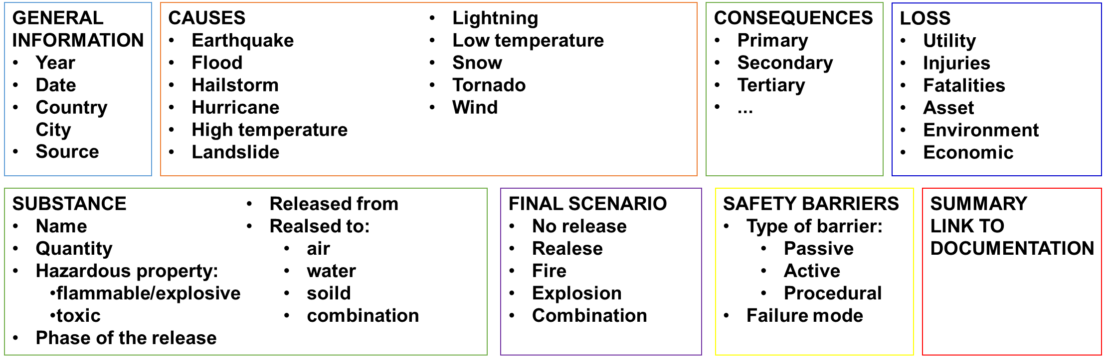

Figure 1: Structure and main content of the database.

* 1. Results and discussion

The dataset built consists of 438 records, covering from 1948 to 2018. Most of the records is from ARIA (94%), followed by FACTS (4%) and eMARS (2%). On one hand, this agrees with the size of each database and the fact that ARIA has been queried first: clearly enough, all the duplicate events found in the other two databases were deleted. On the other hand, there is an unbalance on the geographical distribution of the records, which was found to be: France 66%, Japan 12%, US 8%, Germany 3%, China 2%, Italy and UK 1%. All the other countries represent 11 % of the dataset and for 5% of the records, the Country was not specified.

The trend of the records retained for the analysis is depicted in Figure 2. It must be noted that statistics are not reliable in the last years of data: many reports not available online until few years following the accident (Major Accident Hazards Bureau (MAHB), 2018). In general, the trend somehow reflects the trend of a number of climate and weather-related disasters per year (red line in Figure 2) as reported by the US National Oceanic and Atmospheric Administration (NOAA, 2018).

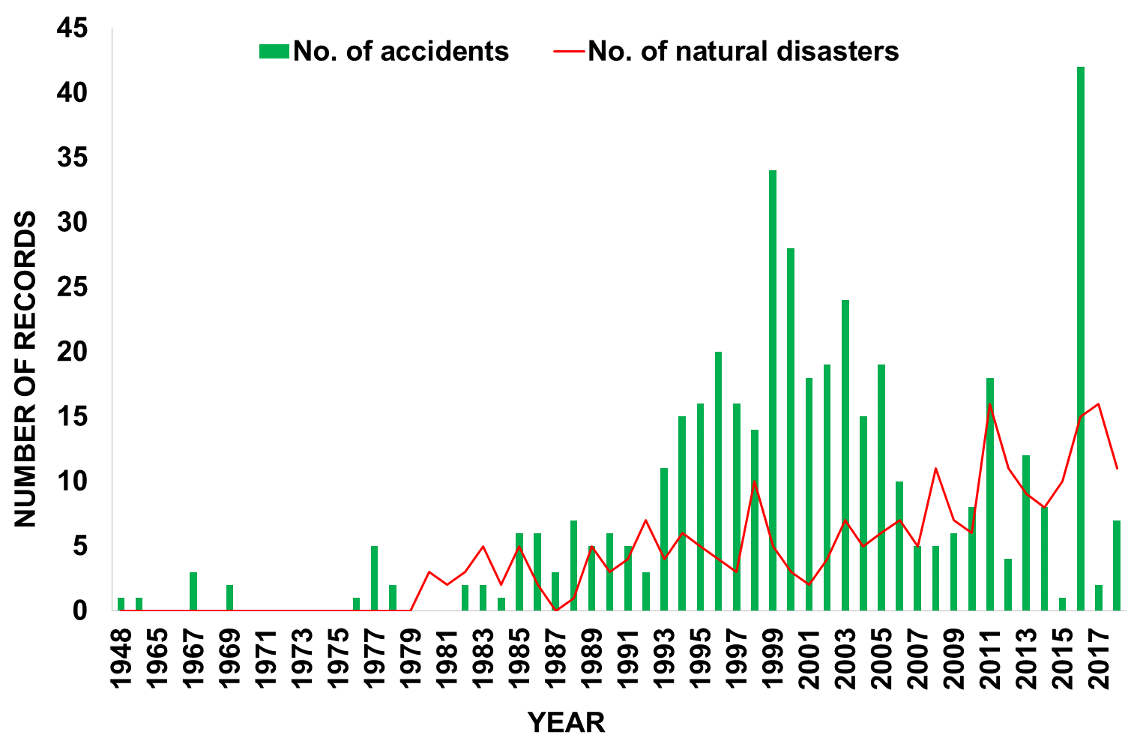

Figure 2: Trend of records retained for the analysis (green bars) and a total number of climate and weather- related disasters per year (red line, source: NOAA, 2018).

The share between the natural phenomena responsible for the records is shown in Figure 3. Most of the events have been caused by floods (44%) and lightning (28%) followed by high temperature (i.e. hot weather, 10%), low temperature (i.e. cold weather, 6%), earthquake (6%) and wind (3%). The rest of the events (3 % of the total number of records) is distributed among landslide (7 cases), snow (4), hurricane (3), hailstorm (1), tornado (1) and wild fire (1).

The share among the final scenarios recorded is depicted in Figure 4. In 27 % of the cases, there was no loss of containment (“no spill”) from the equipment and the record described damage to the equipment only. In 37 % of the cases, there was a spill of toxic material; just one record is about a flammable spill that did not ignite.

Fire characterized 26 % of the events, whereas explosion 3 %. In 6 % of the accidents there was a combination of scenarios such as fire and explosion (19 cases), fire and toxic spill (5) and, in a single case, an explosion plus toxic spill was reported.

Analysing the impact of the events, we recorded a total number of associated injuries approximately equal to 6000 and 1000 fatalities. Considering the 70 years’ time span covered by the dataset and roughly estimating the worldwide number of CPI sites to 4500 (Cefic, 2018), the risk associated to NaTechs is not negligible (≈10-3 events/year). In Table 2 the events have been aggregated based on the number of losses counted: despite the majority of the events involved no casualties, there is a large number of records characterised by severe consequences in terms of human losses.

Table 3 shows the data available on economic losses associated to the events analysed: despite a large number of “unknowns”, 17 % of the cases entailed severe economic damages to the companies. The hugest economic impacts are associated to earthquakes: none of the records was characterised by less than 10 M€ damages. Economic losses associated to flooding and lightning are averagely in the range of 100k€ - 1 M€ per accident.

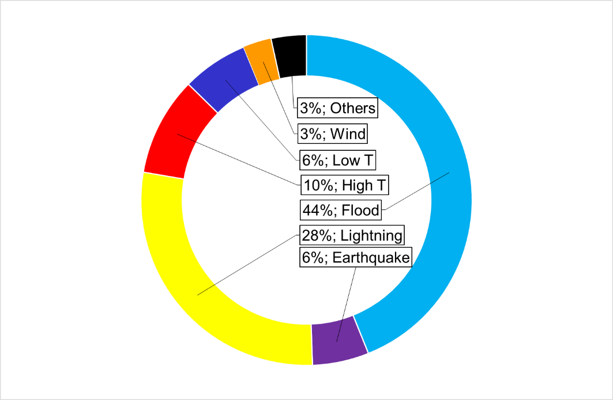

Figure 3: Share between the natural phenomena responsible for the records considered for the present analysis.

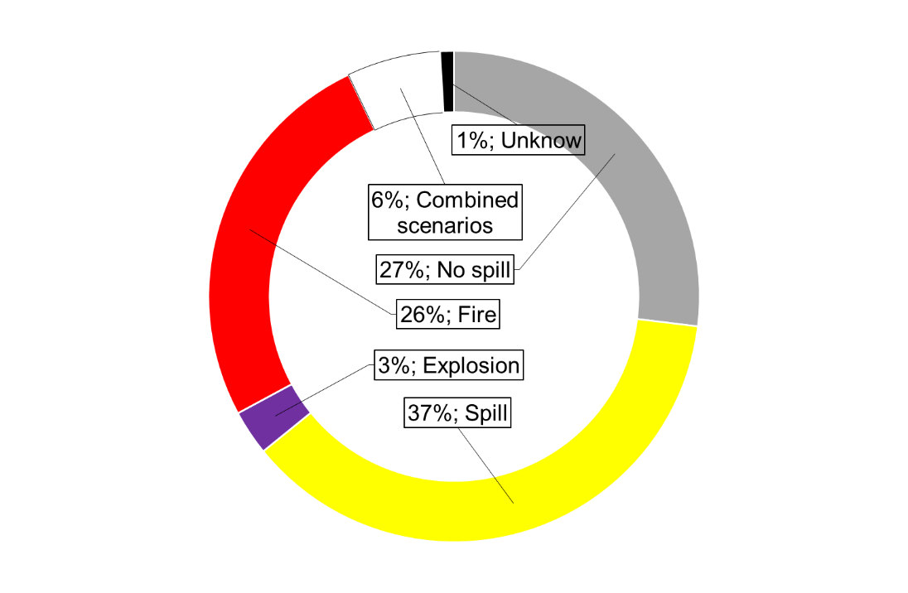

Figure 4: Final scenarios recorded.

Table 2: Human losses associated to the records.

|  |  |  |  |  |  |
| --- | --- | --- | --- | --- | --- |
| **No. of records** | **No casualties** | **10 < x < 100** | **100 < x < 1000** | **x > 1000** | **unknown** |
| **Injuries** | 357 | 23 | 17 | 4 | 33 |
| **Fatalities** | 391 | 17 | 11 | 3 | 13 |

Table 3: Economic losses associated to the records.

|  |  |  |  |  |  |  |  |
| --- | --- | --- | --- | --- | --- | --- | --- |
| **Economic loss** | **minor** | **> 100k€** | **> 1M€** | **> 10 M€** | **> 100 M€** | **> 1000 M€** | **unknown** |
| **No. of records** | 5 | 8 | 18 | 20 | 15 | 8 | 364 |

* 1. Significant records

In the present paragraph, a few meaningful events characterized by less common NaTech causes are described. As forehead mentioned, for causes such as flood, lightning and, earthquake ad hoc studies exist in the literature (Krausmann et al., 2016).

* + 1. Cold weather [ARIA#23839]

In a chemical plant, a release of cyclohexane was discovered after detecting a pressure drop in a pipeline. The substance was transferred via pipeline (partially underground), at 20°C and 2-3 bar, from a 10000 m³ storage tank to two different production units. Cyclohexane is of relatively low toxicity but ecotoxic and flammable.

The root cause was the malfunctioning of the piping heating system (steam system) that led the temperature to be lower than 6.5 °C. Consequently, blocks of crystallized cyclohexane formed. The pipeline broke when part of the crystallized cyclohexane re-liquefied, causing an excessive expansion of the material. As the piping was not yet equipped with a device for rapid leak detection, it took 30 hours to determine the cause of the pressure anomaly. One thousand tons of cyclohexane were approximately released, the majority settled into the ground. Approximately half of them were recovered in the following weeks.

* + 1. Hot weather [ARIA#30122]

A major fire broke out at a gas storage and bottling facility. Nearly 30,000 bottles (propane, propylene, oxygen, hydrogen, acetylene, carbon dioxide, helium, etc.) were being held onsite. An employee noticed the presence of a 3-m high flame at the level of a propylene bottle and triggered the fire alarm. While evacuating people, the fire spread and within 4 minutes, it involved the entire zone occupied by inflammable gas bottles. Repeated explosions (of the BLEVE type) could be heard; blasts of fragments and bottles both inside the facility and extending 250 m beyond the site boundary caused additional fire outbreaks (i.e. a “domino effect”). Multiple fire sources, tall flames, and a thick black smoke complicated the efforts of fire-fighters. Nearly 8,000 bottles had burned. The US Chemical Safety Board (CSB) stated that direct solar radiation coupled with radiant heat emanating from the asphalt caused a rise in temperature, hence pressure, of the propylene, thereby activating the opening of the safety valve and triggering the gas leak that subsequently ignited, most likely as the result of static electricity discharge.

* + 1. Wildfire [ARIA#23132]

An explosion occurred in the distillation column of an air separation unit providing oxygen to a petrochemical industry. The unit was destroyed and surrounding units heavily damaged; furthermore, there were 12 slight injuries and damage up to 5 km. The accident was caused by the pollution of the oxygen closed-loop due to particulate material in the air due to an intense forests fire happening those days (plus organic pollutants from the washing process). The hydrocarbon pollutant acted as an igniter and the fuel was aluminum in liquid oxygen. A similar explosion occurred a few months earlier in China (ARIA#11603).

* + 1. Landslide [ARIA#12507]

Subsequent to the torrential rains (due to the El Niño, Ecuador, 1998), a landslide caused the rupture of a pipeline located at 12 km from a 500 km oil terminal transporting oil from Amazonia to the Pacific coast. Around 2500 m³ of oil spilt into the rivers and the ocean. The explosion and the fire that followed destroyed 160 homes. The fire spread to the piers of the port but spared the refinery and the gas pipeline. Fire waves as high as 10 m were observed. Seven persons were killed, 110 sustained injuries including 40 people who suffered 50% burns. 40 people were reported missing and 600 people evacuated. The rescue operations lasted 6 hours and were complicated due to water shortage following the rupture of pipelines.

* + 1. Wind [ARIA#209]

In a paint manufacturing plant, because of a 120 km/h wind, a coating is detached from a building and falls on the supply line of a 60 m³ SO2 tank. The sectioning is done between the isolation valve and the tank, at the top of it. The compressed air supply of the storage isolation valve is shut off simultaneously; 8 employees and 7 off-site people are intoxicated by the 20-minute rejection for an estimated 18 tons quantity.

* + 1. Hurricane [ARIA#50402]

During Hurricane Harvey (US, 2017), in agreement with the established industrial protocol, in a chemical plant manufacturing organic peroxides, plant operations were shut down, emergency generators were mobilised while other generators were brought to the site to supply storage buildings in the event of a power failure, and refrigerated containers were mobilised on site as an additional safeguard measure.

The hurricane main consequence was a flood of the site (water level: 1.80 m) and the electricity supply being cut off. The unexpected rise in water level resulted in the loss of the permanent generators, backup generators and liquid nitrogen emergency cooling system. The site was no longer accessible.

The operator transferred the products to 9 containers refrigerated by diesel engines, but the rising waters submerged the engines. As the containers heat up, the operator feared the violent outbreak of fire. Eventually, 2 explosions occurred followed by fire. A new fire broke 2 days after. The operator, in collaboration with authorities, decided to conduct controlled fires in the containers that had not yet caught on fire.

* 1. Conclusions

The present work collected and analysed 438 accident involving the Chemical and Process Industry that were caused by natural events (NaTech). Due to the increasing number of climate disasters, NaTechs are becoming more and more a hot topic in the field of process safety. The analyses of such past accidents provide, as proved in the present paper, a wide source of information that can be used both during risk analysis and emergency response planning.

References

The European Chemical Industry Council, 2018. Facts & figures of the European Chemical Industry, www.cefic.org/Documents/RESOURCES/Reports-and-Brochure/Cefic\_FactsAnd\_Figures\_2018\_Industrial\_BROCHURE\_TRADE.pdf

Casson Moreno V., Danzi E., Marmo L., Salzano E., Cozzani V., 2019, Major accident hazard in biodiesel production processes, Saf. Science, 113, 490-503, doi: 10.1016/j.ssci.2018.12.014.

Cozzani V., Antonioni G., Landucci G., Tugnoli A., Bonvicini S., Spadoni G., 2014, Quantitative assessment of domino and NaTech scenarios in complex industrial areas, J. Loss Prev. Proc. Industries, 28, 10-22.

Cozzani V., Campedel M., Renni E., Krausmann E., 2010, Industrial accidents triggered by flood events: Analysis of past accidents, Journal of Hazardous Materials, 175, 501-509.

eMARS Dashboard, <emars.jrc.ec.europa.eu/en/emars> accessed 31.10.2018

European Parliament and Council, 2012. Directive 2012/18/EU.

Factsonline: chemical and industrial accident database, accessed in October 2018. <factsonline.nl> accessed 31.10.2018.

Krausmann E., Renni E., Campedel M., Cozzani V., 2011, Industrial accidents triggered by earthquakes, floods and lightning: lessons learned from a database analysis, 59, 285-300.

Krausmann E., Cruz A.M., Salzano E., 2016, Natech Risk Assessment and Management, Reducing the Risk of Natural-Hazard Impact on Hazardous Installations, Elsevier, Amsterdam, NL.

Mahan, P., Liserio, F., 2018. Managing the risk associated with severe wind and flood events in the chemical processing industries, in: Hazards 28. pp. 1–10.

NOAA National Centers for Environmental Information (NCEI), 2018. U.S. Billion-Dollar Weather and Climate Disasters [WWW Document]. URL https://www.ncdc.noaa.gov/billions/

Organisation for Economic Co-operation and Development (OECD), 2015, Addendum No.2, OECD Series on Chemical Accidents No. 27, Paris, France.

Rasmussen K., 1995, Natural events and accidents with hazardous materials, Journal of Hazardous Materials, 40, 43-54.

Renni E., Basco A., Busini V., Cozzani V., Krausmann E., Rota R., Salzano E., 2010, Awareness and mitigation of NaTech accidents: Toward a methodology for risk assessment, Chemical Engineering Transactions, 19, 383-389.

Salzano E., Basco A., Busini V., Cozzani V., Marzo E., Rota R., Spadoni G., 2013, Public awareness promoting new or emerging risks: Industrial accidents triggered by natural hazards (NaTech), Journal of Risk Research, 16(3-4), 469-485.

Showalter P.S., Myers M.F., 1994, Natural Disasters in the United States as Release Agents of Oil, Chemicals, or Radiological Materials Between 1980-1989: Analysis and Recommendations, Risk Analysis, 14(2), 169-182.

The ARIA database by the French Bureau for Analysis of Industrial Risks and Pollutions (BARPI), <aria.developpement-durable.gouv.fr/the-barpi/the-aria-database/?lang=en> accessed 31.10.2018,

World Health Organization (WHO), 2018, Chemical releases caused by natural hazard events and disasters – information for public health authorities