|  |  |
| --- | --- |
| cetlogo ***CHEMICAL ENGINEERING TRANSACTIONS***  ***VOL. 76, 2019*** | A publication of  aidiclogo_grande |
| The Italian Association  of Chemical Engineering  Online at www.cetjournal.it |
| Guest Editors: Sauro Pierucci, Jiří Jaromír Klemeš, Laura Piazza  Copyright © 2019, AIDIC Servizi S.r.l. **ISBN** 978-88-95608-73-0; **ISSN** 2283-9216 | |

Agarose Gels with Bioresorbable Additives: The Kinetics of the Formation, Structure, Some Properties

Boris G. Pokusaeva, Sergey P. Karlova, Dmitry A. Nekrasova, Nikolay S. Zakharova, Dmitry P. Khramtsova, Vyacheslav V. Reznika, Andrey V. Vyazminb,\*, Nadezhda V. Shumovab

aDepartment of Chemical Engineering, Moscow Polytechnic University, Avtozavodskaya ul., 16, Moscow, Russia

bDepartment of Chemical Engineering, MIREA – Russian Technological University, Vernadskogo ave., 86, Moscow, Russia

av1958@list.ru

For the purposes of prospective use in the creation of bioreactors by additive technology studied some properties of agarose gel of different concentrations with the addition of bioresorbable components. For investigation of the kinetics of gel formation the spectroscopic method was used. The decomposition of the spectrum of the radiation allows one to get more information about the state of the gel. The dependences of the spectral characteristic of the formation of a complex dispersed system on temperature were obtained. Evaporation of liquid from their surface, a process of gel relaxation, presents interest for practical usage. Liquid evaporation from gel mixture surface was studied. Dependencies of liquid evaporation from time were obtained for mixtures of agarose and starch. A non-linear dependency of evaporation speed was observed for all sets of mixtures. It was shown that presence of starch inhibits the process of liquid evaporation. The heat-conducting properties of agarose gel of different concentrations with the addition of bioresorbable components were investigated. It is shown that the study of the thermal properties of the gel should be carried out when it is heated.

* 1. Introduction

Although the idea of ​​growing tissues and organs in vitro using stem cells is simple, for its technical implementation it is necessary to create complex special bioreactors that can maintain the required temperature, pH, osmotic pressure, supply cells with nutrients and oxygen, remove their metabolic products, and perform many other requirements that provide the necessary physiological conditions for cell activity (Rodrigues et al., 2011; Placzek et al., 2009). Using the method of 3D additive technologies in order to create various bioreactors seems promising (Ferris et al., 2013; Melchels et al., 2012); therefore, a separate field of science is currently being formed, which is called 3D-bioprinting (Marga et al., 2012; Wang et al., 2015a).

The material in which it is convenient to cultivate cells is gel (Wang et al., 2015b; Jang et al., 2018). Their rheological properties allow to form bioreactors of complex configurations by layer-by-layer application of gels of different concentrations and compositions. The network of capillaries in gels can be used to supply nutrients and oxygen to the cells and to remove the products of their metabolism. Agarose and some other gels are widely used in microbiology for growing microorganisms (Rivest et al., 2007; Ozbolat et al., 2017). This fact confirms the possibility of creating good external conditions for the growth and reproduction of biological microscopic objects in gels.

Properties of gels are determined by both composition and method of preparation. However, many properties of gels of different nature are similar for technological applications. Kinetics of formation and relaxation of gels, data on their heat capacity and thermal conductivity are necessary for modeling the dynamics of temperature fields in the technology of layer-by-layer application of gels in bioprinting. Th*e*rmal conditions determine the state of the gel, its properties and conditions of immobilization of microbiological objects in it (Watase et al., 1990; Pokusaev et al., 2017a). Based on the assumption that gels will exhibit similar properties when used in additive technologies, it is easier to study the fundamental features of their technological application on simple gel systems, such as agarose gels.

Usually agarose gel is obtained from a heated aqueous solution of agarose at a lower temperature. It is widely used in microbiology for growing microbiological objects. Agarose gels were studied in detail by various methods, including optical ones (Ross et al., 2006; Medina-Esquivel et al., 2008). However, some properties of agarose gels determining the possibility of their use in bioprinting required additional study (Pokusaev et al., 2018). Recently, data was obtained on the thermophysical properties of agarose gel and the dynamics of relaxation processes in it during temporary stabilization (Pokusaev et al., 2017b). In this case, the thermal properties were measured in the temperature range of gel formation from the solution and the heat of the gel formation process was not taken into account during the measurements.

The expansion of practical applicability leads to the need to create gels with the desired properties. For this purpose, either special additives are used or mixed gels containing two or more different gel-forming substances are synthesized (Somboon et al., 2014; Owens, 2016). The situation is more complicated if the gel is used as a skeleton matrix in cell culture. The growth of cells in the bioresorbable frame matrix, freeing up space for the growth of cells (Patel et al., 2011; Hutmacher et al., 2001). Such additives can change the conditions of gel formation, the features of its temporary stabilization and technological properties.

In this article the following properties of agarose gel with added bioresorbable inert substance are studied: temperature range of gel formation, time dynamics of gel stabilization during liquid phase evaporation, thermophysical properties. In this case, the thermal properties were investigated by heating the gel, which is has a physical justification. In the future, the results may be interesting for the further development of additive bioprinting technologies.

* 1. Methods and materials

Spectroscopy is used to study the properties of pure gel with a neutral additive. The scheme of the experimental setup and its detailed description is given in (Pokusaev et al., 2017b). The lighting system was additionally equipped with a network filter system, providing the maximum spectrum of light transmission through distilled water at a wavelength of 550.7 nm. The measuring part in addition to the optical system is equipped with thermocouples that allow to measure the temperature of the gel sample of the radius, and a special heat flow sensor. All this allows us to obtain the necessary experimental data to solve the inverse problem of thermal conductivity and determine the thermal characteristics of the studied gels. Abbe refractometer was used to determine the refractive index of light. The refractive index was measured at the wavelength 589.2 nm.

In the experiments, the gel based on agarose "Chemapol" was used. The gels were obtained by mixing agarose with distilled water, followed by heating up to 90°C and subsequent slow cooling to the initial temperature of the experiment. Gels with a mass concentration of 0.4–1.0% agarose were used. In experiments, indicator starch was used as a bioresorbable additive in agarose gels. The starch was diluted with distilled water to the desired concentration and added to the agarose solution at 90°C. In order to avoid delaminating, the mixture was homogenized when cooled to 50°C.

* 1. Results and discussion

It should be noted that the starch used in the experiments with respect to agarose is a neutral bioresorbable admixture. During the formation of the gel, it does not form a structured dispersed phase, and does not chemically interact with agarose. However, in further experiments it is assumed that the starch will be bioresorbed under the influence of living microorganisms. Thus, through the neutral admixture it is planned to trace the effect of living cells on the properties of the gel as a whole. However, at the initial stage, it is of interest to determine the effect of a neutral impurity on some previously studied properties of agarose gel as a control sample. Similar studies were performed earlier to determine the effect of neutral silver nanoparticles on the dynamics of the formation and aging of silicate gel (Pokusaev et al., 2016).

* + 1. Gels formation and stabilization

In the experiment, the spectra of the samples of the studied gels of different concentrations and compositions were obtained when cooled from 45°C to 20°C. This is the temperature range in which the formation of a pure agarose gel from the solution occurs. It was found that the intensity of light passing through the gel sample decreases with decreasing temperature and increasing the total concentration of the dispersed phase. We assume that due to the changes in the structure of the medium, the maximum wavelength of light in the transmission spectrum is shifted towards the red region of the spectrum during gelation. It is based on the data on the change of light scattering inside the gel during the formation of a microdisperse structured phase.

Experimental data on the change in the wavelength of the maximum light transmission spectrum depending on the temperature of formation of gels at concentrations of agarose by weight 1.0% and different concentrations of starch are shown in Figure 1. As the temperature decreases, the wavelengths coinciding with the maximum of the spectra increase sharply, and then again take new constants. According to observations, the liquid state occurs at a temperature above 45°C, while at a temperature below 25°C it is already a formed gel.

Method of gel formation control by shift in spectra maximum of light transmittance considered as an important for practical applications. However it requires further study. Ross et al. (2006) found that during the agarose gel stirring at the stage of its formation gas microbubbles are formed inside the gel. The size of bubbles increases with intensity of gel stirring. These microbubbles lead to additional light dispersion on surfaces air - gel, which influences shift of spectra maximum. In case of absence of gel stirring, in a temperature range of gel formation, microbubbles are not formed, which corresponds to a situation researched in this article.

The presence of starch in the gel in all studied concentrations does not lead to an additional shift of the spectrum maximum in comparison with pure agarose gel. Thus, starch does not affect the formation of gel from agarose. Probably, starch microparticles only fill the pores of the forming agarose gel. For gels with an increase of the starch concentration density increase as well. However, the bioresorbable properties of starch allow it to release the living space in the gel as a result of biodegradation for the growth of the number of microbiological objects.

Temporary stabilization of gels was studied by measuring the dependence of the change in the relative light transmittance on time in agarose gel with a weight concentration of 1.0 % (as well as the addition of starch). The results are shown in Figure 2. The relative intensity of the light passing through the gel is determined with respect to a similar value taken as the starting point of observations.

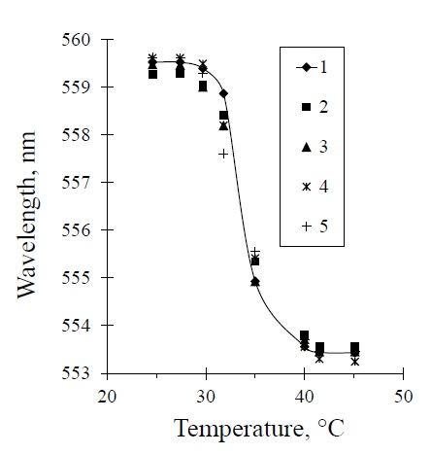

*Figure 1: The dependence of the displacement of the maximum spectrum of transmitted light from the temperature in the formation of agarose-based gels with 1.0 % by weight concentration: 1 – pure agarose gel, 2-5 – with the addition of starch by weight: 2 – 0.25 %, 3 – 0.5 %, 4 – 0.75 %, 5 – 1.0 %*

As it can be seen in Figure 2, even at large times the intensity of the light passing through the gel decreases. Visually, there is the appearance of a free liquid on the gel surface. Thus, the presence of syneresis is typical for gels with the addition of starch. However, the addition of starch slows down the process of syneresis of the structured dispersed phase, as the starch prevents changes in the structure of the gel.

* + 1. Stabilization with evaporation

Changes in the internal structure of the gel during application may be associated with the evaporation of water from the dispersion phase. For combined gels it is necessary to understand the effect of additives on the evaporation dynamics and, as a consequence, on the dynamics of changes in the internal composition of the gel. The dependences of the change in the mass of samples of agarose gel with a weight concentration of 0.4 % and combined gels with different concentrations of starch from time when water evaporates from its surface are shown in Figure 3. It was found that decreasing in gel mass has nonlinear dependence from time.

The initial loss of gel mass occurs due to evaporation of water from the dispersion phase released on its surface as a result of syneresis. The dispersion phase on the gel surface is an aqueous solution of agarose. When water evaporates from it a thin film of agarose is formed on the surface of the gel. At the initial stage, evaporation occurs from the surface of the film liquid under the conditions of external diffusion resistance.

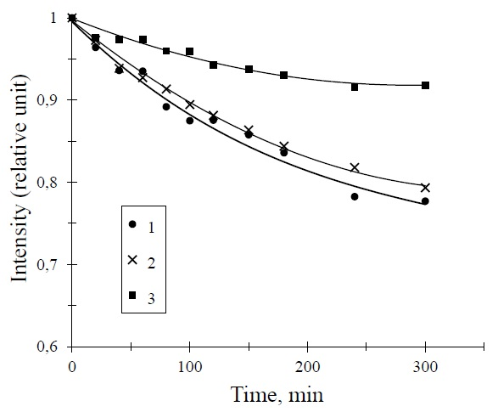

*Figure 2: The dependence of the relative intensity of the light passing through the gel samples weight concentration of 1.0 % agarose with starch from the time of stabilization: 1 – pure agarose gel, 2 – 3 – agarose gel with the addition of starch by weight: 2 – 0.25 %, 3 – 1.0 %*

After evaporation of water from the gel surface, the intra-diffusion regime begins. After about 10 minutes from the beginning of the process, the dependence of the mass loss on time slows down and becomes nonlinear. It begins as a capillary rise of the dispersed phase to the surface, and the simultaneous compaction of the gel structure by reducing the internal amount of moisture. Gels with starch additives show lower evaporation rate of water and the intensity decreases with increasing concentration of starch. Starch increases intra-diffusion resistance, as its molecules clog the pores of the gel and prevent the release of liquid through the internal capillaries.

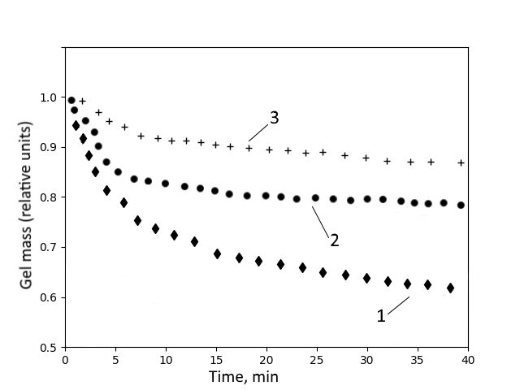

*Figure 3: The time dependence of the intensity of mass loss due to the evaporation of water from the surface of the gels under the stabilization of the agarose gels, the weight concentration of 0.4 % agarose with added starch: 1 – pure agarose gel; 2 – agarose gel with added starch by weight of 0.1 %; 3 – agarose gel with added starch 0,3%*

It is important to note that the mass loss of the gel sample due to evaporation after 40 minutes of stabilization was 22 % of its initial mass, and after 15 days of storage under normal conditions, the mass loss was 36 %. The high evaporation rate during the first 40 minutes of the experiment proves that the process of syneresis in the gel slows down over the time, and the structured dispersed phase tends to an equilibrium state. It is important to emphasize that of the 64% of the remaining weight of the gel, agarose has a mass of only 0.4 %. The rest of the gel mass is water, which is probably mostly in a chemically bound state in the form of hydrated compounds. Further release of water requires additional energy, which significantly slows down the evaporation process.

* + 1. Thermal properties

Previously experiments to determine the thermophysical properties of gels were carried out by cooling the solution to form a gel in the temperature range from 40°C to 25°C. The experimental data processing technique assumes that the calculated thermophysical values are averaged over this temperature range. Therefore, it is not clearly determined whether they belong to the solution or to the gel. It does not take into account the thermal effect associated with the phase transition. If the experiment is carried out when the gel is heated, then these problems will not arise. Due to the phenomenon of hysteresis in the formation of gel in the temperature range from 25°C to 40°C phase transition from gel to solution is absent. It occurs at higher temperatures.

The phenomenon of hysteresis in agarose gel has long been known in microbiology. If the formed gel is heated to a temperature of 90°C, it melts. After cooling to the gel formation temperature, its properties do not change with respect to the microorganisms growth. In this way, the gel can be used repeatedly.

The phenomenon of hysteresis was studied by spectroscopy. The wavelength of the maximum spectrum of light passing through the gel was measured in the temperature range from 25°C to 90°C. As can be seen in Figure 1, at 25°C the wavelength of the maximum spectrum is about 559 nm. When the gel is heated up to 80°C this value remains almost constant within the measurement error. With further heating from 80°C to 90°C degrees the wavelength of the maximum spectrum rapidly decreases to a value of about 553 nm. With subsequent cooling of the gel to a temperature of 35°C this wavelength remains almost unchanged. With further cooling to 25°C a complete reproduction of the dependence shown in figure 1 was observed. This allows us to conclude that when the gel is heated in the temperature range from 25 to 80 degrees, there are no changes in the microstructured dispersed phase. For this reason, the gel should keep its rheological and thermal properties almost unchanged when heated from 25°C to 80°C. Therefore, the most methodically correct is to conduct a thermophysical experiment under the conditions described above.

The gel sample under study was initially formed by mixing the initial components then the gel formation process was carried out to stabilize the temperature (25°C) and the spectral pattern corresponding to the formed gel. Then the gel was heated to a temperature of 45 degrees and at certain intervals recorded the temperature values along the radius of the sample and the heat flow on the wall. On the basis of the obtained experimental data by solving the inverse problem of thermal conductivity average thermal coefficients were calculated. The model of unsteady heat transfer 1D of an infinite cylindrical sample with constant heat capacity and thermal conductivity was used for calculations. The solution of the problem consists in the selection of thermal coefficients minimizing the difference in the norm between the experimental and calculated temperatures, as well as between the values of the heat flow at all times and in all locations of the thermocouples used in the processing. The direct problem of thermal conductivity is solved using an implicit difference scheme. The minimization problem is solved by the coordinate descent method.

On the basis of experimental data and model the values of thermal conductivity and heat capacity for gels with different concentrations of initial components were calculated. The corresponding values are shown in table 1. Within the accuracy of the experiment, the average values of thermal conductivity and heat capacity of samples of pure agarose gel, and with the addition of starch in the temperature range most suitable for the immobilization of microorganisms, practically do not change.

Table 1: Thermal properties of agarose gel with the addition of starch

|  |  |  |
| --- | --- | --- |
| Composition | Thermal conductivity, W/(m∙K) | Heat capacity, W/(m3∙K) |
| Pure agarose gel 1.0 % | 0.51 | 2090 |
| Agarose gel with addition of 0.25 % starch | 0.50 | 2070 |
| Agarose gel with addition of 1.0 % starch | 0,49 | 2070 |

* 1. Conclusions

The addition of starch to the agarose gel as a bioresorbable additive does not affect the conditions of its formation. However, such additives slow down the relaxation processes in the stabilization of the gel and provide a slower change in its original structure.

When stabilizing the gel, it is necessary to take into account that this process includes evaporation of the liquid film from the surface and evaporation from the pores of the gel in the presence of diffusion resistance inside. The presence of starch in the agarose gel reduces the evaporation rate, as it prevents the mass transfer of water from the gel volume to the surface.

It is shown that agarose gel exhibits hysteresis property, i.e. the same agarose gel is obtained from the melt as from the solution. This allows you to measure the thermal characteristics of the gel when it is heated and the microstructured phase is stable. The values of thermal conductivity and volumetric heat capacity for both pure agarose gel and agarose gel with addition of starch were found. These values are close because composite gels and pure agarose gel have similar chemical composition and the same structure of the dispersed phase.

Acknowledgments

This work was financial supported by the Russian Science Foundation (project no. 15-19-00177).

References

Ferris C.J., Gilmore K.G., Wallace G.G., Panhuis M., 2013, Biofabrication: An overview of the approaches used for printing of living cells, Applied Microbiology and Biotechnology, 97, 4243−4258.

Hutmacher D.W., Goh J.C.H., Teoh S.H., 2001, An introduction to biodegradable materials for tissue engineering applications, Annals Academy Medicine Singapore, 30, 2, 183-191.

Jang T.-S., Jung H.-D., Pan H.M., Han W.T., Chen S., Song J., 2018, 3D printing of hydrogel composite systems: recent advances in technology for tissue engineering, International Journal Bioprinting, 4, 126 http://dx.doi.org/10.18063/IJB.v4i1.126.

Marga F., Jakab K., Khatiwala Ch., Shepherd B., Dorfman S., Hubbard B., Colbert S., Forgacs G., 2012, Toward engineering functional organ modules by additive manufacturing, Biofabrication,4, ID 022001.

Medina-Esquivel R., Freile-Pelegrin Y., Quintana-Owen P., Yáñez-Limón J.M., Alvarado-Gil J.J., 2008, Measurement of the sol–gel transition temperature in agar, International Journal Thermophysics, 29, 2036. https://doi.org/10.1007/s10765-007-0332-6.

Melchels F.P.W., Domingos M.A.N., Klein T.J., Malda J., Bartolo P.J., Hutmacher D.W., 2012, Additive manufacturing of tissues and organs, Progress Polymer Science, 37, 1079−1104.

Owens G.J., 2016, Sol-gel based materials for biomedical applications, Progress Materials Science, 77, 1–79.

Ozbolat I.T., Moncal K., Gudupati H., 2017, Evaluation of bioprinter technologies, Additive Manufacturing, 13, 179-200.

Patel H., Bonde M., Srinivasan G., 2011, Biodegradable polymer scaffold for tissue engineering, Trends Biomaterials & Artificial Organs, 25, 1, 20-29.

Placzek M.R., Chung I.M., Macedo H.M., Ismail S., Mortera Blanco T., Lim M., 2009, Stem cell bioprocessing: fundamentals and principles, Journal Royal Society Interface, 6, 209–232.

Pokusaev B.G., Karlov S.P., Vyazmin A.V., Nekrasov D.A., 2016, Diffusion of nano-particles in gels, Chemical Engineering Transactions, 47, 91-96.

Pokusaev B.G., Vyazmin A.V., Karlov S.P., Zakharov N.S., Reznik V.V., Nekrasov D.A., 2017a, Agar gels: kinetics of formation and structure, Chemical Engineering Transactions, 57, 1327-1332.

Pokusaev B., Vyazmin A., Zakharov N., Karlov S., Nekrasov D., Reznik V., Khramtsov D., 2017b, Non-stationary heat transfer in gels applied to biotechnology, Thermal Science, 21, 5, 2237-2246.

Pokusaev B.G., Karlov S.P., Vyazmin A.V., Nekrasov D.A., 2018, Laws of the formation and diffusion properties of silica and agarose gels, Theoretical Foundation Chemical Engineering, 52, 2, 222–233.

Rivest Ch., Morrison D.W.J., Ni B., Rubin J., Yadav V., Mahdavi A., Karp J.M., Khademhosseini A., 2007, Microscale hydrogels for medicine and biology: synthesis, characteristics and applications, Journal Mechanics Materials & Structures*,* 2, 6, 1103–1119.

Rodrigues C.A.V., Fernandes T.G., Diogo M.M., da Silva C.L., Cabral J.M.S., 2011, Stem cell cultivation in bioreactors, Biotechnology Advances, 29, 815–829.

Ross K.A., Pyrak-Nolte L.J., Campanella O.H., Pyrak-Nolte, L. J., and Campanella, O. H.Pyrak-Nolte, L. J., and Campanella, O. H.Pyrak-Nolte, L. J., and Campanella, O. H.Pyrak-Nolte, L. J., and Campanella, O. H.Pyrak-Nolte, L. J., and Campanella, O. H.Pyrak-Nolte, L. J., and Campanella, O. H.2006, The effect of mixing conditions on the material properties of an agar gel – microstructural and macrostructural consideration, Food Hydrocolloids, 20, 79–87.

Somboon N., Karrila T., Kaewmanee T., Karrila S., 2014, Properties of gels from mixed agar and fish gelatin, International Food Research Journal, 21, 2, 485-492.

Wang M.Y., He J.K., Liu Y.X., Li M., Li D., Jin Zh., 2015a, The trend towards in vivo bioprinting, International Journal Bioprinting, 1, 15–26.

Wang S., Lee J.M., Yeong W.Y., 2015b, Smart hydrogels for 3D bioprinting, International Journal Bioprinting, 1, 3–14.

Watase M., [Nishinari](https://www.researchgate.net/profile/Katsuyoshi_Nishinari?_sg=989stQJTyEIOmpT58u3QaB76Px3Gt-DQcet8DUrSZyJALp7ByLHB3vW7mjfOxvpN5DK78jY.lCmeXcO2u7gEz3U6Ren0SM2kHcmKM2671t-TzsmzbyCdvBovBJVXwU96DFQwxj6CmGY-WQwW5j7Oh1RtDgUKyw) K., [Williams](https://www.researchgate.net/scientific-contributions/39364182_Peter_A_Williams?_sg=989stQJTyEIOmpT58u3QaB76Px3Gt-DQcet8DUrSZyJALp7ByLHB3vW7mjfOxvpN5DK78jY.lCmeXcO2u7gEz3U6Ren0SM2kHcmKM2671t-TzsmzbyCdvBovBJVXwU96DFQwxj6CmGY-WQwW5j7Oh1RtDgUKyw) P.A., [Phillips](https://www.researchgate.net/profile/Glyn_Phillips?_sg=989stQJTyEIOmpT58u3QaB76Px3Gt-DQcet8DUrSZyJALp7ByLHB3vW7mjfOxvpN5DK78jY.lCmeXcO2u7gEz3U6Ren0SM2kHcmKM2671t-TzsmzbyCdvBovBJVXwU96DFQwxj6CmGY-WQwW5j7Oh1RtDgUKyw) G.O., 1990, Agarose gels: effect of sucrose, glucose, urea, and guanidine hydrochloride on the rheological and thermal properties, Journal Agricultural & Food Chemistry, 38, 5, 1181–1187.